IE 3301-003

PROJECT PART I (NORMAL DISTRIBUTION)

Anthony Tatowicz

March 25, 2016

DATA SET
Definition of Variable: Pedal length of 100 iris flowers
Source of Data: sklearn (classic dataset)
Date Set:

4.7 4.5 4.9 4. 4.6 4.5 4.7 3.3 4.6 3.9 3.5 4.2 4. 4.7 3.6

4.4 4.5 4.1 4.5 3.9 4.8 4. 4.9 4.7 4.3 4.4 4.8 5. 4.5 3.5

3.8 3.7 3.9 5.1 4.5 4.5 4.7 4.4 4.1 4. 4.4 4.6 4. 3.3 4.2

4.2 4.2 4.3 3. 4.1 6. 5.1 5.9 5.6 5.8 6.6 4.5 6.3 5.8 6.1

5.1 5.3 5.5 5. 5.1 5.3 5.5 6.7 6.9 5. 5.7 4.9 6.7 4.9 5.7

6. 4.8 4.9 5.6 5.8 6.1 6.4 5.6 5.1 5.6 6.1 5.6 5.5 4.8 5.4

5.6 5.1 5.1 5.9 5.7 5.2 5. 5.2 5.4 5.1

Mean:

4.9060000000000006

Standard Deviation:

0.8255784626428901

Frequency Table for Daily High Temperatures

Count/ Relative Cumulative
Class Interval Mid-Point Frequency Frequency Relative Frequency

3.0 – 3.4 | 3.2 | 3 | .03
3.5 – 3.9 | 3.7 | 8 | .08
4.0– 4.4 | 4.2 | 18 | .18
4.5 – 4.9 | 4.7 | 25 | .25
5.0 – 5.4 | 5.2 | 18 | .18
5.5 – 5.9 | 5.7 | 17 | .17
6.0 – 6.4 | 6.2 | 7 | .07
6.5 - 6.9 | 6.7 | 4 | .04

Histogram for Pedal Length

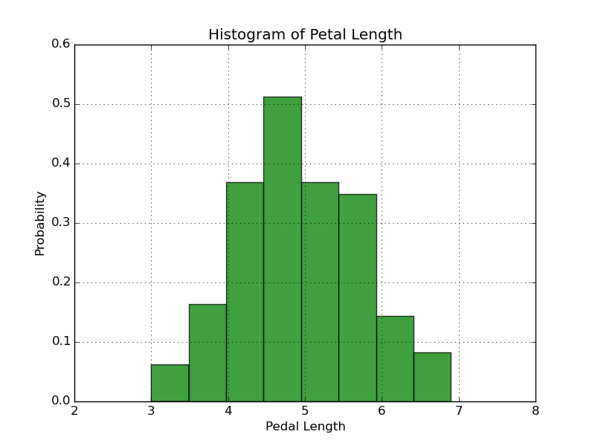

BOX PLOT
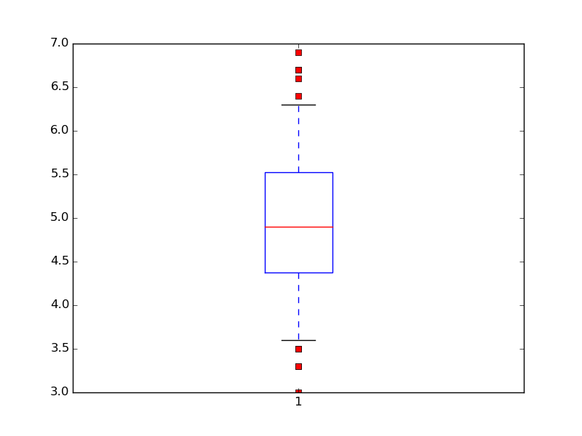

Quartile Values of X (Pedal Length):

Q1: 4.0
Q2: 5.05
Q3: 6.0

