# Operating-Systems-Final-Docker

Docker Challenge Project: Challenges 3 and 4

This repository (https://github.com/Anthony7145/Operating-Systems-Final-

Docker/edit/main/README.md) contains my solutions for Challenges 3 and 4 of the Docker challenge series. The challenges involve setting up a full-stack application using Docker Compose (Challenge 3) and scaling up service within the Docker environment (Challenge 4).

Steps Taken:

Cloned Repository

Cloned the project repository from the provided template (https://github.com/eduluz1976/dockerchallenge-template).

Navigated to Challenge 3 Folder by writing the command " cd

C:\Users\antho\OneDrive\Documents\docker 2\challenge3\docker> docker-compose up"

Added Configuration Files

Created .env file with appropriate configuration variables.

Configured docker-compose.yml to include nginx, node-service, and db services.

1. “docker-compose down”: This command stops and removes the containers, networks, volumes, and images created by docker-compose up. By default, it only removes the containers for services defined in the Compose file and the default network. It does not remove named volumes declared in the “volumes” section of the Compose file attached to containers unless you use ‘-v’ option.
2. “docker-compose up -d”: The ‘docker-compose up’ command builds, recreates, starts, and attaches to containers for a service. Adding the ‘-d’ flag, which stands “detached”, runs the containers in the background and leaves them running. If there are existing containers for a service and the service’s configuration or image has changed since the container’s creation, ‘docker-compose up’ will stop and recreate the containers (preserving mounted volumes).
3. “docker-compose ps”: This command lists the containers for a Compose project, showing their current status and exposed ports. By default, it only shows running containers, but you can use the ‘-a’ flag to show all containers, including stopped ones.
4. “docker-compose up”: Similar to the ‘docker-compose up -d’ command but without the -d flag, this command builds, (re)creates, starts, and attaches to containers for a service. It aggregates the output of each container, essentially running ‘docker-compose log –follow’

Final Displays of the commands

Verified Services:

Accessed http://localhost:8080/api/books in the browser to test the application.

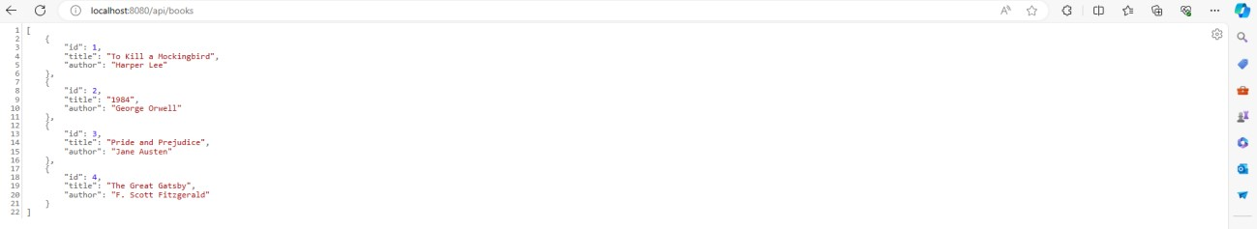

Verified Services:

Accessed http://localhost:8080/api/books/1 in the browser to test the application.

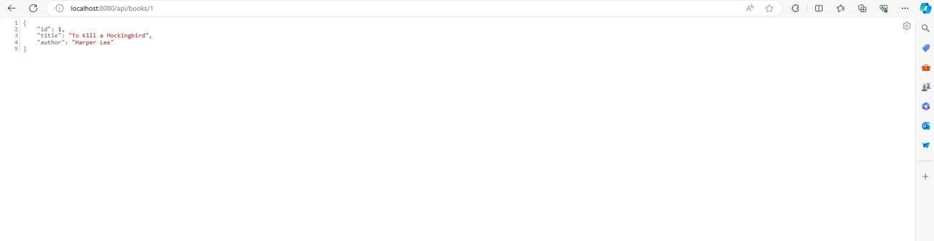

Verified Services:

Accessed http://localhost:8080/api/stats in the browser to test the application.

