# CS 255 System Design Document

## UML Diagrams

### UML Use Case Diagram

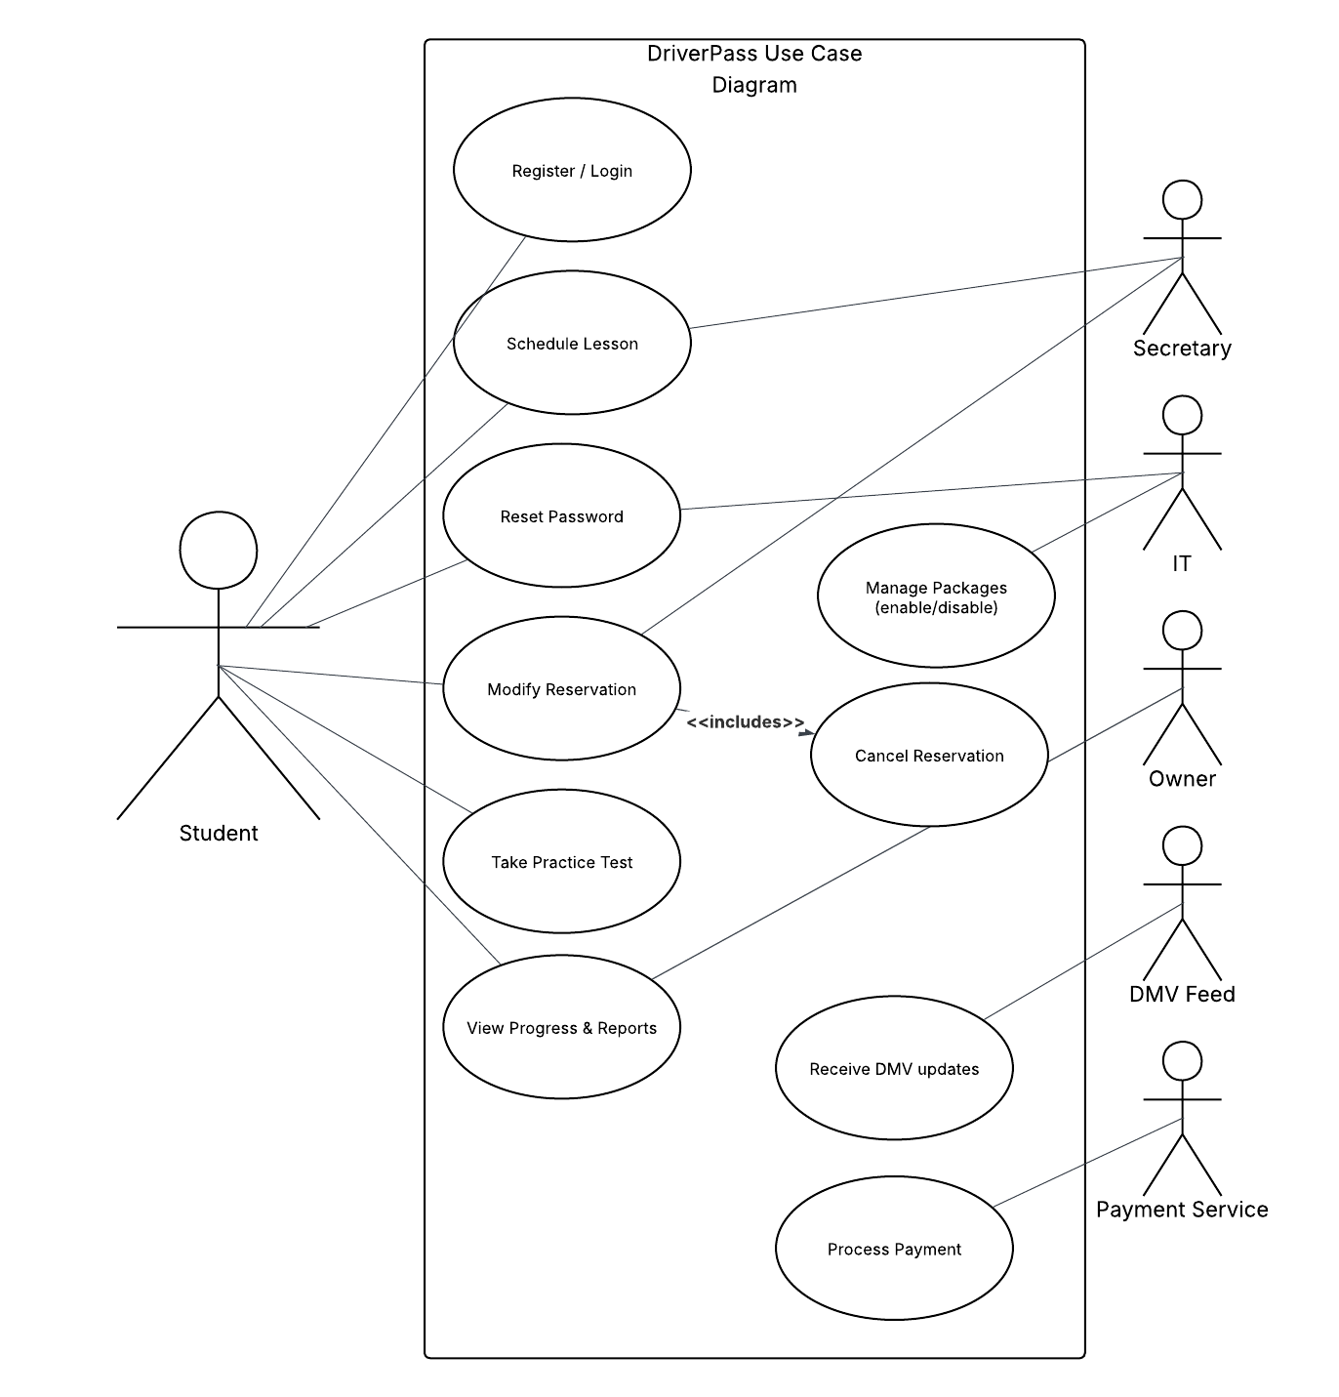

### UML Activity Diagrams

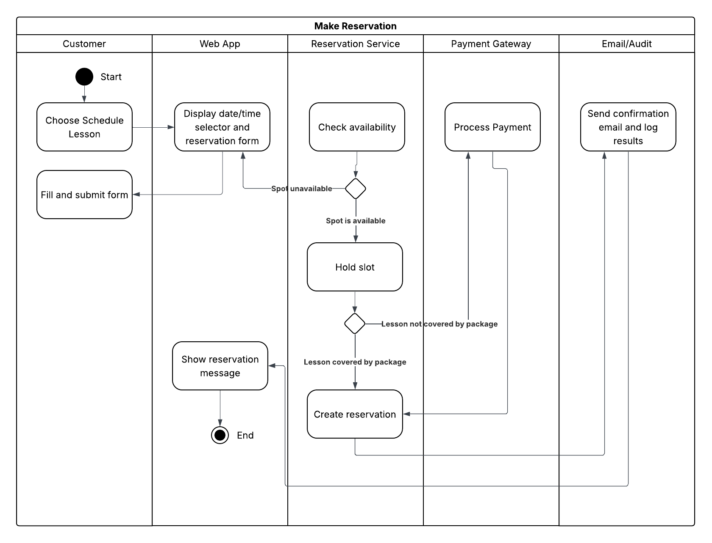

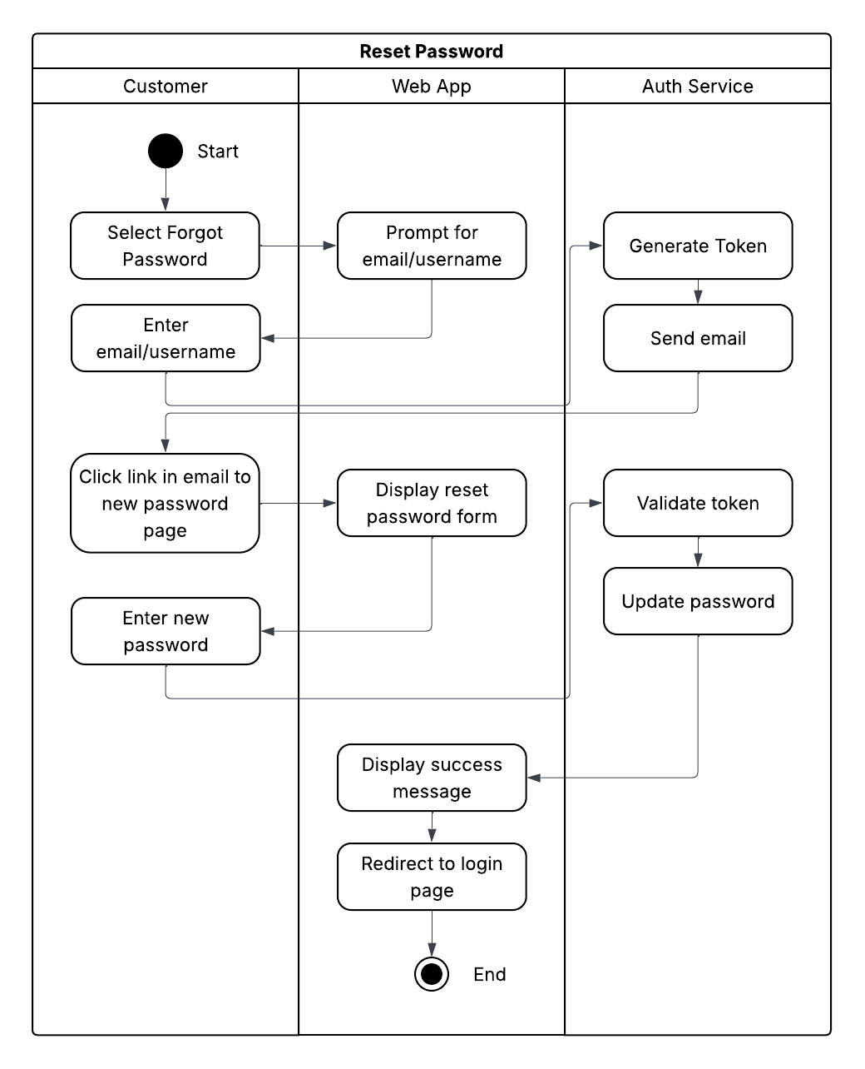

### UML Sequence Diagram

### UML Class Diagram

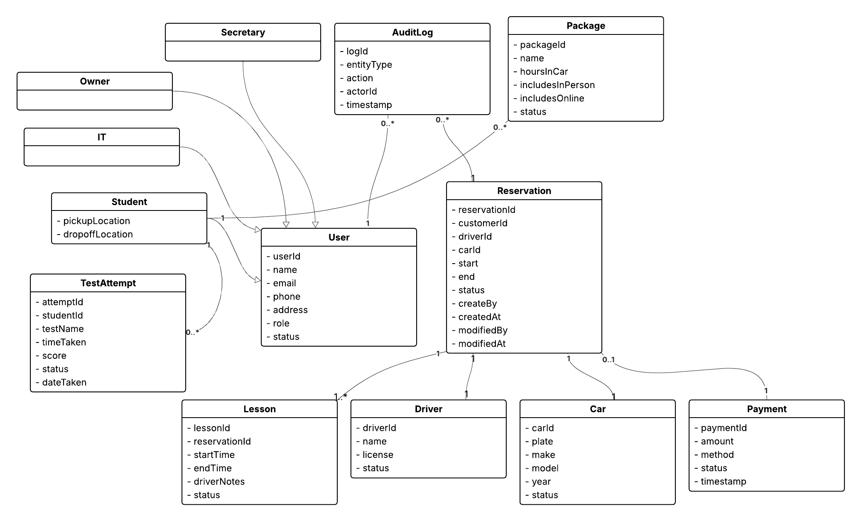

## Technical Requirements

**Software**

* *Frontend.* HTML, CSS, JavaScript
* *Backend.* API built using a secure framework
* *Database.* PostgreSQL (cloud-managed) with role-base access
* *Authentication.* Secure password hashing, multi-factor authentication, and email-based password reset
* *Payments.* Integration with a PCD-DSS compliant payment provider, like Stripe.

**Tools**

* Lucidchart for UML diagrams
* IDE for development
* Git-based version control
* Postman or similar tool for API testing

**Security**

* Traffic encrypted over HTTPS
* Role-based access control – Owner, IT, Secretary, Student
* Parameterized database queries
* Audit logging for sensitive actions – reservations, payments, password resets
* DMV feed over secure channels to ensure compliance

**Maintenance**

* Centralized logging and monitoring for error tracking
* Alerts for suspicious activity and/or downtime
* Regular security updates and framework updates