CVIA (8890) Assignment 2 – Object Recognition Implementation
u3283999 – Anthony Bebek - Dr Noha Khattab

1. Classical Approach:
Method Description:
HOG + HSV histograms were chosen as the extracted features from the images. These features were selected to classify birds based on both shapes (HOG) and color information (HSV). These features were then used as an SVM model. This model was chosen as HOG + HSV histograms provide a high dimensional feature space relative to the number of samples within the dataset.
HOG Feature
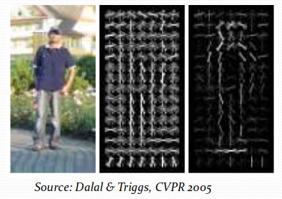
HOG (Histogram of Oriented Gradients) works by computing the intensity changes in both the x and y direction. From these intensity changes (gradients) a magnitude and orientation are calculated for each pixel. The image is then subdivided into small regions called cells, for each cell a histogram of the gradient orientations are computed weighted by the gradient magnitudes. The cells are then normalized over the larger regions. This is done to allow HOG to be more robust against contrast and illumination changes.
As HOG defines the shape of the bird, it’ll be easier for the model to differentiate between breeds with completely different structure, like eagles compared to humming birds. However it won’t work as well differentiating similar species like comparing the white throated sparrow with the white crowned sparrow.
HOG however, also takes the noise in the background into account, this means information in the background, like grass and leaves can mess with the classification from the model. This means the model could learn that if the bird has a forest background means that its a particular species.

HSV Histogram Feature
HSV (Hue, Saturation, Value) Histograms defines the frequency of different colors within the image, this helps the model classify based off the color of the bird as well. Like comparing yellowthroats to cardinal birds. However, HSV classification struggles with similar color intensities like the Pelagic Cormorant and Bronzed Crowbird.
Bronzed Cowbird | Pelagic Cormorant
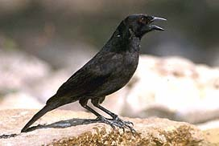 | 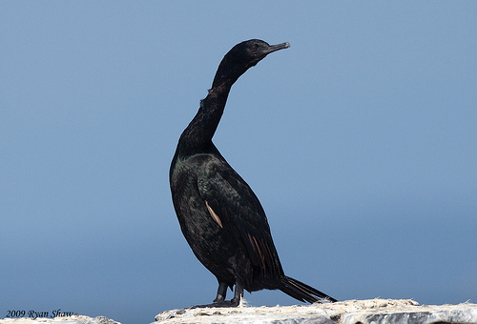

HSV captures color information from the entire image, meaning its sensitive to background data. As a result, the model might learn based off the background color rather than the species. For example, if a particular bird species is often photographed against a blue sky, the model might associate higher blue frequency with that species even if the bird itself is not blue.
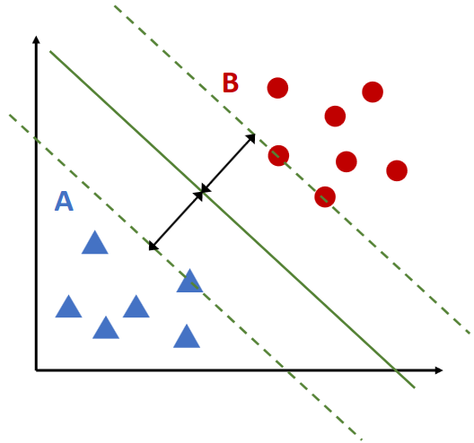
SVM model:
SVM (Support Vector Machines) work by finding an optimal hyperplane in a n⁻dimensional plane, where each dimension is a different feature extracted from the iween the hyperplane and the nearest data point for each class (support vector), models with a larger distance (margin) are more robust to small variations in the data as the small variations (usually caused by noise) are less likely to cause classification. While SVMs take longer to train compared to other models like KNN (K Nearest Neighbors) and Random forest. SVMs are usually quite lightweight and fast when predicting.
mage. SVM was chosen for this as it handles high dimensional data well such as those produced by HOG and HSV histograms. SVMs try to maximize the distance between the hyperplane and the nearest data point for each class (support vector), models with a larger distance (margin) are more robust to small variations in the data as the small variations (usually caused by noise) are less likely to cause classification. While SVMs take longer to train compared to other models like KNN (K Nearest Neighbors) and Random forest. SVMs are usually quite lightweight and fast when predicting.

Parameters:
As the images in the dataset all have unique sizes, originally images were all resized to the most common size (500 x 500 pixels) but due to RAM and compute restrictions, this was later changed to 300 x 300 pixels. This does mean some data is lost due to resizing but at this resolution, the SVM should have enough data.
To save on compute, the HOG feature extractor takes a gray-scale input, and splits into 8x8 cells to then compute the histogram, this was a good starting point as it had a good balance between noise sensitivity and amount of features captured. Each cell was then put within a 2x2 block for normalization.
To save further on training time and compute, a Liner kernel on the SVM was chosen with a C value of 1

2. Deep Learning Approach:
Convolutional Neural Networks (CNN) are neural networks designed for images that consist of multiple layers. Earlier layers learn simpler patterns like edges within the image, while deeper layers combine these into more complex structures as shapes and object parts. As the CNN takes raw pixel values as an input, there isn’t a need for external feature extraction like in the classical approach.

Parameters:
To save on compute and to make both approaches fair, the deep learning approach will have the same input image size. The CNN model consisted of three layers. An low level feature detection layer which should detect simple lower level features like edge and gradients. A medium level which builds on those features extracted from the lower level like finding lines and corners from the edge detection and a higher level which focuses on object parts or more complex shapes.
Initially I trained the CNN to have a higher filter count like 32, 64, 128 with a 3x3 kernel, but found that the model was over fitting, I halved the filter count for each layer to 16, 32 and 64 then introduced a dropout to reduce the over fitting.

3. Results and Comparison:
- Parameter settings:
- Results:

4. Discussion and lessons learnt:
Deep learning
- Why to chose deep learning over the other approach, and vice versa
- Potential Improvements

