CVIA (8890) Assignment 1 – Image Segmentation Implementation
u3283999

Edge-Based Segmentation
For this implementation, Sobel edge detection and threshold was chosen due to simplicity and computational efficiency. It works by approximating the gradient of image intensity, allowing edge areas with strong intensity changes to be identified.
This method uses small convolution kernels, (in this case 3x3 matrices) to focus on local regions of the images. The kernels are designed to detect intensity changes in both the x and y axis, examples of these kernels can be found below.
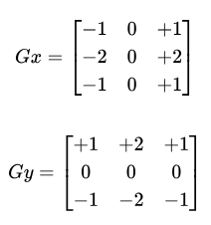
Each kernel is overlaid on a 3x3 section of the image. The pixel values in this region are multiplied by the corresponding kernel values then summed. This new value represents the intensity gradient at the center pixel. With a sliding window approach, the kernel is moved throughout the entire image. Areas with large gradient values produce higher kernel values which show that there is higher intensity differences between neighboring pixels. We can then apply a threshold to filter for only significant edges.
In addition to this, we can apply a threshold technique to segment the image by manually filtering out pixels that less than the threshold value. While this technique is not computationally expensive, it only works well when the pixel intensities between the object and background are very different.
To find reasonable threshold values, a histogram plotting the pixel intensities over frequencies was plotted, and hand picked values were chosen based on the peaks the graph created.

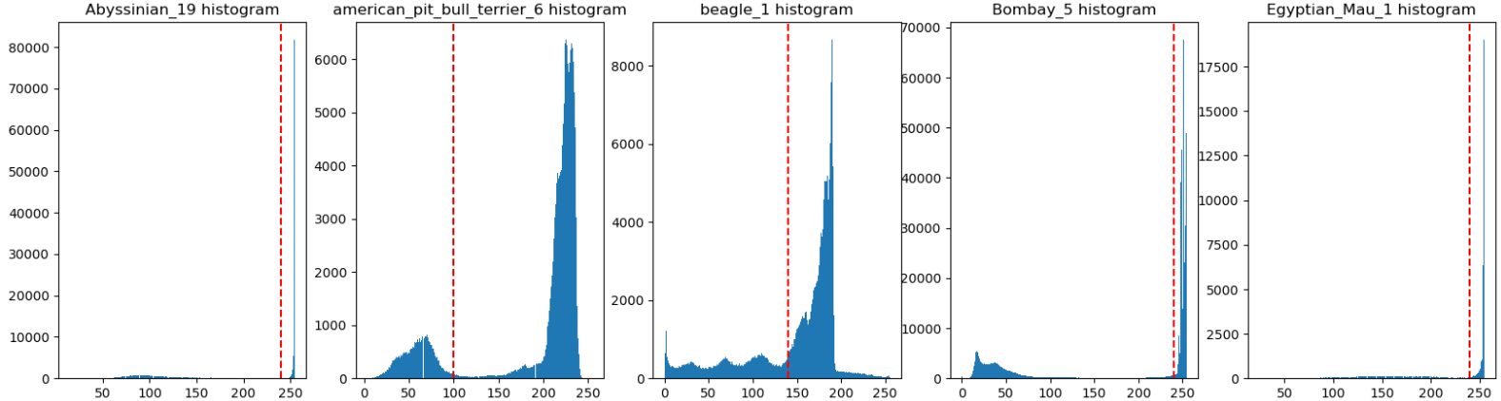
The red line depicts the chosen threshold value for provided image, the left side of the line are the pixel intensities inside the image that are within the segmented region while the pixel intensities that are outside are set as the background.
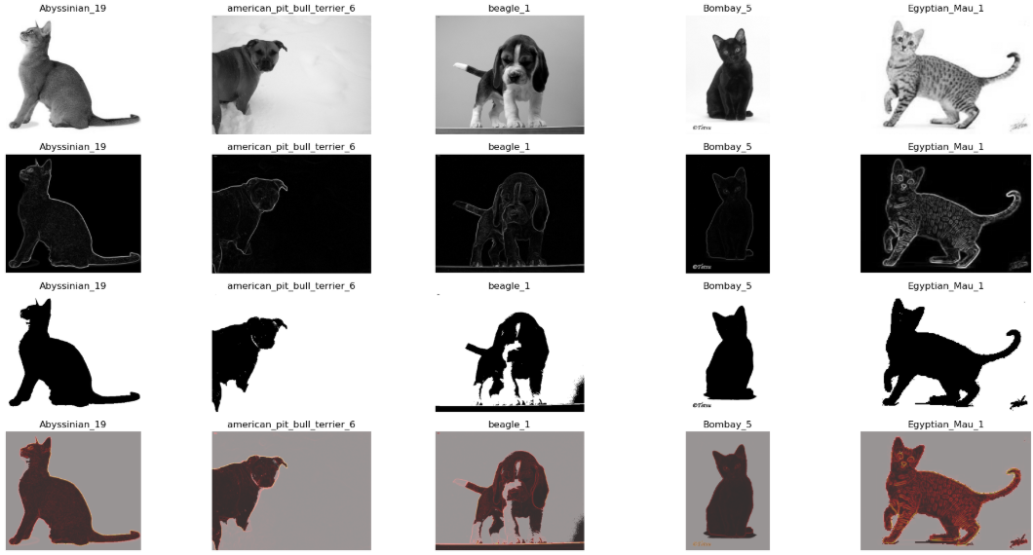
Dice and IoU metrics showed that these methods proved to be effective for segmentation on images that have a distinct solid background.
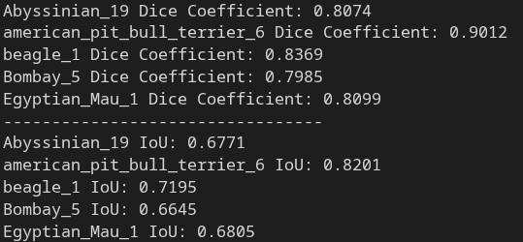
While these methods are effective at separating the object from the background, it only provides instance segmentation. Additionally, a majority of the full segmented map was due to threshold rather than the sobel edge detection.

Region-Based Segmentation
Watershed segmentation treats the image as a 3D surface, where higher gradients create peaks while lower gradients form valleys. The algorithm floods the surface starting from predefined markers. As the regions expand, boundaries are formed along the ridges where each segment touch.
This is similar to region growing techniques, but instead of a singular seed, watershed can handle multiple predefined markers to grow multiple regions simultaneously and determine their boundaries.

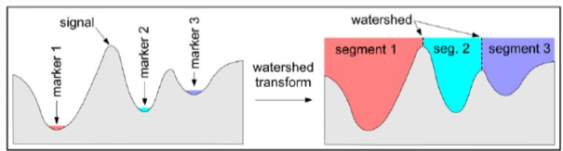
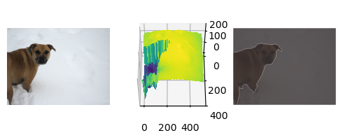
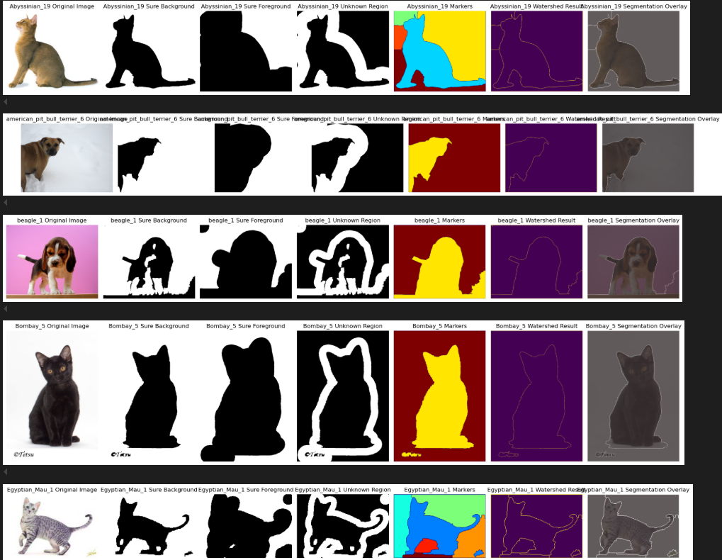
To define the markers, sure foreground is obtained by computing the distance from each foreground pixel to the nearest background pixel, then thresholding that distance map to only use the high confidence foreground pixels. To find the sure background, the thresholded binary image map is dilated. Finally a unknown region is defined by the area between the sure background and sure foreground. Then marker labels are assigned to each segmented part, so each separated region receives a unique marker value.
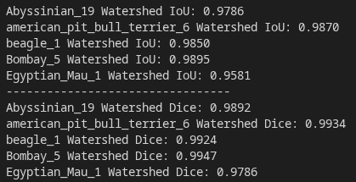
Watershed was effective at segmenting the image, achieving an average performance of 98% based on Dice metrics (as shown in evaluation results). The high contrast between the animal and the background allowed the algorithm to clearly identify object boundries. The sure foreground was obtained by using a distance transform on the thresholded image, which helped define the most reliable foreground regions for marker generation.

Clustering-Based Segmentation
K-means segmentation was chosen for its simplicity and computational efficiency. During testing, mean shift I found it to be much more computationally expensive and provided similar results anyways.
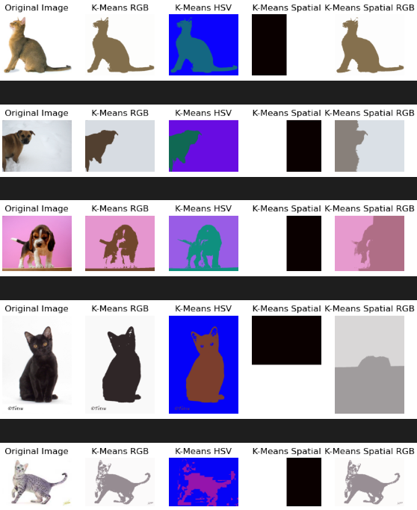
K-means work by plotting all the pixels onto a n-dimensional plane. A set amount of points (centroids) are then placed randomly into the plane, each centroid represents a different class. Each value within the plane is then set to the class of the closest centroid, which essentially separates values in the n-dimensional plane into respective classes. Then each centroid is moved closer towards the average value of its respective class, and the process repeats.
As k-means handles different features (RGB values, HSV values and spatial values), I experimented with the different types to find the most effective feature space. As spatial features only took the x & y location into account for segmentation, it doesn’t provide any useful information for segmentation, therefore a combination of both spatial and RGB values was considered as it provided much better results.

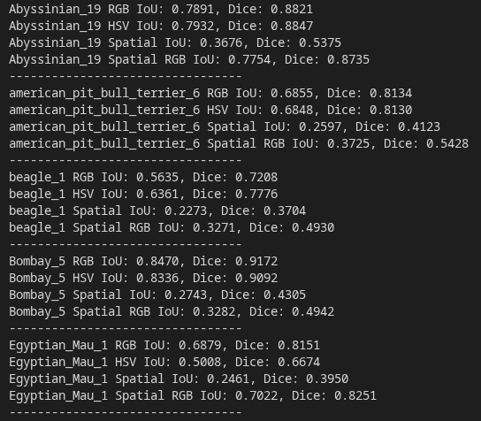
RGB and HSV features usually provided higher IoU and Dice values compared to the spatial features. I believe this is due to the fact that spatial features don’t really help with segmentation at all when the k value is so low and the only reason some spatial values scored so high is due to luck that the centroid happened to be placed in a good starting location.

Comparison
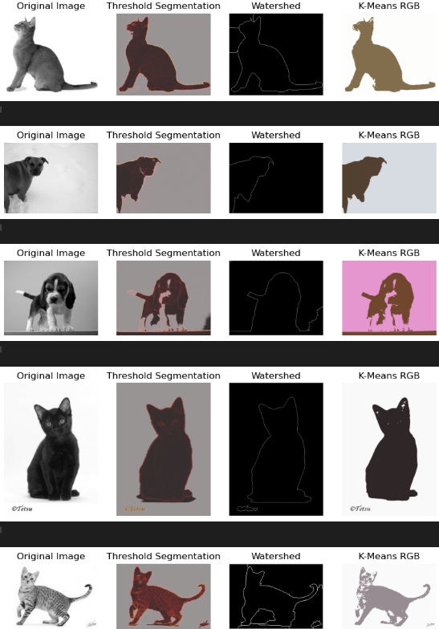
Watershed was the best performing segmentation method on the image set providing values in the high 90% while keeping computation to a minimum. I believe watershed worked so well due to the images having a high contrast from foreground to background allowing distance calculator to draw a good starting point. As watershed further thresholds the distances, it can create a more confident foreground which provides a better result. Pure thresholding with sobel edge detection was able to handle smaller gradients in the image which can be seen in the abyssinian where watershed produces some extra lines near the face of the cat. K-means performed well, but struggled with the detail in the egyptian mau. While K-means didn’t require a predefined threshold value, it was much more computationally expensive compared to the other methods, and I don’t really see much of a use case for this method compared to others. Especially with k-means on just spatial information.

Given all the segmentation methods, watershed performed the best as it provided great results while keeping computation down. Additionally I didn’t need to do any manual calculation to find the best threshold value, as the predefined 20% max cut off value worked well.

