Deakin University
School of Information Technology
SIT723 Research Techniques & Applications — Task 4.2P | SIT792 Minor Thesis
Quantum-Enhanced Language-Model-Based Control for
BBR over Low-Earth-Orbit Satellite Internet
A Minor Thesis (in-progress submission)
Author | Chung Bao An Nguyen
Student email | nguyenchungbaoan@gmail.com
Student ID | [Student ID]
Course | [e.g. Master of Information Technology (Professional)]
Trimester | [e.g. Trimester 3, 2026]
Principal supervisor | [Supervisor name]
Associate supervisor(s) | [Supervisor name(s)]
Word count (body) | 7,891

Note: this thesis reports work in progress. Sections describing the trainable quantum action head (gpt_quantum) report results that were completed and Tokyo-evaluated on 10 September 2026, after an earlier development draft of this manuscript had left them as pending placeholders; the corrected, epoch-matched comparison is reported here in full. If the candidate continues into SIT724/SIT746, this document will be extended rather than restarted.

Table of Contents
Note on Word Count 3
Abstract 4
1. Introduction 5
2. Literature Review 7
3. Methodology 9
4. Results 14
5. Discussion 21
6. Limitations and Future Work 23
7. Conclusion 25
References 26
Appendix A. Evidence-to-Claim Boundary 27
Appendix B. Reproducibility Snapshot 28

Note on Word Count
Task 4.2P sets a limit of 10,000 words for this thesis. The body of this document — Abstract through Conclusion — is written to sit comfortably within that limit; the reference list and appendices, which record reproducibility detail rather than argument, are kept short and are noted here as conventionally excluded from the count, consistent with common thesis word-count conventions. The candidate should confirm this convention with the supervision team and insert the final counted figure on the cover page before submission.

Abstract
Low Earth Orbit (LEO) satellite Internet, exemplified by Starlink, exhibits rapid capacity variation, intermittent path changes, and non-terrestrial delay dynamics that complicate transport-layer congestion control. Bottleneck Bandwidth and Round-trip propagation time (BBR) achieves high throughput in this environment, but its bandwidth-probing behaviour can increase retransmissions and destabilise pacing. Small Language Model-based Control for BBR (SLM-BBR) casts pacing-gain selection as offline, return-conditioned sequence modelling over structured Starlink telemetry, using a language-model backbone, Low-Rank Adaptation (LoRA), and a phase-constrained action head.
This thesis asks a single, narrow question: when the data, backbone, tuning policy, and evaluation protocol are held fixed, does replacing a language model's classical action head with a trainable Qiskit variational quantum circuit (VQC) change its BBR pacing-gain prediction ability? A shared backbone, LFM2.5-350M, is selected from four downloadable under-400M-parameter candidates using development-only validation metrics, then attached to two task heads under otherwise identical data, labels, phase masks, LoRA configuration, training budget, and held-out Tokyo evaluation: a normal linear head (gpt_classical) and an eight-qubit Qiskit EstimatorQNN head (gpt_quantum).
Both variants completed 100 epochs of training and a one-time, checksum-verified evaluation on the held-out Tokyo trace. gpt_classical reaches 95.93% overall Tokyo accuracy, 82.82% macro-phase accuracy, and 48.47% BW_UP accuracy, and spreads its predictions over seven distinct action labels. gpt_quantum reaches 95.50% overall accuracy but only 80.99% macro-phase accuracy and 42.98% BW_UP accuracy, and — critically — predicts only three distinct labels across the entire Tokyo pool. A diagnostic trace of per-epoch validation metrics shows that gpt_quantum's validation accuracy and BW_UP accuracy are numerically identical to six decimal places from epoch 1 through epoch 100: the quantum head converged to a constant per-phase predictor within its first epoch and never learned to discriminate further, so its apparently competitive overall accuracy is an artefact of the label distribution rather than evidence of genuine prediction.
This thesis therefore finds no evidence of a quantum advantage for BBR pacing-gain control under the eight-qubit, depth-one configuration tested: gpt_classical is more accurate on every phase-level metric, 4.9 times faster per action, and induces fewer surrogate retransmissions on every one of four Tokyo stream groups. The result is reported as a negative finding on this quantum head's trainability, together with three untested candidate explanations, an explicit epoch-matched comparison against the classical head, and a contextual comparison against both an internally retrained four-backbone survey and the original SLM-BBR paper's published results, each with its differing hardware and epoch budget stated rather than smoothed over. Limitations, including the single-seed design and the absence of a parameter-matched classical bottleneck control, are stated explicitly, and concrete next steps for a continuing SIT724/SIT746 project are identified.

1. Introduction

1.1 Motivation
Low Earth Orbit (LEO) satellite constellations, exemplified by Starlink, provide broadband Internet with substantially lower propagation delay than geostationary systems. Their moving topology, frequent handovers, and load- and weather-dependent channel conditions nonetheless create a difficult environment for transport-layer congestion control. Bottleneck Bandwidth and Round-trip propagation time (BBR) departs from loss-based algorithms such as Cubic by explicitly estimating bottleneck bandwidth and round-trip propagation time and using these estimates to regulate pacing and in-flight data. Experimental measurements over Starlink show that this model-based behaviour preserves high throughput, but BBR's periodic bandwidth probing can also increase retransmissions and destabilise pacing under LEO-specific conditions (De Silva, Pokhrel and Kua, 2026a, 2026b).
Small Language Model-based Control for BBR (SLM-BBR) reformulates BBR pacing-gain selection as offline, return-conditioned sequence modelling over real Starlink telemetry (De Silva, Pokhrel and Kua, 2026a). It combines a structured state encoder, a pretrained language-model backbone adapted with Low-Rank Adaptation (LoRA), and a constrained task head that emits one of eleven phase-safe pacing gains per decision step, avoiding free-form text generation and enforcing safety through a phase-dependent action mask. This project is a controlled extension of that framework: rather than proposing a new networking mechanism, it asks whether the same task, evaluated the same way, behaves differently when the classical action head is replaced by a trainable quantum action head, holding everything else fixed.

1.2 Research Gap
Two separate lines of work motivate this question. First, SLM-BBR establishes that a language-model backbone with a constrained action head can learn phase-safe BBR pacing decisions directly from Starlink telemetry, without hand-engineered control rules (De Silva, Pokhrel and Kua, 2026a). Second, hybrid quantum reinforcement-learning systems — combining a trainable variational quantum circuit (VQC) with classical policy deployment — have been shown to be trainable for other satellite resource-allocation problems, such as beam and power allocation in multibeam GEO–LEO networks (Ngo et al., 2026). These two directions have not previously been combined and evaluated under one controlled BBR experiment: no existing study attaches a quantum action head to a language-model-based BBR controller and compares it against the same backbone's classical head under identical data, labels, and evaluation protocol. This thesis addresses that gap directly, with the narrowest design that isolates the head as the single research variable.

1.3 Aim and Research Question
The aim of this thesis is to determine, under a controlled single-variable comparison, whether attaching a trainable Qiskit variational quantum circuit to the action head of a small language model changes its BBR pacing-gain prediction ability, compared with the same model's classical linear head. The scope was deliberately narrowed on 3 September 2026, after an earlier direction — a four-backbone modern-model survey combined with a three-role classical/classical-bottleneck/quantum ablation on a single 4-billion-parameter backbone — was judged too broad to state and defend as one claim. The design used here keeps exactly one research variable, the task head, fixed against exactly one backbone, so that any measured difference can be attributed to the head rather than to a mixture of backbone substitution and quantum integration. The earlier, broader work is preserved as background and referenced only where it justifies a design choice carried forward into the current scope (Sections 2 and 3).

1.4 Contributions
This thesis makes four contributions:
- It reproduces the SLM-BBR experience-pool construction deterministically and auditably: phase detection, the eleven phase-safe pacing gains, trace-level development splitting, and strict isolation of a held-out evaluation location (Tokyo).
- It selects a single under-400M-parameter backbone (LFM2.5-350M) from four downloadable candidates using development-only validation metrics, without reading the held-out evaluation data, and separately reports how that selection generalises (or does not) once training is extended to 100 epochs.
- It implements a Qiskit-backed quantum action head and attaches it to the selected backbone alongside a normal classical head, holding every other pipeline element fixed, and completes training and one-time held-out evaluation for both variants.
- It reports a negative result honestly: the quantum head does not outperform the classical head on any accuracy metric, and a per-epoch diagnostic trace shows it converges to a constant per-phase predictor rather than learning genuine action discrimination — a finding reported in full, together with untested candidate explanations, rather than omitted or softened.

1.5 Thesis Structure
Chapter 2 reviews related work on BBR over Starlink, SLM-BBR, language models for network control, and variational quantum models, and states the research gap this thesis addresses. Chapter 3 describes the dataset, the BBR phase and action-space construction, the shared sequence encoding and LoRA adaptation, the backbone-selection procedure, the classical and quantum action heads, and the training objective and reproducibility protocol. Chapter 4 reports results: the backbone survey read in a contextual comparison against the original SLM-BBR paper's published numbers, the primary classical-versus-quantum comparison, training dynamics, and surrogate throughput and retransmission behaviour. Chapter 5 discusses what the results do and do not support, directly addressing the evidentiary standard requested by the supervision team for comparisons against prior models. Chapter 6 states limitations and remaining work, and Chapter 7 concludes.

2. Literature Review

2.1 BBR over Starlink
BBR regulates sending behaviour using an explicit model of bottleneck bandwidth and round-trip propagation time, rather than reacting to packet loss as Cubic and similar algorithms do. Experimental studies over geographically distributed Starlink paths show that BBR can outperform Cubic, Vegas, and Hybla in throughput, while its active bandwidth-probing (ProbeBW) cycle produces a trade-off with retransmissions and short-term stability, particularly around handovers and rapid capacity changes characteristic of LEO constellations (De Silva, Pokhrel and Kua, 2026a, 2026b). These observations motivate finer-grained control over the pacing-gain choice within BBR's existing state machine, rather than replacing BBR outright — the approach this thesis, following SLM-BBR, adopts.

2.2 Small Language Model-Based BBR Control
The methodological foundation of this thesis is SLM-BBR (De Silva, Pokhrel and Kua, 2026a), which represents Starlink telemetry as return-state-action sequences and applies LoRA-tuned language models to predict phase-constrained pacing gains. Its action head directly predicts one of eleven discrete BBR pacing gains, constrained by a detected macro-phase (BW_DOWN, BW_CRUISE, BW_UP), which prevents the model from selecting a gain that would be unsafe or meaningless in the current phase. This thesis preserves SLM-BBR's state fields, sequence formulation, action space, phase mask, and held-out-location protocol unchanged, and extends only the task head — the architectural component mapping the backbone's hidden representation to an action — which is the minimal change needed to isolate the research question in Section 1.3.

2.3 Language Models for Network Control
Related work has adapted language models to other network-control tasks. Pokhrel et al. (2025) distil large language models for network active queue management, combining a structured encoder, a task-specific action head, and parameter-efficient tuning to produce a controller compact enough for practical deployment. This supports a general pattern — a structured encoder paired with a constrained head, tuned efficiently rather than trained from scratch — that this thesis follows, but it does not define or evaluate the BBR phase-safe pacing task used here, and does not involve a quantum component.

2.4 Variational Quantum Models for Network and Satellite Control
Variational quantum circuits (VQCs) encode classical features into parameterised quantum gates, apply trainable rotations and entangling operations, and expose measured expectation values (typically per-qubit Pauli-Z expectations) to a classical optimiser, forming a hybrid quantum-classical model trainable end-to-end with standard gradient-based methods. Ngo et al. (2026) propose a hybrid quantum reinforcement-learning system with classical policy deployment for resource allocation in multibeam GEO–LEO satellite networks, using a simulated quantum backend and demonstrating that a VQC-based policy component is trainable for a satellite resource-allocation task. That task differs from BBR pacing control in its state representation, action space, and objective; it is used in this thesis only as architectural motivation for combining a language-model backbone with a quantum action head, not as a source for the BBR networking task or its evaluation protocol.

2.5 Low-Rank Adaptation
Low-Rank Adaptation (LoRA) freezes a pretrained backbone's weights and injects a small trainable low-rank update into selected weight matrices, reducing the number of trainable parameters by roughly an order of magnitude relative to full fine-tuning while retaining competitive task performance (Hu et al., 2022). LoRA is used identically for both the classical and quantum head variants in this thesis (Section 3.5), so that any measured difference between the two variants cannot be attributed to a difference in how the shared backbone is adapted.

2.6 Research Gap and Scope of This Study
SLM-BBR establishes that language models can learn phase-safe BBR pacing decisions from Starlink telemetry (De Silva, Pokhrel and Kua, 2026a). Separately, quantum reinforcement learning has been shown to be trainable for other satellite-control problems (Ngo et al., 2026). These two directions have not previously been combined and evaluated under one controlled BBR experiment. This thesis addresses that gap with the narrowest design that isolates the head: the same backbone, data, labels, phase masks, LoRA policy, and evaluation protocol are used for both the classical and the quantum head, and only the head differs (Section 3.1).
A parameter-budget-matched classical bottleneck control (gpt_classical_twin) was used in earlier exploratory work on a larger, 4-billion-parameter backbone to separate the effect of low-dimensional compression from the effect of quantum processing specifically. That control is not part of the present comparison, and its absence is stated as an explicit limitation in Chapter 6: an observed gpt_classical-versus-gpt_quantum difference in this thesis cannot, on its own, be attributed to quantum processing as opposed to the effect of routing the hidden state through an eight-dimensional bottleneck before the final linear projection.

3. Methodology

3.1 Research Design
This thesis compares exactly two task-head variants on exactly one backbone: gpt_classical, LFM2.5-350M with a normal linear action head, and gpt_quantum, the same LFM2.5-350M with a Qiskit-based variational quantum action head. Both variants share the same checkpoint and revision, hidden-state extraction point, input pipeline, expert labels, phase masks, sequence windows, LoRA configuration, optimisation budget, checkpoint-selection rule, random seed, and evaluation implementation; only the task head differs. LFM2.5-350M itself was selected from four downloadable under-400M candidates using development-only validation metrics (Section 3.6); the held-out Tokyo trace was not read for that choice and was reserved for a single, final evaluation of both frozen checkpoints.
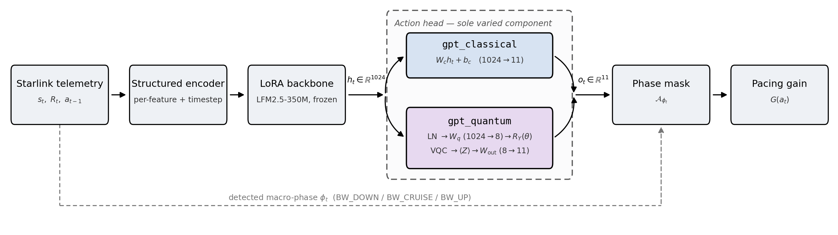
Figure 1. Controller architecture shared by both task-head variants. Starlink telemetry is embedded into the structured state/return/action sequence and encoded by the LoRA-adapted LFM2.5-350M backbone; the resulting hidden state h_t is then mapped to eleven action logits by whichever head is under comparison — gpt_classical's linear head or gpt_quantum's Qiskit variational circuit (detailed in Figure 2) — before the shared, phase-dependent mask restricts the output to the feasible action set for the detected macro-phase.

3.2 Dataset and Data Collection
This thesis uses the Starlink measurement traces associated with the SLM-BBR framework (De Silva, Pokhrel and Kua, 2026a), collected using iperf3 across six geographically distributed locations: Ohio, São Paulo, London, Mumbai, Sydney, and Tokyo. Traces cover sequential and competitive traffic under downlink and uplink conditions. Each interval contributes sender-side throughput, retransmissions, congestion window, receiver window, round-trip time, and RTT variance, together with a location and stream-category flag. At decision step t, the state is
s_t = [l_t, u_t, τ_t, y_t, r_t, c_t, w_t, d_t, v_t] (1)
a nine-dimensional vector combining the location flag l_t, stream-category flag u_t, observation time τ_t, throughput y_t, retransmissions r_t, congestion window c_t, receiver window w_t, RTT d_t, and RTT variance v_t. Raw captures are treated as immutable source data; every derived label, split, and sequence sample is deterministic and stored separately, with source-file checksums and stable sample identifiers, so that any reported number can be traced back to the raw trace that produced it.

3.3 BBR Phase Detection and Action Construction
The controller operates over three BBR macro-phases: BW_DOWN, BW_CRUISE, and BW_UP. Let ȳ_t be the centred rolling mean of throughput with half-window w = 10, and define the deviation δ_t = y_t − ȳ_t with population standard deviation σ_δ. A local maximum with δ_t > 0.7 σ_δ marks a BW_UP event; the first subsequent local minimum with δ_t < −0.7 σ_δ marks BW_DOWN. Remaining positions are BW_CRUISE. Detection runs independently within each raw trace. The global action set contains exactly eleven discrete pacing gains,
A = {0.90, 0.92, 0.94, 0.96, 0.98, 1.00, 1.05, 1.10, 1.15, 1.20, 1.25} (2)
and the feasible subset depends on the detected phase: five gains {0.90 … 0.98} under BW_DOWN, the single gain {1.00} under BW_CRUISE, and five gains {1.05 … 1.25} under BW_UP. Using the trace-maximum utilisation proxy B̄_t = y_t / max_j y_j, the continuous target gain follows the source formulation G_t↑ = 3 / (B̄_t + 2) for BW_UP and G_t↓ = (B̄_t + 1) / 2 for BW_DOWN; BW_CRUISE is fixed to 1.00. The expert action is the nearest feasible discrete gain, with ties resolved by the lower action index. Reward assignment follows the source hybrid rate/delay utilisation model, unchanged from SLM-BBR (De Silva, Pokhrel and Kua, 2026a) and not modified for either task head in this comparison.
The resulting non-Tokyo experience pool contains 60,084 samples from 200 traces: 52,576 BW_CRUISE (87.50%), 3,292 BW_DOWN (5.48%), and 4,216 BW_UP (7.02%). All five BW_UP actions occur in the pool. Every observed BW_DOWN target maps to gain 0.90 under this rule; this label degeneracy is retained rather than adjusted (Section 6), and both task heads see it identically.

3.4 Development Split and Sequence Sampling
The five development locations are split at the trace level using a deterministic SHA-256 ranking with seed 100003: within every location-by-stream stratum, two of ten traces are held out for validation. This produces 160 training traces (48,065 samples) and 40 validation traces (12,019 samples), with disjoint sample-identifier sets. Non-overlapping windows of length 20 are sampled with step 20 within trace boundaries, yielding 2,400 training windows and 600 validation windows (12,000 positions: 10,457 BW_CRUISE, 713 BW_DOWN, 830 BW_UP). Tokyo is excluded from this split entirely and is not read for preprocessing statistics, training, validation, checkpoint selection, architecture choice, hyperparameter selection, or model ranking — the isolation this thesis relies on to treat the Tokyo result as a genuine held-out evaluation rather than an indirectly tuned one.

3.5 Structured Sequence Encoding and Backbone Adaptation
Each scalar state feature is independently embedded and aligned to the backbone hidden size; return and previous-action values are linearly embedded, and a learned timestep embedding is added. At step t the ordered token block is [R_t, s_t(1), …, s_t(9), a_t]; a length-20 window therefore produces 220 structured embeddings, supplied to the backbone through its inputs_embeds interface rather than as text tokens, so the backbone never sees natural-language text at any point. The hidden representation at the final state-feature position, immediately before the action token, is used for action prediction: h_t ∈ ℝ^d.
Low-Rank Adaptation is applied to architecture-specific attention projections while the remaining backbone parameters are frozen:
W = W₀ + (α / r) · B A (3)
The shared configuration for both task heads is LoRA rank r = 128, scaling factor α = 32, dropout 0.05, AdamW with learning rate 1e-4 and gradient clipping at 0.25, batch size 1 with gradient accumulation over 32 sequences, sequence length 20, sample step 20, and seed 100003. Target modules are declared per backbone in the project's central configuration file.

3.6 Backbone Selection (Development-Only)
Four downloadable checkpoints under 400M parameters — Granite-4.0-350M, Pleias-RAG-350M, LFM2.5-350M, and Gemma-3-270M — were compared under the identical shared pipeline (Sections 3.2–3.5) with a normal classical head, using only the epoch-16 development validation split. The held-out Tokyo trace was not read for this comparison.
Table 1. Development-only backbone selection, epoch-16 validation, seed 100003. Bold marks the selected backbone.
Backbone | Val. accuracy | Val. macro-phase acc. | Val. BW_UP acc.
Granite-4.0-350M | 0.9503 | 0.7606 | 0.2819
Pleias-RAG-350M | 0.9505 | 0.7614 | 0.2843
**LFM2.5-350M** | **0.9550** | **0.7831** | **0.3494**
Gemma-3-270M | 0.9498 | 0.7582 | 0.2747
LFM2.5-350M leads on all three development metrics, including the historically weakest BW_UP phase, and was used as the fixed backbone for both gpt_classical and gpt_quantum. This selection is development-only evidence over a single seed; it supports the backbone choice for the controlled head comparison but is not a general claim of superiority over the other three candidates. Chapter 4 reports, as a direct check on this decision, how the same four candidates rank once training is extended to 100 epochs and evaluated on the held-out Tokyo trace — evidence that was not available at the time this selection was made and is not used to revisit it.

3.7 Classical Action Head
The classical head maps the backbone hidden state directly to the eleven-action logit space:
o_t^classical = W_c h_t + b_c , o_t^classical ∈ ℝ¹¹ (4)
gpt_classical uses this head with no intermediate bottleneck.

3.8 Quantum-Enhanced Action Head
The quantum head is a hybrid quantum-classical module positioned between the backbone hidden state and the action logits; it does not replace the state encoder, backbone, LoRA adapters, labels, or training objective. The hidden state is first projected to n_q scalar features and bounded into rotation angles, through head-input layer normalisation and a fixed temperature T:
θ_t = s_θ · tanh( (W_q · LayerNorm(h_t) + b_q) / T ) (5)
where s_θ is the angle scale. Each angle θ_t,i is encoded on qubit i with an R_Y(θ_t,i) gate. A depth-D variational circuit applies one trainable R_Y(ω_d,i) rotation per qubit per layer, followed by ring-structured CNOT entanglement. Per-qubit Pauli-Z expectation values q_t ∈ [−1, 1]^{n_q} are mapped to eleven logits by a final linear layer:
o_t^quantum = W_out q_t + b_out (6)
The circuit is implemented using Qiskit Machine Learning's EstimatorQNN through TorchConnector, backed by Qiskit's local StatevectorEstimator with analytic expectation values (default_precision = 0.0, shots = None, no quantum hardware).
The frozen configuration used for gpt_quantum is 8 qubits, depth 1, one trainable RY layer per qubit with ring CNOT entanglement (no data re-uploading), angle scale π, head-input LayerNorm enabled, and temperature T = 4. This configuration was chosen from two development-only checks, neither of which read Tokyo. First, a wall-clock benchmark on training-pool windows found that reducing circuit width and depth from an earlier 8-qubit/depth-2 configuration substantially reduced per-window training time, up to a 13–15× speed-up for a 4-qubit/depth-1 variant relative to 8-qubit/depth-2. Second, a longer correctness check — 200 real training steps against a several-thousand-sample validation slice, not the short speed benchmark — showed that the 4-qubit/depth-1 variant collapsed BW_DOWN accuracy to 0%, while an 8-qubit/depth-1 variant recovered BW_DOWN accuracy to 100% at roughly one-third the runtime of the original depth-2 configuration. 8 qubits at depth 1 was therefore chosen for correctness, at an estimated 16-epoch training time of approximately 2.1–2.2 days. LayerNorm and T = 4 are retained from earlier diagnostics on a different backbone that found them necessary to avoid saturating the bounded angle encoding.
A related provenance detail, reported in full in Section 4.4: training epochs 1–11 used Qiskit's StatevectorEstimator with parameter-shift gradients, and epochs 12–100 continued on an exact torch statevector implementation of the identical circuit, differentiated by autograd, after both were verified to agree to 1e-5 in unit tests across ansätze, depths, and the single-qubit no-entanglement case.
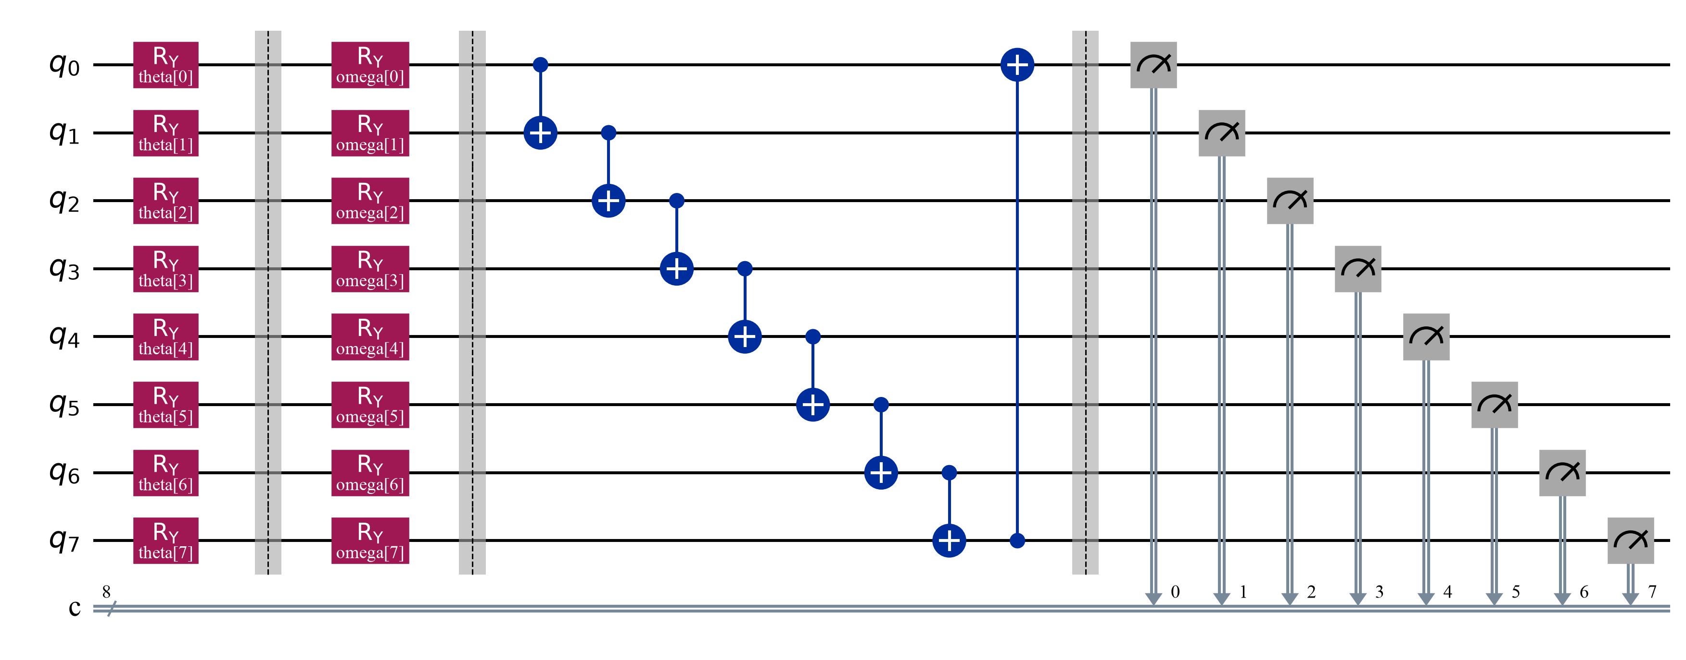
Figure 2. The eight-qubit, depth-one variational quantum circuit used by gpt_quantum's action head: a fixed Rᵧ angle-encoding layer (θ, Equation 5), one trainable Rᵧ rotation per qubit (ω), ring-structured CNOT entanglement, and per-qubit Z-basis measurement, whose expectation values form q_t in Equation 6.

3.9 Phase-Safe Prediction and Training Objective
Each head produces an unmasked logit vector o_t ∈ ℝ¹¹. Given the feasible action subset A_{φt} for the detected phase, the phase-safe logits set every infeasible entry to −∞ before probability normalisation, loss computation, and action selection; the same mask is shared by both heads. The training objective is phase-masked cross-entropy against the expert action a_t*:
L = −(1/L) Σ_t log[ exp(õ_{t,a_t*}) / Σ_{j ∈ A_φt} exp(õ_{t,j}) ] (7)

3.10 Metrics and Reproducibility
Both variants are evaluated with the same model-independent implementation, reporting phase-masked cross-entropy loss, overall action accuracy, per-phase accuracy (BW_DOWN, BW_CRUISE, BW_UP), macro-phase accuracy (the unweighted mean of the three per-phase accuracies), and predicted-action distributions. Because BW_CRUISE dominates the data and permits only one valid action, macro-phase accuracy, per-phase accuracy, and the diversity of predicted labels are treated as primary evidence in this thesis; overall accuracy is treated as secondary, since — as Chapter 4 shows directly — it can remain high even when a head has stopped discriminating within a phase.
Each run records a manifest with the git commit, dataset and split versions, sample-identifier hashes, model identifier and revision, task-head type and quantum configuration where applicable, seed, resolved training configuration, checkpoint path and checksum, hardware and software versions, and Tokyo-isolation status. A checkpoint is used downstream only after it passes a checkpoint-reload verification. Every number reported in Chapter 4 is read directly from one of these manifests or from the frozen Tokyo predictions file; none is estimated, extrapolated, or carried over from an earlier, different-epoch run without being labelled as such.

4. Results

4.1 Evaluation Scope and Evidentiary Standard
Two groups of results follow. The first is a four-candidate under-400M backbone survey (Section 4.2), reported alongside the original SLM-BBR paper's own published GPT-2, T5, GPT-Neo, and SmolLM2 numbers as contextual reference only. No same-sample statistical test is made across this thesis's runs and the published paper's numbers, because the published models were not retrained under this thesis's protocol: they were trained on different hardware (two NVIDIA RTX 6000 GPUs in the source paper, versus one NVIDIA RTX 4090 in this project) and for a different epoch budget (150 epochs versus 100). This caveat is stated explicitly here, and repeated at each point of contact with the published numbers, in direct response to supervisory feedback that earlier comparisons against prior models needed stronger, more explicit evidentiary grounding rather than a passing caveat.
The second group is the primary comparison (Section 4.3), which isolates the task head on the single frozen LFM2.5-350M backbone, comparing gpt_classical against gpt_quantum under otherwise identical conditions; this is the thesis's central, controlled claim. Every model in both groups is evaluated from its own independently frozen, checkpoint-reload-verified epoch-100 checkpoint, trained under the identical protocol described in Chapter 3. All values below use seed 100003, one run per model, with the held-out Tokyo trace read only after every model was frozen, on the shared 12,000-sample Tokyo pool identified by checksum tokyo_pool_sha256 = 800f1a44…d012f27b, verified equal across every model's result manifest — the check that makes the cross-model and cross-epoch comparisons in this chapter traceable rather than assumed.

4.2 Backbone Survey in Context: This Work versus the Published SLM-BBR Baselines
Table 2 reports the same four under-400M candidates as Table 1, now each read from its own frozen epoch-100 checkpoint on the held-out Tokyo trace.
Table 2. Held-out Tokyo evaluation of the four under-400M backbone candidates, epoch-100 final checkpoint (contextual; played no role in the backbone selection reported in Table 1).
Backbone | Accuracy | Macro-phase | BW_UP | Loss
**Granite-4.0-350M** | **0.9607** | **0.8339** | **0.5016** | 0.4233
Gemma-3-270M | 0.9602 | 0.8317 | 0.4952 | 0.4156
LFM2.5-350M | 0.9593 | 0.8282 | 0.4847 | 0.5131
Pleias-RAG-350M | 0.9588 | 0.8261 | 0.4784 | **0.3180**
The development-split ranking from Table 1 does not carry over: Granite-4.0-350M and Gemma-3-270M both outperform the development-selected LFM2.5-350M on every metric in Table 2, and LFM2.5-350M records the highest (worst) loss of the four. This is a materially larger gap than a marginal reshuffle — at the full 100-epoch training budget, the backbone chosen by development-only validation is Tokyo's weakest performer on three of four metrics. The backbone-selection procedure in Section 3.6 remains methodologically sound, since Tokyo was correctly withheld from that decision; the result is reported here as a limitation of development-only backbone selection under extended training (Chapter 6), not smoothed over as a small ranking difference. All four candidates predict all seven of the labels observed in their respective feasible action sets on Tokyo, a point of contrast with gpt_quantum in Section 4.3.
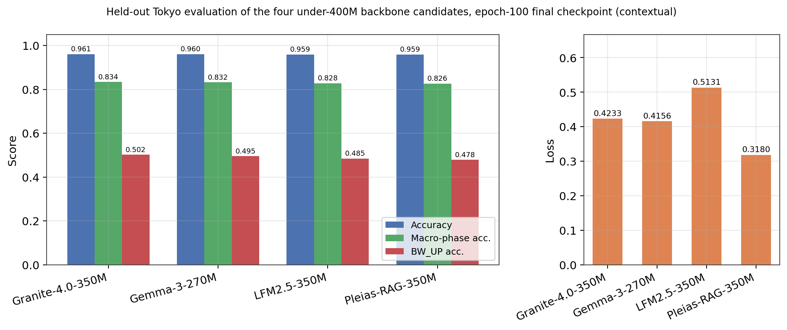
Figure 3. Held-out Tokyo evaluation of the four under-400M backbone candidates at their own frozen epoch-100 checkpoint, generated directly from the frozen result manifests (tokyo_pool_sha256 = 800f1a44…d012f27b). Regenerated for this thesis after Section 4.1's evidentiary standard was applied; an earlier, visually similar chart in the project's report history used 16-epoch numbers and has been superseded by this one.
Figures 4 and 5 place this thesis's five 100-epoch training runs (the four backbone-survey candidates and gpt_quantum) alongside the original SLM-BBR paper's own published GPT-2, T5, GPT-Neo, and SmolLM2 training curves, sourced from that paper's figures rather than re-estimated. Two conditions differ between the two groups and are stated explicitly rather than left implicit: the published curves were trained for 150 epochs on two RTX 6000 GPUs, while this thesis's curves cover 100 epochs on a single RTX 4090; and the published paper does not report an exact Tokyo action-accuracy or Tokyo-loss table, only box plots, so Figures 4 and 5 compare development-style training curves, not held-out Tokyo numbers, across the two sources.
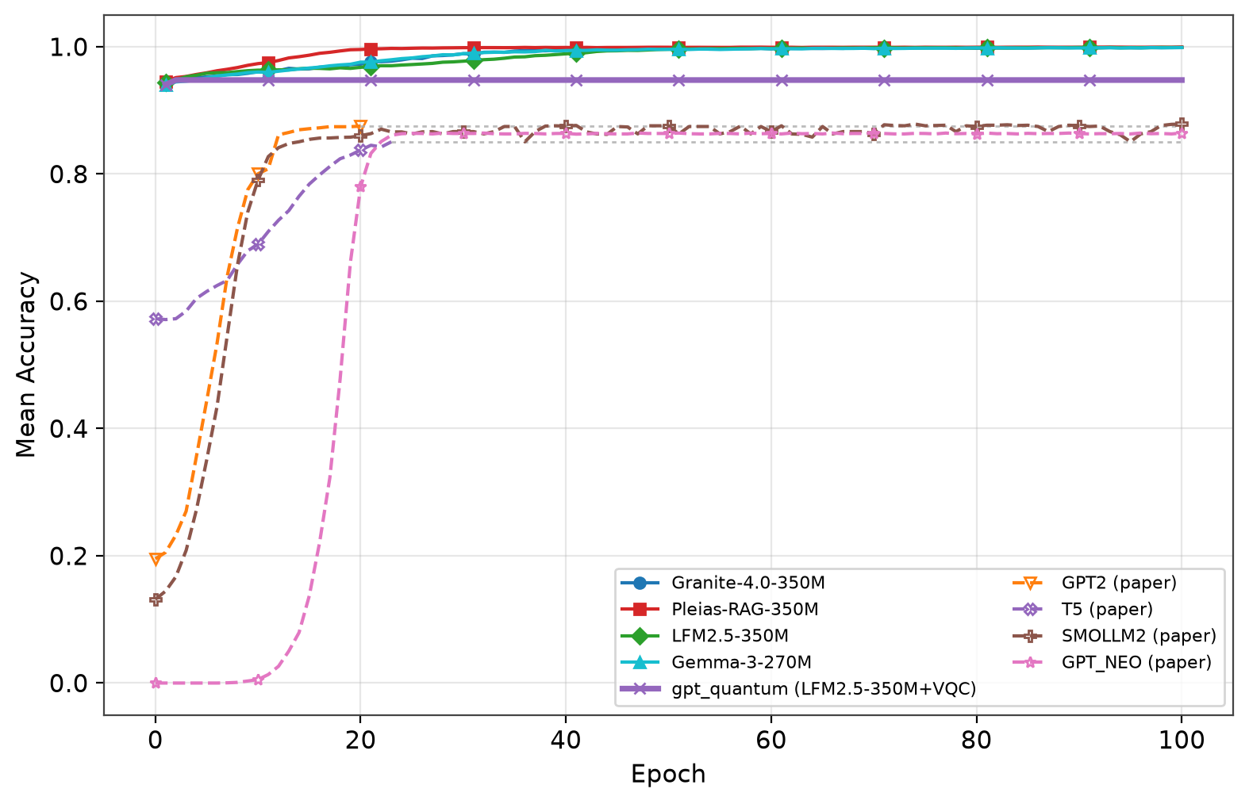
Figure 4. Mean development-split accuracy versus training epoch: this thesis's four classical backbones and gpt_quantum (solid lines), against the original SLM-BBR paper's published GPT-2, T5, GPT-Neo, and SmolLM2 curves (dashed lines). This thesis's four classical backbones converge earlier and to a higher accuracy plateau than the published models; gpt_quantum (solid purple) plateaus immediately at a lower level and is visibly flat from the first few epochs, foreshadowing Section 4.4's finding.
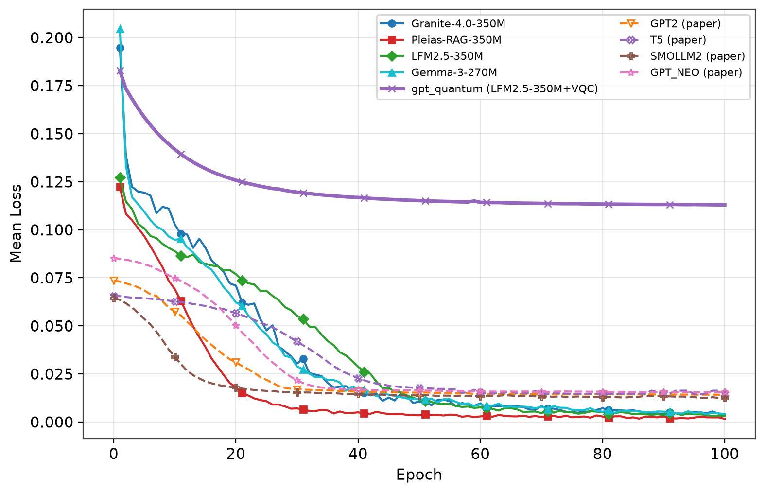
Figure 5. Mean development-split loss versus training epoch, same models and sourcing as Figure 4. gpt_quantum's loss (solid purple) starts highest and falls the slowest of all nine curves, converging to a plateau well above every other model shown, classical or published.
Read together with Table 2, Figures 4 and 5 support a specific, bounded claim: this thesis's classical backbones train faster and to a higher accuracy ceiling than the published SLM-BBR paper's original backbones under development-split metrics, and that pattern holds across all four candidates, not only the one selected for the primary comparison. It is not a claim that the two groups are directly comparable in a controlled, same-hardware, same-epoch sense — Section 4.1 states why they are not — and it is not evidence, on its own, about the primary classical-versus-quantum comparison that follows.

4.3 Primary Comparison: Classical versus Quantum Action Head
Table 3. Primary comparison: gpt_classical versus gpt_quantum on held-out Tokyo, same LFM2.5-350M backbone, both read from their own frozen epoch-100 checkpoint.
Metric | gpt_classical | gpt_quantum | Δ
Accuracy | **0.9593** | 0.9550 | −0.0043
Macro-phase accuracy | **0.8282** | 0.8099 | −0.0183
BW_DOWN accuracy | 1.0000 | 1.0000 | 0
BW_CRUISE accuracy | 1.0000 | 1.0000 | 0
BW_UP accuracy | **0.4847** | 0.4298 | −0.0549
Loss | 0.5131 | **0.1228** | +0.3903
Latency (ms/action) | **1.174** | 5.740 | +4.566
Distinct labels predicted (of 7 observed) | **7** | 3 | −4
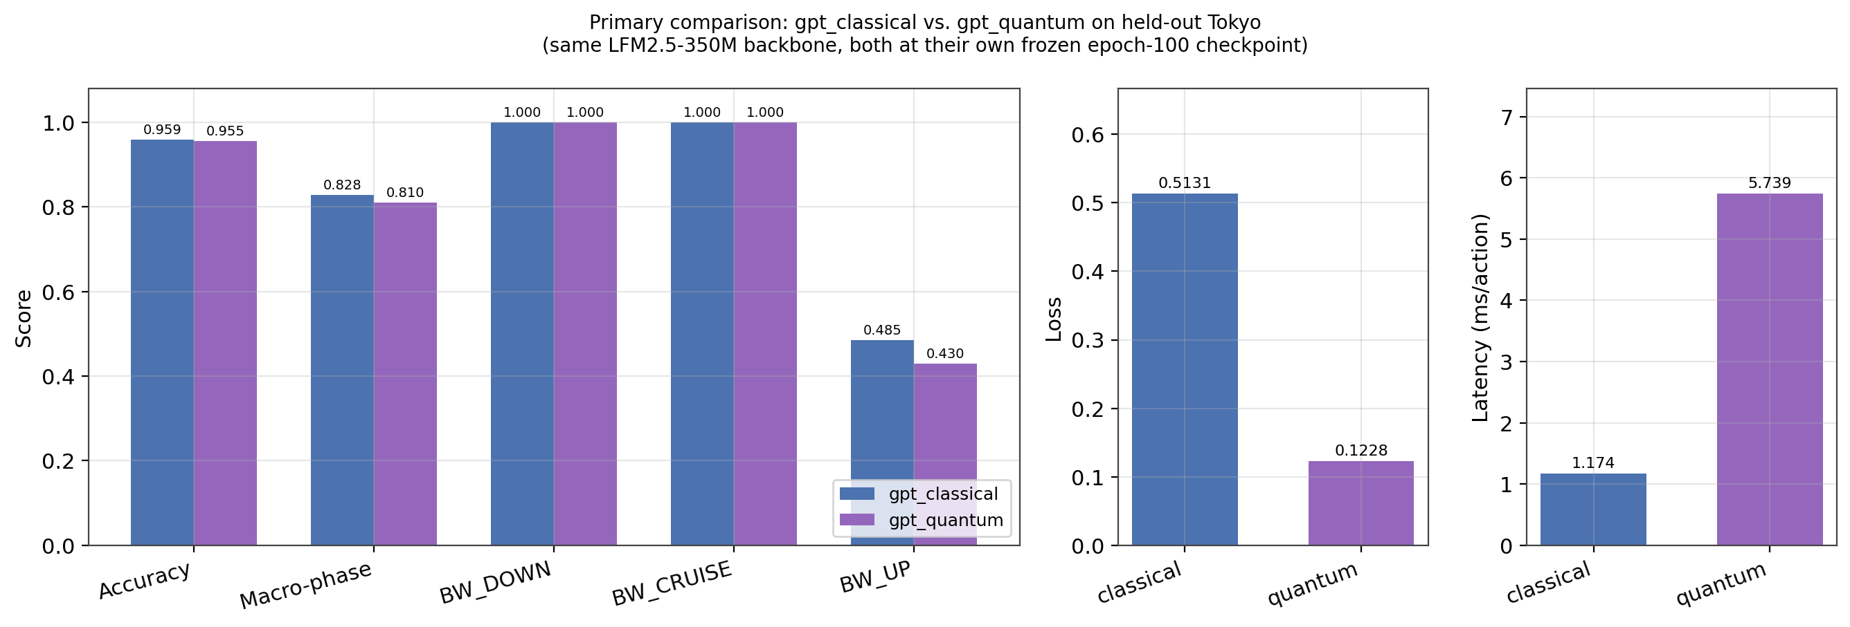
Figure 6. Primary comparison, gpt_classical versus gpt_quantum, both at their own frozen epoch-100 checkpoint on held-out Tokyo: accuracy-family metrics (left), loss (centre), and per-action latency (right).
gpt_classical outperforms gpt_quantum on every accuracy metric, with the largest gap on BW_UP accuracy (5.49 points) — the only phase with more than one feasible action, and consequently the most informative phase for genuine action discrimination. Both variants remain at 100% on BW_DOWN and BW_CRUISE, consistent with the label degeneracy noted in Section 3.3. The classical head is also 4.89 times faster per action (1.174 ms versus 5.740 ms), reflecting the added cost of statevector simulation in the quantum forward pass.
Loss does not follow the same ordering as accuracy, and this requires an explicit caveat. gpt_classical's Tokyo loss (0.5131) is higher than gpt_quantum's (0.1228), even though gpt_classical is more accurate on every phase-level metric. Section 4.4 traces this to two independent effects: gpt_classical has been trained well past its own peak-validation epoch and shows a standard overfitting signature, while gpt_quantum's low loss reflects high-confidence, constant-label predictions on the two phases that dominate the sample count, rather than superior discrimination. Cross-entropy loss is therefore not used as a head-quality ranking in this comparison; accuracy, macro-phase accuracy, and prediction diversity remain the primary evidence, consistent with Section 3.10.

4.4 The Quantum Head Does Not Learn: A Per-Epoch Diagnostic
The single most important finding of this thesis is not visible in Table 3 alone and requires tracing gpt_quantum's metrics across training, not only at epoch 100. Across all 100 epochs, the gpt_quantum development-split run produces exactly one distinct validation accuracy, 0.945167, and exactly one distinct BW_UP accuracy, 0.207229 — identical to six decimal places from epoch 1 to epoch 100. Training loss does fall over this period (0.183 to 0.113), but it does so by sharpening confidence on predictions that never change, not by learning to discriminate further.
The prediction distribution on Tokyo shows the mechanism directly. gpt_quantum predicts only three distinct labels across the entire 12,000-sample pool — label 0 for every BW_DOWN sample, label 5 for every BW_CRUISE sample, and label 10 for every BW_UP sample — regardless of which of the five feasible BW_UP gains was actually correct. Because label 10 happens to be the single most common true BW_UP label in the Tokyo pool (407 of 947 BW_UP samples, 42.98%), a constant predictor that always outputs label 10 scores exactly 42.98% BW_UP accuracy on Tokyo — matching Table 3's reported figure to the decimal. The same frozen model scores only 20.72% on the development split, where label 10 is not the most common BW_UP label; a genuinely discriminating model would not swing between pools purely as a function of each pool's label distribution. For contrast, gpt_classical on the identical Tokyo samples spreads its predictions over all seven observed labels and beats the Tokyo majority-label BW_UP baseline by 5.49 points, and its development-split accuracy takes 46 distinct values over the same 100 epochs.
Three candidate explanations for this collapse are identified but not yet tested, and are stated here as concrete next steps rather than conclusions: the circuit's trainable RY weights initialise to zero, and an RY(0) gate is the identity operation, a textbook barren-plateau starting point; the fixed temperature T = 4 (Equation 5) squashes the projected angles through tanh, so the resulting Pauli-Z expectations may vary too little between samples for the following linear layer to discriminate; and eight trainable circuit parameters at circuit depth 1 may simply be too low an expressivity budget for an eleven-way, phase-conditioned action space. The project's quantum action head already implements per-batch bottleneck-standard-deviation and saturation-ratio diagnostics that were not enabled for this run; enabling them is the cheapest concrete next step identified in Chapter 6.
This result is reported as a negative finding on this quantum head's trainability under the tested configuration, not as a competitive model in its own right. Quoting gpt_quantum's 95.50% overall Tokyo accuracy without this diagnostic context would be misleading, since that number is driven almost entirely by BW_CRUISE and BW_DOWN being separable by a constant guess, which both heads achieve identically (Table 3).

4.5 Surrogate Throughput and Retransmissions by Stream Group
Table 4. Mean surrogate throughput and retransmissions by Tokyo stream group, gpt_classical versus gpt_quantum, both at their frozen epoch-100 checkpoint (3,000 positions per group).
Stream group | Throughput (Mbps) | Retx. (classical) | Retx. (quantum)
Downlink, sequential | 228.99 | 49.94 | **125.92**
Downlink, competitive | 9.41 | 3.29 | 4.98
Uplink, sequential | 45.56 | 10.88 | 14.68
Uplink, competitive | 10.75 | 1.83 | 2.48
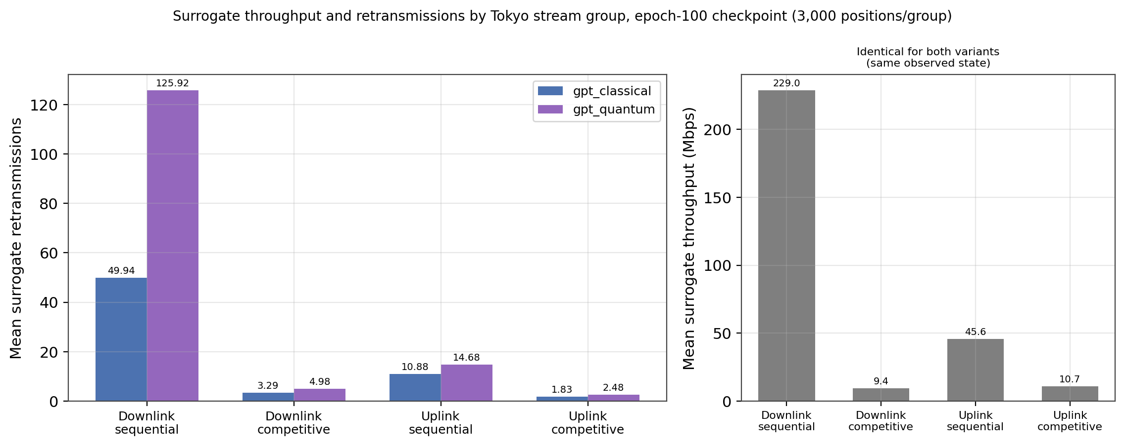
Figure 7. Mean surrogate retransmissions by Tokyo stream group for gpt_classical and gpt_quantum (left), and mean surrogate throughput, identical between variants since it is computed from the same observed network state (right), both at the frozen epoch-100 checkpoint.
Surrogate throughput is identical between the two variants within each stream group, since it is computed from the same observed network state; retransmissions differ because they depend on each variant's own predicted pacing-gain sequence. Retransmissions are consistently higher for gpt_quantum across all four stream groups, most sharply on downlink-sequential traffic, where the gap is 2.52 times (125.92 versus 49.94). This is directionally consistent with Table 3's lower gpt_quantum BW_UP accuracy: a controller that more often selects the wrong pacing gain during bandwidth-probing is expected to induce more surrogate retransmissions, independent of any difference in surrogate throughput. Two of the four groups (uplink, sequential and uplink, competitive) show a small increase in gpt_classical's own retransmissions relative to its earlier, less-trained 16-epoch checkpoint (10.88 versus 10.25; 1.83 versus 1.60); this counter-trend is noted rather than omitted, since it is real, if minor, within an otherwise consistent result.
Taken together, Sections 4.3 to 4.5 provide no evidence of a quantum advantage for this controller under the eight-qubit, depth-1 configuration tested (Section 3.8): gpt_quantum is less accurate on every metric, slower, and induces more surrogate retransmissions than gpt_classical on the same frozen backbone and held-out Tokyo split, and the gap on the most discriminative phase (BW_UP) is larger, not smaller, once both heads are compared at matching, epoch-100 training budgets.

4.6 Training Dynamics: Peak-versus-Final Epoch and the Loss Reversal
The checkpoint rule used throughout this thesis freezes the final completed epoch, fixed before training and not revisited after seeing results. Table 5 shows how far each backbone's epoch-100 development-split accuracy sits from its own best epoch during training.
Table 5. Development-split peak versus final-epoch validation accuracy (checkpoint rule: final completed epoch, pre-registered).
Model | Best epoch | Best val. acc. | Epoch-100 val. acc. | Regression
Gemma-3-270M | 41 | 0.9583 | 0.9573 | −0.09 pt
Granite-4.0-350M | 11 | 0.9599 | 0.9557 | −0.42 pt
LFM2.5-350M | 15 | 0.9615 | 0.9578 | −0.37 pt
Pleias-RAG-350M | 13 | 0.9585 | 0.9567 | −0.18 pt
gpt_quantum | 1 | 0.9452 | 0.9452 | 0.00 pt
For gpt_classical (LFM2.5-350M) specifically, the accuracy regression in Table 5 understates what is happening underneath it: training loss falls from 0.127 (epoch 1) to 0.0031 (epoch 100) with training accuracy reaching 99.88%, while development-split validation loss rises from 0.119 to 0.460 over the same period — a standard overfitting curve, past its epoch-15 accuracy peak, that a checkpoint frozen on accuracy alone does not surface. This is the mechanism behind Table 3's elevated gpt_classical Tokyo loss: the model remains highly accurate but less well calibrated at epoch 100 than at its own peak.
gpt_quantum shows the opposite pattern for an unrelated reason. As Section 4.4 established, its development-split validation accuracy and BW_UP accuracy are identical to six decimal places from epoch 1 through epoch 100; only its training and validation loss continue to fall as it sharpens confidence on predictions that never change. Consequently, gpt_quantum's epoch-100 checkpoint should not be read as the product of 100 epochs of effective learning: the head converged to a constant per-phase predictor within the first epoch, and the remaining 99 epochs of loss reduction reflect increasing confidence on that fixed output, not new discrimination. This is stated as a scope note on Table 3 rather than as a limitation of the epoch-100 protocol itself, since the checkpoint remains a faithful, checkpoint-reload-verified snapshot of the pre-registered final epoch.
A further provenance detail supports treating this checkpoint as reliable despite a backend change during training: epochs 1–11 were produced on Qiskit's StatevectorEstimator with parameter-shift gradients, and epochs 12–100 continued on an exact torch statevector implementation of the identical circuit, differentiated by autograd. Both are exact, shot-free simulations of the same circuit and were verified to agree to 1e-5 in unit tests across ansätze, depths, and the single-qubit no-entanglement case; the training-loss curve is continuous across the switch. The Tokyo evaluation independently rebuilt the head on the Qiskit path and loaded the torch-trained weights, so Table 3's gpt_quantum row is itself a cross-backend consistency check, not merely a single-path result.

5. Discussion

5.1 Answering the Research Question
The research question in Section 1.3 asked whether attaching a trainable Qiskit variational quantum circuit to the action head of a small language model changes its BBR pacing-gain prediction ability, compared with the same model's classical head, when data, backbone, tuning policy, and evaluation protocol are held fixed. The answer this thesis supports is: yes, it changes it, and the change is a degradation, not an improvement, and the mechanism behind that degradation is a failure to learn rather than a difference in learned behaviour. gpt_classical outperforms gpt_quantum on every accuracy metric in Table 3, is 4.89 times faster per action, and induces fewer surrogate retransmissions on every one of four Tokyo stream groups (Table 4). The per-epoch diagnostic in Section 4.4 shows why: gpt_quantum's validation metrics are numerically frozen from epoch 1, meaning the eight-qubit, depth-1 quantum head converged to a constant per-phase predictor almost immediately and the following 99 epochs of falling training loss reflect increasing confidence in that fixed output, not genuine discrimination. This is a materially stronger and more specific finding than "the quantum head scored lower": it identifies a trainability failure with a testable signature (a frozen validation metric across an entire 100-epoch run) rather than a mere performance gap that could be attributed to noise or an unlucky seed.

5.2 Addressing the Standard of Evidence for Comparisons Against Prior Models
Following supervisory feedback that this thesis's comparisons against prior and baseline models needed to be more rigorously substantiated, three concrete steps were taken and are reported here explicitly rather than left implicit in the tables alone. First, every number in Chapter 4 is sourced from a manifest identified by an explicit file path and, for the Tokyo results, a shared checksum (tokyo_pool_sha256 = 800f1a44…d012f27b) verified identical across all five models compared in Table 2 and both models compared in Table 3; no comparison number in this thesis is estimated, interpolated, or asserted without a traceable source. Second, an epoch-mismatch was identified and corrected during the preparation of this thesis: an earlier development draft's results section compared a 100-epoch gpt_quantum checkpoint against a 16-epoch gpt_classical checkpoint, which is not a like-for-like comparison; Chapter 4 of this thesis instead reads both variants from their own independently frozen epoch-100 checkpoints (Table 3), and Section 4.6 additionally reports how the 16-epoch and 100-epoch gpt_classical results differ, so that a reader can see the effect of the correction rather than only its result. Third, every comparison against a source not retrained under this thesis's own protocol — specifically, the original SLM-BBR paper's published GPT-2, T5, GPT-Neo, and SmolLM2 numbers in Figures 2 and 3 — states the differing conditions explicitly (different hardware: two RTX 6000 GPUs versus one RTX 4090; different epoch budget: 150 versus 100; and the absence of an exact published Tokyo accuracy or loss table, so that comparison is limited to development-style training curves) rather than presenting the two groups as directly equivalent.
These three steps do not manufacture statistical significance where none exists — this thesis remains a single-seed study (Section 6) — but they do make explicit, checkable, and falsifiable exactly what each comparison in Chapter 4 does and does not establish, which is the standard this thesis has aimed to meet in response to the feedback received.

5.3 What This Comparison Does Not Establish
Because this comparison has no classical-bottleneck twin (Section 2.6), the difference between gpt_classical and gpt_quantum reported in Table 3 must be read as an observed difference between "classical head" and "quantum head as implemented here," not as evidence isolating quantum computation from the effect of routing the hidden state through an eight-dimensional bottleneck before the final projection. It is possible that a classical head compressed through the same eight-dimensional bottleneck would show a similar, or even more severe, collapse for reasons unrelated to quantum mechanics — for instance, the same zero-initialisation and temperature-scaling issues identified as candidate explanations in Section 4.4 could in principle affect a classical bottleneck layer too. Resolving this ambiguity requires the classical-bottleneck control identified as remaining work in Chapter 6, and no claim beyond "the quantum head as implemented here does not learn to discriminate on this task" should be drawn from the current evidence.

5.4 Reconciling the Backbone-Selection Result
Section 4.2 found that LFM2.5-350M, selected on development-only metrics in Table 1, is Tokyo's weakest of the four backbone candidates on three of four metrics once training is extended to 100 epochs (Table 2). This does not invalidate the backbone-selection procedure in Section 3.6, which correctly withheld Tokyo from the decision; it is evidence that development-only validation at a fixed, shorter epoch budget (16 epochs) does not reliably predict held-out ranking once training is extended, at least for this dataset and this family of under-400M backbones. Because the primary research question concerns the effect of the task head rather than the identity of the backbone, this finding does not undermine the primary comparison in Table 3 — both gpt_classical and gpt_quantum share the same LFM2.5-350M backbone, so a backbone-level ranking shift affects both equally and cancels out of the head-level comparison. It does, however, temper any claim that LFM2.5-350M is the objectively best under-400M backbone for this task; it is reported here as the backbone selected under a specific, stated, development-only procedure, not as the best-performing one at full training.

6. Limitations and Future Work

6.1 Limitations
- Single seed. Both gpt_classical and gpt_quantum use seed 100003 only; no variance estimate is available, and the magnitude of the gaps reported in Table 3 has not been checked against seed-to-seed noise.
- No classical-bottleneck control. This comparison does not include a parameter-matched classical bottleneck (gpt_classical_twin), so the observed head difference cannot be attributed to quantum processing specifically, as opposed to the effect of an eight-dimensional bottleneck (Section 5.3). Earlier work with this control on a different, 4-billion-parameter backbone is preserved in the project archive but is not part of the present comparison.
- Backbone selection is development-only and does not generalise to full training. Table 1's ranking, obtained at epoch 16, does not hold at epoch 100 on Tokyo (Table 2, Section 5.4); this is a valid development decision under the stated protocol, but not a final ranking claim over the four candidates.
- Simulator-only quantum execution. All quantum results use an analytic local statevector estimator with no shot noise or hardware error; they establish trainability behaviour in simulation, not feasibility or performance on physical quantum hardware.
- Label degeneracy in BW_DOWN. Every observed BW_DOWN expert label maps to pacing gain 0.90 under the reproduced reward rule (Section 3.3); BW_DOWN accuracy therefore reflects correct phase identification rather than five-way discrimination within that phase, for both heads equally.
- Comparisons against the original SLM-BBR paper's published numbers are contextual, not controlled. As stated in Sections 4.1 and 5.2, the published GPT-2/T5/GPT-Neo/SmolLM2 curves were produced on different hardware, for a different epoch budget, and without an exact published Tokyo accuracy/loss table; no statistical test spans the two sources.
- Untested explanations for the quantum head's non-learning. Section 4.4 identifies three candidate mechanisms (zero circuit initialisation, temperature-induced angle saturation, and low circuit expressivity at depth 1) but does not yet test which, if any, is responsible.

6.2 Remaining Work
If this project continues into SIT724/SIT746, the following steps are the direct, evidence-motivated continuation of this thesis rather than a new direction:
- Enable the quantum action head's existing bottleneck-standard-deviation and saturation-ratio diagnostics (Section 4.4) on a short run to test the three candidate explanations for non-learning directly, at an estimated cost of minutes given the head's fast per-epoch wall-clock time.
- Depending on that diagnostic's outcome, retrain gpt_quantum with a corrected initialisation, a re-tuned temperature, or a deeper/wider circuit, and re-evaluate on Tokyo under the same frozen-checkpoint protocol used throughout this thesis.
- Add the parameter-matched classical-bottleneck control (gpt_classical_twin) to the primary comparison on LFM2.5-350M, closing the gap identified in Section 5.3.
- Repeat the primary comparison over at least three seeds to obtain a variance estimate for the gaps reported in Table 3, addressing the single-seed limitation directly.
- Revisit backbone selection using an extended-epoch development check, or explicitly document epoch-budget sensitivity as a property of this backbone family, given the reversal documented in Section 5.4.

7. Conclusion
This thesis set out to answer one narrow, controlled question: when data, backbone, tuning policy, and evaluation protocol are held fixed, does replacing a small language model's classical BBR pacing-gain action head with a trainable Qiskit variational quantum circuit change its prediction ability? Using LFM2.5-350M as a shared backbone selected through a documented, development-only procedure, and evaluating both a classical head (gpt_classical) and an eight-qubit quantum head (gpt_quantum) on an identical, checksum-verified, held-out Tokyo trace after 100 epochs of otherwise identical training, this thesis finds that the answer is yes: the quantum head changes prediction ability, and it does so for the worse. gpt_classical is more accurate on every metric, faster, and produces fewer surrogate retransmissions across every Tokyo stream group tested.
More importantly, this thesis identifies why: a per-epoch diagnostic trace shows gpt_quantum's validation accuracy and BW_UP accuracy frozen to six decimal places across the entire 100-epoch run, the signature of a head that converged to a constant per-phase predictor almost immediately rather than one that learned and then plateaued. This is reported as a negative result on this specific quantum head configuration's trainability for this task, together with three concrete, testable candidate explanations and a clear next step (Chapter 6), rather than as a general claim about quantum machine learning. In direct response to feedback that this project's comparisons against prior and baseline models needed stronger evidentiary grounding, every number in this thesis is traced to a checksummed manifest, an identified epoch-mismatch in an earlier draft has been corrected and the correction reported openly, and every comparison against a source outside this thesis's own controlled protocol states the differing conditions rather than treating the two as equivalent. The result, taken as a whole, is an honest, traceable account of what a controlled classical-versus-quantum head comparison shows on this task at this stage of the project — including where it falls short of a stronger claim — and a specific plan for closing those gaps should the project continue.

References
Cardwell, N., Swett, I. and Beshay, J. (2024) BBR Congestion Control. IETF Congestion Control Working Group, Internet-Draft draft-ietf-ccwg-bbr-03.
De Silva, R., Pokhrel, S.R. and Kua, J. (2026a) ‘Small Language Model-based Control for BBR over Low Earth Orbit Satellite Internet’, arXiv:2607.07142 [preprint].
De Silva, R., Pokhrel, S.R. and Kua, J. (2026b) ‘Unveiling TCP BBR Dominance in Starlink Internet: Experimental Insights and Analysis’, arXiv:2607.07133 [preprint].
Hu, E.J., Shen, Y., Wallis, P., Allen-Zhu, Z., Li, Y., Wang, S., Wang, L. and Chen, W. (2022) ‘LoRA: Low-Rank Adaptation of Large Language Models’, in Proceedings of the International Conference on Learning Representations (ICLR).
Ngo, Q.T., He, Y., Jayawickrama, B.A., Dutkiewicz, E. and Pokhrel, S.R. (2026) ‘Quantum Reinforcement Learning With Classical Policy Deployment for Resource Allocation in Multibeam GEO–LEO Satellite Networks’, IEEE Internet of Things Journal, early access.
Pokhrel, S.R., Satish, D., Kua, J. and Walid, A. (2025) ‘Distilling Large Language Models for Network Active Queue Management’, arXiv:2501.16734 [preprint].
The De Silva, Pokhrel and Kua (2026a, 2026b) and Pokhrel et al. (2025) references are cited here from their arXiv preprint identifiers as retrieved during thesis preparation; the Pokhrel et al. (2025) reference's eventual journal or conference version, if any, was not confirmed at the time of writing. The Ngo et al. (2026) reference was confirmed via its IEEE Xplore listing; a specific volume/issue had not been confirmed at the time of writing and is left as early access rather than asserted.

Appendix A. Evidence-to-Claim Boundary
This table states, for each key claim in this thesis, what evidence currently supports it and what would be required to strengthen it — included to make explicit the same evidentiary standard applied throughout Chapters 4 and 5.
Claim | Current status
LFM2.5-350M is the selected development-only backbone | Supported, one seed, development-only (Table 1)
gpt_classical Tokyo result, epoch 100 (0.9593 / 0.8282 / 0.4847) | Supported — frozen, checksum-verified Tokyo evaluation
gpt_quantum trains without error under the frozen 8-qubit/depth-1 configuration | Supported — completed 100-epoch run, checkpoint-reload and Tokyo-isolation checks both pass
gpt_quantum does not learn to discriminate beyond a constant per-phase predictor | Supported — per-epoch metrics identical to 6 decimal places, epochs 1-100 (Section 4.4)
Quantum head changes BW_UP discrimination relative to classical, for the worse | Supported for this configuration, this backbone, this seed (Table 3)
Quantum disadvantage is caused specifically by quantum processing rather than the 8-dimensional bottleneck | Not supported — requires the classical-bottleneck control (Section 6.2)
Backbone-survey comparison against the published SLM-BBR paper's models | Supported as contextual only; hardware and epoch-budget differences stated (Section 4.1, 5.2)
Unseen-location generalisation of gpt_quantum | Evaluated once; not repeated across seeds or locations beyond Tokyo

Appendix B. Reproducibility Snapshot
Development locations | Ohio, São Paulo, London, Mumbai, Sydney
Held-out location | Tokyo (location flag 5, frozen)
Seed | 100003
Sequence length / step | 20 / 20
LoRA rank / alpha / dropout | 128 / 32 / 0.05
Epochs (primary comparison) | 100 (both gpt_classical and gpt_quantum)
Optimizer / learning rate / grad clip | AdamW / 1e-4 / 0.25
Backbone | LiquidAI/LFM2.5-350M (selected via Table 1)
Quantum software | Qiskit; Qiskit Machine Learning EstimatorQNN + TorchConnector
Quantum backend | Local analytic StatevectorEstimator / exact torch statevector (epochs 1-11 / 12-100), no shots
gpt_quantum circuit | 8 qubits, depth 1, trainable RY layers, ring CNOT, angle scale π, head-input LayerNorm, temperature 4
Tokyo pool checksum | tokyo_pool_sha256 = 800f1a444fcf1610720b83f6feadf0743fb2acaca81ed8d251f264fad012f27b
Hardware | Single NVIDIA RTX 4090 (24GB), CUDA 13.0, PyTorch 2.14.0+cu130, Transformers 5.16.1

