FRESHDIRECT STORE MANAGER v1 FUNCTIONAL SPECIFICATIONS

OVERVIEW 4
SIGNIN 4
HOME PAGE 4
comp: home page 5
GLOBAL NAV 5
comp: global nav pulldown 5
ADMIN: GROUPS & PERMISSIONS 6
ADMIN: IMPORT MEDIA & ATTRIBUTES 6
comp: import 6
ADMIN: PUBLISH/MANAGE VERSIONS 7
comp: versions 8
WEB STORE 8
WEB STORE: HIERARCHY: MAIN PAGE 9
WEB STORE: HIERARCHY: SIDE NAV 9
comp: folder selected 9
comp: product selected 9
comp: sku selected 9
comp: filters open 9
comp: search results 10
comp: no search results 10
comp: recent open 10
WEB STORE: HIERARCHY: MANAGE FOLDER CONTENTS 13
comp: folder contents 14
comp: popup new product 15
comp: popup add products 15
comp: popup move products 16
WEB STORE: HIERARCHY: MANAGE FOLDER ATTRIBUTES 19
comp: folder attributes 19
WEB STORE: HIERARCHY: VIEW/EDIT PRODUCT ATTRIBUTES 20
comp: product attributes w/properties hidden 21
WEB STORE: HIERARCHY: VIEW/EDIT PRODUCT ATTRIBUTES: VIEW/EDIT MEDIA POPUP (IMAGES) 23
WEB STORE: HIERARCHY: VIEW/EDIT PRODUCT ATTRIBUTES: VIEW/EDIT MEDIA POPUP (TEXT) 23
comp: popup view/edit image – current 23
comp: popup view/edit image – preview 24
comp: popup view/edit image – none 25
comp: popup view/edit text – current 26
comp: popup view/edit text – preview 27
WEB STORE: HIERARCHY: VIEW/EDIT PRODUCT ATTRIBUTES: VIEW/EDIT COLLECTION POPUP 28
comp: popup view/edit collection 29
comp: popup view/edit domains 30
WEB STORE: HIERARCHY: VIEW/EDIT SKU ATTRIBUTES 30
comp: view/edit sku attributes 31
comp: view/edit material attributes 32
comp: popup add sku 33
WEB STORE: HIERARCHY: PREVIEW SCREEN 34
comp: preview screen 35
WEB STORE: BRANDS: MAIN PAGE 35
WEB STORE: BRANDS: SIDE NAV 35
WEB STORE: BRANDS: VIEW/EDIT BRAND ATTRIBUTES 36
comp: brand attributes 36
WEB STORE: MEDIA: MAIN PAGE 37
WEB STORE: MEDIA: SIDE NAV 37
WEB STORE: MEDIA: MANAGE FOLDER CONTENTS 37
comp: folder contents images 38
comp: folder contents images preview 39
comp: folder contents text preview 40
comp: popup add media file 41
WEB STORE: MEDIA: VIEW/EDIT MEDIA 42
comp: view/edit image 43
comp: view/edit text 44
WEB STORE: DOMAINS: MAIN PAGE 45
WEB STORE: DOMAINS: SIDE NAV 45
WEB STORE: DOMAINS: VIEW/EDIT DOMAIN 46
comp: popup add domain 46
comp: view/edit domain 47
ERPS DATA 49
comp: erps data 49
ERPS DATA: MAIN PAGE 49
ERPS DATA: SKUs 49
ERPS DATA: MATERIALS 50
ERPS DATA: CLASSES 50
ERPS DATA: BATCHES 50
ERPS DATA: AVAILABILITY 50
REPORTS 50
REPORTS: MAIN PAGE 50
REPORTS: SIDE NAV 50
REPORTS: STANDARD REPORTS 51
comp: standard reports 52
REPORTS: BUILD REPORT 52
comp: build reports 53
REPORTS: VIEW REPORT 54
comp: view report 54
comp: save report 55
PROMOTION MANAGER (PHASE 2) 55
LIST BUILDER (PHASE 2) 57
GLOBAL FUNCTIONAL NOTES 58
comp: save changes? 58
comp: system message 58
TRANSITION 58
QUESTIONS/ISSUES/NOT ADDRESSED 58
APPENDIX I: STANDARD REPORTS FOR PRODUCTS/SKUS 58
APPENDIX II: PROPERTY & ATTRIBUTE GLOSSARY 59

OVERVIEW
The FreshDirect Store Manager v1 is a browser-based tool that will replace the Blue Martini cms and the current, standalone ERPS interface. Users will be able to:

- configure products and skus for Web display
- review material data from SAP (via ERPS functions)
- manage Web store hierarchy, and content
  - (to be expanded to QuickShop lists, promotions, etc.)
- run on-demand reports on data and content

Note: Integrating ERPS into the new cms interface is a long-term goal. It may have to be accomplished in stages, with a passive display in the cms of ERPS sku and material attributes coming first, followed by the ability to edit those attributes directly through the cms. The inclusion of the class and batch management features of ERPS in the cms interface would represent the final stage of integration.

SIGNIN

Overview
- on accessing Store Manager URL, system pops up box for user to enter username and password
- on successful signin, HOME PAGE returned
- on session timeout, on next click of mouse pop up box for entry of username/password and if successful, return target page

HOME PAGE

Overview
- links to main areas of site, including:
    - WEB STORE
      - Hierarchy
      - Brands
      - Content
      - Domains
    - ERPS DATA
      - SKUs
      - Materials
      - Classes
      - Batches
      - Availability (if functional)
    - REPORTS
      - Standard Report
      - Custom Report
    - ADMIN
- if user does not have permission for a particular area link is grey
- some minimal personalization
- potentially could include (permissions-based):
  - alert of new batches
  - version select

Comps

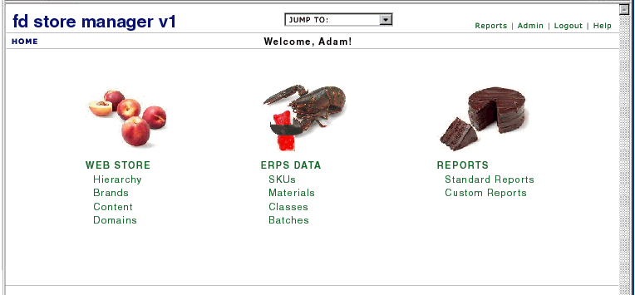

comp: home page

GLOBAL NAV

Overview
- at top of every page

Comps

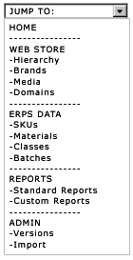

comp: global nav pulldown

Details
Element | Definition/Behavior
Store Manager | - links to STORE MANAGER HOMEPAGE
dropdown navigation | - dropdown box with links to main areas of site  - if user does not have permission for a particular area link is grey (if this is not feasible, then do not show link)  - links to main areas of site
Reports | - links to REPORTS main page
Admin | - links to ADMIN main page if user has permission
Logout | - links to LOGOUT CONFIRMATION page  - confirmation “you’re logged out”  - link to sign in  - opens sign in popup box

ADMIN: GROUPS & PERMISSIONS

Overview
- add, edit, and delete users/user groups
  - tied to network user ids
- set permissions
  - set on entire sections e.g. ERPS DATA as well as on specific properties/attributes or at least groupings of properties/attributes e.g. promotion attributes might be grouped together
  - if user does not have permission to change particular things, all data still visible but not displayed as editable
- view logs of activity

ADMIN: IMPORT MEDIA & ATTRIBUTES

Overview
- allows import of:
  - image and text media files
  - product attribute values
  - erps attributes

Comps

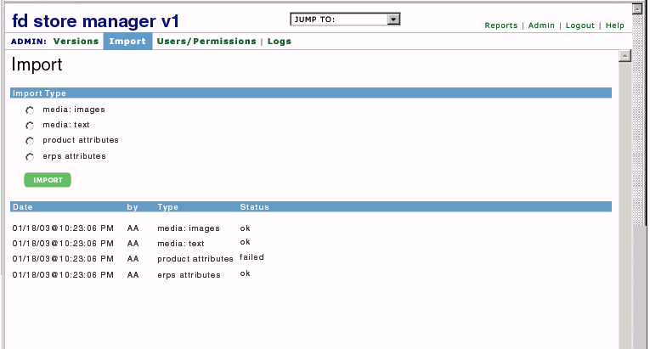

comp: import

Details
Element | Definition/Behavior
import type | - radio button select:  - media: images  - media: text  - product attributes  - erps attributes
[import] | - on click, initiates import sequence, varies depending on import type:  - media: images  - system auto-selects images folder on network and imports new images from there  - use assigned file names  - auto-set height and width  - auto-associate product images: look at file name, match to product name, populate value on product  - place in CMS media folders based on originating folders  - media: text  - opens system box for user to browse to select delimited file for import; for each file, includes:  - file name  - text  - editorial title  - other editorial attributes...  - when file is selected and user clicks ok, import media  - auto-associate descriptions: look at file name, match to product name, populate value on product  - product attributes  - opens system box for user to browse to select delimited file for import with attribute names and values, including:  - product id  - component sku ids  - full name  - glance name  - nav name  - brand 1  - brand 2  - keywords  - rating values  - others tbd  - when file is selected and user clicks ok, import data  - auto-create brand new products, skus  - place new products at root level of Working folder  - erps attributes  - opens system box for user to browse to select delimited file for import with attribute names and values  - when file is selected and user clicks ok, import data  - when import is complete, refresh import list with new import and status
import list | - shows all imports by date  - date and time of import, most recent to least recent, top to bottom  - initials of user who initiated import  - import type  - import status: “ok” or “failed”

ADMIN: PUBLISH/MANAGE VERSIONS

Overview
- admin function
- publish version in preparation to moving to stage
- is the cms preview site the same as dev? in other words a published version is a snapshot of dev at a particular moment
- can rollback simply be restaging an older version?
- how long are versions kept? manual delete like in BM? keep at least last two?
- any restrictions on when/how often publish can be done? is cms usable during publish?
- are there any other details of a published version that should be displayed?
- are there any errors which would previously have been auto-corrected by the extractor or that would at least have caused the extractor to fail -- mistakes that we could make through the new cms interface -- that the publish process would need to take a look at before beginning e.g. “can’t publish because...”
- add auto-stage feature?

Comps

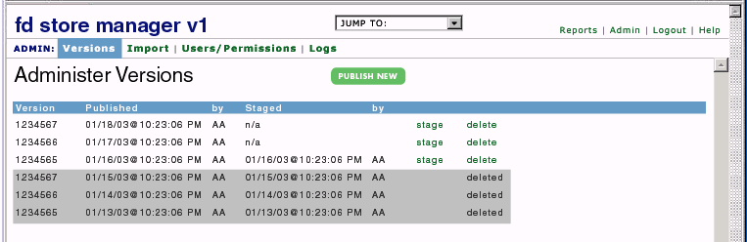

comp: versions

Details
Element | Definition/Behavior
[publish new] | - initiates publish process for current version of db on dev  - show status of publish  - when publish completed, page refreshes with new version at top of list
version list | - displays all published versions of the store including:  - version number  - date and time publication complete  - initials of user who initiated publication  - date and time stage complete  - display “n/a” if version was never staged  - initials of user who initiated stage  - options to “stage” or “delete”  - if only one non-deleted published version, cannot delete  - “stage” initiates stage process (tbd)  - show status of stage  - “delete” deletes version, cannot be subsequently staged  - on click, display “are you sure” system box with y/n option  - if already deleted, then just display status “deleted”

WEB STORE
Overview
- allows management of:
  - store hierarchy
  - Web category contents and properties/attributes
  - component products and skus
  - domains
  - content
  - brands
  - eventually will include lists, recipes, promotions

WEB STORE: HIERARCHY: MAIN PAGE

Overview
- side nav plus in-page content TBD, for now blank

WEB STORE: HIERARCHY: SIDE NAV

Overview
- allows browse/management of store hierarchy
- includes search and filtering functions

Comps

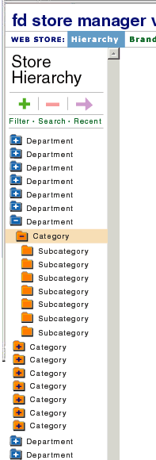  comp: folder selected | 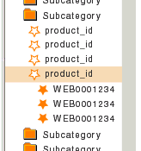  comp: product selected  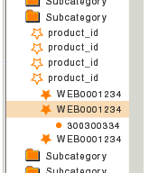  comp: sku selected | 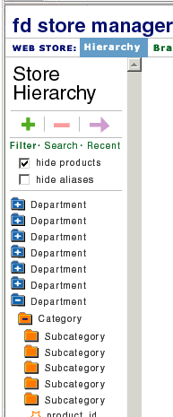  comp: filters open
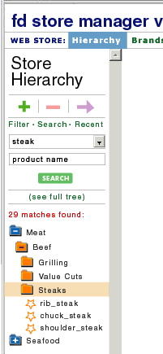  comp: search results | 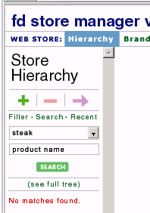  comp: no search results | 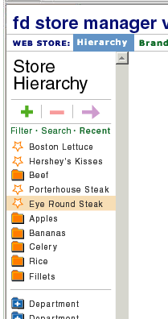  comp: recent open

Details
Element | Definition/Behavior
Store Hierarchy | - on click refreshes right pane with HIERARCHY MAIN PAGE
folder tree | - folders  - show folder names (not IDs)  - unopened folders with subfolders show “+”  - opened folders with subfolders show “-“  - opened/unopened folders with no subfolders are blank  - on click:  - any subfolders are exposed  - IDs of any products at that level are exposed  - right pane refreshes, displaying contents (products only) of selected folder  - many folders will not contain products – right pane should display message “no contents” between top and bottom new|add|delete|move controls  - first click opens, second click closes  - leave open until explicitly closed  - products  - show product ids  - alt text-style popups on rollover with full name  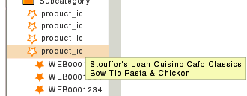  - on click:  - web IDs of component skus are exposed  - right pane refreshes, showing product attributes view  - first click opens, second click closes  - leave open until explicitly closed  - skus  - show web IDs  - on click  - right pane refreshes with sku tab of parent product, with attributes for that sku exposed  - most recently clicked item is always highlighted/selected
filters | - on click:  - expose filter controls  - bold link  - click again to collapse  - checkboxes toggle on/off  - hide products  - default N  - selecting checkbox sets to Y  - do not show products in side nav (does not affect right pane)  - hide aliases  - default N  - selecting checkbox sets to Y  - do not show aliases in side nav (does not affect right pane)  - save filter settings for session  - filters will be added as needed
search | - on click bold link and display:  - search box  - [search] button  - pulldown with:  - product name (search on all names, full, glance, nav)  - product ID  - sku Web ID  - material SAP ID  - material SAP name  - click “see full tree” link to restore full hierarchy  - also click “search” a second time to collapse and restore full hierarchy  - when search button clicked:  - results returned as objects in a version of the store hierarchy tree that exposes only the folders necessary to contain results...when item is clicked:  - folders – refresh right pane with folder contents  - products – refresh right pane with product attribute page  - skus – refresh right pane with sku attribute page  - materials – refresh right pane with material attribute page  - show number of matches  - if no matches, return “no matches found” message  - search only products, skus, and materials for now  - search should accept wildcards e.g. “MEA*” could be entered to return all skus with web IDs starting “MEA”  - always remember last search
recent | - on click  - expose list of (10) most recently visited category folders and products  - most to least recent, top to bottom  - don’t show department folders  - bold link  - click again to collapse  - clicking items refreshes right pane with  - attributes view for products  - products in “recent” list do not open to expose skus  - either attributes or content view for folders, whichever was last used for that particular folder  - folders in “recent” list do not open to expose subfolders/products
[add folder] | - select target folder and click add  opens ADD FOLDER popup  text box for entry of folder name  - text box for entry of folder ID  - on save, side nav refreshes with new folder in place  - if new parent folder was collapsed, open to show all subfolders to level of added folder  - [x] cancels all and closes popup
[delete folder] | select/highlight folder to delete and click delete  - on click opens ARE YOU SURE popup  - cancel – no change  - ok deletes folder  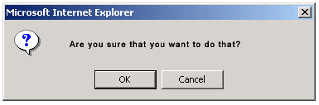  - refreshes side nav  - if contents of deleted folder were on display in right pane, refresh right pane with system message confirming deletion  - any contents (subfolders and/or products) are not removed from system but moved to a "Discard" folder within the Working folder
[move folder] | - select/highlight folder to move and click move  opens MOVE FOLDER popup  - top of popup displays current path to folder (“move from”)  - browse folder tree (automatically opened to source of move) to select new home (“move to”)  [move] moves selected folder into target folder, closes popup and refreshes side nav with moved folder in new home  - folder and all contents including subfolders and products are moved  - moved folder inherits attributes from new parent folder  - if new parent folder collapsed, open to show all subfolders to level of moved folder  - [x] cancels all and closes popup

WEB STORE: HIERARCHY: MANAGE FOLDER CONTENTS
Overview
- shows all products in the category; allows addition/deletion/move/selection of products

Comps

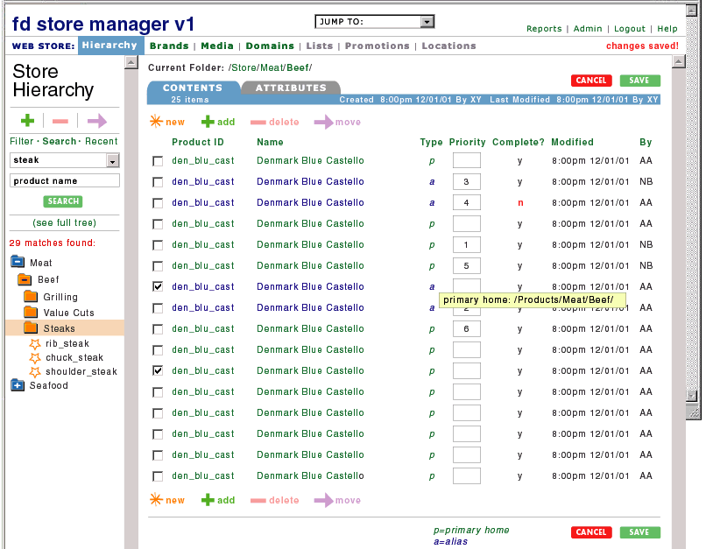

comp: folder contents

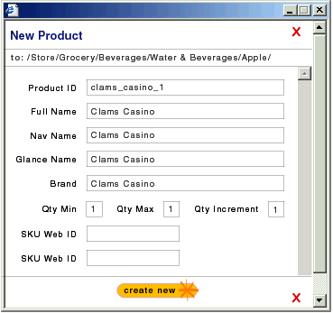

comp: popup new product

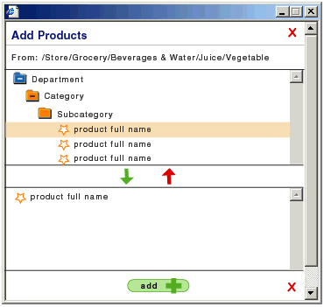

comp: popup add products

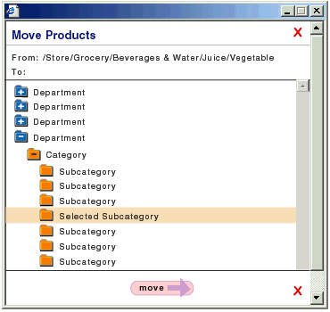

comp: popup move products

Details
Element | Definition/Behavior
breadcrumb | - shows path to current folder from root  - folders are linked  - on click page is refreshed with folder contents view  - highlight new location in side nav
Attributes | - text link, refreshes right pane with WEB STORE: HIERARCHY: VIEW/EDIT FOLDER ATTRIBUTES for current folder
version info | - displays time and date of last update to folder attributes/contents
folder contents | - does not include folders, only products  - many folders will not contain products  - all products in folder are displayed with:  - checkbox for selection  - product ID (linked to WEB STORE: HIERARCHY: VIEW/EDIT PRODUCT ATTRIBUTES page)  - product full name (linked to WEB STORE: HIERARCHY: VIEW/EDIT PRODUCT ATTRIBUTES page)  - priority field for category page display  - priority sorts low-high  - “complete” flag  - show “y” or “n”  - set to y if all of the following are true:  - has a brand value  - image_product assigned (at least coming soon image)  - image_product_detail assigned (at least coming soon image)  at least one SKU is assigned  - on rollover of flag value (y/n) alt text lists the items that are missing  - modified date/time/user stamp  - two types of products, color-coded and flagged to distinguish them  - in primary home (“p” for primary, green)  - alias (“a” for alias, all text blue)  - size unit/unit of measure  - default sort is alphabetical by full name, a-z  - all titles clickable to sort columns  - product id sorts alpha a-z  - full name sorts alpha a-z  - complete sorts y then n  - priority sorts 1-x  - type sorts P then A  - modified sorts recent-past  - by sorts alpha a-z  - sort should stick for session  - clicking alias link always returns primary product...there are no separate alias product attributes
[X] items | number of items in folder
new product | opens NEW PRODUCT popup  - top of popup shows path to current folder  - text fields for entry of required properties including:  - product id (auto create algorithim?)  - full name  - nav name (prefill with whatever’s entered in full name box since some items in DFGS do not need nav names)  - glance name  - brand  - qty min (prefill with 1)  - qty max (prefill with 99)  - qty increment (prefill with 1)  - Web IDs for component skus  - [create new] closes popup and refreshes right pane of page with new product in place (the “complete” flag will have a value of “n”)…on save, system checks that data is unique  - [X] cancels all and closes popup
add products | - opens ADD PRODUCT popup  - top of popup shows path to current folder  - store hierarchy displayed in scroll box  - can select multiple with [ctrl]/[shift]  - down arrow adds products (and only products) to selection box  - up arrow removes products from selection box  - [add] closes popup, adds all products in selection box and refreshes right pane of page with additional products in place  - aliases have special ids, formed from parent id plus sequential suffix eg “a1” “a2” etc.  - flagged as alias and color-coded
move products | select products using checkboxes  on click opens MOVE PRODUCT popup  - if no products selected, pop system box “please select a product”  browse tree (automatically opened to source of move) to select target folder  - [move] moves selected products into target folder, closes popup and refreshes right pane of page (without moved products) and system message confirming that products were moved  - aliases can be moved  - aliases can not be moved to same folder as primary home
delete products | select products using checkboxes  on click opens ARE YOU SURE popup  - cancel closes popup  - ok deletes products  - refreshes page with system message confirming deletion  - aliases are deleted outright  - primary products are not deleted from system but are moved to Discard folder in Working folder  - do not allow delete of primary home product if aliases exist elsewhere in hierarchy – aliases must be deleted first
[cancel] | clears any unsaved changes from form  refreshes page with last-saved changes
[save] | - saves all changes  - refreshes page with system message confirming changes saved

Note:
- if user is viewing folder contents, stay in contents view mode as user browses through folders with side nav or uses breadcrumb to select another folder in path
- if user is viewing folder attributes or product/sku attributes, stay in attributes view mode as user browses through folders with side nav or uses breadcrumb to select another folder in path

Note:
- some assumptions about attributes:
  - attributes can be inheritable or not
  - a new subfolder inherits the attributes and attribute values of its parent folder
  - inherited values can be overridden
  - if a value is overridden on the child folder level, it belongs to the child and can not subsequently be overridden by a new value at the parent level
  - if an inherited attribute value is cleared (empty) at the child folder level, it is automatically populated by the parent-level value (although there needs to be a kill here, such as “nm”)
  - when the primary home of products changes they inherit from their new parent; aliases reflect changes
  - initially, attributes can not be overriden on aliases

WEB STORE: HIERARCHY: MANAGE FOLDER ATTRIBUTES
Overview
- set property and attribute values on folders (departments and categories) in the consumer hierarchy
- allows set of attributes/attribute values across all primary home products in folder/subfolder

Comps

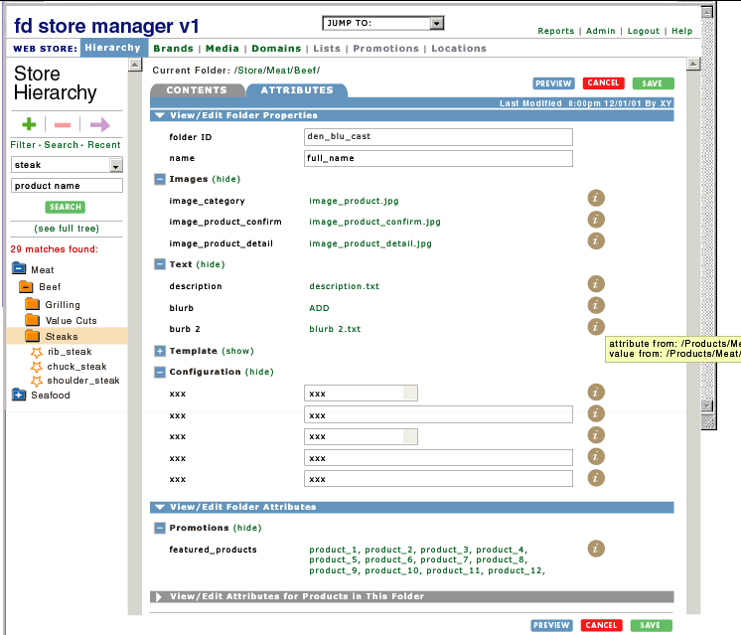

comp: folder attributes

Details
- includes only attributes
- very similar to WEB STORE: HIERARCHY: VIEW/EDIT PRODUCT ATTRIBUTES; differences include:

breadcrumb | - returns folder attributes view
Contents tab | - refreshes right pane with WEB STORE: HIERARCHY: VIEW/EDIT FOLDER CONTENTS for current folder
view/edit attributes for products in folder | - default closed  - allows set of attributes on all products in folder for which folder is primary home  - on save, inherited values are set across all primary home products in folder

WEB STORE: HIERARCHY: VIEW/EDIT PRODUCT ATTRIBUTES
Overview
- shows current values of all product properties/attributes
- allows edit of property/attribute values
- allows access to component sku properties/attributes

Comps

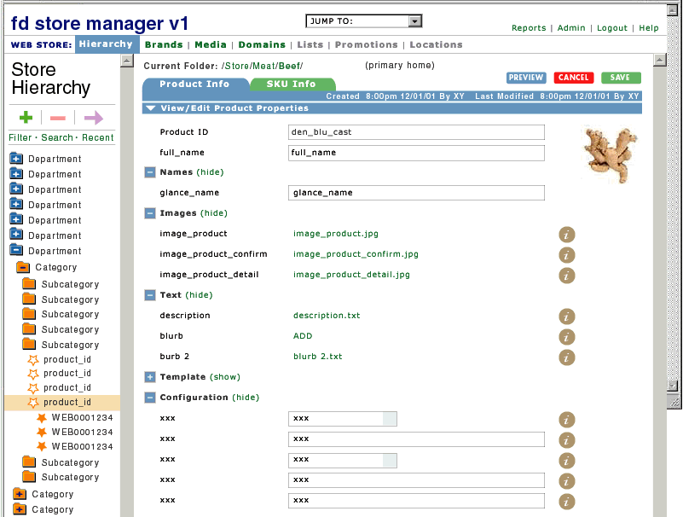
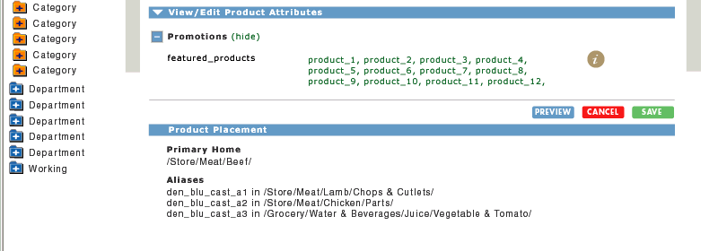

comp: product attributes

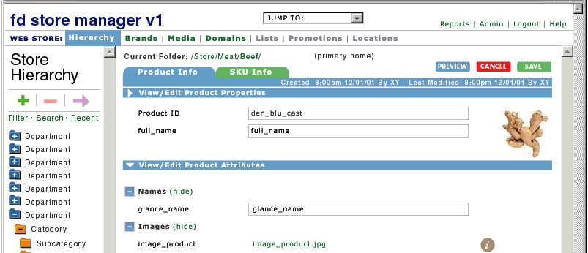

comp: product attributes w/properties hidden

Details
Element | Definition/Behavior
breadcrumb | - shows path to current folder from root  - folders are linked  - clicking on folder returns folder attributes view
primary/alias indicator | - “primary” if primary home, “alias” if alias
version info | - displays time and date of last update to product properties/attributes  - also show date of creation
Product Info tab | - always default selected  - on click from SKU info tab, refreshes page with product properties and attributes  - property/attribute values editable depending on user permissions
SKU Info tab | - on click, refreshes page with all SKU properties and attributes (see below)
property/attribute names | - properties grouped together under header View/Edit Properties  - click icon to left of header to hide/show all...default open...sections are opened and closed independently...selection sticks for session across Product Manager  - attributes grouped together under header View/Edit Attributes  - click icon to left of header to hide/show all...default open...sections are opened and closed independently...selection sticks for session across Product Manager  - within attribute/property groupings, further organized by type (see APPENDIX II), in general:  Names  - Images  - Text  - Navigation/Layout  - Rating  - product ID and full name are always displayed and not rolled up in any group  - all attribute/property groupings by default rolled up – clicking icon to left of type header opens/closes (also “hide/show”)...sections are opened and closed independently – multiple sections may be open at one time...selection sticks for session across Product Manager  - if user has scrolled to a particular position on page, jump to same position when user opens another attributes page
property/attribute values | displayed as:  - text boxes  - populated with current value, if there is one  - pulldown boxes  - defaulted to current value, populated with possible values  - checkboxes/radio buttons  - defaulted to current selection  - text (file name, product name, folder name, etc)  - collections e.g. featured products displayed as comma separated text, in priority order  - click on name to open popup that allows view details and change/edit...any name in collection links to a popup that enables management of full collection  - if there is no value, “ADD” link will be displayed – will open the appropriate popup  - display category image for product on page
product placement | list primary and alias locations and IDs  - display aliases in order of alias id suffix, low to high  - link alias locations
information icon | appears next to all properties/attributes  alt text displayed on icon rollover shows where the attribute was inherited from and where the value was inherited from (full path)  if there is a value that was not inherited, show “self”
[preview] | saves all changes  opens new window with preview of page in context of site hierarchy
[cancel] | clears any unsaved changes from form  refreshes page with last-saved changes
[save] | - saves all changes  - refreshes page with system message confirming changes saved

WEB STORE: HIERARCHY: VIEW/EDIT PRODUCT ATTRIBUTES: VIEW/EDIT MEDIA POPUP (IMAGES)

WEB STORE: HIERARCHY: VIEW/EDIT PRODUCT ATTRIBUTES: VIEW/EDIT MEDIA POPUP (TEXT)
Overview
- popup window
- allows view of current image/text selection
- allows browse, preview, and save of new selection
- blank if no current selection

Comps

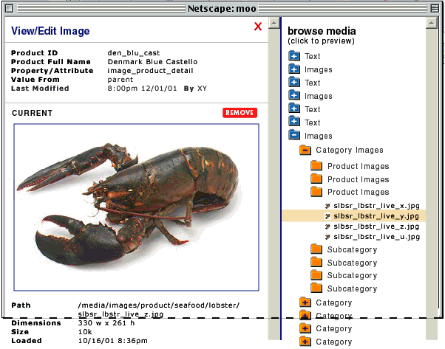

comp: popup view/edit image – current

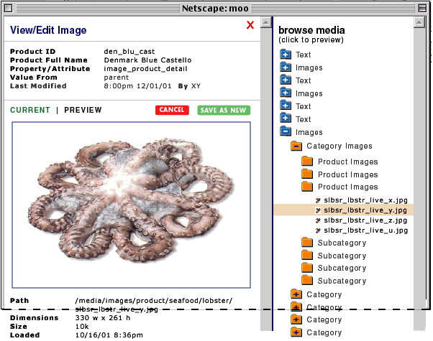

comp: popup view/edit image – preview

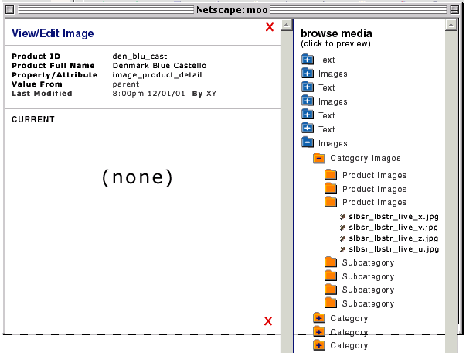

comp: popup view/edit image – none

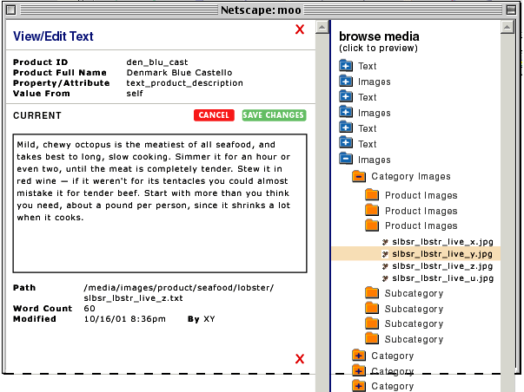

comp: popup view/edit text – current

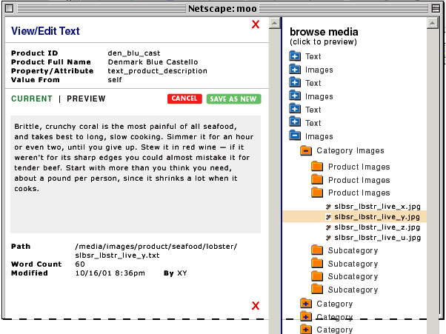

comp: popup view/edit text – preview

Details
Element | Definition/Behavior
Product Summary | information about product on which attribute value is being set including:  product ID  - product Full Name  - the particular property/attribute name  - where value inherited from (or “self”)  - date value last modified
Current [Image/Text] | text displayed in text box; editable  - when cursor is in text box, right click to select special characters  - [save] saves text changes, refreshes popup with changes in place  - [cancel] refreshes popup with last-saved version  - images displayed full size  - [remove] clears current value and refreshes popup blank  - if no content is currently assigned, selecting item in right frame refreshes left frame in Preview Display mode
Content Information | - includes:  - path in content hierarchy  - (for images) dimensions: image height & width  - (for text) word count  - k size  - date file loaded to system if relevant  - date last modified if relevant
Browse Content | - right frame allows browse of Media hierarchy  - selecting folder opens it to display contents  - clicking on item opens in left frame as preview  - also drag and drop item into left frame opens as preview
Preview Display | - text not editable  - toggle back to current content  - [cancel] refreshes frame with current asset  - [save as new] saves content as current and refreshes frame in Current mode
[x] | - cancels all and closes

WEB STORE: HIERARCHY: VIEW/EDIT PRODUCT ATTRIBUTES: VIEW/EDIT COLLECTION POPUP
Overview
- popup window
- used to manage collections of: folders, products, brands, also domains (e.g. for variation matrix)
- allows view of current list of items
- allows deletion of items
- allows priority to be set on items
- allows browse and addition of new items

Comps

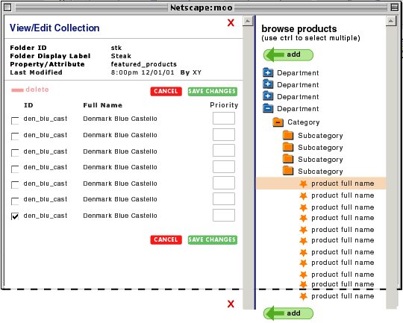

comp: popup view/edit collection

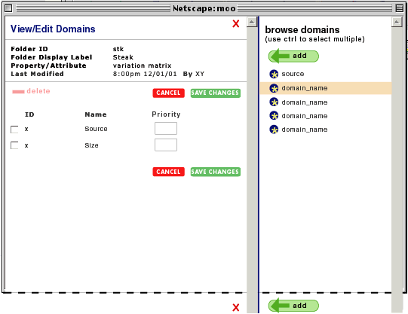

comp: popup view/edit domains

Details
Element | Definition/Behavior
Product Summary | information about product on which attribute value is being set including:  product ID  - product Full Name  - the particular property/attribute name  - where value inherited from (or “self”)  - date value last modified
Current Items | - line includes:  - checkbox to select for delete  - ID  - item name (Full Name if product)  - priority (optional – does not have to be set)
Browse [Products/Folders] | - right frame allows browse of appropriate hierarchy (based on attribute type)  - selecting folder opens it to display contents  - select item (folder or folder contents) and click Add adds it to left frame  - also drag and drop item into left frame  - use [shift]/[ctrl] to select multiple
Cancel | - clears left frame of any new items added if unsaved  - clears any new priorities and restores old  - restores any items that were deleted if changes unsaved
Save Changes | - saves all new items, priorities, and deletions
delete | - checkboxes used to select items  - clicking delete refreshes popup with items removed (no are you sure? warning in popups)
[x] | - cancels all and closes

WEB STORE: HIERARCHY: VIEW/EDIT SKU ATTRIBUTES

Overview
- edit of Web-side attributes including variation values
- view of material data from SAP
- linkage of virtual products
- link to edit characteristics

Comps

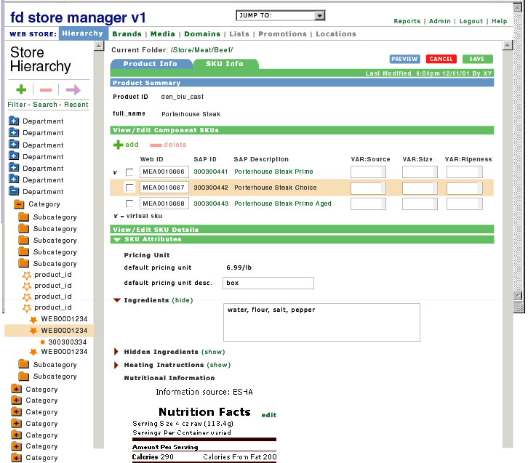

comp: view/edit sku attributes

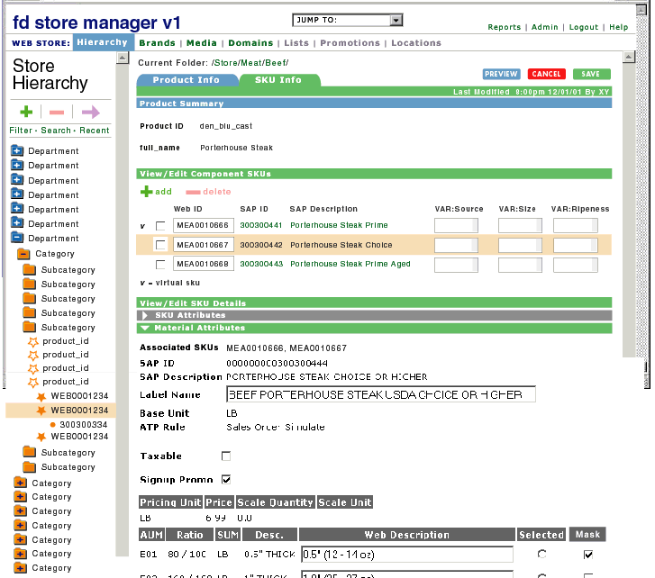

comp: view/edit material attributes

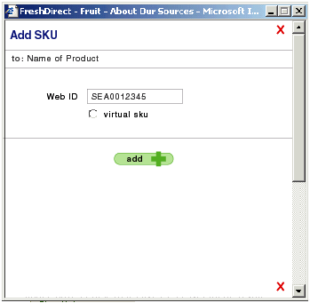

comp: popup add sku

Details
Element | Definition/Behavior
breadcrumb | - shows path to current folder from root  - folders are linked  - clicking on folder returns folder attributes view
version info | - displays time and date of last update to SKU properties/attributes
Product Info tab | - refreshes page with product properties and attributes
SKU Info tab | - on click from Product info tab refreshes page with all SKU properties and attributes (see below)
Product Summary | - ID of product with which sku is associated (not editable)  - full name of product with which sku is associated (not editable)
View/Edit Component SKUs | - info for each SKU includes:  - Web ID  - SAP ID of matching material  - SAP Description (not editable)  - variation values with current selection defaulted and pulldown to change value  - variation name is column header  - special flag “v” displayed next to virtual skus  - skus listed in order of Web ID, lowest to highest  - click on SAP ID to view sku details; current selection not clickable – selected sku line line is highlighted  - details of first sku displayed by default in View/Edit SKU details area  - selection checkbox to select SKU or SKUs for deletion from product (see below)
[add sku] | - on click opens popup  - text box to enter Web ID  - on submit popup closed and system looks for material in ERPS with corresponding Web ID  - if match found, page refreshed with new line for sku in V/E Component SKUs area including SAP ID and new SKU details displayed in V/E SKU Details area  - if no match found, page refreshed with new line for sku in V/E Component SKUs area without SAP ID  - (every time page loads or at some regular interval) system will try to match Web ID to materials and if a match is found, refreshes page with SAP ID and full details  - radio button: “virtual sku”  - on submit popup closed and system looks for material in ERPS with corresponding Web ID  - if match found, page refreshed with new line for sku in V/E Component SKUs area and new SKU details displayed in V/E SKU Details area with special icon denoting status as virtual sku and ability to mask aums and characteristic values  - if no match found, same as above
[delete sku] | - select sku or skus to be deleted with checkbox  - when delete is clicked, open ARE YOU SURE popup  - cancel – no change  - ok deletes sku from product, refreshes page with topmost sku selected
View/Edit SKU & Material Attributes | - for selected sku:  - sku attributes  - default closed...clicking arrow to left of type header opens/closes (also “hide/show”)...sections are opened and closed independently...multiple sections may be open at one time...selection sticks for session across skus  - allows edit of:  - pricing unit description  - nutrition  - clicking “edit” refreshes page with fields for editing nutrition  - ingredients, hidden ingredients, heating instructions  - text boxes  - material attributes  - header default closed, same rules as for sku attributes header  - allows edit of:  - label name  - taxable flag  - signup promo flag  - AUM web description  - link to edit characteristic data  - refreshes page with characteristic data in form fields (no longer in STORE area so ERPS: CLASS side nav displayed)  - display skus with which material is associated  - for virtual products, allows masking of aums and characteristic values  - checkbox next to aums, check to mask  - on save as well as on subsequent loads of page, checkbox is selected for masked aums/characteristics  - if it is not possible to display sku and/or material attributes in editable fields, show read-only with “edit” link to appropriate page in ERPS
[preview] | saves all changes  opens new window with preview of product page
[cancel] | clears any unsaved changes from form  refreshes page with last-saved changes
[save] | - saves all changes  - refreshes page with system message confirming changes saved

WEB STORE: HIERARCHY: PREVIEW SCREEN
Overview
- allows preview of current category/product page in context of site templates

Comps

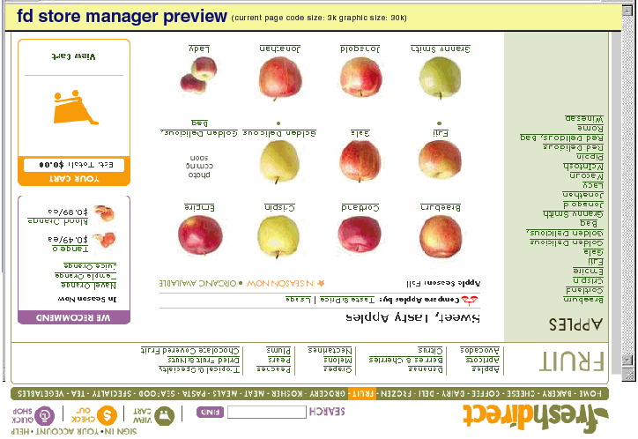

comp: preview screen

Details
- any unsaved attribute/property changes are automatically saved when user clicks “Preview”
- new browser window opens with current screen displayed and special preview header
- preview header includes:
  - Store Manager header
  - code size in k
  - total image size in k
- preview page is clickable

WEB STORE: BRANDS: MAIN PAGE
Overview
- side nav plus in-page content TBD, for now blank

WEB STORE: BRANDS: SIDE NAV

Overview
- allows browse of brand folders
- hierarchy flat, no subfolders (for now)

Details
Element | Definition/Behavior
Brands | - on click refreshes right pane with BRANDS main page
folder tree | - very similar to WEB STORE: HIERARCHY: SIDE NAV; differences include:  - on selecting folder, right pane refreshes with folder attributes
[add folder] | - see WEB STORE: HIERARCHY: SIDE NAV
[delete folder] | - select folder to be deleted  on click opens ARE YOU SURE popup  - cancel closes popup  - ok deletes folder
[move folder] | - see WEB STORE: HIERARCHY: SIDE NAV

WEB STORE: BRANDS: VIEW/EDIT BRAND ATTRIBUTES
Overview
- set brand attributes

Comps

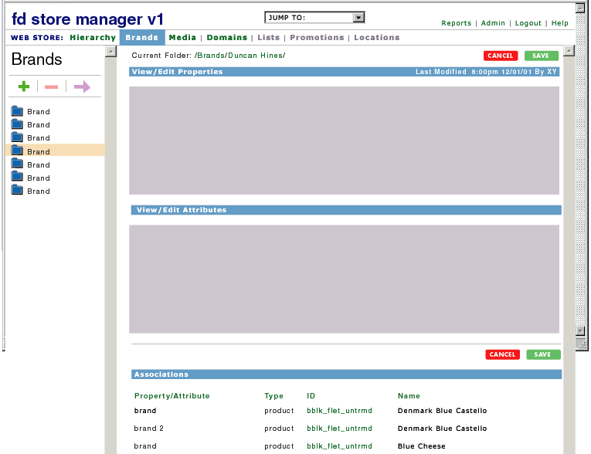

comp: brand attributes

Details
- see WEB STORE: HIERARCHY: VIEW/EDIT PRODUCT ATTRIBUTES plus:
  - displays associations, similar to WEB STORE: DOMAINS: VIEW/EDIT DOMAIN

WEB STORE: MEDIA: MAIN PAGE
Overview
- side nav plus in-page content TBD, for now blank

WEB STORE: MEDIA: SIDE NAV
Overview
- folder structure mirrors current folder structure
- selecting folder opens to show subfolder
- if folder has content files inside, right side of page refreshes with details

Details
Element | Definition/Behavior
Content | - on click refreshes right pane with CONTENT main page
folder tree | - see WEB STORE: HIERARCHY: SIDE NAV plus:  - right click to change folder name
[add folder] | - see WEB STORE: HIERARCHY: SIDE NAV
[delete folder] | - see WEB STORE: HIERARCHY: SIDE NAV plus:  - contents moved to Discard folder
[move folder] | - see WEB STORE: HIERARCHY: SIDE NAV

WEB STORE: MEDIA: MANAGE FOLDER CONTENTS

Overview
- allows browse of content

Comps

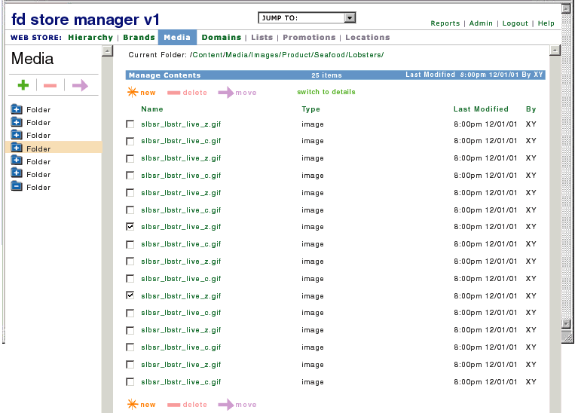

comp: folder contents images

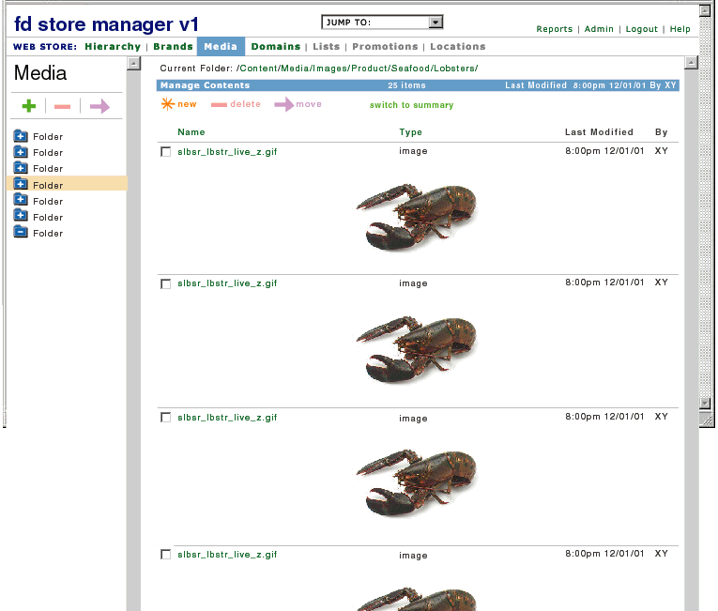

comp: folder contents images preview

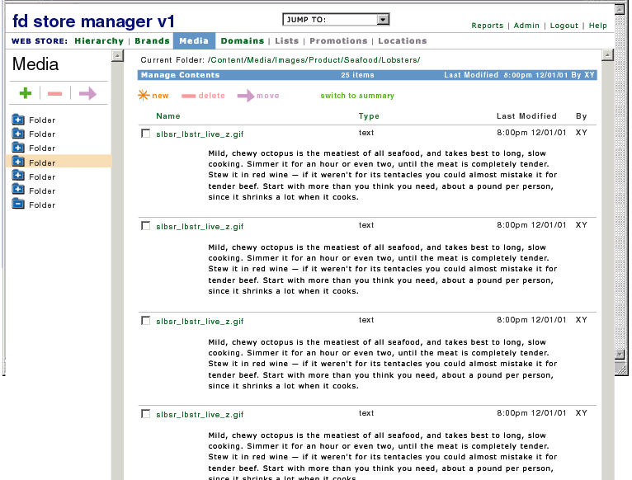

comp: folder contents text preview

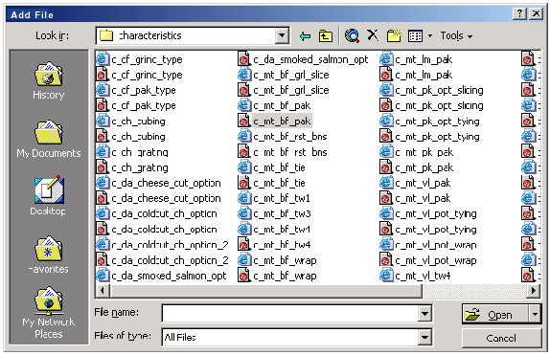

comp: popup add media file

Details
Element | Definition/Behavior
breadcrumb | - shows path to current folder from root  - folders are linked  - clicking refreshes page with contents of new folder
version info | - displays time and date of last update to folder contents
folder contents | - does not include folders, only media files  - many folders will not have contents – right pane should display message “no contents” between top and bottom new|delete|move controls  - toggle between Summary and Detail view  - Summary view:  - all items in folder are displayed with:  - checkbox for selection  - name (linked to WEB STORE: MEDIA: VIEW EDIT CONTENT page)  - type  - modified date/time/user stamp  - default sort is alphabetical by name, a-z  - all titles clickable to sort columns  - name sorts alpha a-z  - type sorts images then text  - modified sorts recent-past  - by sorts alpha a-z  - sort should stick for session  - Detail view:  - all items in folder are displayed with:  - checkbox for selection  - name (linked to WEB STORE: MEDIA: VIEW EDIT CONTENT page)  - type  - modified date/time/user stamp  - image if media file is image (linked to WEB STORE: MEDIA: VIEW EDIT CONTENT page)  - text (not editable) if media file is text  - same sort rules as for summary view
[X] items | number of items in folder
new | opens CHOOSE FILE popup  - allows browse and select of file (multiple, if possible)  - [save] closes popup, uploads file, and refreshes right pane of page with new file in place  - image dimensions set automatically  - [cancel] closes popup
move | select items using checkboxes  on click opens MOVE popup  browse content tree to select target folder  - [move] moves selected items into target folder, closes popup and refreshes right pane of page (without moved items) and system message confirming that items were moved
delete | select items using checkboxes  on click opens ARE YOU SURE popup  - cancel closes popup  - ok deletes items  - refreshes page with system message confirming deletion  - file is removed from system

WEB STORE: MEDIA: VIEW/EDIT MEDIA

Overview
- allows view/edit of media files

Comps

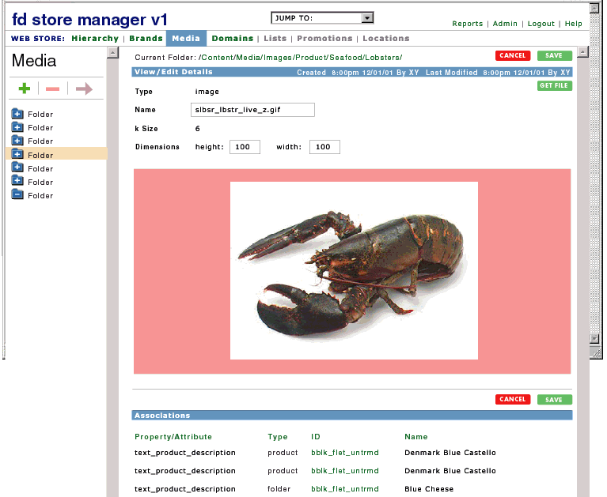

comp: view/edit image

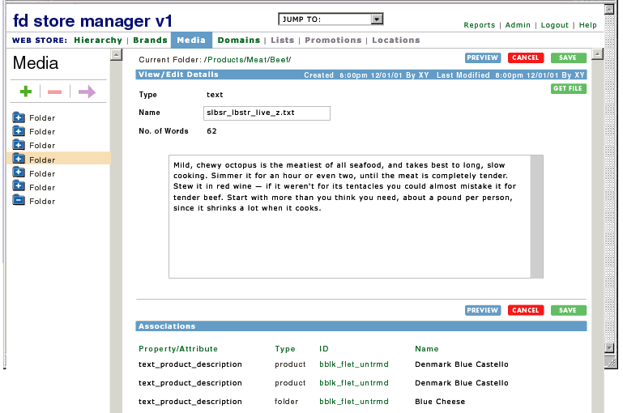

comp: view/edit text

Details
Element | Definition/Behavior
breadcrumb | - shows path to current folder from root  - folders are linked  - clicking refreshes page with contents of new folder
version info | - displays time and date of last update to item  - also show date of creation
View/Edit Details | - for text display:  - type  - name in editable text field (populated automatically on import)  - # of words  - text in text field  - for images display:  - type  - name in editable text field (populated automatically on import)  - k size  - height and width in editable text field (populated automatically on import)  - image
Get File | - opens SAVE FILE popup
Associations | - list of items (folders/products) for which this media file is the selected value for an attribute  - for each item, display:  - attribute name  - item type:  - product/folder  - item ID  - item name  - all titles clickable to sort columns  - attribute name sorts alpha a-z  - item type sorts product then folder  - item ID sorts alpha a-z  - item name sorts alpha a-z  - default sort is by attribute name, a-z  - sort should stick for session  - IDs and names are clickable
[cancel] | clears any unsaved changes from form  refreshes page with last-saved changes
[save] | - saves all changes  - refreshes page with system message confirming changes saved

Note:
- initially no versioning
- initially no check in/check out (last save wins)

WEB STORE: DOMAINS: MAIN PAGE

Overview
- side nav plus in-page content TBD, for now blank

WEB STORE: DOMAINS: SIDE NAV
Overview
- allows browse, addition and deletion of domains
- any hierarchy necessary here?

Details
Element | Definition/Behavior
Domains | - links to Domains main page
add domain | - on click opens ADD DOMAIN popup  - popup includes text boxes for entry of:  - name  - label  - cancel closes popup  - save adds new domain, refreshes side nav with new domain and right pane with domain details page
delete domain | on click opens ARE YOU SURE popup  - cancel closes popup  - ok deletes items  - delete not allowed if domain is attached to any folder or product in store; popup “Sorry” message  - BUT! no one should really be allowed to do this...
domains | icon and name  sorted in alpha order a-z

WEB STORE: DOMAINS: VIEW/EDIT DOMAIN
Overview
- allows view/edit of domain values; displays domain associations

Comps

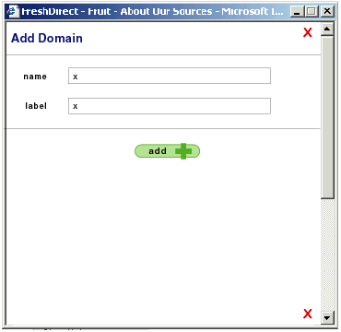

comp: popup add domain

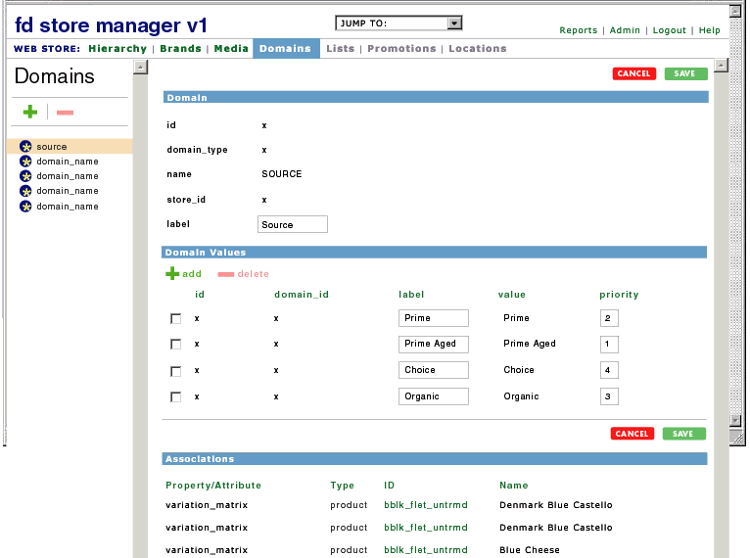

comp: view/edit domain

Details
Element | Definition/Behavior
Domain summary | - displays domain:  - id  - domain type  - name (editable)  - store_id  - label
Domain Values | - for each value, the following is displayed:  - select box  - id  - automatically assigned  - label  - editable text box  - value  - priority  - editable text box  - all titles clickable to sort columns  - id sorts ?  - label sorts alpha a-z (and integers low to high)  - value sorts alpha a-z (and integers low to high)  - priority sorts none then low to high  - default sort is by label, a-z  - sort should stick for session
add | - opens ADD DOMAIN VALUE popup with:  - text box to enter value  - text box to enter label  - (id automatically assigned)  - cancel closes popup  - save adds new domain value, refreshes right pane with new domain value (priority will need to be set manually)
delete | select values to be deleted  - delete not allowed if values are selected for any folder or product in store; popup “Sorry” message  on click opens ARE YOU SURE popup  - cancel closes popup  - ok deletes items
domain associations | show up to 100; if more than 100, then do not expose associations but display link to “Show All Associations;” refreshes page with all associations exposed  shows all attributes using domain  - for each item, display:  - attribute name  - item type:  - product/folder  - item ID  - item name  - all titles clickable to sort columns  - attribute name sorts alpha a-z  - item type sorts product then folder  - item ID sorts alpha a-z  - item name sorts alpha a-z  - default sort is by attribute name, a-z  - sort should stick for session  - IDs and names are clickable
[cancel] | clears any unsaved changes from form  refreshes page with last-saved changes
[save] | - saves all changes  - refreshes page with system message confirming changes saved

ERPS DATA

Overview
- allows management of sku and material-level properties and attributes
- rename what is now “products” “skus”?
- integrates erps batch manager
- link to availability gui
- subsections include
  - SKUs
  - Materials
  - Classes
  - Batches
  - Availability

Comps

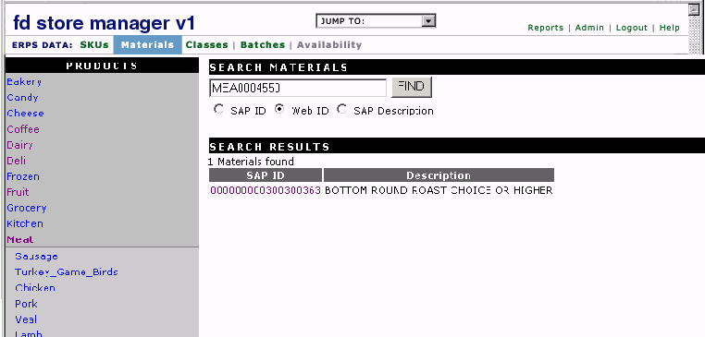

comp: erps data

ERPS DATA: MAIN PAGE

Overview
- links to main areas, no side nav
- alert of new batches
- other contents tbd

ERPS DATA: SKUs

Overview
- allows user to change sku attributes
  - nutrition
  - ingredients
  - heating instructions
  - pricing unit description
- hierarchy same as store tree?

ERPS DATA: MATERIALS

Overview
- allows user to view material configuration and edit display attributes
  - sales unit attributes
  - label name
  - characteristics attributes
  - promo flag
  - tax flag
- hierarchy same as store tree?
- same as current display in erps plus:
  - new feature request: show materials that are not attached to products in a special “Orphans” folder
  - show SAP status 31/32/33 etc. and availability
  - show UPC

ERPS DATA: CLASSES
Overview
- allows user to edit class, characteristic and characteristic value display attributes
- same as current display in erps plus:
  - group classes in side nav into folders based on prefix

ERPS DATA: BATCHES
Overview
- allows review, approve, reject, promote (to production) of batch loads from SAP
- same as current display in erps plus:
  - for each material in batch show status: new/updated/deactivated
  - email notify of new batches

ERPS DATA: AVAILABILITY
Overview
- allows management of short-term availability
- link opens availability gui in new browser window
- distinct from other Store Manager functions

REPORTS
Overview
- eventually may include browsable log of reports run
- eventually may include ability for user to add built report to standard reports

REPORTS: MAIN PAGE
Overview
- side nav plus in-page content TBD, for now blank

REPORTS: SIDE NAV
Overview
- allows browse to select area to run report

Details
Element | Definition/Behavior
Report | - links to Reports main page
folder tree | - setup by admin, not editable  - allows browse to select area to run report:  - ERPS Data (no reports at this level)  - Products/SKUs  - Materials  - Classes  - Batches  - Web Store (no reports at this level)  - Hierarchy  - Brands  - Content  - Domains  - on selecting folder, right pane refreshes with standard reports and link to build reports if appropriate  - define standard reports for each area  - other areas to be added as necessary e.g. promotions

REPORTS: STANDARD REPORTS
Overview
- displays standard reports for selection; for example, Product Data/Classes standard reports might include
  - class, characteristic ID, ch. priority, ch. description, ch. under label, ch. optional flag, ch. format, ch. value, ch. value description, ch. value Web description, ch. value selected, ch. value label value, ch. value priority, ch. value sku code
  - class, materials in class
  - class, characteristic ID, ch. description, materials that share ch.
- see APPENDIX I for catalog of proposed Product Data/Product/SKU standard reports

Comps

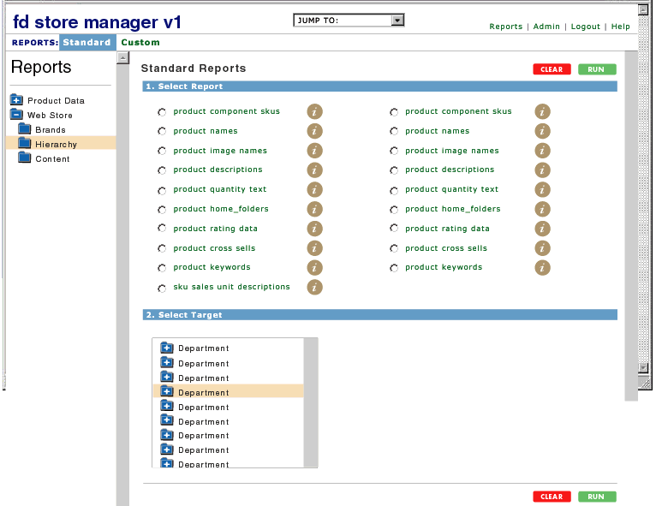

comp: standard reports

Details
Element | Definition/Behavior
Build a Report | - appears if applicable  - links to REPORTS: BUILD REPORT
Select Report | - reports listed by name in alpha order a to z  - radio button selects  - information icon:  - on rollover, component attributes and properties/report description appears in alt text popup
Select Target | - scrollbox contains relevant folder tree  - clicking folder opens to display subfolders and also highlights/selects  - <ctrl> and <shift> can be used to select multiple items
[clear] | - clears form and refreshes page
[run] | - runs report, refreshes screen with REPORTS:VIEW REPORT

REPORTS: BUILD REPORT
Overview
- build report: select target folders then select attributes/properties for inclusion; for example, for Product Data: Products/SKUs, user might:
  - select Fruit folder
  - select the properties product full name and minimum order quantity

Comps

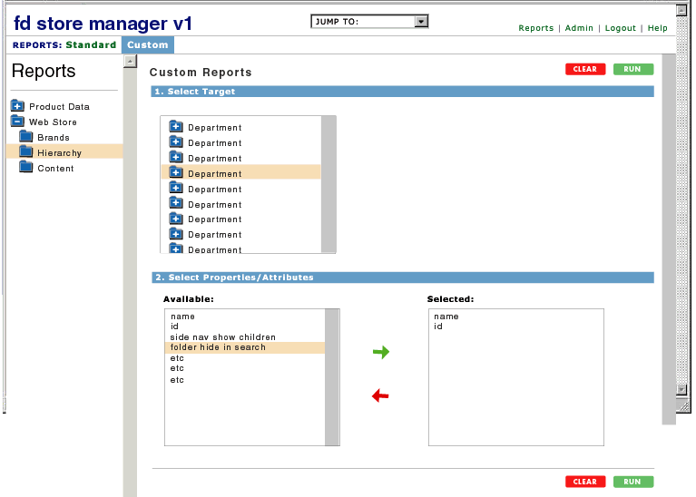

comp: build reports

Details
Element | Definition/Behavior
Standard Reports | - links to REPORTS: STANDARD REPORTS
Select Target | - scrollbox contains relevant folder tree  - clicking folder opens to display subfolders and also highlights/selects
Select Properties/Attributes | - “available” scrollbox lists all relevant attributes/properties in alpha order a-z  - selecting item highlights it  - <ctrl> and <shift> can be used to select multiple items  - “add” button moves item to “selected” box  - selected box prefilled with standard properties/attributes define these  - prefilled items can be removed  - drag and drop possible?  - “remove” button removes item from “selected” box
[clear] | - clears form and refreshes page
[run] | - runs report, refreshes screen with REPORTS:VIEW REPORT

REPORTS: VIEW REPORT
Overview
- full-screen view of report in tabular form

Comps

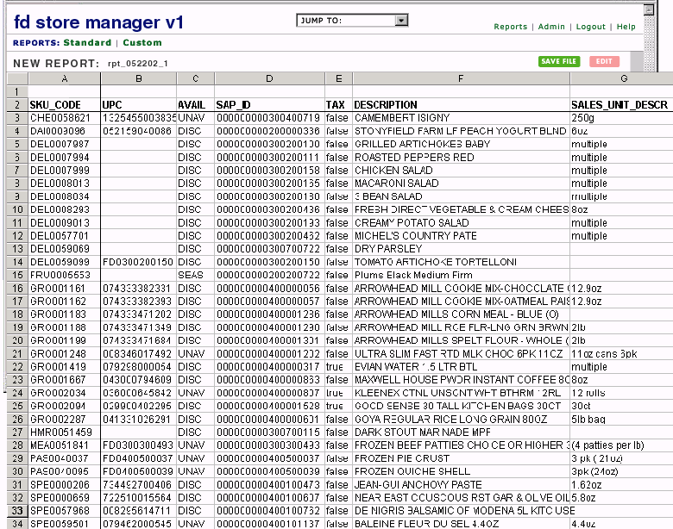

comp: view report

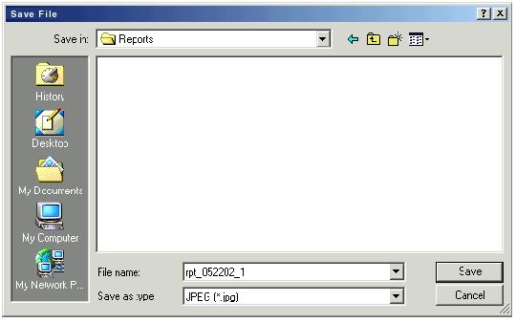

comp: save report

Details
Element | Definition/Behavior
report name | - uniquely identifies report with date, sequential integer, and initials of user
get file | - opens SAVE FILE popup  - file saved in comma-delimited text format
edit | - displayed if user built report; not displayed for standard reports  - returns REPORTS: NEW REPORT prefilled with variables used to create report
report table | - column headers are property/attribute names  - first row should be report name

PROMOTION MANAGER (PHASE 2)

Overview
Interface for managing promotion campaigns:
- setup promotions
- group promotions into flights
- group flights into campaigns
- setup profiles
- setup location groups
- preview
- realtime/fast-track promotion of changes
- reports

Details
Access Control | login/logout
Promotions | - a promotion includes:  - name  - media  - load images  - automatically set h&w  - target  - select folder, product in hierarchy  - OR select popup (e.g. brand) or enter path (e.g. photo tour)  - filters  - price point  - # of orders  - average $ amount of order  - composition of orders  - etc. etc.  - OR select applicable profile from profiles list – price point would still be promo-specific  - add new promotion  - enter name, select media, enter target, set filters  - name and media should be enough to save new promo though not enough to add to flight; sometimes target and filters will come later  - filter settings should default to every user, all the time OR default profile  - if all promotions must be in flights, auto-create a flight for each promotion when it’s added so that it can be assigned singly as well as being added to a group flight; put these singles together in one folder in the flights hierarchy  - delete promotion  - can’t delete promotions included in active or scheduled flights  - for each promotion, see a list of flights that promotion belongs to  - organize promotions in folders
Profiles | - specific filter configuration, could be used for promotions, You Might Also Like, featured products...would help ensure consistency when adding multiple promos with same filter settings  - create profile:  - name  - set filter values  - save  - delete profile  can’t delete profile if it’s being used by active or scheduled flight
Flights & Campaigns | - create, name, save, delete flights and campaigns  - setup flights  - name is all that’s required to set up new flight  - browse, add and delete component promotions  - for each promotion, show name, media, target, filters (OR profile name)  - can only add complete promotions ie those with all attributes in place  - warn if promos don’t share same profile (not on add -- just display message)  - set in-flight promotion rotation sequence  - field for #  - if all or some are set to same # then default rotation for those (order added to flight?)  - set in-flight promotion weighting  - field for #  - if all or some are set to same # then equal weight for those  - select locations/location groups  - for locations, browse (some version of site perhaps), select folder or product  - select multiple  - for location groups browse and select from list of groups  - select multiple  - if there are overlapping flights on location/location group  - provide warning with list of overlapping flights when location is selected for a new flight  - during customer browse, when there are overlapping flights, system will look at relevance of promotion filters (profile) to customer profile and serve promo with highest score  - set start time & date  - set end time & date  - can be open-ended  - flights can be saved with name alone  - setup campaigns  - browse, add and delete component flights  - in-campaign weighting of flights (?)  - campaign weighting (?)
Location Groups | - create, name, save, delete new groups  - browse a version of the store hierarchy, selecting multiple products and/or folders to add to group  - selecting a folder selects all products underneath  - location group can also be functional page like View Cart (how selected?)  - organize groups into folders (maybe just alpha would be sufficient)  - in display of groups, show which have been assigned to flights/campaigns  - don’t allow delete of a group that is referenced by an active or not-yet-started flight  - make groups available for You Might Also Like
Preview & Promote | - cms preview function  - set preview profile  - control panel to select filter values, save, reset OR select preconfigured profile  - possible to change “date” of preview to fool flights/campaigns into starting and ending?  fast-track promotion to production
Reports | - promotions overview  - promotion name  - promotion media file name  - promotion target  - filter values -- a column for every possible filter and the value if there is one OR just profile name  - flight names  - flight start dates  - flight end dates  - flights overview  - flight name  - flight start date  - flight end date  - flight location paths and names, and/or location group names  - component promotion names  - campaign names  - campaigns overview  - campaign name  - component flight names  - profiles overview  - profile name  - filters and filter values

LIST BUILDER (PHASE 2)
tbd

GLOBAL FUNCTIONAL NOTES
- left nav pane and right pane scroll independently
- if user makes changes in right pane then clicks any link in top or leftside nav without saving changes, open SAVE CHANGES popup

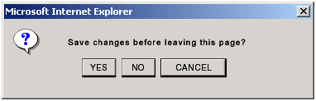

comp: save changes?

  - save and continue: saves changes and returns new page
  - don’t save and continue: does not save changes and returns new page
  - cancel: does not save changes but also does not return new page, keeps current page in view
- system messages displayed in top right corner under section navbar

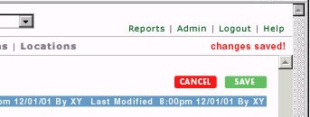

comp: system message

- popups should be set to open at a certain size (585w x 400h) but freely expandable
- right click functionality tbd

TRANSITION
- populate Working folder with current product hierarchy from BM...everything not in store hierarchy will have its primary home here, everything else will be an alias

QUESTIONS/ISSUES/NOT ADDRESSED
- define system and error messages e.g. what happens when product IDs are identical
- availability gui reports
- composite products
- preview from popups?
- define logs for admin area
- should all skus have ability to mask aums?
- no way to browse attributes independently of the objects they’re attached to – may be ok
- attribute value select-format (pulldown. text box, collection popup, domain select popup etc.) needs to be defined
- permission profiles
- full integration of erps: add batches and classes to store area
  - material search can be flat tree, similar to current material search in erps
  - batch tree, with materials inside batch folders
- include date entered in addition to modified date

APPENDIX I: STANDARD REPORTS FOR PRODUCTS/SKUS
Note:
- always show path
- always show modify date

Report | Attribute
product component skus | group_products
 | also_sold_as_name
 | hmr_side_offerings
 | cheese_board_contents
product full name, nav name, glance name | full_name
 | nav_name
 | glance_name
product image file names | image_product
 | image_product_confirm
 | image_product_detail
 | image_product_feature
 | image_product_zoom
product descriptions | product_description
product quantity text | quantity_text
 | quantity_text_secondary
product home_folders | home_folders
product rating data | rrssf_fat (i.e.)
 | u_spicy (i.e.)
category rating data | product_page_rating_label
 | product_page_rating_names
 | rating_groups
 | ratinghome
 | rg_taste_price (i.e.)
product cross sells | related_cross_sells
product keywords | keywords
product size information | Size_Unit
 | unit_of_measure
sku sales unit descriptions | web description
 | pricing unit
 | aum
characteristic value descriptions | description
 | under label
 | web description
 | selected
 | priority
 | sku code

Mismatch Report
- web Ids in store not found in ERPS
- web Ids in ERPS not found in store

APPENDIX II: PROPERTY & ATTRIBUTE GLOSSARY
Gloassry subheads (e.g. ATTRIBUTES: PROMOS) delimit groups of attributes that are functionally related from the standpoint of a cms user. These groups correspond to independently expandable/collapsible subsections of the attribute management pages detailed above, for example WEB STORE: HIERARCHY: VIEW/EDIT PRODUCT ATTRIBUTES.

attached to |  |  |  |  | name | data type | inheritable | definition/notes | example
d | c | p | s | b
PROPERTIES
d | c | p | s | b | CONTENT_NODE_ID | String
d | c | p | s | b | ALT_TEXT | String
d | c | p | s | b | FULL_NAME | String
d | c | p | s | b | GLANCE_NAME | String
d | c | p | s | b | NAV_NAME | String
d | c | p | s | b | KEYWORDS | String
d | c | p | s | b | CONTENT_NAME | String
d | c | p | s | b | BLURB | String
d | c | p | s | b | BLURB_TITLE | String
d | c | p | s | b | EDITORIAL_TITLE | String
d |  |  |  |  | PRIORITY | Integer Number
d |  |  |  |  | MAX_ROWCOUNT (for department nav) | Integer Number
 | c |  |  |  | SIDE_NAV_BOLD | true/false |  | incorporates side_nav_break attribute from BM
 | c |  |  |  | SIDE_NAV_LINK | true/false
 | c |  |  |  | SIDE_NAV_PRIORITY | true/false
 | c |  |  |  | SIDE_NAV_SHOWCHILDREN | true/false
 | c |  |  |  | SIDE_NAV_SHOWSELF | true/false
 | c |  |  |  | SHOW_SELF | true/false
 | c |  |  |  | SHOW_CHILDREN | true/false
 | c |  |  |  | PRIORITY | Integer Number
 | c |  |  |  | FEATURED | Integer Number
 | c |  |  |  | SECONDARY | Integer Number
 |  | p |  |  | AKA | String
 |  | p |  |  | QUANTITY_MIN | Integer Number
 |  | p |  |  | QUANTITY_MAX | Integer Number
 |  | p |  |  | QUANTITY_INCR | Integer Number
 |  | p |  |  | INVISIBLE | true/false |  | obsolete?
 |  | p |  |  | PERISHABLE | true/false |  | obsolete?
 |  | p |  |  | FROZEN | true/false |  | obsolete?
 |  | p |  |  | GROCERY | true/false |  | obsolete?
 |  |  | s |  | SKUCODE | true/false
 |  |  | s |  | ORGANIC | true/false |  | obsolete?
 |  |  | s |  | KOSHER | true/false |  | obsolete?
ATTRIBUTES: PROMOS
d | c |  |  |  | BANNERS | Category Reference, Department Reference, Product Reference, String | y | banner target and content
d | c |  |  | b | FEATURED_PRODUCTS | Product Reference | n | the products that are featured on category pages, as "Popular Items" or "Our Favorites"
 | c |  |  |  | FEATURED_BRANDS | Brand Reference | n | the brands that are featured on department and category pages
 |  | p |  |  | RECOMMEND_TABLE | media | n | products to be displayed in the We Recommend box above side cart | currently not used
 |  | p |  |  | RELATED_PRODUCTS | Category Reference, Product Reference | n | "You Might Also Like" products and categories displayed on cart confirm page
ATTRIBUTES: LAYOUT/NAV
d | c |  |  |  | FAVORITE_ALL_SHOW_PRICE | true/false | y | instructs favorite_all layout type to expose product prices
d | c |  |  |  | LAYOUT | Integer Number | y | layout type
d | c |  |  |  | LIST_AS | String | y | specifies which of the three product names (full, nav, glance) to display on category page
d |  |  |  |  | FEATURED_CATEGORIES | Category Reference | n | categories featured on DFGS department pages
d |  |  |  |  | BOTTOM_RIGHT_DISPLAY | Integer Number | y | # of items to display on bottom right corner of department page | may be obsolete
d |  |  |  |  | DEPT_NAV | Category Reference | n | the folders that should be included in the department-wide category navbar
 | c |  |  |  | COLUMN_NUM | Integer Number | y | the column at which subcategory display should start on category page
 | c |  |  |  | COLUMN_SPAN | Integer Number | y | the number of columns that subcategory should span on category page
 | c |  |  |  | FAKE_ALL_FOLDER | true/false | y | if true then add to category a subcategory folder that contains all of the products in all of the other subcategory folders. Does not exist in hierarchy
 | c |  |  |  | SHOW_SIDE_NAV | true/false | y | if true then display side nav on category pages
 | c |  |  |  | TREAT_AS_PRODUCT | true/false | y | if true then display folder on category pages as if it were a product
 | c |  |  |  | HOW_TO_COOK_IT_PRODUCTS | Product Reference | n | set on htci subfolders; the collection of products that should appear under each subfolder header
 | c |  |  |  | HOWTOCOOKIT_USAGE | Domain | n | set on htci folders; the usage rating that corresponds to a given HTCI folder
 |  | p |  |  | ALSO_SOLD_AS | Product Reference | n | related products linked to directly from product page
 |  | p |  |  | ALSO_SOLD_AS_NAME | String | y | name that is used to form link to a product when it is included in any ALSO_SOLD_AS collection
 |  | p |  |  | NUTRITION_MULTIPLE | true/false | y | if true then product page will display separate nutrition information for each sku
 |  | p |  |  | PRIMARY_HOME | Category Reference | n | the primary home of a product | going away
 |  | p |  |  | HOWTOCOOKIT_FOLDERS | Category Reference | n | the htci folders that can appear on the product page. whether or not a folder actually appears is determined by looking at the HOWTOCOOKIT_USAGE ratings on the HTCI folder itself -- if any of the ratings match a rating in the USAGE_LIST attribute on the product, then the folder is displayed.
ATTRIBUTES: HIDE & REDIRECT
d | c | p |  |  | NOT_SEARCHABLE | true/false | n | if true then item is not returned in search results
d | c | p |  |  | REDIRECT_URL | String | y | folder displayed but any links to it will redirect to specified url
 | c |  |  |  | ALIAS | Category Reference | n | link to another folder | london broil in steaks
 | c |  |  |  | HIDE_URL | String | y | folder will be hidden and any links to it that do exist (hard-coded somewhere perhaps) will redirect to the specified url
ATTRIBUTES: PRODUCT CONFIG
 |  | p |  |  | SELL_BY_SALESUNIT | String | n | how product is sold, determines left-side configuration
 |  | p |  |  | SALES_UNIT_LABEL | String | y | text displayed at the top of the sales unit pulldown, if there is one | "Thickness"
 |  | p |  |  | QUANTITY_TEXT | String | y | text displayed next to the quantity box on the product page | Quantity (pints)
 |  | p |  |  | QUANTITY_TEXT_SECONDARY | String | y | text displayed after the quantity on the cart confirm page | pints
 |  | p |  |  | VARIATION_MATRIX | Domain | n | the types/variations into which component skus are grouped | source, size
 |  |  | s |  | VARIATION_MATRIX | Domain Value | n | the value of a variation | farm fresh, small
 |  | p |  |  | VARIATION_OPTIONS | Domain | n | 3rd dimension for organizing component skus | ripeness
 |  |  | s |  | VARIATION_OPTIONS | Domain Value | n | the value of a variation option | ripe
 |  | p |  |  | SERVING_SUGGESTION | String | n | text displayed under the "How Much Should I Buy?" header on product pages
 |  | p |  |  | PACKAGE_DESCRIPTION | String | y | text displayed under product name on product page, can be used for supplemental packaging information if erps sales unit description is insufficient
 |  | p |  |  | CONTAINER_WEIGHT_HALF_PINT | true/false | y | for products that have container weight guides, the lb weight of one half pint
 |  | p |  |  | CONTAINER_WEIGHT_PINT | true/false | y | for products that have container weight guides, the lb weight of one pint
 |  | p |  |  | CONTAINER_WEIGHT_QUART | true/false | y | for products that have container weight guides, the lb weight of one quart
 |  | p |  |  | UNIT_QUANTITY | true/false | n | size, followed by UNIT_OF_MEASURE | 16
 |  | p |  |  | UNIT_OF_MEASURE | Domain Value | n | unit of measure appended to UNIT_QUANTITY | oz
ATTRIBUTES: MEDIA - IMAGES
d |  |  |  |  | DEPT_MGR | media | n | department manager image
d |  |  |  |  | DEPT_MGR_NONAME | media | n | secondary department manager image displayed on category pages
d |  |  |  |  | DEPT_NAVBAR | media | n | image for top navbar | may be obsolete
d |  |  |  |  | DEPT_NAVBAR_ROLLOVER | media | n | rollover image for top navbar | may be obsolete
d |  |  |  |  | DEPT_PHOTO | media | n | image representing department | in call center
d |  |  |  |  | DEPT_PHOTO_SMALL | media | n | small image representing department | may be obsolete
d |  |  |  |  | DEPT_TITLE | media | n | image in department top navbar
 | c |  |  |  | CAT_LABEL | media | n | extra category image | cofee/roast and cheese homepage
 | c |  |  |  | CAT_PHOTO | media | n | category image displayed on parent folder pages
 | c |  |  |  | CAT_TITLE | media | n | side nav category title image
 |  | p |  |  | ALTERNATE_IMAGE | media | n | product image | marinade popups
 |  | p |  |  | DESCRIPTIVE_IMAGE | media | n | additional product image | bulk meat titles
 |  | p |  |  | PROD_IMAGE | media | n | image displayed on product page
 |  | p |  |  | PROD_IMAGE_CONFIRM | media | n | image displayed on cart confirm page
 |  | p |  |  | PROD_IMAGE_DETAIL | media | n | tiny image, currently not used by any template
 |  | p |  |  | PROD_IMAGE_FEATURE | media | n | image displayed on product page
 |  | p |  |  | PROD_IMAGE_ROLLOVER | media | n | image displayed on rollover of category image
 |  | p |  |  | PROD_IMAGE_ZOOM | media | n | zoom image
 |  |  |  | b | BRAND_LOGO | media | n | large brand logo
 |  |  |  | b | BRAND_LOGO_MEDIUM | media | n | medium brand logo
 |  |  |  | b | BRAND_LOGO_SMALL | media | n | small brand logo
ATTRIBUTES: MEDIA - MIXED
d | c |  |  |  | EDITORIAL | media | n | text displayed at the top of department or category pages (intro copy)
d |  |  |  |  | ASSOC_EDITORIAL | media | n | content in bottom left corner of department page
d |  |  |  |  | DEPARTMENT_BOTTOM | media | n | content in bottom right corner of department page
d |  |  |  |  | DEPT_MGR_BIO | media | n | department manager blurb + bio
 | c | p |  |  | FRESH_TIPS | Titled Media | y | popups with tip content
 | c |  |  |  | ARTICLES | Article Media | n | articles included in folders in FD in the News
 | c |  |  |  | CATEGORY_BOTTOM_MEDIA | media | y | content displayed at the bottom of category pages
 | c |  |  |  | CATEGORY_DETAIL_IMAGE | media | n | additional product image | bulk meat products, left side of page
 | c |  |  |  | CATEGORY_TOP_MEDIA | media | y | content displayed at the top of category pages
 |  | p |  |  | PROD_DESCR | media | n | product description displayed on product page
 |  | p |  |  | DONENESS_GUIDE | Titled Media | y | popup with cooking instructions
 |  | p |  |  | FDDEF_FRENCHING | Titled Media | y | popup with content that defines the Frenching variation
 |  | p |  |  | FDDEF_GRADE | Titled Media | y | popup with content that defines the Grade variation
 |  | p |  |  | FDDEF_RIPENESS | Titled Media | y | popup with content that defines the Ripeness variation
 |  | p |  |  | FDDEF_SOURCE | Titled Media | y | popup with content that defines the Source variation
 |  | p |  |  | SALES_UNIT_DESCRIPTION | media | n |  | thickness definition for steaks
 |  | p |  |  | PARTIALLY_FROZEN | media | n | if there is a media reference here then parbaked/frozen icon and text displayed on product page
 |  |  |  | b | BRAND_POPUP_CONTENT | Titled Media | n | the content that appears in a brand popup
ATTRIBUTES: RATING
d | c |  |  |  | RATING_BREAK_ON_SUBFOLDERS | true/false | y | if true then when rating table is displayed group products by subfolder | true for /Fruit/Citrus/, false for /Meat/Beef/Steaks/
d | c |  |  |  | RATING_CHECK_SUBFOLDERS | true/false | y | if true then when rating table is displayed include products that are in subfolders. If RATING_BREAK_ON_SUBFOLDERS is set to true then this will be assumed to be true as well
d | c |  |  |  | RATING_PROD_NAME | String | y | the title above the rating values displayed on the product page | in /Meat/Beef/:"Beef Rating"
 | c | p |  |  | SEASON_TEXT | String | ? | text indicating peak season for the folder/product
 | c |  |  |  | PROD_PAGE_RATINGS | String | y | the ratings that are displayed on product pages within this category | in /Meat/Beef/Roasts/: rrssf_tender, rrssf_flavorful
 | c |  |  |  | RATING_GROUP_NAMES | String | y | the rating tables that are displayed at the category level | in /Meat/Beef/Roasts/:rg_usage, rg_taste_price
 | c |  |  |  | RG_MORE_USAGE_LABEL | String | y | the text that is used for link to/title of rating table
 | c |  |  |  | RG_POP_USAGE_LABEL | String | y | the text that is used for link to/title of rating table
 | c |  |  |  | RG_PRICE_LABEL | String | y | the text that is used for link to/title of rating table
 | c |  |  |  | RG_SIZE_PRICE_LABEL | String | y | the text that is used for link to/title of rating table
 | c |  |  |  | RG_TASTE_PRICE_LABEL | String | y | the text that is used for link to/title of rating table | in /Meat/Beef/Roasts/:"Taste & Price"
 | c |  |  |  | RG_TASTE_TYPE_PRICE_LABEL | String | y | the text that is used for link to/title of rating table
 | c |  |  |  | RG_TASTE_USE_PRICE_LABEL | String | y | the text that is used for link to/title of rating table
 | c |  |  |  | RG_TEXTURE_PRICE_LABEL | String | y | the text that is used for link to/title of rating table
 | c |  |  |  | RG_TYPE_PRICE_LABEL | String | y | the text that is used for link to/title of rating table
 | c |  |  |  | RG_USAGE_LABEL | String | y | the text that is used for link to/title of rating table | in /Meat/Beef/Roasts/:"Usage"
 | c |  |  |  | RG_USAGE_PRICE_LABEL | String | y | the text that is used for link to/title of rating table
 | c |  |  |  | RATING | Domain | y | the list of possible ratings that products in category can have
 | c |  |  |  | RATING_HOME | Category Reference | y | sets the rating table link from the product page if needs to go elsewhere than to its parent | in /Meat/Beef/Roasts/Pot Roasts/: /Meat/Beef/Roasts/
 | c |  |  |  | RG_MORE_USAGE | Domain | y | specifies the ratings used in rating table
 | c |  |  |  | RG_POP_USAGE | Domain | y | specifies the ratings used in rating table
 | c |  |  |  | RG_SIZE_PRICE | Domain | y | specifies the ratings used in rating table
 | c |  |  |  | RG_TASTE_PRICE | Domain | y | specifies the ratings used in rating table | in /Meat/Beef/Roasts/:rrssf_fat_content, rrssf_tender, rrssf_flavorful
 | c |  |  |  | RG_TASTE_TYPE_PRICE | Domain | y | specifies the ratings used in rating table
 | c |  |  |  | RG_TASTE_USE_PRICE | Domain | y | specifies the ratings used in rating table
 | c |  |  |  | RG_TEXTURE_PRICE | Domain | y | specifies the ratings used in rating table
 | c |  |  |  | RG_TYPE_PRICE | Domain | y | specifies the ratings used in rating table
 | c |  |  |  | RG_USAGE | Domain | y | specifies the ratings used in rating table | in /Meat/Beef/Roasts/:u_roast_grill_u_broil, u_braise, u_stew
 | c |  |  |  | RG_USAGE_PRICE | Domain | y | specifies the ratings used in rating table
 | c |  |  |  | SHOW_RATING_RELATED_IMAGE | true/false | y | show images related to rating table | show coffee flags
 |  | p |  |  | RATING | Domain Value | n | rating values that a product has for each rating
 |  | p |  |  | RATING_RELATED_IMAGE | media | n | image associated with a rating table | coffee flags
 |  | p |  |  | USAGE_LIST | Domain | y | ? | obsolete?
 |  | p |  |  | PROD_PAGE_TEXT_RATINGS | Domain | y | extra text ratinngs for product page | milk type, coffee region of origin
*
d=dept.
c=category
p=product
s=sku
b=brand

