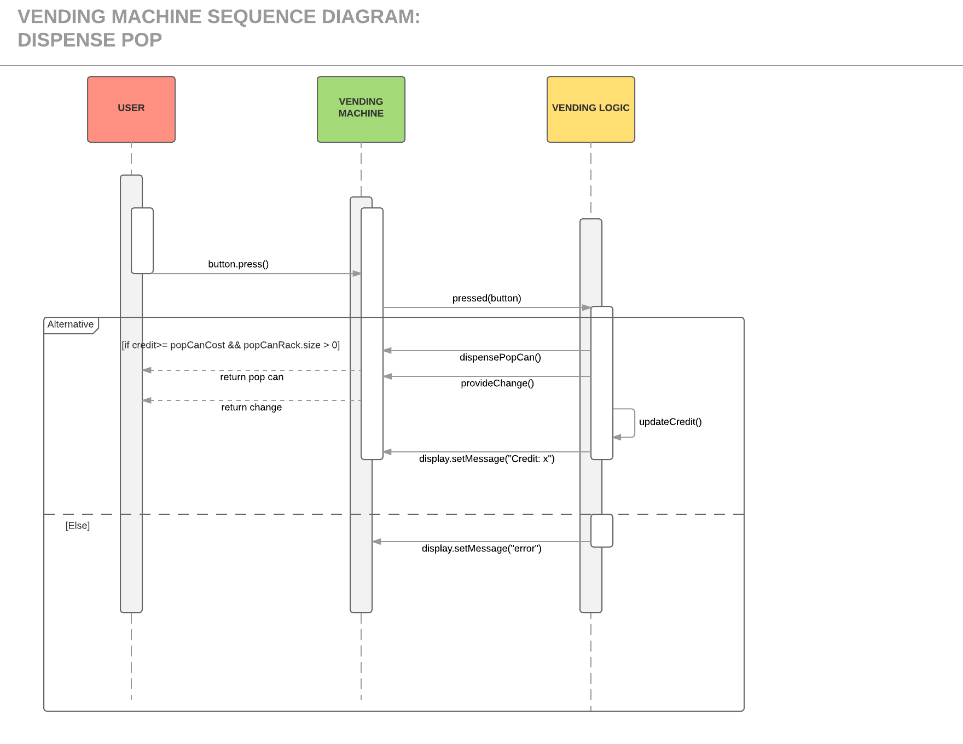

Figure . Behavioral Model for Dispensing a Pop Can.

The sequence diagram shown above illustrates the steps required by the vending machine software and hardware to dispense a pop can. This scenario assumes that the machine already has coins inserted. Once a selection button is pressed, the vending machine determines whether it has sufficient credit to purchase a pop and whether there is enough pop to dispense.

Note: An instance of “User” is a placeholder for the JUnit test suite provided with the solution submission.

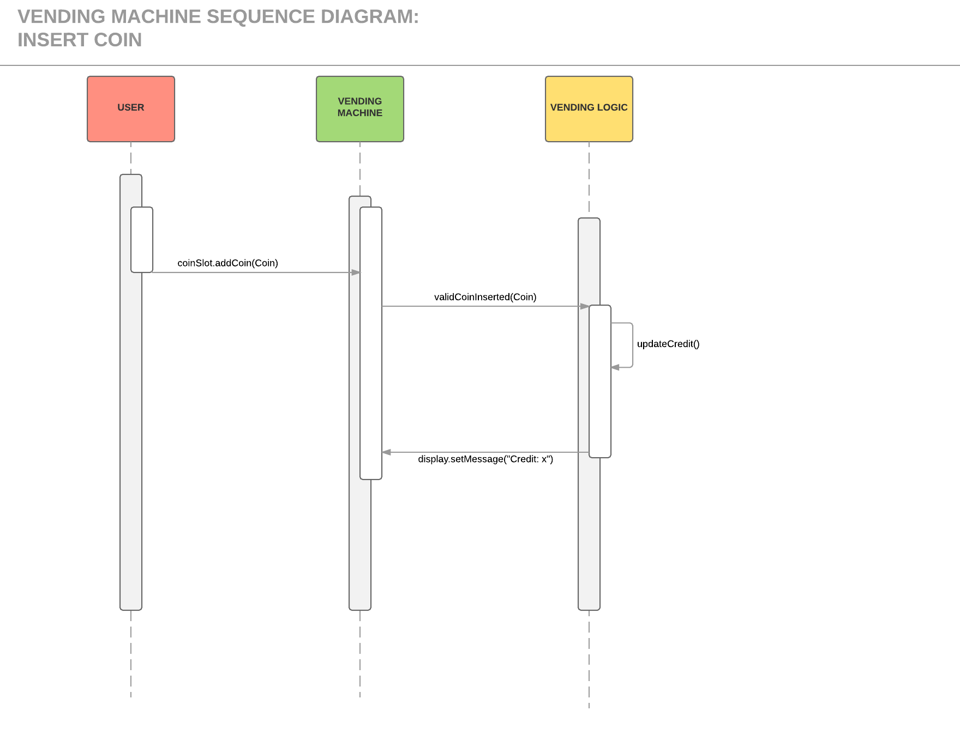

Figure . Behavioral Model for Inserting a Coin.

The sequence diagram shown above illustrates the steps required by the vending machine software and hardware to accept a coin inserted into a coin slot. This scenario assumed that the coin inserted by the user is valid. In case of an invalid coin, the machine would simply return it through the coin return slot.

Note: An instance of “User” is a placeholder for the JUnit test suite provided with the solution submission.