Problem Set Submission Form

Overview

|  |  |
| --- | --- |
| Your Name | Anthony Johnson |
| Your SU Email | Ajohn152 |

Instructions

Put your name and SU email at the top. Answer these questions from the lab. When asked to include screenshots, please follow the screen shot guidelines as indicated in the first lab.

Remember as you complete the problem sets it is not only about getting it right / correct. We will discuss the answers in class so it’s important to articulate anything you would like to contribute to the discussion in your answer:

* If you feel the question is vague, include any assumptions you've made.
* If you feel the answer requires interpretation or justification, provide it.
* If you do not know the answer to the question, articulate what you tried and how you are stuck.

This is how you receive credit for answering questions which might not be correct.

Questions From Lab to Be Answered:

1. A screenshot of a computer

   Description automatically generated After adding this code, I get these errors, so I’m not sure what caused them. I can’t see any new tables after this.
2. A screenshot of a computer program

   Description automatically generated
3. A screenshot of a computer

   Description automatically generated
4. A screenshot of a computer screen

   Description automatically generated
5. I can’t provide a screenshot of the tables because of these errors:   
    A computer screen shot of a computer screen

   Description automatically generated
6. A computer screen shot of a computer

   Description automatically generated
7. A screenshot of a computer

   Description automatically generated
8. A screenshot of a computer program

   Description automatically generated
9. 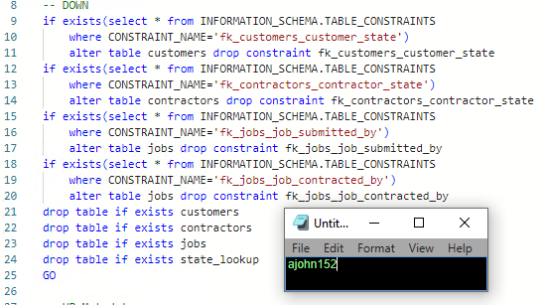
10. Again, I can’t show the tables because of the errors after I added the contractors table. I don’t know what happened or how to fix them.

Reflection

Use this section to reflect on your learning. To achieve the highest grade on the assignment you must be as descriptive and personal as possible with your reflection.  Take time to consider these questions before you answer them. Your reflection should be personal. I consider it just as important as the work itself.

1. Reflect upon 3 things you learned this week.   
      
    I learned that coding environments can be finnicky

I learned basic SQL in undergrad, but I didn’t know anything about drops or constraints.

1. What do you feel is still unclear about the topics covered this week?   
      
    I think I understand how to do everything, but I was frustrated by the error messages. I’ve tried looking into them, but I couldn’t find anything that would help and nothing that I tried worked.
2. Do you feel you were prepared for this assignment? What can you do to be better prepared?

I felt like I was prepared.

1. Now that you have completed this topic, rate your comfort level with this week’s material. This should be an honest assessment: (choose one)   
      
   4 ==> I understand this material and can explain it to others.   
   3 ==> I understand this material.   
   2 ==> I somewhat understand the material but sometimes need guidance from others.   
   1 ==> I understand very little of this material and need extra help.
2. Please provide any additional thoughts you have regarding your learning journey in this course to date.

I think it would be good to go through troubleshooting, especially for people who might not know a lot about coding. I also wasn’t sure if I was just supposed to repeat code or add on to already existing code.