**FDA JUMPSTART SCRIPTS**

**TESTING USING FDA DATA AND ALSO ACCENTURE DATA**

**PROGRAM NAME**: exposure_v1_test.sas (Exposure General Analysis Panel)

.

**TESTING AUTHORS**: June Cheng , Latha

**SAS VERSION**: 9.4

**DESCRIPTION**: The program was tested in Accenture’s SAS server in order to produce 15 Demographics Analysis displays (described in Table 1 below) using FDA-provided data (TEST) and also Accenture (ACN) datasets.

**TESTING STEPS**

1. All the necessary files were stored into the appropriate Accenture’s folder structure
2. CHANGES MADE TO THE SCRIPT TO MAKE IT RUN: the following parameters were defined in order to point to the right locations within Accenture’s environment:
   * Studypath: location of the drug study datasets.
   * Utilpath: location of external SAS programs.
   * Templatepath: filename of the template.
   * Outpath: location of the output.
   * Also, Text **ver=2003** was added to statement **libname xls pcfiles path="&demout.”;** which became **libname xls excel "&demout." ver=** **2003**;
   * No hardcoding was introduced into the program
3. Run the program.
4. Check that LOG file is free of ERRORS, and other suspicious messages.
5. Output file name is **Exposure.xls** which must be manually renamed based on library name used. For example: if you are running TEST data, rename output to exposure_test.xls so outputs won’t overwrite each other when generating output for ACN data.
6. Check that spreadsheet **Exposure Error Summary.xls** was NOT created for any of the program runs.
7. Spreadsheet **Exposure.xls** was created for every program ran and checked as follows:

**ADDITIONAL WORK PERFORMED**

The testing described before checks only for results displays but not for the accuracy of the numbers being displayed. Therefore, Accenture created a validation program that confirmed that all numbers yielded by exposure_v1_test.sas are correct. Obviously, the only discrepancies are the ones entered in column COMMENTS of Table 1.

**SUGGESTION**

Some code of exposure_v1_test.sas should be reviewed to prevent the SAS NOTE which appears in Figure 1 below

Figure 1

NOTE: Numeric values have been converted to character values at the places given by: (Line): (Column).

1:1 1:1 1:1. (See screenshot below).

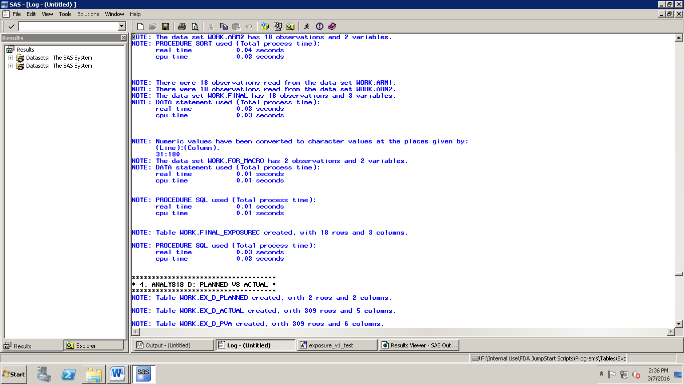

Figure 2

WARNING: Variable arm already exists on file WORK.BY_USUBJID2.

