# Central Tendency White Paper Requirements Specification

## Scripts for Output defined in: Figure 7.1 Box Plot – Observed Values of xxx Over Time

### Script Specification

#### Specific Output Requirements

* Generates a box plot of AVAL by AVISITN and TRTPN. See domain variations in Usage Requirements, below
* Basic script functionality (user options)
* ***data display features***
* Schematic or Tukey notched box plots, as described in [SAS/STAT 9.4 Graph Template Language: Reference (Boxplot Statement)](http://support.sas.com/documentation/cdl/en/grstatgraph/67882/HTML/default/p0vuh82v39fsasn1vqhzmhdl8y16.htm#n0g9wrnpg9zsryn1dk5csdrdfnqy)
* analyze by treatment
* group boxes by time point, and label clearly
* outliers:
* **IQR outliers** as box outlines, and
* **reference range outliers** as red dots
* reference ranges - options to draw reference lines for various scenarios (based on values found in data)
* **uniform:** If all reference range values are uniform for a set of measures, draw those uniform low/high reference range line.
* **narrow:** If reference range values are NOT uniform for a set of measures, draw the only the *narrow* reference range lines (highest of the lows, lowest of the highs)
* **all:** Discouraged by white paper authors – draw all reference lines relevant to the set of measures.
* **none**
* **numeric value(s):** draw exactly these specific reference lines (e.g., a zero (0) line for change from baseline boxplots.
* ***User variability***
* location and name of each input data sets
* output location (user-specified path)
* parameterize core variables required for analysis & display:
* AVAL (measured outcome)
* ANRLO (lower limit of reference range)
* ANRHI (upper limit of reference range)
* SAFFL (population flag)
* ANL01FL (analysis flag)
* ***basic readability features***
* maximum number of boxes to display on a page (basic paging control)
* Restrictions
* Footnote:
* Box plot type is schematic: the box shows median and interquartile range (IQR, the box edges); the whiskers extend to the minimum and maximum data points within 1.5 IQR below 25% and above 75%, respectively. Values outside the whiskers are shown as outliers. Means are marked with a different symbol for each treatment. Red dots indicate measures outside the normal reference range.

#### General Output and Formatting Requirements

See the specification document **CSS_GeneralOutputandFormattingRequirements.docx**.

### Usage Requirements

#### Required Input

##### Vital Signs Domain

* Dataset: ADVS
* Variables: STUDYID, USUBJID, SAFFL, ANL01FL, TRTP, TRTPN, PARAM, PARAMCD, AVAL, ANRLO, ANRHI, AVISIT, AVISITN, ATPT, ATPTN
* Record selection: SAFFL='Y' and ANL01FL='Y'

##### Laboratory Domain

* Dataset: ADLBC or ADLBH or ADLBHY?
* Variables: STUDYID, USUBJID, SAFFL, ANL01FL, TRTP, TRTPN, PARAM, PARAMCD, AVAL, A1LO, A1HI, AVISIT, AVISITN~~, ATPT, ATPTN~~
* Record selection: SAFFL='Y' and ANL01FL='Y'

##### ECG Domain

* Dataset: ???
* Variables: ???
* Record selection: ???

#### Macros

* Requires the PhUSE/CSS macro library:   
   <https://github.com/phuse-org/phuse-scripts/tree/master/whitepapers/utilities>
* User must ensure that SAS can find PhUSE/CSS macros in the SASAUTOS path

### Test Data

* Data sets from <https://github.com/phuse-org/phuse-scripts/tree/master/data/adam/cdisc>
* Domain data
  + Vital Signs Domain
  + ADVS – Vital signs
  + ADLBC, ADLBH, ADLBHY – Laboratory measures
  + ??? – ECG measures

### Sample Output

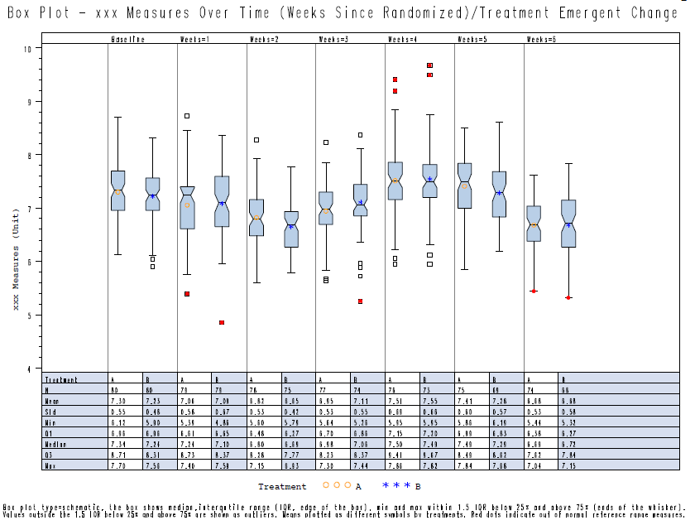

### Reference Documents:

White paper: <http://www.phusewiki.org/wiki/images/4/48/CSS_WhitePaper_CentralTendency_v1.0.pdf>

Programming Guidelines: <http://www.phusewiki.org/wiki/index.php?title=WG5_P02_Programming_Guidelines>