# Central Tendency White Paper Requirements Specification

## Scripts for Figure 7.3 Box Plot – Observed Values and Change in xxx Over Time

Figure 7.3 combines Figures 7.1 and 7.2 onto a single page, side-by -side. The processing and analyses are the same, the layout is compressed to a single page.

The plot is intended to describe a baseline measurement with a single post-baseline measurement.

### Script Specification

#### Specific Output Requirements

* Generates a box plot of AVAL by AVISITN and TRTPN. See domain variations in Usage Requirements, below
* Basic script functionality (user options)
* ***See Fig. 7.1 specifications for the left-hand plot (Observed values)***
* ***See Fig. 7.2 specifications for the right-hand plot (Change from baseline)***
* ***In addition to those:***
* Restrictions
* Footnote:
* Box plot type is schematic: the box shows median and interquartile range (IQR, the box edges); the whiskers extend to the minimum and maximum data points within 1.5 IQR below 25% and above 75%, respectively. Values outside the whiskers are shown as outliers. Means are marked with a different symbol for each treatment. Red dots indicate measures outside the normal reference range. [ Red lines indicate any upper and low limits of normal range, and only the most conservative values if they differ by gender, age, etc..] P-value is for the treatment comparison from ANCOVA model Change = Baseline + Treatment.
* The statement about *Red lines ... limits of normal range* should only appear if one or more appears on the page.

#### General Output and Formatting Requirements

See the specification document **CSS_GeneralOutputandFormattingRequirements.docx**.

### Usage Requirements

#### Required Input

##### Vital Signs Domain

* Dataset: ADVS
* Variables: STUDYID, USUBJID, SAFFL, ANL01FL, TRTP, TRTPN, PARAM, PARAMCD, AVAL, ANRLO, ANRHI, AVISIT, AVISITN, ATPT, ATPTN
* Record selection: SAFFL='Y' and ANL01FL='Y'

##### Laboratory Domain

* Dataset: ADLBC or ADLBH or ADLBHY?
* Variables: STUDYID, USUBJID, SAFFL, ANL01FL, TRTP, TRTPN, PARAM, PARAMCD, AVAL, A1LO, A1HI, AVISIT, AVISITN~~, ATPT, ATPTN~~
* Record selection: SAFFL='Y' and ANL01FL='Y'

##### ECG Domain

* Dataset: ???
* Variables: ???
* Record selection: ???

#### Macros

* Requires the PhUSE/CSS macro library:   
   <https://github.com/phuse-org/phuse-scripts/tree/master/whitepapers/utilities>
* User must ensure that SAS can find PhUSE/CSS macros in the SASAUTOS path

### Test Data

* Data sets from <https://github.com/phuse-org/phuse-scripts/tree/master/data/adam/cdisc>
* Domain data
  + Vital Signs Domain
  + ADVS – Vital signs
  + ADLBC, ADLBH, ADLBHY – Laboratory measures
  + ??? – ECG measures

### Sample Output

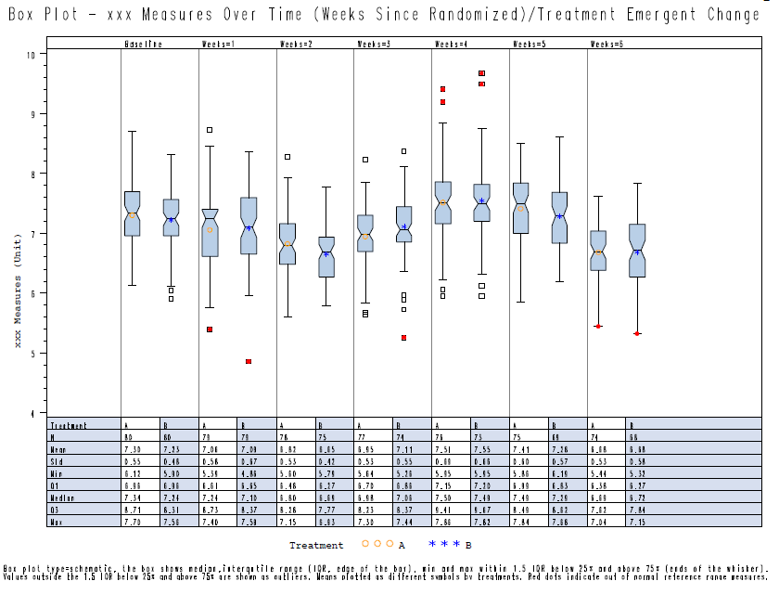

### Reference Documents:

White paper: <http://www.phusewiki.org/wiki/images/4/48/CSS_WhitePaper_CentralTendency_v1.0.pdf>

Programming Guidelines: <http://www.phusewiki.org/wiki/index.php?title=WG5_P02_Programming_Guidelines>