Modification History:

|  |  |  |  |  |
| --- | --- | --- | --- | --- |
| **Unique Identifier for this Version** | **Date of the Document Version** | **Author** | **Significant Changes from Previous Version** |  |
|  |
| 1 | 16-Jun-2016 |  |  |  |
|  |  |  |  |  |
|  |  |  |  |  |
|  |  |  |  |  |
|  |  |  |  |  |

# Central Tendency White Paper Requirements Specification

## Scripts for Figure 7.6 Box Plot – Measurements at Last/Min/Max Baseline and Last/Min/Max Post-baseline for Multiple Studies and Analysis Timepoint

Figure 7.6 is similar to Figure 7.1, with several significant difference:

* Display results for **multiple studies**. "Study" replaces "Visit" on the x-axis.
* The plot clusters results by study rather than by visit
* Display results for just two study visits: Last/Min/Max Baseline and Last/Min/Max Post-baseline
* Clearly label and separate Last/Min/Max Baseline and Last/Min/Max Post-baseline results

### Script Specification

#### Specific Output Requirements

* Generates a box plot of AVAL by STUDYID and TRTPN. See domain variations in Usage Requirements, below
* *Include all patients that have both a baseline and post-baseline measure.*
* *This point requires clarification. There is no mention of* ***change*** *in this plot, so why this restriction? Must Fig. 7.6 always match the left-hand plot in Fig. 7.8?*
* Basic script functionality (user options)
* ***See Fig. 7.1 specifications (Observed values)***
* ***Changes versus Fig. 7.1 specifications***
* group boxes by ***study***, and baseline vs. post-baseline
* **Default setting** for reference ranges is **NARROW** rather than UNIFORM
* **Additional parameterized settings** required for analysis & display:
* "Analysis flag" variable must identify exactly 1 Baseline and 1 Post-baseline value per subject (per parameter and analysis timepoint)
* Each obs must contain non-missing CHG (Change from Baseline) and BASE (Baseline) measurements.
* User declares whether this change-from-value is based on LAST/MIN/MAX values for Baseline and Post-baseline (the *change mode*).
* Restrictions
* ADaM BDS structure required
* SAS 9.4 TS Level 1M2 or higher
* Footnote:
* Box plot type is schematic: the box shows median and interquartile range (IQR, the box height); the whiskers extend to the minimum and maximum data points within 1.5 IQR of the lower and upper quartiles, respectively. Values outside the whiskers are shown as outliers. Means are marked with a different symbol for each treatment. Red dots indicate measures outside the normal reference range. *[ Red lines indicate any upper and low limits of normal range, and only the most conservative values if they differ by gender, age, etc..]*. Baseline and post-baseline blocks have different background colors. BASE = baseline, POST = post-baseline.
* The statement about *Red lines ... limits of normal range* should only appear if one or more lines does appear on the left-hand (absolute value) plot.

#### General Output and Formatting Requirements

See the specification document **CS_GeneralOutputandFormattingRequirements.docx**.

### Usage Requirements

#### Required Input

##### Vital Signs Domain

* Dataset: ADVS
* Variables: STUDYID, USUBJID, SAFFL, ANL01FL, TRTP, TRTPN, PARAM, PARAMCD, AVAL, ANRLO, ANRHI, AVISITN, ATPT, ATPTN
* Record selection: SAFFL='Y' and ANL01FL='Y'
* ANL01FL='Y' must identify *exactly 1 Baseline and 1 Post-baseline* value per subject per parameter and analysis timepoint

##### Laboratory Domain

* Dataset: ADLBC or ADLBH or ADLBHY or ADLB
* Variables: STUDYID, USUBJID, SAFFL, ANL01FL, TRTP, TRTPN, PARAM, PARAMCD, AVAL, A1LO, A1HI, AVISITN
* Record selection: SAFFL='Y' and ANL01FL='Y'
* ANL01FL='Y' must identify *exactly 1 Baseline and 1 Post-baseline* value per subject per parameter and analysis timepoint

##### ECG Domain

* Dataset: ADEG
* Variables: STUDYID, USUBJID, SAFFL, ANL01FL, TRTP, TRTPN, PARAM, PARAMCD, AVAL, ANRLO, ANRHI, AVISITN, ATPT, ATPTN
* Record selection: SAFFL='Y' and ANL01FL='Y'
* ANL01FL='Y' must identify *exactly 1 Baseline and 1 Post-baseline* value per subject per parameter and analysis timepoint

#### Macros

* Requires the PhUSE CS macro library:   
   <https://github.com/phuse-org/phuse-scripts/tree/master/whitepapers/utilities>
* User must ensure that SAS can find PhUSE CS macros in the SASAUTOS path

### Test Data

* Data sets from <https://github.com/phuse-org/phuse-scripts/tree/master/data/adam/cdisc>
* Domain data
  + ADVS – Vital signs
  + ADLBC, ADLBH, ADLBHY, ADLB – Laboratory measures
  + ADEG – ECG measures

### Sample Output

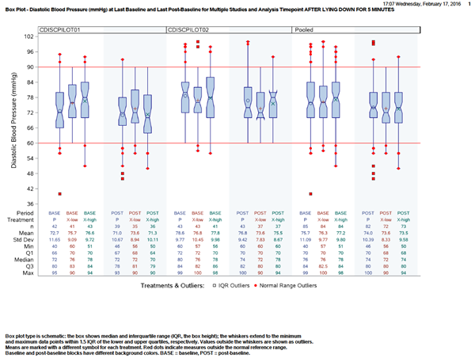

### Reference Documents:

White paper: <http://www.phusewiki.org/wiki/images/4/48/CSS_WhitePaper_CentralTendency_v1.0.pdf>

Programming Guidelines: <http://www.phusewiki.org/wiki/index.php?title=WG5_P02_Programming_Guidelines>