# Central Tendency White Paper Requirements Specification

## Scripts for Figure 7.7 Box Plot – Change from Last/Min/Max Baseline and Last/Min/Max Post-baseline for Multiple Studies and Analysis Timepoint

Figure 7.6 is similar to Figure 7.1, with several significant difference:

* Display results for **multiple studies**. "Study" replaces "Visit" on the x-axis.
* The plot clusters results by study rather than by visit
* Display results for just two study visits: Last/Min/Max Baseline and Last/Min/Max Post-baseline
* label and visually separate Last/Min/Max Baseline and Last/Min/Max Post-baseline results

### Script Specification

#### Specific Output Requirements

* Generates a box plot of Change from Baseline by STUDYID and TRTPN. See domain variations in Usage Requirements, below
* Include all patients that have both a baseline and post-baseline measure. See discussion in **Section 8.1**.
* Basic script functionality (user options)
* ***See Fig. 7.2 specifications (Observed values)***
* ***Changes versus Fig. 7.2 specifications***
* group boxes by ***study***, and label clearly
* P-value comparing Active Treatment with Comparator, using ANCOVA containing terms for treatment and the continuous covariate of baseline measurement. *For Pooled data, the model includes STUDY ID, as well.*
* **Additional parameterized settings** required for analysis & display:
* "Analysis Flag" that identifies exactly 1 non-missing Post-baseline value per subject (per parameter and analysis timepoint)
* This record must contain non-missing CHG (Change from Baseline) and BASE (Baseline) measurements.
* User declares whether this change-from-value is based on LAST/MIN/MAX values for Baseline and Post-baseline.
* Restrictions
* Footnote:
* Box plot type is schematic: the box shows median and interquartile range (IQR, the box height); the whiskers extend to the minimum and maximum data points within 1.5 IQR of the lower and upper quartiles, respectively. Values outside the whiskers are shown as outliers. Means are marked with a different symbol for each treatment. P-value is for the treatment comparison from ANCOVA model Change = Baseline + Treatment (+ Study for "Pooled").

#### General Output and Formatting Requirements

See the specification document **CS_GeneralOutputandFormattingRequirements.docx**.

### Usage Requirements

#### Required Input

##### Vital Signs Domain

* Dataset: ADVS
* Variables: STUDYID, USUBJID, SAFFL, ANL02FL, TRTP, TRTPN, PARAM, PARAMCD, CHG, BASE, ATPT, ATPTN
* Record selection: SAFFL='Y' and ANL02FL='Y'
* User specifies appropriate flag, ANL02FL

##### Laboratory Domain

* Dataset: ADLBC or ADLBH or ADLBHY?
* Variables: STUDYID, USUBJID, SAFFL, ANL02FL, TRTP, TRTPN, PARAM, PARAMCD, CHG, BASE, ~~ATPT, ATPTN~~
* Record selection: SAFFL='Y' and ANL02FL='Y'
* User specifies appropriate flag, ANL02FL

##### ECG Domain

* Dataset: ???
* Variables: ???
* Record selection: ???

#### Macros

* Requires the PhUSE CS macro library:   
   <https://github.com/phuse-org/phuse-scripts/tree/master/whitepapers/utilities>
* User must ensure that SAS can find PhUSE CS macros in the SASAUTOS path

### Test Data

* Data sets from <https://github.com/phuse-org/phuse-scripts/tree/master/data/adam/cdisc>
* Domain data
  + Vital Signs Domain
  + ADVS – Vital signs
  + ADLBC, ADLBH, ADLBHY – Laboratory measures
  + ??? – ECG measures

### Sample Output

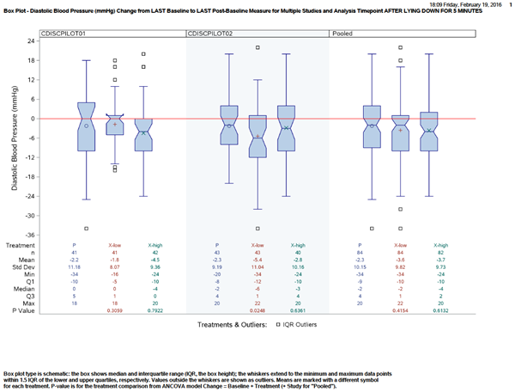

### Reference Documents:

White paper: <http://www.phusewiki.org/wiki/images/4/48/CSS_WhitePaper_CentralTendency_v1.0.pdf>

Programming Guidelines: <http://www.phusewiki.org/wiki/index.php?title=WG5_P02_Programming_Guidelines>