Modification History:

|  |  |  |  |  |
| --- | --- | --- | --- | --- |
| **Unique Identifier for this Version** | **Date of the Document Version** | **Author** | **Significant Changes from Previous Version** |  |
|  |
| 1 | 16-Jun-2016 |  |  |  |
|  |  |  |  |  |
|  |  |  |  |  |
|  |  |  |  |  |
|  |  |  |  |  |

# Central Tendency White Paper Requirements Specification

## Scripts for Figure 7.8 Box Plot – Last, Minimum and Maximum Baseline versus Post-baseline by Treatment and Analysis Timepoint, Multiple Studies

Figure 7.8 combines and summarizes elements of Figure 7.6 (by-study measures) and 7.7 (by-study change), in particular for Integrated Summaries involving a large number of studies. In such cases, it becomes unreasonable to display by-study results. So instead, Figure 7.8 presents pooled results of observed measures side-by-side with change from baseline. Figure 7.8 further consolidates Last, Minimum and Maximum Baseline versus Post-baseline to a single page.

### Script Specification

#### Specific Output Requirements

* Generate a box plot of measurements side-by-side with change from baseline. See domain variations in Usage Requirements, below.
* Last, Minimum and Maximum Baseline vs. corresponding Last, Minimum and Maximum Post-baseline,
* By Treatment and Analysis Timepoint (esp. for Vital Signs data)
* Include only patients that **have both a baseline and post-baseline measure**.
* Basic script functionality (user options)
* ***See Fig. 7.1 specifications (Observed values)***
* ***Changes versus Fig. 7.1 specifications***
* group boxes by *type of measures (last, min and max)*, and baseline vs. post-baseline
* **Default setting** for reference ranges is **NARROW** rather than UNIFORM
* **Additional parameterized settings** required for analysis & display:
* CHG variable (derived change-from-baseline)
* BASE variable, with "baseline" measurement for this record
* ANCOVA p-value option: Leave this reference trt blank to omit ANCOVA p-values
* "Reference" treatment number, such as a TRTPN value like zero (0)
* Analysis flags to identify unique records per patient (USUBJID), parameter (PARAMCD) and analysis timepoint (ATPT):
* 3 separate analysis flags: Last, Minimum and Maximum logic
* Last baseline and post-baseline measures, non-missing values
* Minimum baseline and post-baseline measures, non-missing values
* Maximum baseline and post-baseline measures, non-missing values
* *At least one analysis-flag setting must be non-missing*
* Each analysis record must contain non-missing values for
* Measurement (AVAL)
* Baseline (BASE)
* Change from baseline (CHG, derived from AVAL and BASE)
* Restrictions
* *Select Last, Minimum and Maximum BL and P-BL values* ***from all non-missing values****, rather than restricting to valued flagged as preferred "analysis" values (? to be clarified)*
* *Only include subjects (N) with non-missing baseline and post-baseline measurements.*
* Footnote:
* Box plot type is schematic: the box shows median and interquartile range (IQR, the box height); the whiskers extend to the minimum and maximum data points within 1.5 IQR of the lower and upper quartiles, respectively. Values outside the whiskers are shown as outliers. Means are marked with a different symbol for each treatment. Red dots indicate measures outside the normal reference range. *[ Red lines indicate any upper and low limits of normal range, and only the most conservative values if they differ by gender, age, etc..]*. Baseline and post-baseline blocks have different background colors. P-value is for the treatment comparison from ANCOVA model Change = Baseline + Treatment + Study. BASE = baseline, POST = post-baseline measures.
* The statement about *Red lines ... limits of normal range* should only appear if one or more lines does appear on the left-hand (absolute value) plot.

#### General Output and Formatting Requirements

See the specification document **CS_GeneralOutputandFormattingRequirements.docx**.

### Usage Requirements

#### Required Input

##### Vital Signs Domain

* Dataset: ADVS
* Variables: STUDYID, USUBJID, SAFFL, ANL*last*FL, ANL*min*FL, ANL*max*FL, TRTP, TRTPN, PARAM, PARAMCD, AVAL, BASE, CHG, ANRLO, ANRHI, ATPT, ATPTN
* Record selection:
* SAFFL='Y' and ANL*last*FL='Y' (for LAST assessment)
* SAFFL='Y' and ANL*min*FL='Y' (for MIN assessment)
* SAFFL='Y' and ANL*max*FL='Y' (for MAX assessment)

##### Laboratory Domain

* Dataset: ADLB or ADLBC or ADLBH or ADLBHY?
* Variables: STUDYID, USUBJID, SAFFL, ANL*last*FL, ANL*min*FL, ANL*max*FL, TRTP, TRTPN, PARAM, PARAMCD, AVAL, BASE, CHG, A1LO, A1HI, AVISITN~~, ATPT, ATPTN~~
* Record selection:
* SAFFL='Y' and ANL*last*FL='Y' (for LAST assessment)
* SAFFL='Y' and ANL*min*FL='Y' (for MIN assessment)
* SAFFL='Y' and ANL*max*FL='Y' (for MAX assessment)

##### ECG Domain

* Dataset: ADEG
* Variables: , USUBJID, SAFFL, ANLlastFL, ANLminFL, ANLmaxFL, TRTP, TRTPN, PARAM, PARAMCD, AVAL, BASE, CHG, ANRLO, ANRHI, ATPT, ATPTN
* Record selection:
* SAFFL='Y' and ANL*last*FL='Y' (for LAST assessment)
* SAFFL='Y' and ANL*min*FL='Y' (for MIN assessment)
* SAFFL='Y' and ANL*max*FL='Y' (for MAX assessment)

#### Macros

* Requires the PhUSE CS macro library:   
   <https://github.com/phuse-org/phuse-scripts/tree/master/whitepapers/utilities>
* User must ensure that SAS can find PhUSE CS macros in the SASAUTOS path

### Test Data

* Data sets from <https://github.com/phuse-org/phuse-scripts/tree/master/data/adam/cdisc>
* Domain data
  + ADVS – Vital signs
  + ADLBC, ADLBH, ADLBHY – Laboratory measures
  + ADEG – ECG measures

### Sample Output

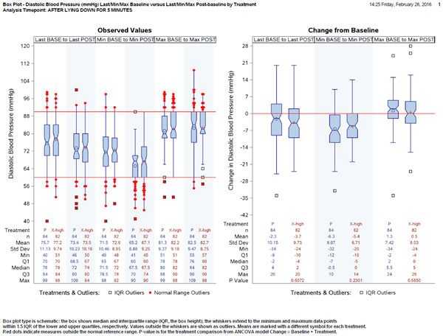

### Reference Documents:

White paper: <http://www.phusewiki.org/wiki/images/4/48/CSS_WhitePaper_CentralTendency_v1.0.pdf>

Programming Guidelines: <http://www.phusewiki.org/wiki/index.php?title=WG5_P02_Programming_Guidelines>