Question 1 screen shots:

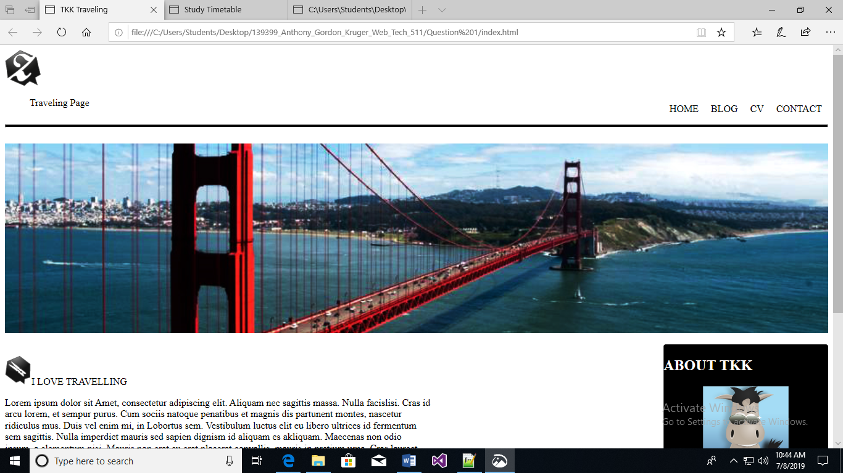

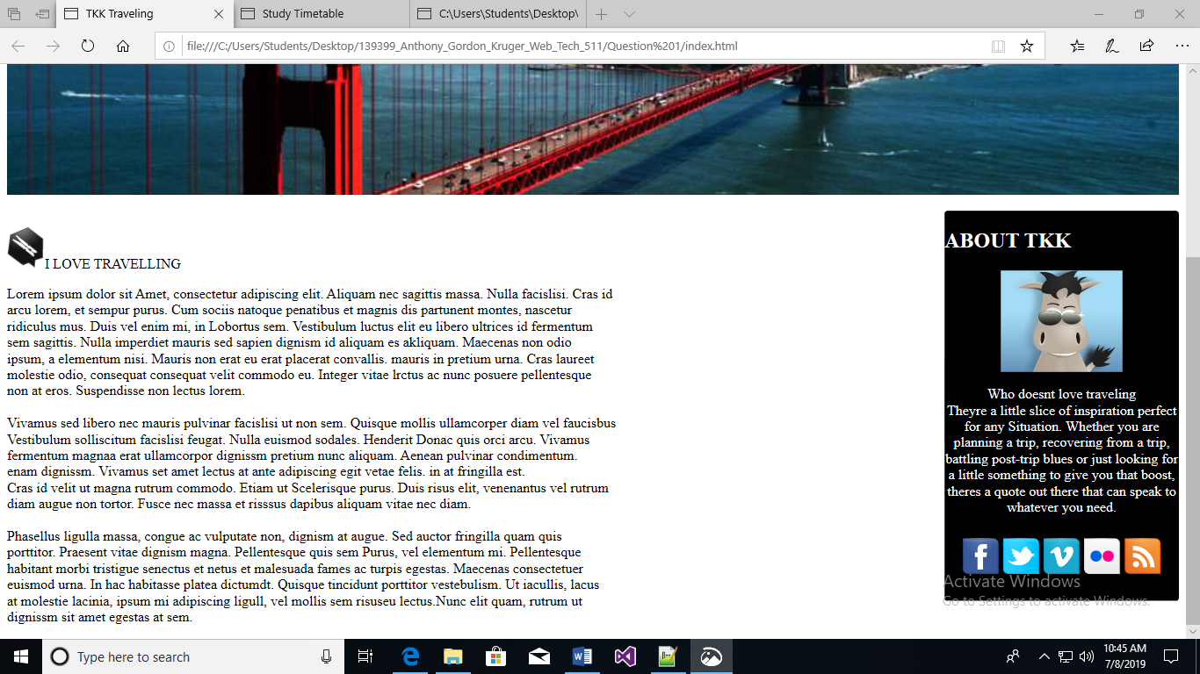

Question 1 source code:

<DOCTYPE! html>

<html>

<head>

<title>

TKK Traveling

</title>

<style>

#leftTab{

float:left;

list-style: none;

display: in-line;

overflow: hidden;

}

.rightTab{

float:right;

list-style: none;

display: in-line;

overflow: hidden;

padding: 10px;

}

#rule{

height:3px;

background-color: black;

}

#sanfrancisco{

width:100%;

}

#socialMedia{

list-style: none;

display: in-line;

overflow: hidden;

padding: 10px;

}

#icons{

list-style: none;

display: in-line;

overflow: hidden;

padding: 10px;

float:left;

}

#main{

width::80%;

float:left;

}

#about{

background-color:black;

color:white;

width:20%;

float:right;

border-radius: 4px;

}

</style>

</head>

<body>

<img src="zozor_logo.png">

<nav>

<ul id="navbar">

<li id="leftTab"><a href="#"></a>Traveling Page</li>

<li class="rightTab"><a href="#"></a>CONTACT</li>

<li class="rightTab"><a href="#"></a>CV</li>

<li class="rightTab"><a href="#"></a>BLOG</li>

<li class="rightTab"><a href="#"></a>HOME</li>

</ul>

</nav>

<br/>

<br/>

<hr id="rule"/>

<br/>

<img id="sanfrancisco" src="sanfrancisco.jpg" alt="San Francisco"/>

<br/>

<br/>

<div id="main">

<br/>

<img src="ico_epingle.png"/><x-large>I LOVE TRAVELLING</x-large>

<p>

Lorem ipsum dolor sit Amet, consectetur adipiscing elit. Aliquam nec sagittis massa. Nulla facislisi. Cras id<br/>

arcu lorem, et sempur purus. Cum sociis natoque penatibus et magnis dis partunent montes, nascetur<br/>

ridiculus mus. Duis vel enim mi, in Lobortus sem. Vestibulum luctus elit eu libero ultrices id fermentum<br/>

sem sagittis. Nulla imperdiet mauris sed sapien dignism id aliquam es akliquam. Maecenas non odio<br/>

ipsum, a elementum nisi. Mauris non erat eu erat placerat convallis. mauris in pretium urna. Cras laureet<br/>

molestie odio, consequat consequat velit commodo eu. Integer vitae lrctus ac nunc posuere pellentesque<br/>

non at eros. Suspendisse non lectus lorem.

<br/>

<br/>

Vivamus sed libero nec mauris pulvinar facislisi ut non sem. Quisque mollis ullamcorper diam vel faucisbus<br/>

Vestibulum solliscitum facislisi feugat. Nulla euismod sodales. Henderit Donac quis orci arcu. Vivamus <br/>

fermentum magnaa erat ullamcorpor dignissm pretium nunc aliquam. Aenean pulvinar condimentum.<br/>

enam dignissm. Vivamus set amet lectus at ante adipiscing egit vetae felis. in at fringilla est. <br/>

Cras id velit ut magna rutrum commodo. Etiam ut Scelerisque purus. Duis risus elit, venenantus vel rutrum<br/>

diam augue non tortor. Fusce nec massa et risssus dapibus aliquam vitae nec diam.

<br/>

<br/>

Phasellus ligulla massa, congue ac vulputate non, dignism at augue. Sed auctor fringilla quam quis <br/>

porttitor. Praesent vitae dignism magna. Pellentesque quis sem Purus, vel elementum mi. Pellentesque<br/>

habitant morbi tristigue senectus et netus et malesuada fames ac turpis egestas. Maecenas consectetuer<br/>

euismod urna. In hac habitasse platea dictumdt. Quisque tincidunt porttitor vestebulism. Ut iacullis, lacus <br/>

at molestie lacinia, ipsum mi adipiscing ligull, vel mollis sem risuseu lectus.Nunc elit quam, rutrum ut <br/>

dignissm sit amet egestas at sem.

</p>

</div>

<div id="about">

<h2>

ABOUT TKK

</h2>

<center>

<img src="zozor_classe.png">

<p>

Who doesnt love traveling <br/>

Theyre a little slice of inspiration perfect for any Situation.

Whether you are planning a trip, recovering from a trip,

battling post-trip blues or just looking for a little something to give you that boost,

theres a quote out there that can speak to whatever you need.

</p>

<p id="SocialMedia">

<a href="#"><img src="facebook.png" alt="Facebook"/></a>

<a href="#"><img src="twitter.png" alt="Twitter"/></a>

<a href="#"><img src="vimeo.png" alt="Vimeo"/></a>

<a href="#"><img src="flickr.png" alt="Flickr"/></a>

<a href="#"><img src="rss.png" alt="Rss"/></a>

</p>

</center>

</div>

</body>

</html>

Question 2 screen shots:

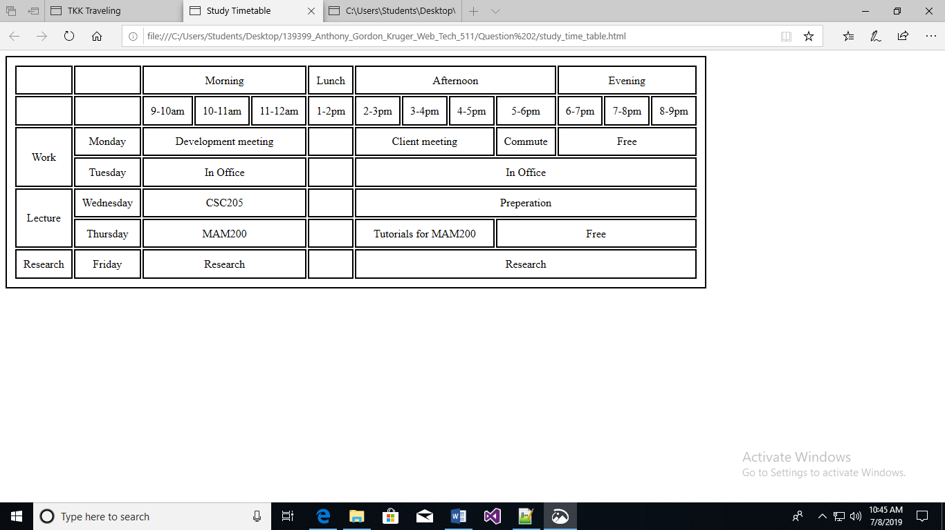

Question 2 source code:

<DOCTYPE! html>

<html>

<head>

<title>

Study Timetable

</title>

<style>

#timetable, th, td{

border:2px solid black;

text-align: center;

padding:10px;

}

</style>

</head>

<body>

<table id="timetable">

<tr>

<td>

</td>

<td>

</td>

<td colspan="3">

Morning

</td>

<td>

Lunch

</td>

<td colspan="4">

Afternoon

</td>

<td colspan="3">

Evening

</td>

</tr>

<tr>

<td>

</td>

<td>

</td>

<td>

9-10am

</td>

<td>

10-11am

</td>

<td>

11-12am

</td>

<td>

1-2pm

</td>

<td>

2-3pm

</td>

<td>

3-4pm

</td>

<td>

4-5pm

</td>

<td>

5-6pm

</td>

<td>

6-7pm

</td>

<td>

7-8pm

</td>

<td>

8-9pm

</td>

</tr>

<tr>

<td rowspan="2">

Work

</td>

<td>

Monday

</td>

<td colspan="3">

Development meeting

</td>

<td>

</td>

<td colspan="3">

Client meeting

</td>

<td>

Commute

</td>

<td colspan="3">

Free

</td>

</tr>

<tr>

<td>

Tuesday

</td>

<td colspan="3">

In Office

</td>

<td>

</td>

<td colspan="7">

In Office

</td>

</tr>

<tr>

<td rowspan="2">

Lecture

</td>

<td>

Wednesday

</td>

<td colspan="3">

CSC205

</td>

<td>

</td>

<td colspan="7">

Preperation

</td>

</tr>

<tr>

<td>

Thursday

</td>

<td colspan="3">

MAM200

</td>

<td>

</td>

<td colspan="3">

Tutorials for MAM200

</td>

<td colspan="4">

Free

</td>

</tr>

<tr>

<td>

Research

</td>

<td>

Friday

</td>

<td colspan="3">

Research

</td>

<td>

</td>

<td colspan="7">

Research

</td>

</tr>

</table>

</body>

</html>

Question 3 screen shots:

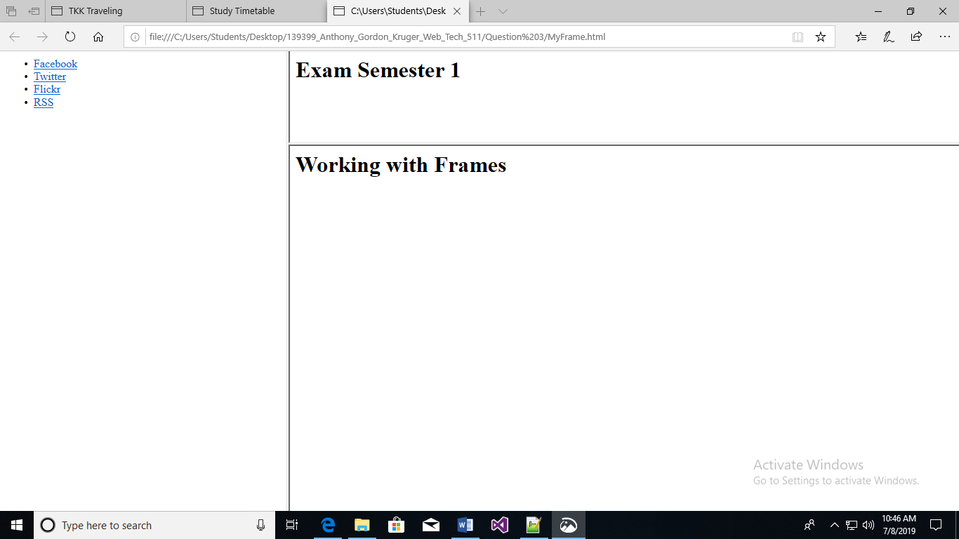

Question 3 source code:

MYFRAME.HTML

<DOCTYPE! html>

<html>

<head>

<title>

</title>

<style>

</style>

</head>

<frameset cols="30%, *">

<frame name="social" src="Sidebar.html">

<frameset rows="20%, *">

<frame name="title" src="TitlePage.html">

<frame name="Exam1" src="Exam1.html">

</frameset>

<noframes>

<body>

Your browser does not support frames

</body>

</noframes>

</frameset>

</html>

TITLEPAGE.HTML

<DOCTYPE! html>

<html>

<head>

<title>

titlePage

</title>

<style>

</style>

</head>

<body>

<h1>Exam Semester 1</h1>

</body>

</html>

SIDEBAR.HTML

<DOCTYPE! html>

<html>

<head>

<title>

</title>

<style>

</style>

</head>

<body>

<ul>

<li><a href="#">Facebook</a></li>

<li><a href="#">Twitter</a></li>

<li><a href="#">Flickr</a></li>

<li><a href="#">RSS</a></li>

</ul>

</body>

</html>

EXAM1.HTML

<DOCTYPE! html>

<html>

<head>

<title>

exam1

</title>

<style>

</style>

</head>

<body>

<h1>Working with Frames</h1>

</body>

</html>