## 

## 

**Experiment 6: NoSQL Database Models**

CPE106L (Software Design Laboratory)

**Anthony Yapcengco**

**Andrea Kayla Zalameda**

Group No.: **9**

Section: **B2**

## **PreLab**



**Readings, Insights, and Reflection**

**Building Cross-Platform Mobile and Web Apps for  
Engineers and Scientists: An Active Learning Approach  
9781305855892**

**Chapter 9:**

[Yapcengco]:

[Zalameda]: *I gained knowledge of MongoDB and the fundamentals of NoSQL database modeling in this chapter. I learned that MongoDB is a well-known document-oriented NoSQL database that keeps data in adaptable documents with a structure akin to JSON. I also learned more about modeling a NoSQL database, which is creating schema-free structures that can handle changing and dynamic data requirements and offer more scalability and flexibility than conventional relational databases.*

## **PostLab**



**Programming Problems**

Using the ERD shown here >> Chinook DB ERD , create the artists-albums-tracks database in MongoDB compass.

The chinook.db is downloaded and viewed in DB Browser to export the albums, artists, and tracks as .JSON files.

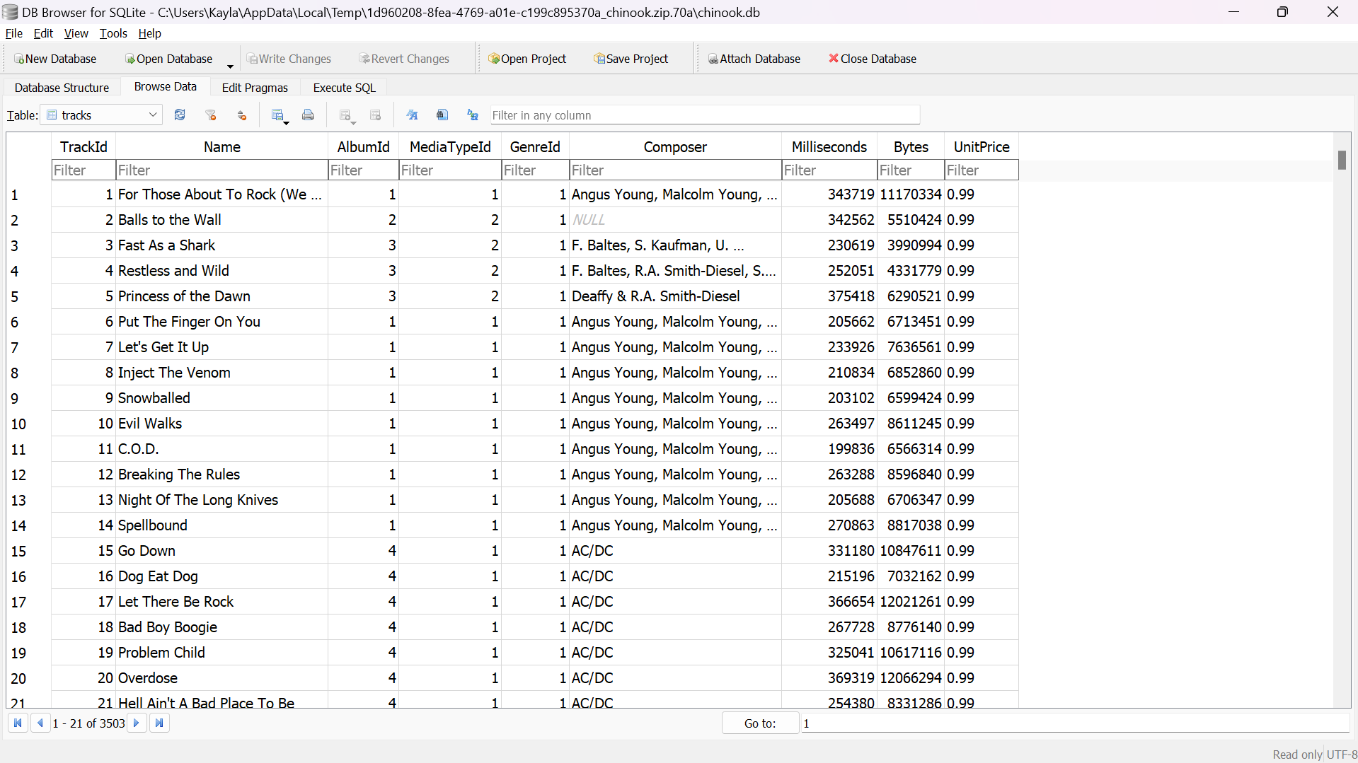

***Figure P.1****. Viewing the tracks table in DB Browser*

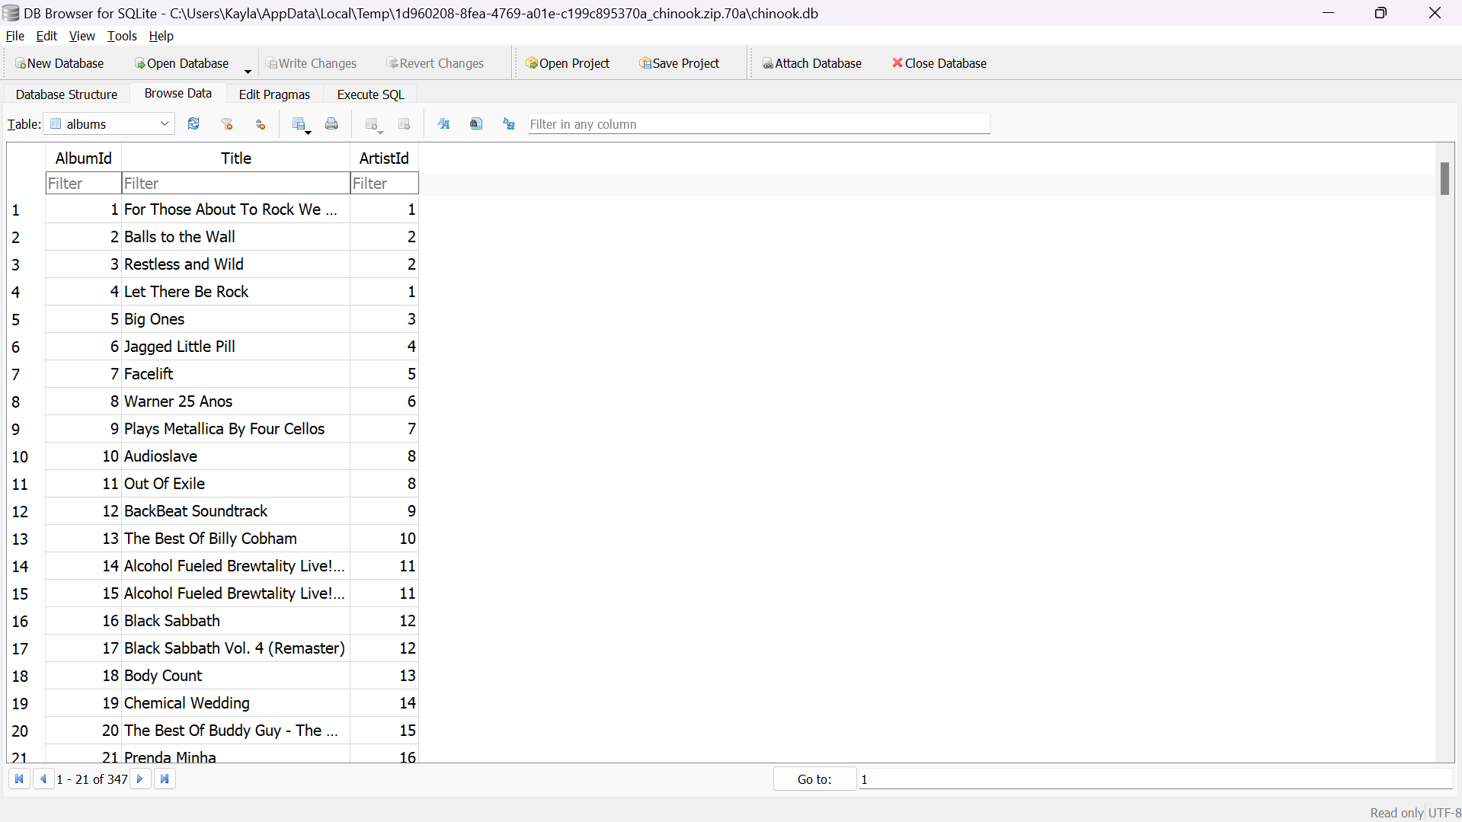

***Figure P.2****. Viewing the albums table in DB Browser*

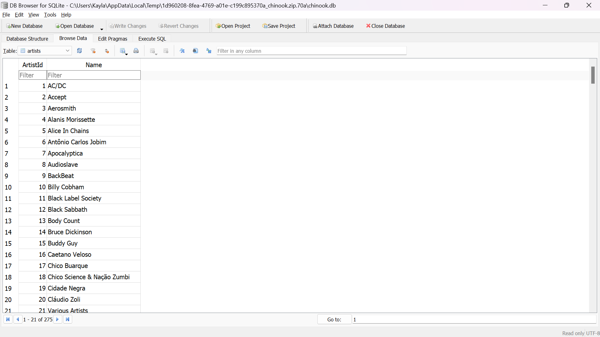

***Figure P.3****. Viewing the artists table in DB Browser*

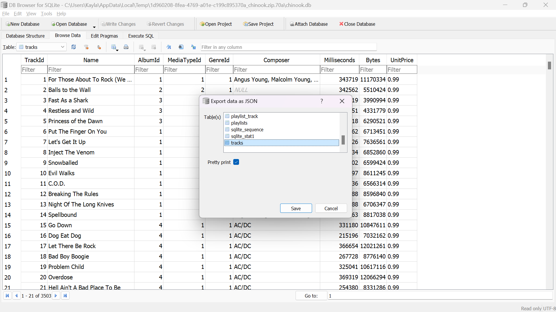

***Figure P.4****. Exporting tracks table as JSON file*

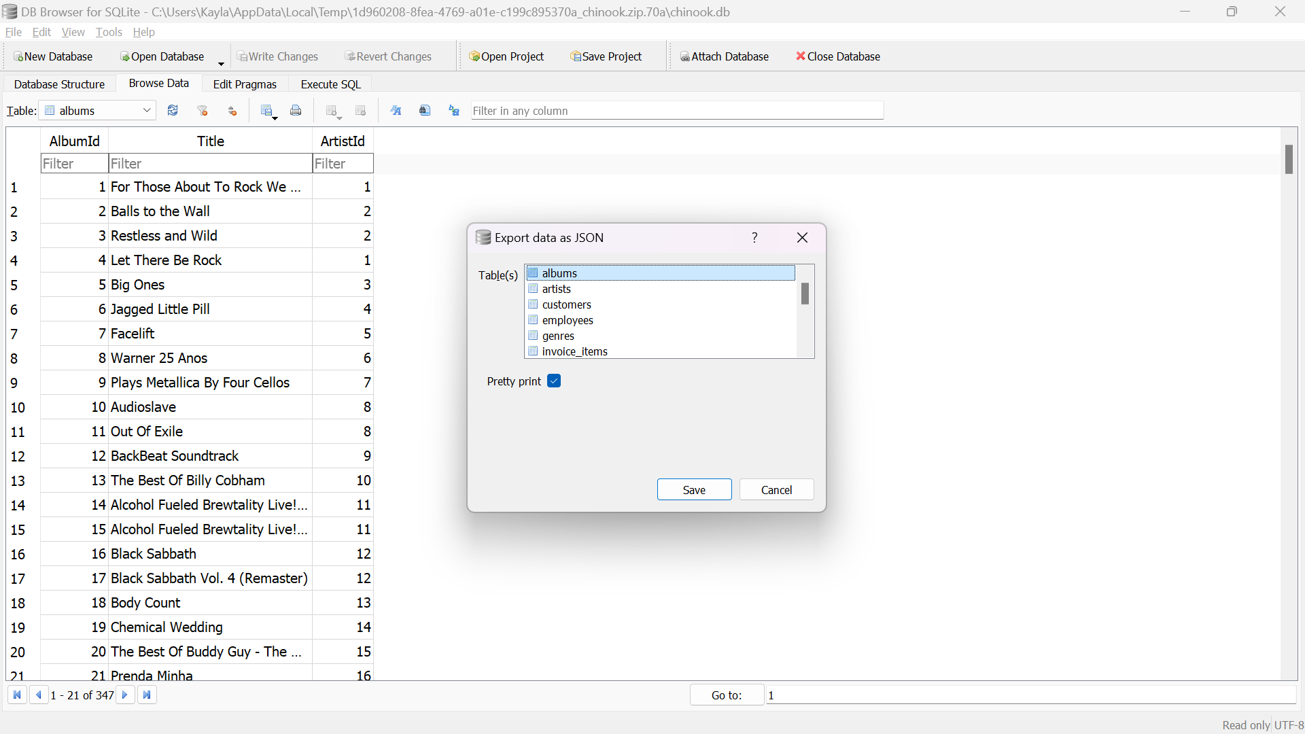

***Figure P.4****. Exporting albums table as JSON file*

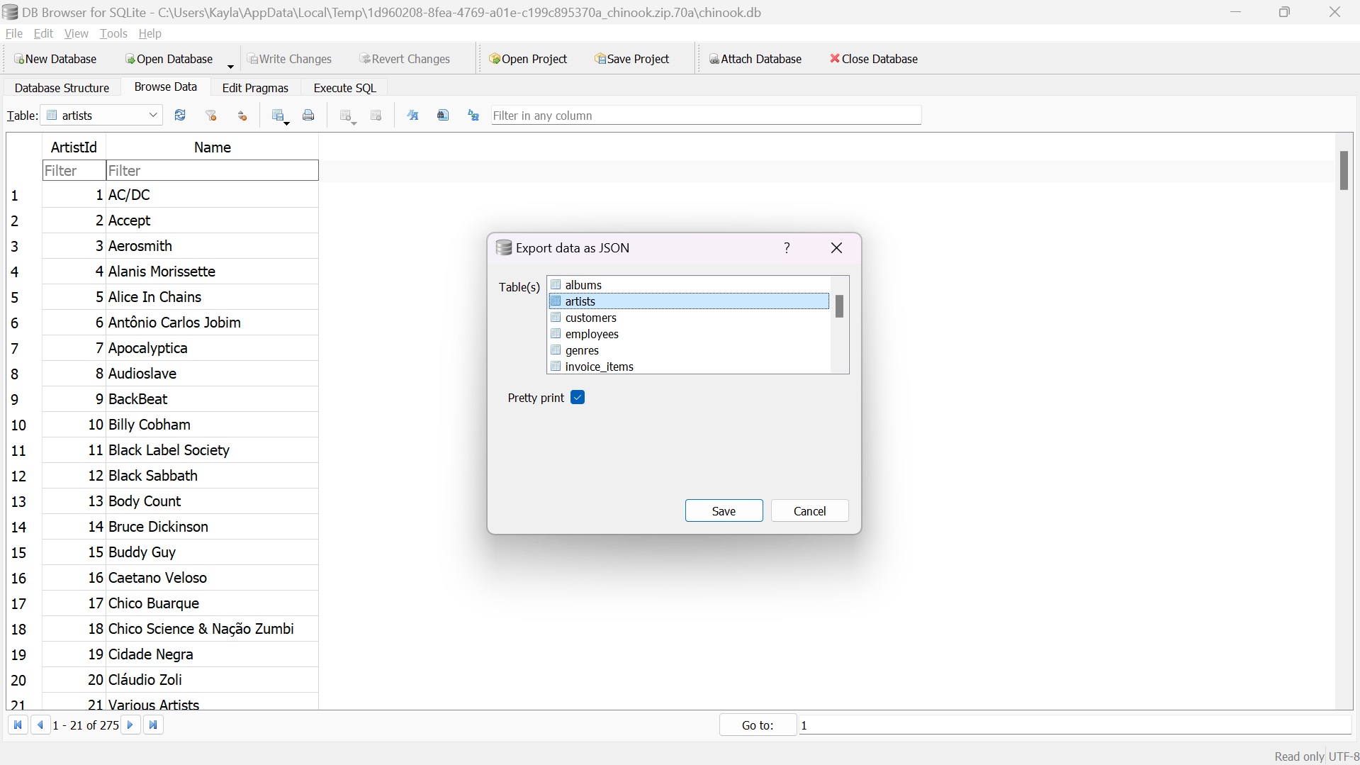

***Figure P.4****. Exporting artists table as JSON file*

The files are then imported to the MongoDB Compass.

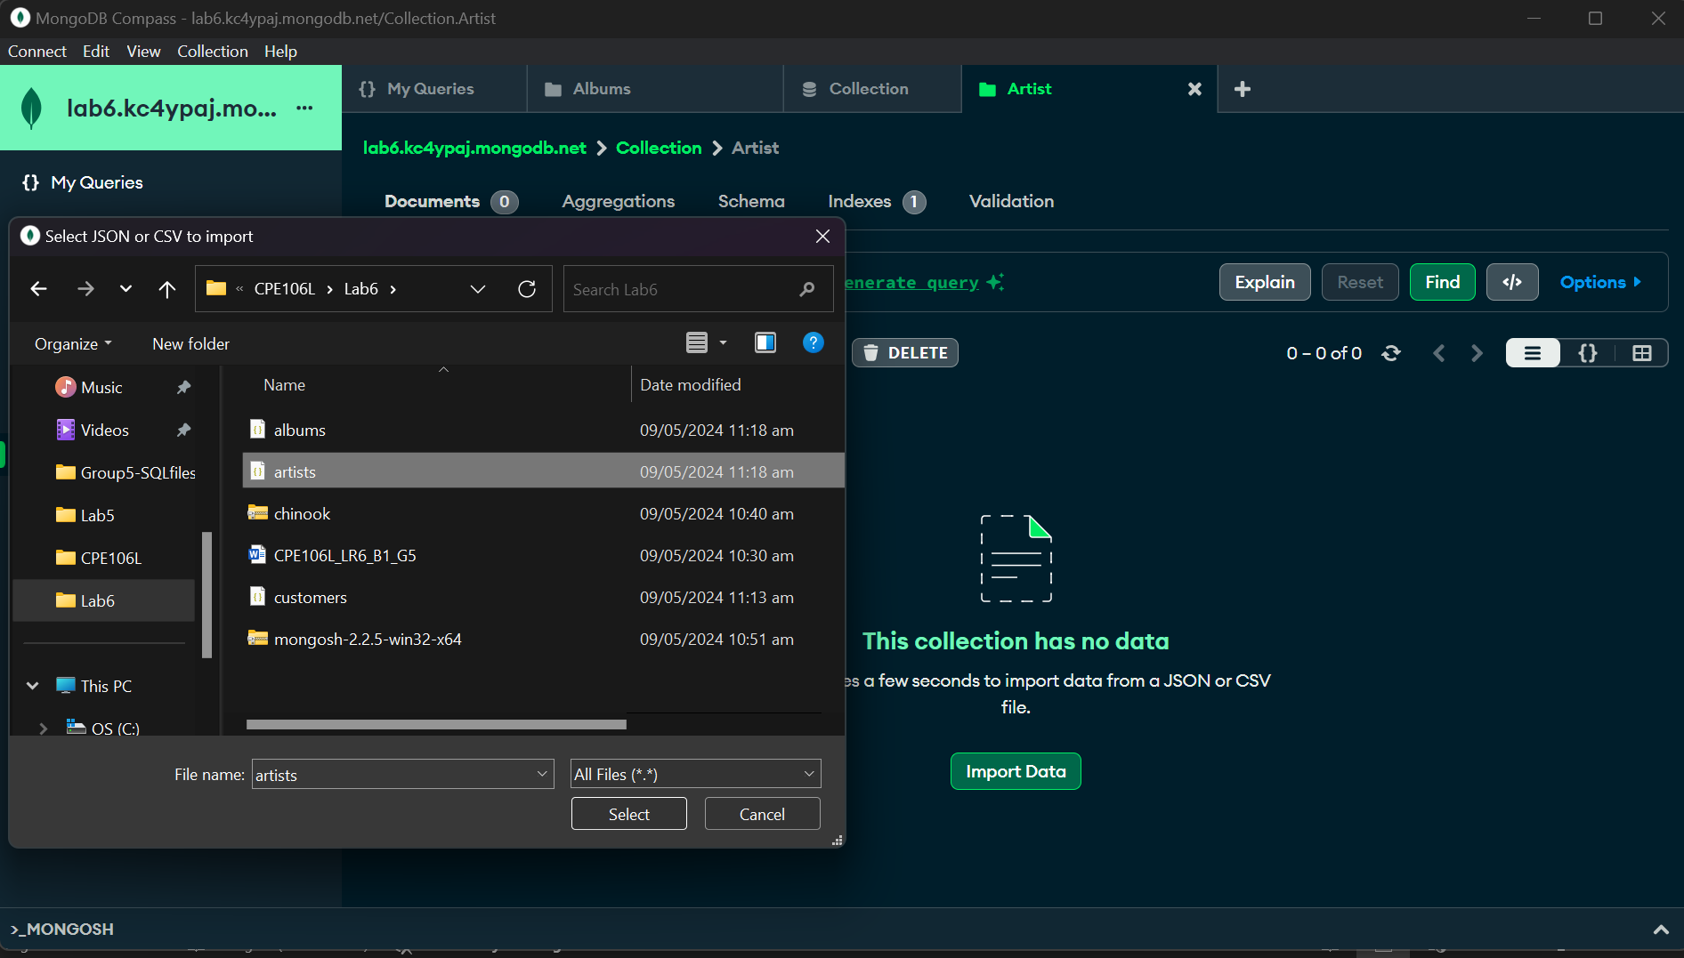

***Figure P.5****. Importing artists table in MongoDB Compass*

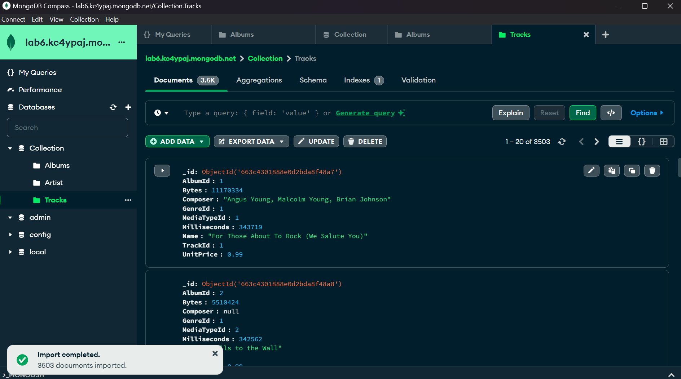

***Figure P.6****. Successfully imported tracks table in MongoDB Compass*

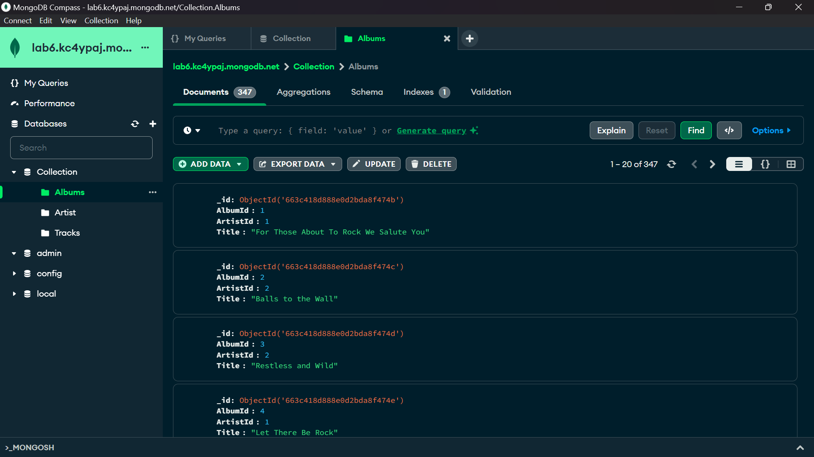

***Figure P.6****. Successfully imported albums table in MongoDB Compass*

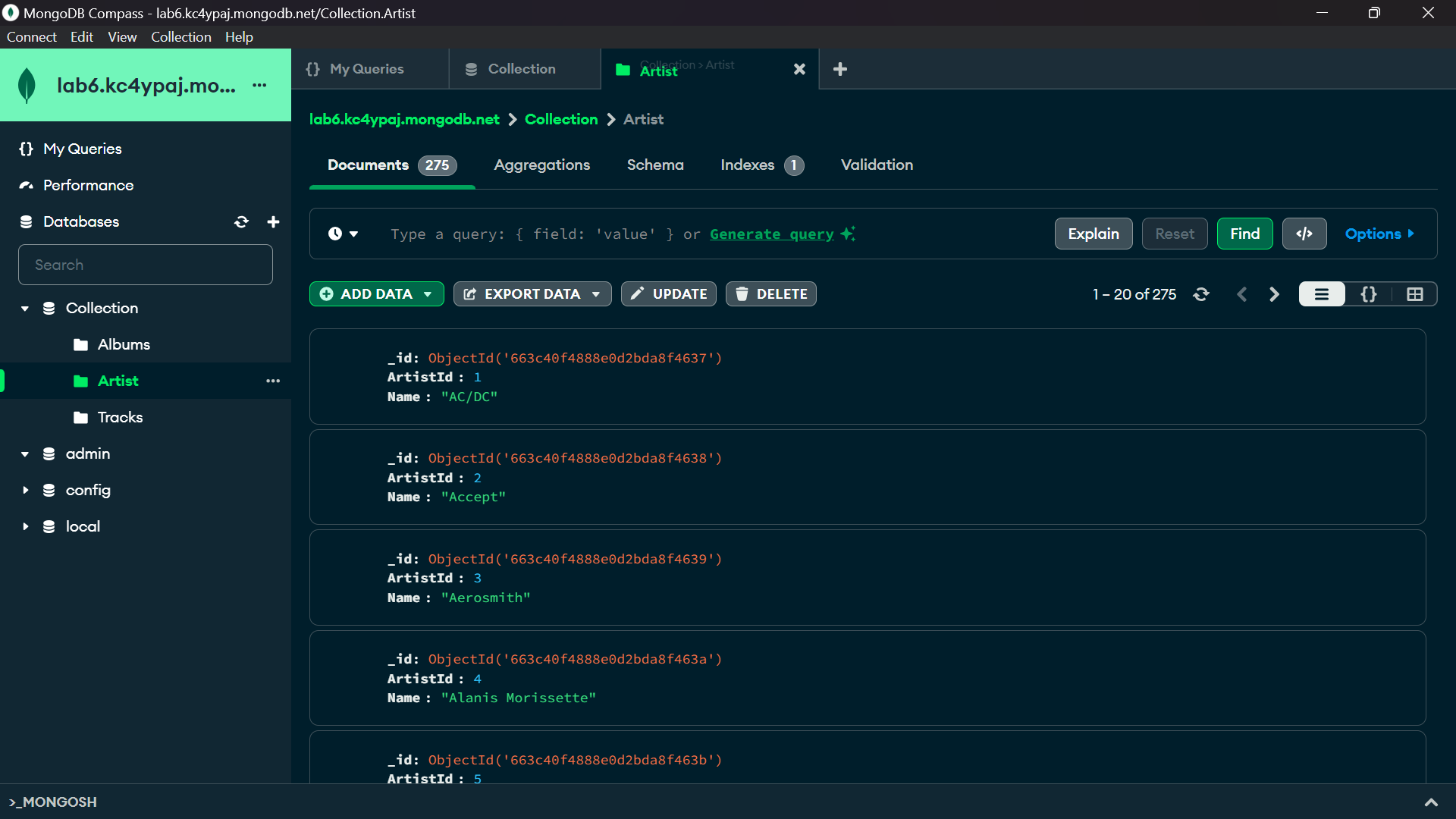

***Figure P.6****. Successfully imported artists table in MongoDB Compass*

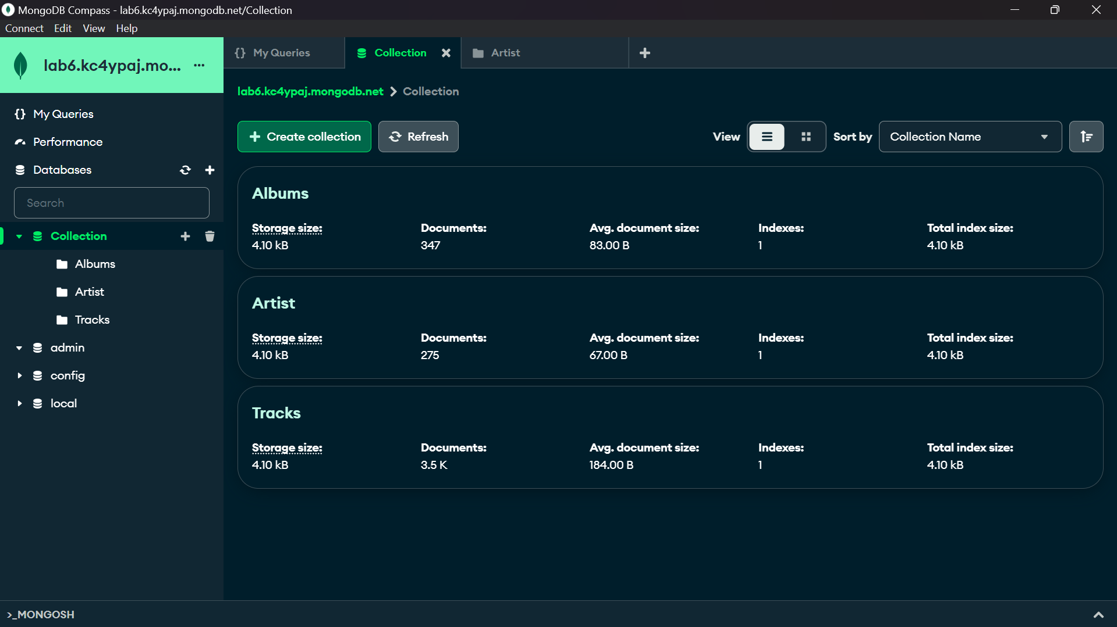

***Figure P.6****. Successfully imported tables and the full collection in MongoDB Compass*