IBM’s Attribution

Anthony

2017.11.20

人员的不稳定性，一直是困扰很多企业的一个的问题，怎么才能降低员工的离职率，留住人才呢？本文选取了IBM员工的开放数据进行研究。首先，探索员工离职率与其相关的各个变量之间的关系，从而找出对离职影响最为严重的因素，为企业留住人才、保持员工的幸福感提供建议。然后，探索员工工资与其各个相关因素之间的关系，建立线性回归方程。

# IBM’s attrition

## 探索数据

### 插入数据

setwd('E:/RCode/')  
ibm<-read.csv('IBM.csv')  
str(ibm)

## 'data.frame': 1470 obs. of 35 variables:  
## $ Age : int 41 49 37 33 27 32 59 30 38 36 ...  
## $ Attrition : Factor w/ 2 levels "No","Yes": 2 1 2 1 1 1 1 1 1 1 ...  
## $ BusinessTravel : Factor w/ 3 levels "Non-Travel","Travel_Frequently",..: 3 2 3 2 3 2 3 3 2 3 ...  
## $ DailyRate : int 1102 279 1373 1392 591 1005 1324 1358 216 1299 ...  
## $ Department : Factor w/ 3 levels "Human Resources",..: 3 2 2 2 2 2 2 2 2 2 ...  
## $ DistanceFromHome : int 1 8 2 3 2 2 3 24 23 27 ...  
## $ Education : int 2 1 2 4 1 2 3 1 3 3 ...  
## $ EducationField : Factor w/ 6 levels "Human Resources",..: 2 2 5 2 4 2 4 2 2 4 ...  
## $ EmployeeCount : int 1 1 1 1 1 1 1 1 1 1 ...  
## $ EmployeeNumber : int 1 2 4 5 7 8 10 11 12 13 ...  
## $ EnvironmentSatisfaction : int 2 3 4 4 1 4 3 4 4 3 ...  
## $ Gender : Factor w/ 2 levels "Female","Male": 1 2 2 1 2 2 1 2 2 2 ...  
## $ HourlyRate : int 94 61 92 56 40 79 81 67 44 94 ...  
## $ JobInvolvement : int 3 2 2 3 3 3 4 3 2 3 ...  
## $ JobLevel : int 2 2 1 1 1 1 1 1 3 2 ...  
## $ JobRole : Factor w/ 9 levels "Healthcare Representative",..: 8 7 3 7 3 3 3 3 5 1 ...  
## $ JobSatisfaction : int 4 2 3 3 2 4 1 3 3 3 ...  
## $ MaritalStatus : Factor w/ 3 levels "Divorced","Married",..: 3 2 3 2 2 3 2 1 3 2 ...  
## $ MonthlyIncome : int 5993 5130 2090 2909 3468 3068 2670 2693 9526 5237 ...  
## $ MonthlyRate : int 19479 24907 2396 23159 16632 11864 9964 13335 8787 16577 ...  
## $ NumCompaniesWorked : int 8 1 6 1 9 0 4 1 0 6 ...  
## $ Over18 : Factor w/ 1 level "Y": 1 1 1 1 1 1 1 1 1 1 ...  
## $ OverTime : Factor w/ 2 levels "No","Yes": 2 1 2 2 1 1 2 1 1 1 ...  
## $ PercentSalaryHike : int 11 23 15 11 12 13 20 22 21 13 ...  
## $ PerformanceRating : int 3 4 3 3 3 3 4 4 4 3 ...  
## $ RelationshipSatisfaction: int 1 4 2 3 4 3 1 2 2 2 ...  
## $ StandardHours : int 80 80 80 80 80 80 80 80 80 80 ...  
## $ StockOptionLevel : int 0 1 0 0 1 0 3 1 0 2 ...  
## $ TotalWorkingYears : int 8 10 7 8 6 8 12 1 10 17 ...  
## $ TrainingTimesLastYear : int 0 3 3 3 3 2 3 2 2 3 ...  
## $ WorkLifeBalance : int 1 3 3 3 3 2 2 3 3 2 ...  
## $ YearsAtCompany : int 6 10 0 8 2 7 1 1 9 7 ...  
## $ YearsInCurrentRole : int 4 7 0 7 2 7 0 0 7 7 ...  
## $ YearsSinceLastPromotion : int 0 1 0 3 2 3 0 0 1 7 ...  
## $ YearsWithCurrManager : int 5 7 0 0 2 6 0 0 8 7 ...

* 初步观察数据可以看到 EmployeeCount、EmployeeNumber、Over18、OverTime四个变量的所有数据全部一样，不需要对其进行分析

### 加载需要的包

#install.packages('grid')  
#install.packages('gridExtra')  
#install.packages('ggplot2')  
library(grid)  
library(gridExtra)  
library(ggplot2)

### 探索Attrition和Gender、Age之间的关系

ggplot(ibm, aes(x= Gender, y=Age, group = Gender, fill = Gender)) +   
 geom_boxplot(alpha=0.7) +   
 theme(legend.position="none") +   
 facet_wrap(~ Attrition) +   
 ggtitle("Attrition") +   
 theme(plot.title = element_text(hjust = 0.5))+  
 scale_fill_manual(values = c("#7EC0EE","#EEA2AD"))

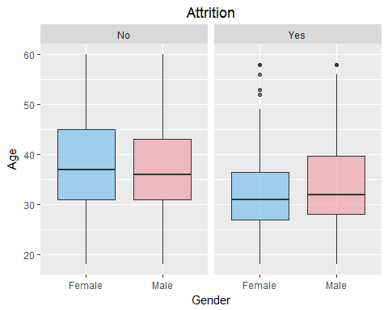

* 从图中可以看出离职情况和年龄是有一定关系的：(1)离职的人年龄普遍较小，这很符合现实，一方面，员工本身进入职场都会在不断更换工作中找到最适合自己的职业，另一方面，公司针对新人群体重视不够，缺乏有效的管理措施，同时，工资待遇是新进员工离职的很大一部分原因，管理、沟通不畅也会导致新员工因为失落感而离职；(2)少部分离职的人年龄极大，本文推测是因为退休导致的离职
* 从图中可以看出离职情况和性别关系是不大的

### 探索Attrition和WorkLifeBalance、DistanceFromHome之间的关系

ggplot(ibm,aes(WorkLifeBalance,DistanceFromHome,color=Attrition))+  
 geom_point(position = 'jitter')+   
 scale_fill_manual(values = c("#7EC0EE","#EEA2AD"))

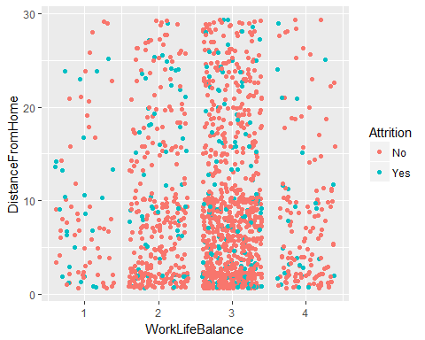

* 从公司到家里距离的以及生活幸福的平衡情况两个维度看，所有离职的数据点基本上是均匀分布的，所以距离和平衡度对离职情况并不产生重要影响
* 图中也反映了一个真实情况，家里距离公司近的员工人数较多

### 探索Attrition与Education、EducationField之间的关系

levels(ibm$EducationField) <- c("HR", "LS", "MRK", "MED", "Oth", "TD")  
p5 <- ggplot(ibm, aes(x = Education, fill = Attrition)) +   
 geom_histogram(stat="count")+scale_fill_manual(values = c("#7EC0EE","#EEA2AD"))+coord_flip()  
p6 <- ggplot(ibm, aes(x = EducationField, fill = Attrition)) +   
 geom_histogram(stat="count")+scale_fill_manual(values = c("#7EC0EE","#EEA2AD"))+coord_flip()  
grid.arrange(p5, p6, ncol = 1, nrow = 2)

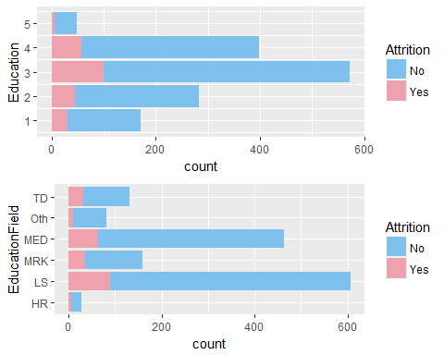

* 从图中可以看到，教育程度和离职情况有一定关系，离职率随着教育程度的不断增加先呈增加再降低的趋势
* 从图中也可以看到，教育研究领域维度中研究Life Sciences的离职率较高，HR和其他领域的离职率较低

### 探索Attrition与JobSatisfaction、RelationshipSatisfaction、EnvironmentSatisfaction之间的关系

s1 <- ggplot(ibm, aes(x = JobSatisfaction, fill = Attrition)) +   
 geom_bar()+scale_fill_manual(values = c("#7EC0EE","#EEA2AD"))  
s2 <- ggplot(ibm, aes(x = RelationshipSatisfaction, fill = Attrition)) +   
 geom_bar()+scale_fill_manual(values = c("#7EC0EE","#EEA2AD"))  
levels(ibm$JobRole) <- c("HC", "HR", "LT", "Man", "MD", "RD", "RS", "SE", "SR")  
s3 <- ggplot(ibm, aes(x = EnvironmentSatisfaction, fill = Attrition)) +   
 geom_bar()+scale_fill_manual(values = c("#7EC0EE","#EEA2AD"))  
grid.arrange(s1, s2, s3, ncol = 3, nrow = 1)

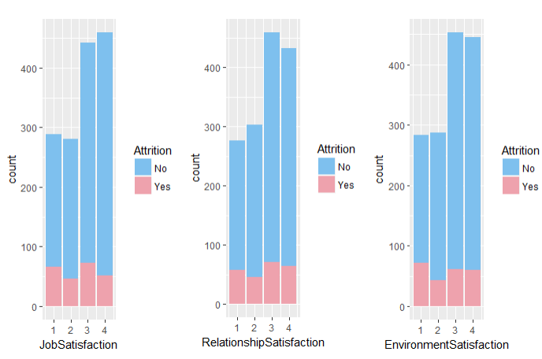

* 从图中可以看出个人对公司内部各方面的满意度并不直接导致离职，离职率不随着满意度上升而降低，因此可以说明人们对IBM公司的满意度高低与是否离职无关

### 探索Attrition与JobInvolvement、JobLevel、JobRole的关系

w1 <- ggplot(ibm, aes(x = JobInvolvement, fill = Attrition)) +   
 geom_bar()+scale_fill_manual(values = c("#7EC0EE","#EEA2AD"))+coord_flip()  
w2 <- ggplot(ibm, aes(x = JobLevel, fill = Attrition)) +   
 geom_bar()+scale_fill_manual(values = c("#7EC0EE","#EEA2AD"))+coord_flip()  
levels(ibm$JobRole) <- c("HC", "HR", "LT", "Man", "MD", "RD", "RS", "SE", "SR")  
w3 <- ggplot(ibm, aes(x = JobRole, fill = Attrition)) +   
 geom_bar()+scale_fill_manual(values = c("#7EC0EE","#EEA2AD"))+coord_flip()  
grid.arrange(w1, w2, w3, ncol = 1, nrow = 3)

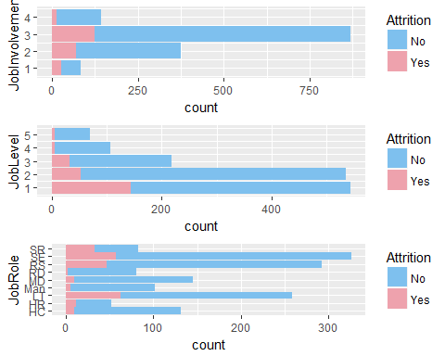

* 工作的参与度情况与离职率没有相关关系
* 工作的层级越高离职数量越少，联系实际，导致这个的原因是：（1）工作层级高的员工基数本身就小，所以离职人数相对来说也会较少；（2）人们在一个公司工作很久已经升上管理层，那么换工作的想法会比较小，相反，底层员工则会不断寻找自己最适合的工作而不断的换岗位
* 从图中可以看到，Sales Executive，Sales Representative，Laboratory Technician离职率较高，这些工作相对来说属于低层级的工作，而Manufacturing Director，Manager，Research Director离职率较低，这些部门主管、经理则是在公司待得比较久的，也和刚才分析的工作层级和离职率的关系相符合

### 探索Attrition与BusinessTravel、Department、OverTime、TrainingTimesLastYear之间的关系

levels(ibm$BusinessTravel) <- c("R", "F", "N")  
levels(ibm$Department) <- c("S", "RD", "HR")  
a1 <- ggplot(ibm, aes(x = BusinessTravel, fill = Attrition)) +   
 geom_bar()+scale_fill_manual(values = c("#7EC0EE","#EEA2AD"))+coord_flip()  
a2 <- ggplot(ibm, aes(x = Department, fill = Attrition)) +   
 geom_bar()+scale_fill_manual(values = c("#7EC0EE","#EEA2AD"))+coord_flip()  
a3 <- ggplot(ibm, aes(x = OverTime, fill = Attrition)) +   
 geom_bar()+scale_fill_manual(values = c("#7EC0EE","#EEA2AD"))  
a4 <- ggplot(ibm, aes(x = TrainingTimesLastYear, fill = Attrition)) +   
 geom_bar()+scale_fill_manual(values = c("#7EC0EE","#EEA2AD"))  
grid.arrange(a1, a2, a3, a4, ncol = 2, nrow = 2)

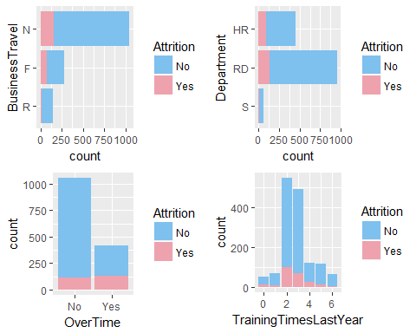

* 左上图中，出差次数越少，离职率越高
* 右上图中，RD部门离职人数较多，但是RD部门的总人数较多，所以也不能说明情况
* 左下图中，是否加班与离职情况有紧密关系，明显加班的人离职率较高
* 右下图中，去年在公司受培训的次数与离职率也没有明显关系

### 探索Attrition与PerformanceRating、StockOptionLevel、PercentSalaryHike之间的关系

ggplot(ibm,aes(PerformanceRating,StockOptionLevel,color=PercentSalaryHike))+  
 geom_point(position = 'jitter')+  
 facet_wrap(~Attrition)+ggtitle("Attrition")

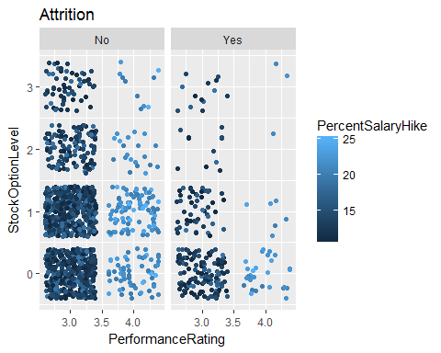

* 从图中可以看出，离职率随StockOptionLevel增长而降低，随PerformanceRating越好而降低

### 探索MonthlyIncome、HourlyRate、DailyRate、MonthlyRate之间的关系

g1<-ggplot(ibm, aes(x = MonthlyIncome, fill = Attrition,  
 alpha = .7)) +geom_density()+scale_fill_manual(values = c("#7EC0EE","#EEA2AD"))  
g2<-ggplot(ibm, aes(x = HourlyRate, fill = Attrition,  
 alpha = .7)) +geom_density()+scale_fill_manual(values = c("#7EC0EE","#EEA2AD"))  
g3<-ggplot(ibm, aes(x = DailyRate, fill = Attrition,  
 alpha = .7)) +geom_density()+scale_fill_manual(values = c("#7EC0EE","#EEA2AD"))  
g4<-ggplot(ibm, aes(x = MonthlyRate, fill = Attrition,  
 alpha = .7)) +geom_density()+scale_fill_manual(values = c("#7EC0EE","#EEA2AD"))  
grid.arrange(g1, g2, g3, g4, ncol = 2, nrow = 2)

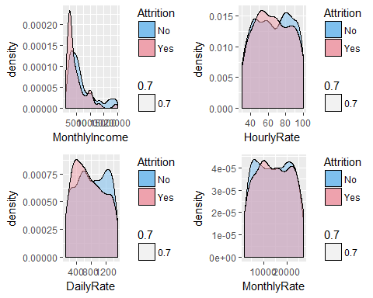

* 从图中可以看出，大部分离开的人月收入和日率相对较低，小时费率和月利率则和离职率没有什么显而易见的关系。

## RandomForest

### 加载需要的包

#install.packages('randomForest')  
#install.packages('party')  
#install.packages('rpart.plot')  
#install.packages('rattle')  
#install.packages('rpart')  
library(randomForest)

library(party)

library(rpart.plot)

library(rattle)

library(rpart)

### 将样本分为80%训练数据，20%测试数据

set.seed(12345)  
ibm<-ibm[c(-9,-10,-22,-27)]  
ins<-sample(2,nrow(ibm),replace = TRUE,prob = c(0.8,0.2))  
trainData<-ibm[ins==1,]  
testData<-ibm[ins==2,]

### 建立随机森林模型

ibm.rf1<-randomForest(Attrition~.,trainData,ntree=500,nPerm=10,mtry=30,proximity=TRUE,importance=TRUE)  
print(ibm.rf1)

##   
## Call:  
## randomForest(formula = Attrition ~ ., data = trainData, ntree = 500, nPerm = 10, mtry = 30, proximity = TRUE, importance = TRUE)   
## Type of random forest: classification  
## Number of trees: 500  
## No. of variables tried at each split: 30  
##   
## OOB estimate of error rate: 14.03%  
## Confusion matrix:  
## No Yes class.error  
## No 961 16 0.01637666  
## Yes 147 38 0.79459459

varImpPlot(ibm.rf1,main='Ranking variable importance that associated with nest site selection of the ibm by Random Forest1')

* 随机森林预测模型的误差率14.03%，模型需要进一步优化

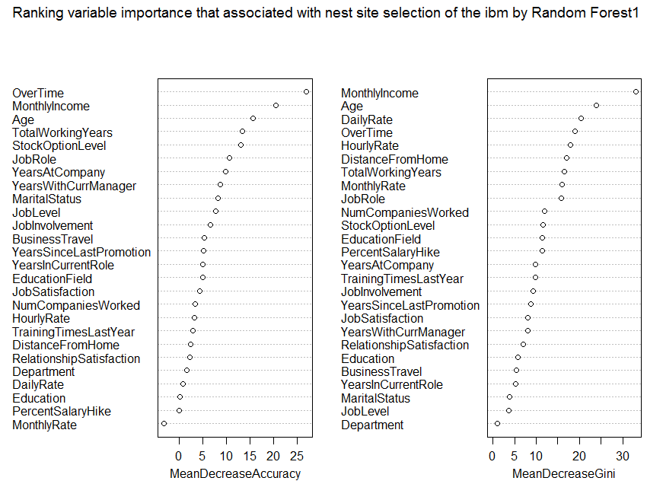

### 画出决策树

dtree1 <- rpart(Attrition ~., data = trainData)  
fancyRpartPlot(dtree1,cex=0.7)

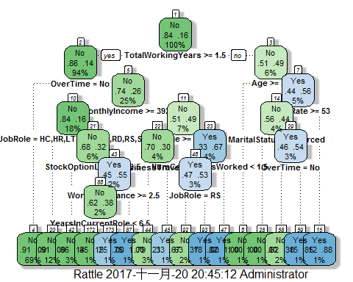

print(dtree1)

## n= 1162   
##   
## node), split, n, loss, yval, (yprob)  
## * denotes terminal node  
##   
## 1) root 1162 185 No (0.84079174 0.15920826)   
## 2) TotalWorkingYears>=1.5 1090 150 No (0.86238532 0.13761468)   
## 4) OverTime=No 798 75 No (0.90601504 0.09398496) *  
## 5) OverTime=Yes 292 75 No (0.74315068 0.25684932)   
## 10) MonthlyIncome>=3924 206 33 No (0.83980583 0.16019417)   
## 20) JobRole=HC,HR,LT,Man,MD,RD,RS,SR 140 12 No (0.91428571 0.08571429) *  
## 21) JobRole=SE 66 21 No (0.68181818 0.31818182)   
## 42) StockOptionLevel>=0.5 37 5 No (0.86486486 0.13513514) *  
## 43) StockOptionLevel< 0.5 29 13 Yes (0.44827586 0.55172414)   
## 86) WorkLifeBalance>=2.5 21 8 No (0.61904762 0.38095238)   
## 172) YearsInCurrentRole< 6.5 13 2 No (0.84615385 0.15384615) *  
## 173) YearsInCurrentRole>=6.5 8 2 Yes (0.25000000 0.75000000) *  
## 87) WorkLifeBalance< 2.5 8 0 Yes (0.00000000 1.00000000) *  
## 11) MonthlyIncome< 3924 86 42 No (0.51162791 0.48837209)   
## 22) Age>=33.5 43 13 No (0.69767442 0.30232558)   
## 44) BusinessTravel=N 34 7 No (0.79411765 0.20588235) *  
## 45) BusinessTravel=R,F 9 3 Yes (0.33333333 0.66666667) *  
## 23) Age< 33.5 43 14 Yes (0.32558140 0.67441860)   
## 46) NumCompaniesWorked< 1.5 30 14 Yes (0.46666667 0.53333333)   
## 92) JobRole=RS 19 7 No (0.63157895 0.36842105) *  
## 93) JobRole=HR,LT,SR 11 2 Yes (0.18181818 0.81818182) *  
## 47) NumCompaniesWorked>=1.5 13 0 Yes (0.00000000 1.00000000) *  
## 3) TotalWorkingYears< 1.5 72 35 No (0.51388889 0.48611111)   
## 6) Age>=33.5 10 0 No (1.00000000 0.00000000) *  
## 7) Age< 33.5 62 27 Yes (0.43548387 0.56451613)   
## 14) HourlyRate>=53 45 20 No (0.55555556 0.44444444)   
## 28) MaritalStatus=Divorced 8 0 No (1.00000000 0.00000000) *  
## 29) MaritalStatus=Married,Single 37 17 Yes (0.45945946 0.54054054)   
## 58) OverTime=No 24 9 No (0.62500000 0.37500000) *  
## 59) OverTime=Yes 13 2 Yes (0.15384615 0.84615385) *  
## 15) HourlyRate< 53 17 2 Yes (0.11764706 0.88235294) *

### 在测试集上测试训练集上建立的随机森林

ibm.pre1<-predict(ibm.rf1,testData)  
prop.table(table(predictd=ibm.pre1, observed=ibm[ins==2,"Attrition"],   
 dnn = c( "Predicted","Actual")),1)

## Actual  
## Predicted No Yes  
## No 0.8671329 0.1328671  
## Yes 0.3636364 0.6363636

* 结果中可以看到，预测的结果和实际差别有点大，需要进行模型优化

### 优化决策模型

ibm.rf2<-randomForest(ibm[,c('Age','BusinessTravel','EducationField','JobInvolvement',  
 'JobLevel','JobRole','JobSatisfaction','MonthlyIncome','NumCompaniesWorked',  
 'OverTime','StockOptionLevel','TotalWorkingYears','YearsAtCompany')],  
 ibm[,'Attrition'],importance = TRUE,ntree=500)  
print(ibm.rf2)

##   
## Call:  
## randomForest(x = ibm[, c("Age", "BusinessTravel", "EducationField", "JobInvolvement", "JobLevel", "JobRole", "JobSatisfaction", "MonthlyIncome", "NumCompaniesWorked", "OverTime", "StockOptionLevel", "TotalWorkingYears", "YearsAtCompany")], y = ibm[, "Attrition"], ntree = 500, importance = TRUE)   
## Type of random forest: classification  
## Number of trees: 500  
## No. of variables tried at each split: 3  
##   
## OOB estimate of error rate: 13.88%  
## Confusion matrix:  
## No Yes class.error  
## No 1204 29 0.02351987  
## Yes 175 62 0.73839662

varImpPlot(ibm.rf2,main='Ranking variable importance that associated with nest site selection of the ibm by Random Forest2')

* 随机森林预测模型优化后的的误差率13.88%，有微小降低，但是仍然很高，需要继续优化

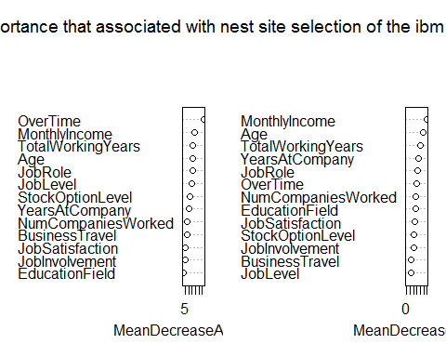

dtree2 <- rpart(Attrition ~Age+BusinessTravel+EducationField+JobInvolvement+JobLevel+  
 JobRole+JobSatisfaction+MonthlyIncome+NumCompaniesWorked+OverTime+  
 StockOptionLevel+TotalWorkingYears+YearsAtCompany, data = trainData)  
fancyRpartPlot(dtree2,cex=0.7)

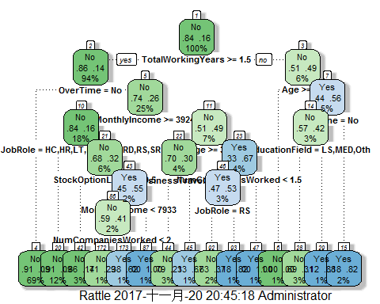

print(dtree2)

## n= 1162   
##   
## node), split, n, loss, yval, (yprob)  
## * denotes terminal node  
##   
## 1) root 1162 185 No (0.84079174 0.15920826)   
## 2) TotalWorkingYears>=1.5 1090 150 No (0.86238532 0.13761468)   
## 4) OverTime=No 798 75 No (0.90601504 0.09398496) *  
## 5) OverTime=Yes 292 75 No (0.74315068 0.25684932)   
## 10) MonthlyIncome>=3924 206 33 No (0.83980583 0.16019417)   
## 20) JobRole=HC,HR,LT,Man,MD,RD,RS,SR 140 12 No (0.91428571 0.08571429) *  
## 21) JobRole=SE 66 21 No (0.68181818 0.31818182)   
## 42) StockOptionLevel>=0.5 37 5 No (0.86486486 0.13513514) *  
## 43) StockOptionLevel< 0.5 29 13 Yes (0.44827586 0.55172414)   
## 86) MonthlyIncome< 7933 22 9 No (0.59090909 0.40909091)   
## 172) NumCompaniesWorked< 2 14 4 No (0.71428571 0.28571429) *  
## 173) NumCompaniesWorked>=2 8 3 Yes (0.37500000 0.62500000) *  
## 87) MonthlyIncome>=7933 7 0 Yes (0.00000000 1.00000000) *  
## 11) MonthlyIncome< 3924 86 42 No (0.51162791 0.48837209)   
## 22) Age>=33.5 43 13 No (0.69767442 0.30232558)   
## 44) BusinessTravel=N 34 7 No (0.79411765 0.20588235) *  
## 45) BusinessTravel=R,F 9 3 Yes (0.33333333 0.66666667) *  
## 23) Age< 33.5 43 14 Yes (0.32558140 0.67441860)   
## 46) NumCompaniesWorked< 1.5 30 14 Yes (0.46666667 0.53333333)   
## 92) JobRole=RS 19 7 No (0.63157895 0.36842105) *  
## 93) JobRole=HR,LT,SR 11 2 Yes (0.18181818 0.81818182) *  
## 47) NumCompaniesWorked>=1.5 13 0 Yes (0.00000000 1.00000000) *  
## 3) TotalWorkingYears< 1.5 72 35 No (0.51388889 0.48611111)   
## 6) Age>=33.5 10 0 No (1.00000000 0.00000000) *  
## 7) Age< 33.5 62 27 Yes (0.43548387 0.56451613)   
## 14) OverTime=No 40 17 No (0.57500000 0.42500000)   
## 28) EducationField=LS,MED,Oth 32 10 No (0.68750000 0.31250000) *  
## 29) EducationField=HR,MRK,TD 8 1 Yes (0.12500000 0.87500000) *  
## 15) OverTime=Yes 22 4 Yes (0.18181818 0.81818182) *

## Gradient Boosting Machines

### 加载需要的包

#install.packages('caret')  
#install.packages('gbm')  
#install.packages('ROCR')  
#install.packages('pROC')  
library(ROCR)

library(pROC)

library(gbm)

library(caret)

### 将响应变量转为0-1格式

data <- ibm[c(-9,-10,-22,-27)]#去掉数值相同，对结果没影响的变量  
data$Attrition <- as.numeric(data$Attrition)  
data <- transform(data,Attrition=Attrition-1)

## 建立模型并预测，求出auc值

model <- gbm(Attrition~.,data=data,shrinkage=0.01,  
 distribution='bernoulli',cv.folds=5,n.trees=3000,verbose=F)  
gbm.predict = predict(model,data)

## Using 2188 trees...

auc(data$Attrition,gbm.predict)

## Area under the curve: 0.8848

* 可以看到模型预测的精确度达到88.48%

### 用交叉检验确定最佳迭代次数

best.iter <- gbm.perf(model,method='cv')

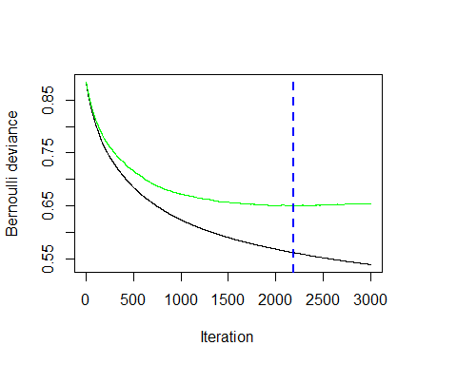

## 观察各变量的重要程度

summary(model,best.iter)

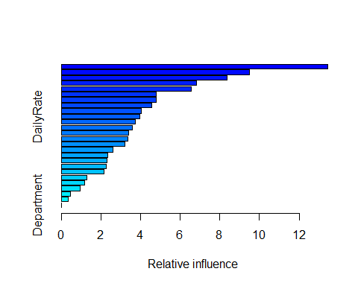

## var rel.inf  
## OverTime OverTime 13.4554665  
## MonthlyIncome MonthlyIncome 9.4844019  
## JobRole JobRole 8.3738137  
## Age Age 6.8159676  
## StockOptionLevel StockOptionLevel 6.5639248  
## TotalWorkingYears TotalWorkingYears 4.8031740  
## NumCompaniesWorked NumCompaniesWorked 4.7993857  
## JobInvolvement JobInvolvement 4.5517174  
## BusinessTravel BusinessTravel 4.0257955  
## DailyRate DailyRate 3.9737030  
## YearsWithCurrManager YearsWithCurrManager 3.7192388  
## DistanceFromHome DistanceFromHome 3.5723627  
## JobSatisfaction JobSatisfaction 3.4075800  
## EducationField EducationField 3.3547052  
## YearsAtCompany YearsAtCompany 3.2044773  
## RelationshipSatisfaction RelationshipSatisfaction 2.6068148  
## JobLevel JobLevel 2.3288474  
## MonthlyRate MonthlyRate 2.3059917  
## YearsSinceLastPromotion YearsSinceLastPromotion 2.2537875  
## TrainingTimesLastYear TrainingTimesLastYear 2.1625711  
## HourlyRate HourlyRate 1.2800840  
## MaritalStatus MaritalStatus 1.1688000  
## PercentSalaryHike PercentSalaryHike 0.9610313  
## Education Education 0.4673412  
## YearsInCurrentRole YearsInCurrentRole 0.3590171  
## Department Department 0.0000000

综上所述，我们认为影响IBM公司员工离职最重要的5个因素是：OverTime、MonthlyIncome、JobRole、Age、StockOptionLevel.因此，我们建议IBM公司可以从以下几个方面进行优化改进从而留住员工：

（1）合理安排工作计划，减少加班频率；

（2）在公司能够财务状况允许的合理范围内尽量为员工增加工资，员工是公司最重要的财富，因此公司应该为留住员工而努力；

（3）职业的选择关乎员工的能力、兴趣等各个方面，这不是公司能够决定的，但是建议公司可以根据现有的离职率较高的职业，对其人员进行合理的关怀，以得打最好的效果；

（4）年龄也是影响人员流动率的一个主要因素，刚进公司的人员离职率较高，建议公司可以在两个方面进行提升：第一，HR方面应该重点关注，是否在招聘时没有找到最合适该岗位的人才，或者将人才用错了地方；第二，公司可以适当地为初进入公司的职员进行相应人文关怀，并配备导师为其进行指导，降低人员的流动率。