**Axial Capacity Prediction of Concrete Filled Stainless Steel Tubular Columns Using Machine Learning Algorithms**

**Course Instructor:**

Dr. Hangzhou Yang

**Teaching Assistants:**

Rhea Zambra

Suarav Uprety

Zelin Zhou

Ananya Vishwanath

**Course:**

ENGG 680: Introduction to Digital Engineering

**Group 3:**

Ishpreet Kapoor - UCID: 30226713

Jasleen Badhesha - UCID: 30042981

Negar Raika - UCID: 30042689

Deep Patel - UCID: 30193207

Anthony Kelly - UCID: 30093084

David Amoah Vervoorn - UCID: 30265659

Pinyi Lin - UCID: 30258334

Max Willms - UCID: 30270049

**Submission Date:** Monday, December 9, 2024

Fall 2024

# ABSTRACT

Concrete-filled stainless-steel tubular (CFSST) columns are preferred over traditional concrete-filled steel tubular (CFST) columns, given their superior corrosion resistance. While extensive experimental and numerical research has been conducted to assess the behaviour of CFSST columns under various loading conditions, accurately predicting their axial capacity remains challenging. The distinct properties of stainless steel compared to carbon steel render the existing design code equations for conventional CFST columns unreliable for predicting the strength of the CFSST columns. The main aim of this study is to leverage machine learning techniques to overcome the limitations of traditional prediction methods and provide a more reliable solution to estimating the axial capacity of CFSST columns. Datasets were compiled to predict axial capacity for rectangular and circular columns. Linear Regression, CatBoost, XGBoost, and RandomForest models were created, with XGBoost performing the best for rectangular columns and CatBoost for circular columns. Our models’ performance provides an accurate way to predict axial capacity compared to industry design codes.

citations?

Take out the below??

The model’s accuracy is evaluated using a range of performance metrics to ensure a comprehensive assessment. These metrics include coefficient of determination (R2), root mean square error (RMSE), mean absolute error (MAE), Nash-Sutcliffe Model (NSE), and Index of Agreement (d).

Mention the ML algorithms used and point out the findings i.e. the best one based on the accuracy metrics mentioned above like RMSE, R2, etc.

To demonstrate the validity and exceptional performance of the top-performing ____________ machine learning model, the predictions/results are then compared against the prediction from the most commonly and widely used design codes around the world.

# TABLE OF CONTENTS

ABSTRACT 2

TABLE OF CONTENTS 3

CERTIFICATE OF WORK 4

INTRODUCTION 5

Background 5

Comparison between CFSST and Conventional CFST 5

Literature Review 6

Research Gaps 7

OBJECTIVES 8

METHODOLOGY 8

Dataset 8

Libraries Implemented 9

Model Selection 9

Pre-Processing: Stratifying the Data 10

Correlation of the Four Chosen Models 10

RESULTS 11

Evaluation Metrics 11

Linear Regression 11

Random Forest 11

XGBoost Regressor 11

CatBoost Regressor 11

Overall Model Performance 12

DISCUSSION 13

Model Performance and Fitting 13

Comparison of ML Model Results with Existing Design Code Equations 13

Feature Correlation Analysis 14

CONCLUSION 15

APPENDIX 1: TABLES 16

APPENDIX 2: FIGURES 20

APPENDIX 3: EQUATIONS 26

REFERENCES 29

DATABASES 31

# CERTIFICATE OF WORK

*We, the undersigned, certify that this is our own work, which has been done expressly for this course, either without the assistance of any other party or where appropriate we have acknowledged the work of others. Further, we have read and understood the section in the university calendar on plagiarism/cheating/other academic misconduct and we are aware of the implications thereof. We request that the total mark for this assignment be distributed as follows among group members:*

| **First Name** |  | **Last Name** | **Signature**  **(Full Name, Date)** | **Hours** | **Contribution %** |
| --- | --- | --- | --- | --- | --- |
| Jasleen |  | Badhesha | Jasleen Badhesha December 9, 2024 | 12 | 12.5% |
| Negar |  | Raika | Negar Raika December 9, 2024 | 12 | 12.5% |
| Deep |  | Patel | Deep Patel December 9, 2024 | 12 | 12.5% |
| Ishpreet |  | Kapoor | Ishpreet Kapoor December 9, 2024 | 12 | 12.5% |
| Anthony |  | Kelly | Anthony Kelly December 9, 2024 | 12 | 12.5% |
| Max |  | Willms | Max Willms December 9, 2024 | 12 | 12.5% |
| David |  | Amoah Vervoorn | David Amoah Vervoorn December 9, 2024 | 12 | 12.5% |
| Pinyi |  | Lin | Pinyi Lin December 9, 2024 | 12 | 12.5% |

# INTRODUCTION

## Background

Stainless steel has seen increasing adoption in the construction industry in recent years, due to its enhanced performance characteristics like superior durability [1], corrosion resistance [2], and fire resistance [3] compared to traditional carbon steel. It also provides greater strength-to-weight ratios, allowing for more efficient structural designs [4]. Associated costs with the material have been the biggest challenges in its wider adoption. To address this, engineers came up with an innovative approach to offset its higher initial cost by filling the hollow tube with concrete to take advantage of both materials compensating for each other’s weaknesses [5]. The resulting composite system is called Concrete-Filled Stainless-Steel Tubes (CFSST). This technique offers several benefits, such as increased load-bearing capacity, reduced overall production costs, and the composite action of steel and concrete. This approach allows designers to leverage the superior properties of stainless steel while mitigating some of the cost concerns, especially as an axially loaded compression member, potentially expanding its applicability in construction projects.

While CFSST columns may have a higher upfront cost, they offer substantial advantages when considering the total life cycle expenses of a project. This long-term perspective reveals their cost-effectiveness over time, potentially outweighing the initial investment. CFSST can be designed with smaller cross-sections while maintaining equivalent or superior strength. This feature allows for more efficient use of space within structures. These combined attributes make CFSST columns an attractive option for architects and engineers seeking to balance structural performance, long-term cost-effectiveness, and design aesthetics in their projects [6].

## Comparison between CFSST and Conventional CFST

Conventional Concrete-Filled Steel Tubular (CFST) Columns have been widely used in construction due to their balance of strength, cost-effectiveness, and ease of fabrication for quite some time now and have proved their usefulness in high-rise buildings and industrial facilities, especially in high seismic zones, where the composite behaviour of steel and concrete provides excellent load-bearing capacity and ductility. However, they require regular maintenance to prevent corrosion in harsher environments, and the application of CFST columns has been limited to regions with moderate conditions. To address this issue, engineers investigated replacing carbon steel with stainless steel, resulting in the development of Concrete-Filled Stainless-Steel Tube (CFSST) Columns. A comparison of their properties, advantages, disadvantages, and typical applications is provided (Table 1).Stainless steel fixes most of the flaws of steel as a material making it more advantageous to use over conventional CFST Columns. Therefore, CFSST is now increasingly used in specialized applications where durability and corrosion resistance are essential, such as in marine and coastal environments, high-end architectural projects, and infrastructure in industrial or pollutive areas.

## Literature Review

Over the last two decades, the exceptional performance of Concrete Filled Stainless Steel Tubular (CFSST) columns has sparked significant interest in the research community, leading to many experimental and numerical studies [5], [7], [8], [9]. This has led to our comprehensive understanding of Concrete-Filled Stainless-Steel Tubular (CFSST) columns. Key findings from the following studies are:

1. **Uy et al. [6]:** Uy et al. tested 117 short and slender CFSST columns, showing that existing design codes like AS 5100 [10], AISC 360-16 [11], DBJ/T [12] and EC4 [13] generally provide conservative estimates for axial capacities for both short and slender columns.
2. **He and Zhao [14]:** He and Zhao examined 18 circular CFSST specimens under partial and full loading, concluding that current design standards (EC4 and AISC 360-16) yield conservative results compared to experimental data.
3. **Lam and Gardner [15]:** Lam and Gardner's study on circular and square CFSST sections with concrete strengths ranging from 30 to 100 MPa showed that code provisions, especially for circular columns, were overly conservative.
4. **Young and Ellobody [16]:** Young and Ellobody's experiments on high-strength cold-formed stainless steel tubes with concrete with compressive strength ranging from 40 to 80 MPa demonstrated that code equations' accuracy varied depending on specimen type but still were quite conservative.
5. **Dai et al. [17]:** Dai et al.'s study on 18 CFSST columns comprising 9 having an austenitic shell and 9 with duplex stainless-steel shell under compression revealed that both European and Chinese codes underestimated axial resistance, leading them to propose and develop new analytical methods for strength prediction for both austenitic and duplex CFSST columns.
6. **Guo et al. [18] and Li et al [19]:** Proposed new formulations to more accurately estimate the axial load-carrying capacity of stainless-steel tubular stub columns, addressing the limitations of existing design codes.

On the machine learning front, there has been extensive development in academia to explore the application of data-driven approaches for the strength prediction of conventional CFST Columns [20], [21], [22], [23] [24]. Various machine learning algorithms were employed to analyze and predict axial capacity using the available dataset. The algorithms tested most included:

* Back-propagation neural network (BPNN)
* Radial basis function neural network (RBFNN)
* Gaussian process regressor (GPR)
* Multiple linear regression (MLR)

Their performance was then evaluated against established design codes, specifically AISC-360 and EC-4. It was noted based on the multiple error evaluation criteria like coefficient of determination (R2), root mean square error (RMSE), etc. that data-driven approaches, especially advanced algorithms like GPR predicted the axial capacity with much better accuracy than existing design standards. In addition to this Vu et al. [22], Lee et al. [23], Ngo et al. [25] explored the use of advanced ML algorithms like gradient tree boosting (GTB), categorical gradient boosting (CATBoost), Additive Random Forests (ARF), and Artificial Neural Networks (ANNs) for predicting CFST axial capacity. Tables 2-6 highlight the performance metrics and accuracy scores of different ML models tested in each study. These studies conclude that Machine Learning can be considered an effective alternative approach and may offer a valuable complement or alternative to existing design code calculations, potentially leading to more efficient and reliable structural designs.

## Research Gaps

De Carvalho et al. [26] and V-Linh Tran et al. [27] have explored this approach for CFSST in the past. De Carvalho et al. used ANN and Random Forest algorithms to develop the machine learning model. However, there are a few downsides to their study, the biggest of which is that their data set only comprises a circular section, and data points have been taken from the numerical study instead of real experimental data. This is not wrong per se but can be subjected to the modelling inaccuracies associated with Finite Element Modeling. V-Linh Tran on the other hand used multiple machine-learning algorithms like RF, KNN AdaBoost, GNRT, and XGBoost trained on the 142 data samples of circular CFSST Columns. They found that XGBoost provides the best accuracy based on the R2 measurement.

Both studies were limited by the number of data points and the lack of diversity in the dataset on which the model has been trained. These two studies focused only on circular sections, leading to a narrow dataset that lacks diversity in cross-sectional shapes which is not representative of a variety of the configurations used in practice. To address these limitations, our study expands upon prior work by incorporating a broader variety of CFFST column sections, including both rectangular and circular shapes, and by increasing the dataset to 422 data points. This comprehensive dataset allows for more accurate and generalizable ML predictions of column strength across various section geometries.

In addition to this, the current state of research reveals a significant gap in the field of Concrete-Filled Stainless-Steel Tubular (CFSST) columns:

1. It can be noted across all the aforementioned different studies that the applicability of the various proposed analytical models for the prediction of the axial strength of CFSST requires different input parameters that vary quite widely based on the geometric shape and the grade of the material used.
2. Extensive machine learning (ML) studies have been conducted on Concrete-Filled Steel Tubular (CFST) columns. However, there is a notable absence of data-driven prediction models specifically tailored for CFSST columns in the existing literature.
3. Previous research has highlighted limitations in the current codified equations for CFSST columns:
   1. These equations tend to produce overly conservative estimates.
   2. They often fail to accurately predict the axial capacity of CFSST columns.
4. A critical shortcoming in applying conventional CFST column equations to CFSST columns is that it does not account for the strain-hardening behaviour of stainless steel. This omission is particularly significant as strain hardening is a crucial component affecting the performance of CFSST columns.

To come up with the one-size-fits-all approach for strength prediction of CFFST Columns that accurately address these inconsistencies and uncertainties while applying to a wide range of configurations, the data-driven approach based on a large amount of the open experimental database is explored in this study.

# OBJECTIVES

This research aims to create a robust model that improves prediction accuracy and addresses limitations in existing design equations for Concrete-Filled Stainless-Steel Tubular (CFSST) columns. The study's key objectives are:

* **Database Development:** Compile a comprehensive database from available literature to serve as a foundation for the analysis.
* **Parameter Identification:** Determine the most influential factors affecting the axial capacity of CFSST columns.
* **Development of the Machine Learning Models:** Mention all the ML models being tested in this study.
* **Model Comparison:** Evaluate the accuracy of newly developed Machine Learning (ML) models against current design codes using metrics like RMSE, R2, etc.
* **Result Interpretation:** Utilize Shapley Additive explanations (SHAP) to elucidate the relationship between input parameters and predicted outcomes.

By addressing these objectives, the study aims to provide a more accurate and practical approach to CFSST column design and analysis, bridging the gap between theoretical models and real-world applications. Using ML models, it is possible to avoid costly and time-consuming experimental work.

# METHODOLOGY

## Dataset

A reliable database is essential for developing dependable prediction models and identifying the key factors influencing prediction accuracy. A comprehensive dataset was compiled from multiple peer-reviewed journals and open dissertation papers describing their experimental findings based on the studies conducted in the past. In this project, a total of 422 data points have been gathered and are evenly divided between circular and rectangular Concrete-Filled Stainless-Steel Tubular (CFSST) columns, with 211 datasets for each type. This extensive compilation is the foundation for the study's analysis and model development. This study aims to develop a reliable machine learning (ML) model for predicting the axial capacity of Concrete-Filled Stainless-Steel Tubular (CFSST) columns using a data-driven approach. The model's output is the axial compression capacity (N_Test) measured in kilonewtons (kN).

The features we used to predict axial capacity in our models are:

1. Column length (L, mm)
2. Tube thickness (t, mm)
3. Stainless steel proof stress (f0.2, MPa)
4. Stainless steel ultimate strength (fu, MPa)
5. Stainless steel elastic modulus (Eo, MPa)
6. Strain hardening component (n)
7. Concrete compressive strength (f’c, MPa)
8. Column diameter (D, mm) for circular sections
9. Cross-section width (B, mm) and height (H, mm) for rectangular sections

## Libraries Implemented

Various libraries were used to set up and run the four different machine learning models. Pandas and Numpy were used for all data manipulation. MatplotLib and Seaborn were used to visualize the results for each model. Libraries from Scikit-learn were implemented to evaluate the model performance, split up the data into training and testing datasets, and prepare the data for the machine learning models. The error metrics implemented were Mean-Squared Error, R2 Score, and Mean Absolute Percentage Error. The Train Test Split library was used specifically to divide the dataset for either training the model or testing the model. The scalers used were Standard Scaler, Robust Scaler, and Polynomial Features. Pipeline was also implemented to streamline the overall workflow. Finally, GridSearchCV was used to find the best hyperparameters to use for each machine learning model.

## Model Selection

A total of four different machine learning models were used for analysis in this project, and the libraries for each of these models was used. These models are Linear Regression, Random Forest Regressor, XGB Regressor, and Catboost Regressor.

**Linear Regression**

The Linear Regression machine learning model assumes a linear relationship between the feature variables (input) and target variable (output) (Equation 1). The model has a risk of being inaccurate because of the assumption of a linear relationship between features, therefore the model isn’t capable of dealing with non-linear relationships. This is predicted to produce a model that is underfit.

**Random Forest Regressor**

The Random Forest Regressor model combines multiple decision trees, which makes it an ensemble method, which should reduce overfitting (Equation 2). The hyperparameters to tune for this model are the number of trees, the depth of each tree, the minimum number of samples required to split a node, and the maximum number of features to be considered for a split. This model risks underfitting if there aren’t enough trees or the trees aren’t deep enough. Conversely, the model could produce an overfit result if the trees are too deep or there is too much noise within the data. The Random Forest Regressor model is also more computationally extensive than the Linear Regression model, so training the data can take longer.

**XGBoost Regressor**

The XGBoost Regressor is a type of gradient boosting algorithm that has been optimized that create trees by building off of previous ones. It first minimizes the Loss L by using gradient descent (Equation 3). Then, each newly created tree will correct errors in trees before it by using the general gradient boosting equation (Equation 4). There is overfitting protection due to regularization, and it is able to handle non-linear relationships, unlike Linear Regression. The hyperparameters to tune for the XGBoost Regressor model are the number of boosting rounds, the size of each iteration step, how deep the trees are, and which percentage of data to be used in each boosting round. The model has a risk of underfitting if the learning rate is too high or the trees are too shallow. Overfitting may occur if there are too many rounds of boosting or the learning rate is too small without regularization.

**CatBoost Regressor**

The CatBoost Regressor builds an ensemble of decision trees, similar to the Random Forest Regressor. Similar to XGBoost Regressor, it incorporates the Loss Function to minimize loss using gradient descent (Equation 3). The general gradient boosting is similar to XGBoost (Equation 4).

The CatBoost Regressor model also uses a lot of memory compared to Linear Regression and Random Forest Regressor models. The primary advantage of the CatBoost Regressor over XGBoost is that there are fewer hyperparameters to tune. Another difference between the two models is that CatBoost Regressor uses symmetric decision trees as opposed to the asymmetric tree structure of XGBoost. Another key difference between the models is that Catboost utilizes ordered boosting to help prevent overfitting and generalizing the data too much.

This model does still have a chance to produce an overfit model if there are too many iterations, the trees are too deep, and the learning rate is too low. The model risks producing an underfit result if the boosting iteration number is too low, the trees are too shallow, or the learning rate is set too high.

## Pre-Processing: Stratifying the Data

For all four machine learning models (Linear Regression, Random Forest Regressor, XGBoost Regressor, and CatBoost Regressor) the data was stratified using the train_test_split function. The models used 80% of the data to train the model, and the other 20% to test the model.

## Correlation of the Four Chosen Models

All models (Linear Regression, Random Forest Regressor, XGBoost Regressor, and CatBoost Regressor) aim to optimize and minimize the error by using the loss function (Equation 3). Since all models have the same goal, the results should be somewhat similar. The models also use the same input features, and if some of these features are good predictors all four models will rely on them to generate their results. The Random Forest Regressor, XGBoost Regressor, and CatBoost Regressor all rely on ensemble tree-based models which help them each complex non-linear relationships within the data, so these results should be correlated with each other. Finally, the models all use 80% of the data for training and the other 20% for testing, and all four models use a random state of 42, so the data used for training and testing is the same for each of the models.

# RESULTS

## Evaluation Metrics

For this project, we decided to create Linear Regression, Random Forest Regression, XGBoost, and CatBoost models to handle both our Rectangular and Circular datasets which resulted in the construction of eight models. We evaluated the performance of these models based on Mean Square Error (Equation 5), R2 (Equation 6), and Mean Absolute Percent Error (Equation 7). We also used plots representing the predicted vs actual axial capacities of the testing set for each model.

The three error metrics were used to determine model accuracy and whether the model was underfitting or overfitting. Our primary evaluation metric was R2 for our grid search results. This decision was made because R2  is the easiest to compare between models, especially since our rectangular dataset and circular dataset contain different numbers and types of features. These error metrics were applied to the best results from our grid searches.

## Linear Regression

For the rectangular columns, our Linear Regression Model had a R2 value of 0.944 during training, and a R2 value of 0.923 during testing (Table 8). For circular columns, the R2 values were lower than they were with rectangular columns, achieving values of 0.909 during the training phase and 0.812 for the testing phase (Table 9).

## Random Forest

Random Forest Regressor had R2 values of 0.99 during the training phase and 0.95 for the testing phase for rectangular columns (Table 8). For circular columns, these values increased, as the R2 values were 1.00 and 0.99 for training and testing respectively (Table 9).

## XGBoost Regressor

XGBooost regressor had R2 values of 0.999 in the training phase and 0.952 in the testing phase for the rectangular columns (Table 8). For circular columns, performance in the testing phase remained the same, as seen by the R2 values of 0.999. Performance also increased in the testing phase, with R2 values of 0.978 (Table 9).

## CatBoost Regressor

For rectangular columns, the CatBoost Regressor had R2 values of 0.996 for the training phase and 0.950 during testing (Table 8). The R2 values increased for circular columns, with scores of 0.998 and 0.990 for testing and training respectively (Table 9). Catboost was the best-performing model for circular columns, achieving the highest R2 values.

## 

## Overall Model Performance

We determined that for the rectangular dataset, the XGBoost and the Random Forest Regressor did the best job of minimizing the change in magnitude of the error between training and testing. Along with the error metrics we mentioned that we also generated plots based on the predicted values. Using the error metric results and the visualized final predictions of the models, we can see that for the rectangular data set the XGBoost model was our best performing model due to its ability to reduce the magnitude and number of over predictions, making it suitable for predicting the axial capacity of rectangular columns.

The top-performing models for the circular dataset were more obviously determined to be the Catboost and the Random Forest Regressor. The CatBoost model performed the best as it minimized the magnitude and the number of over predictions as seen in their respective figures. Overall the circular CatBoost was the best-performing model among all eight that we evaluated, as it minimized change in error between the training and testing set while also providing one of the best fits for the plot. In the remaining three models for the circular dataset, we see an inverse in performance with the XGBoost now in the third place spot and the CatBoost as our top performer.

Comparing the datasets, there are only four features in the circular dataset with a correlation above a value of 0.4, compared to the six found within the rectangular dataset. Because of this, we believe the slightly less complex model in the CatBoost performed best for the circular dataset. Looking at each dataset individually, the Linear Regression model is the worst performing for both the rectangular and circular datasets. This was expected, as Linear Regression is a simpler model and was primarily used as a baseline to compare against more complex models. As seen in the plots in figures 1 through 8, we have the x-axis set to display the actual axial capacity while the y-axis represents the model's predicted axial capacity. There is also an x = y line running through the middle of each plot, this line would represent a perfect fit, but we are also using this line to help determine the best-fitting model. Since we are using these models to predict the strength of columns, we also need to consider safety concerns. This means we would much rather have a model that underpredicts the axial capacity rather than overpredicts the overall strength.

Considering this, we examined the plots for the Random Forest Regressor and XGBoost for the rectangular dataset, and the Random Forest Regressor and CatBoost for the circular dataset. These four models represent the top two performers for each of the rectangular and circular datasets. Using both the error metric results and the visualized final predictions of the models, we can confirm that for the rectangular dataset, the XGBoost model was our best performing model and for the circular dataset it was the CatBoost model as they both minimized the magnitude and the number of overpredictions seen in their respective figures. Among all eight models, the circular CatBoost stood out as the overall best, as it minimized the error between training and testing and provided the most accurate fit in the plots.

# DISCUSSION

## Model Performance and Fitting

Our models produced overfits for both our rectangular and circular datasets, with the exception of Linear Regression, as can be seen by the difference in R2 scores of training and test sets (Table 8, Table 9). It was expected that Linear Regression would produce an underfit, demonstrated by the decreasing R2 value between the training and test sets. This model is too simple for our complex dataset and was used as a baseline measure of model performance.

XGBoost and CatBoost were our top performing models for rectangular and circular sections respectively, as established by their ability to maintain a high R2 value in both test and training sets (Table 8, Table 9). Additionally, both models were able to slightly underestimate axial capacity making them the ideal model for real-world applications (Figure 6, Figure 7). Despite their high performance, the models are overfitting. Both had a near perfect R2 value in the training set, which then dropped in the test sets. This indicates that the models may be memorizing the dataset, making them less accurate when exposed to the testing datasets.

## Comparison of ML Model Results with Existing Design Code Equations

The consequences of incorrectly predicting axial capacity are very dangerous. If it is underestimated, there are many safety concerns such as the risk of buildings collapsing. Underestimating capacity can increase financial burdens, as more materials would be needed to complete the same construction project. Therefore, it is important to compare our top performing models to the current industry standards.

To evaluate our top performing models’ accuracy, their results were compared against three established design code provisions: the American Institute of Steel Construction (AISC) [11], Eurocode 4 [13], and the Canadian Standards Association (CSA) [28] (Equations 8, 9, and 10). To calculate the accurate capacities, the resistance factors have been taken as 1 to rule out any intended conservatism from the picture. It is important to note that since there are no specific codes for stainless steel, equations for conventional CFST columns were applied.

Code equations generally yield less accurate results for several reasons:

1. Input Restrictions: Many codes have limitations on input values, particularly for material strengths.
2. Exclusion of High-Strength Materials: Some codes, such as EC4, do not account for high-strength materials in their equations.
3. Steel Yield Strength Limitations: In some codes, the maximum steel yield strength (fy) is capped at 460 MPa.

Our XGBoost and CatBoost models were able to minimize the mean percent error when compared to the three design codes (Table 10). This means our predictions are closer to the expected axial capacity values, demonstrating our models’ improved accuracy. This difference could result from our model providing a more comprehensive evaluation of axial capacity, enabling it to handle scenarios beyond the limitations of standard equations. This inclusivity and robustness ensure consistent performance across a diverse range of conditions, making our model a practical and superior alternative to traditional industry practices.

## Feature Correlation Analysis

When investigating the possible reasons our models were producing overfits, we explored how our features may be correlated with one another. Correlation Analysis is a statistical method that quantifies the relationship between two variables. The Pearson correlation coefficient (r) indicates the strength and direction of this relationship, with values near 1 suggesting a strong positive correlation, those close to 0 indicating a weak correlation, and values approaching -1 signifying a strong negative correlation.

We found that for rectangular sections, thickness proves to be the dominant feature, giving a correlation coefficient of 0.86 (Figure 9). Height and width rank as the second and third most significant parameters, with r values of 0.73 and 0.66, respectively. For circular sections, thickness is the most influential dimension, with a correlation coefficient (r-value) of 0.85 (Figure 10). Diameter and length follow as the second most important features, both with r values of 0.84. These trends are further supported by the distributions of key geometric parameters (Figure 11, Figure 12). There is a high variability in thickness, height, width, and diameter, reflecting their influence on the correlation results. The concentrated distributions of these dominant features suggest their strong contribution to structural capacity across the dataset.

Including these correlated features in our machine learning models will specifically help by improving the model's ability to capture the complex interactions between input parameters and the target variable. By including these features, the models can account for their combined influence, which reflects the physical relationships inherent in structural behaviour. These correlated features reduce the reliance on less important or noisy features, enabling the model to focus on the dominant factors that drive predictions. Additionally, by capturing these dominant relationships, the model is less likely to overfit to minor fluctuations or noise in the data because its predictions are grounded in the most influential and meaningful parameters.

# CONCLUSION

This study demonstrated the superior predictive capabilities of machine learning models for axial capacity estimation in CFSST columns. In particular, XGBoost and CatBoost models achieved the highest accuracy for rectangular and circular columns, respectively, as validated by evaluation metrics like MSE, R2, and MAPE. The application of comprehensive error metrics provided an in-depth assessment of model accuracy. Compared to traditional methods, the ML models showcased reduced error margins and higher consistency, affirming their effectiveness for structural design applications. These results highlight the potential of data-driven approaches to outperform traditional design codes in accuracy and reliability.

Our developed ML models achieved great accuracy but it's important to acknowledge their limitations and areas for future improvement. Our study focuses solely on concentrically loaded short and medium-height columns subjected to the availability of the dataset. Parameters like residual stresses, imperfections, and confinement of concrete were not incorporated into the ML models. These limitations highlight the need for continued research to develop more robust and versatile models for accurate axial capacity prediction in CFSST columns.

To improve model performance, future studies could develop experimentally validated numerical models covering a broader range of parameters to enrich the current dataset. Including large cross-sectional sizes and slender columns to enhance the database for ML-based axial capacity prediction would also be beneficial to increase the scale of impact. Finally, creating more comprehensive models that account for previously omitted factors, such as feature correlations, and a wider variety of loading conditions would improve model performance. By addressing these gaps, we can ultimately lead to more reliable and widely applicable prediction tools for structural engineering applications

# APPENDIX 1: TABLES

**Table 1:***Comparison between Concrete Filled Steel Tubes (CFSTs) and Concrete Filled Stainless Steel Tubes (CFSSTs). Green highlighting indicates the more advantageous material.*

| **Aspect** | **Concrete-Filled Steel Tube (CFST)** | **Concrete-Filled Stainless-Steel Tube (CFSST)** |
| --- | --- | --- |
| **Material Composition** | Carbon steel tube filled with concrete | Stainless steel tube filled with concrete |
| **Corrosion Resistance** | Moderate; needs additional protection (e.g., coatings) | High; stainless steel provides excellent corrosion resistance |
| **Cost** | Generally lower than CFSST | Higher due to stainless steel material costs |
| **Strength and Ductility** | High strength with good ductility | Higher strength and enhanced ductility due to stainless steel |
| **Fire Resistance** | Improved fire resistance due to concrete infill but lower than CFSST | Enhanced fire resistance as stainless steel resists oxidation and thermal degradation better |
| **Load-bearing Capacity** | High axial and flexural strength | Typically, higher than CFST due to the higher yield strength of stainless steel |
| **Durability** | Susceptible to corrosion if not protected | Highly durable in harsh environments (marine, industrial) due to corrosion resistance |
| **Maintenance Requirements** | Regular maintenance to prevent corrosion | Low maintenance due to the inherent corrosion resistance of stainless steel |
| **Aesthetic Appeal** | Requires finishing or painting for aesthetics | Stainless steel offers a modern, polished appearance; often used in visible structures |
| **Environmental Impact** | Lower environmental impact than stainless steel | Higher due to the energy-intensive production of stainless steel |
| **Thermal Conductivity** | Higher thermal conductivity than stainless steel | Lower thermal conductivity, potentially improving fire performance |
| **Common Applications** | Bridges, industrial buildings, seismic applications | Marine structures, high-end buildings, coastal bridges, corrosive environments |
| **Life Cycle** | Shorter life cycle in corrosive environments | Longer life cycle with reduced need for repairs/replacement |
| **Sustainability** | Easier to recycle but requires a protective coating | Stainless steel is highly recyclable and durable but more resource-intensive |

**Table 2:***Machine Learning Model Performance Metrics from Cakiroglu et al.*

| **Cakiroglu et al. [20]** | | | | |
| --- | --- | --- | --- | --- |
| **ML Model Parameter** | **RMSE (kN)** | **R2** | **MAPE (%)** | **MAE (kN)** |
| **XGBoost** | 93.4 | 0.986 | 4.3 | 74.5 |
| **LightGBM** | 198.1 | 0.935 | 7.2 | 141.3 |
| **Random Forest** | 148.9 | 0.963 | 3.4 | 80.7 |
| **CatBoost** | 193.1 | 0.938 | 7.8 | 157.4 |
| **Best Model** | **XGBoost** | | | |

**Table 3:***Machine Learning Model Performance Metrics from Hou & Hou.*

| **Hou & Zhou [21]** | | | | | | |
| --- | --- | --- | --- | --- | --- | --- |
| **ML Model/ Parameter** | **R2** | **MAE (kN)** | **RMSE (kN)** | **MAPE (%)** | **MEAN** | **COV** |
| **Genetic Algorithm Back-Propagation Neural Network** | 0.983 | 178.39 | 306.856 | 9.98 | 0.999 | 0.148 |
| **Radial Basis Function Neural Network** | 0.977 | 200.29 | 346.641 | 10.34 | 1.001 | 0.139 |
| **Gaussian Process Regression** | 0.986 | 136.55 | 270.308 | 6.99 | 0.996 | 0.097 |
| **Multiple Linear Regression** | 0.954 | 254.18 | 486.357 | 21.80 | 0.880 | 0.676 |
| **Best Model** | **GPR** | | | | | |

**Table 4:***Machine Learning Model Performance Metrics from Viet Vu et al.*

| **Viet Vu et. al. [22]** | | | |
| --- | --- | --- | --- |
| **ML Model /Parameter** | **MSE (kN)** | **R2** | **R-2** |
| **Gradient Tree Boosting** | 0.00000453 | 0.9989 | 0.9989 |
| **Random Forest** | 0.00023600 | 0.9711 | 0.9696 |
| **Support Vector Machines** | 0.00023800 | 0.9650 | 0.9632 |
| **Decision Tree** | 0.00025000 | 0.9635 | 0.9616 |
| **Deep Learning** | 0.00007520 | 0.9884 | 0.9878 |
| **Best Model** | **GTB** | | |

**Table 5:***Machine Learning Model Performance Metrics from S. Lee et al.*

| **S. Lee et al. [23]** | | | | |
| --- | --- | --- | --- | --- |
| **ML Model Parameter** | **R2** | **MSE (kN)** | **RMSE (kN)** | **MAE (kN)** |
| **CatBoost** | 0.981 | 43428.23 | 190.032 | 98.119 |
| **Classification and Regression Tree** | 0.920 | 162416.92 | 362.688 | 152.579 |
| **AdaBoost** | 0.950 | 126628.76 | 316.854 | 208.387 |
| **Gradient Boosting** | 0.966 | 61777.21 | 226.751 | 100.316 |
| **Random Forest** | 0.957 | 128965.34 | 312.323 | 158.732 |
| **XGBoost** | 0.976 | 49058.14 | 202.280 | 105.445 |
| **LightGB** | 0.962 | 66739.86 | 240.303 | 118.770 |
| **Neural Network** | 0.949 | 203086.50 | 361.436 | 190.276 |
| **Support Vector Machines** | 0.911 | 157703.82 | 338.940 | 186.258 |
| **Best Model** | **CatBoost** | | | |

**Table 6:***Machine Learning Model Performance Metrics from Tri Ngo et al.*

| **Tri Ngo et at. [24]** | | | |
| --- | --- | --- | --- |
| **ML Model Parameter** | **R** | **MAE (kN)** | **MAPE (%)** |
| **Additive Random Forest** | 0.98 | 211.31 | 6.39 |
| **Artificial Neural Networks** | 0.98 | 610.44 | 40.26 |
| **Best Model** | **Additive Random Forest** | | |

**Table 7:** *Mean and Standard Deviation for Input Parameters.*

| **Input** | **Circular Columns** | | **Rectangular Columns** | |
| --- | --- | --- | --- | --- |
|  | **Mean** | **SD** | **Mean** | **SD** |
| *D (mm)* | 134.2 | 68.7 | - | - |
| *t (mm)* | 3.5 | 2.2 | 3.8 | 2.0 |
| *H (mm)* | - | - | 120.9 | 41.5 |
| *B (mm)* | - | - | 124.7 | 44.5 |
| *L (mm)* | 399.9 | 205.5 | 377.6 | 122.6 |
| *L/B* | - | - | 3.2 | 0.8 |
| *L/D* | 3 | 0.5 | - | - |
| *E*o (MPa) | 196780.3 | 7491.6 | 199730.0 | 6793.5 |
| *f*0.2 (MPa) | 324.5 | 72.2 | 433.1 | 101.1 |
| *f*u (MPa) | 692.0 | 58.9 | 674.7 | 120.9 |
| *n* | 6.0 | 1.7 | 6.3 | 2.0 |
| *f*c*’ (*MPa*)* | 52.1 | 29.1 | 48.0 | 20.6 |

# 

**Table 8a:***Error Results for the Rectangular Models Training*

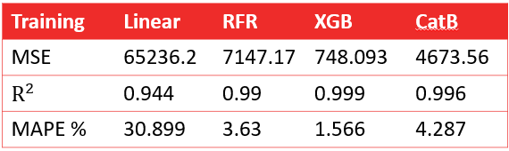

**Table 8b:** *Error Results for the Rectangular Models Testing*

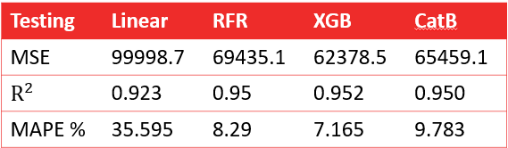

**Table 9a:***Error Results for the Circular Models Training*

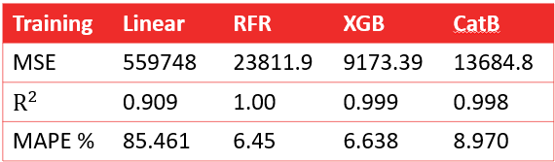

**Table 9b:** *Error Results for the Circular Models Testing*

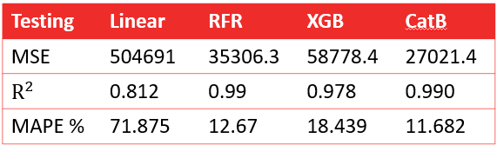

**Table 10:** *Minimum, maximum, and mean error (%) of our top performing models (XGBoost for Rectangular columns; CatBoost for Circular Columns) compared to existing design code equations from CSA, AISC, and Eurocode 4.*

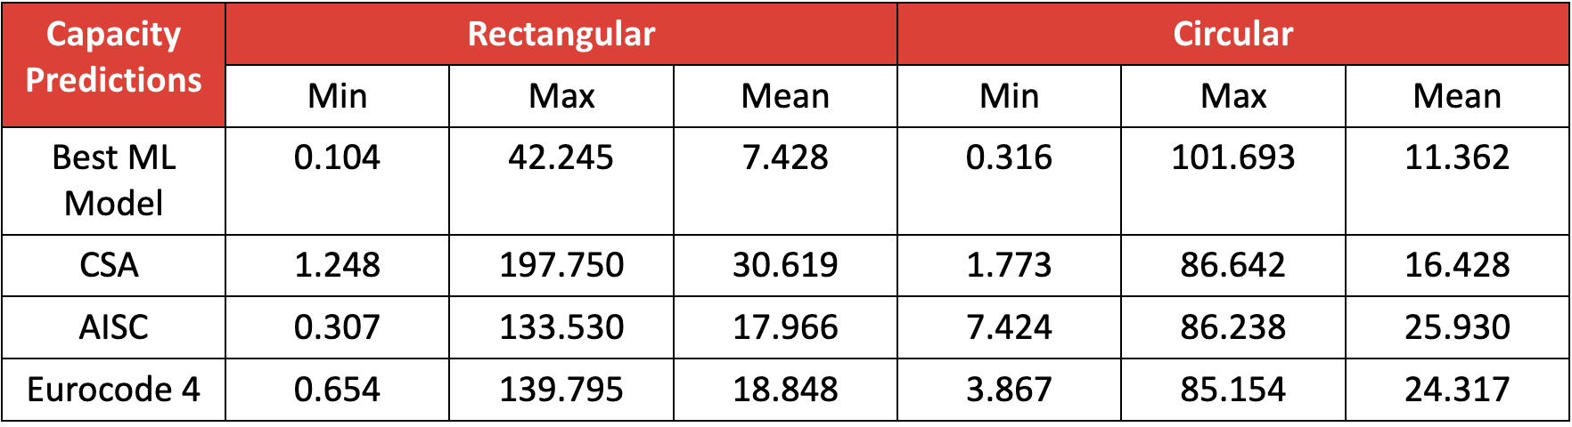

# APPENDIX 2: FIGURES

# 

*Figure 1.* Results of the Circular Linear Regression Model

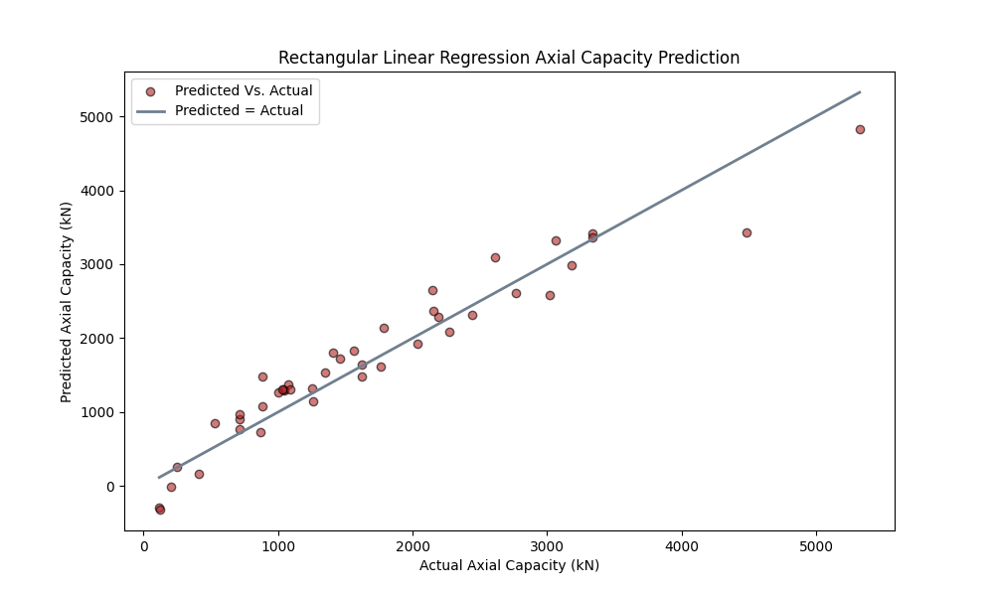

*Figure 2.* Results of the Rectangular Linear Regression Model

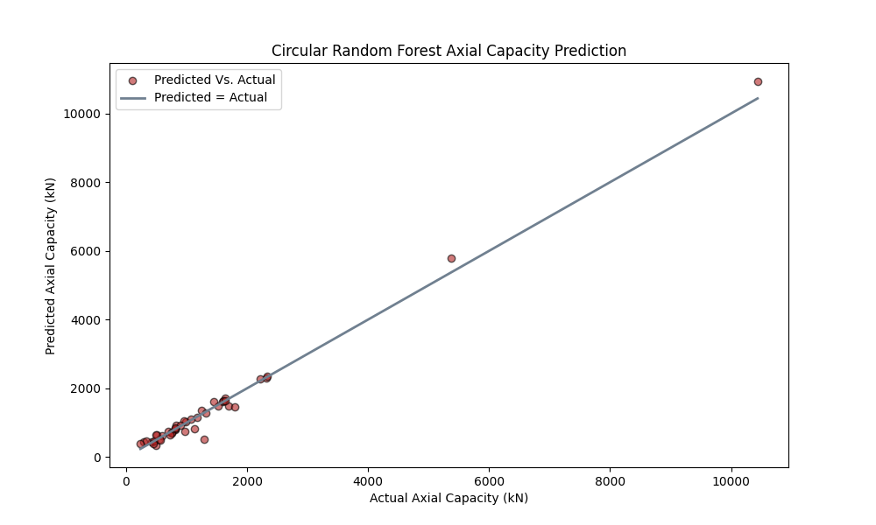

*Figure 3.* Results of the Circular Random Forest Regressor Model

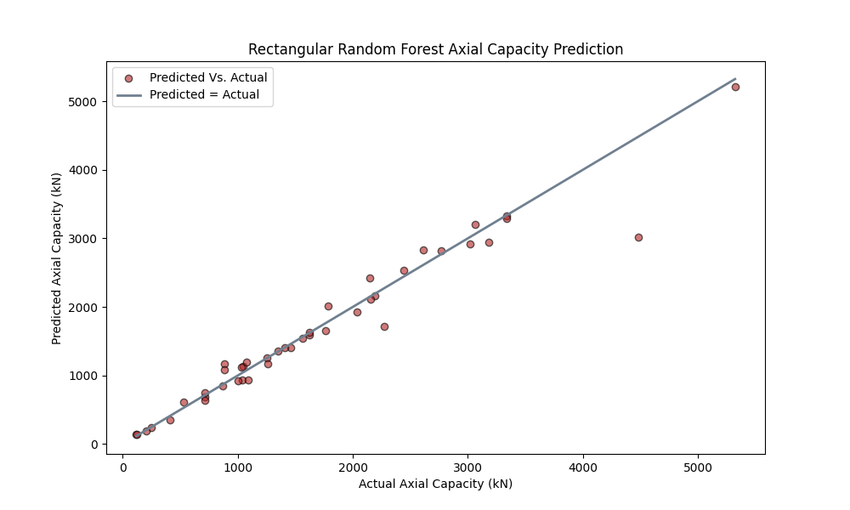

*Figure 4.* Results of the Rectangular Random Forest Regression Model

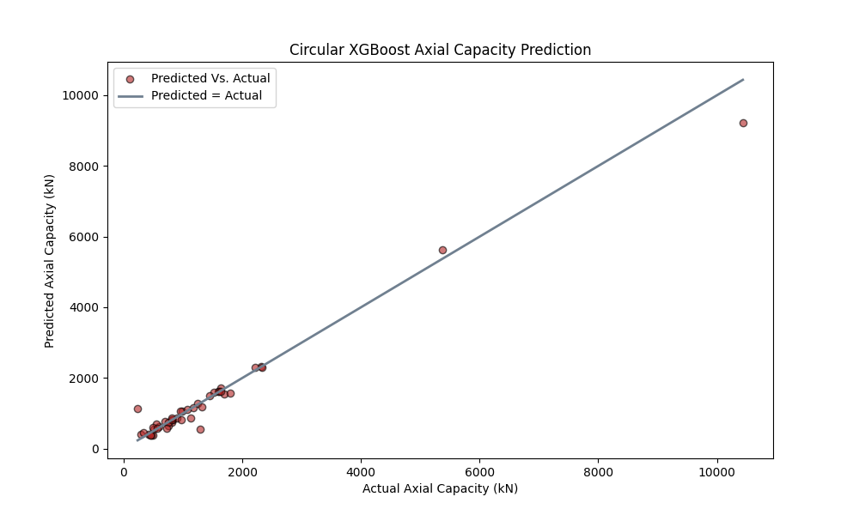

*Figure 5.* Results of the Circular XGBoost Model

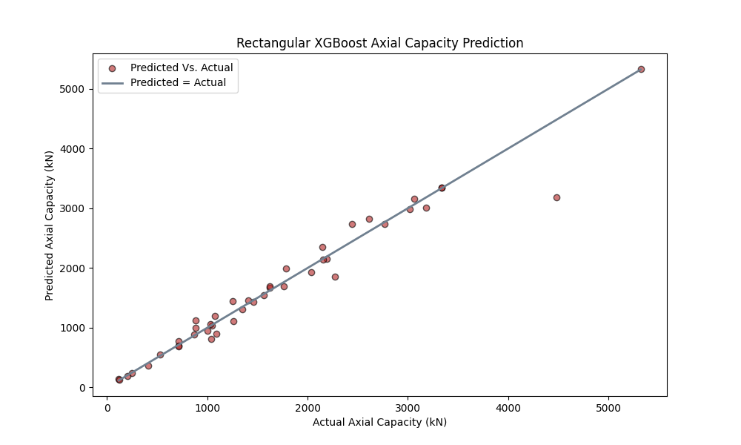

*Figure 6.* Results of the Rectangular XGBoost Model

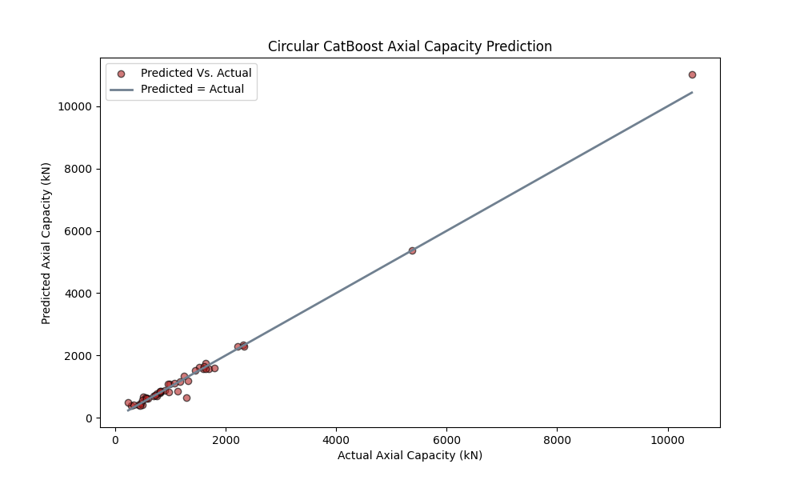

*Figure 7.* Results of the Circular CatBoost Model

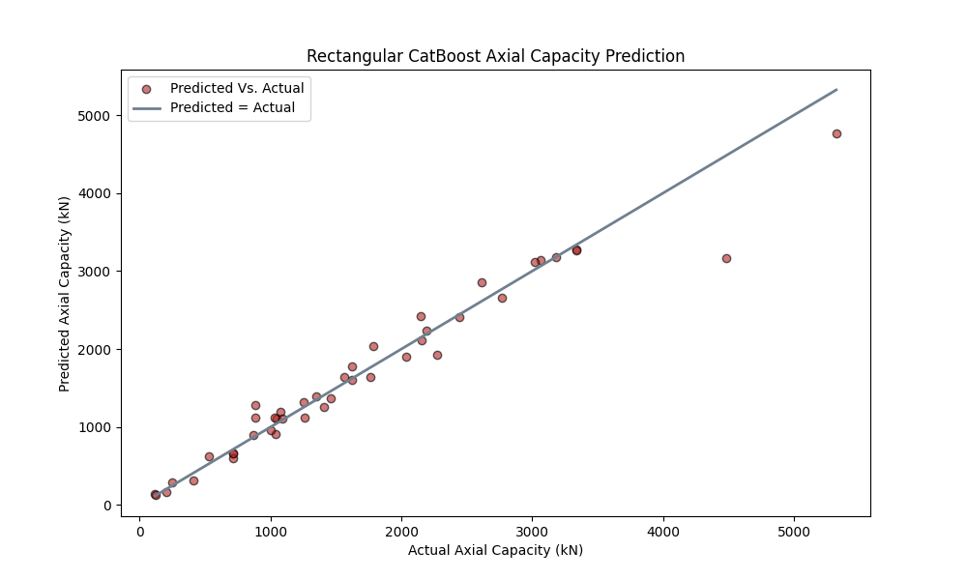

*Figure 8.* Results of the Rectangular CatBoost Model

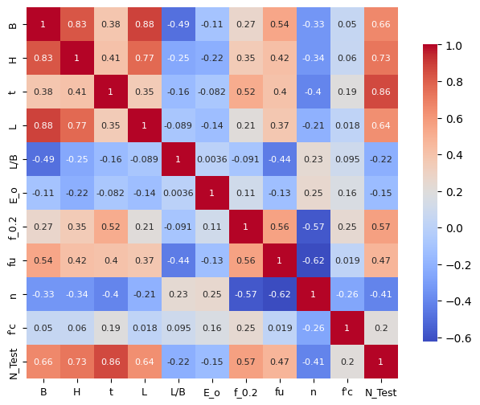

*Figure 9.* Correlation matrix for Rectangular CFSST columns

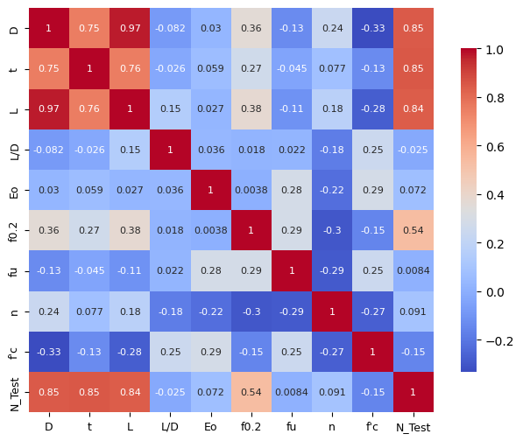

*Figure 10.* Correlation matrix for Circular CFSST columns.

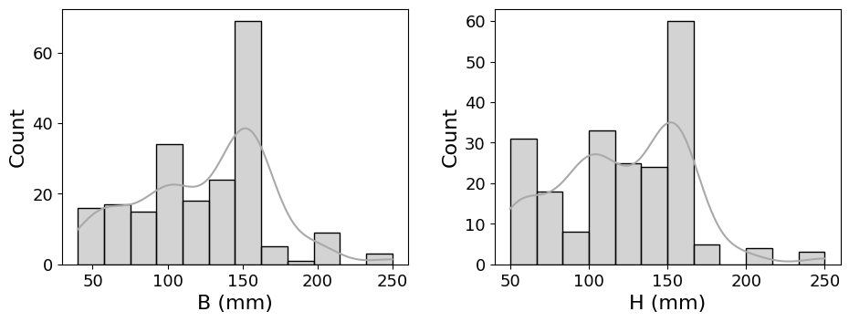

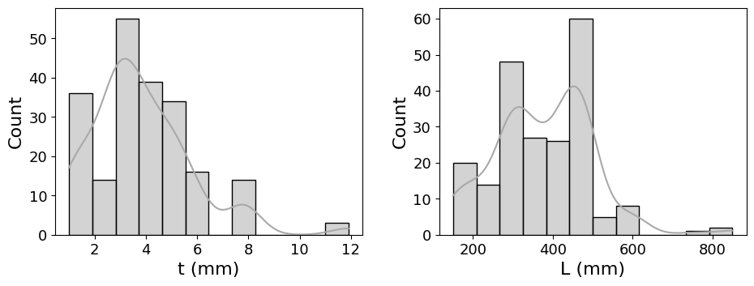

*Figure 11.* Histograms for parameters of Rectangular CFSST columns.

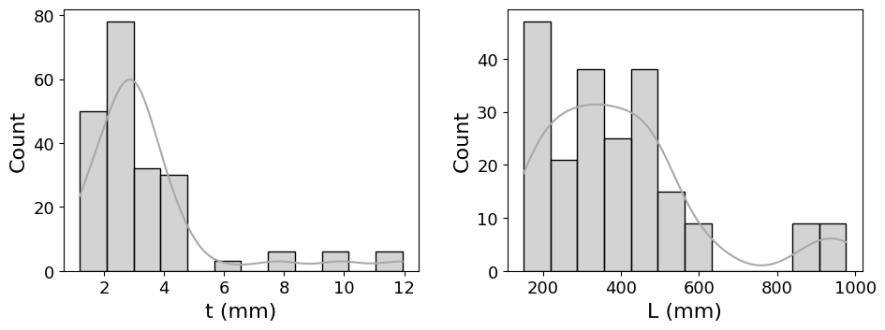

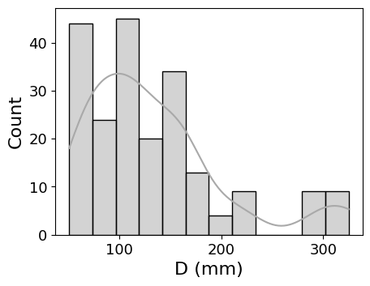

*Figure 12.* Histograms for parameters of Circular CFSST columns.

# APPENDIX 3: EQUATIONS

| Linear Regression: | $y=β_{0}​+β_{1}​X_{1}​+β_{2}​X_{2}​+⋯+β_{n}​X_{n}​+ϵ$ | (1) |
| --- | --- | --- |
| Random Forest Regressor: | $\hat{y}=\frac{1}{T}\sum_{t=1}^{T}{}Tree_{t}​(x)$ | (2) |
| Loss Function: | $L=\sum_{i=1}^{n}{}​(y_{i}​−{\hat{y}}_{i}​)^{2}$ | (3) |
| CatBoot Regressor and  XGBoost Regressor: | ${\hat{y}}_{i }=F(x_{i})=F_{0}(x_{i})+\sum_{t=1}^{T}{}η⋅h_{t}(x_{i})$ | (4) |
| Where: ${\hat{y}}_{i }$ = predicted target value, $F(x_{i})$ = ensemble model, $F_{0}(x_{i})$ = initial model, $η$ =learning rate, $h_{t}(x_{i})$ = prediction from the t-th decision tree, T = number of boosting iterations(trees) | | |
| Mean Squared Error: | $MSE = \frac{1}{N}\sum_{i=1}^{N}{}(y_{i}-\hat{y})^{2}$ | (5) |
| Coefficient of Determination: | $R^{2}=1-\frac{\sum{}(y_{i}-\hat{y})^{2}}{\sum{}(y_{i}-\underline{y})^{2}}$ | (6) |
| Mean Absolute Percentage Error: |  | (7) |
| Where: $y_{i}$ = initial value, $\hat{y}$ = predicted value, N = number of data points | | |
| American Institute of Steel Construction (AISC) 360-16: | $N_{y}=A_{s}f_{y} +0.7A_{c}{f'}_{c}$ For Compact Sections: $N_{u}^{AIS}=A_{s}f_{c} +0.95A_{c}{f'}_{c}$ For Noncompact Sections: $N_{u}^{AIS}=N_{p}-\left(N_{p}-N_{y}\right){\left(\frac{λ-λ_{P}}{λ_{r}-λ_{P}}\right)}^{2}$ | (8) |
| Where:  *λ* = Section's slenderness ratio is equivalent to the proportion of diameter to thickness  *NuAIS* = axial compressive strength of CFSST column  Np= Plastic Strength of the Composite Section  Ny = Yield Strength of the Composite Section | | |
| Eurocode 4 Axial Capacity: | $N_{u}^{EC}=η_{s}A_{s}f_{y} +A_{c}f_{c}\left(1+η_{c}\frac{t}{D}\frac{f_{y}}{f_{c}}\right)$ $η_{s}=0.25(3+2\underline{λ})≤1$ $η_{c}=4.9-18.5\underline{λ}+17{\underline{λ}}^{2}≥0$ $\underline{λ}=\sqrt{\frac{N_{cr}}{A_{s}f_{y}+A_{c}f_{c}}}$ $N_{cr}=\frac{π^{2}{\left(EI\right)}_{eff}}{{\left(L_{e}\right)}^{2}}$ ${\left(EI\right)}_{eff}=E_{s}I_{s}+0.6E_{c}I_{c}$ | (9) |
| Where: $\underline{λ}=Relative Slenderness ; \underline{λ}≤0.5$ $η_{s} and η_{c}=$  coefficients of the CFST column which represents the confinement effect  Le = Effective length of the CFST column  Es = Elastic Modulus of the Exterior Steel tube  Ec = Elastic Modulus of Concrete  Is = Second Moments of Area of the Exterior Steel tube  NuEC = axial compressive strength of CFSST column  *Ncr* = Critical Compressive Strength of the Column based on Euler Buckling strength | | |
| Canadian Standards Association (CSA) S16-19 Axial Capacity: | $N_{u}^{Cs}=\frac{τϕA_{s}f_{y} +{{ τ}^{'}α}_{1}ϕ_{c}A_{c}f_{c}}{{\left(1+λ^{2n}\right)}^{1∕n}}$ $τ=1∕\sqrt{1+ρ+ρ^{2}}$ $τ^{'}=1+\frac{25ρ^{2}π}{\frac{D}{t}}\frac{f_{y}}{α_{1}f_{c}}$ $ρ=0.02\left(25-D_{0}∕L\right)$ $λ=\sqrt{N_{p}∕N_{cr}}$ $N_{cr}=\frac{π^{2}{\left(EI\right)}_{eff}}{{\left(L_{e}\right)}^{2}}$ ${\left(EI\right)}_{eff}=E_{s}I_{s}+\frac{0.6E_{c}I_{c}}{1+C_{fs}∕C_{f}}$ | (10) |
| Where:  *Cfs* = Sustained Axial Load  *Cf* = Total Load on the Column  *NuCs* = axial compressive strength of CFSST column $ϕ$ = Resistance Factor $α_{1}$ = 0.85 – 0.0015f′c > 0.73  *Le* = Effective length of the CFST column  *Is* = Moments of Inertia of the Exterior Steel tube  *Ic* = Moments of Inertia of the Concrete, *n = 1.80* | | |

# REFERENCES

[1] B. Rossi, “Discussion on the use of stainless steel in constructions in view of sustainability,” *Thin-Walled Struct.*, vol. 83, pp. 182–189, Oct. 2014, doi: 10.1016/j.tws.2014.01.021.

[2] G. Gedge, “Structural uses of stainless steel — buildings and civil engineering,” *J. Constr. Steel Res.*, vol. 64, no. 11, pp. 1194–1198, Nov. 2008, doi: 10.1016/j.jcsr.2008.05.006.

[3] S. Fan, B. He, X. Xia, H. Gui, and M. Liu, “Fire resistance of stainless steel beams with rectangular hollow section: Experimental investigation,” *Fire Saf. J.*, vol. 81, pp. 17–31, Apr. 2016, doi: 10.1016/j.firesaf.2016.01.013.

[4] L. Gardner, “The use of stainless steel in structures,” *Prog. Struct. Eng. Mater.*, vol. 7, no. 2, pp. 45–55, Apr. 2005, doi: 10.1002/pse.190.

[5] B. Uy, Z. Tao, and L.-H. Han, “Behaviour of short and slender concrete-filled stainless steel tubular columns,” *J. Constr. Steel Res.*, vol. 67, no. 3, pp. 360–378, Mar. 2011, doi: 10.1016/j.jcsr.2010.10.004.

[6] L.-H. Han, C.-Y. Xu, and Z. Tao, “Performance of concrete filled stainless steel tubular (CFSST) columns and joints: Summary of recent research,” *J. Constr. Steel Res.*, vol. 152, pp. 117–131, Jan. 2019, doi: 10.1016/j.jcsr.2018.02.038.

[7] Z. Tao, B. Uy, F.-Y. Liao, and L.-H. Han, “Nonlinear analysis of concrete-filled square stainless steel stub columns under axial compression,” *J. Constr. Steel Res.*, vol. 67, no. 11, pp. 1719–1732, Nov. 2011, doi: 10.1016/j.jcsr.2011.04.012.

[8] A. He, F. Wang, and O. Zhao, “Experimental and numerical studies of concrete-filled high-chromium stainless steel tube (CFHSST) stub columns,” *Thin-Walled Struct.*, vol. 144, p. 106273, Nov. 2019, doi: 10.1016/j.tws.2019.106273.

[9] A. He, Y. Liang, and O. Zhao, “Behaviour and residual compression resistances of circular high strength concrete-filled stainless steel tube (HCFSST) stub columns after exposure to fire,” *Eng. Struct.*, vol. 203, p. 109897, Jan. 2020, doi: 10.1016/j.engstruct.2019.109897.

[10] Standards Australia, “Bridge design,part 6: steel and composite construction.”

[11] “ANSI/AISC 360-16 Specification for Structural Steel Buildings,” 2016.

[12] The Department of Housing and Urban–Rural and Development of Fujian Province; 2010, “DBJ/T 13-51-2010 Technical Specification for concrete filled structures. Fuzhou (China).”

[13] “Eurocode 4. Design of composite steel and concrete structures, Part 1.1: General rules and rules for buildings (together with United Kingdom National Application Document). DD ENV 1994-1-1:1994. London W1A2BS: British Standards Institution; 1994.” 1994.

[14] A. He and O. Zhao, “Experimental and numerical investigations of concrete-filled stainless steel tube stub columns under axial partial compression,” *J. Constr. Steel Res.*, vol. 158, pp. 405–416, Jul. 2019, doi: 10.1016/j.jcsr.2019.04.002.

[15] D. Lam and L. Gardner, “Structural design of stainless steel concrete filled columns,” *J. Constr. Steel Res.*, vol. 64, no. 11, pp. 1275–1282, Nov. 2008, doi: 10.1016/j.jcsr.2008.04.012.

[16] B. Young and E. Ellobody, “Experimental investigation of concrete-filled cold-formed high strength stainless steel tube columns,” *J. Constr. Steel Res.*, vol. 62, no. 5, pp. 484–492, May 2006, doi: 10.1016/j.jcsr.2005.08.004.

[17] P. Dai, L. Yang, J. Wang, and Y. Zhou, “Compressive strength of concrete-filled stainless steel tube stub columns,” *Eng. Struct.*, vol. 205, p. 110106, Feb. 2020, doi: 10.1016/j.engstruct.2019.110106.

[18] L. Guo, Y. Liu, F. Fu, and H. Huang, “Behavior of axially loaded circular stainless steel tube confined concrete stub columns,” *Thin-Walled Struct.*, vol. 139, pp. 66–76, Jun. 2019, doi: 10.1016/j.tws.2019.02.014.

[19] Y. L. Li, X. L. Zhao, R. K. Raman Singh, and S. Al-Saadi, “Tests on seawater and sea sand concrete-filled CFRP, BFRP and stainless-steel tubular stub columns,” *Thin-Walled Struct.*, vol. 108, pp. 163–184, Nov. 2016, doi: 10.1016/j.tws.2016.08.016.

[20] C. Cakiroglu, K. Islam, G. Bekdaş, U. Isikdag, and S. Mangalathu, “Explainable machine learning models for predicting the axial compression capacity of concrete filled steel tubular columns,” *Constr. Build. Mater.*, vol. 356, p. 129227, Nov. 2022, doi: 10.1016/j.conbuildmat.2022.129227.

[21] C. Hou and X.-G. Zhou, “Strength prediction of circular CFST columns through advanced machine learning methods,” *J. Build. Eng.*, vol. 51, p. 104289, Jul. 2022, doi: 10.1016/j.jobe.2022.104289.

[22] Q.-V. Vu, V.-H. Truong, and H.-T. Thai, “Machine learning-based prediction of CFST columns using gradient tree boosting algorithm,” *Compos. Struct.*, vol. 259, p. 113505, Mar. 2021, doi: 10.1016/j.compstruct.2020.113505.

[23] S. Lee, T. P. Vo, H.-T. Thai, J. Lee, and V. Patel, “Strength prediction of concrete-filled steel tubular columns using Categorical Gradient Boosting algorithm,” *Eng. Struct.*, vol. 238, p. 112109, Jul. 2021, doi: 10.1016/j.engstruct.2021.112109.

[24] M. Zarringol, V. I. Patel, Q. Q. Liang, M. F. Hassanein, and M. Ahmed, “Machine-learning-based predictive models for concrete-filled double skin tubular columns,” Engineering Structures, vol. 304, p. 117593, Apr. 2024, doi: 10.1016/j.engstruct.2024.117593.

[25] N.-T. Ngo, H. A. Le, V.-V. Huynh, and T.-P.-T. Pham, “Machine Learning Models for Inferring the Axial Strength in Short Concrete-Filled Steel Tube Columns Infilled with Various Strength Concrete,” *EJ*, vol. 25, no. 7, pp. 135–145, Jul. 2021, doi: 10.4186/ej.2021.25.7.135.

[26] V.-L. Tran, M. Ahmed, and S. Gohari, “Prediction of the ultimate axial load of circular concrete-filled stainless steel tubular columns using machine learning approaches,” *Structural Concrete*, vol. 24, no. 3, pp. 3908–3932, 2023, doi: https://doi.org/10.1002/suco.202200877.

[27] A. S. De Carvalho, A. Rossi, S. G. Morkhade, and C. H. Martins, “Machine Learning-Based Design Approach for Concrete-Filled Stainless Steel Tubular Columns,” *Arab J Sci Eng*, vol. 48, no. 10, pp. 14105–14118, Oct. 2023, doi: 10.1007/s13369-023-08090-3.

[28] CSA, “Design of Steel Structures (CSA-S16–09),” *Can. Stand. Assoc.*, 2009.

## 

# DATABASES

[1] H. Tang, R. Liu, X. Zhao, R. Guo, and Y. Jia, “Axial compression behavior of CFRP-confined rectangular concrete-filled stainless steel tube stub column,” *Front. Struct. Civ. Eng.*, vol. 15, no. 5, pp. 1144–1159, Oct. 2021, doi: 10.1007/s11709-021-0762-4.

[2] L. Rao, Q. Yue, B. Huang, and X. Liu, “Axial compressive performance of novel square coral concrete-filled duplex stainless steel tubes,” *Journal of Building Engineering*, vol. 49, p. 104068, May 2022, doi: 10.1016/j.jobe.2022.104068.

[3] W.-H. Zhang, R. Wang, H. Zhao, D. Lam, and P. Chen, “Axial-load response of CFST stub columns with external stainless steel and recycled aggregate concrete: Testing, mechanism analysis and design,” *Engineering Structures*, vol. 256, p. 113968, Apr. 2022, doi: 10.1016/j.engstruct.2022.113968.

[4] L. Guo, Y. Liu, F. Fu, and H. Huang, “Behavior of axially loaded circular stainless steel tube confined concrete stub columns,” *Thin-Walled Structures*, vol. 139, pp. 66–76, Jun. 2019, doi: 10.1016/j.tws.2019.02.014.

[5] Q. Ri and F. Dqg, “BEHAVIOR OF CONCRETE FILLED STAINLESS STEEL TUBULAR COLUMN UNDER AXIAL LOADS,” vol. 7, no. 1, 2019.

[6] Y. Cai and A. K. H. Kwan, “Behaviour and design of cold-formed austenitic stainless steel circular tubes infilled with seawater sea-sand concrete,” *Engineering Structures*, vol. 241, p. 112435, Aug. 2021, doi: 10.1016/j.engstruct.2021.112435.

[7] A. He, Y. Liang, and O. Zhao, “Behaviour and residual compression resistances of circular high strength concrete-filled stainless steel tube (HCFSST) stub columns after exposure to fire,” *Engineering Structures*, vol. 203, p. 109897, Jan. 2020, doi: 10.1016/j.engstruct.2019.109897.

[8] V. W. Y. Tam, Z.-B. Wang, and Z. Tao, “Behaviour of recycled aggregate concrete filled stainless steel stub columns,” *Mater Struct*, vol. 47, no. 1–2, pp. 293–310, Jan. 2014, doi: 10.1617/s11527-013-0061-1.

[9] B. Uy, Z. Tao, and L.-H. Han, “Behaviour of short and slender concrete-filled stainless steel tubular columns,” *Journal of Constructional Steel Research*, vol. 67, no. 3, pp. 360–378, Mar. 2011, doi: 10.1016/j.jcsr.2010.10.004.

[10] S. Kazemzadeh Azad, D. Li, and B. Uy, “Compact and slender box concrete-filled stainless steel tubes under compression, bending, and combined loading,” *Journal of Constructional Steel Research*, vol. 184, p. 106813, Sep. 2021, doi: 10.1016/j.jcsr.2021.106813.

[11] P. Dai, L. Yang, J. Wang, and Y. Zhou, “Compressive strength of concrete-filled stainless steel tube stub columns,” *Engineering Structures*, vol. 205, p. 110106, Feb. 2020, doi: 10.1016/j.engstruct.2019.110106.

[12] A. He, A. Su, Y. Liang, and O. Zhao, “Experimental and numerical investigations of circular recycled aggregate concrete-filled stainless steel tube columns,” *Journal of Constructional Steel Research*, vol. 179, p. 106566, Apr. 2021, doi: 10.1016/j.jcsr.2021.106566.

[13] A. He and O. Zhao, “Experimental and numerical investigations of concrete-filled stainless steel tube stub columns under axial partial compression,” *Journal of Constructional Steel Research*, vol. 158, pp. 405–416, Jul. 2019, doi: 10.1016/j.jcsr.2019.04.002.

[14] A. He, F. Wang, and O. Zhao, “Experimental and numerical studies of concrete-filled high-chromium stainless steel tube (CFHSST) stub columns,” *Thin-Walled Structures*, vol. 144, p. 106273, Nov. 2019, doi: 10.1016/j.tws.2019.106273.

[15] S. Boulaares, D. Boutagouga, and A. Houam, “Experimental behavior of circular composite columns with different weld arrangements,” *Journal of Constructional Steel Research*, vol. 192, p. 107229, May 2022, doi: 10.1016/j.jcsr.2022.107229.

[16] Y.-F. Yang and G.-L. Ma, “Experimental behaviour of recycled aggregate concrete filled stainless steel tube stub columns and beams,” *Thin-Walled Structures*, vol. 66, pp. 62–75, May 2013, doi: 10.1016/j.tws.2013.01.017.

[17] B. Young and E. Ellobody, “Experimental investigation of concrete-filled cold-formed high strength stainless steel tube columns,” *Journal of Constructional Steel Research*, vol. 62, no. 5, pp. 484–492, May 2006, doi: 10.1016/j.jcsr.2005.08.004.

[18] F.-Y. Liao, C. Hou, W.-J. Zhang, and J. Ren, “Experimental investigation on sea sand concrete-filled stainless steel tubular stub columns,” *Journal of Constructional Steel Research*, vol. 155, pp. 46–61, Apr. 2019, doi: 10.1016/j.jcsr.2018.12.009.

[19] Y. Chen and Y. Huang, “Experimental research on static behavior of welded concrete-filled stainless steel square stub columns under axial compression,” *Jianzhu Jiegou Xuebao/Journal of Building Structures*, vol. 34, pp. 113–118, Feb. 2013.

[20] Y. L. Li, X. L. Zhao, R. K. R. Singh, and S. Al-Saadi, “Experimental study on seawater and sea sand concrete filled GFRP and stainless steel tubular stub columns,” *Thin-Walled Structures*, vol. 106, pp. 390–406, Sep. 2016, doi: 10.1016/j.tws.2016.05.014.

[21] A. He, Y. Liang, and O. Zhao, “Flexural buckling behaviour and resistances of circular high strength concrete-filled stainless steel tube columns,” *Engineering Structures*, vol. 219, p. 110893, Sep. 2020, doi: 10.1016/j.engstruct.2020.110893.

[22] Z. Tao, B. Uy, F.-Y. Liao, and L.-H. Han, “Nonlinear analysis of concrete-filled square stainless steel stub columns under axial compression,” *Journal of Constructional Steel Research*, vol. 67, no. 11, pp. 1719–1732, Nov. 2011, doi: 10.1016/j.jcsr.2011.04.012.

[23] D. Lam and L. Gardner, “Structural design of stainless steel concrete filled columns,” *Journal of Constructional Steel Research*, vol. 64, no. 11, pp. 1275–1282, Nov. 2008, doi: 10.1016/j.jcsr.2008.04.012.

[24] A. M. Sharif, G. M. Al-Mekhlafi, and M. A. Al-Osta, “Structural performance of CFRP-strengthened concrete-filled stainless steel tubular short columns,” *Engineering Structures*, vol. 183, pp. 94–109, Mar. 2019, doi: 10.1016/j.engstruct.2019.01.011.

[25] L. Li, “Structural performance of concrete-filled cold-formed stainless steel members,” Doctor of Philosophy, The University of Hong Kong, Pokfulam Road, Hong Kong SAR, 2017. doi: 10.5353/th_991043979524003414.

[26] Y. L. Li, X. L. Zhao, R. K. Raman Singh, and S. Al-Saadi, “Tests on seawater and sea sand concrete-filled CFRP, BFRP and stainless steel tubular stub columns,” *Thin-Walled Structures*, vol. 108, pp. 163–184, Nov. 2016, doi: 10.1016/j.tws.2016.08.016.