Riverbank sound system
TinyControlBoard
Technical software Manual
Anthony Roy
[Date]

TinyControlBoard Firmware Technical Design

This document was generated on 2026-06-12 through automated analysis of the TinyControlBoard PlatformIO firmware project. The analysis was performed directly against the source code, build configuration, and test suites contained within the repository.
To ensure the document reflects the current implementation rather than previously written documentation, existing Markdown files under docs/ were intentionally excluded from the source material. All architecture descriptions, behaviour summaries, protocol details, and implementation notes are derived from the code found in src/, lib/, host_tests/, and test/.
The goal of this document is to provide a code-accurate engineering reference for the firmware as it exists today. Where applicable, the document also highlights design patterns, subsystem interactions, and operational behaviour inferred from the implementation itself rather than external commentary or historical documentation.

1. Executive Summary
TinyControlBoard is an ESP32-S3-based front-panel controller that manages local power rails, user inputs, LED indicators, and a UART command link to a Raspberry Pi. Its primary role is to convert physical button and rotary interactions into either local control actions, such as relay switching and brightness adjustments. It manages PowerState transistions and communication with the RPI4.
The firmware is architected around a small top-level orchestrator, controlSystem::ControlBoard, which composes four main concerns:
- hardware bring-up for relays, LEDs, UART, and the MCP I2C input expander,
- an event-driven input pipeline that converts button and rotary activity into IAction objects,
- a policy layer that routes those actions either to power sequencing, local hardware control, or UART transmission,
- a heartbeat-based power-state coordinator that treats Raspberry Pi liveness as part of the system power model.
The intended use case is a custom audio or media front panel where the ESP32 controls panel LEDs, display brightness, and multiple power rails while delegating higher-level media behavior to a Raspberry Pi. The principal design goals visible in code are:
- isolate interrupt-level input capture from application policy,
- make button-to-command mapping data-driven,
- centralize power sequencing and heartbeat waits,
- keep the main task simple and move work into FreeRTOS worker tasks,
- normalize toggle-style UI commands into compact UART messages.
The hardware target is Espressif ESP32-S3-DevKitC-1-N16 (16 MB flash, no PSRAM) configured via PlatformIO with the ESP-IDF framework.

Contents
TinyControlBoard Firmware Technical Design 1
1. Executive Summary 2
2. System Overview 6
2.1 Architectural Summary 6
2.2 Data Flow 6
2.3 External Interfaces 7
2.4 Architecture Diagram 8
3. Hardware Architecture 9
3.1 Hardware Platform 9
3.2 Attached Devices and Functions 9
3.3 GPIO Allocation Table 10
3.4 I2C Devices 11
3.5 SPI Devices 11
3.6 UART Interfaces 11
3.7 PWM Outputs 11
3.8 Interrupt Sources 12
4. Software Architecture 13
4.1 Major Components 14
4.2 Component Responsibilities 14
4.3 Architectural Style 16
4.4 Why It Was Designed This Way 16
4.5 Incomplete Implementations 16
4.6 Dead Code, Compatibility Code, and Technical Debt 16
5. Application Startup Sequence 18
5.1 Step-by-Step Startup 18
5.2 Startup Sequence Diagram 19
5.3 Network Initialization 20
6. Task Architecture 21
6.1 Project-Created Tasks 21
6.2 Task Interaction Diagram 22
6.3 Design Implications 23
7. Interrupt Architecture 23
7.1 Interrupt Inventory 23
7.2 Synchronization Primitives 24
7.3 Interrupt-Related Risks 24
8. State Machines 25
8.1 Power State Machine 25
8.2 Input Action-State Machines 26
8.3 SPI Boot Indicator State Machine 28
8.4 Brightness Control State Logic 28
9. Communication Interfaces 29
9.1 UART 29
9.2 I2C 30
9.3 SPI 30
9.4 Network 31
10. Data Structures 32
10.1 Key Runtime Types 32
10.2 Type Relationships 33
10.3 Buffers and Queues 34
11. User Interface 35
11.1 Inputs 35
11.2 LED Semantics 36
11.3 User Interaction Flow 37
11.4 Sleep-Mode Input Policy 38
12. Error Handling 39
12.1 Error Condition Table 39
12.2 Recovery Strategy Summary 40
12.3 Potential Bugs and Behavioral Risks 40
13. Logging and Diagnostics 41
14. Memory Usage 42
14.1 Allocation Model 42
14.2 Risks 42
14.3 Optimization Opportunities 42
15. Performance Analysis 43
15.1 Timing-Critical Paths 43
15.2 CPU and Latency Concerns 43
15.3 Bottlenecks 43
15.4 Recommendations 43
16. Security Considerations 44
17. Build System 45
17.1 PlatformIO Configuration 45
17.2 CMake Structure 45
17.3 Build Behavior 45
18. Dependency Analysis 46
19. Maintenance Guide 47
19.1 Adding a New Front-Panel Feature 47
19.2 Adding a New Peripheral 47
19.3 Modifying the UART Protocol 47
19.4 Areas Requiring Caution 47
20. Appendix 48
20.1 File Structure 48
20.2 Configuration Parameters 54
20.3 Important Constants and Definitions 55
20.4 Summary of Highest-Value Follow-Up Work 55

2. System Overview

2.1 Architectural Summary

System Diagram

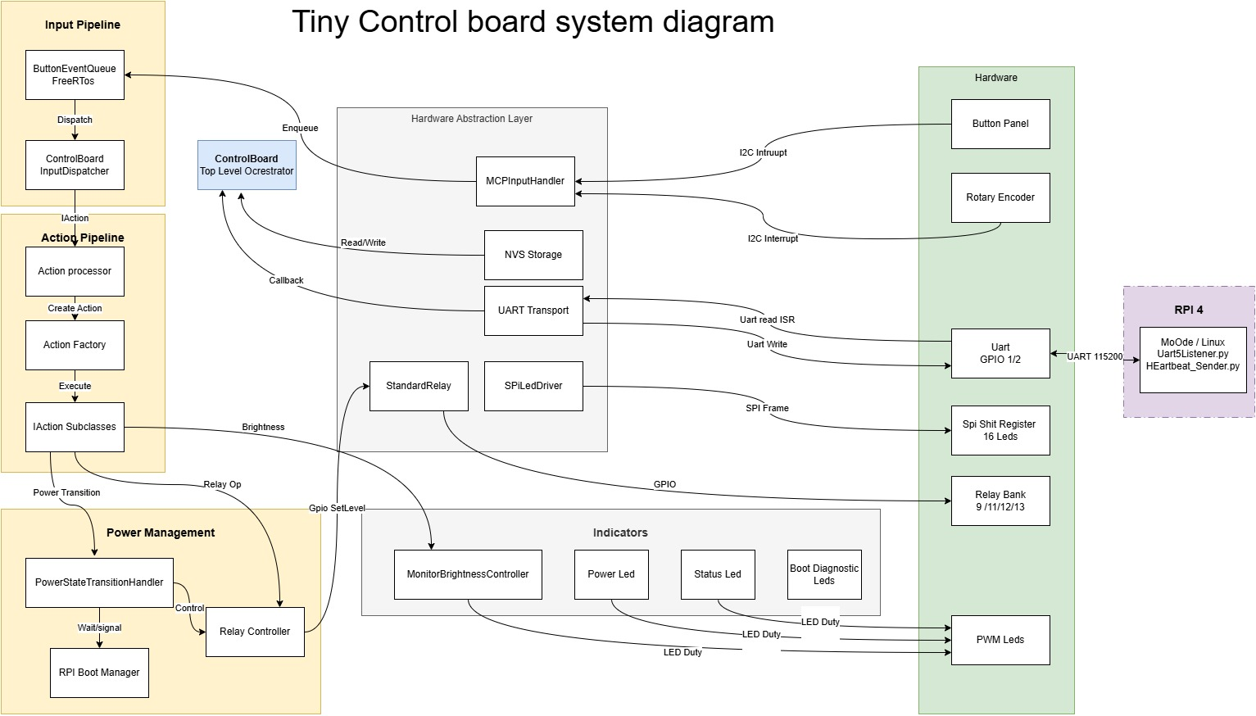

Software component descriptions

Component | Purpose | Inputs | Outputs | Dependencies
ControlBoard | Top-level runtime composition | app_main(), UART RX callbacks, MCP callbacks | System initialization, action execution | bootstrap helpers, UART transport, relays, input dispatcher, action processor
ControlBoardBootstrap | Boot-time wiring helpers | board config constants | Relay setup, serial config, MCP config, indicator startup | relays, McpInputHandler, UartTransport, indicators
ButtonEventQueue | Queue and dispatch raw input events | button/rotary callbacks | Calls into ControlBoardInputDispatcher | FreeRTOS queue/task
ControlBoardInputDispatcher | UI policy and event-to-action conversion | ButtonEvent objects | IAction objects plus LED changes | action map, indicator sink
ControlBoardActionRegistry | Populates the action map | static registration table | ActionMap entries | Dynamic*Action classes
ActionProcessor | Executes actions and enforces power gating | IAction objects, inbound UART messages | power transitions, relays, UART sends, brightness changes | transport, relay controller, power handler, indicators
ActionUartDispatcher | Converts actions into wire-format UART messages | executed actions | UartMessage sends | command catalog, UART sink
UartTransport | UART framing, handshake, RX task, heartbeat monitor | bytes from UART, GPIO42 IRQ | parsed UartMessage objects and heartbeat timeout callback | UART driver, GPIO ISR, UartReceiver
McpInputHandler | I2C expander access and rotary decode | GPIO18 IRQ and I2C reads | button and rotary callbacks | I2C driver, GPIO ISR
PowerStateTransitionHandler | Boot, sleep, and deep-sleep sequencing | power actions and current state | relay operations, LED state changes, waits | relay controller, boot manager, serial
RpiBootManager | Synchronizes heartbeat-based waits | heartbeat received/timeout events | boot/shutdown wait results | FreeRTOS event group
RelayController | Encapsulates relay operations | action/power requests | GPIO changes | StandardRelay
MonitorBrightnessController | Brightness persistence and display-off mode | brightness commands, power state changes | PWM duty changes, NVS writes | LEDC, NVS
PowerLed | User-visible power-state indicator | power state changes | active/standby LED patterns | LEDC, esp_timer
StatusLed | User-visible activity and button-status indication | status messages | LEDC duty and blink patterns | FreeRTOS queue, timer, tasks
SpiBootIndicator | Boot-wait/failure indicator using 16 button LEDs | boot outcome | SPI LED blink patterns | SPI LED driver

ControlBoard action Areas

We will now describe each of the macro functions for this board and the process by which they are enabled

Controlboard power applied
If the current state is OFF, SLEEP, or DEEPSLEEP, a power-button release enters the power-on path.
- A ControlBoard instance is constructed.
- ControlBoard::init() initializes NVS.
- Startup indicators are prepared by setting the power LED state to TURNING_ON.
- ControlBoard::initTransport() acquires the singleton UART transport and relay interface and configures serial RX and heartbeat callbacks.
- ControlBoard::initComponents() allocates the action processor and input dispatcher.
- Relay GPIOs are initialized and forced off.
- The MCP input expander is initialized over I2C, its interrupt pin is configured, and mcp_int_task is created.
- ButtonEventQueue creates its queue and action_task.
The late-heartbeat promotion path is now partly isolated behind DelayedBootRecoveryState, which gives the host-side CMake test suite direct coverage over the one-shot degraded-boot recovery decision without needing the ESP-IDF runtime.
- MCP callbacks are installed so button/rotary changes feed the queue.
- UART is initialized, the Pi data-ready input ISR is attached, and uart_rx_task plus heartbeat_task are started.
- The action map is populated.
- A final fixed delay of 5000 ms is applied by finalizeStartupIndicators().
- ActionProcessor::triggerInitialPowerOn() synthesizes a power command.
- Power-on sequencing enables screen, DAC, output stage, and Pi relays in order.
- SpiBootIndicator flashes all button LEDs while the firmware waits for heartbeat.
- If heartbeat arrives, the system enters ON; otherwise it falls back to SLEEP and initialization is reported as failed.
- If initialization fails, app_main() deinitializes portions of the board, waits 1 second, and retries indefinitely.
If initialization succeeds, app_main() remains alive and all runtime work is performed by background tasks.

Shutdown

Sleep Sequence
If the current state is ON and the power button hold time is less than 3000 ms, the firmware enters the sleep path.
Current sequence:
- power LED state becomes GOING_TO_SLEEP,
- CMD_SYS_RPI_SHUTDOWN is sent over UART,
- firmware waits up to 60 seconds for shutdown confirmation via heartbeat timeout,
- Raspberry Pi power relay is turned off,
- firmware delays 500 ms,
- screen power relay is turned off,
- firmware delays 5000 ms,
- power LED state becomes SLEEP,
- activity status becomes sleeping.
Practical result:
- the Raspberry Pi and screen are shut down,
- DAC and output stage power remain on,
- the board stays in a lower-power standby style state rather than a full deep power-down.

DeepSleep
If the current state is ON and the power button hold time is 3000 ms or more, the firmware enters the deep-sleep path.
Current sequence:
- power LED state becomes GOING_TO_SLEEP,
- CMD_SYS_RPI_SHUTDOWN is sent over UART,
- firmware waits up to 60 seconds for shutdown confirmation via heartbeat timeout,
- Raspberry Pi power relay is turned off,
- firmware delays 500 ms,
- screen power relay is turned off,
- DAC relay is turned off,
- output stage relay is turned off,
- power LED state becomes DEEPSLEEP,
- activity status becomes sleeping.
Practical result:
- Raspberry Pi power is removed,
- screen power is removed,
- DAC power is removed,
- output stage power is removed,
- board logic still remains present enough to respond later, so this is a project-specific deep sleep state, not necessarily ESP-IDF chip deep sleep.

Buttons

Press

Release

Rotary control

Turn Left

Turn Right

2.2 Data Flow

Button and rotary data flow:
- MCP interrupt asserts on GPIO18.
- McpInputHandler::gpioIsr() wakes mcp_int_task.
- McpInputHandler::handleInterrupt() reads GPIO state over I2C and emits button press, release, or rotary callbacks.
- ControlBoard callbacks enqueue ButtonEvent objects into ButtonEventQueue.
- action_task dequeues the event and calls ControlBoardInputDispatcher.
- The dispatcher updates UI status, optionally toggles button LEDs, and invokes the mapped IActionSource.
- The produced IAction is passed to ActionProcessor.
- ActionProcessor executes the action locally or routes it to UART.

Inbound serial data flow:
- Raspberry Pi asserts the data-ready input on GPIO42.
- UartTransport::gpioIsrHandler() wakes uart_rx_task.
- UartTransport::handleUartRx() reads bytes from UART2 and feeds UartReceiver.
- UartReceiver scans the byte stream for valid 18-byte protocol frames.
- Parsed UartMessage objects are forwarded to ControlBoard::handleSerialRxMessage().
- Heartbeat commands update boot/shutdown synchronization; all other inbound commands currently log and fall through because inbound protocol handling is still scaffolded.

2.3 External Interfaces

- UART2 to Raspberry Pi at 115200 baud.
- GPIO handshake lines for UART data-ready signaling.
- I2C master to the MCP input expander at address 0x20.
- SPI output to a 16-bit LED shift-register or similar latch-based LED driver.
- GPIO outputs for power relays.
- LEDC PWM outputs for power-state LEDs, button status LED, and monitor brightness control.
- NVS for persistent brightness level storage.

2.4 Architecture Diagram

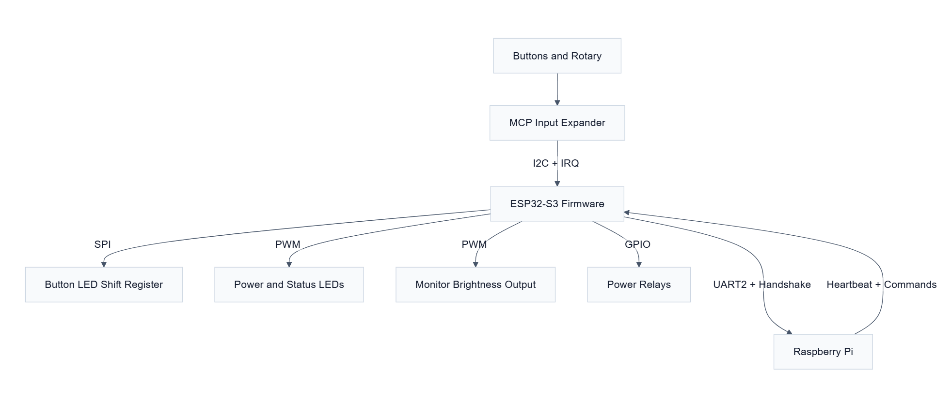
Figure 1

3. Hardware Architecture

3.1 Hardware Platform

- MCU: ESP32-S3.
- Board definition: esp32-s3-devkitc-1-16mb.
- Flash: 16 MB.
- Framework: ESP-IDF under PlatformIO.
- CPU clock configured to 240 MHz.
- Board definition advertises Wi-Fi and Bluetooth capability, but the firmware does not use either stack.

3.2 Attached Devices and Functions

- I2C device: one MCP23018-style 16-bit GPIO expander at address 0x20.
- SPI device: one 16-bit LED driver or shift-register chain with a manual latch line.
- UART device: Raspberry Pi control link.
- Relays: seven GPIO-controlled outputs.
- LEDs:
  - active power LED,
  - standby power LED,
  - working status LED,
  - button status LED PWM output,
  - 16 SPI-driven button LEDs.
- Rotary encoder: represented in firmware as two MCP input bits and decoded in software.
- Display: no display protocol driver exists in firmware; the firmware only controls monitor brightness and a display-off brightness mode.
- Sensors: none present in code.
- Network peripherals: none initialized in firmware.

3.3 GPIO Software Allocation Table
GPIO | Function | Direction | Notes
1 | UART2 RX | Input | Raspberry Pi to ESP32 serial RX
2 | UART2 TX | Output | ESP32 to Raspberry Pi serial TX
3 | Active power LED PWM | Output | PowerLed active channel
4 | Standby power LED PWM | Output | PowerLed standby channel
5 | SPI LED latch | Output | Manual latch pulse after 16-bit transfer
6 | SPI LED clock | Output | SPI2 SCLK
7 | SPI LED data | Output | SPI2 MOSI
9 | Output-stage power relay | Output | Power sequencing
10 | Proto DAC enable relay | Output | Exposed but not used in runtime policy
11 | Raspberry Pi power relay | Output | Power sequencing
12 | DAC power relay | Output | Power sequencing and toggle DAC action
13 | Screen power relay | Output | Power sequencing
15 | I2C SCL | Output/Open-drain | MCP bus clock
16 | I2C SDA | Bidirectional/Open-drain | MCP bus data
17 | I2C enable | Output | Gates external I2C hardware enable
18 | MCP interrupt | Input | Negative-edge ISR source
21 | Button status LED PWM | Output | StatusLed with default SolidIdle
39 | General relay 2 | Output | Initialized but not used by action policy
41 | ESP32 data-ready to Pi | Output | Asserted after UART transmit
42 | Pi data-ready to ESP32 | Input | Rising-edge ISR source for UART RX
43 | Monitor brightness PWM | Output | Backlight or brightness control
47 | General relay 1 | Output | Initialized but not used by action policy
48 | Activity status LED PWM | Output | StatusLed for work/idle/sleep patterns

3.4 I2C Devices

Device | Address | Role | Access Pattern
MCP23018-style input expander | 0x20 | Reads 16 button lines and rotary bits | Interrupt-driven, read-on-change
The code uses the MCP register model directly, enables pull-ups on both banks, and enables interrupt-on-change for all 16 inputs.

3.5 SPI Devices

Device | Role | Data Width | Notes
SPI LED driver / shift register | Drives button LEDs | 16 bits | Low byte sent first, then high byte

3.6 UART Interfaces

Interface | Port | Baud | Purpose
Main control link | UART_NUM_2 | 115200 | ESP32 <-> Raspberry Pi command protocol

3.7 PWM Outputs

Output | Implementation | Purpose
Active power LED | LEDC | ON state indication
Standby power LED | LEDC | OFF, sleep, and transition indication
Activity status LED | LEDC + timer/task | Work/active/sleep blips
Button status LED | LEDC + timer/task | Idle brightness and sleep/active blips
Monitor brightness | LEDC | Display backlight or monitor dimming

3.8 Interrupt Sources
Source | GPIO | Trigger | Consumer
MCP interrupt | 18 | Negative edge | McpInputHandler::gpioIsr()
Pi data-ready | 42 | Positive edge | UartTransport::gpioIsrHandler()

4. Software Architecture

4.1 Major Components

4.2 Component Responsibilities

4.3 Architectural Style
Three design choices dominate the codebase:
- Event capture is separated from policy. GPIO ISRs only wake tasks. The tasks then read hardware state and enqueue higher-level events.
- Button behavior is data-driven. ControlBoardActionRegistry uses a registration table so mapping changes mostly affect one file.
- Side effects are command-oriented. Buttons do not directly manipulate relays or UART; they create IAction objects that are executed later with an ActionContext.

4.4 Why It Was Designed This Way

The design reduces the amount of logic in interrupt context and avoids coupling user input semantics to transport or relay code. The Raspberry Pi is treated as an external application processor, so the ESP32 owns front-panel determinism, local safety, and power rails while delegating media behavior and UI context to the Pi.
The power model also explains several implementation choices:
- heartbeat is used as a boot-complete and shutdown-complete signal,
- toggle commands are normalized on the wire to avoid duplicating Raspberry Pi handlers,
- the monitor brightness controller persists state locally because brightness must survive Pi resets.

4.5 Incomplete Implementations

- ActionProcessor::handleInboundUartMessage() is explicitly a scaffold and currently only logs inbound non-heartbeat messages.
- No network stack, web API, Wi-Fi client, Ethernet, or MQTT code is present.
- SystemAction only performs meaningful work for CMD_SYS_RPI_SHUTDOWN; CMD_EXIT_ITEM is a log-only no-op.
- The board definition supports Wi-Fi and Bluetooth, but the firmware does not initialize them.

4.6 Dead Code, Compatibility Code, and Technical Debt
Observed dormant or compatibility-oriented paths:
- actions::Action in actionsResponse.hpp is a no-op test helper and is not produced by the live firmware pipeline.
- SimpleCommandAction.hpp is a backward-compatibility include shim; the implementation lives in actionTemplates.hpp.
- Template action sources ToggleAction<>, TimedAction<>, and RotaryAction<> remain defined, but the live registry uses DynamicToggleAction, DynamicTimedAction, and DynamicRotaryAction.
- StatusLed::startBreatheEffect() and StatusLed::getBlinkInterval() are defined but not referenced by the runtime path.
- UartTransport::sendData(const char *p_message) is declared in the header but has no implementation.
- CMD_ROTARY_LEFT and CMD_ROTARY_RIGHT remain in the protocol catalog, but the active runtime emits CMD_ROTARY_ACTION with parameter 0 or 1.
- ControlBoardPowerState::SHUTTING_DOWN and GOING_INTO_DEEP_SLEEP are handled in indicators but are not emitted by the current transition policy.
Technical debt worth calling out:
- Power-management configuration in app_main() is annotated by the source as ineffective.
- A fixed 5-second startup delay exists solely to wait for power to stabilize.
- Hardware pin aliases are split between board::... namespaces and legacy PIN_* macros.
- Command routing rules are distributed across multiple places: the registration table, ActionCommandRoutingPolicy, and ActionUartDispatcher toggle normalization.

5. Application Startup Sequence

5.1 Step-by-Step Startup

- Power is applied to the ESP32-S3 board.
- ESP-IDF initializes the runtime and enters app_main().
- app_main() configures esp_pm_config_t with max 240 MHz, min 40 MHz, and light sleep enabled.
- app_main() waits 5000 ms before any board work begins.
- A ControlBoard instance is constructed.
- ControlBoard::init() initializes NVS.
- Startup indicators are prepared by setting the power LED state to TURNING_ON.
- ControlBoard::initTransport() acquires the singleton UART transport and relay interface and configures serial RX and heartbeat callbacks.
- ControlBoard::initComponents() allocates the action processor and input dispatcher.
- Relay GPIOs are initialized and forced off.
- The MCP input expander is initialized over I2C, its interrupt pin is configured, and mcp_int_task is created.
- ButtonEventQueue creates its queue and action_task.
The late-heartbeat promotion path is now partly isolated behind DelayedBootRecoveryState, which gives the host-side CMake test suite direct coverage over the one-shot degraded-boot recovery decision without needing the ESP-IDF runtime.
- MCP callbacks are installed so button/rotary changes feed the queue.
- UART is initialized, the Pi data-ready input ISR is attached, and uart_rx_task plus heartbeat_task are started.
- The action map is populated.
- A final fixed delay of 5000 ms is applied by finalizeStartupIndicators().
- ActionProcessor::triggerInitialPowerOn() synthesizes a power command.
- Power-on sequencing enables screen, DAC, output stage, and Pi relays in order.
- SpiBootIndicator flashes all button LEDs while the firmware waits for heartbeat.
- If heartbeat arrives, the system enters ON; otherwise it falls back to SLEEP and initialization is reported as failed.
- If initialization fails, app_main() deinitializes portions of the board, waits 1 second, and retries indefinitely.
- If initialization succeeds, app_main() remains alive and all runtime work is performed by background tasks.

5.2 Startup Sequence Diagram

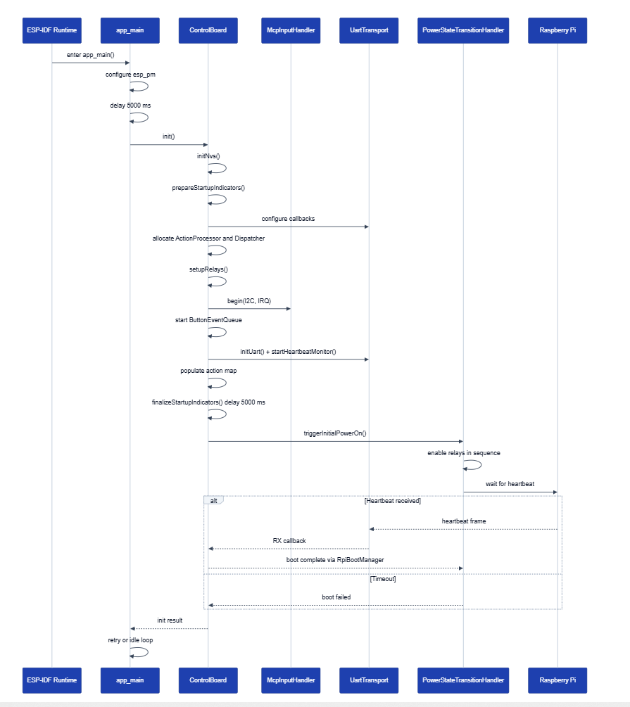
Figure 2

5.3 Network Initialization
There is no network initialization path. No Wi-Fi, Ethernet, TCP/IP, HTTP, or MQTT code is present in the firmware.

6. Task Architecture

6.1 Project-Created Tasks

Task | Priority | Stack | Purpose | Execution Model | Dependencies
action_task | 5 | 4096 | Dequeue ButtonEvent objects and call the dispatcher | Blocks on queue receive | ButtonEventQueue, dispatcher
uart_rx_task | 10 | 4096 | Handle UART receive after GPIO42 data-ready interrupt | Woken by task notification | GPIO42 ISR, UART driver
heartbeat_task | 5 | 4096 | Poll last-RX timestamp and detect heartbeat timeout | 100 ms periodic loop | esp_timer_get_time(), callback
mcp_int_task | 10 | 4096 | Read MCP state and decode button/rotary changes | Woken by task notification | GPIO18 ISR, I2C driver
LED_Task (activity LED) | 5 | 4096 | Drive the activity-status LED state machine | Queue-driven | FreeRTOS queue and timer
LED_Task (button status LED) | 5 | 4096 | Drive the button-status LED state machine | Queue-driven | FreeRTOS queue and timer
spi_boot_ind | tskIDLE_PRIORITY + 1 | 4096 | Flash all SPI LEDs during boot wait or failure | Delay loop until stop flag | SPI LED driver
BreatheTask | 5 | 2048 | Unused runtime breathe effect for StatusLed | Delay loop | Not referenced by live runtime
Additional execution contexts used by the firmware:
- app_main() task from ESP-IDF.
- esp_timer callback context for PowerLed::handleTimer().
- FreeRTOS software timer service task for StatusLed blink timers.

6.2 Task Interaction Diagram

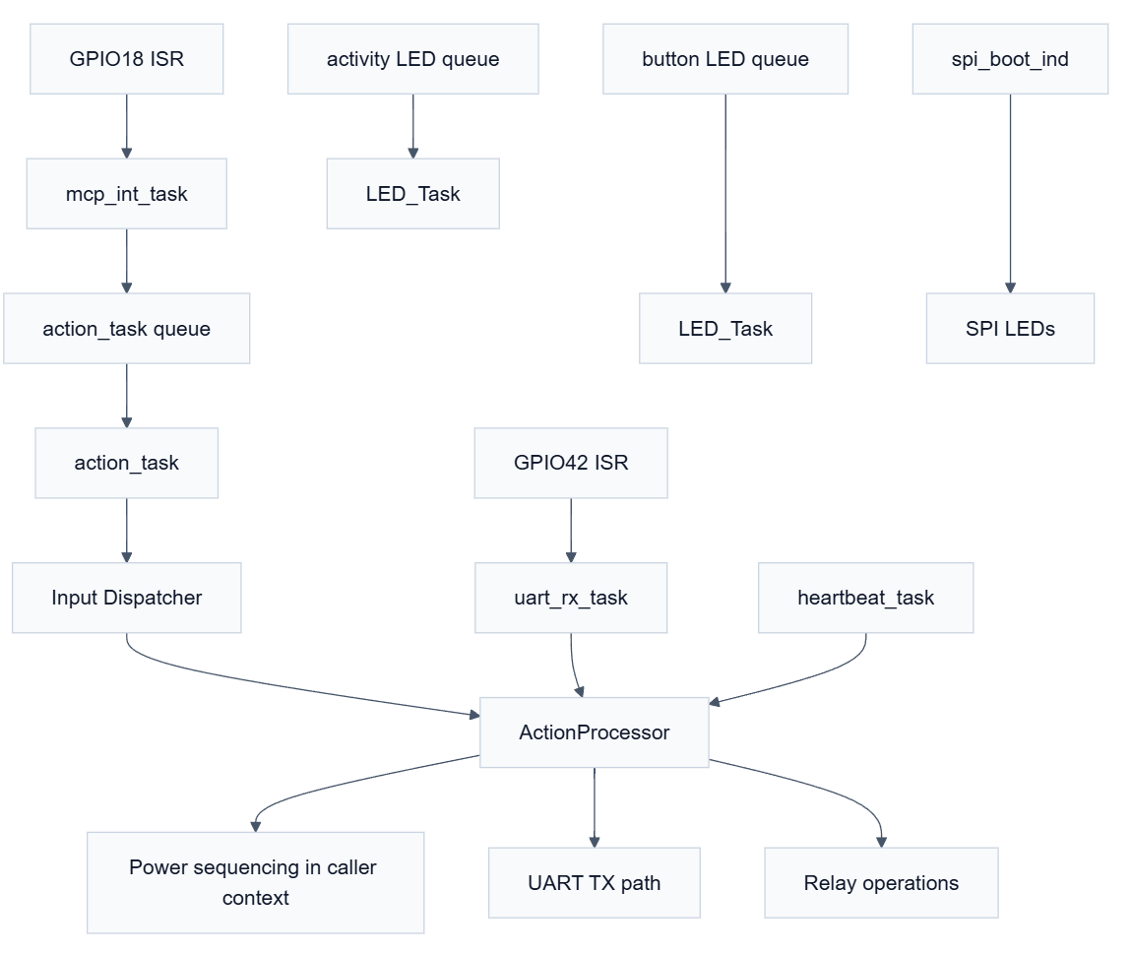
Figure 3

6.3 Design Implications
- Input processing is serialized through action_task, which simplifies button logic and avoids race-heavy action execution.
- Both MCP and UART receive work run at priority 10, above the action and status tasks.
- Heartbeat monitoring is coarse-grained at 100 ms, which is acceptable for 30-second liveness windows.
- Several blocking delays occur in the caller context of power transitions and UART TX signaling; those are acceptable for the current architecture because those paths are not ISR-bound, but they do reduce responsiveness during long sequencing steps.

7. Interrupt Architecture

7.1 Interrupt Inventory

Source | Trigger | ISR | Actions Performed | Synchronization
MCP interrupt on GPIO18 | Negative edge | McpInputHandler::gpioIsr() | Notify mcp_int_task only | Task notification
Pi data-ready on GPIO42 | Positive edge | UartTransport::gpioIsrHandler() | Notify uart_rx_task only | Task notification
The project follows a sound ISR policy: the ISR body only performs vTaskNotifyGiveFromISR() and optional portYIELD_FROM_ISR().

7.2 Synchronization Primitives
Queues:
- ButtonEventQueue uses a depth-16 FreeRTOS queue to move input events from callback context to action_task.
- Each StatusLed instance owns a depth-1 queue and uses xQueueOverwrite() so the latest status always wins.
Task notifications:
- mcp_int_task waits on a notification from GPIO18.
- uart_rx_task waits on a notification from GPIO42.
- StatusLed::sendStatus() also uses task notification to wake the LED task quickly after queue overwrite.
Event groups:
- RpiBootManager owns one event group.
- One bit represents heartbeat received.
- One bit represents heartbeat timeout, which the code interprets as shutdown confirmation.
Semaphores:
- No explicit FreeRTOS semaphores are used by the application code.
Atomics:
- SystemState::powerState is atomic.
- UartTransport uses atomics for task-stop flags, initialization state, and last-RX timestamp.
- StatusLed and SpiBootIndicator use atomics for state and stop flags.

7.3 Interrupt-Related Risks
- The UART RX wakeup relies on a separate data-ready GPIO rather than the UART driver’s own event queue, so any mismatch between GPIO handshake timing and UART framing can starve or burst the RX task.
- GPIO ISR service installation is attempted in both UART and MCP layers; the code tolerates ESP_ERR_INVALID_STATE, which is practical but indicates shared-global initialization concerns.

8. State Machines

8.1 Power State Machine

The primary state machine is ControlBoardPowerState plus evaluatePowerTransition().
Actual decision states in the current runtime:
- OFF
- TURNING_ON
- ON
- GOING_TO_SLEEP
- SLEEP
- DEEPSLEEP
Declared but not actively emitted by the transition policy:
- SHUTTING_DOWN
- GOING_INTO_DEEP_SLEEP
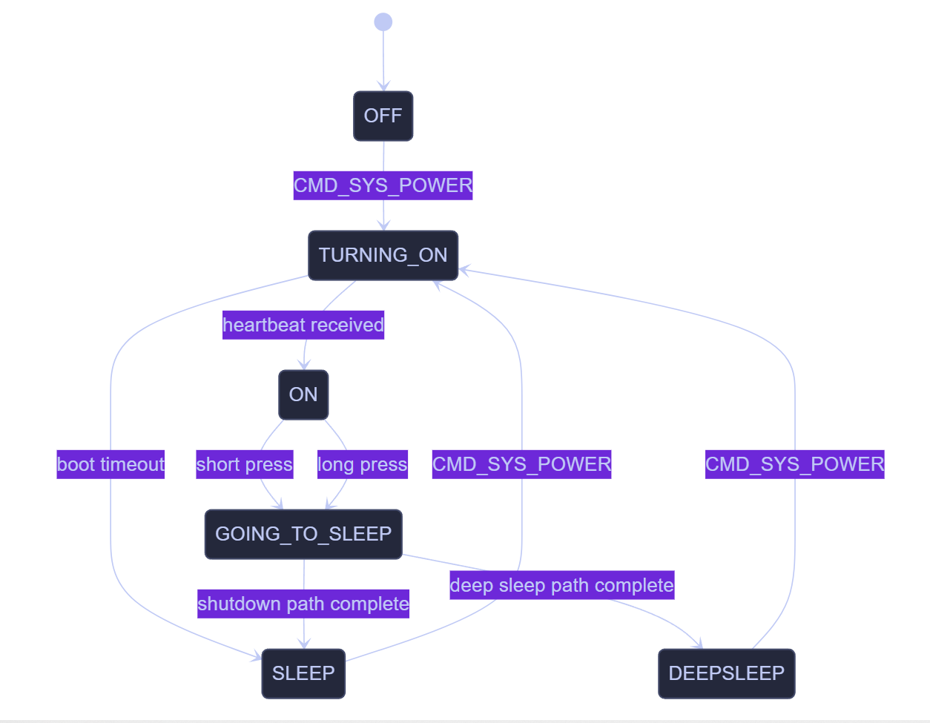
Figure 4

Entry and exit behavior:
- Enter TURNING_ON: set LED indicators, enable relays in order, start boot-wait SPI blink.
- Enter ON: stop boot indicator, restore brightness, set activity to active.
- Enter SLEEP: screen and Pi off, LEDs cleared, activity becomes sleeping.
- Enter DEEPSLEEP: screen, Pi, DAC, and output-stage rails off, activity becomes sleeping.

8.2 Input Action-State Machines
Button behavior is implemented by IActionSource variants rather than a single explicit enum.
Timed action state machine, used by the power button:

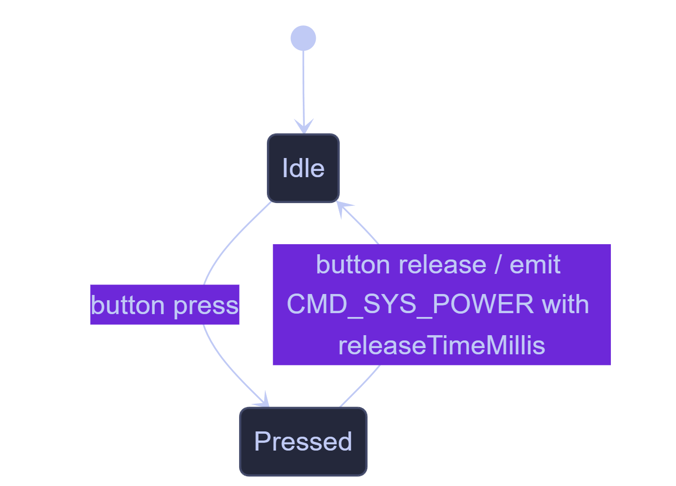
Figure 5

Toggle action state machine, used by cover, repeat, random, DAC, and meter toggles:

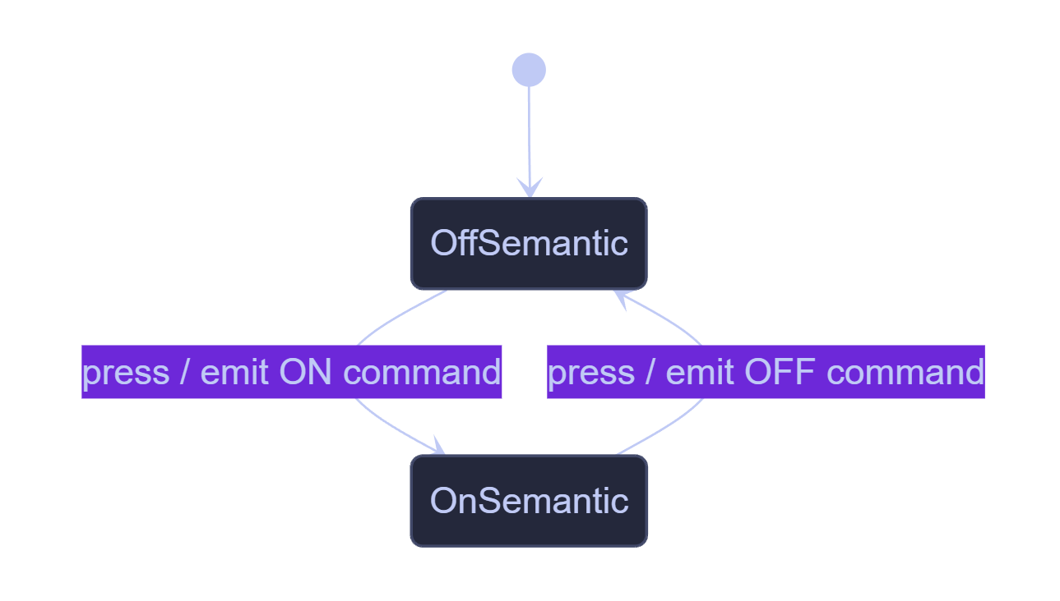
Figure 6
Rotary State Machine:
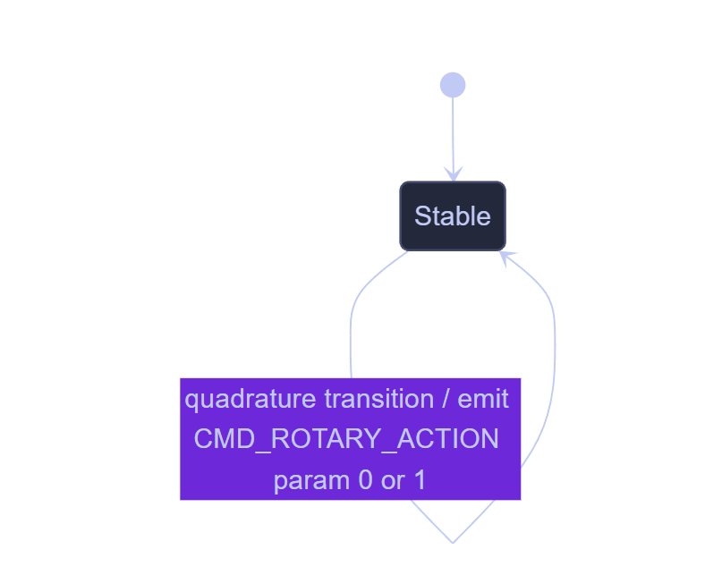
Figure 7

8.3 SPI Boot Indicator State Machine

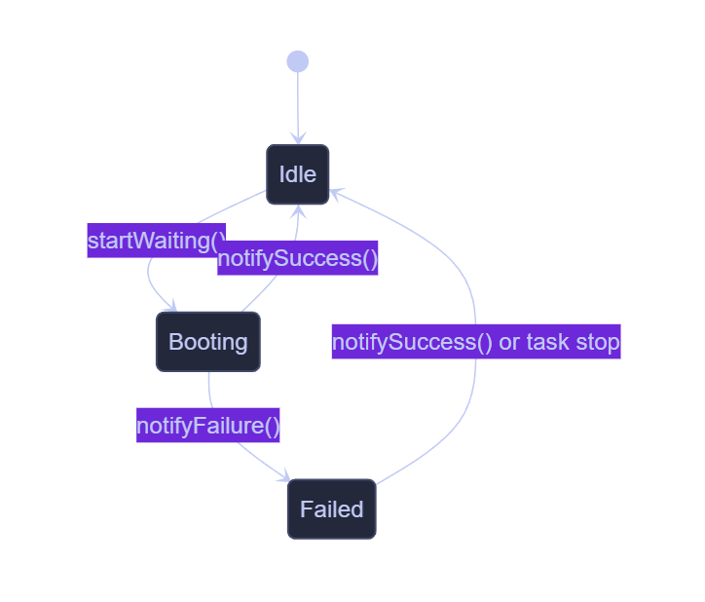
Figure 8
Behavior:
- Booting: flash all button LEDs at 500 ms half-period.
- Failed: flash all button LEDs at 150 ms half-period.

8.4 Brightness Control State Logic

The monitor brightness controller keeps an independent mode flag, m_displayOffActive, which temporarily forces brightness to zero and ignores further brightness changes until toggled back.

9. Communication Interfaces

9.1 UART
Configuration:
- port: UART_NUM_2
- baud rate: 115200
- frame format: 8 data bits, no parity, 1 stop bit
- flow control: disabled
- receive buffer configured in firmware: 256 bytes requested from board::serial::k_bufferSize, doubled to 512 bytes when installing the driver

Packet structure:
Byte Offset | Field | Size (bytes)
0 | start byte | 1
1 | protocol version | 1
2 | source app | 1
3 | message type | 1
4 | sequence | 1
5–6 | command ID | 2
7–16 | five 16-bit parameters | 10
17 | checksum | 1
Message Types
Name | Value
MSG_COMMAND | 0x01
MSG_STATUS | 0x02
MSG_ACK | 0x03
MSG_NACK | 0x04
Application ID’s
Name | Value
APP_ESP32 | 0x01
APP_PI | 0x02

Command Catalog

Command | Value
CMD_NO_ACTION | 0x0000
CMD_SYS_POWER | 0x0001
CMD_SYS_RPI_SHUTDOWN | 0x0002
CMD_SYS_HEARTBEAT | 0x0003
CMD_SYS_NOHEARTBEAT | 0x0004
CMD_NEXT_TRACK | 0x0100
CMD_PREVIOUS_TRACK | 0x0101
CMD_PLAY_PAUSE | 0x0102
CMD_STOP_TRACK | 0x0103
CMD_SKIP_FORWARD | 0x0104
CMD_SKIP_BACK | 0x0105
CMD_PREV_MENU_ITEM | 0x0106
CMD_NEXT_MENU_ITEM | 0x0107
CMD_ITEM_SELECT | 0x0108
CMD_EXIT_ITEM | 0x0109
CMD_TOGGLE_DAC_ON | 0x010A
CMD_DISPLAY_OFF | 0x010B
CMD_TOGGLE_METER_ON | 0x010C
CMD_TOGGLE_METER_OFF | 0x010D
CMD_DISPLAY_ON | 0x010E
CMD_TOGGLE_DAC_OFF | 0x010F
CMD_ROTARY_LEFT | 0x0110
CMD_ROTARY_RIGHT | 0x0111
CMD_ROTARY_ACTION | 0x0112
CMD_TOGGLE_DAC | 0x0113
CMD_TOGGLE_DISPLAY | 0x0114
CMD_TOGGLE_METER | 0x0115
CMD_CYCLE_BRIGHTNESS | 0x0116
CMD_COVER_VIEW_ON | 0x0117
CMD_COVER_VIEW_OFF | 0x0118
CMD_TOGGLE_COVER_VIEW | 0x0119
CMD_REPEAT_ON | 0x011A
CMD_REPEAT_OFF | 0x011B
CMD_TOGGLE_REPEAT | 0x011C
CMD_RANDOM_ON | 0x011D
CMD_RANDOM_OFF | 0x011E
CMD_TOGGLE_RANDOM | 0x011F

Checksum
The checksum is computed as the sum of bytes 1 through 16, masked to 8 bits. Pi-side Python expression: sum(packet_bytes[1:17]) & 0xFF

4.6 Heartbeat
Heartbeat command ID: CMD_SYS_HEARTBEAT = 0x0003
Current firmware compatibility note: the firmware also still accepts the legacy heartbeat command 0x9999.
Heartbeat behavior:
- the ESP32 starts a heartbeat timeout monitor during initialization,
- when a heartbeat packet is received, the action processor is notified,
- if the timeout expires (30 seconds), the action processor is notified that the Pi is offline,
- during power-on, absence of heartbeat for 60 seconds causes boot timeout.

Supported outbound command patterns:
- simple one-shot commands such as track controls,
- normalized toggle commands such as cover, repeat, meter, and random,
- CMD_ROTARY_ACTION with parameter 0 for left and 1 for right,
- CMD_SYS_RPI_SHUTDOWN for power sequencing.
Responses and inbound commands:
- heartbeat is fully handled,
- legacy heartbeat 0x9999 is still accepted,
- all other inbound messages are currently only logged.

UART protocol diagram:

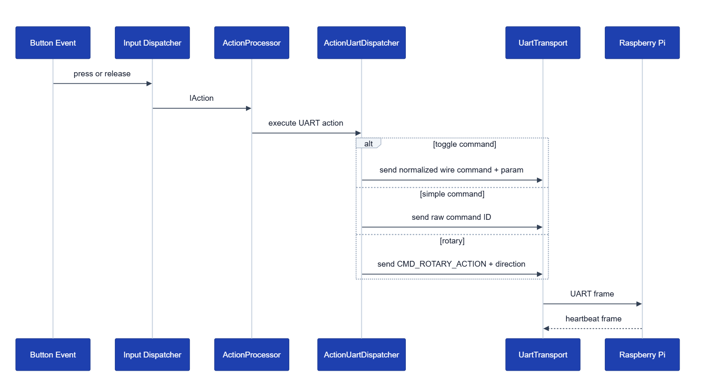
Figure 9

9.2 I2C
- one bus on GPIO15/16,
- one target at address 0x20,
- 50 kHz clock rate,
- used only for MCP register access,
- interrupt-driven read-on-change, not periodic polling.

9.3 SPI
- SPI2 host,
- 1 MHz clock,
- MOSI-only data path,
- no chip-select line; latch is controlled manually on GPIO5,
- used only for button LED state output.
Data flow:
- ControlBoardInputDispatcher decides LED policy.
- ControlBoard::setButtonLed() calls SpiLedDriver::setLed().
- SpiLedDriver updates a 16-bit software bitmask.
- The driver transmits 16 bits over SPI and pulses the latch GPIO.

9.4 Network
No network communication interface exists in the current firmware. There is no Wi-Fi station setup, no AP mode, no sockets, no HTTP endpoints, and no MQTT client.

10. Data Structures

10.1 Key Runtime Types
Type | Purpose | Key Members
UartMessage | Wire-format message DTO | header fields, commandId, params[5], checksum
ButtonEvent | Queue payload from input callbacks | type, buttonId, rotaryDelta
SystemState | Minimal cross-component runtime state | atomic powerState
ButtonConfig | Maps a button slot to behavior | action, ledPolicy
ActionContext | Dependency bundle for IAction::execute() | UART dispatcher, power handler, relays, serial, state, LEDs, brightness
IAction | Executable command object | command, parameters, releaseTimeMillis, virtual execute()
IActionSource | Event-to-action factory | virtual produce(bool)

10.2 Type Relationships
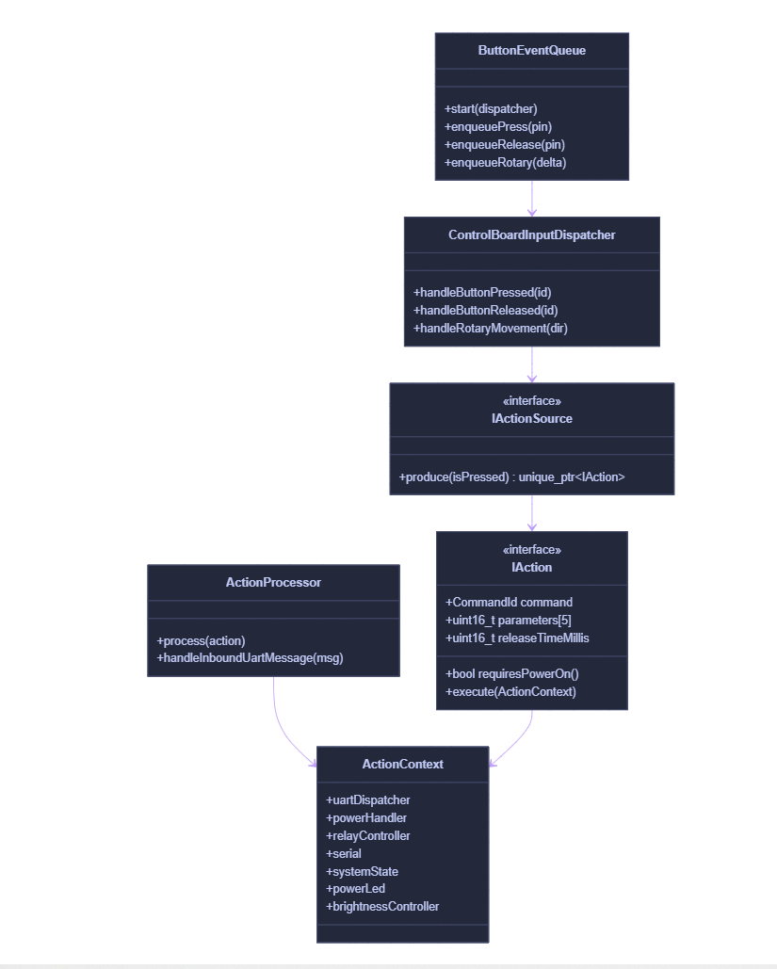
Figure 10

10.3 Buffers and Queues

Item | Size | Purpose
ButtonEventQueue queue | 16 events | Absorb bursty button and rotary activity
StatusLed queue | 1 status value | Keep only latest UI status
UART temporary buffer | 64 bytes | Pull chunks from driver
UartReceiver buffer | 256 bytes | Assemble frames and resynchronize on stream errors
ESP-IDF UART RX ring | 512 bytes | Installed as bufferSize * 2

11. User Interface

11.1 Inputs
User-facing controls exposed by code:
Button ID | Function | Behavior Type | Effect
0 | Power | timed | power on, sleep, or deep sleep depending on hold duration and current state
1 | Previous track | simple | UART command
2 | Next track | simple | UART command
3 | Skip forward | simple | UART command
4 | Skip back | simple | UART command
5 | Play/pause | simple | UART command
6 | Toggle display | simple local command | toggles monitor brightness blanking mode
7 | Cover | toggle | normalized UART toggle command
8 | Repeat | toggle | normalized UART toggle command
9 | Random | toggle | normalized UART toggle command
10 | Toggle DAC | toggle | local relay control
11 | Next panel | simple | UART command
12 | Toggle meter | toggle | normalized UART toggle command
13 | Rotary left event | rotary | UART rotary command param 0
14 | Rotary right event | rotary | UART rotary command param 1
15 | Cycle brightness | simple local command | cycles persisted brightness level

Full Button Mapping Table
For toggle-backed buttons, the action can emit one of two raw command IDs depending on current state, and the action processor may then normalize that into a different UART command.

Index | Button Name | Action Type | SPI Bit Pattern | SPI TX (low, high) | Raw Command ID(s) | Final Routed Command | Final Effect
0 | Power | TimedAction | n/a | n/a | 0x0001 CMD_SYS_POWER | CMD_SYS_POWER | Enters ON, SLEEP, or DEEPSLEEP based on state + hold time; no SPI LED
1 | Previous Track | Simple | 0000 0000 0000 0010 | 0x02 0x00 | 0x0101 CMD_PREVIOUS_TRACK | CMD_PREVIOUS_TRACK | UART command to Pi
2 | Next Track | Simple | 0000 0000 0000 0100 | 0x04 0x00 | 0x0100 CMD_NEXT_TRACK | CMD_NEXT_TRACK | UART command to Pi
3 | Skip Forward | Simple | 0000 0000 0000 1000 | 0x08 0x00 | 0x0104 CMD_SKIP_FORWARD | CMD_SKIP_FORWARD | UART command to Pi
4 | Skip Back | Simple | 0000 0000 0001 0000 | 0x10 0x00 | 0x0105 CMD_SKIP_BACK | CMD_SKIP_BACK | UART command to Pi
5 | Play/Pause | Simple | 0000 0000 0010 0000 | 0x20 0x00 | 0x0102 CMD_PLAY_PAUSE | CMD_PLAY_PAUSE | UART command to Pi
6 | Stop | Simple | 0000 0000 0100 0000 | 0x40 0x00 | 0x0103 CMD_STOP_TRACK | CMD_STOP_TRACK | UART command to Pi
7 | Cover | Toggle | 0000 0000 1000 0000 | 0x80 0x00 | 0x0117/0x0118 | 0x0119 CMD_TOGGLE_COVER_VIEW param 1/0 | Pi toggles cover view
8 | Repeat | Toggle | 0000 0001 0000 0000 | 0x00 0x01 | 0x011A/0x011B | 0x011C CMD_TOGGLE_REPEAT param 1/0 | Pi toggles repeat mode
9 | Toggle Random | Toggle | 0000 0010 0000 0000 | 0x00 0x02 | 0x011D/0x011E | 0x011F CMD_TOGGLE_RANDOM param 1/0 | Pi toggles random mode
10 | Toggle DAC | Toggle | 0000 0100 0000 0000 | 0x00 0x04 | 0x010A/0x010F | local relay toggle only | Toggles DAC power relay
11 | Next Panel | Simple | 0000 1000 0000 0000 | 0x00 0x08 | 0x0107 CMD_NEXT_MENU_ITEM | CMD_NEXT_MENU_ITEM | Pi cycles to next moOde Display panel
12 | Toggle Meter | Toggle | 0001 0000 0000 0000 | 0x00 0x10 | 0x010C/0x010D | 0x0115 CMD_TOGGLE_METER param 1/0 | Display meter ON/OFF
13 | Rotary Left | Rotary | n/a | n/a | 0x0112 CMD_ROTARY_ACTION | CMD_ROTARY_ACTION param 0 | Pi interprets as previous/left
14 | Rotary Right | Rotary | n/a | n/a | 0x0112 CMD_ROTARY_ACTION | CMD_ROTARY_ACTION param 1 | Pi interprets as next/right
15 | Cycle Brightness | Simple | 1000 0000 0000 0000 | 0x00 0x80 | 0x0116 CMD_CYCLE_BRIGHTNESS | local brightness cycle | Cycles monitor and button LED brightness

Per Button Notes

Power button (index 0):
- Press starts a timer; release emits CMD_SYS_POWER with releaseTimeMillis.
- Hold < 3000 ms → sleep path; hold ≥ 3000 ms → deep-sleep path.
- No corresponding SPI LED.
Toggle buttons (Cover, Repeat, Random, DAC, Meter):
- Keep internal software state in the action object.
- First press uses the action's default state; subsequent presses alternate ON/OFF.
- LED retention (keepLedActive) keeps the LED latched when the toggle state is ON.
Rotary (indices 13/14):
- Both directions use the same command ID; direction is carried in parameter 0.
- Rotary movement does not currently update a button LED.
SPI LED notes:
- Button 0 (power) is skipped — setLed() is not called for it; SPI LED bit 0 is unused in the normal button path.
- For all other buttons, ledIndex = buttonId.
- The SPI driver transmits the 16-bit register low byte first: byte 0 = bits 0–7, byte 1 = bits 8–15.
- If a toggle-backed LED is latched on, the transmitted SPI value will be the OR-combination of all active bits.

5.5 Local vs UART Actions
Actions that send UART commands to the Pi:
previous track, next track, skip forward, skip back, play/pause, stop, next menu, menu select, panel cycling, cover view toggle, meter toggle, rotary action, Raspberry Pi shutdown during power-down paths.
Actions that stay local on the ESP32:
power sequencing, DAC relay toggle, brightness cycling, relay shutdown sequencing, heartbeat wait and timeout handling.

11.2 LED Semantics
Power LED meanings:
- OFF: standby LED medium brightness.
- TURNING_ON: standby LED flashes.
- ON: active LED steady at configured duty.
- GOING_TO_SLEEP: standby LED flashes.
- SLEEP: standby LED breathes.
- DEEPSLEEP: standby LED blips periodically.
Activity LED meanings:
- doingWork: full brightness steady on.
- Active: short periodic blip.
- Idle: off.
- SolidIdle: steady idle duty.
- sleeping: brief blip every 10 seconds.
Button LED meanings:
- momentary buttons light while pressed,
- toggle buttons flip retained LED state on each press,
- power button and rotary do not use button LED feedback,
- boot wait and boot failure temporarily override all button LEDs through SpiBootIndicator.

11.3 User Interaction Flow

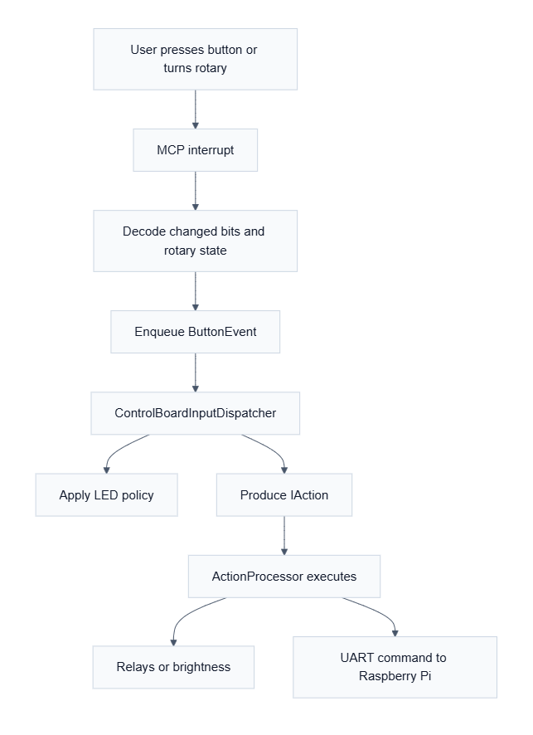
Figure 11

11.4 Sleep-Mode Input Policy
When the background status is sleeping, all inputs except the power button are suppressed. This prevents accidental wake-path side effects from transport or panel buttons while the system is in sleep or deep sleep.

12. Error Handling

12.1 Error Condition Table
Error | Cause | Detection | Recovery
NVS init failure | partition issues or version mismatch | nvs_flash_init() result | erase-and-retry for known page/version errors; otherwise log warning and continue without persistence
Relay setup or UART init failure | GPIO or driver errors | return value from bootstrap helpers | fail ControlBoard::init() and retry whole board init from app_main()
MCP init failure | I2C or GPIO interrupt setup failure | begin() returns error | fail init, flash failure indicator, retry from app_main()
Button queue full | bursty input or blocked consumer | xQueueSend() failure | drop event and log every 16th drop
UART checksum or framing error | corrupted or partial byte stream | deserializeMessage() false | byte-by-byte resynchronization in UartReceiver
No Pi heartbeat during boot | Pi absent or link down | waitForRpiToBoot() timeout | set boot-failure blink pattern, move to SLEEP, report init failure
No Pi heartbeat while ON | Pi crash, cable issue, or heartbeat loss | heartbeat_task timeout callback | set event bit and force SystemState to SLEEP unless debug simulate mode is enabled
SPI LED driver not initialized | premature caller use | m_started guard | log warning and ignore request
Status LED task creation failure | heap or RTOS failure | xTaskCreate() return | log error; corresponding indicator may not function

12.2 Recovery Strategy Summary

- Initialization errors are mostly handled by failing ControlBoard::init() and letting app_main() retry forever.
- Runtime UART corruption is handled by frame resynchronization rather than transport reset.
- Heartbeat loss is treated as a semantic system-state event, not just a communication error.
- Several low-level errors only log and continue, especially LED and NVS failures.

12.3 Potential Bugs and Behavioral Risks

- UartTransport::sendData() checks PIN_ESP32_DATA_READY before transmit even though the log says it is testing whether the Raspberry Pi is ready. That condition appears to inspect the ESP32 output line rather than the Pi input-ready line, so the readiness guard is likely wrong.
- ActionProcessor::triggerInitialPowerOn() returns failure when boot heartbeat times out, and app_main() responds by retrying initialization indefinitely. On a bench without a Pi, this can create repeated power-cycle behavior rather than a stable degraded mode.
- StatusLed objects are global statics and call init() from their constructors. That means FreeRTOS objects and LEDC configuration are created during static initialization, which is an unusual lifetime model and increases startup-order risk.
- test/test_simple_command_action/test_main.cpp still targets an old ActionResponse/execute() API, which suggests the embedded test suite contains drifted or stale tests.
- PowerStateTransitionHandler::runRpiShutdownSequence() ignores the boolean result of waitForRpiShutdown(). The shutdown path proceeds even if no heartbeat-timeout confirmation ever arrives.

13. Logging and Diagnostics

The firmware uses ESP_LOGI, ESP_LOGW, and ESP_LOGE extensively. Logging is not centralized; each subsystem owns its own log tag.
Diagnostic capabilities visible in code:
- startup logs for each major initialization phase,
- relay and UART operation logs,
- heartbeat received and timeout logs,
- MCP interrupt and rotary decode logs,
- NVS restore/save logs for brightness,
- compatibility warning when legacy heartbeat 0x9999 is received.
Available test assets:
- host-side CMake test target for protocol, routing, and dispatcher logic,
- Unity-based embedded tests for UART protocol, SPI LED driver, SPI boot indicator, and power LED.
Diagnostic limitations:
- there is no structured fault manager,
- there are no persistent error counters,
- inbound UART ACK/NACK handling is not implemented,
- no watchdog-specific recovery behavior is present in project code,
- stale tests reduce confidence that all declared tests still represent the current runtime model.
Troubleshooting guidance for maintainers:
- verify GPIO18 and GPIO42 interrupts first when input or serial paths appear dead,
- inspect heartbeat timing before assuming a power-state bug,
- confirm board::debug::k_simulateRpiBoot build behavior before bench testing without a Pi,
- treat boot-failure SPI flashing and power LED state separately because they come from different subsystems.

14. Memory Usage

14.1 Allocation Model
Static allocation:
- global singleton-like indicator objects in ledManager.cpp,
- fixed-size buffers in UartReceiver and UartTransport,
- compile-time action registration table.
Dynamic allocation:
- std::make_unique for ActionProcessor, ControlBoardInputDispatcher, SerialUartCommandSink, ActionUartDispatcher, RpiBootManager, RelayController, and PowerStateTransitionHandler,
- std::make_unique for each registered IActionSource,
- one heap allocation per produced IAction via createAction(),
- FreeRTOS queues, tasks, software timers, and event groups,
- UART driver allocation inside ESP-IDF.

14.2 Risks
- Frequent short-lived action-object allocation can fragment heap over long runtimes if button usage is heavy.
- Multiple worker tasks with 4096-byte stacks consume nontrivial RAM on a device without PSRAM.
- The project does not expose any stack high-water-mark or heap telemetry.
- Static-initialization creation of StatusLed RTOS objects makes memory lifetime harder to reason about.
- Brightness persistence depends on NVS being available; if NVS is degraded the system silently falls back to nonpersistent behavior.

14.3 Optimization Opportunities
- Replace heap-allocated IAction objects with a fixed-capacity object pool or value-type command struct.
- Collapse the two StatusLed task implementations into a shared worker or more timer-driven design.
- Consider explicit stack watermark logging for the MCP, UART RX, and action tasks.

15. Performance Analysis

15.1 Timing-Critical Paths

- MCP interrupt handling, because it must preserve rapid button and rotary transitions.
- UART RX wake and frame parsing, because the data-ready handshake depends on timely consumption.
- Power sequencing, because it includes long waits and determines user-perceived boot behavior.

15.2 CPU and Latency Concerns

- The UART heartbeat task polls every 100 ms, which is cheap.
- Power transitions block in the caller context with vTaskDelay() calls ranging from hundreds of milliseconds to tens of seconds.
- SpiBootIndicator continuously toggles all LEDs with its own worker task, which is simple but not the cheapest way to generate patterns.
- PowerLed uses a 50 ms periodic esp_timer callback to maintain flash, breathe, and blip behavior.

15.3 Bottlenecks

- action_task is a single consumer for all input events.
- I2C reads are performed during every MCP interrupt handling pass and include multiple register reads.
- UartReceiver uses repeated memmove() while resynchronizing corrupted streams, which is acceptable at current protocol volume but not ideal for higher throughput.

15.4 Recommendations

- Fix the UART handshake readiness check before attempting higher-rate command traffic.
- Replace the hard-coded startup delays with explicit power-good or rail-ready signals if hardware supports them.
- Consider a nonblocking or state-machine-based power sequencer if future work adds more concurrent runtime behavior.
- If button traffic increases, move from heap-allocated actions to a fixed message structure.

16. Security Considerations
The firmware does not implement authentication, encryption, or secure session management. Security concerns are therefore limited to local robustness and input validation.
Observed protections:
- UART frame checksum validation,
- start-byte framing and resynchronization,
- bounds checks on LED indices and button IDs,
- fixed-size queues and buffers,
- command gating so most non-power actions are ignored when the system is not ON.
Observed gaps:
- any device on the UART link that can emit valid frames can control the Raspberry Pi-facing command path,
- no authorization layer exists for system or relay-affecting commands,
- no replay protection or sequence validation is enforced,
- no tamper detection exists on I2C or GPIO inputs.

17. Build System

17.1 PlatformIO Configuration

- Platform: espressif32 @ ~6.5.0
- Framework: espidf
- Default environment: esp32-s3-devkitc-1-16mb
- Release environment: esp32-s3-devkitc-1-16mb-release
- Monitor speed: 115200
- CPU frequency: 240000000L
- Partition table: partitions.csv
- Library dependency finder mode: deep+
- Shared build flag: -Ilib
- Release-only extra flag: -DNDEBUG

17.2 CMake Structure

- Top-level CMakeLists.txt registers an ESP-IDF project.
- src/CMakeLists.txt glob-registers all .c and .cpp files in src/ and major lib/ subtrees.
- host_tests/CMakeLists.txt builds a separate host executable for logic tests on a desktop compiler.

17.3 Build Behavior

- Debug builds enable board::debug::k_simulateRpiBoot unless overridden, which changes boot behavior materially.
- Release builds define NDEBUG, which disables simulated-RPi boot by default.

18. Dependency Analysis

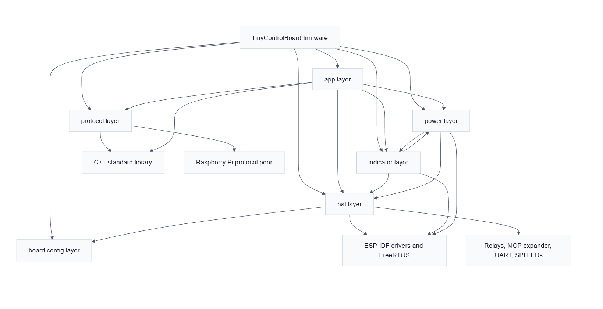
External dependencies actually used by code:
- ESP-IDF FreeRTOS primitives,
- ESP-IDF UART, GPIO, I2C, SPI, LEDC, NVS, and esp_timer APIs,
- C++ standard library features such as std::unique_ptr, std::function, std::array, and std::atomic.

19. Maintenance Guide

19.1 Adding a New Front-Panel Feature
For a new button-driven command:
- Add the new CommandId in uartProtocol.hpp if it needs a protocol ID.
- If it is a simple remote command, add one row to ControlBoardActionRegistry.cpp.
- If it is a local-only action, also update ActionCommandRoutingPolicy.hpp and potentially ActionFactory.cpp if a new action class is needed.
- If it is a toggle that should normalize to one wire command plus a boolean parameter, update ActionUartDispatcher.cpp.
- Update tests for dispatcher, protocol, and any new runtime policy.

19.2 Adding a New Peripheral
- Add pins and constants to boardConfig.hpp.
- Encapsulate the peripheral in lib/hal/ or lib/indicators/ depending on whether it is generic hardware or UI-specific.
- Expose it through ControlBoard only if it participates in application behavior.
- Avoid direct ISR-to-policy coupling; follow the existing callback plus queue pattern.

19.3 Modifying the UART Protocol
- Update CommandId or frame semantics in uartProtocol.hpp and uartProtocol.cpp.
- Update command naming in commandCatalog.cpp.
- Update ActionUartDispatcher.cpp if routing or normalization changes.
- Update both host tests and Unity protocol tests.
- Keep Raspberry Pi-side handlers synchronized, especially for normalized toggle commands and heartbeat IDs.

19.4 Areas Requiring Caution
- Do not change power-state timing casually; it affects relay sequencing, user-visible LEDs, and Raspberry Pi boot assumptions.
- Be careful with static object construction in ledManager.cpp; indicator lifetime is unusual and tightly coupled to runtime startup.
- Avoid broadening ISR responsibilities. The current design depends on tasks doing the real work.
- Treat debug-mode simulated Pi boot as a behavioral fork, not just a logging option.
- Verify embedded tests before trusting them; at least one test target is stale relative to the runtime action API.

20. Appendix

20.1 File Structure

src
File | Purpose
src/main.cpp | Firmware entry point, PM configuration, startup delay, init retry loop.
src/main.h | Minimal include wrapper that pulls ControlBoard into main.cpp.

lib/app
File | Purpose
lib/app/ActionCommandRoute.hpp | Enum describing intrinsic command routing categories.
lib/app/ActionCommandRoutingPolicy.hpp | Compile-time policy that maps command IDs to routing categories.
lib/app/ActionContext.hpp | Dependency bundle passed into IAction::execute().
lib/app/ActionFactory.cpp | Creates concrete IAction implementations from command IDs.
lib/app/ActionFactory.hpp | Factory declaration for command-to-action creation.
lib/app/actionProcessor.cpp | Executes actions, enforces power gating, handles heartbeat, scaffolds inbound UART handling.
lib/app/actionProcessor.hpp | ActionProcessor public interface.
lib/app/ActionUartDispatcher.cpp | Normalizes and sends UART-facing actions.
lib/app/ActionUartDispatcher.hpp | ActionUartDispatcher and UART sink interface declarations.
lib/app/ButtonEvent.hpp | Queue payload type for press, release, and rotary events.
lib/app/ButtonEventQueue.cpp | FreeRTOS queue/task wrapper for serialized input dispatch.
lib/app/ButtonEventQueue.hpp | ButtonEventQueue declaration and queue/task constants.
lib/app/ControlBoard.cpp | Top-level orchestrator implementation and UART callback owner.
lib/app/ControlBoard.hpp | ControlBoard declaration and owned subsystem references.
lib/app/ControlBoardActionRegistry.cpp | Populates the button-to-action map from a registration table.
lib/app/ControlBoardActionRegistry.hpp | Registry declaration.
lib/app/ControlBoardBootstrap.cpp | Boot helper functions for relays, serial, MCP, and indicators.
lib/app/ControlBoardBootstrap.hpp | Bootstrap helper declarations and callback typedefs.
lib/app/ControlBoardButtonIds.hpp | Namespace alias from board button IDs into app code.
lib/app/ControlBoardInputDispatcher.cpp | Applies sleep suppression, LED policy, and action production for inputs.
lib/app/ControlBoardInputDispatcher.hpp | Dispatcher interfaces, LED policy enum, and action-map types.
lib/app/SerialHeartbeatRouter.hpp | Heartbeat compatibility constants and helper predicate.
lib/app/SerialUartCommandSink.cpp | Thin adapter from command sink interface to UartTransport.
lib/app/SerialUartCommandSink.hpp | SerialUartCommandSink declaration.
lib/app/SystemState.hpp | Atomic runtime power-state container.

lib/app/commands
File | Purpose
lib/app/commands/BrightnessAction.cpp | Executes local display-off and brightness-cycle commands.
lib/app/commands/BrightnessAction.hpp | Brightness action declaration.
lib/app/commands/PowerTransitionAction.cpp | Executes power-state transitions through the power handler.
lib/app/commands/PowerTransitionAction.hpp | Power transition action declaration.
lib/app/commands/RelayAction.cpp | Executes local DAC relay toggles.
lib/app/commands/RelayAction.hpp | Relay action declaration.
lib/app/commands/SystemAction.cpp | Executes local system commands such as Pi shutdown.
lib/app/commands/SystemAction.hpp | System action declaration.
lib/app/commands/UartDispatchAction.cpp | Executes remote-command dispatch via ActionUartDispatcher.
lib/app/commands/UartDispatchAction.hpp | UART dispatch action declaration.

lib/board
File | Purpose
lib/board/boardButtonIds.hpp | Canonical button and rotary ID assignments.
lib/board/boardConfig.hpp | Timing, serial, I2C, relay, indicator, and debug configuration constants.
lib/board/boardIdentity.hpp | Board identity strings such as model and firmware version.

lib/hal/buttons
File | Purpose
lib/hal/buttons/mcpInputHandler.cpp | MCP input expander driver, interrupt-task loop, and rotary decode.
lib/hal/buttons/mcpInputHandler.hpp | MCP register constants, callbacks, and class declaration.
lib/hal/buttons/project_cfg.hpp | Optional MCP debug-scan compile-time flag holder.

lib/hal/leds
File | Purpose
lib/hal/leds/pwmLed.cpp | Small LEDC wrapper implementation.
lib/hal/leds/pwmLed.hpp | LedPwm abstraction declaration.
lib/hal/leds/spiLedDriver.cpp | SPI-backed 16-bit LED driver implementation.
lib/hal/leds/spiLedDriver.hpp | SPI LED driver declaration and LED count constant.

lib/hal/relay
File | Purpose
lib/hal/relay/relay.cpp | GPIO-based relay initialization and state setting.
lib/hal/relay/relay.hpp | Relay pin aliases and StandardRelay singleton interface.

lib/hal/storage
File | Purpose
lib/hal/storage/nvsStorage.cpp | Generic NVS read/write wrapper implementation.
lib/hal/storage/nvsStorage.hpp | NVS wrapper declaration for typed key-value access.

lib/hal/uart
File | Purpose
lib/hal/uart/serial.cpp | UART transport implementation, GPIO handshake, RX task, and heartbeat monitor.
lib/hal/uart/serial.hpp | UART transport declaration, pin aliases, and buffer members.
lib/hal/uart/uartReceiver.cpp | Byte-stream framing and resynchronization logic.
lib/hal/uart/uartReceiver.hpp | UartReceiver declaration and fixed buffer sizes.

lib/indicators
File | Purpose
lib/indicators/activityStatus.hpp | Working-status enum and activity-status sink interface.
lib/indicators/ledDefinitions.hpp | LEDC channel and timing macros.
lib/indicators/ledManager.cpp | Singleton-style construction and lazy init accessors for indicators.
lib/indicators/ledManager.hpp | Indicator accessor declarations.
lib/indicators/MonitorBrightnessController.cpp | Brightness persistence, display-off mode, and PWM updates.
lib/indicators/monitorBrightnessController.hpp | Brightness controller declaration and state members.
lib/indicators/powerLed.cpp | Dual-LED power-state indicator with timer-driven patterns.
lib/indicators/powerLed.hpp | Power LED class declaration.
lib/indicators/SpiBootIndicator.cpp | Boot/failure flashing task over SPI button LEDs.
lib/indicators/SpiBootIndicator.hpp | SPI boot indicator declaration and state enum.
lib/indicators/statusLed.cpp | Queue-driven status LED controller with blink and breathe helpers.
lib/indicators/statusLed.hpp | Status LED declaration.

lib/input
File | Purpose
lib/input/input.hpp | Aggregation header for input-related includes.

lib/input/actions
File | Purpose
lib/input/actions/actionsResponse.cpp | Empty implementation unit retained for build compatibility.
lib/input/actions/actionsResponse.hpp | Test-helper no-op Action implementation.
lib/input/actions/actionTemplates.hpp | Live IActionSource implementations for simple, toggle, timed, and rotary behavior.
lib/input/actions/buttonAction.hpp | IActionSource interface declaration.
lib/input/actions/IAction.hpp | Core executable action interface and payload fields.
lib/input/actions/SimpleCommandAction.hpp | Backward-compatibility include shim for the simple action source.

lib/power
File | Purpose
lib/power/powerState.hpp | Power-state enum.
lib/power/PowerStateTransitionHandler.cpp | Boot, sleep, and deep-sleep sequencing logic.
lib/power/PowerStateTransitionHandler.hpp | Power transition handler declaration.
lib/power/PowerStateTransitionPolicy.hpp | Power-button decision policy based on current state and hold time.
lib/power/RelayController.cpp | Relay-sequencing helper implementation.
lib/power/RelayController.hpp | Relay controller declaration.
lib/power/RPIBootManager.cpp | Event-group-based boot and shutdown wait logic.
lib/power/RPIBootManager.hpp | Boot manager declaration and event bits.

lib/protocol
File | Purpose
lib/protocol/commandCatalog.cpp | Maps command IDs to names and simple UART log tags.
lib/protocol/commandCatalog.hpp | Command-catalog lookup declarations.
lib/protocol/uartProtocol.cpp | UART serialization, deserialization, and checksum implementation.
lib/protocol/uartProtocol.hpp | Protocol constants, enums, and UartMessage definition.

host_tests
File | Purpose
host_tests/host_test_action_stubs.cpp | Desktop-link stubs for action execute methods.
host_tests/test_logic.cpp | Host-side unit tests for protocol, routing, dispatcher, and heartbeat helpers.

test
File | Purpose
test/test_power_led/test_main.cpp | Unity tests for power LED constructor defaults and brightness clamping.
test/test_simple_command_action/test_main.cpp | Embedded test targeting an older simple-action API; appears stale relative to current code.
test/test_spi_boot_indicator/test_main.cpp | Unity tests for SPI boot-indicator state and task behavior.
test/test_spi_led_driver/test_main.cpp | Unity tests for SPI LED driver guards and constants.
test/test_uart_protocol/test_main.cpp | Unity tests for UART message defaults, serialization, and checksum validation.

20.2 Configuration Parameters

Parameter | Value | Meaning
board::timing::k_heartbeatTimeoutMs | 30000 ms | Loss-of-heartbeat threshold
board::timing::k_initDelayMs | 5000 ms | Additional startup settle delay in bootstrap
board::timing::k_powerSettleDelayMs | 1500 ms | Delay after enabling DAC/output-stage rails
board::timing::k_screenOnDelayMs | 1000 ms | Screen and Pi power-on delay
board::timing::k_rpiBootTimeoutMs | 60000 ms | Max wait for boot heartbeat
board::timing::k_rpiShutdownTimeoutMs | 60000 ms | Max wait for shutdown confirmation
board::timing::k_rpiShutdownSettleDelayMs | 500 ms | Delay after Pi relay off
board::timing::k_screenPowerOffDelayMs | 5000 ms | Delay before sleep finalization
board::serial::k_baudRate | 115200 | UART link speed
board::serial::k_bufferSize | 256 bytes | Requested UART buffer size
board::i2c::k_clockSpeedHz | 50000 Hz | I2C bus speed
board::i2c::k_mcpTimeoutMs | 10 ms | I2C command timeout
controlSystem::kLongPressThresholdMs | 3000 ms | Power short-vs-long press threshold

20.3 Important Constants and Definitions
Constant | Value | Notes
UART_START_BYTE | 0xAA | Start of frame
UART_PROTOCOL_VERSION | 0x01 | Protocol version
UART_PACKET_SIZE | 18 | Fixed frame length
APP_ESP32 | 0x01 | Source app ID
APP_PI | 0x02 | Peer app ID
MSG_COMMAND | 0x01 | UART message type
MSG_STATUS | 0x02 | UART message type
MSG_ACK | 0x03 | UART message type
MSG_NACK | 0x04 | UART message type
board::debug::k_simulateRpiBoot | build-dependent | true by default in debug, false by default in release
kLegacyHeartbeatCommandId | 0x9999 | Backward compatibility heartbeat alias

20.4 Summary of Highest-Value Follow-Up Work
- Fix the UART handshake readiness check so transmit gating uses the correct peer-ready signal.
- Decide whether missing Pi heartbeat at boot should produce a stable degraded mode instead of perpetual init retries.
- Replace or validate stale embedded tests, especially the simple-command action test target.
- Consolidate command-routing rules so adding a new command does not require touching multiple disconnected tables.
- Remove or explicitly classify dormant helper code to reduce ambiguity for future maintainers.

