/****************************************************************

* Class: CMSC203 CRN46667

* Program: Assignment 2 Birthday Gift

* Instructor: Dr. Grinberg

* Description: A program takes in the names, ages, and choices of gifts from

* user and returns order information to user.

* Due: 07/05/2020

* I pledge that I have completed the programming assignment independently

* I have not given my code to any student.

* Anthony Liu

****************************************************************/

**Pseudocode**

Start

Display dialog welcome message

Display console Header message

Initialize anotherGift to “”

Initialize totalCost to zero

DO

GET and initialize name from user

GET and initialize age from user

GET and initialize and pick toy user wants

WHILE toy doesn’t equal valid toy

GET valid toy from user

Create Toy object with picked toy and age

Initialize Boolean goodGift with toy.ageOK method

IF goodGift is false

Display input “Gift isn’t age appropriate, cancel Y/N”

IF input is N

goodGift = true

ELSE

anotherGift equals “yes”

IF goodGift is true

Display “Do you want a card with gift? Y/N”

IF Y

Add card to toy cost

Display “Do you want a balloon with gift? Y/N”

IF Y

Add balloon to toy cost

Display “The gift is for name and cost”

Add toy cost to total cost

Display and SET anotherGift “Do you want another toy? Yes or No”

WHILE anotherGift equals “yes”

Create random object

Initialize num to random from 0-99999

FORMAT num to %05d

Display totalCost

Display order num

Display programmer name

Test Plan

Case 1 tests for 1 gift, valid gift, with both balloon and card added

Case 2 tests for 1 gift, an invalid gift, with only card added

Case 3 tests for 1 gift, 1 inappropriate gift not replaced

Case 4 tests for 2 gift, 1 inappropriate gift replace, only balloon added

|  |  |  |  |  |
| --- | --- | --- | --- | --- |
| **Test Case #** | **Input** | **Expected Output** | **Actual Output** | **Did the test pass?** |
| 1 | Enter the name of the child: Jason Smith  How old is the child? 3  Choose a toy: a plushie, blocks, or a book: blocks  Do you want a card with the gift? Yes  Do you want a balloon with the gift? Yes  Do you want another toy? No | BIRTHDAY GIFTS  The gift for Jason Smith at 3 years old is blocks for $28.95  The total cost of your order is $28.95  Order number is: #####  Programmer: Anthony Liu | BIRTHDAY GIFTS  The gift for Jason Smith at 3 years old is blocks for $28.95  The total cost of your order is $28.95  Order number is: 34476  Programmer: Anthony Liu | Yes |
| 2 | Enter the name of the child: Anthony Liu  How old is the child? 1  Choose a toy: a plushie, blocks, or a book: plushi  Invalid Toy: Please choose ad plushie, blocks, or book: plushie  Do you want a card with the gift? Yes  Do you want a balloon with the gift? No  Do you want another toy? No | BIRTHDAY GIFTS  The gift for Anthony Liu at 1 years old is a plushie for $27.95  The total cost of your order is $27.95  Order number is: #####  Programmer: Anthony Liu | BIRTHDAY GIFTS  The gift for Anthony Liu at 1 years old is a plushie for $27.95  The total cost of your order is $27.95  Order number is: 10994  Programmer: Anthony Liu | Yes |
| 3 | Enter the name of the child: Jenny Ha  How old is the child? 13  Choose a toy: a plushie, blocks, or a book: book  Not age appropriate, do you want to cancel this toy? No  Do you want a card with the gift? No  Do you want a balloon with the gift? No  Do you want another toy? No | BIRTHDAY GIFTS  The gift for Jenny Ha at 13 years old is a book for $15.00  The total cost of your order is $15.00  Order number is: #####  Programmer: Anthony Liu | BIRTHDAY GIFTS  The gift for Jenny Ha at 13 years old is a book for $15.00  The total cost of your order is $15.00  Order number is: 94524  Programmer: Anthony Liu | Yes |
| 4 | Enter the name of the child: John Smith  How old is the child? 7  Choose a toy: a plushie, blocks, or a book: book  Do you want a card with the gift? No  Do you want a balloon with the gift? Yes  Do you want another toy? Yes  Enter the name of the child: Katie Smith  How old is the child? 2  Choose a toy: a plushie, blocks, or a book: blocks  Not age appropriate, do you want to cancel this toy? Yes  Enter the name of the child: Nina Smith  How old is the child? 3  Choose a toy: a plushie, blocks, or a book: blocks  Do you want a card with the gift? No  Do you want a balloon with the gift? Yes  Do you want another toy? No | BIRTHDAY GIFTS  The gift for John Smith at 7 years old is a book for $21.00  The gift for Nina Smith at 3 years old is blocks for $26.00  The total cost of your order is $47.00  Order number is: #####  Programmer: Anthony Liu | BIRTHDAY GIFTS  The gift for John Smith at 7 years old is a book for $21.00  The gift for Nina Smith at 3 years old is blocks for $26.00  The total cost of your order is $47.00  Order number is: 56183  Programmer: Anthony Liu | Yes |

CASE 1 Screen Shots

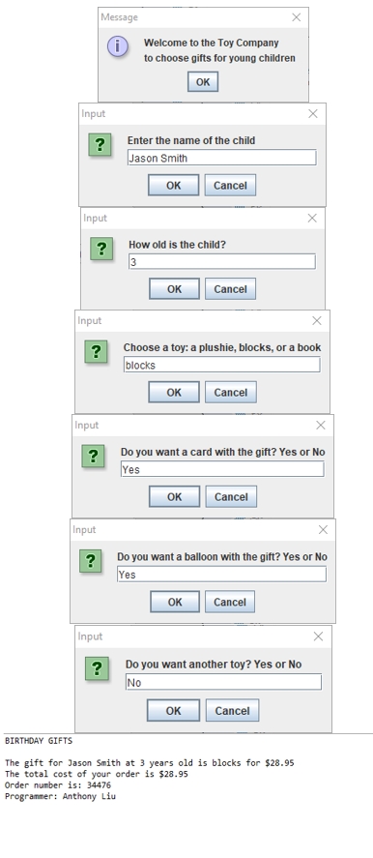

Case 2

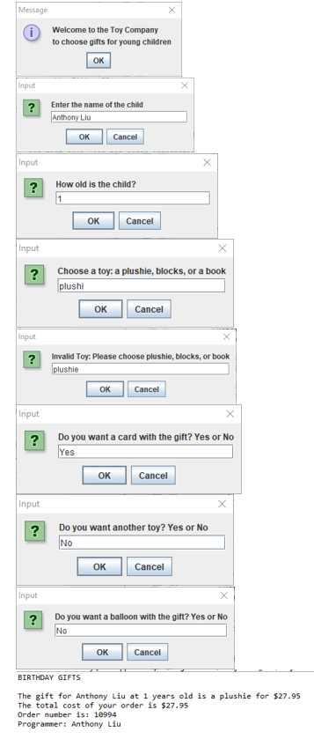

Case 3

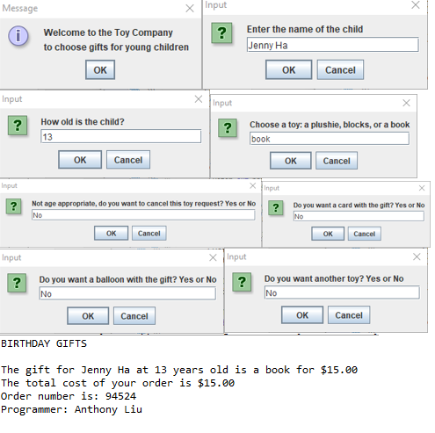

Case 4

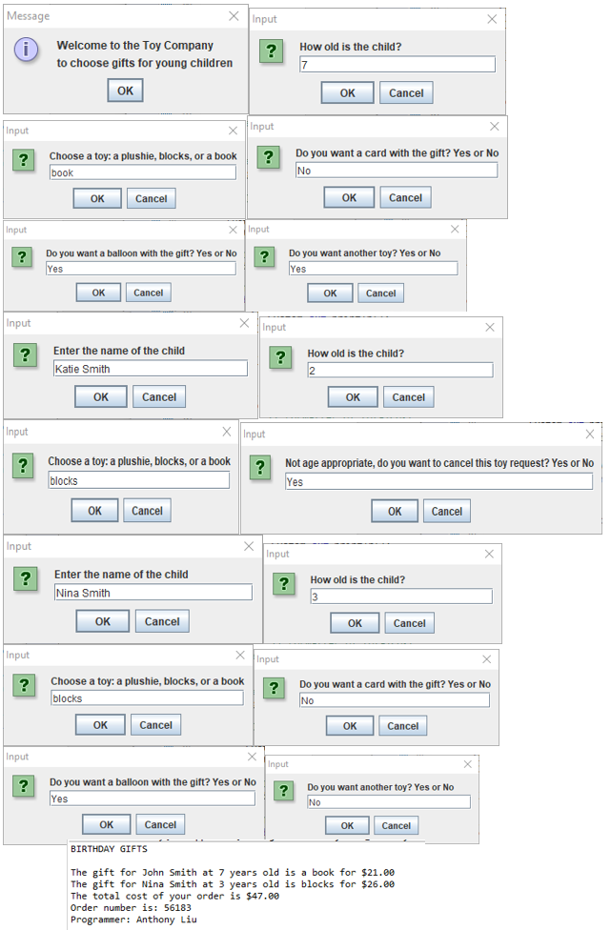

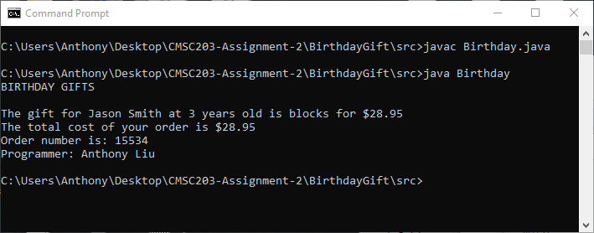

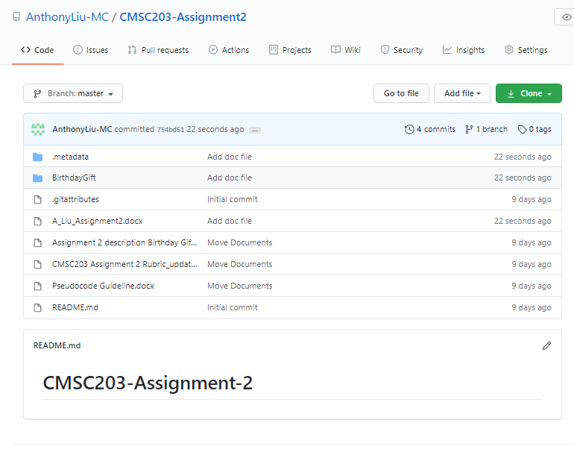

**Lessons Learned:**

**What have you learned**? This was a good project to use JOptionPane. Since we normally use print statements in most projects it was not practice it a lot.

**What did you struggle with?** Learning how to implement the do-while loop property was the hardest part in my opinion. The program had a large set of requirements and nuances that I had to work though.

**What would you do differently on your next project?** On my next emphasis, I will put greater emphasis on creating a plan for writing the code. Although my pseudo code served as a good guideline, there were a few details that I missed and I ended up having to rewrite portions of my code,

**What parts of this assignment were you successful with, and what parts (if any) were you not successful with.** I feel that I have a pretty good understanding now of all the concepts taught in this project. It helped solidify my understanding of validation loops.

**Check List:**

|  |  |  |  |
| --- | --- | --- | --- |
| **#** |  | **Y/N** | **Comments** |
|  | **Assignment files:** |  |  |
|  | * FirstInitialLastName_ Assignment#_Moss.zip | **Yes** |  |
|  | * FirstInitialLastName_Assignment#.docx | **Yes** |  |
|  | * Source java files | **Yes** |  |
|  | **Program compiles** | **Yes** |  |
|  | **Program runs with desired outputs related to a Test Plan** | **Yes** |  |
|  | **Documentation file:** |  |  |
|  | * Comprehensive Test Plan | **Yes** |  |
|  | * Screenshots based on Test Plan | **Yes** |  |
|  | * Screenshots of your GitHub account with submitted Assignment# (if required) | **Yes** |  |
|  | * UML Diagram (if required) | **N/A** |  |
|  | * Algorithms/Pseudocode (if required) | **N/A** |  |
|  | * Flowchart (if required) | **N/A** |  |
|  | * Lessons Learned | **Yes** |  |
|  | * Checklist is completed and included in the Documentation | **Yes** |  |