Assignment 01
Data Cleaning and Summarising

Name: Anthony Mackenzi Fernando Student ID: S4129857

Data Preparation

Data preparation is one of the most significant parts in data analyzing. This consists few major parts such that cleaning unappropiate data, anomalies, outlier detection, ect. First of all the work path is defined and the hotel data is loaded into the work direction. Then the head of the data frame is prnted to get a better idea of the data structure.

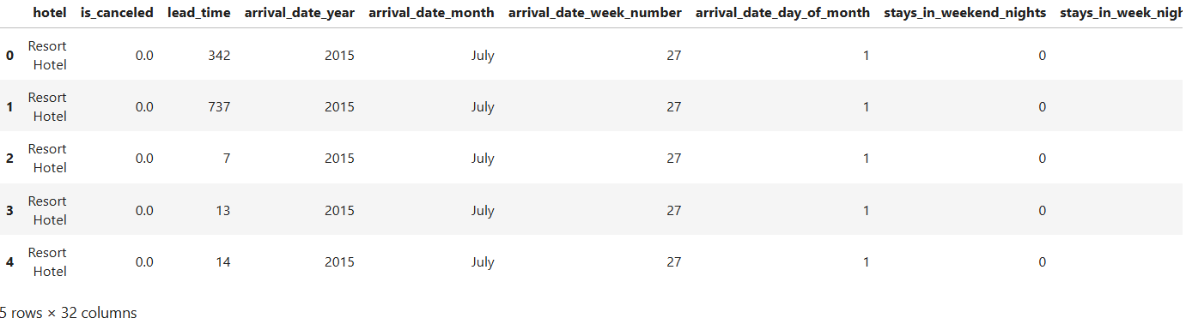
The shape of the dataframe is checked to find dimension of the dataframe.

Error 1
The data frame contains 119392 rows and 32 columns.
Then duplicate values are eliminated from the dataframe. Otherwise they can make a bad influence when data is analysed.

Error 2
Standardizing and dropping un appropriate data

Then zero entries of guests are swept off. All none zero missing values are checked. Since zero total guests are meaningless for the analysis they are swept and some attributes structure is changed in to correct data type.
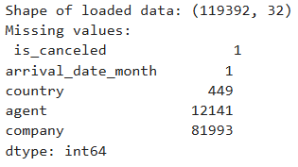

Error 3
Handling missing data(Drop column)

Since total amount of row data is 119392, there are 81993 missing values in the variable “company”. As a percentage it’s more than 50% of total row data. There’s no certain way to impute these missing data therefore the attribute iis eliminated from the dataframe. [1]

Error 4
Data replace (Imputing data)
Since agent includes a significant amount of data but still it’s nearly 10% of the total data set, missing values are replaced with the mean of the remaining data. Mean is a most propable value for the attribute. Performance could be improved further if the missing values are replaced with median.

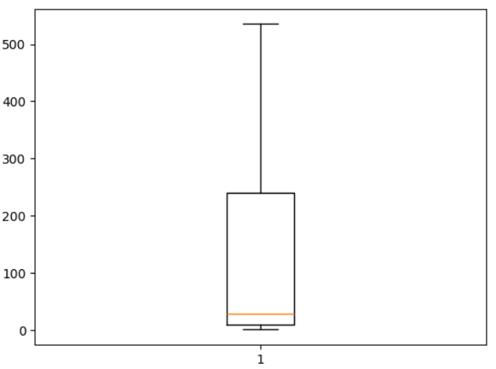
Then the summary of the cleaned data frame is executed and attached below.

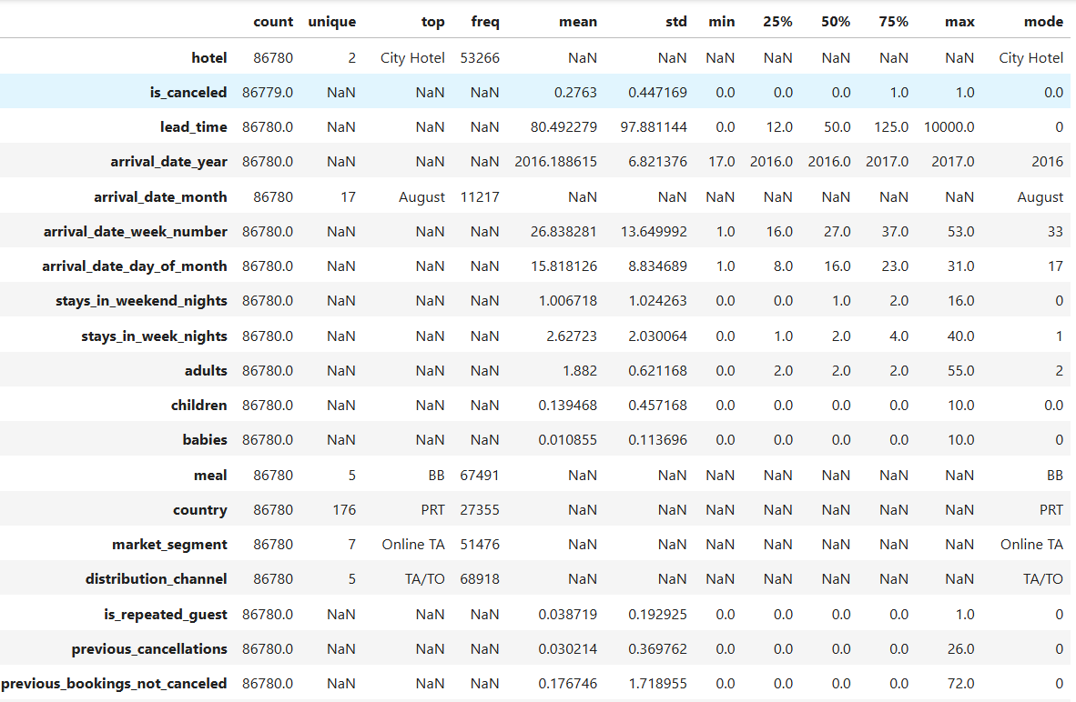
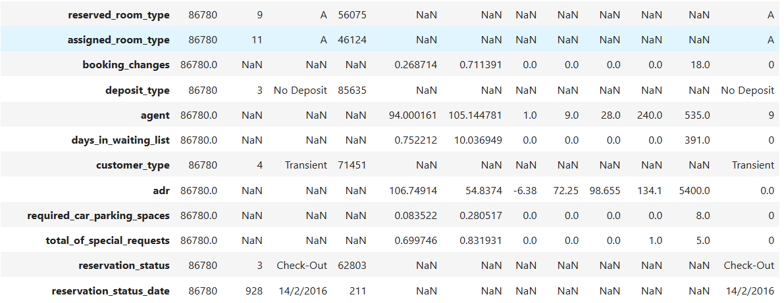

Data Exploration

Task 2.1

In the question we are supposed to highlight possible trends of booking attributes over time in 2016. First of all 2016 data are filtered from the cleaned data frame. Then three key attributes are selected to analyse over time. ‘total booking’, ‘cancellations’, and ‘mean lead time’ are grouped by month to calculate the total count. Finally monthly booking trend graph is made with the help of packages “seaborn’, and ‘matplotlib.pyplot’.
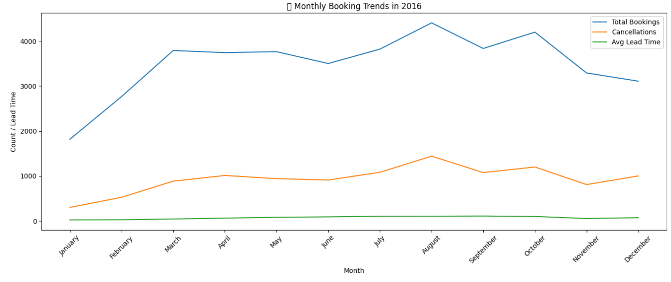
Overally in all months over year has a same shape of trend in between total booking and, cancellation except in december. In december total booking is decresed and total cancellation is increased. Peak months of booking hotel are august, october, and march.

Task 2.2

This question subjects seasonal fluctuations between 2015 and 2017. First of all seasons are defined and it’s added to the data frame. Then data are filtered from 2015 to 2017. Grouped by season and counted in summary. Hence barplot is made to interpret seasonal changes from 2015 to 2017.
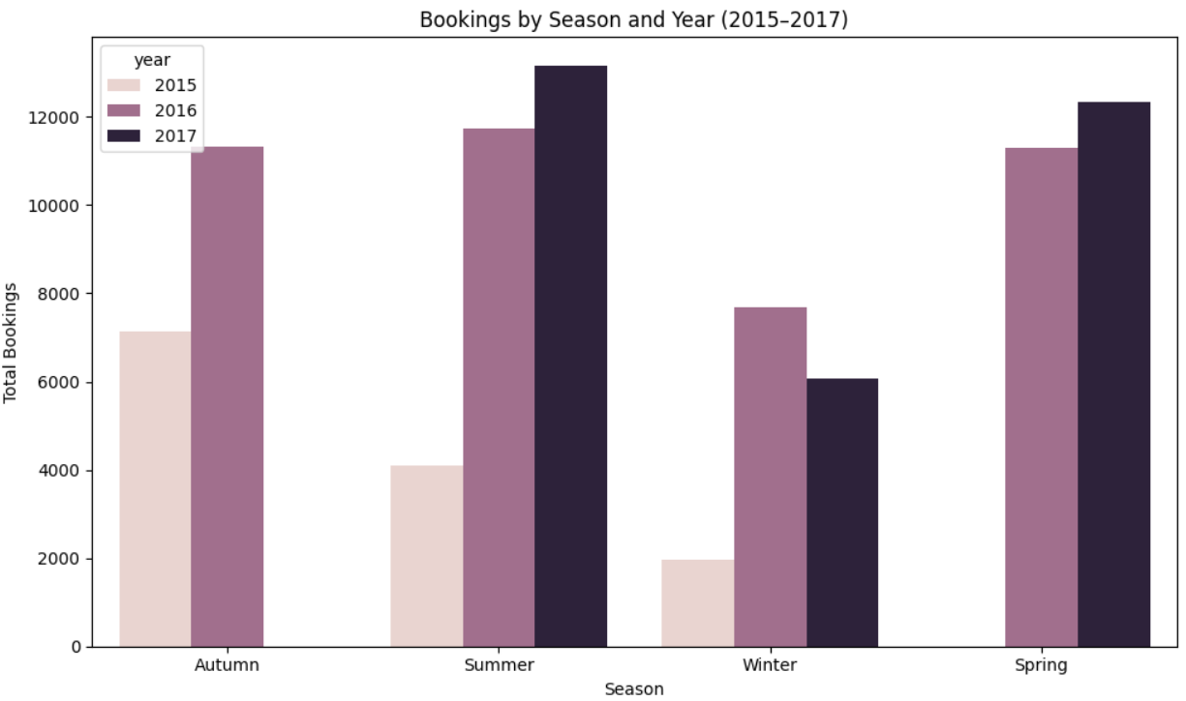
Total amount of booking is higher respectively in 2016 based on available data. Total booking has a peak in 2017 in summer. Overally summer has a better influence for booking hotels. In 2016 total booking in each seasons is almost equal.

Task 2.3
Top five countries of booking hotel are selected by determining the total amount of guests with the sum of adults, children, and babies. They are summarised by total stay nights and cancelled. Barplot and a frequency plot are used at same time to interpret them. Average night stay is higher from Great Britain and Protugal. But cancellation rate is lower from Great Britain and higher from Protugal.
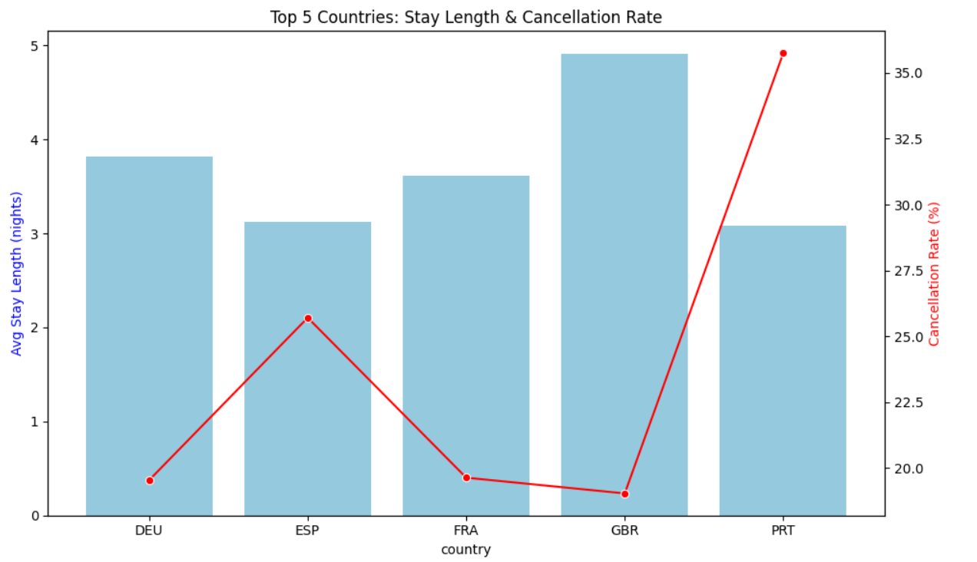

References
[1]
“Dealing With Missing Values in Python,” Analytics Vidhya, May 19, 2021. https://www.analyticsvidhya.com/blog/2021/05/dealing-with-missing-values-in-python-a-complete-guide/

‌

