**CS 316 Program 5**

ASP.NET/VB.NET web game that allows a user to gamble a stake in a card selection game across multiple sessions by recording the user’s session via cookies.

Author: Anthony Neace

Date: November 29, 2012

Purpose: This program is a stand-alone card game that allows a player to gamble a persistent stake. Based on the outcome of the card game, the player may win multiple of their wager, or lose their wager outright.

**Preconditions:**

Game Server is available and HTML generated pages have been presented correctly in Internet Explorer, Firefox, or Chrome

Images load correctly

User submits valid name and stake information

**Postconditions:**

Browser receives a cookie to remember the user’s session (within the next 24 hours)

A game is completed in a win/loss state dependent upon user input and card selection

Cookie is updated each time the stake is updated (each time the game is completed)

**Components:**

1. Initial HTML Page
2. Main Game HTML Page
3. Session Cookie
4. VB Script to handle game logic

**Interfaces:**

1. Initial Name/Stake Web Form to VB Script to process user Data
2. Game Web Form – User Selects Wager, Card, clicks card to continue
3. Updated Game Web Form for win/loss state – displays revealed card, won/lost value
4. Script to cookie to set cookie with new or updated stake values

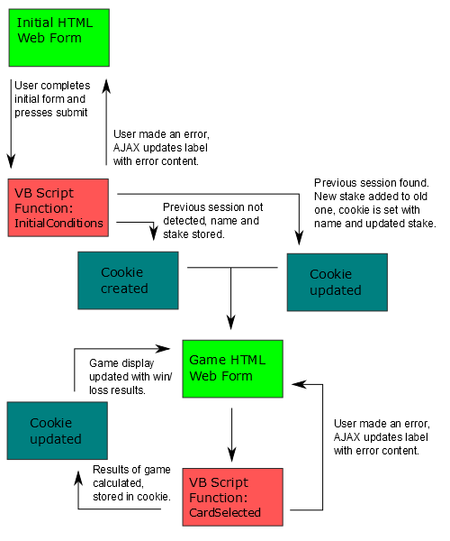

**Procedure:**

Use the Visual Studio toolbox to create form elements for the name, stake, wager, and card selection fields. Each of these will have a unique ID to be accessed by the VB script.

For error handling, use the toolbox to create labels associated with the name, stake, wager, and card selection. Each of these will have a unique ID to be accessed by the VB script.

Create buttons and image for the playing card.

Drag appropriate Ajax update tools from the Ajax extensions in the toolbox.

Retrieve the current time and display it on the initial display and every subsequent display for the game’s session.

Set appropriate header tags in aspx page. (Following the example project given in class.)

**Function InitialConditions**

Preconditions: Handles form input. Submit button is pressed to execute InitialConditions.

Postconditions: Cookie is created or otherwise updated. User is led to game display. Timestamp is made.

If name is blank, set name error label text to “**Please enter your name.**”

If stake is not a digit, set stake error label to “**Stake must be between 10 and 500**.”

If stake is out of the range 10-500, set stake error label to “**Stake must be between 10 and 500**.”

(Errors are updated via ajax).

If a cookie with the user’s input name exists, add the new input stake to the existing stake and set the cookie to expire in 24 hours.

Else, set a new cookie with the user’s name and stake to expire in 24 hours.

Direct the user the Game Interface. Display the card back.

End function.

**Function CardSelected**

Preconditions: Handles form input. Card is clicked to execute CardSelected.

Postconditions: Handles win/loss state to update form. Cookie updated with new stake.

If wager is greater than stake, set wager error label text to “Bet is greater than current stake.”

If wager is not a non-negative integer, set wager error label text to “Please enter a valid bet.”

If card name is not upper/lower A,F,E, or O, set card error label text to “Please enter A, F, E or O.”

(Errors are updated via ajax).

Randomly Select a Card to compare against the player’s card. This will be selected by “shuffling” the deck… choosing a random number from (1-52), where each value is paired to a single card in the deck.

If the player card matches the computer’s card

If Ace, set stake to stake+(wager*12)

If Face, set stake to stake+(wager*4)

If Even, set stake to stake+(wager*2)

If Odd, set stake to stake+(wager*3)

Else, set stake to stake-wager.

Update image on the HTML page to display the selected card, instead of the covered card.

Update the user’s cookie to hold the new stake.

Via AJAX: Update the stake, display “earnings” in next to win/loss label.

End function.