Provisional Patent Application of
Anthony J. Nystrom
Lawrence Botley
Genetibase, Inc.
For
TITLE: Mobile matching internet social networking and marketing

Description
Match service. (Bluetooth and or WIFI implementation)
Random user marketing (Targeted ad placement, Bluetooth)
Bounce Marketing (Bluetooth and or WIFI implementation)
Marketing network (business access to user base, Bluetooth, Site)
Mobile → Internet → Mobile video conferencing (Bluetooth and WIFI or implementation)
The invention is about finally merging the online social networking world with the "real" world. Bluetooth messaging and protocol stack has been largely ignored, except for hardware devices. Its capabilities rival any form of rich media delivery such as mms, but without having to involve the online carriers!
Current social networking sites up until now are pretty much all the same. It's virtual, nothing tangible, no real context. And revenue is quite simply limited to site advertising.
Where do social networking sites fail? Well, if you are interested in meeting someone in Japan that shares your interests then great. If not, well then, at least you met someone in Japan. The point is, why not utilize the fever of the online social networking world and extend it to the "real" world. So now you can meet people online that you can actually meet in person. For example, for some people it may be nice to know that girl standing 3 feet behind you in the starbucks line shares your interests. And it would be good to know that when you are actually standing in line. This is just the beginning. Check out the plan and let me know if it interests you. One more point... All of what you will read can be done with zero involvement of the mobile carriers, which would in most circumstances kill ideas that intermix online and mobile solutions.
I hear some people saying. "I don't want to receive ads on my phone". I say sure you don't. You don't want to receive ads for things you won't buy. But hey, if you like Sushi, and you are walking past a Sushi restaurant and you get a BT message that today's sushi is 20% percent off just for you, you might like that ad!
After looking at the plan, it is important to remember that this isn't limited to Bluetooth. Wi-Fi works just as well as a delivery platform that avoids the mobile carriers and their "suck em dry" mentality with sms and mms. And with Bluetooth the short range technology is only getting better. Before limited to 30 feet, now as far as 300 feet, and only improving with BT 2.0 +.
Social networking and online dating web sites are amongst the most popular forms of web use amongst web users aged 16-25. This report makes a detailed analysis of existing systems and through this a new mobile device system will be designed which allows users to host a Bluetooth client/server that matches other users in the near proximity when going about daily activities. Matched users are then able to log onto a central web server to view and chat to others who were matched when doing similar activities in the same places at the same time. As well we have incorporated a viable and extensive marketing platform based upon the social networking concept.
Bluetooth also offers the potential for very specific marketing. Due to its short range, proximity detection features and auto connection. The software will be marketing to users within specific areas of interest and with location awareness. Bluetooth also offers marketing opportunities for users outside the network, for the very same reasons. Retailers can utilize it to market to individuals in real-time and with specific relevant content.
This mobile matching system improves on existing social networking by creating a fun and interactive way of meeting people who live and work the same area. The system creates a more personal way of meeting new people than the traditional method of searching large databases of members using keywords and locality options.
The final device application has been designed for Windows Mobile 2003, WM6, Symbian and Java, and uses a purpose built secure binary protocol for Bluetooth communications. Users running the application as a background service can normally be within a 10M proximity of each other for around 3 seconds before both devices communicate and decide whether to match. This is fast enough to match people walking past each other in the street. As Bluetooth technology improves these distances can be maximized to over 100M.
Profiles and match filters that are set by individual users are traded to then decipher if each users meets basic criteria such as age and gender. Upon a successful match users are stored locally on the device in XML along with device configuration settings. With a single click users can synchronize their devices with the central server via a binary protocol over HTTP over WAP. Once this has been invoked matches will appear in their account instantaneously where they are given the ability to send messages back and forth allowing personal communication.
Dating systems have been around for years. Paper profiles were kept on file and allowed agents to cross reference a client's criteria to find what they hope to be their "perfect" partner. The Internet changed the face of this forever; companies like date.com have emerged and hold literally millions of profiles that allow people to accurately search through the database themselves. Over the last few years this has brought rise to an unexpected result. Not only has it dropped the notion that dating systems are taboo but has turned what once used to be a slightly seedy medium into virtual communities enabling people of all ages and types to chat online about anything and even meet up in the real world.
It is no longer out of the ordinary to explain that you met a friend through the Internet. Buddy finding networks such as friendster.com or myspace.com allow people to discover and chat with new friends via the links of their friends in the real world. This is achieved with an online system which creates a map of who is friends with who and allows users to drill down and meet people through the people they already know. These "networking" web sites may seem just a novel way of meeting new people online but its more than that. The very fact that they are meeting new people that know friends of theirs could be immediately appealing as they instantly gain a level of credible trust. It is also likely that the members who appear in their network live in the same town. This makes it more practical to actually meet members in person and bridge the gap between online and real world. Online friend networking systems are no longer considered a last resort for people who have difficulty making friends in the real world but instead a powerful, safe and easy way to contact other people with whom they share similar interests.
The system is not perfect however and one such problem with online systems is users don't necessarily want to sit down and detail every part of their life in their "about me" section. It could be considered a laborious task for users to constantly detail their interests, so their profile is found when certain keywords are used. In some instances a site may offer options on physical locality that is not concise enough. Eight million people live in New York City and most sites do not offer the facility to pinpoint which county or suburb members reside thus making some searches yield ambiguous results.
There could be activities that users carry out but to which they do not necessarily want to draw attention; for example a member may be looking to involve others in activities of an adult nature but not want to publicize this in their profile in case friends or family were to view it. The possibility would have to be conceived that a user would sign up to the service and not return. This would mean that members would be awaiting a message from a user that would never log back onto the system and would therefore be a redundant profile. The searcher may not realize this and repeatedly attempt to contact that person.
Imagine a system where users never needed to update their activities in order for them to be matched by keyword. So consider a situation where a user wanted to meet new people with similar interests and who visit the same localities (local book shops, bars, clubs, gigs, gym, sports games). Users who are in the same proximity could be digitally tagged by a central system in order for them to be contacted online later in a safe and secure environment where a user has complete control over who is allowed to contact them.
Users would have the freedom to reply to or ignore messages. Furthermore they could have control over future communication with that user. This could be achieved with a mobile Bluetooth device that sits on a keychain and stores a list of matches of other people with the same device so it can be viewed later online. However, a purpose build device would be expensive to produce, tedious for users to charge the battery and a nuisance to carry around and operate.
There is another solution; almost all mobile phones on the market today have an API for software development. The symbian operating system is a joint collaboration between Ericsson, Nokia, Panasonic, Samsung, Siemens and Sony and is responsible for vast coverage of the market. The platform executes native code written C++ and supports J2ME, the java micro edition virtual machine. Microsoft have their adaptation of windows in their smart phone edition of Windows mobile which will also execute intermediate code (written in languages such as C#) for the .NET compact framework.
Bluetooth chips are small, low voltage, short range radios and provide a communication services such as object transfer and audio streaming between other Bluetooth devices. Bluetooth chips are becoming more common amongst hand held devices.
Antero Taivalsaari, a core designer for the j2ME platform speaks about the growth of J2ME embedded mobile devices and says "It is fairly safe to forecast that there will be at least 500 million J2ME-enabled devices in the world by the end of 2006".
The system comprises of a mobile phone real time streaming application, a centralized real-time streaming server and a web application server that streams live video and audio feeds to a web browser client encapsulating a multimedia video player such Macromedia flash or Microsoft’s Silverlight, formerly WPF/E..
Users of the mobile application are able to record live video streams from the camera in their mobile phone. This is achieved by encoding the video stream into a real time streaming codec and is then streamed to a video server over a real time protocol (RTP) using the mobile phones internet connectivity such as GPRS or WIFI connection. Once the video stream has is being transmitted to the server it is then published to end users who can view the video from within their web browser. This will enable users of the web site to view a mobile stream and view the live video being streamed from the end mobile phone user. The system will allow multiple users to view the same stream.
The system comprises of a mobile phone real time streaming application, a centralized real-time streaming server and a web application server that streams live video and audio feeds to a web browser client encapsulating a multimedia video player such Macromedia flash or Microsoft’s Silverlight, formerly WPF/E..
Users of the mobile application are able to record live video streams from the camera in their mobile phone. This is achieved by encoding the video stream into a real time streaming codec and is then streamed to a video server over a real time protocol (RTP) using the mobile phones internet connectivity such as GPRS or WIFI connection. Once the video stream has is being transmitted to the server it is then published to end users who can view the video from within their web browser. This will enable users of the web site to view a mobile stream and view the live video being streamed from the end mobile phone user. The system will allow multiple users to view the same stream.
Random user marketing (RUM)
Software is installed on device when user signs up at site. Ads are automatically downloaded to device in hidden state. These ads are demographic based from business and user interest. Randomly the software on the device asks the user if they want to view new content, user says yes at some point, ads display (ad) therefore an impression for the business. Every 30 days we cycle the content in the user’s device. Algorithms in development identify the content of ads for that particular user. As well while it may seem random to user, we know from day 1 of 30, which ads will show and when and in what quantity. Businesses pay via subscription or per impression to have their ads within a user’s cycle. Ads are targeted to a very specific degree.

Marketing network (MAN)
Users are identified when they sign up as to locality. Asked to invite friends, told they can receive very special offers just for them.

Businesses are marketed to sign up as business and via subscription are given access to the user demographic. They are allowed to market directly via the site network to those individuals. They are given software to install on their establishments pc, link to purchase BT transmitter, and are given the access codes to proximity detect user BT devices within their establishment. Where they can offer specials, coupons, etc. They will have advanced knowledge as to when users will be in proximity.

Note: We already know these users frequent these establishments via the network site. Therefore marketing to the business becomes relatively easy since we can show how our network base already frequents their business.

Users get these ads and are asked to view new content from the site
(Network) and they appear on device via site. Or from BT Transmitter when in establishment.

Hence marketing starts at one place the free user (assuming they are not interested in subscription dating services or of the like)

Bounce marketing (BOM)
As ads content is pushed either through MAN or RUM, the device software bounces that ad to other Bluetooth devices that are not necessarily on our network but within proximity of the engaging device, this is done anonymously.

Live video conferencing
Webcams enable users to chat face to face with others online with full audio. It seems like an amazing idea, even with 3G allowing video calls it would seem like the treky style future is here. However it isn't and these are the reasons:
Use the camera in your handset, automatically stream the upload video and view the downlink video through your web browser.
Users only use the uplink on your phone for video; downlink is all happening through your desktop PC so you could in theory get twice the quality and much better reliability as there is room for error.
Users can call anyone regardless of whether they are at work, home or wherever.
No software needs to be installed on a PC, only install on your phone once!
No fast computer is needed; if you can watch a video on youtube.com then you can use this system. PC, Mac, Linux... it doesn't matter! As long as they have flash installed (which is on 95% of desktops)
the java application avoids device compatibility problems as does using XML web services.
Who wants to see a tiny image on a phone when you can have a window or full screen on your PC?
Data-rates are free and unlimited on some cellular carriers. I pay $60.00 p/m for always on, unlimited data transfers.
Data-rates for GPRS now stand at 3.6 mbps maximum. As we know from watching web casts, 300-400 is more than enough.
Recording live messages means that users will have a mailbox of video messages that they can view later.
Most mobile phones are coming with 640,480 resolutions which are more than standard definition TV
Most phones are loaded with video compression codec's such as MPEG4 and 3G which can be utilized for streaming. (Although we need to implement a custom real time protocol as this isn't not provided in the MIDP framework... however there are open source alternatives available for the platform)Simply put...
I can call my friends with full screen video capabilities from any computer. No software or web cam required!
I can have my own live TV channel! Broadcasting live events as they happen and with the click of a button.
Never pay for 3G video messaging services! It's now free! (PC locality permitting)
Organizers of large Event such as gigs, concerts and festivals could in real-time stream the event without the need for expensive hardware.
Private Real time video conferencing channels for businesses of all types

Bluetooth social networking
The annoying thing about social networking is that the networks are so large that they are really meaningless... Facebook makes a better attempt at this and also includes photo tagging but it seems a bit of a novelty and I feel fairly short lived. Allowing users to meet one another via Bluetooth technology means that users can find people that go to the same places and do the same things. On top of this concept is the idea of going to Hotspots. When users enter a designated hotspot (setup by other users) they are tagged.
Scenarios:
Club or bar: Everyone who went to a specific bar on Saturday is tagged. Users are able to chat too that cute girl or guy that they didn't get a change to at the time... (Probably too chicken)
Music Concert: 2,000 people turn up for a Justin Timberlake gig. The organizers of the gig create the hotspot and 200 people are tagged as being there from the service installed on their phone. When they get home the users who took photos and videos at the gig go online and select a few to upload. The time of the hotspot automatically detects that these photos and videos where taken at this time and are automatically tagged on the hotspot.
Users can search for hotspots search: Justin Timberlake or indeed the members that were present have a direct link on their home page. They can view all the videos and photos that were taken, rate them, make comments on them etc.
The hotspots videos/photos could then be organized into
Favorites
Top rated
Most viewed
Most comments
Allowing users to send links to these pages would generate an enormous amount of external publicity for our system. Events could be cataloged and organized into groups of media sets, instead of say, searching on youtube.com
The introduction of GPS (which I have in my phone) could also allow hotspots to be created, regardless of Bluetooth communication. Matching could be done by GPS proximity and time codes. This would allow the users to never need Bluetooth... which can eat batteries if left on all the time.
Meet people who do the same things in exactly the same surroundings
Automatically tag events like concerts... no more searching for Justin Timberlake, June 23, Apollo theatre London. (If it's even tagged with that much detail)
All big and historic events are automatically archived with complete with photos, videos and reviews from the people who are there and comments made each of the video/photo files.
Videos could be time coded so you could watch and even in real time and "switch" camera angles from one phone to the next. (Phones with the wrong time could have its delay or advance inaccuracy quantum adjusted from a centralized atomic clock on the main server)? Imagine that for a concert!
Users could assemble their own 'edit' and others could rate how good it was...
Four of the things teenage kids like to do are:
Share their videos and photos
chat on the phone... Even better... chat with video!
Meet new people
Use cool technologies that they can show off with
It might be a hard thing to do to get the critical mass of users to use the Bluetooth matching system. If no result after a few days then it may never be used again... However, by providing high quality and cutting edge services such as the Phone Cam and video and audio upload, we would obtain the number of users we need and piggy back the Bluetooth system on the back.
This idea is a triple whammy! Each of the ideas is an amazing concept and highly desirable system in itself. With all three in one, we could totally take the person video platform.
Not only is this concept a fantastic idea in itself but it sets our platform up for delivering TV and video on demand. This will be absolutely huge in the next few years and having a streaming platform already in place means that our technology could be licensed out. Content providers would not need to distribute and manage software as they could use a "channel" from our system.

Technologies
Bluetooth specific:
Person to Person Networking <-- advertising revenue from the site
Meeting groups of people, hosted and dynamic (on the fly) hotspots <-- advertising revenue from the site, when chatting and viewing profiles
Multi angle live video from planned events <-- Premium membership charge for events holders. This could be pushed towards band promotion and profit from commission from mp3 or mpeg media sales;
Multi angle Dynamic Hotspots <-- premium membership charge for more features (higher video resolution). Forced advertising at the start of a video
Bluetooth matching in general <-- being proximity matched means that the certain people can be tagged as confirmed present... Which means that we could allow VIP members (that were tagged present) to become gig reviewers. This would allow a gateway for many music fanatics to create a user space for themselves at these gigs or events... much like a music blog. Allowing members to create wholesome content will drive new visitors to the site that are specifically targeting a band and its review of a gig. With this in mind, being able to sell a CD, MP3, DVD or similar related paraphernalia when the user reaches the page is high. So, in essence, Bluetooth confirms members who were definitely there at the gig. This creates credibility when VIP members write and create reviews for the gig/hotspot as members could be rated and scored (even in a competitive scoreboard). By creating credibility, more users will visit their page (perhaps from external non member referrals). More users with a specific target in mind (this band) will more likely purchase the products from our site.
So this is talking specifically about Bluetooth... We have some fantastic ideas about creating switchable channels for Live broadcasts... so others may come up with systems in time but they won’t have some of the ideas that I have in mind (like user video gig edits)... I want to make the service as addictive as possible on a number of different levels... It would be far less accurate and more effort create locality from user selection... so Bluetooth is the grouping mechanism...
Another idea is that we could invent a couple of Bluetooth tagging games... maybe some sort of statistics game or tagging... having a public league would be something that city (NY) types would enjoy and get addicted to using in their daily boring subway travels…
Video specific:
Live TV broadcasting from members, Live TV streaming (quality content)
By having a TV style interface we could allow users to literally channel surf through different live broadcasts... Categorization could also be added here so users can view customized channels for the category(s) they have in mind
This can be used for target advertising either at the start of the session, intermediately throughout the session (As commercials do on regular TV) or at the side with banner advertising.
We could customize what commercials the viewers see with the following criteria.
- The category or keywords used to customize the channel
- The tags that the individual channels have attached to them (set by the broadcaster)
- Voice to text recognition that can actually translate and algorithmically determine what we are watching
- Later on we could potentially introduce computer vision techniques that could determine objects from the broadcast
These various methods of commercial targeting would probably yield a higher banner hit rate as the ads would be highly targeted and customized.
We will get more as it comes to us but we think that the TV channel broadcasting... in whatever form that it happens (IE, from a group of users, single user, TV Network content ) , it will all fall under the same revenue stream and the same method of harnessing user click through.....
The only exception we can think of is subscriptions for a no ad service, higher resolution, unlimited uploads and resolution for Broadcasters and for commercial TV channel viewing...

Device Technology
LCD's on current and future devices are so spectacular that I really think that there is no reason at all why people wouldn't use mobiles to film events in the future instead of cameras.. Bluetooth is the middle technology that groups all these people together. So, while there are no further and exact immediate business objectives for Bluetooth, it allows a different type of platform with a different mechanism to draw people together. That mechanism is "relevance and similarity" as people are matched to local and similar people and groups of people. This creates a different model of social interaction that is more value to the user. This will drive new members to the site in greater numbers... It may be a little like YouTube or flickr or MySpace... but its content is far more relevant...
It is good to note that should Bluetooth ever become obsolete then the protocol could function exactly the same on either the Bluetooth superseding technology or even possibly with a custom TCP/IP server over Wi-Fi.
Users only use the uplink on your phone for video; downlink is all happening through your desktop PC so you could in theory get twice the quality and much better reliability as there is room for error.
Users can call anyone regardless of whether they are at work, home or wherever.
Multi camera channels can be created allowing users to have their own live, mobile TV shows.
No software needs to be installed on a PC, only install on your phone once!
3G video calls are expensive but many mobile carriers allow unlimited data transfers which will essentially make the service very low cost for the end user.
No fast computer is needed as all the encoding is performed on the client’s mobile phone and/or the streaming server, if you can watch a video on youtube.com then you can use this system. PC, Mac, Linux... it doesn’t matter! As long as they have flash installed (which is on 95% of desktops)
Users who wish to video conferencing will be able to view a high resolution video stream as opposed to a small screen on their mobile.
Mailbox of video messages that they can view later.
Most mobile phones are coming with 640,480 pixel resolution which is higher than standard definition TV

Drawings
The following drawings further describe by illustration the advantages and objects of the present invention. Each drawing is referenced by corresponding figure reference characters within the “DETAILED DESCRIPTION OF THE INVENTION” section to follow.

Drawings below:

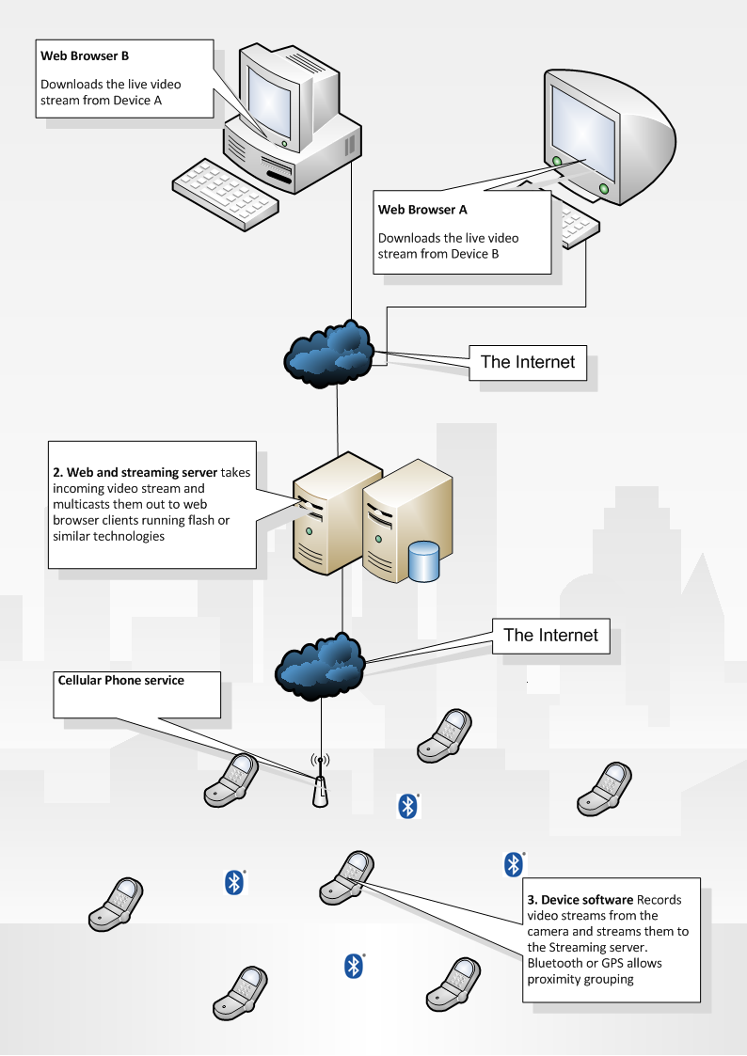
Example of live event video streaming with multiple camera connections within a designated group
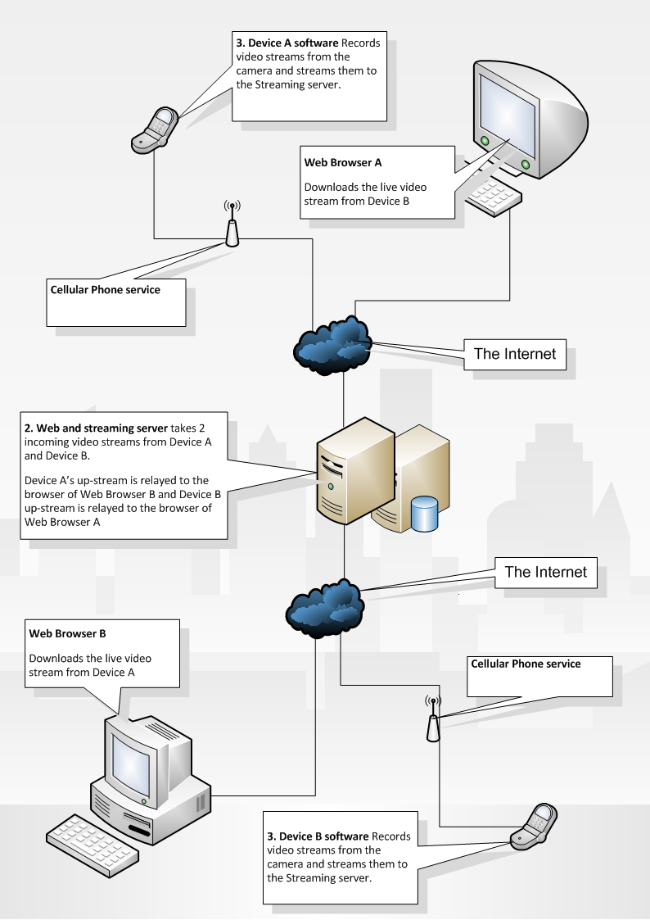

Matching Process
For the matching process it is important that hackers cannot spoof the match to pretend to be places our around others that they were not. A signing process achieves this by each node encrypting the connected users Globally Unique Identifier with their own private encryption key. This is then returned to the connected user. If the message can be successfully decrypted server-side with the according encryption key then the match is certified as genuine.
Since there is no way of obtaining a users private key, it would be impossible to encrypt the message themselves. Likewise, if a user were to capture packets of data over the air in attempt to utilize them it would render useless as the message would contain a different Guid and Time stamp.
Each node will have:
- A public 128bit unique identifier (Guid)
- A private 128bit unique encryption key
Once a device has identified another device running the same service it connects to the server via the custom TCP/IP protocol. All device software will run the client and server so it can make outgoing connections as well as receive incoming
The client application will connect to the server and inform the server of its public Guid. This Guid is encrypted using the server’s unique encryption key.
This Guid is encrypted into a message and is returned to the client along with the servers own public Guid
At this point the client now has an encrypted message containing its own public Guid although the client could not read the message as it doesn’t know the server private encryption key.
The client then takes the servers public Guid and encrypts it with the clients private encryption key and then passes the encrypted message back.
At this point both the client and the server have an encrypted message with the name and time securely stamped with their own ID and encrypted using the recipient’s encryption key.
A datagram is sent to the server from a user containing the encrypted message and the Guid of the user who created the encrypted message.
A lookup on the database is performed and the private encryption key for the recipient is used to decrypt the key. To authenticate the match, the decrypted message should contain a valid time stamp and the Guid of the current user.
Matching can be performed on two levels.
A system match is made only once both of the users inform the server with the encrypted messages
A system match is made once either of the users informs the server with the encrypted message Example of Bluetooth match and signing between two devices:

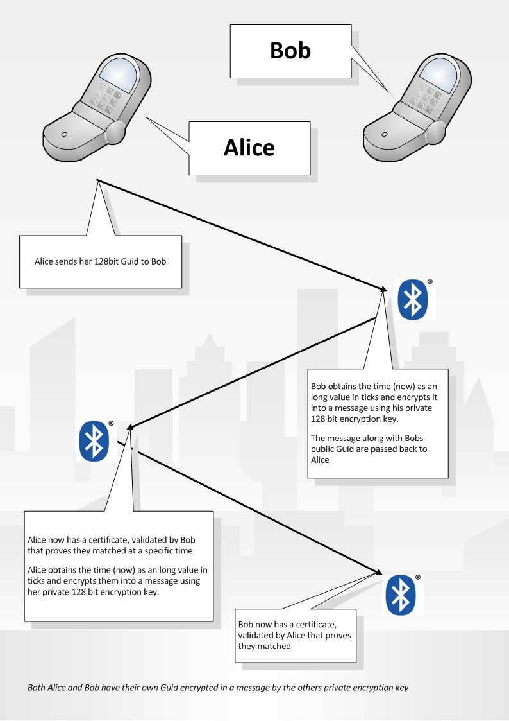

Alice and Bob example
Once the data is stored in the database with corresponding matches and times, a number of algorithmic concepts can be applied to the data to yield a different swarm graph connection. (The swarm being a cluster of mobile device users that were in a specific place, at a specific time and for a specific time.)
The three variables (place, time, duration) can be tweaked to alter the shape and size of a swarm. Further to this, the algorithm could be genetic and the effect of other nodes could affect other algorithmic properties.
Algorithms could be used to determine:
Statistics and identification of behavioral patterns
Groups of users by proximity localization for the purpose of live video camera views
Allow users to erode and expand their view of matches outside or inside specific boundaries for friend meeting and matching.
Assuming that the range of a mobile Bluetooth device is 10M, we can assume accuracy in a range of 0M to 10M. The middle point being 5M. If Node A can talk to Node B, Node B can talk to Node C but Node A cannot talk to Node C then Node C is classed as being 2 hops away from A
This estimated as a distance between 0 and 20M. Or 10M as an average approximation.

Alice & Carl are 2 hops away from each other
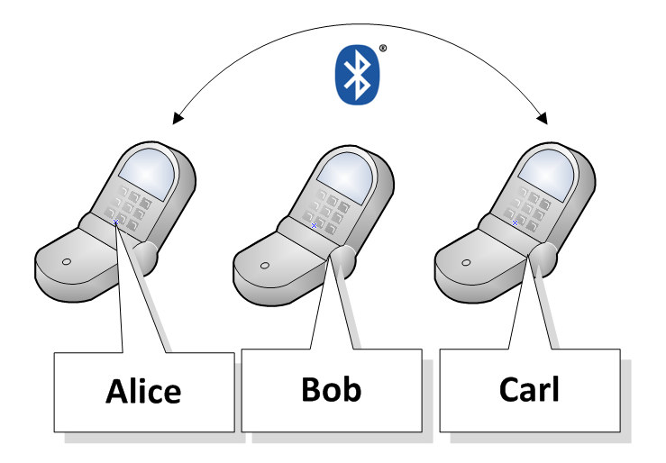

The graph can be used in a static form to identify users added to the swarm or in a real-time swarm where users can be mapped over a time span. This is useful for creating a dynamic swarm of users who are capturing live video and streaming it to a central server as their video streams can be localized and grouped.
Another purpose could be for new friend matching: e.g. matches after 8pm and have been around me for 30 minutes and tag at least 5 others who have also been around for 15 minutes....
this might denote that they was in a bar.....they might not be interesting in the matches they made on a bus stop or walking to their destination....
Clever algorithms could also guess whether you were in a type of place... IE a bar, concert/ festival,
Car journeys could be fun if someone wanted a car conference call with everyone in the car (minus the driver of course)... this could be automatically detected

Scripting Language
A scripting language will be introduced to allow algorithms to be displayed. The scripting language, (although not concretely defined in this document) will allow algorithms to be performed on the fly.
An API will allow Node objects with functions and properties to be performed upon.
The following code adds all the nodes to the swarm that were 2 hops away. (The Match object represents a Bluetooth match)

Matches=Match.GetSurroundingNodes(Time=16:00, TimeSpan=20seconds);
Loop through matches with m
Hop2Matches = m.GetSurroundingNodes(Time=16:00, TimeSpan=20seconds)
Loop through Hop2Matches with m2
AddToSwarm(m2)
End loop
End loop

Extended properties and functions of the match object will allow a greater depth or algorithmic precision. For example, additional properties might contain information about a user’s connection quality and camera resolution.

Here is a script to get all users plus all users that are 2 hops away from a specific node (maybe me), have a high resolution camera and have a low internet connection lag
Matches=Match.GetSurroundingNodes(Time=16:00, TimeSpan=20seconds);
loop through matches with m
//get all the users that are one hop away from all my matches
hop1List = m.GetAllMatchesBetween(TimePeriodA, TimePeriodB)
//add the user to the channel
AddCameraToChannel(m)
// loop through all the users that are 2 hop away from m
loop through hop1List with
// if they have a high resolution and lag less than 100ms then add the user to the channel
if hop1List[i].HasResolution==Resolution.High && hop1List[i].Lag < 100ms
AddCameraToChannel(hop1List[i))
end loop
end loop
So this is an script for a video channel.... When watching a live broadcast of an event users could switch camera views according to the users that are part of the swarm that the algorithm is choosing in real time. Once a user falls out of the swarm by algorithmic disclusion, the video being displayed to the viewer would have the video channel automatically switched to another user who is in the swarm, perhaps the nearest hop, again, algorithm determined.
For a centralized staged event such as a concert where the assumption is that all the cameras are recording the same view space, an algorithm could allow the switching of angles to work over a large range of distances (or hops). This would create a better perspective of the event due to different perspective and work in similar ways to how producers of live TV shows manually switch from camera to camera in a studio.
The following example changes different camera angles between a period of 2 and 7 seconds. On each camera change the view moves further away until the hop reach is 10. After this point the hop count resets to 1.
This sequence of camera changes will move the camera further and further away from a specified user and then suddenly near again... where the algorithm repeats…

While True
If i > 10 then i = 1
Node = getNodesFromNumberOfHopsAway(i++)
Node.ViewCamera();
Sleep for RandomSeconds(between 2 & 7 seconds)
End Loop
Note: Reaching 10 hops and then decrementing backwards would cause the camera angle to move away and then back again, not necessarily through the same path it took.
Further to social networking in a leisure scenario, algorithms could be created for advertising and research corporations who wanted to do mass mining of the swarms over great periods of time and a greater hop depth... think of the possibilities of behavioral patterns we could recognize.... and who might want access to them...Large corps!
For example, in a simple sense, it would be possible to determine a number of people who went out on a Saturday night in Manhattan, how long they were out in bars and restaurants, and what time they came home. Location can be approximated by taking the highest count location property for users. For example, if 20 different matches were made and 15 of the users reside in Manhattan (according to their user profile) then it is likely that the location that all the users were matched in was Manhattan. The higher number of users in the swarm would more accurately approximate location.
The following algorithm returns all the users who are from Manhattan, and got a high number of matches on Saturday night. It also gets all the matches the each of the users obtained. This could allow market researches to determine how many people are visiting a city or place from a specific place and at a specific time span.

UsersOutOnSaturdayNightPartying = NONE
Users GetAllUsersWithLocation(ProfileLocation=”Manhatten”)
Loop though users with u
SaturdayNightMatches = u.GetMatchesBetween(8pm Saturday and 2 am Sunday)
SaturdayNightMatchesFiltered = SaturdayNightMatches.GetMatchesWithMatchCountAbove(20)
UsersOutOnSaturdayNightPartying += SaturdayNightMatchesFiltered + u
End loop

Note: The algorithm could be improved by incorporating a greater depth of hops
User scripts would allow clever algorithms to be created from the framework
Further to this, a library could be created that encapsulates the estimation of distances according to the number of hops and the connection graph of other nodes.
The system comprises of a mobile phone real-time streaming application, a centralized real-time streaming server and a web application server that streams live video and audio feeds to a web browser client encapsulating a multimedia video player such as Macromedia flash , Microsoft’s Silverlight (formerly WPF/E) or similar technologies..
Users of the mobile application are able to record live video streams from the camera in their mobile phone. This is achieved by encoding the video stream into a real time streaming codec and is then streamed to a video server over a real time protocol (RTP) using the mobile phones internet connectivity such as GPRS or WIFI connection. Once the video stream has is being transmitted to the server it is then published to end users who can view the video from within their web browser. This will enable users of the web site to view a mobile stream and view the live video being streamed from the end mobile phone user. The system will allow multiple users to view the same stream.
Two or more users will also be able to utilize the system as a video conferencing model. Such that at least two users will be able to point their mobile phone camera at themselves to transmit video and then view the downlink of the other users stream from within their web browser. This creates a video conferencing environment without the need for video camera hardware to be installed in the client desktop PC.
Further to this, by using a geographical positioning system such as GPS or even Bluetooth technology to pair users who are recording in the same proximity, mobile users’ video streams can be grouped. This will allow users who are recording different video streams in the same vicinity to be grouped together as being at the same “event”. From this point, web browser users will be able to view the group and watch the live streams from the same event. Using the real time protocol will allow web browser users to switch camera views from either of the live streams in the group. This essentially provides different camera angles from the same event in real time.
Users will also be able to create edits of the recorded media and save them for other users to watch. This can be accomplished by taking the duration in seconds for a video stream and the according id of the stream.

