UNIVERSITY OF MORATUWA
Department of Electronic and Telecommunication Engineering
ME5120 Computer Aided Design and Manufacture
PCB Design Project — Design Report
Adjustable Linear Bench Power Supply
3–18 V output, 50 mA–1 A current limit — LM723 + TIP3055 + BC547 (Circuit option #8)
Author: V.N.A. Perera
Index number: 259110H
Programme: MSc / PG Diploma in Electronics and Automation
Board revision: Rev A
Date: 8 November 2026

1 Circuit description and datasheet references
This bench supply runs from an external 24 V adapter. RV1 sets the output anywhere from 2.95 V to 18.0 V, and RV3 sets the current limit between 50 mA and 1.05 A. At its core is the LM723 regulator [1], which compares part of the output voltage with its internal 7.15 V reference. R4 and R5 divide this reference down to 2.95 V at the non-inverting input, while RV1, R6 and RV2 provide the gain needed to reach 18 V (Table 2 and Fig. 19 of [1]). RV2 is a multi-turn trimmer that is set once during testing. It is needed because the ±20 % tolerance of the pot, together with the spread in V_{REF}, could otherwise place the full-scale output anywhere between 14.2 V and 22.0 V. The LM723 cannot supply 1 A on its own, so it drives a BD139 and TIP3055 [2] Darlington pair that carries the load current. The BD139 also protects the LM723: under a short circuit, the regulator dissipates only 0.04 W instead of 0.95 W, comfortably below its 660 mW rating. Current limiting works through the 0.56 Ω sense resistor R_{SC}. A BC547 [3] across R_{SC} turns on once the sense voltage, plus a small bias from a BC557 current source (I₀ ≈ 0.8 mA through RV3 and 47 Ω), reaches V_{BE}; it then pulls the compensation node low and holds the current at I_{LIM} = (V_{BE} − I₀R_{CL}) / R_{SC}. On the input side, a 1.5 A resettable PTC fuse (MF-SM150/33-2) guards against overcurrent, and an SS34 Schottky diode clamps a reversed adapter to −0.44 V. A shunt clamp was chosen over a series diode so that no voltage is lost in normal operation. C4, a 470 pF C0G capacitor, keeps the loop stable. Before layout, the complete circuit was simulated in LTspice with an LM723 model built from the datasheet. The results confirmed an output range of 2.948–17.991 V, load regulation of 0.53 % at 1 A, current limits of 1.051 A, 0.626 A and 0.201 A, and a stable response to a 10 mA ↔ 0.8 A load step, with deviations of −206 mV and +156 mV at 18 V.
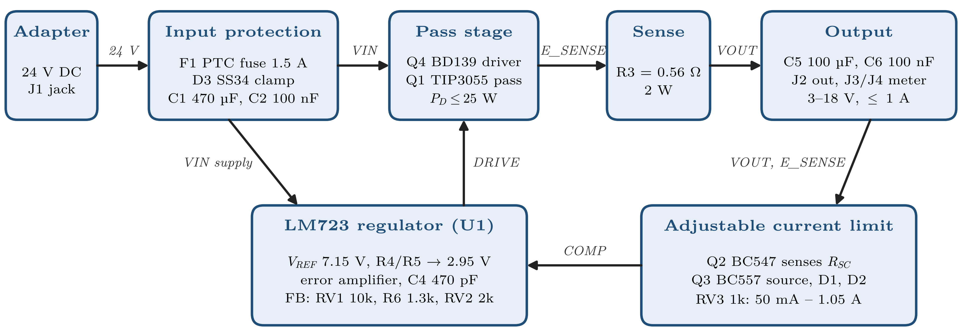
Figure 1. Block diagram: power path (top) and control loop (bottom)
Connectors (all on the board edge; pin 1 = square pad). Load current returns from OUT− to GND either through a panel ammeter on J4 or through the JP1 jumper; one of the two must be fitted.
Ref | Part | Pin: net — function
J1 | DC jack CUI PJ-063AH, 5.5/2.1 mm | Centre: VIN_RAW — +24 V adapter in (→ F1, D3); sleeve: GND; MP: mounting tabs only
J2 | Terminal block Phoenix MKDS 1,5, 5.08 mm | 1: VOUT — OUT+ to panel post (3–18 V, 1 A); 2: OUT_NEG — OUT− load return
J4 | Terminal block Phoenix MKDS 1,5, 5.08 mm | 1: OUT_NEG — meter loop −OUT; 2: GND — ammeter return (carries full 1 A)
J3 | Pin header 1×03, 2.54 mm | 1: VIN — 24 V supply for panel voltmeter; 2: GND; 3: VOUT — voltmeter sense
JP1 | Pin header 1×02 + shunt, 2.54 mm | 1: OUT_NEG; 2: GND — ammeter bypass, fit jumper when no ammeter on J4
2 Power budget and key calculations
At full load (18 V, 1 A) the supply draws 24 V × 1.03 A = 24.7 W from the adapter, of which 18 W reaches the load; the remainder covers the power LED (2.2 mA), the LM723 and the panel meter. Most of the loss appears in Q1, since P = (V_{IN} − V_{OUT})·I. At 1 A the TIP3055 dissipates 5.3 W at 18 V and 20.0 W at 3 V, rising to 24 V × 1.05 A = 25.2 W under a short circuit (SIM09f). Holding T_{J} at 125 °C with T_{A} = 40 °C therefore requires R_{θSA} ≤ 85/25.2 − 1.39 − 0.5 = 1.48 °C/W, using R_{θJC} = 1.39 °C/W [2]. The on-board AAVID 531302 (≈ 8 °C/W) handles about 10 W by natural convection, so forced air is needed for sustained 20–25 W operation. The remaining parts are lightly stressed: Q4 (BD139) dissipates 0.34 W at 1 A and 0.95 W at a short, R_{SC} dissipates 0.56 W in a 2 W part, and the LM723 stays at 0.04 W, well below its 0.66 W limit [1] (SIM06, SIM09f). At 18 V and 1 A the LM723 has about 4 V of headroom against the 3.0 V minimum ([1] p. 4); this minimum is reached at V_{IN} = 23.0 V (SIM09d), so the adapter must deliver at least 23 V under load. The current limit follows from I_{LIM} = (0.626 − 0.038)/0.56 = 1.05 A with RV3 at 0 Ω, falling to 50 mA at 700 Ω. Finally, for 1 A on a 1 oz outer layer with a 10 °C rise, IPC-2221 [4] and the KiCad Track Width calculator give a minimum width of 0.30 mm; 1.0 mm was used on all power tracks, a 3.3× margin.
3 Manufacturer and design rules
Board made by PCBWay [5]: 2 layers, FR-4 1.6 mm, 1 oz copper, HASL lead-free, 80 × 77 mm with 3 mm corner radius. Each KiCad rule is the stricter of the PCBWay capability and the brief minimum:
Rule | PCBWay | Brief | Used
Signal track / clearance | 0.10 / 0.10 mm | 0.25 / 0.20 mm | 0.25 / 0.20 mm
Power net class (VIN, VOUT, E_SENSE, OUT_NEG, GND) | — | ≥ 0.5 mm | 1.0 mm / 0.30 mm clearance
Via drill / pad | 0.15 mm drill | 0.3 / 0.6 mm | 0.3 / 0.6 mm (power 0.5 / 1.0)
Copper to edge; silkscreen text | 0.25 mm; 0.8/0.15 mm | 0.3 mm; 1.0/0.15 mm | 0.5 mm; 1.0/0.15 mm
M3 mounting holes | — | copper keep-out | Ø7 mm track/via/pour keep-out each
4 Three key placement and routing decisions
- Mechanics first, connectors on the edge. M3 holes 4 mm from each corner (with copper keep-outs) were placed and locked first; the 16 mm panel pots RV1/RV3 sit on the front edge with bushings through the panel, J1 on the left edge, and all terminals and headers (J3, JP1, J4, J2) on the right edge with wire entries facing out. Q1 sits on the back edge inside the channel of an on-board AAVID 531302 heatsink. Board: 80 × 77 mm, inside the 100 × 80 mm limit.
- Function-grouped placement around U1. U1 was rotated 180° so FB, NI and VREF face a short vertical column (R4, R5, R6, C3), C7 sits 3 mm from V+/VC (supply enters through the cap pad), and C5/C6 sit at the output terminal. Short loops keep the reference and error amplifier quiet and make most signal routing single-layer.
- Power trunks, Kelvin sense, solid ground. 1 A paths are straight 1.0 mm top-layer trunks; R2 and R7 connect to the R_{SC} pad with separate thin tracks (Kelvin), so the track drop is not read as current. Bottom-layer tracks were kept few and short, and GND is poured on both layers with 7 stitching vias beside the SMD ground pads and island removal on.
5 ERC/DRC results and exclusions
ERC (KiCad 10.0.8, footprint-link check = error): 0 errors, 0 warnings, no exclusions. DRC with refilled zones and schematic parity: 0 errors, 0 unconnected items, 0 parity errors. Excluded with comments: courtyard overlap / PTH inside courtyard (4) and silkscreen overlaps between Q1 and HS1 — Q1 is bolted inside the HS1 channel by design; 4 × "silkscreen clipped by board edge" on RV1/RV3 — the pot body crosses the front edge so the bushing passes through the panel; 2 × "footprint does not match library" on RV1/RV3 — the difference is in the stock RK163 footprint, pads unaffected.
6 Tools used (including AI assistance)
Tool | Used for
KiCad 10.0.8 | Schematic capture, ERC, PCB layout, DRC, Gerber/drill/BOM/position outputs, 3D view
LTspice 26.1 / ngspice | Block and full-circuit simulations (SIM01–SIM09) with a datasheet-based LM723 macro-model
Git / GitHub | Version control of design and simulation files, one approved commit per step
Claude (Anthropic) AI assistant | Checking calculations against datasheets; drafting simulation netlists; scripted KiCad edits via a KiCad MCP connector (placement moves, track/zone geometry), each followed by a GUI ERC/DRC check by the designer; plotting figures; drafting this report. All design decisions and final checks were made and approved by the designer.
References: [1] TI, LM723/LM723C, SNVS765C, 2013. [2] onsemi, TIP3055/D. [3] onsemi, BC546–BC550. [4] IPC-2221, Generic Standard on Printed Board Design. [5] PCBWay, PCB Capabilities (standard rigid PCB).

