**Tecnologies**

In this challenge, I used the visual studio 2019and I created three projects**:**

-**Blazor.Server**-**Web Api** Core Net Core 3.1-Services consumes Rest Api Star War

-**Blazor.Cliente**-**Blazor WebAssembly**- WebPage show registers about people of Start war

**-Blazor.Shared-Net Standard** -ViewModels People,PeopleResults,Pagination.

On the other hand, I had to install package in console nuget Install-Package Microsoft.AspNetCore.Blazor.HttpClient -Version 3.2.0-preview3.20168.3 for use the method GetJsonAsync inside of DetailPeople.razor.

**Description functional about Web Application**

1. Web Application contains a filter by height of people

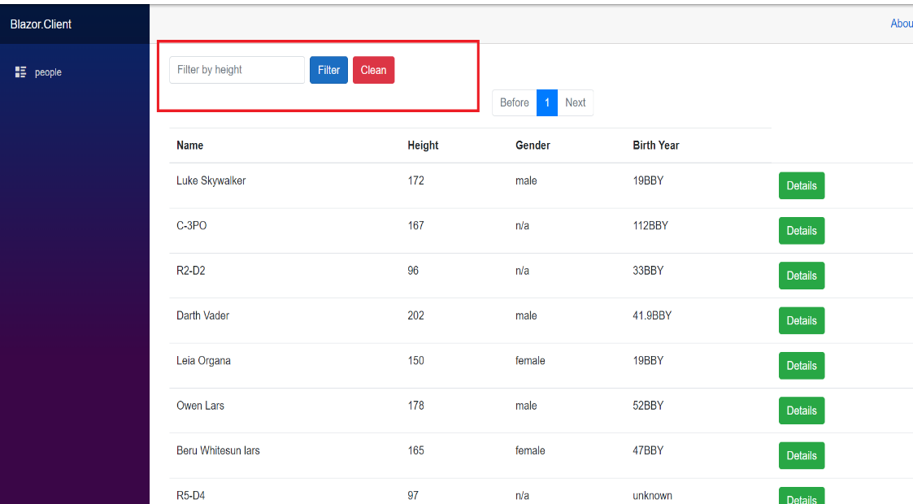

1. furthermore this has pagination and buttons details for you can see the details of people

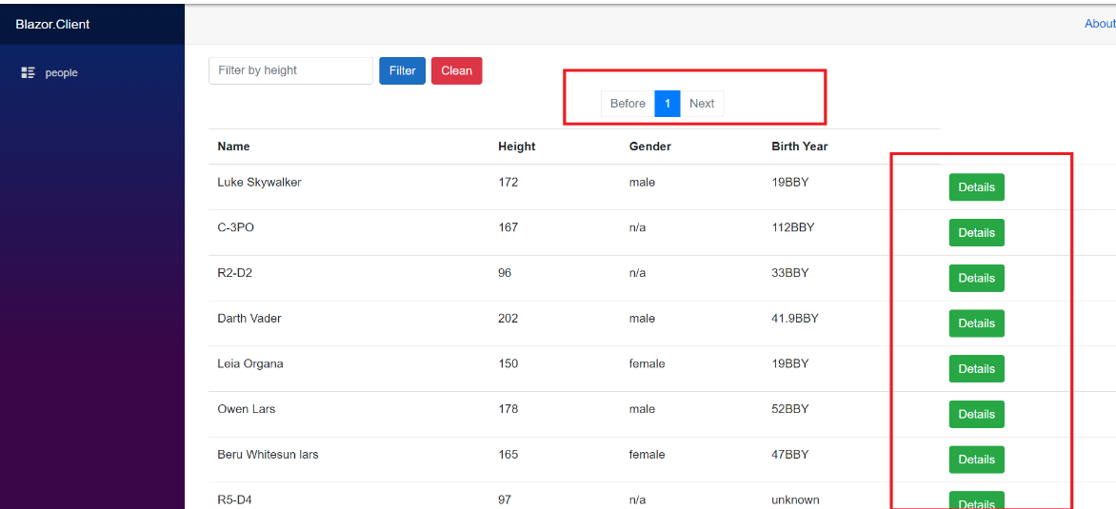

1. Finally, in this image show the form of details of people and button return that return to principal page.

