IT Technologies – Autonomous Vehicles:

What does it do?

* Autonomous vehicles are considered to be an “upgraded” version of current vehicles, capable of driving and operating itself without any, or at least minimal, human interaction. Currently, vehicles in general, automated or not, have been categorised into different levels of “automation” or “self-driving”. Different sites and places may have a different number of levels, but generally they are categorised into 5/6 levels starting from level 0, which has not autonomous features at all, to level 5/6 which is a vehicle that is fully autonomous in all conditions. There are also levels 1, 2, 3, and 4 in between which, as you go up in the levels, progressively become more autonomous. As of the year 2020, the most common and readily available autonomous vehicle for the public are at level 2. These vehicle feature the ability to perform some automated task, such as “advanced cruise control” (Daniel Faggella, 2020), and navigating and accelerating around a slow vehicle. Some of the more advanced features of this level include some capability of driving on a highway, and automatically parallel parking.
* Level 3 autonomous vehicles are not as available as level 2 as of now, but are currently in development. These vehicles feature the ability to control the vehicle in certain conditions (certain road conditions) and has the capability of understanding those conditions. Due to this capability, there is a large technological gap between level 2 and level 3 vehicles.
* Within the next 3 or so years, the development of autonomous vehicles will most likely focus on completing the development of Level 3 autonomous vehicles and deploying them to the public. As some vehicles that could be considered Level 3 still have some faults within their systems and are not 100% safe to use as of yet, it is important that developers focus on making them safe first, rather than trying to achieve the next level.
* As time goes on, development of the autonomous vehicle will most likely follow the different levels of automation that a vehicle can have. As of recently, level 4 automated vehicles was only believed to be only a “theoretical level” (Zach Wendt, 2020) and was believed to not be feasible. However, as technology becomes more advanced and certain companies, like Tesla, are focusing purely on developing technology capable of supporting level 4 automation, a vehicle capable of level 4 and above becomes more feasible. Although some companies claim to have the technology capabilities, level 4 and above vehicles are still only a theoretical concept as of now.
* The technology that makes the concept of autonomous vehicles possible are mainly technologies surrounding artificial technology, as well as sensor technology, including cameras. Artificial technology, or simply AI, is the key technology when creating an autonomous vehicle, as the vehicle needs to be able to make decisions on its own and learn from the situations it’s in. Simply programming the vehicle in a manner of “if A occurs, then do B, otherwise do C” is not ideal, this is because the vehicle would be operating alongside human drivers, and humans are very unpredictable, not everyone will make the same choices in the same situation.
* Camera and sensor technologies are also an important part of autonomous vehicles. These are used to detect and examine the objects around the vehicle, emulating the way that humans would observe their surroundings with their eyes. One advantage the cameras and sensors have over human drivers is the ability to have 360 degree view around the car, which a human driver would have blind spots. However, one aspect that could still be improved is the quality of the devices, as they still struggle to maintain a decent quality in most weather conditions, as well as when the colours of objects are very similar. As such, in terms of cameras and sensors, these technologies would eventually be improved upon in the future and therefore eventually improve the quality and level of autonomous vehicles.

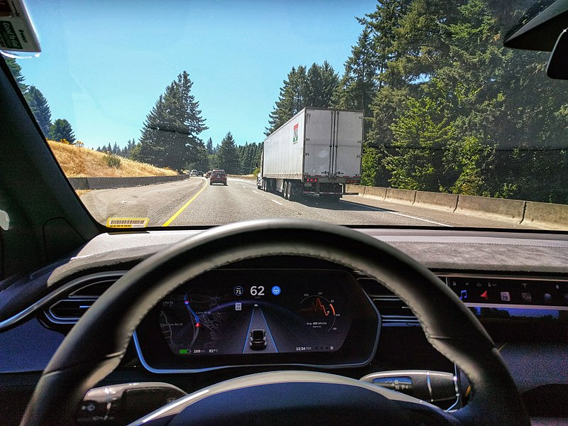

Maddox, I 2017, *Tesla Autopilot Engaged in Model X*, Ian Maddox, viewed 27 April 2021, <https://commons.wikimedia.org/wiki/File:Tesla_Autopilot_Engaged_in_Model_X.jpg>

What is the likely impact?

* In terms of environmental impact, there currently seems to be more of an advantage rather than a disadvantage to using autonomous vehicles as compared to human operated ones. The reason for this is rather than using traditional fuel, such as petrol, for autonomous vehicles, the plan is for them to be entirely electric powered. This would in turn reduce emissions from cars and air pollution. However, this does not necessarily mean a reduction in energy consumption as the vehicles still use electricity. There is also the concern of where and how the electricity is produced, but that is a different area of concern.
* Regarding jobs, and the concern of autonomous vehicles replacing jobs, there is a high probability that some jobs may be replaced. The jobs being replace would be driving-related jobs, such as taxi drivers and bus drivers. Although there is a high possibility of this happening, there is still a long way to go before these jobs would be made redundant. This is because the only level of autonomous vehicles that would be capable of replacing a driver would be level 5, and, as stated before, this is still only a theoretical idea.
* Although some driving-related jobs would be made redundant, new jobs opportunities will arise. There may be a rise in jobs in other areas, particularly those relating to maintain autonomous vehicles. This could involve manufacturing them, or repairing them.
* Some of the other predicted benefits would be improved road safety and efficiency. In terms of road safety this would affect both drivers and pedestrians, and anyone else who uses the road in general. As autonomous vehicles would be programed to operate a certain way, one of those ways would hopefully be to avoid a collision if possible. As human drivers tend to be distracted on the road, more accidents occurs, but with an autonomous vehicle which is constantly monitoring its surroundings, avoiding accidents will be easier.
* Time efficiency is another benefit that autonomous vehicles are predicted to bring. As drivers spend most of their time in traffic jams, their time is wasted just sitting in their car doing nothing but waiting. However, with an autonomous vehicle people can spend that time doing something else such as working or even just relaxing. Autonomous vehicles are also predicted increase traffic flow and reduce traffic jams.
* A potential negative effect relates to hacking the autonomous vehicle. Depending on the data stored on the vehicle, such as current destination, previous destinations, and personal user information, hackers could have more access to information they wouldn’t have had before. This could aid stalkers follow their target just by hacking a vehicle and knowing their destination beforehand.

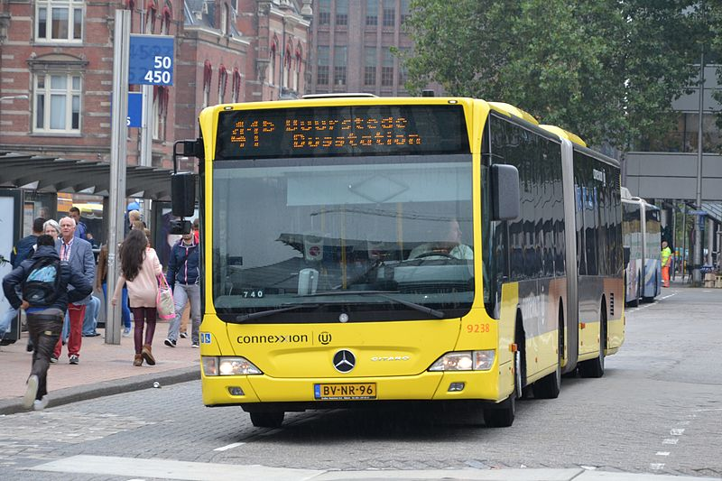

Alfenaar 2013, *Connexxion 9238, Utrecht CS-Oost*, photograph, viewed 27 April 2021, <https://commons.wikimedia.org/wiki/File:Connexxion_9238,_Utrecht_CS-Oost_(9952048314).jpg>

How will this affect you?

* Currently, this would not affect me or members of my family as much, as autonomous vehicles are not something we have or wish to have. The level of autonomous vehicles now is also quite low, so there are not a lot of benefits compared to the cost of an autonomous vehicle compared to regular vehicles. However, in the future, we may switch to an autonomous vehicle, which can drive itself in all conditions, this would benefit us during trips or long drives, as the driver can also rest during the commute.
* In terms of getting to and from work, the time taken would be significantly reduced. This is because the commute to work (for those who go to work and drive) mostly consist of sitting and waiting in traffic jams or in low traffic flow areas as everyone is trying to get to work at the same time. When level 5 autonomous vehicles are introduced, their time taken to get to work would significantly be reduced and they can do their own things in the vehicle, rather than just sitting and waiting.
* In terms of affecting friends, some of them enjoy four-wheel driving and off-road driving. In this sense, autonomous vehicles would be useless to them, rather, they would hinder their enjoyment instead. If the government was to force all vehicles to be automated, and regular vehicles were made illegal, people who enjoy off-roading, four-wheel driving, or just driving a vehicle, would be very upset rather than be happy.

Reference:

Daniel Faggella, 2020, *The Self-Driving Car Timeline – Predictions from the Top 11 Global Automakers*, viewed 17 April 2021, <<https://emerj.com/ai-adoption-timelines/self-driving-car-timeline-themselves-top-11-automakers/>>

Sandra Khvoynitskaya, 2020, *3 types of autonomous vehicle sensors in self‑driving cars*, viewed 17 April 2021, <<https://www.itransition.com/blog/autonomous-vehicle-sensors#:~:text=Autonomous%20cars%20often%20have%20video,drivers%20do%20with%20their%20eyes.&text=These%20image%20sensors%20automatically%20detect,between%20them%20and%20the%20vehicle.>>

Zach Wendt, 2020, *The Future of Self-Driving Cars: 5 Levels of Autonomous Driving Technology*, viewed 17 April 2021, <<https://www.arrow.com/en/research-and-events/articles/5-levels-of-autonomous-driving-technology#:~:text=As%20of%202020%2C%20Level%202,lane%20assist%20and%20collision%20avoidance.>>

Suhasini Gadam, 2018, *Artificial Intelligence and Autonomous Vehicles*, viewed 17 April 2021, <<https://medium.datadriveninvestor.com/artificial-intelligence-and-autonomous-vehicles-ae877feb6cd2>>

Adam Hayes, 2019, *The Unintended Consequences of Self-Driving Cars*, viewed 17 April 2021, <<https://www.investopedia.com/articles/investing/090215/unintended-consequences-selfdriving-cars.asp>>

*5 Effects of the Adoption of Autonomous Vehicles*, viewed 17 April 2021, <<https://onlinemasters.ohio.edu/blog/5-effects-of-the-adoption-of-autonomous-vehicles/#:~:text=A%20recent%20McKinsey%20%26%20Company%20study,year%20in%20health%20care%20costs.>>

Larry Alton, 2018, *How Self-Driving Cars Could Impact the Environment*, viewed 17 April 2021, <<https://blueandgreentomorrow.com/environment/self-driving-cars-could-impact-environment/#:~:text=Many%20autonomous%20vehicles%20are%20also,choose%20to%20make%20it%20so.>>