# Calculate live FM

* These python / R scripts calculate gridded live fuel moisture content using the live FM model presented in Nolan et al (2016, Geophys. Res. Lett. 43, 4229-4238).
* Input data is MODIS 8-day surface reflectance data.
* Scripts were prepared by Rachael Nolan.

**Step 1: Obtain MODIS data**

* Select data files to download.
  + Go to the website: <http://reverb.echo.nasa.gov/reverb/>
  + <https://search.earthdata.nasa.gov/search>
  + Select the temporal domain
  + Select the spatial domain by drawing a polygon over your region of interest. The polygon does not have to fully contain your region of interest. A small polygon over Sydney will allow you to download the MODIS tile h30v12 which covers NSW (h29v30 covers Victoria).
  + Select the platform by clicking on ‘Platforms & Instruments’. See below:

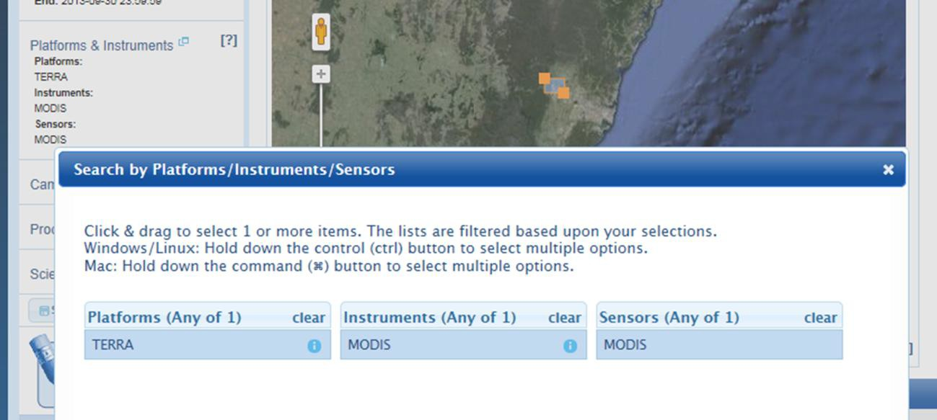

* + Select the Dataset of interest from **Select Datasets**. For MODIS TERRA: Reflectance data ‘MOD09GA’ (Daily data) and ‘MOD09A1’ (8-day composite) Surface Temperature data ‘MOD11A1’ (Daily data) and ‘MOD11A2’ (8-day composite).
  + Click on **Search Granules**
  + A window will pop up. Click on **Accept** (if this does not occur it may be because you are using an old browser, try firefox)**.**
  + Make sure that the granules (i.e., images) in your **Granule ID** list are only h30v12 and/or h29v12. Click on **All** to select all the granules. It will take a few seconds for all the items to be added to your cart (i.e., they will turn yellow). Now click on **View Items in Cart.**
  + Click on **Download** and select **Text file** as **Download Option.** Save the text file to “…….\WGET\WinWGetPortable\App\winwget\wget” NB: You need wget to be installed, which is freely available online: <http://www.gnu.org/software/wget/>
* To download the granules, open the **Command Prompt** window and follow these steps:
  + Change the directory to where you save the text file:

cd C:\Users\122590\WinWGetPortable\App\winwget\wget

* + Type in:

wget -i data.txt

(Assuming the text tile is named “data.txt”

* + Important note, make sure you have the authorization to access FTP websites, which may be an issue for some servers.

**Step 2: Unpack and extract files**

This is done through Python, and requires both Python and ArcMap to be installed (python will check the licence for ArcMap, so make sure there’s no problems getting through any firewalls). This also requires LDOPE to be installed, which is freely available online: <https://lpdaac.usgs.gov/tools/ldope_tools>

There is a package in R called rPython, which looks promising for calling python code into R, but it is currently not available for windows. To unpack and extract files, run the relevant python script below, making sure that the files are in the LDOPE bin folder, and that path names are changes as necessary in the python script:

* “MOD09A1_unpack_and_extract.py”

**Step 3: Mask data with clouds or poor quality assurance**

This is again done through Python and needs Arcmap installed, run the relevant python script below, again making sure that the files are in the correct directory and the path names are changed in the python script as necessary.

* “MOD09A1_masking.py”

**Step 4: Estimate live FM from MODIS files**

Run the following R script:

* “Calc Live FM.R”

NOTE: Live FM is currently clipped to forests and woodlands, with any wildfire in the previous 5 years masked out. If these maps are produced, the spatial layer which masks out previous fire will need to be updated (i.e. first need to mask to forest and woodland shapefile, then mask out fire in previous 5 years).