Screenshot 1
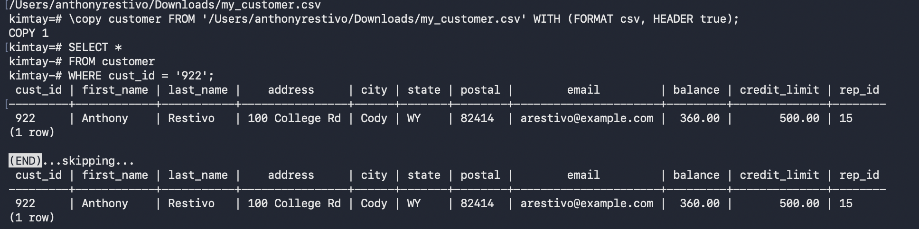

Screenshot 2
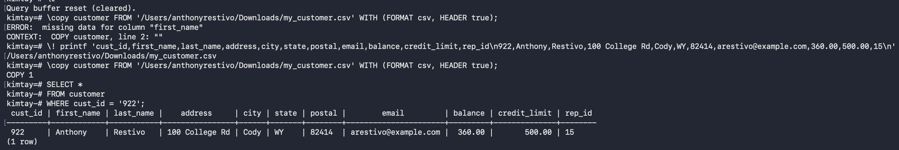

Screenshot 3
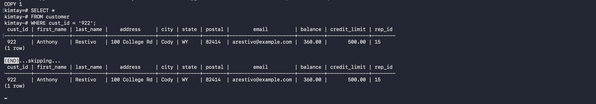

Screenshot 4
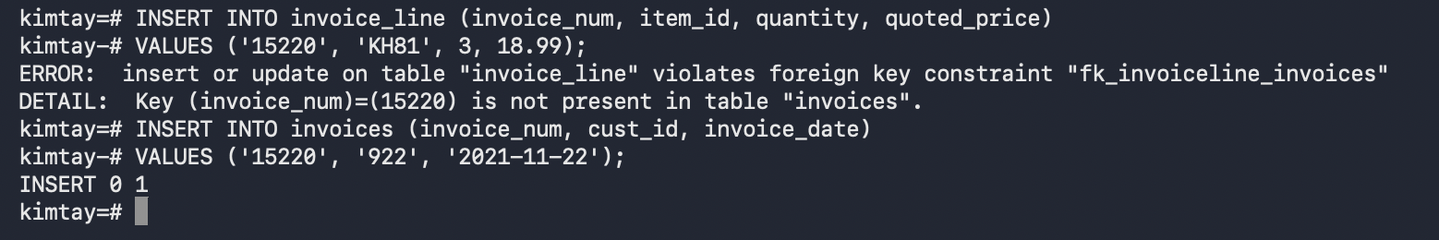

Screenshot 5
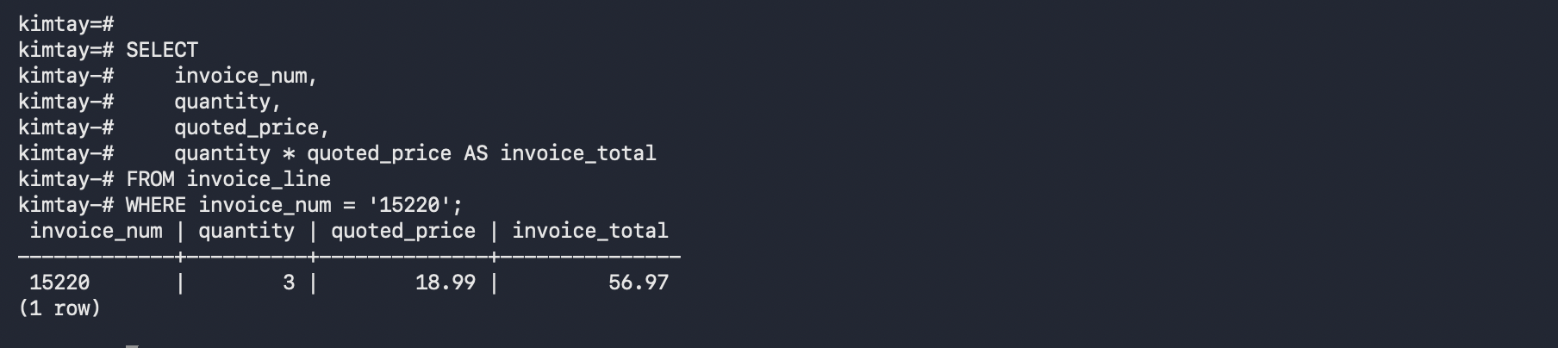

Screenshot 6

Screenshot 7

Screenshot 8
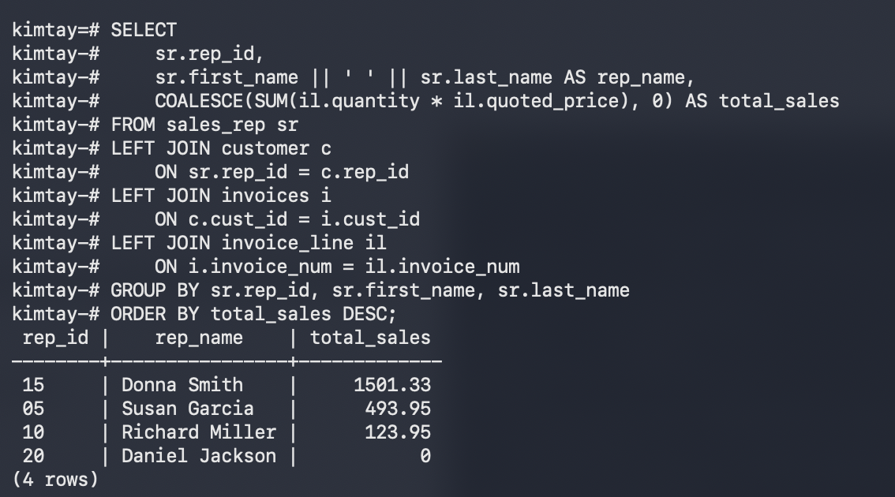

Screenshot 9
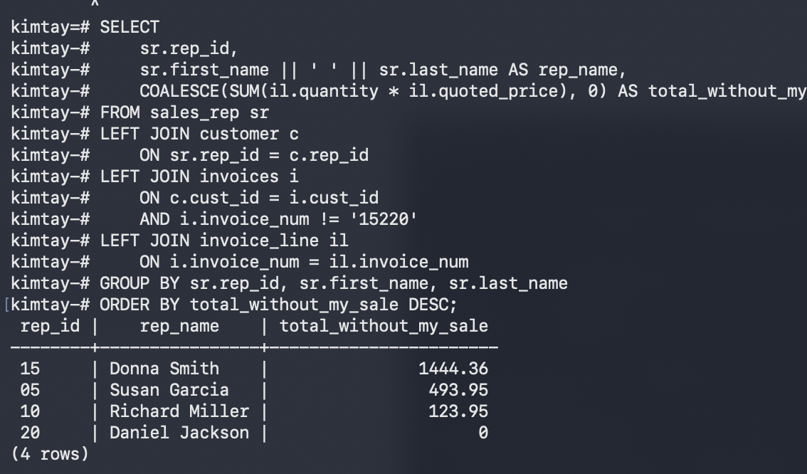

Screenshot 10
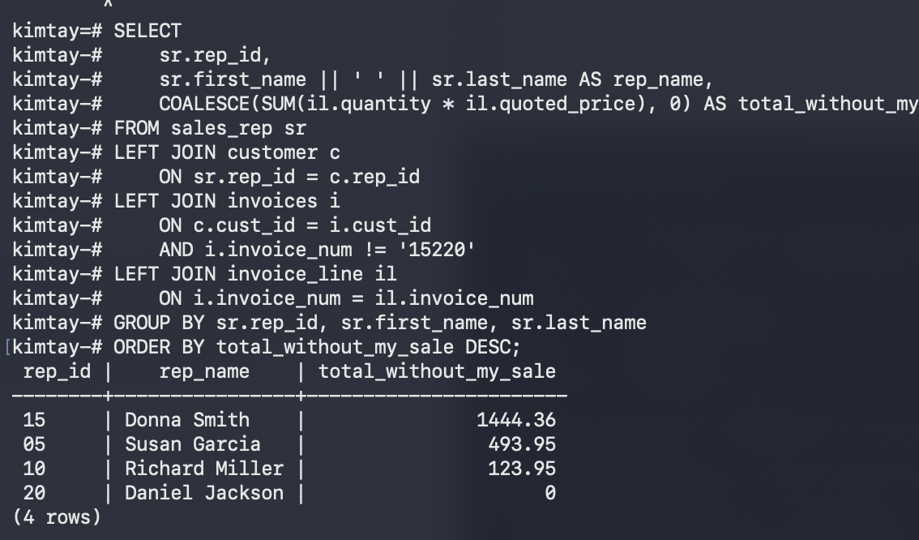

Screenshot 11
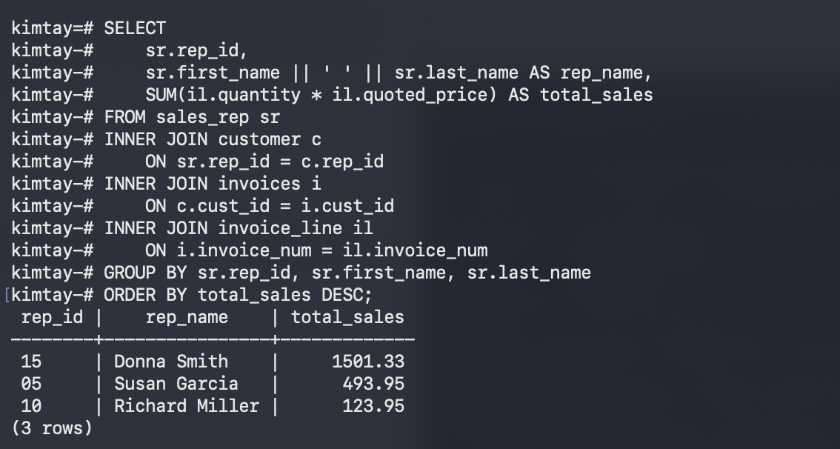

Screenshot 12
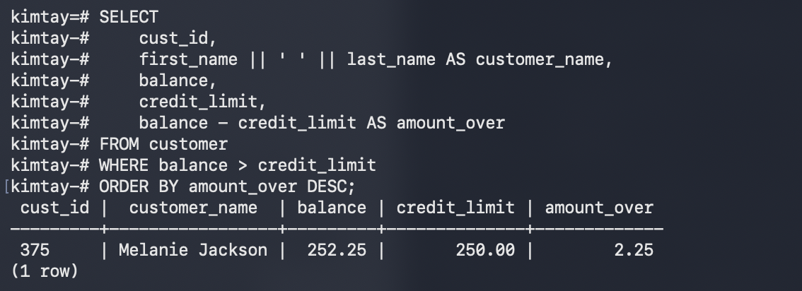

Screenshot 13
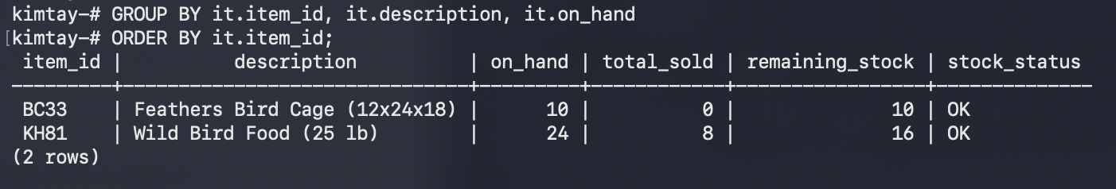

Screenshot 14
