MERIDIAN TECHNOLOGIES — CONFIDENTIAL
Investor Day Positioning Memo · March 11, 2026
From: Catherine Park, CEO · Distribution: Board, CFO, CPO, CRO, Chief of Staff

Meridian is the agentic work platform that regulated enterprises can actually trust —
built on the governance infrastructure no one else in this category has.

EXECUTIVE SUMMARY

On March 11 Meridian will declare itself an agentic work platform — not a project management tool with AI features bolted on. This is the right call for three reasons that converge: the competitive white space is real and time-limited (no competitor combines agentic ambition with regulated-enterprise governance depth), our largest and fastest-growing customer segment is already demanding exactly the governance layer that is our moat, and the alternative — positioning alongside Smartsheet as the cautious governance-forward PM tool — is a shrinking market with a decelerating comparable. This memo states the position, the rationale, the competitive context, the three risks the board should hold us accountable for, and the three specific commitments we are making to investors at Investor Day.
THE POSITION

Option B. “Meridian is the agentic work platform that regulated enterprises can actually trust — built on the governance infrastructure no one else in this category has.”
This sentence does four things: (1) claims the agentic category without abandoning enterprise credibility; (2) leads with trust and governance, which is what our customers are actually asking for; (3) implicitly contrasts with Asana and Monday, who are agentic but ungoverned; and (4) implicitly contrasts with Smartsheet, who is governed but not agentic. It is a sentence the Helio team joined to hear, the enterprise sales team can use in regulated-industry deals, and that is defensible for three years — not three quarters.
WHY

- The white space is real. No competitor occupies the upper-right quadrant of the positioning matrix — agentic ambition plus regulated-enterprise governance depth. Asana and Monday have committed to agentic positioning but have not built FedRAMP, HIPAA, or regulated-vertical depth. Atlassian is agentic with premium pricing (Rovo), but its governance is shaped for dev/IT teams, not financial services or pharma. Smartsheet has governance but has surrendered the agentic narrative and is decelerating. Meridian has both. The window to claim this position is 18–24 months before Atlassian closes the regulated-industry gap.
- Our best customers are already asking for it. 18 of 22 enterprise advisory board sessions in the last 90 days raised agent governance requirements as urgent: auditability of agent actions, role-based agent permissions, model selection, and data residency. These are agentic platform governance requirements — not PM feature requests. Enterprise NRR is 125%. This segment will pay for what we are describing, and it is asking us to be what Option B says we are.
- The alternative is a shrinking peer group. Option A puts Meridian alongside Smartsheet — the competitor that has explicitly rejected the agentic narrative. Smartsheet guided low-single-digit growth for 2026 and carries takeout-premium speculation in its share price. Investors will apply that multiple to Meridian if we share its positioning. Option B puts us alongside Atlassian — a higher-growth, higher-multiple comparable — with a defensible differentiation story in verticals Atlassian does not serve.
COMPETITIVE LANDSCAPE

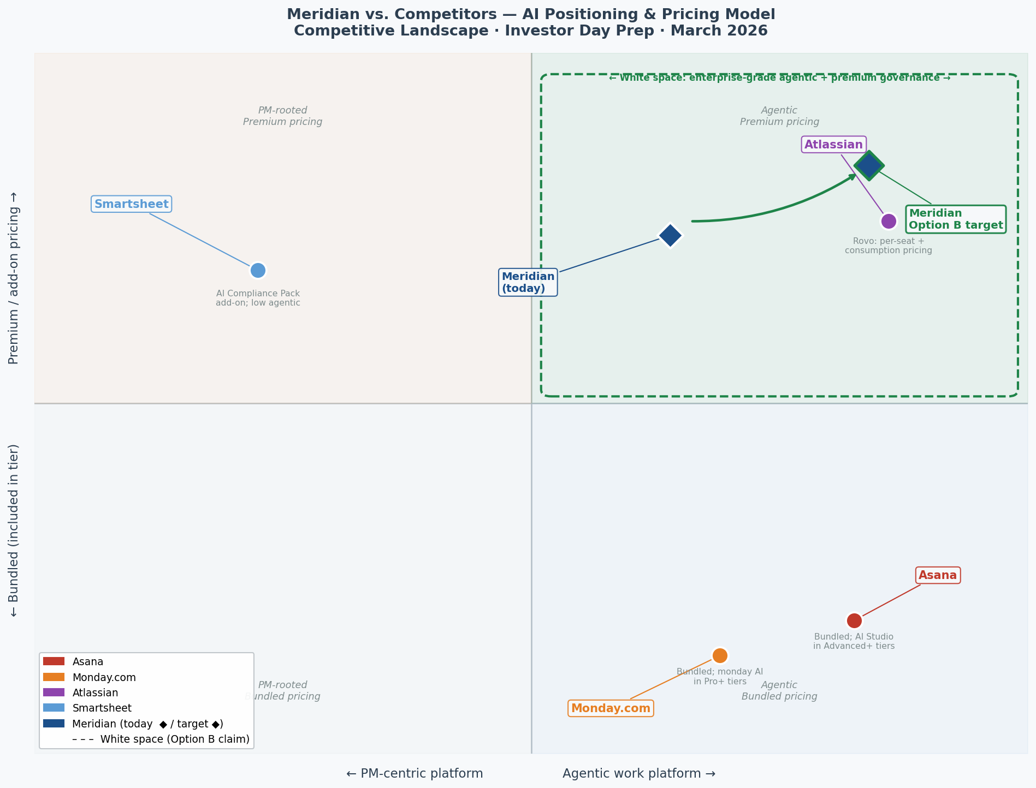
Figure 1. X-axis: PM-centric → Agentic. Y-axis: Bundled pricing → Premium pricing. Green dashed box = white space Meridian is claiming with Option B.
Competitor | AI Positioning | Pricing | vs. Meridian Option B
Asana | Agent operating system for work; AI Studio bundled into Advanced+ tiers (Nov 2025) | Bundled; no consumption pricing | Agentic but ungoverned — Meridian differentiates on governance depth
Monday.com | Work OS with AI everywhere; monday AI Agents GA Jan 2026; price-aggressor | Bundled into Pro+; no consumption pricing | Breadth and price; zero regulated-industry or governance depth
Atlassian | Agentic enterprise platform for software/IT teams; Rovo Studio agent builder | Rovo: per-seat + consumption (only competitor with live consumption pricing) | Closest Option B peer; governance thin outside dev/IT — Meridian’s opening
Smartsheet | Enterprise work platform you can trust with AI; explicitly not agentic; decelerating | AI bundled Business/Enterprise; Compliance Pack add-on ~$15/seat | Option A peer group — shrinking, low-multiple; the bucket to avoid

THREE RISKS THE BOARD WILL HOLD US TO

- The air gap. Copilot ARR is $3.5M — less than 1% of the base. Declaring an agentic platform before the revenue validates it creates a window where the PM business is being deprioritized and consumption revenue has not yet materialized. We must give investors a specific Q4 2026 Copilot ARR target on March 11 and report against it every quarter. The bridge must be visible or the declaration becomes a liability.
- Atlassian closes the regulated-industry gap. Atlassian has the R&D budget and install base to build FedRAMP High and deepen pharma/financial services in 18–24 months. If they get there before we have named lighthouse accounts in those verticals, our differentiation narrows to tenure rather than moat. Two referenceable regulated-industry agent deployments by Q3 2026 are required — not aspirational.
- Helio attrition undermines the roadmap. 26 of 28 Helio engineers are still here; the 2026 cash compensation cliff is approaching. Loss of 8–10 key engineers sets the agent framework back 18+ months. Retention packages must be executed before Investor Day. This is a board-level risk, not an HR task.
THREE COMMITMENTS TO INVESTORS ON MARCH 11

- A specific Copilot ARR bridge. We will disclose our internal Copilot ARR target for Q4 2026 and the consumption pricing rollout timeline (H2 2026). Investors will have a quantitative benchmark, not just a vision statement.
- Named regulated-industry lighthouse accounts. We will announce at least two named enterprise customers deploying Meridian’s agent governance suite in a regulated-industry context (financial services or life sciences) by Q3 2026 — the proof points that validate the differentiation from Atlassian and the AI-native upstarts.
- A quarterly AI metrics cadence. Starting Q1 2026, we will report three AI-specific metrics every quarter: Copilot ARR, Copilot attach rate on enterprise renewals, and weekly active agent usage per seat. The agentic platform story is earned quarter by quarter, not declared once and forgotten.

Sources: meridian_ai_strategy_options.md · meridian_internal_brief.md · meridian_recent_customer_feedback.md · meridian_financials_summary.csv · competitors_cached/ (Asana, Monday, Atlassian, Smartsheet) · Competitive matrix: meridian_competitive_matrix.png

