MERIDIAN TECHNOLOGIES
Board of Directors — Annual Strategic Review
May 2026 | Catherine Park, President & CEO

Meridian has a strong enterprise foundation and a closing window to decide
whether it becomes the agentic work platform for regulated industries — or gets left behind.

Good morning. I want to use my five minutes to be direct with you about where this company stands, what keeps me up at night, and the one decision I am asking the board to make today. Everything else is detail.
THREE ISSUES

Issue 1 — Growth deceleration is structural, not cyclical.
Revenue growth has decelerated every year for four consecutive years: 28% (2022), 19% (2023), 16% (2024), 11% (2025). Our 2026 guidance of 10–14% is below analyst consensus. This is not a macro story. It has three structural drivers operating simultaneously.
- SMB hemorrhage: $30M ARR headwind guided for 2026. SMB NRR is 84%; gross logo churn 22% per year. SMB ARR has fallen from ~$105M (Q4 2022) to ~$54M (Q4 2025). [meridian_segments_overview.md; meridian_kpis_2024.csv]
- Mid-market plateauing: NRR compressed from 115% (2022) to 102% (2025). Renewals now routinely demand price holds, seat count expansions at flat price, or Copilot bundled at no cost. [meridian_kpis_2024.csv; Q3 2025 earnings call]
- Sales efficiency eroding: Magic number fell from 1.20 (Q1 2024) to 0.92 (Q4 2025). New ARR per rep declined 16% over the same period — with headcount flat. [meridian_kpis_2024.csv]

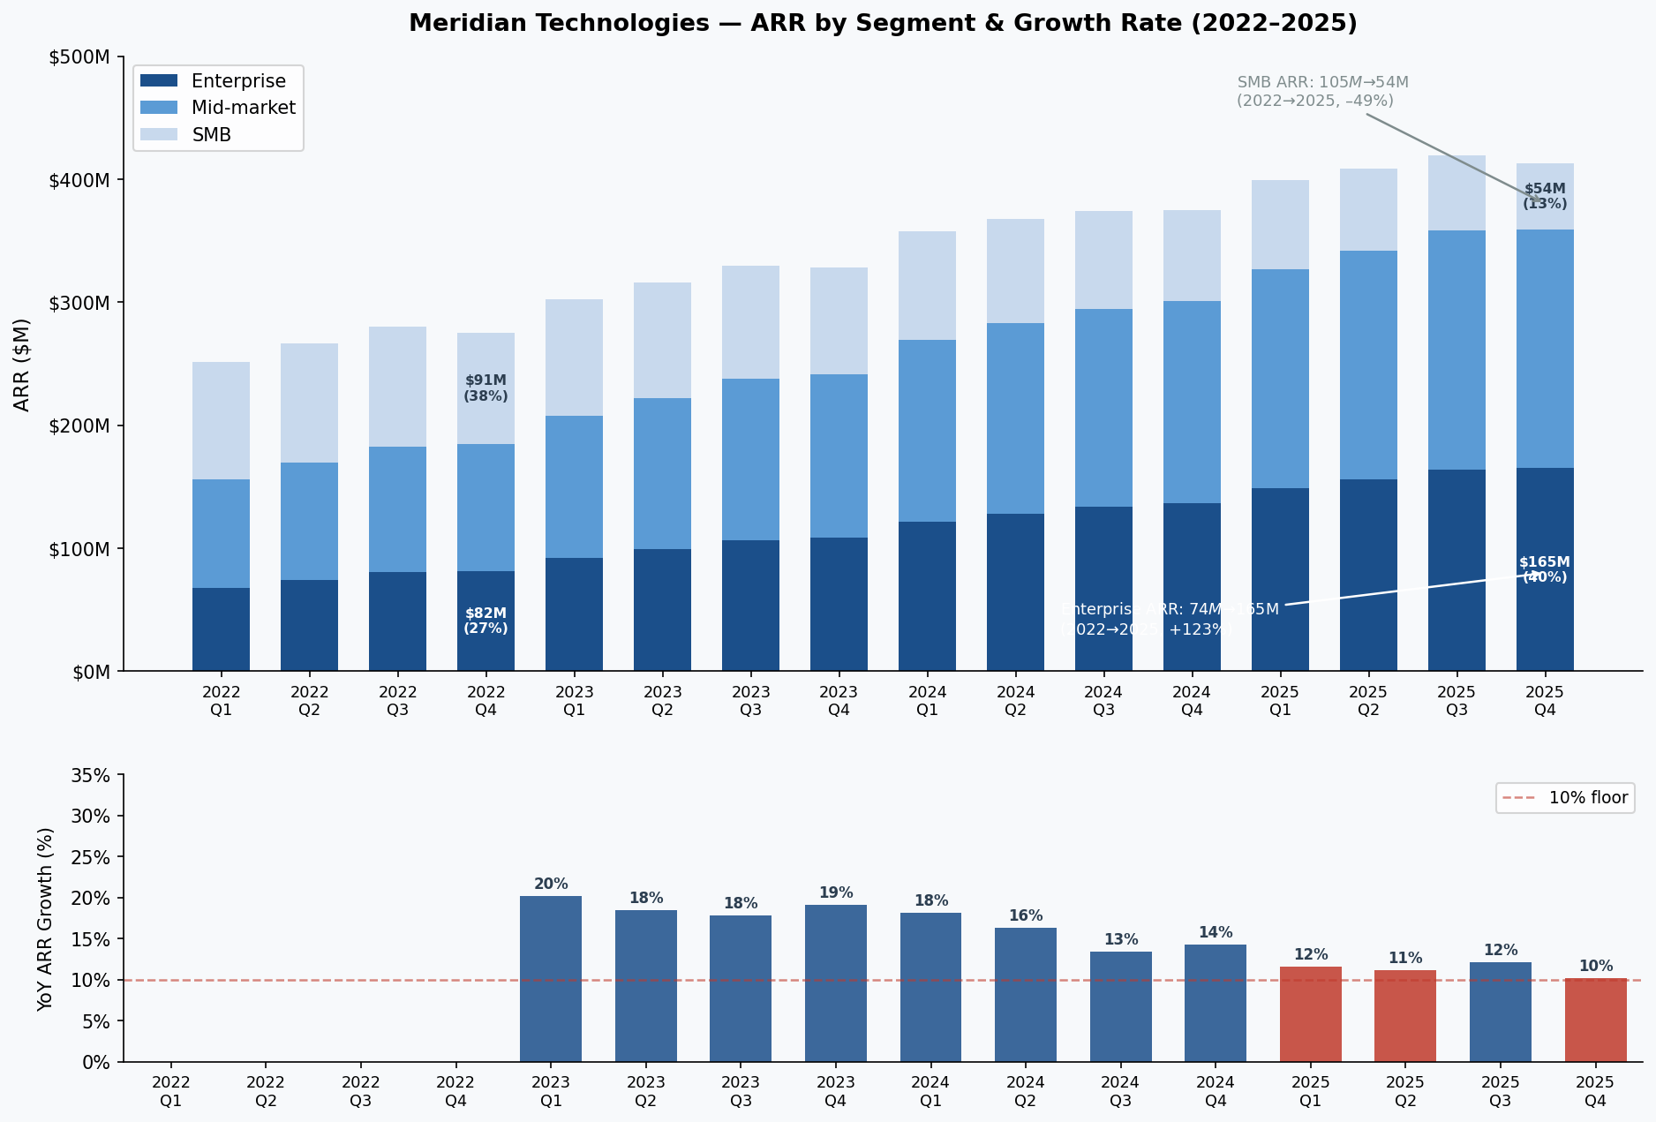
Figure 1. Meridian ARR by segment (stacked bars) and YoY ARR growth rate (bottom panel), Q1 2022–Q4 2025. Enterprise (dark blue) is the growth engine. SMB (light blue) is in structural decline. Growth rate has decelerated every year.
Issue 2 — AI competitive position is real but fragile — and the pricing model is unresolved.
AI Copilot reached GA in September. We ended 2025 with 710 paying seats, $3.5M in ARR contribution, and a 44% attach rate on enterprise renewals — ahead of our own 40% target. These are genuine proof points. They are also less than 1% of our ARR base, and the competitive window is compressing.
- Asana bundled AI into its standard tier in Q4 2025, eliminating the add-on pricing argument in every mid-market renewal. Monday is now larger than us by ARR. ClearAI Work raised at $1B+ — competitive in SMB. [Q4 2025 earnings call]
- Atlassian agentic Jira announced last week. This is the most consequential competitive development because it enters our enterprise base directly. [Q4 2025 earnings call]
- Engineering capacity is the binding constraint. The 2026 roadmap assumes 80 new hires in H1; at current 15% attrition, net adds are ~25. Six of twelve 2025 commitments slipped ≥1 quarter. Two were deferred. [meridian_product_roadmap_2025.md]
- The Copilot pricing model is unmade. Per-seat add-on versus consumption pricing implies a fundamentally different sales motion, revenue forecasting, and customer segmentation. The board needs to weigh in. [meridian_product_roadmap_2025.md]
Issue 3 — Organizational coherence is at risk.
We are running a transformation across four dimensions simultaneously — segment reorg, AI pivot, international build-out, and leadership transition. The 2025 employee survey (81% response rate, 2,402 eligible employees) shows the seams.
- "Roadmap thrash" cited by 31% of engineering and 24% of product respondents. "Three AI roadmap pivots in eighteen months." [meridian_employee_survey_2025.md]
- "We don't know what we are anymore" cited by 28% of sales respondents. "I cannot crisply say what makes Meridian different from Asana with AI." [meridian_employee_survey_2025.md]
- Senior engineering attrition risk: 27% of senior engineers flagged compensation below market. People team projects 15–25 departures in a tight AI talent market without a Q1 2026 equity refresh. These are the engineers who own the Copilot and Helio roadmap. [meridian_employee_survey_2025.md]

MY ONE ASK
Approve the strategic direction and the Copilot pricing model today — not as a formality, but as a durable commitment the organization can build against.
I will present our full 2026–2029 strategic plan, financial targets, AI roadmap, and Investor Day narrative at the March 11 Investor Day. What I need from this board today is alignment on two specific questions: (1) Do we go all-in on the agentic work platform positioning — which means accepting lower 2026 growth while we invest — or do we optimize for near-term margin expansion? (2) Do we price AI Copilot on a per-seat or consumption basis going forward? Both decisions are mine to make. Both are better made with the board's explicit backing, because the organization will watch how durable this direction is. Roadmap thrash ends when the strategy is visibly locked.

Data sources: meridian_financials_2022_2025.csv · meridian_kpis_2024.csv · meridian_segments_overview.md · meridian_earnings_calls_Q1–Q4_2025 · meridian_product_roadmap_2025.md · meridian_employee_survey_2025.md · meridian_board_memo_strategic_outlook_2024.md

