# Peer Assessment 1

Peer assessment 1 assignment for Coursera course [Reproducible Research](Reproducible%20Research).

## Introduction

It is now possible to collect a large amount of data about personal movement using activity monitoring devices such as a [Fitbit](http://www.fitbit.com), [Nike Fuelband](http://www.nike.com/us/en_us/c/nikeplus-fuelband), or [Jawbone Up](https://jawbone.com/up). These type of devices are part of the "quantified self" movement -- a group of enthusiasts who take measurements about themselves regularly to improve their health, to find patterns in their behavior, or because they are tech geeks. But these data remain under-utilized both because the raw data are hard to obtain and there is a lack of statistical methods and software for processing and interpreting the data.

This assignment makes use of data from a personal activity monitoring device. This device collects data at 5 minute intervals through out the day. The data consists of two months of data from an anonymous individual collected during the months of October and November, 2012 and include the number of steps taken in 5 minute intervals each day.

## Data

The data for this assignment can be downloaded from the course web site:

* **Dataset**: [Activity monitoring data](https://d396qusza40orc.cloudfront.net/repdata%2Fdata%2Factivity.zip) [52K]

The variables included in this dataset are:

* **steps**: Number of steps taking in a 5-minute interval (missing values are coded as NA)
* **date**: The date on which the measurement was taken in YYYY-MM-DD format
* **Interval5MinIncrement**: Identifier for the 5-minute interval in which measurement was taken

The dataset is stored in a comma-separated-value (CSV) file and there are a total of 17,568 observations in this dataset.

## Assignment

This assignment will be described in multiple parts. You will need to write a report that answers the questions detailed below. Ultimately, you will need to complete the entire assignment in a **single R markdown** document that can be processed by **knitr** and be transformed into an HTML file.

Throughout your report make sure you always include the code that you used to generate the output you present. When writing code chunks in the R markdown document, always use echo = TRUE so that someone else will be able to read the code. **This assignment will be evaluated via peer assessment so it is essential that your peer evaluators be able to review the code for your analysis**.

For the plotting aspects of this assignment, feel free to use any plotting system in R (i.e., base, lattice, ggplot2)

Fork/clone the [GitHub repository created for this assignment](http://github.com/rdpeng/RepData_PeerAssessment1). You will submit this assignment by pushing your completed files into your forked repository on GitHub. The assignment submission will consist of the URL to your GitHub repository and the SHA-1 commit ID for your repository state.

NOTE: The GitHub repository also contains the dataset for the assignment so you do not have to download the data separately.

## Suggested answer to assignment questions in the following steps:

### **Step 1.** Loading and preprocessing the data

Show any code that is needed to:

**Step 1.1** Load the data (i.e. read.csv())**-- DONE**   
Setup work enviroment: Load required R packages for process + unzip data file.

setwd("C:/Anthony_Wynn/Docs/R/R_Lang/hopkins/ReproducipleResearch/peerAss1")  
#install.packages("SeqKNN")  
packages <- c("data.table", "ggplot2", "xtable", "VIM", "knitr")  
sapply(packages, require, character.only=TRUE, quietly=TRUE)

## VIM is ready to use.   
## Since version 4.0.0 the GUI is in its own package VIMGUI.  
##   
## Please use the package to use the new (and old) GUI.  
##   
##   
## Attaching package: 'VIM'  
##   
## The following object is masked from 'package:datasets':  
##   
## sleep

## data.table ggplot2 xtable VIM knitr   
## TRUE TRUE TRUE TRUE TRUE

Use data.table for analysis instead of DF for better performance [data.table](http://cran.r-project.org/web/packages/data.table/index.html) package.

unzip("activity.zip", files=NULL, exdir=getwd(), overwrite=TRUE)  
dtActvMonData <- read.csv(file.path(getwd(), "activity.csv"))  
dtActvMonData <- data.table(dtActvMonData)  
# Rename the "interval" column for easier to understand.   
dtActvMonData <- setnames(dtActvMonData,"interval","Interval5MinIncrement")

**Step 1.2** Process/transform the data (if necessary) into a format suitable for your analysis -- **DONE**

#transform `date` variable to a date class.  
dtActvMonData <- dtActvMonData[, date := as.Date(date)]

### Step 2.0 What is mean total number of steps taken per day?

For this part of the assignment, you can ignore the missing values in the dataset. When we calculate the median and the mean in the Step 2.2 we will exclude na (na.rm = TRUE)

**Step 2.1** Make a histogram of the total number of steps taken each day**-- DONE**

#Aggregate the number of steps taken each day & save in new DT  
dtDailySteps <- dtActvMonData[, list(sumSteps = sum(steps)), date]  
head(dtDailySteps)

## date sumSteps  
## 1: 2012-10-01 NA  
## 2: 2012-10-02 126  
## 3: 2012-10-03 11352  
## 4: 2012-10-04 12116  
## 5: 2012-10-05 13294  
## 6: 2012-10-06 15420

graph <- ggplot(dtDailySteps, aes(x=sumSteps))+geom_histogram(alpha=1/2, binwidth=1000)+ggtitle("Mean total number of steps taken per day")  
# set Black-and-white theme  
graph + theme_bw() + theme(axis.title.x = element_text(colour="blue", size=15, face="bold")) + theme(axis.title.y = element_text(colour="blue", size=17, face="bold"))

plot of chunk plot histogram StepsTakenEachDay

**Step 2.2** Calculate and report the **mean** and **median** total number of steps taken per day. Calculate the mean and median total number of steps taken per day **before imputing**.**-- DONE**

#Aggregate the number of steps taken each day. Days with missing values (`NA`) will have `NA` when aggregated.  
aggResult <- dtDailySteps[, list(n = .N, nValid = sum(!is.na(sumSteps)), mean = mean(sumSteps, na.rm=TRUE), median = median(sumSteps, na.rm=TRUE))]  
#TAble below is the answer for mean and median value.  
print(xtable(aggResult), type="html", include.rownames=FALSE)

n

nValid

mean

median

61

53

10766.19

10765

#Copy the data table `dtDailySteps` before imputation to be used later. Add new coln status  
dtDailySteps <- dtDailySteps[, status := "Before imputation"]  
dtDailyStepsB4Imptt <- dtDailySteps

### Step 3.0 What is the average daily activity pattern?

**Step 3.1** Make a time series plot (i.e. type = "l") of the 5-minute interval (x-axis) and the average number of steps taken, averaged across all days (y-axis)**-- DONE**   
**Step 3.2** Which 5-minute interval, on average across all the days in the dataset, contains the maximum number of steps? **-- DONE**   
Aggregate the average number of steps taken by 5-minute interval.

dtIntervals<-dtActvMonData[, list(meanSteps = mean(steps, na.rm=TRUE)), Interval5MinIncrement]

Plot a time series of the 5-minute interval and the average number of steps taken across all days.

graph<-ggplot(dtIntervals, aes(x=Interval5MinIncrement, y=meanSteps))+  
 geom_line()+ggtitle("Time series with average daily activity pattern 5 min increment")  
# set Black-and-white theme  
graph + theme_bw() + theme(axis.title.x = element_text(colour="blue", size=15, face="bold")) + theme(axis.title.y = element_text(colour="blue", size=17, face="bold"))

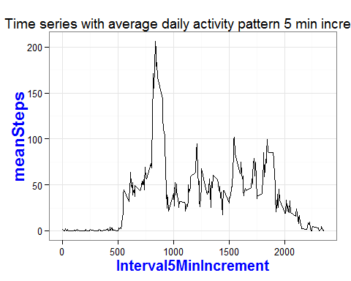

### Step 4.0 Imputing missing values

**Note**: that there are a number of days/intervals where there are missing values (coded as NA). The presence of missing days may introduce bias into some calculations or summaries of the data.

Step 4.1 Calculate and report the total number of missing values in the dataset (i.e. the total number of rows with NAs)**-- DONE**

dtActvMonData <- dtActvMonData[, isStepsMissing := is.na(steps)]  
aggResult <- dtActvMonData[, .N, isStepsMissing]  
print(xtable(aggResult), type="html", include.rownames=FALSE)

isStepsMissing

N

TRUE

2304

FALSE

15264

summary(dtActvMonData)

steps date Interval5MinIncrement

Min. : 0.0 Min. :2012-10-01 Min. : 0  
 1st Qu.: 0.0 1st Qu.:2012-10-16 1st Qu.: 589  
 Median : 0.0 Median :2012-10-31 Median :1178  
 Mean : 37.4 Mean :2012-10-31 Mean :1178  
 3rd Qu.: 12.0 3rd Qu.:2012-11-15 3rd Qu.:1766  
 Max. :806.0 Max. :2012-11-30 Max. :2355  
 NA's :2304  
 isStepsMissing Mode :logical  
 FALSE:15264  
 TRUE :2304  
 NA's :0

**Step 4.2** Devise a strategy for filling in all of the missing values in the dataset. The strategy does not need to be sophisticated. For example, you could use the mean/median for that day, or the mean for that 5-minute interval, etc.

Use the [VIM](http://cran.r-project.org/web/packages/VIM/index.html) package to impute missing values of the steps variable. Use k-Nearest Neighbour Imputation.**-- DONE**   
k-Nearest Neighbour Imputation based on a variation of the Gower Distance for numerical, categorical, ordered and semi-continous variables.

dtActvMonData <- kNN(dtActvMonData, metric = NULL,  
 k = 5, dist_var = colnames(dtActvMonData), weights = NULL,  
 numFun = median, catFun = maxCat, makeNA = NULL,  
 NAcond = NULL, impNA = TRUE, donorcond = NULL,  
 mixed = vector(), mixed.constant = NULL, trace = FALSE,  
 imp_var = TRUE, imp_suffix = "imp", addRandom = FALSE)

## Time difference of -4.81 secs

The kNN function returns a dataset with all NAs replaced. So the steps variable now contains imputed values replacing the NAs.

**Step 4.3** Create a new dataset that is equal to the original dataset but with the missing data filled in.**-- DONE**   
Verify that there are no missing values for steps after imputation.

aggResult <- dtActvMonData[, .N, list(isMissing = is.na(steps))]  
print(xtable(aggResult), type="html", include.rownames=FALSE)

isMissing

N

FALSE

17568

Verify that missingness is complete for an entire day. Show all days with at least 1 missing value for the steps variable. Calculate the proportion of records with missing values for each such day. All proportions are 100%.

dtMissingValue <- dtActvMonData[, list(countMissing = sum(isStepsMissing), countRecords = .N, propMissing = sum(isStepsMissing / .N)), date]  
dtMissingValue[countMissing > 0]

## date countMissing countRecords propMissing  
## 1: 2012-10-01 288 288 1  
## 2: 2012-10-08 288 288 1  
## 3: 2012-11-01 288 288 1  
## 4: 2012-11-04 288 288 1  
## 5: 2012-11-09 288 288 1  
## 6: 2012-11-10 288 288 1  
## 7: 2012-11-14 288 288 1  
## 8: 2012-11-30 288 288 1

#### After imputation of missing values

Aggregate the number of steps taken each day.

dtDailySteps <- dtActvMonData[, list(sumSteps = sum(steps), isImputed = sum(steps_imp) > 0), date]  
head(dtDailySteps)

## date sumSteps isImputed  
## 1: 2012-10-01 3036 TRUE  
## 2: 2012-10-02 126 FALSE  
## 3: 2012-10-03 11352 FALSE  
## 4: 2012-10-04 12116 FALSE  
## 5: 2012-10-05 13294 FALSE  
## 6: 2012-10-06 15420 FALSE

**Step 4.4** Make a histogram of the total number of steps taken each day and Calculate and report the **mean** and **median** total number of steps taken per day. Do these values differ from the estimates from the first part of the assignment? What is the impact of imputing missing data on the estimates of the total daily number of steps? Plot a histogram of the total number of steps taken each day **after imputing** and compare with the histogram **before imputing**.**-- DONE**   
Need to add an isImputed column to dtDailyStepsB4Imptt to make rbind work.

dtDailySteps <- dtDailySteps[, status := "After imputation"]  
  
dtDailyStepsB4Imptt <- dtDailyStepsB4Imptt[, isImputed := FALSE]  
  
dtDailySteps <- rbind(dtDailySteps, dtDailyStepsB4Imptt, use.names=TRUE)  
  
graph<-ggplot(dtDailySteps, aes(x=sumSteps, fill=isImputed)) +  
geom_histogram(alpha=1/2, binwidth=1000)+facet_wrap(~ status, nrow=2)+  
 theme(legend.position="bottom")+ggtitle("Mean + median of steps taken per day")  
  
# set Black-and-white theme  
graph + theme_bw() + theme(axis.title.x = element_text(colour="blue", size=15, face="bold")) + theme(axis.title.y = element_text(colour="blue", size=17, face="bold"))

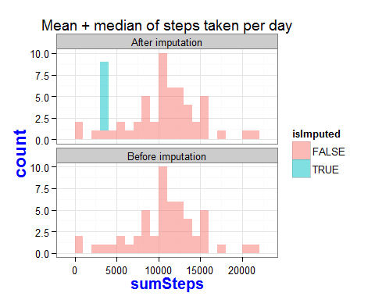

Calculate the mean and median total number of steps taken per day **after imputing**.

aggResult <- dtDailySteps[, list(n = .N, nValid = sum(!is.na(sumSteps)), mean = mean(sumSteps, na.rm=TRUE), median = median(sumSteps, na.rm=TRUE)), status]  
print(xtable(aggResult), type="html", include.rownames=FALSE)

status

n

nValid

mean

median

After imputation

61

61

9752.39

10395.00

Before imputation

61

53

10766.19

10765.00

The median of the imputed values is the same as the original values where missing values were not imputed. However, the mean of the imputed values is **less than** the original values. The overall impact of the imputed values is to **lower** the estimates of the number of steps taken each day.

### Step 5.0 Are there differences in activity patterns between weekdays and weekends?

For this part the weekdays() function may be of some help here. Use the dataset with the filled-in missing values for this part.

Step 5.1 Create a new factor variable in the dataset with two levels -- "weekday" and "weekend" indicating whether a given date is a weekday or weekend day. Create a new factor variable in the dataset with two levels -- "weekday" and "weekend" indicating whether a given date is a weekday or weekend day.**-- DONE**   
Use this solution to [collapse the factor values](http://stackoverflow.com/a/9053619) for day of week. Verify that dayOfWeek and dayType are factor class variables.

levels <- c("Sunday", "Monday", "Tuesday", "Wednesday", "Thursday", "Friday", "Saturday")  
newLevels <- c("Weekend", rep("Weekday", 5), "Weekend")  
dtActvMonData <- dtActvMonData[, dayOfWeek := factor(weekdays(date), levels=levels)]  
dtActvMonData <- dtActvMonData[, dayType := factor(newLevels[dayOfWeek])]  
dtActvMonData[, .N, list(dayType, dayOfWeek)]

## dayType dayOfWeek N  
## 1: Weekday Monday 2592  
## 2: Weekday Tuesday 2592  
## 3: Weekday Wednesday 2592  
## 4: Weekday Thursday 2592  
## 5: Weekday Friday 2592  
## 6: Weekend Saturday 2304  
## 7: Weekend Sunday 2304

message(sprintf("Is dayOfWeek a factor? %s. Is dayType a factor? %s", is.factor(dtActvMonData$dayOfWeek), is.factor(dtActvMonData$dayType)))

## Is dayOfWeek a factor? TRUE. Is dayType a factor? TRUE

Aggregate the average number of steps taken by 5-minute interval. Use the imputed values in the steps variable.

dtIntervals<-dtActvMonData[, list(meanSteps=mean(steps, na.rm=TRUE)), list(dayType, Interval5MinIncrement)]

**Step 5.2** Make a panel plot containing a time series plot (i.e. type = "l") of the 5-minute interval (x-axis) and the average number of steps taken, averaged across all weekday days or weekend days (y-axis). The plot should look something like the following, which was creating using **simulated data**:**-- DONE**

Plot two time series (one for weekdays and the other for weekends) of the 5-minute intervals and average number of steps taken (imputed values).

graph<-ggplot(dtIntervals, aes(x=Interval5MinIncrement, y=meanSteps, color=dayType))+geom_line()+ facet_wrap(~ dayType, nrow=2)+theme(legend.position="none")+ggtitle("Activity patterns difference between weekdays and weekends.")  
# set Black-and-white theme  
graph + theme_bw() + theme(axis.title.x = element_text(colour="blue", size=15, face="bold")) + theme(axis.title.y = element_text(colour="blue", size=17, face="bold"))

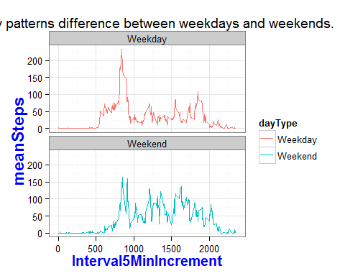

Another angle of seeing data differences by overlay the time series on a single plot instead of using a panel plot.

graph<-ggplot(dtIntervals, aes(x=Interval5MinIncrement, y=meanSteps, color=dayType)) +geom_line()+theme(legend.position="bottom")+ggtitle("Activity patterns difference above: Overlay in 1 plot.")  
# set Black-and-white theme  
graph + theme_bw() + theme(axis.title.x = element_text(colour="blue", size=15, face="bold")) + theme(axis.title.y = element_text(colour="blue", size=17, face="bold"))

