ITEC301 DELIVERABLE 1
PROJECT PROPOSAL

Student Name: | Anthony Shepherd
Student Number: | DQXF8H5N9
Project Title: | Candy Land – Ecommerce Website
Submission Date: | 1st April 2021

I. Introduction 3
II. Needs/Problems 3
III. Goals/Objectives 4
IV. Procedures/Scope of Work 4
V. Timetable 5
VI. Budget 6
VII. Key Personnel 7
VIII. CONCLUSION 7
ix. SIGN-OFF 7

  - Introduction
Candy Land was the go-to place to buy your junk food, treats, snacks, it was the place to go to for all of those who call themselves sugar addicts (truth be told its more the people around us that call us sugar addicts) who live in the now bustling town of Hillcrest.
Mr. Berry the Owner of Candy Land has been in the candy game his whole life, while talking to him he tells me stories about how his Mum used to make meringues by the tray for him and his siblings, his stories all include some form of sweet. My story though is of his handing out a peppermint for each of the children from the tin he kept in his coat after dinner, a tradition similar to one I had with my Oupa back when I was a boy. For Mr. Berry its his way of life, he hops the sweets he sells make memories mirroring his own.
Like most small businesses when Covid-19 stuck they where in a bind, unable to keep the store open as it was not an essential service, they were forced to close it down until the restrictions lessoned. I did not ask the impact this had on him directly but from the slight grimace while talking to him I can see it was a struggle.
Over the last year I have googled countless times for Candy Land to see if they had finally gotten a website (jellybeans are a personal addiction for me, and I have missed them a lot). When I found out that I would be needing to create an ecommerce site for this module my thought first was of Candy land.
When I called Mr. Berry to explain the situation he was thrilled at the idea, he told me that him and his wife had been discussing it at length lately and they had started the process of looking for a web designer to create them an ecommerce site. For them, the ability to sell products without having a physical store is critical to surviving the pandemic and retaining existing customers, and hopefully find some new ones.

  - Needs/Problems.
Candy Land is a popular store in normal times, however with the Covid 19 restrictions, customers being wary of entering shops and the increased popularity of shopping online, Candy land is forced to keep up with the times in order to regain the market share they had before the pandemic. By saying keep up with the times – I mean getting a digital presence – an online shop – a place shoppers can shop from the comfort of there lounges free from any worry about leaving the house.
However, Mr. Berry is not the most tech savvy man, he would like payments to be made on delivery and not through a third-party plugin on his website. He has a Yoco device that he currently uses in his shop that the driver (his eldest son) will use when he is making the delivers to capture payments.
Will need a simple way for Mr. Berry to add new items / categories. This is vital so that he can have control over the content of the site, and thus what he can and cannot sell.
Note: This needs to be taken into consideration when doing the prototype and technical design / will need a mechanism to confirm that payment was made, and delivery was successful.

  - Goals/Objectives
- Online presence that advertises Candy Lands products
  - (The site needs to be visually appealing, as its secondary function is advertising) Get a third party user to test the prototype and offer advice on usability.
- Ecommerce functionality that will allow consumers to purchase products off of the Candy Land site.
  - Is there functionality for adding new products into the database
  - Are consumers able to find and purchase a product
  - Consumers will need the ability to create an account and manage there details
- Mechanism for recording deliver and payment status
  - Receive notification that a deliver and payment was successful (email perhaps??) Will need to investigate solutions during the prototyping phase.
- Mechanism for managing stock on hand.
  - Stock needs to be managed both instore and online. When a product is purchased in store it needs to be deducted online.
  - When a product is purchased the database will need to be updated.
  - Procedures/Scope of Work
Since there are no other developers and I will be doing all the work myself I will batch the work into sprint like blocks that tie closely with the deliverables but are more aligned with type of work that needs to be completed at each stage.
Block 1: Building and signing of the prototypes.
- Will be using Figma to create visually appealing / functioning prototypes. I want Mr. Berry to be able to see how his site will function as soon as possible and receive any user input at that stage while I haven’t invested to much time in the coding, or technical design.
- This will be paired tested with Mr. Berry (If you want the technical term we call it User Acceptance testing), we will be focusing on potential functionality and site usability.
Block 2: Front-End development
- The next step will be to focus on the front end. In an ideal world I would be able to take the prototype and model the front-end after that.
- There will be a tiny bit of testing at this stage, mainly just focusing on the look and feel, there will be no data or backend setup so more complicated testing cannot be preformed.
Block 3: Internal Technical Documentation & backend Development:
- These two things will happen together, traditionally you would want to sign off on the technical documentation before starting development. However, since I am the only developer I would rather have simple technical documentation and update it as I develop the backend and resolve the challenges that I face.

Any Additional user documentation will be completed in the final week before handover to Mr. Berry.
  - Timetable

 | Description of Work | Start and End Dates
Deliverable 1 | Interview Mr Berry  Project Proposal Documentation  Handover | 29th March – 1st April
Deliverable 2 | Prototypes building  Prototypes Sign-Off  Technical Designs  Coding  Handover | 1st June – 25th June
Deliverable 3 | User Documentation  Presentation  Handover | 28th June – 2nd July

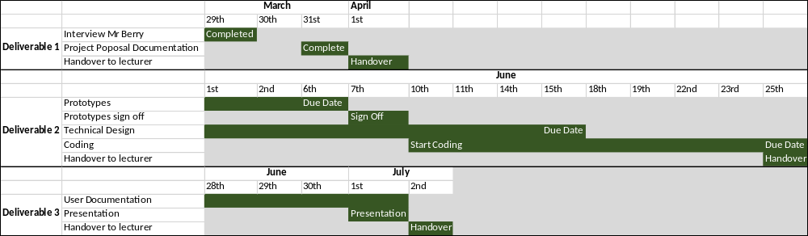

  - Budget

 | Description of Work | Cost (R)
Costs | Costs:  Labor: R200 per hour  Fuel: R4 per km  Cell/Internet: R800pm
Deliverable 1 | For this deliverable I estimate 3 hours of labor:  Interviews: 1 hour  Proposal: 2 hours  Labor = 3 x 200 = R600  Candy land is +- 5 km from my house.  Fuel = 10 X 4 = R40  Will not charge for my internet/cell usage.  This fee will be added into the final cost and will not be charged upfront. | R 640
Deliverable 2 | Prototypes will take around 6 hours to complete (given the attention to detail and that two of them need to be completed, 6 hours should be enough time to get them done. I am confident in this estimate as there is no added complexity)  Labor = 6 x 200 = R1200  Design & Coding this is not a specialty of mine so I will need to over estimate a bit (will be charged actual time spent unless it is above this estimate) 20 hours  Labor = 30 * 200 = R6000 | R 7200
Deliverable 3 | User Manual and Presentation will take around 3 hours to complete. The presentation will be done over Zoom so there is no need to charge fuel.  Labor = 3 * 200 = 600 | R 600
 | Total | R8440

  - Key Personnel

Stakeholders | Name [and Company] | Contact Details
Client | Clive Berry – Candy Land | clive@candlyland.co.za ;  076 148 8787
Sponsor | Zivanai – Eduvos | zivanai.taruvinga@pihe.ac.za
Project manager | Anthony Shepherd (student) | Ant.shepherd.93@gmail.com
Team | Anthony Shepherd (student)

  - Conclusion
This document highlights the work I will be doing for Mr. Berry over the next few months. It is the initial proposal that we will both be signing in order to confirm that we are happy and ready to go to the next phase of the project. Both Mr. Berry and I are extremely excited to get this project underway, with this first step delivered on time, we are off to a good start.

  - Sign-off

Clive Berry |  |  | Anthony Shepherd
[Name], Project Client  Date: _2021-03-30______________ |  |  | [Name], Project Manager  Date: __2021-03-31__________

