**Anthony Sturdy FOGGS Semester 2 Report**

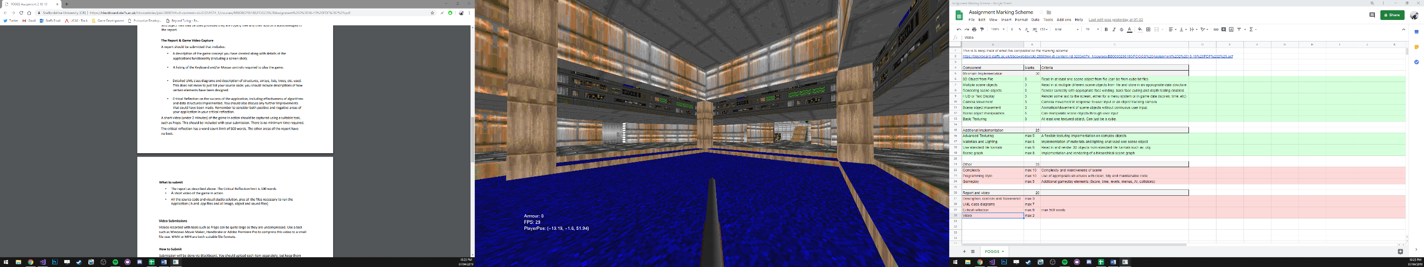The 3D scene I created is of Doom’s E1M1 map. You can walk around the level, there is collision, gravity, armour pickups and you walk with a shotgun. The level is fully textured (except for one in-accessible secret area) and has a skybox. The armour pickups and gun all have lighting enabled on them, the level doesn’t have lighting enabled. The collision used a separate mesh for navigation, which determines where the player can walk and the height of the floor the player is currently standing on.

**Controls**

WASD – Movement

Shift – Sprint (Have to hold shift *then* press movement button)

Caps lock – Toggle sprint (Have to press caps lock *then* press movement button)

Mouse – Look around

Escape – Exit

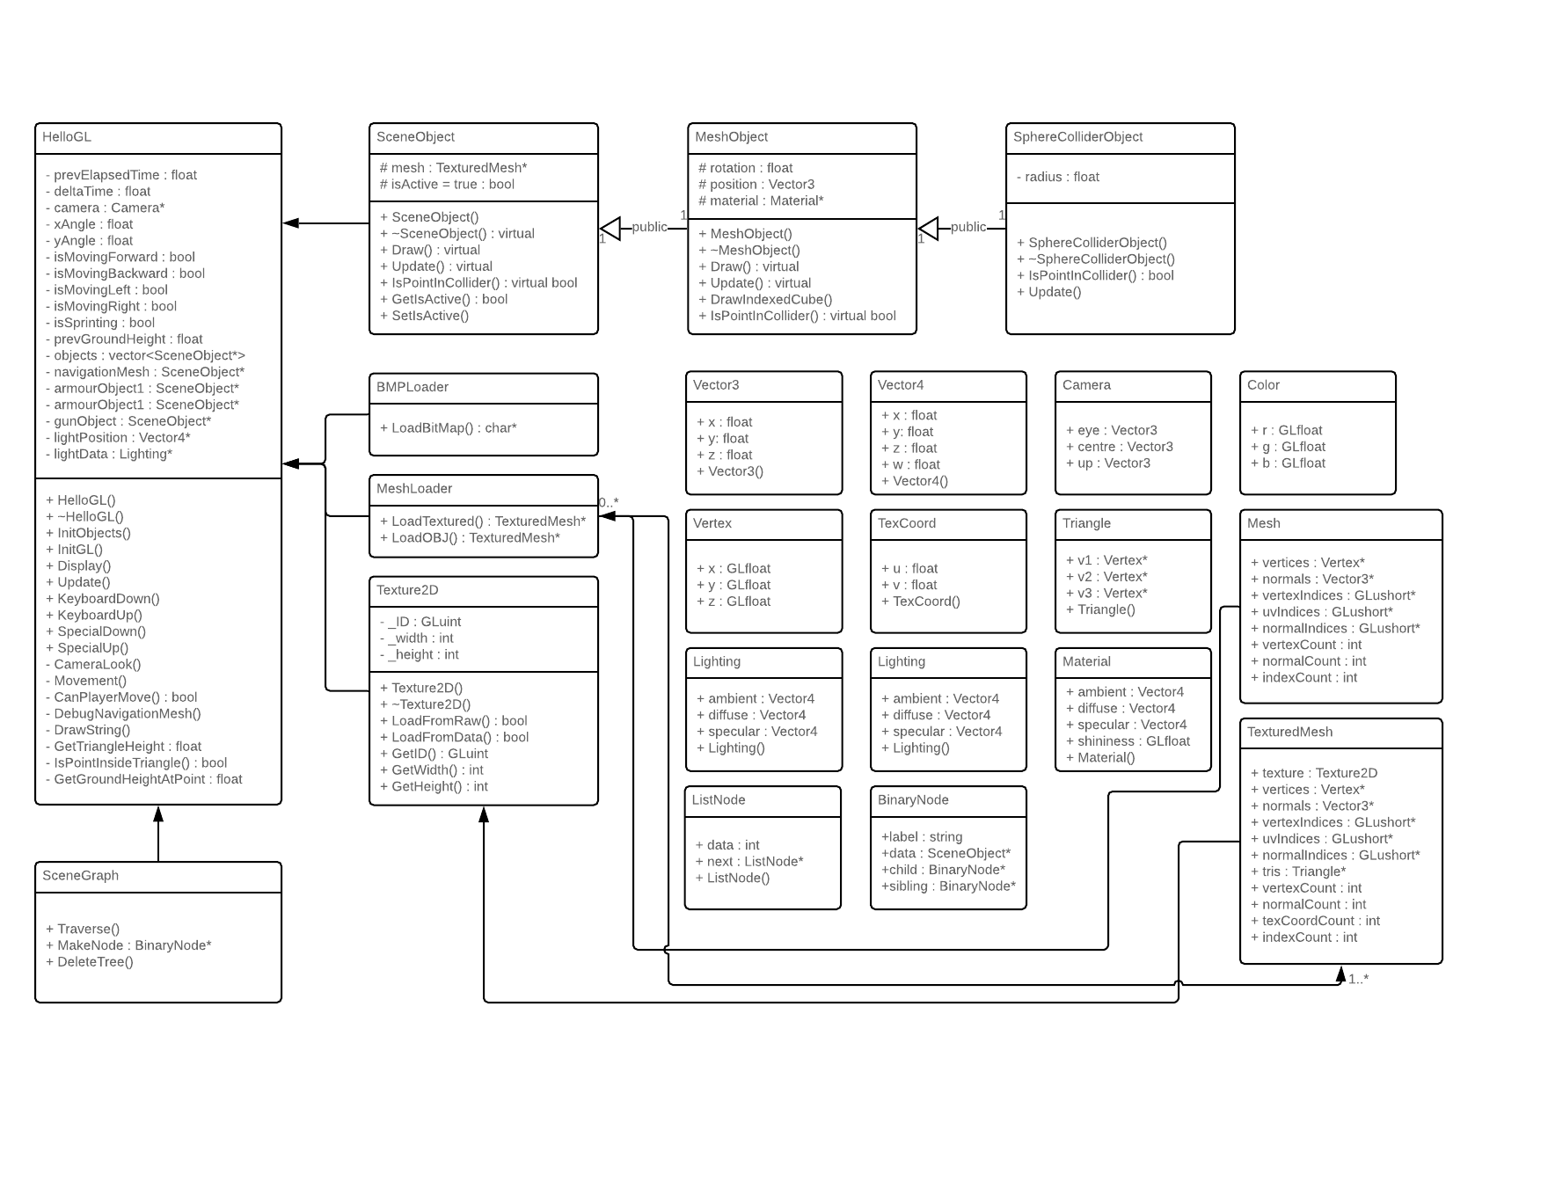**UML Class Diagrams**

**Critical Reflection**

I’m happy with the progress I made in my application, although I would like to have added more functionality if I had more time or knowledge. I think what went well, was the getting the level model rendered and textured fully. I managed to fit all of the textures I needed onto one 2048x2048 texture, then UV mapped the model to that one texture.

The gun and armour pickups have lighting enabled on them, to improve this I’d like to have lighting on the whole level with shadow mapping, although when researching this, I realised it’d probably take me a long time to implement as it seems very complex. Hopefully I will be able to apply more advanced lighting to future projects when I know more about 3D rendering.

I would also like to improve the UI. I think if I had the original Doom UI it would look a lot better. UI is something I’d like to more in the future, as it’s an important part of making a game/game engine. At the moment I don’t think the UI stands out well at all, and is mainly used for getting displaying information about the game which probably wouldn’t be shown if in a game (apart from the armour).

I like the collision system I’m using, it worked well for this application. I use a navigation mesh to decide where the player can walk, check if the player tries to go ‘out of bounds’ (hit a wall) and get the height of the floor (so the player can walk up and down stairs, drop off ledges, etc). The navigation mesh has allowed me to make the movement feel a lot like the original doom. Although the navigation mesh is great for this scene, it might not work as well in other games which require more player freedom when moving around the level.

I have also implemented a BMP loader for textures and OBJ loader for 3D models. They both work great, but I feel could be improved. The BMP loader can only load 24 bit BMP files, and the OBJ loader can only load meshes split into triangles, a lot of models I downloaded online for testing used quads, meaning they had to be converted to triangles. This wasn’t a problem for a small application like this, but if the project was bigger it would be good to add support for these files, or if I wanted to have transparency on textures, I’d need to be able to load 32 bit BMP’s.