Anthony Waddell
CSS 430
Program 1 Report

Part 1
Output of my process.cpp vs actual system calls

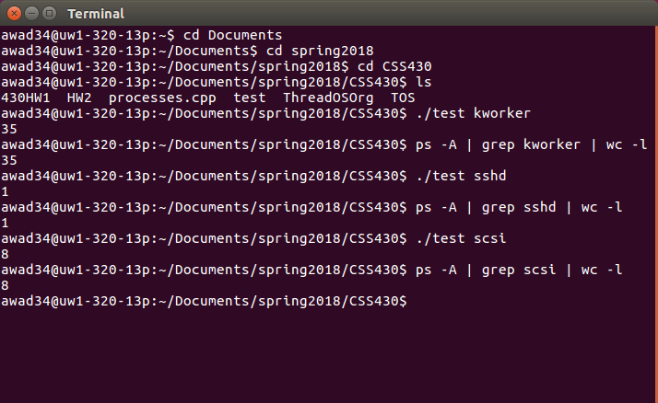
Part 2
Output when testing my Shell.java with PingPong.java for given test cases

Shell[1]% PingPong abc 100 ; PingPong xyz 50 ; PingPong 123 100

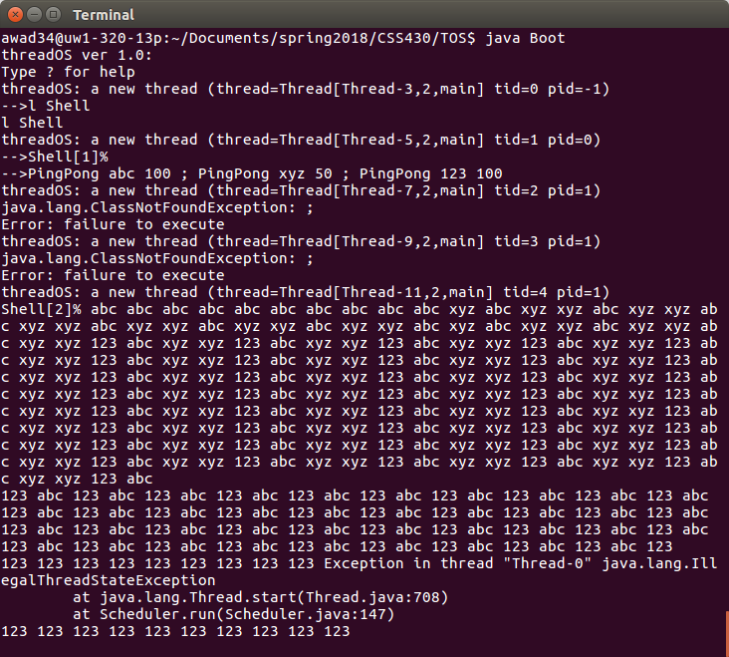

Shell[2]% PingPong abc 50 ; PingPong xyz 100 & PingPong 123 100

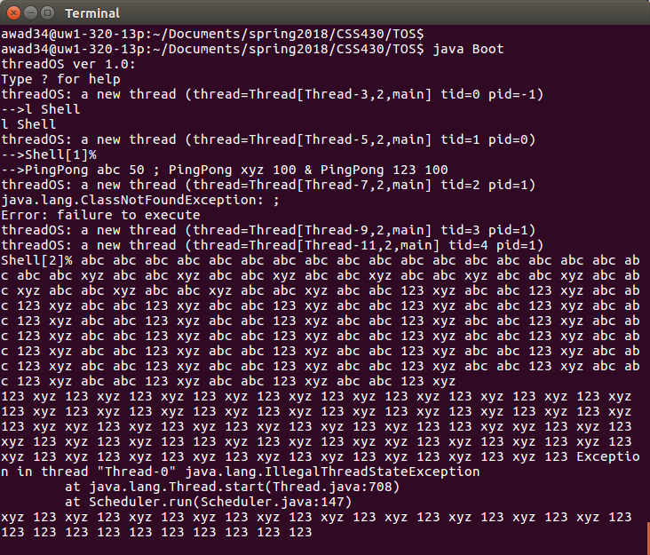
Shell[3]% PingPong abc 100 & PingPong xyz 100 ; PingPong 123 50

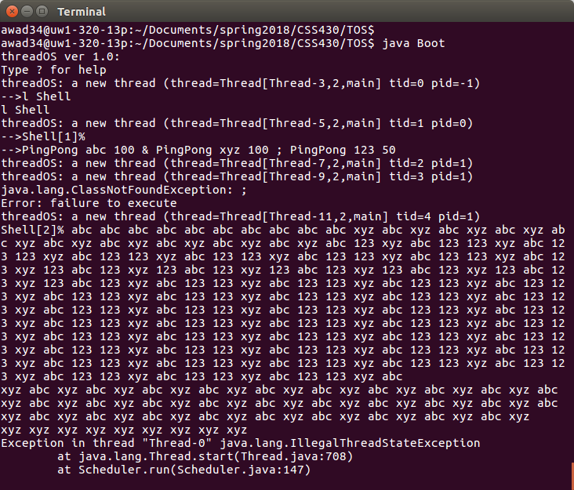
Shell[4]% PingPong abc 50 & PingPong xyz 50 & PingPong 123 100

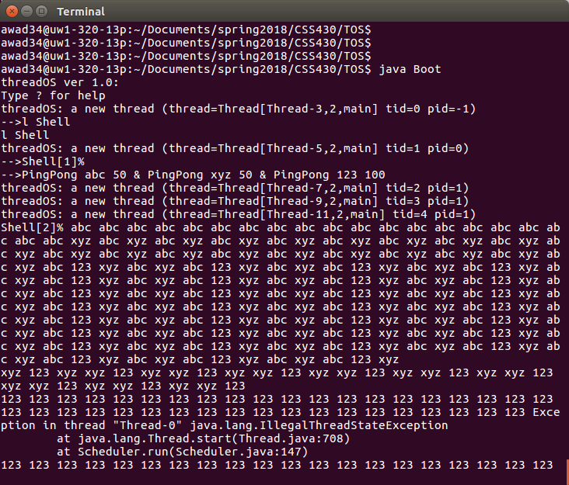
Documentation of processes.cpp

My processes.cpp uses three different pid_t variables to help the reader keep track of and visualize what’s happening in the source code. The first thing That should be done is call the pipe command on one of the file descriptor tables so that there is some sort connection between child processes. Afterwards, an attempt is made to fork the parent process. If successful, go into the newly created child process and create a new pipe with a second file descriptor table to limit its scope. Afterward, fork the child process to create a grandchild process and if successful, fork again to create a great grandchild process so we can start imitating system calls.

Once inside the great grandchild process, we can close some of the file descriptor table index’s it doesn’t need and dup the its write of the “ps -A” command to the standard out of the first file descriptor table. When the execution of that command finishes we repeat a similar process for the grandchild process only this time running the second “grep argv[1] command. Before running this command we want to call dup2 twice, once to redirect the read side of the first file descriptor to standard in. After that we call dup2 again to redirect the write of file descriptor 2 to standard out. Afterwards, we can execute the grandchild command and move to the child process. The child process closes the file descriptor indices it doesn’t need and makes one more dup call to redirect the read of the second file descriptor table to standard in. Once that’s done we can execute the child command “wc -l” and move out to the parent process. The parent process closes all file descriptor indices for good hygiene and waits for all spawned processes to complete before exiting.

Documentation of Shell.java

To test Shell.java:
1) Compile with: javac Shell.java <ENTER>
2) Enter : java Boot <ENTER>
3) Enter: l Shell <ENTER>
4) Enter: <ENTER>
5) Enter PingPong abc 100 ; PingPong xyz 50 ; PingPong 123 100

* Due to bug, you have to Ctrl + c out and repeat steps 2-5 above with different test cases such as:

PingPong abc 50 ; PingPong xyz 100 & PingPong 123 100
PingPong abc 100 & PingPong xyz 100 ; PingPong 123 50
PingPong abc 50 & PingPong xyz 50 & PingPong 123 100
Shell.java must extend Thread to be implemented and requires at least a default constructor and a public void run() method. Inside the run method we want to keep track of the commands, starting with one, and increment it for every command(s) entered. It prints a prompt to simulate the shell and waits for user input. It then creates a buffer to read into and uses SysLib to read input from the user into the buffer. If the user enters “exit” it will exit, otherwise it uses another SysLib function to parse the command into an array of strings, delimited by white space characters. Since this isn’t as useful as we need it to be, we create a new string array to logically group commands longer than one string, such as “PingPong abc 50”. So we iterate over every string in the original array and if it’s a command/arguement or anything other than a delimiter, it begins storing it in a second array index, sequentially, until it encounters one of the two delimiters “;” or “&”. If it iterates over one of the delimiters, it makes the next index in the second array the delimiter and advances to one index after thye newly inserted delimiter to process a new string of command/arguements.
After all input has been “cleaned” we can start iterating over it and executing the actual commands. This is where I ran into bugs. My Shell.java processes commands one by one and begins by checking for the “;” delimiter to see if SysLib.join() should be called to wait for the current child thread to finish executing. If its not a delimiter, then it tries to execute the command string by using SysLib.stringToArgs() to parse the line of commands into individual string arguments.
I am honestly not sure where the bug is that is causing my issue. From the actual terminal, when trying to process a command, it throws an IllegalThreadStateException. According to the Thread API, this exception is the result of it trying to start the same thread more than once, which is illegal. However, I am not sure how this is being triggered. I know it should be listening for SysLib.wait() to return the correct child ID so the child process can be terminated but I am not sure how to tie that into the execution. Any ideas/tips/solutions would be greatly appreciated since I have been stuck on this for some time now.

