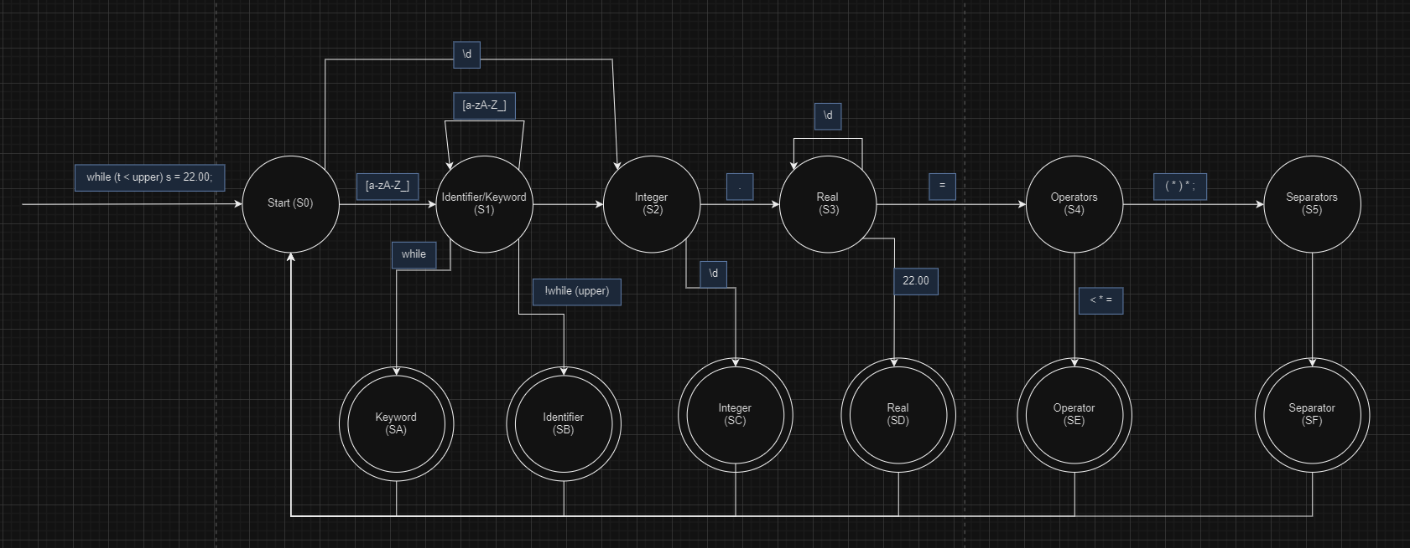
REs (Regular Expressions):
Keywords: \bwhile\b
Identifiers: [a-zA-Z_]
Integers: \bd+\
Real: \bd+\.\d+\b
Operators: [= | < | > | + | -]
Separators: [\(\)\;]

