Project Name: Blitz Barrels

### Team Name: Blazn’ Squad

### Team Members: Minh Phan, Anthony Zolman

#### **What are we building?**

We are building a **grid-based shooting game** called **Fish in a Barrel**, where the player must shoot fish appearing in random grid locations. The game has multiple difficulty levels that, decrease the number of fish and supplies fewer bullets at higher rounds.

#### **Why do we want to build it?**

We want to create an engaging and fun game that tests the player's ability strategize under increasing levels of difficulty. It’s inspired by classic arcade games with a modern twist, combining randomness and strategic shooting.

#### **What will it be useful for?**

The game will be useful for people looking for quick, challenging entertainment. It tests the player’s decision-making, and resource management (bullets vs fish). Additionally, it’s designed to be simple but addictive, offering replay ability through random fish placement and escalating difficulty.

#### **How will it be used?**

Players will:

* Choose a difficulty level.
* Be presented with a grid, where fish will appear at random locations.
* Use 3 bullets (or fewer on harder difficulties) to try and hit as many fish as possible within the grid. Fish change position every game, and harder levels feature fewer fish and fewer bullets, adding more challenge.
* The goal is to shoot all the fish with the given number of bullets.

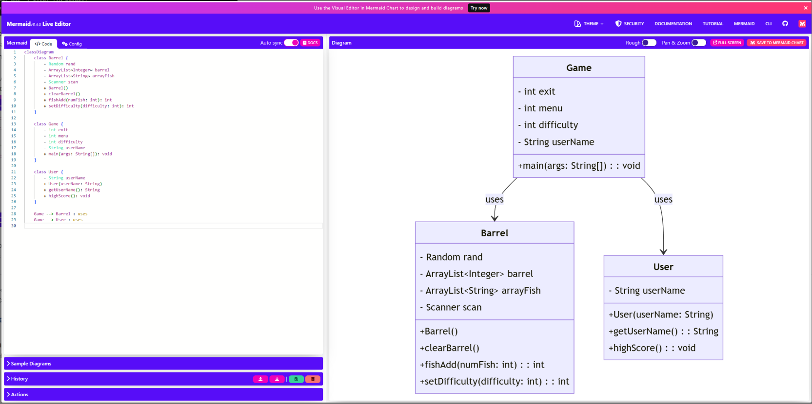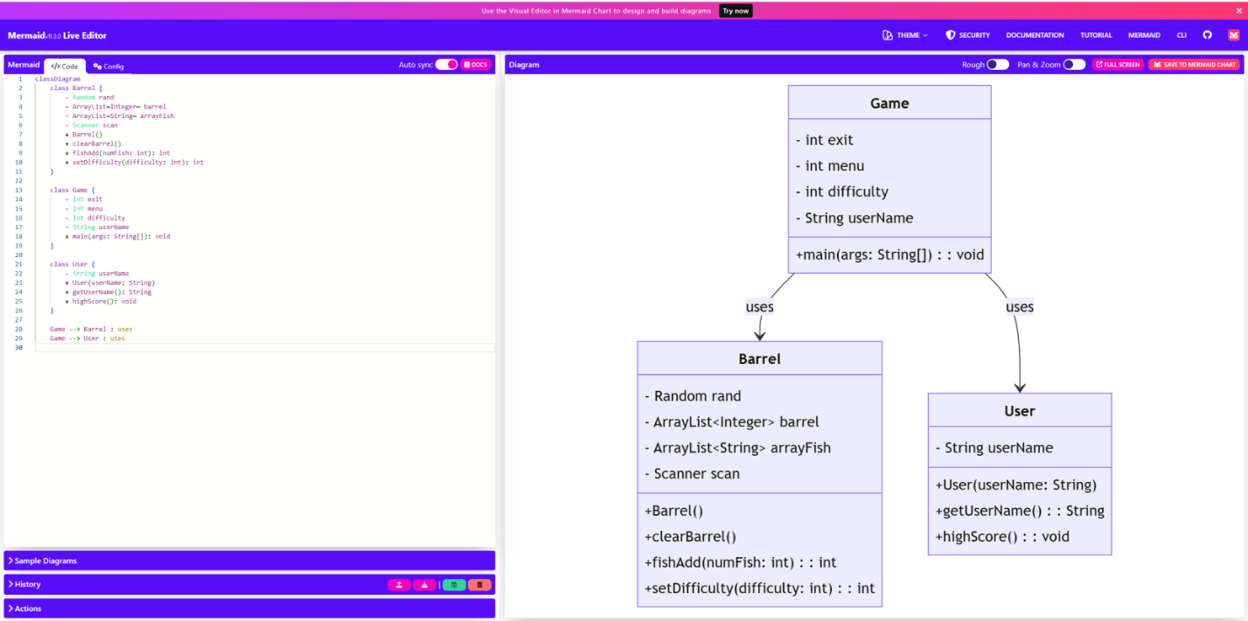

#### **Phase 1: Project Setup**

* Set up GitHub repository, create initial project structure.
* Design basic GUI layout (grid with clickable areas for shooting).

#### **Phase 2: Core Game Mechanics**

* Implement **Game** class with the logic for setting difficulty levels.
* Implement random fish spawning on the grid.
* Handle shooting logic and bullet count reduction.
* Develop a method for checking hits and ending the game when bullets run out or all fish are shot.

#### **Phase 3: User Interface with JavaFX**

* Implement the GUI using **JavaFX**, including clickable grid cells.
* Show fish randomly in the grid, allow player to click on cells to shoot.
* Display the number of bullets left and fish shot.

#### **Phase 4: Additional Features & Polish**

* Add sounds and effects when shooting and hitting fish.
* Implement a scoring system and allow replaying with increasing difficulty.

#### **Phase 5: Testing & Documentation**

* Debug and test the game for various difficulty levels.
* Write documentation for usage and future development.

#### **Estimated Commitment & Time:**

* We estimated that the required time to complete this project will be around 5 hours weekly from each team member. We plan to achieve roughly one of our phases weekly with our combined efforts.