Project 1: Static Foundations
Feedback for Gym Starter Guide
Student: Anthony (GitHub Anthonydosse777) Course: CSC 436, Fall 2026 Reviewed at: ff1daf7
Repo: github.com/Anthonydosse777/csc436_Project1 Live: gainsforyou.netlify.app

Grade: 95 / 100
Category | Points | Earned | One line
Semantic HTML | 20 | 19 | Zero validator messages on both pages, skip link, labelled navs and sections, dl, ol, details, figure, a real form with fieldset, output and progress; the theme button says its state twice
CSS layout | 25 | 24 | 56 tokens used 372 times, 16 Flexbox and 10 Grid containers, intrinsic auto-fit grids, mobile-first with no max-width query; the file was grown by appending, so core rules exist two and three times
Responsive design | 15 | 15 | No horizontal scroll at 320, 375, 768 or 1280 on either page; every layout changes with width
JavaScript interaction | 15 | 15 | Seven interactions, all verified with known inputs, accessible state, storage in try/catch, motion and pointer guards
Repository and deployment | 15 | 14 | Most complete README in the class, twenty well-described commits across five days, deploy matches repo; a tool worktree reference was committed and had to be removed
Content and polish | 10 | 8 | Real coaching content, seventeen licensed photographs with descriptive alt text, two themes; no lazy loading, oversized portrait files, a placeholder contact address and no author name
Total | 100 | 95 | The highest score in the class. Nothing here is broken. What is left is three small edits and one conversation.

How this review was made
Your instructor reviewed this project with Claude (Anthropic's AI) as a second set of eyes. Claude cloned the repo, read both pages, both scripts and the 2,530-line stylesheet, ran the W3C validator on both pages, loaded the live site at 320, 375, 768 and 1280 pixels, and exercised all seven interactions with known inputs: the level picker, the theme toggle across pages and reloads, the protein calculator in both units, the diet filter, the checklist and its reset, and the scroll reveal on a short phone with the longest cards open. It diffed the live site against the repo and read all twenty commits. Every note and every point in this document was read and approved by your instructor.

The short version
Everything on this site works, and I tried to break it. Both pages validate with zero messages. There is no horizontal scroll at 320 pixels, which is narrower than the brief asks for and which your README claims; the claim is true. The level picker shows 0, then 16, then 32 tips and never hides a card. The calculator turns 70 kg into 112 to 154 g and 160 lb into 116 to 160 g, re-ranges the input when the unit changes, and refuses a weight of 5. The diet filter shows 12, 8 and 4 foods. The checklist survives a reload and resets. The theme survives a reload and follows you to the second page. The scroll reveal fires for every section on a 375 by 667 phone with the longest cards open, and a noscript rule keeps the page visible without JavaScript. Zero console errors anywhere.
The five points that came off are small and real. The theme button changes its label and its aria-pressed at the same time, so a screen reader hears a contradiction. The stylesheet was extended by adding new layers at the bottom instead of editing the rules above, so :root exists three times and .card, .reveal and .site-header twice each. None of the seventeen photographs lazy-load, and the files are 1000 by 1500 portraits cropped into 400 by 260 boxes. The contact link is a .example placeholder, and your name is nowhere on the site. And a tool's worktree folder was committed and then removed.
One more thing, said plainly and without accusation. The brief allows AI and asks two things in return: that you submit your AI log, and that you can explain every line. The repo shows this was built with Claude Code, which is fine. No log came in with the submission, so the explanation is the check. The five spots to prepare are listed near the end.

What Claude measured
Check | Result
W3C HTML validator | 0 errors, 0 warnings, 0 info, on both pages
Horizontal scroll at 320 / 375 / 768 / 1280 | None, on both pages
Heading order | h1 > h2 > h3 > h4, no skipped levels, one h1 per page
Semantic elements, home page | skip link, header, 2 labelled nav (ul), main, 8 section (8 of 8 with aria-labelledby), 16 article, dl, ol, 5 details, footer
Semantic elements, nutrition page | form with label, 2 fieldset and legend, output, progress, figure with figcaption
Media queries | 17: 11 min-width (40em, 64em, 80em), 0 max-width, 4 reduced-motion, 1 coarse-pointer guard
Layout | 16 display: flex, 10 display: grid, 12 auto-fit or auto-fill
Custom properties | 56 defined, 372 uses; 0 unused classes; 13 !important, all in safety blocks
Level picker: Beginner / Intermediate / Advanced | 0 / 16 / 32 tips; 16 of 16 cards visible at every level; aria-pressed moves; live status updates
Theme toggle | Dark to white, stored, restored on reload, carried to the second page
Calculator: 70 kg | 112–154 g a day, about 28–39 g at each of 4 meals
Calculator: 160, then switch to lb | 116–160 g a day; input limits become 66 to 550
Calculator: weight 5 | Rejected by checkValidity, result unchanged
Diet filter: All / Vegetarian / Plant-based | 12 / 8 / 4 cards, status line matches
Checklist | 2 of 6 ticked, progress 2, saved with the date, still ticked after reload, reset clears all
Scroll reveal at 375x667 and 320x568, Advanced open | 6 of 6 sections revealed; tallest section 3,613 px
Console errors | 0
Images | 17 JPEGs, 1.86 MB, all 1000 px wide (most 1000x1500), drawn in 400x260 boxes; 0 lazy, 0 srcset
Commits | 20 across Sep 4, 5, 6, 11 and 13; every message says what changed
Live vs repo | CSS and JS identical; HTML identical apart from Netlify rewriting .html links

The site at three widths
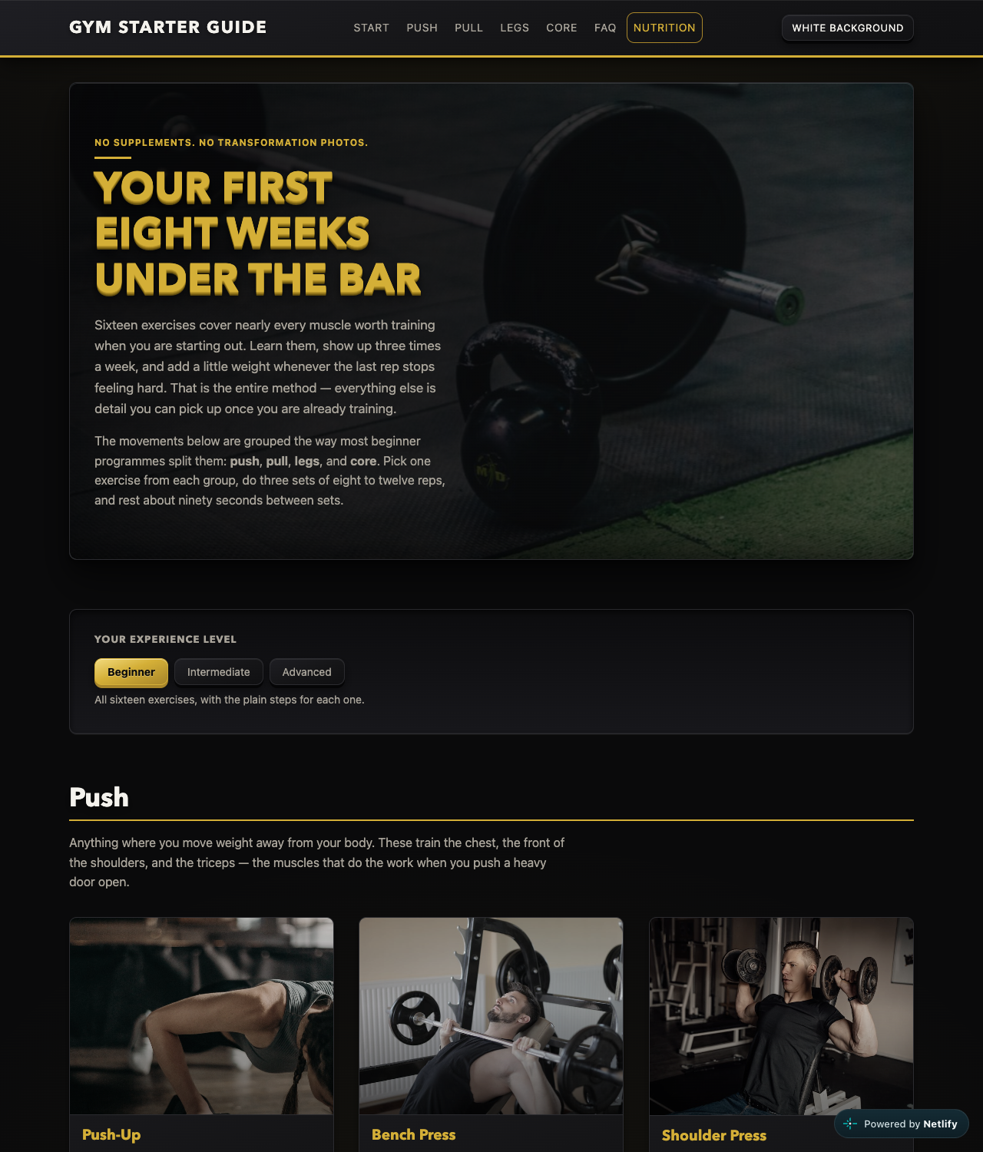
Desktop, 1280px. Single-row header, hero, level picker, three-column exercise gallery.
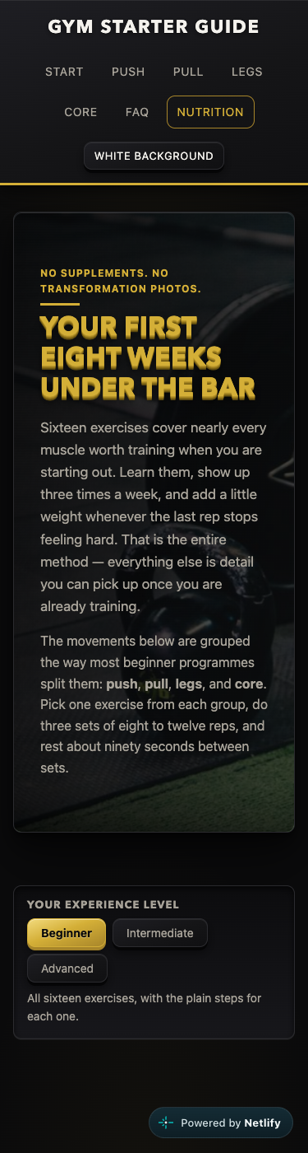  Phone, 375px. Stacked header, wrapping nav, no horizontal scroll. | 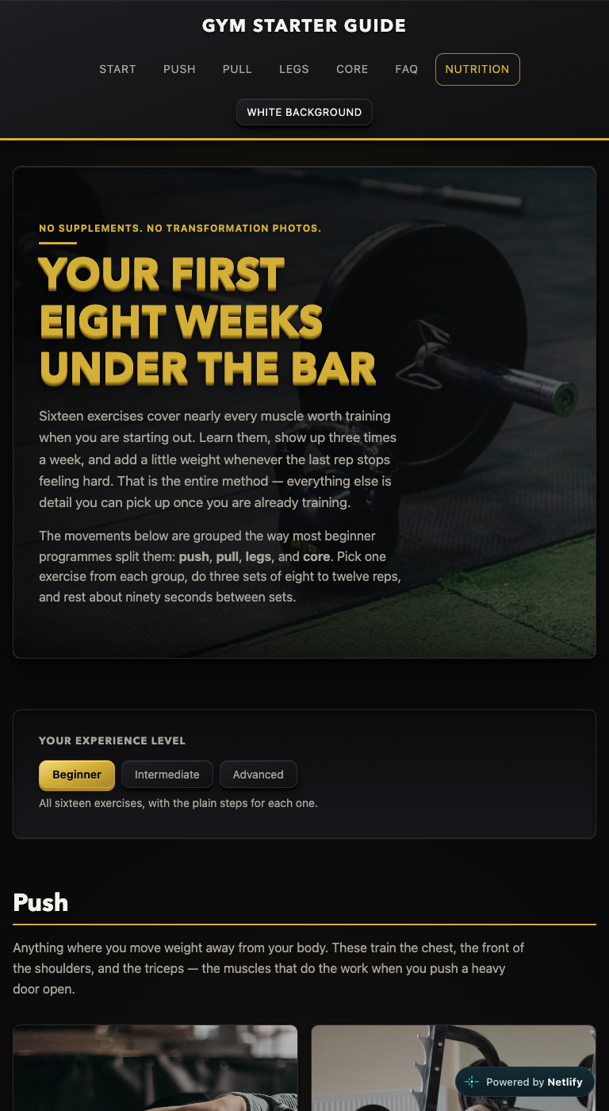  Tablet, 768px. Two-column gallery via auto-fit.

Semantic HTML: 19 / 20

What is working
- The validator has nothing to say about either page, which no other two-page site in the class managed. A skip link is the first tab stop (index.html line 23). Two navs, each with an aria-label and a list. All eight sections carry aria-labelledby. Exercises are articles, the muscle and difficulty labels are a dl (line 109), the steps are an ol because order matters (line 113), and the FAQ is native details.
- The nutrition page uses the elements most students never reach for. A real form with a label, a fieldset and legend for the unit, an output tied to the input with for (nutrition.html lines 156 to 175), a native progress for the checklist, and a figure with figcaption for the plate. The status line is role="status" with aria-live="polite" (index.html line 88). Every one of the seventeen images has alt text that describes the photograph, not just the exercise name.

What to change
- The theme button expresses its state twice, and the two disagree (index.html lines 44 to 46, script.js lines 116 to 125). On the dark page it reads "White background" with aria-pressed="false". Click it and it reads "Black background" with aria-pressed="true". A screen reader announces "Black background, toggle button, pressed" while the page is white. A toggle button should either keep one label and let aria-pressed carry the state, or change its label and have no aria-pressed at all. Pick one.
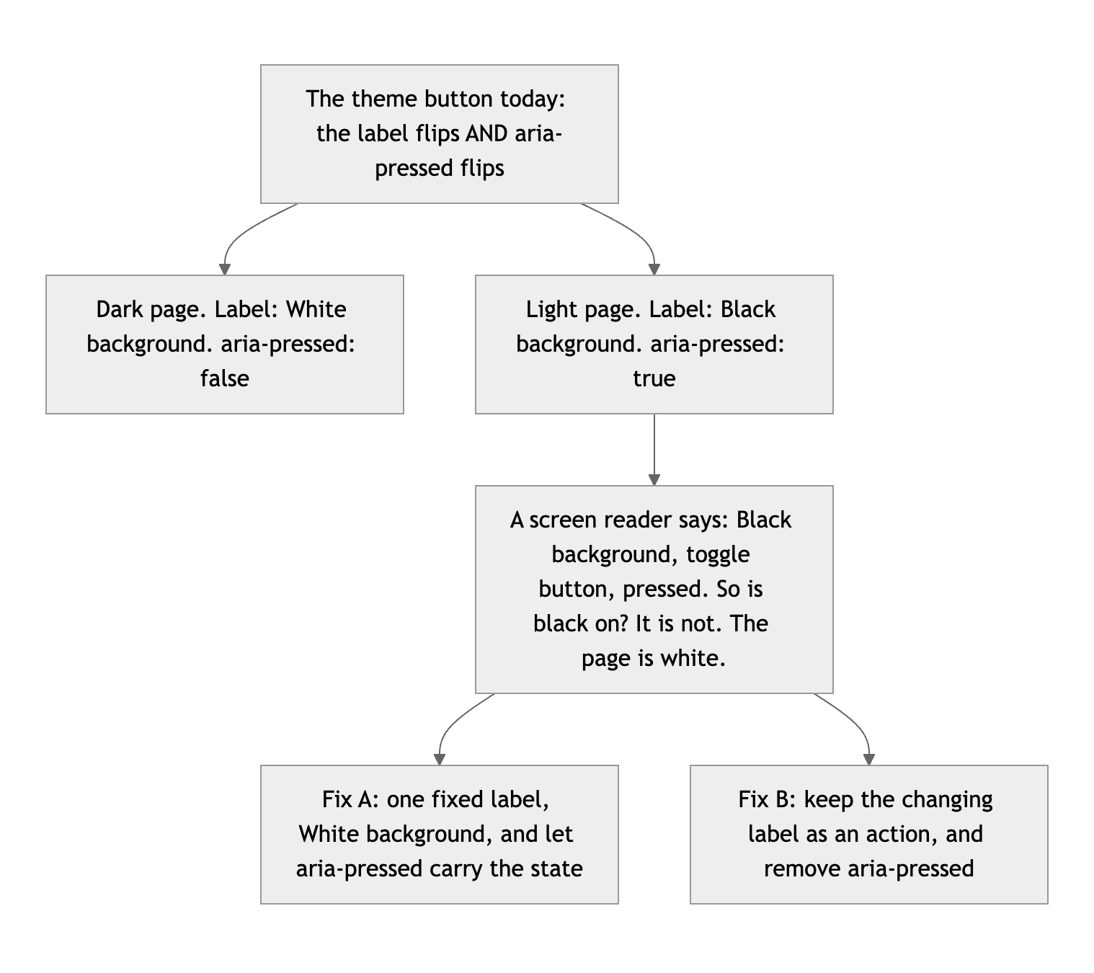
Diagram 1. What the button says in each state, what a screen reader hears, and the two fixes.

CSS layout: 24 / 25

What is working
- A real token system, actually used. 56 custom properties, 372 var() references, and a light theme that is nothing but a second set of values under :root[data-theme="light"] (styles.css lines 15 and 43). Not one class in the stylesheet is unused.
- Flexbox and Grid each doing the job they are for. Flex for the header shell, nav row, filter bars and card interiors; Grid for the galleries, the calculator beside its result, the plate beside its legend. Twelve of the grids are intrinsic. The food cards use auto-fill instead of auto-fit on purpose, so the filtered list of four keeps its card size instead of stretching across the row (lines 2097 to 2111). That is a distinction most working developers cannot explain.
- Mobile-first, strictly. Eleven min-width queries, zero max-width. Four reduced-motion blocks and a coarse-pointer guard that zeroes the 3D tilt on touch screens (line 1609). All thirteen !importants live inside those safety blocks. :focus-visible outlines throughout.

What to change
- The file was grown by appending, not editing. :root is declared at lines 15, 1103 and 1671, and the light theme three times to match. .card is at 409 and again at 1326; .reveal at 1000 and 1590; .site-header at 185 and 1247. Each later block overrides part of the earlier one. It works, because the cascade is doing what it is told, but to know what a card looks like you have to read two rules 900 lines apart and merge them in your head. This is what a stylesheet looks like when each new feature is added as a new layer at the bottom. Fold each pair into one rule and the file loses several hundred lines without changing a pixel.

Responsive design: 15 / 15

What is working
- No horizontal scroll at 320, 375, 768 or 1280 on either page, measured in real viewports. The header stacks on a phone and becomes a single row at 80em. The galleries reflow on their own. The workout timeline is vertical on a phone and horizontal on a desktop. Your README says it was checked at 320; Claude checked it at 320 too, and the README is right. Full marks.

JavaScript interaction: 15 / 15

What is working
- Seven interactions, each one finished. Every one selects, listens and changes the page, and every one was tested with inputs whose answers Claude worked out in advance. The level picker uses hidden and dataset, moves aria-pressed, and hides the empty "Taking it further" heading so beginners never see it (script.js lines 57 to 79). The calculator reads valueAsNumber, defers to the browser's own validation, and swaps the input's min and max when the unit changes (nutrition.js lines 49 to 58 and 80 to 89). The checklist stores the date with the ticks so it clears itself at the visitor's own midnight (lines 185 to 196).
- The defensive details are the impressive part. Every localStorage call is in a try/catch. The reveal falls back to showing everything if the API is missing or the visitor prefers reduced motion (script.js lines 162 to 187), and a noscript style makes the page visible with JavaScript off (index.html lines 14 to 18). The tilt is throttled to one update per frame, reads layout inside the frame, and cancels its queued frame on the way out so a card is never left crooked (lines 225 to 264).
- Claude specifically tried to break the reveal: a 375 by 667 phone, Advanced selected so every card is at its tallest, sections up to 3,613 pixels high against an 8 percent threshold. All six sections revealed.

What to change
- Nothing that costs points. One consistency note: statusMessage is guarded for the page that lacks a level picker, but themeButton.addEventListener on line 137 is not guarded at all. Both pages have the button today. The first page that does not will throw there and take the reveal and the tilt down with it.

Repository and deployment: 14 / 15

What is working
- The README is the best in the class. Title, description, two ways to run it, the live link, a file table, a section mapping each rubric requirement to where it is met, and accessibility notes. Every claim in it that Claude could test turned out to be true.
- Twenty commits on five separate days, Sep 4 to Sep 13, all before the deadline, each with a message that says what changed. The history also shows the design changing its mind: a muscle-group filter became a difficulty filter, and then became tips that never hide a card, with a comment in the script explaining why. The live site matches the repo, and .gitignore is thorough.
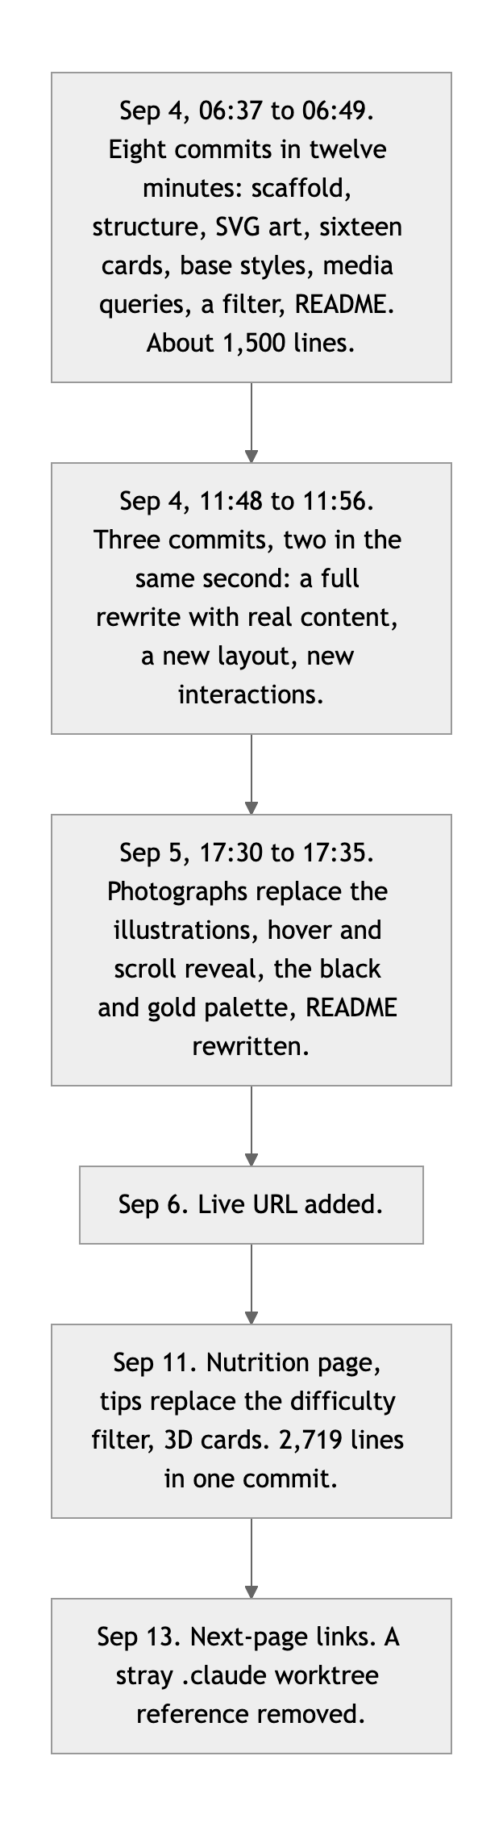
Diagram 2. The commit history, by session.

What to change
- A tool's working folder was committed and then removed in the final commit: a .claude/worktrees/ reference that git recorded as a submodule. You caught it and added the ignore rule, which is the right fix. The lesson is to look at git status before each commit rather than committing everything in the folder.
- A note, not a deduction: eight commits and about 1,500 lines in twelve minutes, and two commits in the same second, is not the pace of typing. The history is a faithful record of how the work was split up. It is not by itself evidence of what you understand, which is why the next section exists.

Content and polish: 8 / 10

What is working
- The content is real and it is good. Sixteen exercises with coaching cues a beginner could follow, progressive-overload notes that know which lifts not to keep loading, nutrition numbers with their basis stated, and an opening line ("No supplements. No transformation photos.") that gives the site a point of view. Seventeen licensed photographs, a consistent black and gold identity, a working light theme, a favicon.

What to change
- Nothing lazy-loads, and the files are bigger than their boxes (index.html line 105). All seventeen images are requested up front on a page that is well over 10,000 pixels tall on a phone; sixteen of them are below the fold. Add loading="lazy" to every card image. Then look at the files: most are 1000 by 1500 portraits, drawn into a 400 by 260 landscape box, so about four fifths of every download is cropped away. Crop them to 800 by 520 and the 1.86 MB becomes roughly a third of that. The width and height attributes should also describe the file you actually ship.
- The contact link goes nowhere, and the site is unsigned (index.html line 709). hello@gymstarterguide.example is a placeholder domain. There is no author name in the footer, the head, or anywhere else on either page. Put your name on your work and link something real.

On the "explain every line" rule
The brief allows AI, asks you to submit your AI log, and requires that you can explain every line you hand in. The .claude entries and the commit pace show this was built with Claude Code. That is allowed, and nobody is accusing you of anything. No log arrived with the submission, so please send it, and come to office hours ready to walk through these five in your own words:
- The frame throttle (script.js lines 223 to 252). What does "if (pendingFrame !== null) return" prevent? Why is getBoundingClientRect called inside the frame and not in the event handler? Why is rotateX negated and rotateY not?
- The exit (script.js lines 257 to 264). What goes wrong if you delete the cancelAnimationFrame call? Why does removing the inline property flatten the card instead of setting it to zero?
- The unit switch (nutrition.js lines 80 to 89). A visitor types 160 while "kg" is selected, then picks "lb". Walk through every line that runs and what the page shows at each step.
- The date (nutrition.js lines 185 to 196). Why "en-CA"? What would break with toISOString() for a visitor in New York at 9 PM? Why is JSON.parse inside the try?
- auto-fit versus auto-fill (styles.css lines 2097 to 2111). Show what the plant-based filter would look like with auto-fit, and explain why.
If those come easily, this is a 95 that was earned, and it is the best project in the class.

Your next three moves
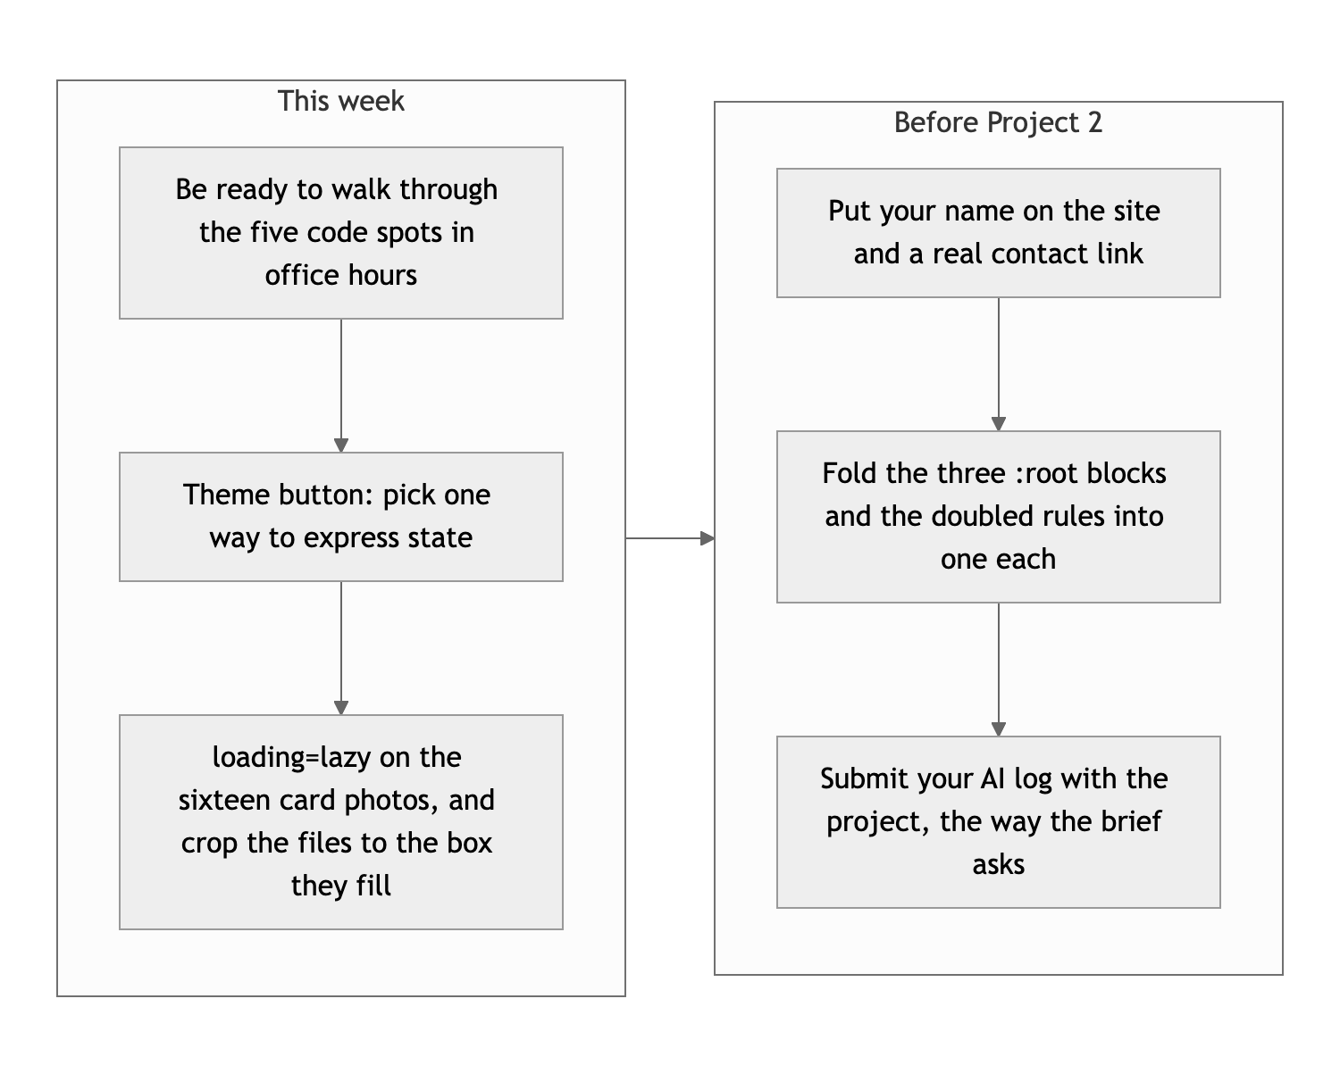
Diagram 3. This week, then before Project 2.
- Prepare the five explanations and send the AI log. It is the only item on this list that is not a code edit, and it is the one that matters.
- Fix the theme button and the images. One attribute removed or one label fixed; loading="lazy" sixteen times; seventeen files cropped.
- Sign the site and consolidate the stylesheet. Your name, a real link, and one :root instead of three.

This is excellent work, Anthony. Come show us you own it.
This review lives in a pull request on your repo. It only adds feedback files and does not touch your code. Merge it, close it, or just read it. Questions go to office hours or the Brightspace board.

