**Project Report**

**Airline**

**Reservation**

**System**

**JERIN J JOHN**

**XII – A**

**AECS – 4, Mumbai**

**INTRODUCTION**

This project simulates an airline reservation system. This program is written in C++ and constitutes a basic UI, created using graphics libraries provided by the language. The system works solely in SVGA256 graphics mode and displays images in bitmap (bmp) format. Also involves interaction through the use of mouse which is not common in C++ console applications.

Users can choose to do the following:

* BOOK A TICKET
* CANCEL A TICKET
* VIEW PREVIOUS BOOKINGS
* VIEW DESTINATIONS
* VIEW ACCOUNT STATUS

Appropriate functions are invoked to carry out each of these functions. The previously booked tickets get written onto a binary file using the basic concepts of data files and classes.

Flow charts illustrating the working of this program have been included in the next few pages followed by the Program Code and important Output Windows.

START

Log in

Log in OK?

Main Menu

Is book?

Is view or Cancel?

Is destination?

Exit screen

Is account?

2

Retry / Quit

Retry

Quit

3

1

Is logout?

END

Show destinations

Show account details

Yes

No

Yes

No

Yes

No

Yes

No

Yes

No

Show map

Is confirm?

Select origin & destination

Show payment option

2

Payment option

Yes

No

Yes

No

Credit / Debit Card

Emirates account

Travel Date

Show flights & select

Is confirm?

Passenger details &

Travel class

Card details

Store data

Display booking confirmation

1

Display ticket

Exit or Cancel?

Delete ticket from file

3

Cancel

Exit

1

Read data from file

======================================================================================

***Airline Reservation System (Emirates) Source Code:***

Project made by:

1. Jerin J John

2. Jay Vivarekar

======================================================================================*/

//HEADER FILES USED IN PROJECT

#include<stdlib.h>

#include<process.h>

#include<string.h>

#include<fstream.h>

#include<conio.h>

#include<graphics.h>

#include<stdio.h>

#include<dos.h>

#include<math.h>

#include<time.h>

//SOME IMPORTANT MOUSE AND BITMAP RELATED FUNCTIONS AND DECLARATIONS

union REGS in,out;

void mouseposi(int &xpos,int &ypos,int &click)

{ in.x.ax=3;

int86(51,&in,&out);

click=out.x.bx;

xpos=out.x.cx;

ypos=out.x.dx;

}

void setposi(int &xpos,int &ypos)

{ in.x.ax=4;

in.x.cx=xpos;

in.x.dx=ypos;

int86(51,&in,&out);

}

void showmouse(int x2,int y2)

{ setcolor(5);

pieslice(x2,y2,285,325,10);

}

int huge detectsvga()

{ return 5;}

struct A

{ char type[2];

unsigned long size;

unsigned short int reserved1, reserved2;

unsigned long offset;

} Header;

struct B

{ unsigned long size;

long width,height;

unsigned short int planes;

unsigned short int bits;

unsigned long compression;

unsigned long imagesize;

unsigned long xresolution,yresolution;

unsigned long ncolours;

unsigned long importantcolours;

}Infoheader;

char city[50],city1[50];

//CLASS USED IN PROJECT

class passenger

{ char name[100];

int age;

char classe;

char origin[50],dest[50];

char flight[6];

long int fare;

char date[10];

public:

passenger()

{classe='E';

flight[0]='E';

flight[1]='K'; }

void getpassenger();

void showpassenger(int p);

void setorigindest(char a[50],char b[50])

{ strcpy(origin,a);

strcpy(dest,b);

}

void setflight(char a,int g)

{ flight[g]=a;}

void setfare(int w)

{fare=((long int)w*1000)+999;

}

void setdate(char t[10])

{strcpy(date,t); }

void copydate(char u[10])

{strcpy(u,date); }

void copyorigindest(char j[50],char k[50])

{strcpy(j,origin);

strcpy(k,dest); }

};

void passenger::getpassenger()

{ clrscr();

setcolor(5);

for(int i=0;i<14;i++)

cout<<"\n";

cout<<"\t\t\t\t\t ";

outtextxy(156,211,"Enter full name : ");

gets(name);

cout<<"\n\n\t\t\t\t\t ";

outtextxy(210,259,"Enter Age : ");

cin>>age;

setcolor(1);

rectangle(570,150,980,350);

setcolor(15);

outtextxy(630,190,"Press E for Economy class ");

outtextxy(630,245,"Press B for Buisness class ");

outtextxy(620,285," (Total Fare + INR 20000)");

a:classe=getch();

if(!(classe=='e'||classe=='b'))

{setcolor(11);

outtextxy(250,600,"Select valid class");

delay(1000);

setcolor(0);

outtextxy(250,600,"Select valid class");

goto a;}

}

void passenger::showpassenger(int p)

{ settextstyle(1,0,3);

if(p==0)

{setcolor(1);

line(0,50,1023,50);

line(0,100,1023,100);

setcolor(10);

outtextxy(420,60,"TICKET DETAILS");

setcolor(3);

rectangle(150,150,875,610);}

setcolor(4);

outtextxy(300+p,200,"NAME : ");

outtextxy(300+p,250,"AGE : ");

outtextxy(300+p,300,"FROM : ");

outtextxy(570+p,300,"TO : ");

outtextxy(300+p,350,"DATE OF JOURNEY : ");

outtextxy(300+p,400,"FLIGHT NO : ");

outtextxy(300+p,450,"CLASS : ");

outtextxy(300+p,500,"FARE : ");

setcolor(14);

outtextxy(390+p,200,name);

char c[3];

itoa(age,c,10);

outtextxy(370+p,250,c);

setcolor(15);

outtextxy(385+p,300,origin);

outtextxy(623+p,300,dest);

setcolor(9);

outtextxy(535+p,350,date);

setcolor(2);

if(classe=='e')

outtextxy(396+p,450,"Economy");

else

{outtextxy(396+p,450,"Buisness");

fare=fare+20000;}

outtextxy(450+p,400,flight);

char d[6];

ltoa(fare,d,10);

outtextxy(380+p,500,"INR ");

outtextxy(430+p,500,d);

}

//FUNCTION DECLARATIONS

void showmouse(int,int);

void page();

void mouse();

void mouse1();

void mouse2();

void mouse3();

void creditcard();

void show(char a[]);

void pos(float,float);

void password();

void rev1(int a);

int book();

void final();

int view();

void strata();

int checkey();

void title();

void accset();

void destinations();

void design(int a);

void console();

void check();

void transaction();

void ab();

void swipe(int a);

void delete1(int p);

void avail();

void disp(char[50]);

int check(int,int,int);

//GLOBAL DATA MEMBERS

int x,y,cl=0,temp1,temp2,c=1,h=135,fc=0;

int i2,e=0,flag=3,flag1=0,flags=1;

float x1,y1;

int ch,aq=0,cl1=0,a,at,at1;

char *buf,*buf1;

int list1[10];

char list[10][3];

int e1;

passenger p;

//MAIN FUNCTION

void main()

{ int gd,gm;

gd=installuserdriver("SVGA256",&detectsvga);

gd=DETECT;

initgraph(&gd,&gm,"C:\\TURBOC3\\BGI");

getch();

//password();

settextstyle(4,0,5);

int ch1,ch2;

cleardevice();

show("logo.bmp");

int xc=imagesize(0,0,200,85);

buf1=new char[xc];

getimage(0,0,200,85,buf1);

cleardevice();

a:closegraph();

gd=installuserdriver("SVGA256",&detectsvga);

gd=DETECT;

initgraph(&gd,&gm,"C:\\TURBOC3\\BGI");

page();

if(flags==0)

goto a;

}

//PASSWORD FUNCTION

void password()

{ title();

char useract[100]={"a"};

char userent[100];

char passent[30];

setcolor(15);

line(0,200,1023,200);

setcolor(4);

line(0,205,1023,205);

settextstyle(4,0,4);

setcolor(11);

outtextxy(155,210," Welcome To Emirates >>> The World's Best Airline ");

setcolor(4);

line(0,255,1023,255);

setcolor(15);

line(0,260,1023,260);

settextstyle(3,0,3);

setcolor(10);

outtextxy(10,300," Please login with your Emirates account below :- ");

d:for(int q=0;q<23;q++)

cout<<"\n";

cout<<"\t\t\t\t\t\t ";

setcolor(YELLOW);

outtextxy(350,356,"Username : ");

cin>>userent;

if( strcmp(useract,userent)!=0 )

{ a:setcolor(RED);

outtextxy(350,450,"Incorrect Username ...... ACCESS DENIED");

outtextxy(350,500,"Press Q/q to quit...");

outtextxy(350,550,"Press T/t to try again...");

char ch1;

ch1=getch();

if(ch1=='t'||ch1=='T')

{setcolor(0);

outtextxy(350,450,"Incorrect Username ...... ACCESS DENIED");

outtextxy(350,500,"Press Q/q to quit...");

outtextxy(350,550,"Press T/t to try again...");

setfillstyle(1,0);

bar(350,370,1000,390);

clrscr();

goto d;

}

else if(ch1=='q'||ch1=='Q')

{swipe(1);

exit(0); }

else

{setcolor(0);

outtextxy(350,450,"Incorrect Username ...... ACCESS DENIED");

outtextxy(350,500,"Press Q/q to quit...");

outtextxy(350,550,"Press T/t to try again...");

setcolor(YELLOW);

outtextxy(350,450,"Enter valid choice");

getch();

setcolor(0);

outtextxy(350,450,"Enter valid choice");

goto a;

} }

delay(500);

d1:setcolor(YELLOW);

settextstyle(3,0,3);

outtextxy(353,390,"Password : ");

moveto(488,395);

int i=0;

char ch;

fflush(stdin);

while(2)

{ ch=getch();

if(ch=='\r')

break;

else

{passent[i]=ch;

outtext("*");

i++; }

}

passent[i]='\0';

setcolor(1);

settextstyle(1,0,4);

line(0,450,1024,450);

line(0,600,1024,600);

setcolor(4);

outtextxy(85,500," Verifying Password ");

for(int j=0;j<4;j++)

{rev1(2);

rev1(0);}

setcolor(0);

outtextxy(85,500," Verifying Password ");

setcolor(2);

if(strcmp(passent,"cpp")==0)

{outtextxy(380,500,"Access Granted");

delay(60);

swipe(1);

}

else

{outtextxy(390,500,"Access Denied");

delay(700);

settextstyle(3,0,3);

setfillstyle(1,0);

bar(0,452,1023,598);

a1:setcolor(RED);

outtextxy(350,500,"Press Q/q to quit...");

outtextxy(350,550,"Press T/t to try again...");

char ch2;

ch2=getch();

if(ch2=='t'||ch2=='T')

{setcolor(0);

outtextxy(350,500,"Press Q/q to quit...");

outtextxy(350,550,"Press T/t to try again...");

line(0,450,1024,450);

line(0,600,1024,600);

setfillstyle(1,0);

bar(340,400,1000,420);

goto d1;

}

else if(ch2=='q'||ch2=='Q')

{swipe(1);

exit(0); }

else

{setcolor(0);

outtextxy(350,500,"Press Q/q to quit...");

outtextxy(350,550,"Press T/t to try again...");

setcolor(YELLOW);

outtextxy(350,450,"Enter valid choice");

getch();

setcolor(0);

outtextxy(350,450,"Enter valid choice");

goto a1;

}

}

}

//MAIN MENU

void page()

{ setcolor(4);

line(0,45,1023,45);

setcolor(4);

line(0,145,1023,145);

cleardevice();

title();

setcolor(4);

line(60,365,340,365);

line(60,375,340,375);

line(680,365,960,365);

line(680,375,960,375);

line(505,200,505,300);

line(515,200,515,300);

line(505,440,505,600);

line(515,440,515,600);

setcolor(14);

line(510,200,510,300);

line(510,440,510,600);

line(60,370,340,370);

line(680,370,960,370);

setcolor(14);

setfillstyle(1,1);

settextstyle(1,0,4);

delay(100);

bar(60,200,360,300);

bar(660,200,960,300);

delay(90);

fillellipse(510,370,170,70);

delay(80);

bar(60,440,360,540);

bar(660,440,960,540);

delay(70);

fillellipse(510,650,100,50);

rectangle(60,200,360,300);

setcolor(14);

rectangle(60,440,360,540);

rectangle(660,200,960,300);

rectangle(660,440,960,540);

setcolor(2);

delay(60);

outtextxy(95,228,"BOOK A TICKET");

outtextxy(682,228,"CANCEL A TICKET");

delay(50);

outtextxy(400,348,"DESTINATIONS");

delay(40);

outtextxy(95,450,"VIEW PREVIOUS");

outtextxy(95,490," BOOKINGS ");

outtextxy(745,450,"EMIRATES");

outtextxy(745,490,"ACCOUNT");

delay(30);

outtextxy(455,630,"LOGOUT");

mouse();

swipe(1);

switch (i2)

{case 0: book();

break;

case 1 : fc=1;

view();

break;

case 2: fc=0;

view();

break;

case 3: accset();

break;

case 4: destinations();

break;

case 5: final();

}

swipe(2);

}

//FUNCTION TO BOOK A TICKET

int book()

{ cleardevice();

settextstyle(1,0,3);

setcolor(3);

outtextxy(280,100," >> SELECT ORIGIN & DESTINATION << ");

delay(50);

show("world1.bmp");

do

{console();

mouse1();}

while(flag!=0);

swipe(3);

p.setorigindest(city,city1);

cl1=0;

e=0;

avail();

settextstyle(3,0,3);

setcolor(2);

line(0,50,1023,50);

line(0,110,1023,110);

setcolor(4);

outtextxy(350,65,"ENTER PASSENGER DETAILS");

p.getpassenger();

setcolor(2);

line(0,598,1023,598);

setcolor(4);

line(0,602,1023,602);

setfillstyle(1,1);

bar(112,550,460,650);

bar(564,550,912,650);

setcolor(14);

rectangle(112,550,460,650);

rectangle(564,550,912,650);

settextstyle(1,0,4);

setcolor(4);

outtextxy(315,460," || PAYMENT OPTIONS || ");

settextstyle(1,0,4);

setcolor(2);

outtextxy(123,580," EMIRATES ACCOUNT ");

outtextxy(573,580," CREDIT/DEBIT CARD");

mouse3();

if(at1==1)

{ creditcard();}

swipe(0);

cleardevice();

transaction();

cleardevice();

p.showpassenger(0);

outtextxy(270,650,"PRESS ENTER TO RETURN TO MAIN MENU");

getch();

fstream file;

file.open("RECORD.DAT",ios::binary|ios::in|ios::out);

file.seekg(0,ios::end);

file.write((char*)&p,sizeof(p));

file.close();

swipe(1);

flags=0;

return 1;

}

//FUNCTION TO VIEW AND CANCEL TICKETS

int view()

{ o:c=1;

cleardevice();

passenger s;

setcolor(1);

line(400,0,400,767);

line(0,70,400,70);

line(0,100,1023,100);

line(200,70,200,767);

settextstyle(1,0,4);

setcolor(4);

outtextxy(135,13,"TICKETS");

outtextxy(610,25,"TICKET DETAILS");

settextstyle(1,0,3);

outtextxy(60,70,"ORIGIN");

outtextxy(232,70,"DESTINATION");

setcolor(2);

ifstream file;

h=130;

settextstyle(3,0,3);

file.open("RECORD.DAT",ios::binary);

int i=1;

while(file&&i<13)

{file.read((char*)&s,sizeof(s));

char origin1[50];

char dest1[50];

s.copyorigindest(origin1,dest1);

outtextxy(35,h,origin1);

outtextxy(230,h,dest1);

h+=50;

i++;

}

h=145;

setcolor(14);

line(12,h-5,22,h);

line(12,h+5,22,h);

int a=0;

do

{if(fc==1)

setcolor(3);

else

setcolor(4);

outtextxy(430,300,"USE W AND S TO NAVIGATE THROUGH THE RECORDS");

outtextxy(430,360,"PRESS ENTER TO VIEW TICKET");

outtextxy(430,420,"PRESS E TO RETURN TO MAIN MENU");

a=checkey();

if(a==5)

{file.seekg(0,ios::beg);

setfillstyle(1,0);

bar(401,101,1024,767);

file.seekg((c-1)*sizeof(s));

file.read((char*)&s,sizeof(s));

s.showpassenger(200);

if(fc==0)

{ setcolor(3);

outtextxy(500,580,"PRESS ENTER TO RETURN TO RECORDS");

getch();

setfillstyle(1,0);

bar(401,101,1024,767);

continue; }

else

{setcolor(14);

setfillstyle(1,1);

settextstyle(1,0,2);

delay(100);

fillellipse(713,620,150,60);

bar(450,715,580,750);

outtextxy(455,720," <<< BACK ");

settextstyle(1,0,3);

outtextxy(600,605,"CANCEL THIS TICKET");

mouse2();

if(at==0)

{setfillstyle(1,0);

bar(401,101,1024,767);

outtextxy(450,200,"PRESS Y TO COFIRM CANCELLATION..");

outtextxy(450,300,"PRESS N TO RETURN TO RECORDS..");

char dash;

dash=getch();

if(dash=='n'||dash=='N')

{setfillstyle(1,0);

bar(401,101,1024,767);

continue;}

else if(dash=='y'||dash=='Y')

{setfillstyle(1,0);

bar(401,101,1024,767);

file.close();

delete1(c);

goto o;

}

}

else if(at==1)

{setfillstyle(1,0);

bar(401,101,1024,767);

continue;}

} }

} while(a!=-1);

swipe(1);

c=1;

flags=0;

return 1;

}

//FUNCTION TO CHECK POSITION OF MOUSE POINTER

int check(int x2,int y2,int d)

{ settextstyle(3,0,2);

setcolor(2);

if (d==0)

if((x2>60&&x2<360)&&(y2>200&&y2<300))

{i2=0;

return 0;}

else if((x2>660&&x2<960)&&(y2>200&&y2<300))

{i2=1;

return 0;}

else if((x2>60&&x2<360)&&(y2>440&&y2<540))

{i2=2;

return 0;}

else if((x2>660&&x2<960)&&(y2>440&&y2<540))

{i2=3;

return 0;}

else if((x2>340&&x2<680)&&(y2>300&&y2<440))

{i2=4;

return 0;

}

else if((x2>410&&x2<610)&&(y2>600&&y2<700))

{i2=5;

return 0;

}

else return 1;

else if(d==1)

if((cl==1)&&(x2>283&&x2<293)&&(y2>323&&y2<333))

{disp("New York");

return 0; }

if((cl==1)&&(x2>275&&x2<285)&&(y2>339&&y2<349))

{disp("Washington DC");

return 0;}

if((cl==1)&&(x2>275&&x2<285)&&(y2>299&&y2<309))

{disp("Toronto");

return 0;}

if((cl==1)&&(x2>249&&x2<259)&&(y2>311&&y2<321))

{disp("Chicago");

return 0;}

if((cl==1)&&(x2>169&&x2<179)&&(y2>263&&y2<273))

{disp("Vancouver");

return 0;}

if((cl==1)&&(x2>157&&x2<167)&&(y2>319&&y2<329))

{disp("San Francisco");

return 0;}

if((cl==1)&&(x2>163&&x2<173)&&(y2>343&&y2<353))

{disp("Los Angelos");

return 0;}

if((cl==1)&&(x2>209&&x2<219)&&(y2>413&&y2<423))

{disp("Mexico City");

return 0;}

if((cl==1)&&(x2>357&&x2<367)&&(y2>575&&y2<585))

{disp("Rio De Janerio");

return 0;}

if((cl==1)&&(x2>313&&x2<323)&&(y2>649&&y2<659))

{disp("Buenos Aires");

return 0;}

if((cl==1)&&(x2>519&&x2<529)&&(y2>623&&y2<633))

{disp("Cape Town");

return 0;}

if((cl==1)&&(x2>567&&x2<577)&&(y2>499&&y2<509))

{disp("Nairobi");

return 0;}

if((cl==1)&&(x2>615&&x2<625)&&(y2>395&&y2<405))

{disp("Dubai");

return 0;}

if((cl==1)&&(x2>501&&x2<511)&&(y2>321&&y2<331))

{disp("Rome");

return 0;}

if((cl==1)&&(x2>501&&x2<511)&&(y2>287&&y2<297))

{disp("Frankfurt");

return 0;}

if((cl==1)&&(x2>477&&x2<487)&&(y2>293&&y2<303))

{disp("Paris");

return 0;}

if((cl==1)&&(x2>467&&x2<477)&&(y2>271&&y2<281))

{disp("London");

return 0;}

if((cl==1)&&(x2>565&&x2<575)&&(y2>255&&y2<265))

{disp("Moscow");

return 0;}

if((cl==1)&&(x2>679&&x2<689)&&(y2>383&&y2<393))

{disp("New Delhi");

return 0;}

if((cl==1)&&(x2>667&&x2<677)&&(y2>419&&y2<429))

{disp("Mumbai");

return 0;}

if((cl==1)&&(x2>685&&x2<695)&&(y2>439&&y2<449))

{disp("Chennai");

return 0;}

if((cl==1)&&(x2>763&&x2<773)&&(y2>309&&y2<319))

{disp("Beijing");

return 0;}

if((cl==1)&&(x2>783&&x2<793)&&(y2>357&&y2<367))

{disp("Shanghai");

return 0;}

if((cl==1)&&(x2>771&&x2<781)&&(y2>401&&y2<411))

{disp("Hong Kong");

return 0;}

if((cl==1)&&(x2>747&&x2<757)&&(y2>469&&y2<479))

{disp("Kuala Lumpur");

return 0;}

if((cl==1)&&(x2>755&&x2<765)&&(y2>495&&y2<505))

{disp("Singapore");

return 0;}

if((cl==1)&&(x2>863&&x2<873)&&(y2>641&&y2<651))

{disp("Sydney");

return 0;}

if((cl==1)&&(x2>831&&x2<841)&&(y2>333&&y2<343))

{disp("Tokyo");

return 0;}

if((cl==1)&&(x2>880&&x2<980)&&(y2>10&&y2<30))

{if (!strcmp(city1,city))

{setcolor(3);

outtextxy(400,1,"Select different locations");

delay(1000);

aq=1;

flag=1;

e=0;

cl1=0;}

else

{aq=1;

flag=0;

cl1++;}

return 0;}

if((cl==1)&&(x2>880&&x2<980)&&(y2>50&&y2<70))

{aq=1;

flag=1;

cl1=0;

e=0;

return 0;}

else if(d==2)

{ if((cl==1)&&(x2>413&&x2<1013)&&y2>560&&y2<680)

{at=0;

return 0;}

else if((cl==1)&&(x2>450&&x2<580)&&y2>715&&y2<750)

{ at=1;

return 0;}

}

else if(d==3)

{ if((cl==1)&&(x2>112&&x2<460)&&y2>550&&y2<650)

{at1=0;

return 0;}

else if((cl==1)&&(x2>564&&x2<912)&&y2>550&&y2<650)

{at1=1;

return 0;}

}

return 1;

}

//ACCOUNT SETTINGS FUNCTIONS

void accset()

{ cleardevice();

clrscr();

settextstyle(1,0,4);

setcolor(14);

line(0,50,1023,50);

line(0,120,1023,120);

setcolor(1);

line(0,45,1023,45);

line(0,125,1023,125);

setcolor(4);

outtextxy(365,65,"EMIRATES ACCOUNT");

settextstyle(1,0,3);

setcolor(14);

line(819,50,819,120);

line(205,50,205,120);

setcolor(1);

line(200,50,200,120);

line(824,50,824,120);

setcolor(2);

delay(40);

outtextxy(290,220," Profile Name : Sean Parker");

delay(40);

outtextxy(293,250," Age : 25");

delay(40);

outtextxy(302,280,"City of Residence : Mumbai");

delay(40);

outtextxy(278,340," User Name : interpol101");

delay(40);

outtextxy(291,370," Password : cpp");

delay(40);

outtextxy(288,430,"Emirates Acct NO. : R23UX90");

delay(40);

outtextxy(286,460," Account Balance : INR 8,79,549");

delay(40);

outtextxy(283,490," EK Reward Points : 40,921");

setcolor(1);

delay(40);

outtextxy(250,600,"Press any key to return to Main Menu...");

getch();

swipe(1);

page();

}

//MISCELLANEOUS FUNCTIONS

void console()

{ setfillstyle(1,0);

bar(0,0,1024,85);

setfillstyle(1,4);

bar(880,10,980,30);

bar(880,50,980,70);

putimage(0,0,buf1,0);

settextstyle(3,0,2);

setcolor(6);

outtextxy(300,30,"FROM : ");

outtextxy(550,30,"TO : ");

outtextxy(890,7,"CONFIRM");

outtextxy(900,46,"CLEAR");

}

void ab()

{ a=375;

if (cl1!=0)

{setfillstyle(1,0);

bar(600,30,780,85);

a=600;}

}

void disp(char s[50])

{ if(e==0)

strcpy(city,s);

else

strcpy(city1,s);

e++;

ab();

outtextxy(a,30,s);

aq=0;

cl1++;

}

void avail()

{ closegraph();

int gd,gm;

char s[3];

char s1[3];

char s2[3];

char s3[3];

char s4[3];

gd=installuserdriver("SVGA256",&detectsvga);

gd=DETECT;

initgraph(&gd,&gm,"C:\\TURBOC3\\BGI");

settextstyle(3,0,3);

char list[10][3];

for(int q=0;q<23;q++)

cout<<"\n";

cout<<"\t\t\t\t\t\t\t\t\t\t ";

setcolor(14);

line(0,50,1023,50);

outtextxy(400,60,"FLIGHTS AVAILABLE");

line(0,100,1023,100);

setcolor(4);

outtextxy(150,130,"FROM : ");

setcolor(11);

outtextxy(237,130,city);

setcolor(4);

outtextxy(176,160,"TO : ");

setcolor(11);

outtextxy(237,160,city1);

outtextxy(175,355,"ENTER DATE OF JOURNEY(dd/mm/yyyy) :");

char date3[10];

gets(date3);

p.setdate(date3);

setfillstyle(1,0);

bar(70,330,1023,390);

setcolor(4);

outtextxy(150,190,"DATE :");

setcolor(11);

p.copydate(date3);

outtextxy(237,190,date3);

setcolor(15);

line(85,270,935,270);

line(85,320,935,320);

line(85,270,85,767);

line(135,270,135,767);

line(935,270,935,767);

line(85,767,935,767);

line(155,270,155,270);

line(285,270,285,767);

line(510,270,510,767);

line(610,270,610,767);

line(710,270,710,767);

int h=370;

for(int i=0;i<8;i++)

{line(85,h,935,h);

h=h+50;}

randomize();

int l=random(9)+2;

setcolor(3);

h=330;

for(int y=1;y<l;y++)

{char w[2];

itoa(y,w,10);

outtextxy(105,h,w);

h+=50;}

setcolor(10);

outtextxy(155,279,"FLIGHT NO.");

h=330;

setcolor(3);

for(y=0;y<l-1;y++)

{ char c[3];

int x=random(100)+200;

itoa(x,c,10);

list[y][0]=c[0];

list[y][1]=c[1];

list[y][2]=c[2];

outtextxy(170,h,"EK");

outtextxy(196,h,c);

int e=random(50)+10;

itoa(e,s,10);

outtextxy(380,h,s);

int u,f,m,n;

f=random(9)+1;

u=random(24)+1;

m=random(50)+10;

n=random(50)+10;

itoa(f,s1,10);

itoa(u,s2,10);

itoa(m,s3,10);

itoa(n,s4,10);

outtextxy(565,h,s3);

outtextxy(665,h,s4);

if(f>=10)

outtextxy(522,h,s1);

else

outtextxy(530,h,s1);

outtextxy(555,h,":");

if(u>=10)

outtextxy(622,h,s2);

else

outtextxy(630,h,s2);

outtextxy(655,h,":");

int r=random(20)+30;

long int t=((long int)r*1000)+999;

list1[y]=r;

char s5[6];

ltoa(t,s5,10);

outtextxy(760,h,"INR");

outtextxy(800,h,s5);

h+=50;

}

setcolor(10);

outtextxy(305,279,"SEATS AVAILABLE");

outtextxy(538,279,"E.T.D");

outtextxy(638,279,"E.T.A");

outtextxy(755,279,"TOTAL FARE");

int flag=1;

while(5)

{if(flag==0)

{setcolor(0);

outtextxy(455,150,"PLEASE CHOOSE VALID FLIGHT NUMBER");

outtextxy(500,160,"PRESS Y TO CONFIRM...");

outtextxy(500,190,"PRESS N TO RESELECT...");

outtextxy(500,220,"PRESS E TO RETURN TO MAIN MENU...");

outtextxy(500,120,"CONFIRM TICKET ON FLIGHT ");

flag=1;}

setcolor(10);

outtextxy(455,150,"ENTER THE DESIRED FLIGHT'S SERIAL NO.");

char cha=getch();

char chg[1];

chg[0]=cha;

setcolor(0);

outtextxy(455,150,"ENTER THE DESIRED FLIGHT'S SERIAL NO.");

e1=atoi(chg);

e1=e1%10;

if(e1>=l)

{setcolor(10);

outtextxy(455,150,"PLEASE CHOOSE VALID FLIGHT NUMBER");

flag=0;

getch();

continue;}

else

{setcolor(10);

outtextxy(500,120,"CONFIRM TICKET ON FLIGHT ");

itoa(e1,chg,10);

outtextxy(800,120,chg);

setcolor(9);

outtextxy(500,160,"PRESS Y TO CONFIRM...");

outtextxy(500,190,"PRESS N TO RESELECT...");

outtextxy(500,220,"PRESS E TO RETURN TO MAIN MENU...");

char chb=getch();

setcolor(10);

if(chb=='E'||chb=='e')

{ swipe(1);

page(); }

else if(chb=='Y'||chb=='y')

break;

}

setcolor(0);

outtextxy(800,120,chg);

flag=0;

}

p.setflight(list[e1-1][0],2);

p.setflight(list[e1-1][1],3);

p.setflight(list[e1-1][2],4);

p.setfare(list1[e1-1]);

swipe(2);

}

void destinations()

{ setcolor(4);

settextstyle(1,0,5);

line(0,50,1023,50);

setcolor(3);

outtextxy(370,55,"DESTINATIONS");

setcolor(4);

line(0,110,1023,110);

setcolor(1);

line(12,180,12,680);

line(262,180,262,680);

line(512,180,512,680);

line(762,180,762,680);

line(1012,180,1012,680);

line(12,180,1012,180);

line(12,230,1012,230);

line(12,680,1012,680);

settextstyle(1,0,3);

setcolor(14);

outtextxy(340,120,"Centre of Operations : Dubai");

settextstyle(1,0,4);

outtextxy(30,185,"THE AMERICAS");

outtextxy(293,185,"ASIA PACIFIC");

outtextxy(580,185,"AFRICA");

outtextxy(835,185,"EUROPE");

settextstyle(3,0,3);

setcolor(2);

outtextxy(840,250,"Frankfurt");

outtextxy(840,280,"Paris");

outtextxy(840,310,"London");

outtextxy(840,340,"Rome");

outtextxy(840,370,"Moscow");

outtextxy(580,250,"Cape Town");

outtextxy(580,280,"Nairobi");

outtextxy(310,250,"Mumbai");

outtextxy(310,280,"Delhi");

outtextxy(310,310,"Chennai");

outtextxy(310,340,"Shanghai");

outtextxy(310,370,"Hong Kong");

outtextxy(310,400,"Beijing");

outtextxy(310,430,"Kuala Lumpur");

outtextxy(310,460,"Singapore");

outtextxy(310,490,"Tokyo");

outtextxy(310,520,"Sydney");

outtextxy(40,250,"New York");

outtextxy(40,280,"Washington DC");

outtextxy(40,310,"Chicago");

outtextxy(40,340,"Los Angelos");

outtextxy(40,370,"San Fransisco");

outtextxy(40,400,"Vancouver");

outtextxy(40,430,"Toronto");

outtextxy(40,460,"Mexico City");

outtextxy(40,490,"Buenos Aires");

outtextxy(40,520,"Rio de Janerio");

settextstyle(3,0,2);

outtextxy(245,700,"Press any key to return to the main menu... ");

getch();

page();

}

void final()

{ cleardevice();

show("end8.bmp");

setfillstyle(1,0);

bar(0,665,1024,768);

settextstyle(4,0,5);

setcolor(2);

outtextxy(195,675," Thank You for Choosing Emirates ");

getch();

swipe(1);

closegraph();

exit(0);

}

void show(char a[])

{ fstream f;

f.open(a,ios::in);

unsigned char Ch;

f.read((char*)&Header,14);

f.read((char*)&Infoheader,40);

unsigned int i;

char ColorBytes[4];

char *PaletteData;

PaletteData=new char[256*3];

if(PaletteData)

{for(i=0;i<256;i++)

{ f.read(ColorBytes,4);

PaletteData[(int)(i*3+2)]=ColorBytes[0]>>2;

PaletteData[(int)(i*3+1)]=ColorBytes[1]>>2;

PaletteData[(int)(i*3+0)]=ColorBytes[2]>>2;

}

outp(0x03c8,0);

for(i=0;i<256*3;i++)

{ outp(0x03c9,PaletteData[i]); }

delete[]PaletteData;

}

for(i=0;i<Infoheader.height;i++)

{ for(int j=0;j<Infoheader.width;j++)

{ f.read(&Ch,1);

putpixel(j,Infoheader.height-i-1,Ch);

}

}

f.close();

}

int checkey()

{ char w;

w=getch();

int x=(int)w;

if((w=='w'||w=='W')&&c!=1)

{setcolor(0);

line(12,h-5,22,h);

line(12,h+5,22,h);

h-=50;

setcolor(14);

line(12,h-5,22,h);

line(12,h+5,22,h);

c--;

return 0;

}

else if((w=='s'||w=='S')&&c!=12)

{setcolor(0);

line(12,h-5,22,h);

line(12,h+5,22,h);

h+=50;

setcolor(14);

line(12,h-5,22,h);

line(12,h+5,22,h);

c++;

return 1;

}

else if(w=='e'||w=='E')

return -1;

else if(x==13)

return 5;

else

return 4;

}

void mouse()

{ setcolor(4);

temp1=200; temp2=200;

setposi(temp1,temp2);

int xa=imagesize(200,200,210,210);

buf=new char[xa];

getimage(200,200,210,210,buf);

putimage(temp1,temp2,buf,0);

showmouse(200,200);

int q;

delete buf;

while(!kbhit())

{mouseposi(x,y,cl);

x1=x<<2;

y1=y<<2;

if(x1==temp1&&y1==temp2)

{if (cl==1)

q=check(x1,y1,0);

if(q==0)

break;

continue; }

else

{buf=new char[xa];

putimage(temp1,temp2,buf,0);

getimage(x1,y1,x1+10,y1+10,buf);

showmouse(x1,y1);

temp1=x1;

temp2=y1;

}

delete buf; }

}

void mouse1()

{ setcolor(4);

temp1=200; temp2=200;

int xa1=imagesize(200,200,210,210);

buf=new char[xa1];

getimage(200,200,210,210,buf);

putimage(temp1,temp2,buf,0);

showmouse(200,200);

int q1;

delete buf;

while(2)

{mouseposi(x,y,cl);

x1=x<<1;

y1=y<<2;

if(x1==temp1&&y1==temp2)

{if (cl==1)

q1=check(x1,y1,1);

if(q1==0&&aq==0)

continue;

else if(q1==0&&aq==1)

break;

continue; }

else

{buf=new char[xa1];

putimage(temp1,temp2,buf,0);

getimage(x1,y1,x1+10,y1+10,buf);

showmouse(x1,y1);

temp1=x1;

temp2=y1;

}

delete buf;

}

}

void mouse2()

{ setcolor(4);

temp1=200; temp2=200;

int xa1=imagesize(200,200,210,210);

buf=new char[xa1];

getimage(200,200,210,210,buf);

putimage(temp1,temp2,buf,0);

showmouse(200,200);

int q1;

delete buf;

while(2)

{mouseposi(x,y,cl);

x1=x<<1;

y1=y<<2;

if(x1==temp1&&y1==temp2)

{if (cl==1)

q1=check(x1,y1,2);

if(q1==0)

break;

continue; }

else

{buf=new char[xa1];

putimage(temp1,temp2,buf,0);

getimage(x1,y1,x1+10,y1+10,buf);

showmouse(x1,y1);

temp1=x1;

temp2=y1;

}

delete buf;

}

}

void mouse3()

{ setcolor(4);

temp1=200; temp2=200;

int xa1=imagesize(200,200,210,210);

buf=new char[xa1];

getimage(200,200,210,210,buf);

putimage(temp1,temp2,buf,0);

showmouse(200,200);

int q1;

delete buf;

while(2)

{mouseposi(x,y,cl);

x1=x<<1;

y1=y<<2;

if(x1==temp1&&y1==temp2)

{if (cl==1)

q1=check(x1,y1,3);

if(q1==0)

break;

continue; }

else

{buf=new char[xa1];

putimage(temp1,temp2,buf,0);

getimage(x1,y1,x1+10,y1+10,buf);

showmouse(x1,y1);

temp1=x1;

temp2=y1;

}

delete buf;

}

}

void delete1(int p)

{ int f=1;

ifstream g;

ofstream e;

passenger y;

g.open("RECORD.DAT",ios::binary|ios::in);

e.open("TEMP.DAT",ios::binary|ios::out);

while(g)

{if(f!=p)

{ g.read((char*)&y,sizeof(y));

e.write((char*)&y,sizeof(y));

}

else

g.seekg(sizeof(y),ios::cur);

f++;

}

g.close();

e.close();

remove("RECORD.DAT");

rename("TEMP.DAT","RECORD.DAT");

}

void rev1(int a)

{ float y2,n,m,z;

for(float x=-20.00;x<=20.00;x=x+1.00)

{n=500-pow(x,2);

m=450-pow(x,2);

y2=sqrt(n);

z=sqrt(m);

delay(5);

putpixel((int)x+625,(int)y2+520,a);

putpixel((int)x+625,(int)z+520,a); }

for(x=20.00;x>=-20.00;x=x-1.00)

{n=500-pow(x,2);

m=450-pow(x,2);

y2=-(sqrt(n));

z=-(sqrt(m));

delay(5);

putpixel((int)x+625,(int)y2+520,a);

putpixel((int)x+625,(int)z+520,a); }

}

void swipe(int a)

{ setcolor(0);

int x,y;

if(a==0)

{x=0;

while(x<1025)

{line(x,0,x,767);

x++;

delay(1);}}

if(a==1)

{y=0;

while(y<767)

{line(0,y,1024,y);

y++;

delay(1);}}

if(a==2)

{x=1024;

while(x>0)

{line(x,0,x,767);

x--;

delay(1);}}

if(a==3)

{y=767;

while(y>0)

{line(0,y,1024,y);

y--;

delay(1);}}

}

void transaction()

{ setcolor(2);

settextstyle(3,0,6);

moveto(600,50);

for(int n=0;n<3;n++)

{setcolor(2);

moveto(600,75);

outtext("VERIFYING");

design(2);

moveto(600,135);

outtext("TRANSACTION...");

delay(3);

moveto(600,75);

setcolor(4);

outtext("VERIFYING");

design(4);

moveto(600,135);

outtext("TRANSACTION...");}

delay(6);

setcolor(0);

design(0);

moveto(600,75);

outtext("VERIFYING");

moveto(600,135);

outtext("TRANSACTION...");

settextstyle(1,0,5);

setcolor(2);

moveto(120,300);

outtext(" >> TRANSACTION SUCCESSFULL << ");

delay(2000);

cleardevice();

settextstyle(1,0,4);

moveto(50,300);

outtext(" Your ticket has been booked successfully....");

getch();

swipe(2);

}

void design(int a)

{ setcolor(a);

int c=0,d=0;

while(d<1024)

{ delay(10);

line(c,d,1024-c,768-d);

c=c+10;

d=d+10;}

}

void strata()

{ int x=0,y=80;

while(x<1024)

{if(x<600||x>952)

putpixel(x,y-30,15);

if(x<592||x>960)

putpixel(x,y-25,4);

if(x<586||x>966)

putpixel(x,y-20,2);

if(x<581||x>971)

putpixel(x,y-15,0);

if(x<577||x>975)

putpixel(x,y-10,15);

if(x<574||x>978)

putpixel(x,y-5,14);

if(x<572||x>980)

putpixel(x,y,4);

if(x<570||x>982)

putpixel(x,y+5,2);

if(x<569||x>983)

putpixel(x,y+10,1);

if(x<568||x>984)

putpixel(x,y+15,0);

if(x<569||x>983)

putpixel(x,y+20,15);

if(x<570||x>982)

putpixel(x,y+25,2);

if(x<572||x>980)

putpixel(x,y+30,4);

if(x<574||x>978)

putpixel(x,y+35,14);

if(x<577||x>975)

putpixel(x,y+40,1);

if(x<581||x>971)

putpixel(x,y+45,0);

if(x<586||x>966)

putpixel(x,y+50,2);

if(x<592||x>960)

putpixel(x,y+55,4);

if(x<600||x>952)

putpixel(x,y+60,15);

delay(2);

x++;

}

}

void title()

{ strata();

settextstyle(4,0,9);

int b;

for(int a=0;a<6;a++)

{for(int n=0;n<15;n++)

{ if(a%3==0)

b=9;

if(a%3==1)

b=4;

if(a%3==2)

b=14;

if(n==0)

moveto(615,27);

if(n==5)

moveto(615,27);

if(n==6)

{setcolor(b);

outtext("E");}

if(n==7)

{setcolor(b);

outtext("m");

}

if(n==8)

{setcolor(b);

outtext("i");

}

if(n==9)

{setcolor(b);

outtext("r");

}

if(n==10)

{setcolor(b);

outtext("a");

}

if(n==11)

{setcolor(b);

outtext("t");

}

if(n==12)

{setcolor(b);

outtext("e");

}

if(n==13)

{setcolor(b);

outtext("s");

}

delay(17);}}

}

void creditcard()

{ swipe(1);

clrscr();

char bank[50];

char acctno[10];

char pin[6];

settextstyle(3,0,3);

setcolor(2);

line(0,50,1023,50);

line(0,110,1023,110);

setcolor(4);

outtextxy(360,65,"ENTER PAYMENT DETAILS");

for(int i=0;i<15;i++)

cout<<"\n";

cout<<"\t\t\t\t\t\t\t ";

setcolor(14);

outtextxy(200,228,"Enter Name of Bank : ");

gets(bank);

cout<<"\n\n\t\t\t\t\t\t ";

outtextxy(200,275,"Enter Card No. : ");

gets(acctno);

cout<<"\n\n\t\t\t\t\t\t ";

outtextxy(200,324,"Enter 5-Digit PIN : ");

gets(pin);

setcolor(4);

settextstyle(1,0,4);

line(0,450,1024,450);

line(0,600,1024,600);

setcolor(2);

outtextxy(160,500," Verifying PIN ");

for(int j=0;j<2;j++)

{rev1(2);

rev1(0);

rev1(4);}

setcolor(0);

outtextxy(160,500," Verifying PIN ");

setcolor(2);

outtextxy(280,480," Authenticating ");

outtextxy(300,520," Transaction ");

for(j=0;j<2;j++)

{rev1(2);

rev1(4);

rev1(2);

rev1(0);}

setcolor(0);

outtextxy(280,480," Authenticating ");

outtextxy(300,520," Transaction ");

settextstyle(3,0,4);

setcolor(1);

outtextxy(220,500,"Press ENTER to confirm payment ... ");

getch();

}

**Program Output:**

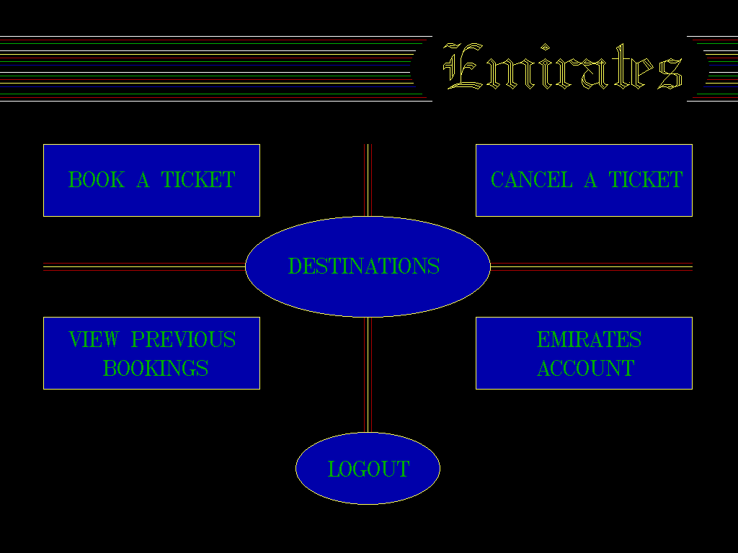

**Main Menu**

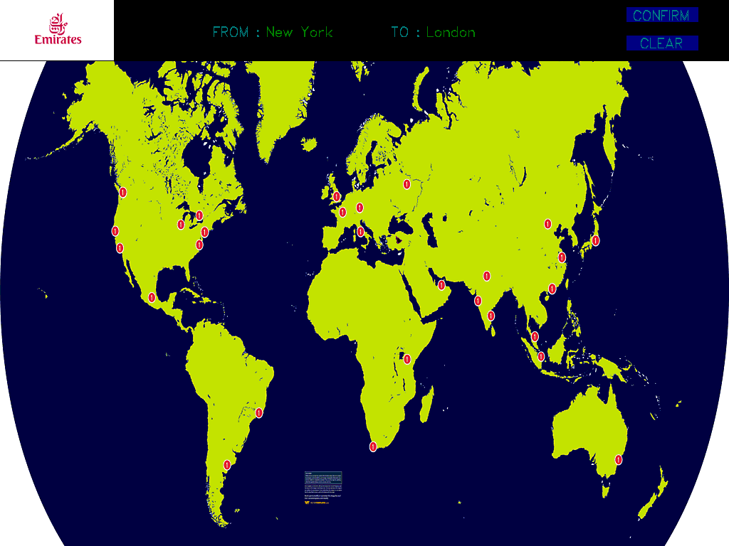

**Ticket Booking Screen**

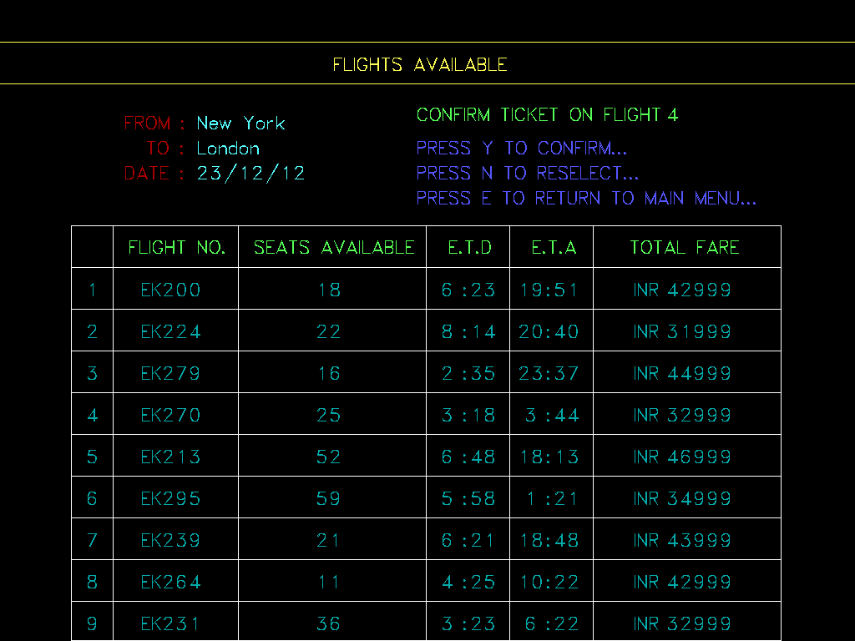

**Flight Availability**

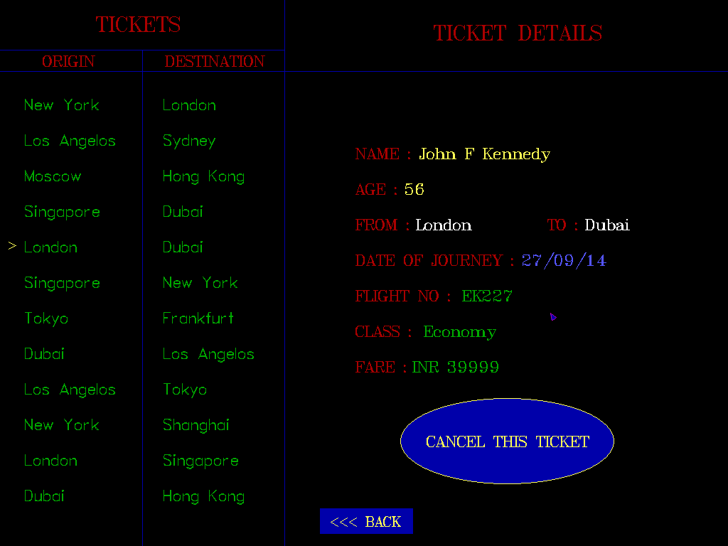

**View / Cancellation Screen**