Import the project into IntelliJ or eclipse and wait for it to finish syncing.

After that click on the run button and open postman,

The pictures attached explain in detail how to add hotels and book rooms

To add a hotel, you open the URL <http://localhost:8080/newhotel> and set the method to POST, the body to “raw and the type to json, as shown in the picture below, then click send:

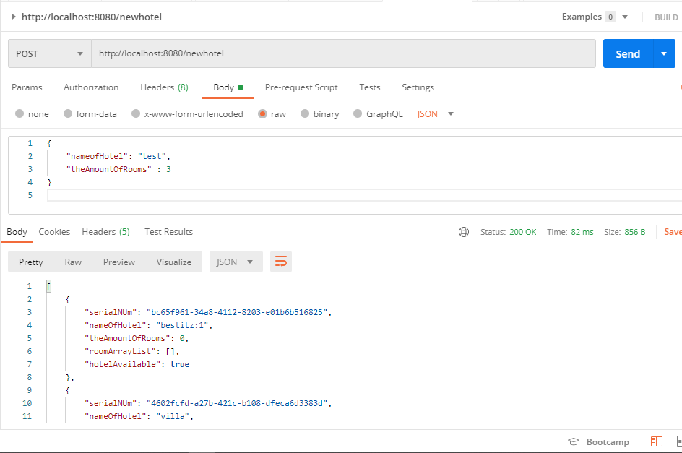

{

    "nameofHotel": "test",

    "theAmountOfRooms" : 3

}

To list all hotels, the URL is: <http://localhost:8080/hotels> as shown below

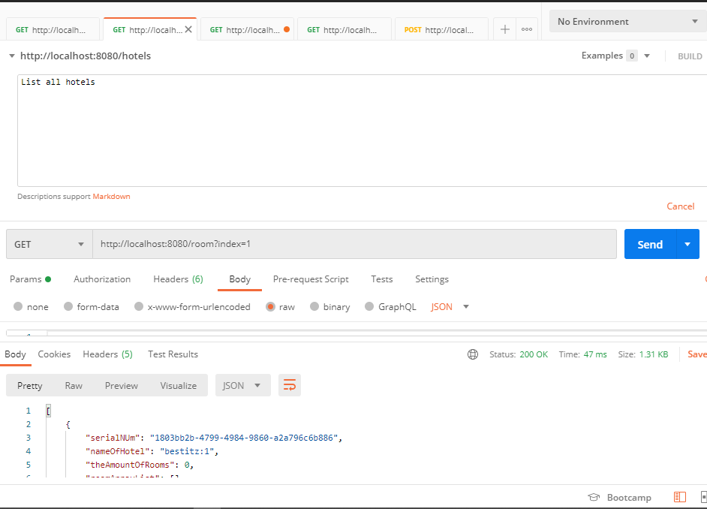

To add a room, the URL is <http://localhost:8080/room?index=1>, wjere index is the position of the jotel: Tjis is illustrated below:

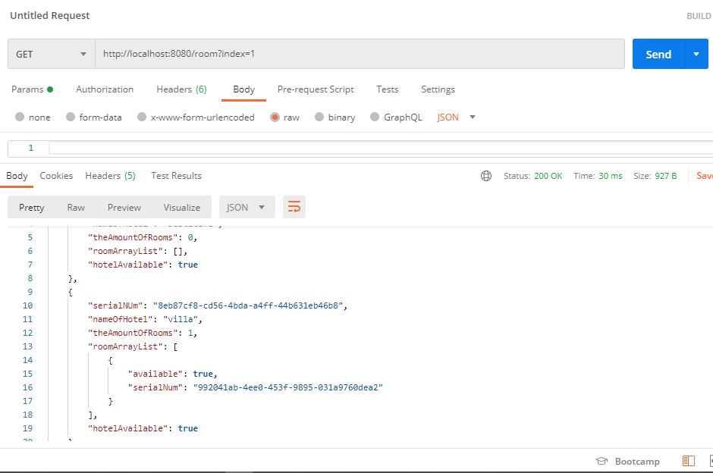

To book a room:

