**IMGS-351**

**Project 2 report**

**Team #:**

**Names:**

**Date:**

1) Insert the image of your real/imaged color patches in light booth from Project 1, step 4) here.

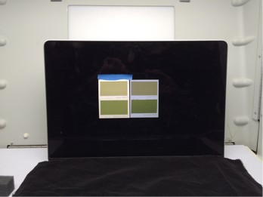

2) Insert the image of your real/matched color patches in light booth from Project 2, step 6) here.

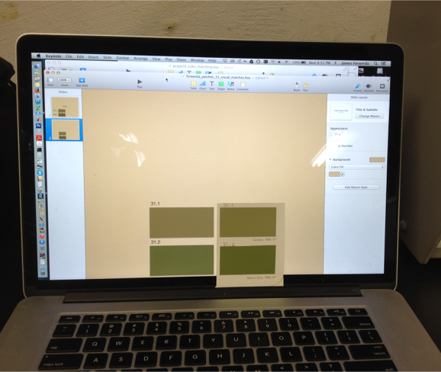

3) Insert a listing of the MATLAB code a screenshot of the table you created Project 2, step 9) here.

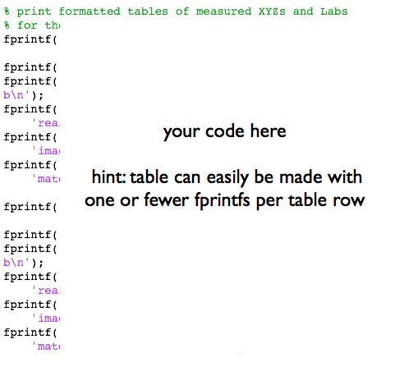

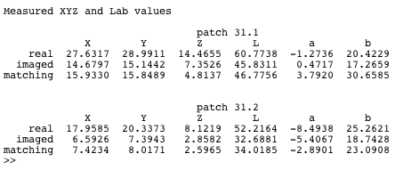

4) Insert the graphs of the patch spectral data you created in Project 2, Step 11) here.

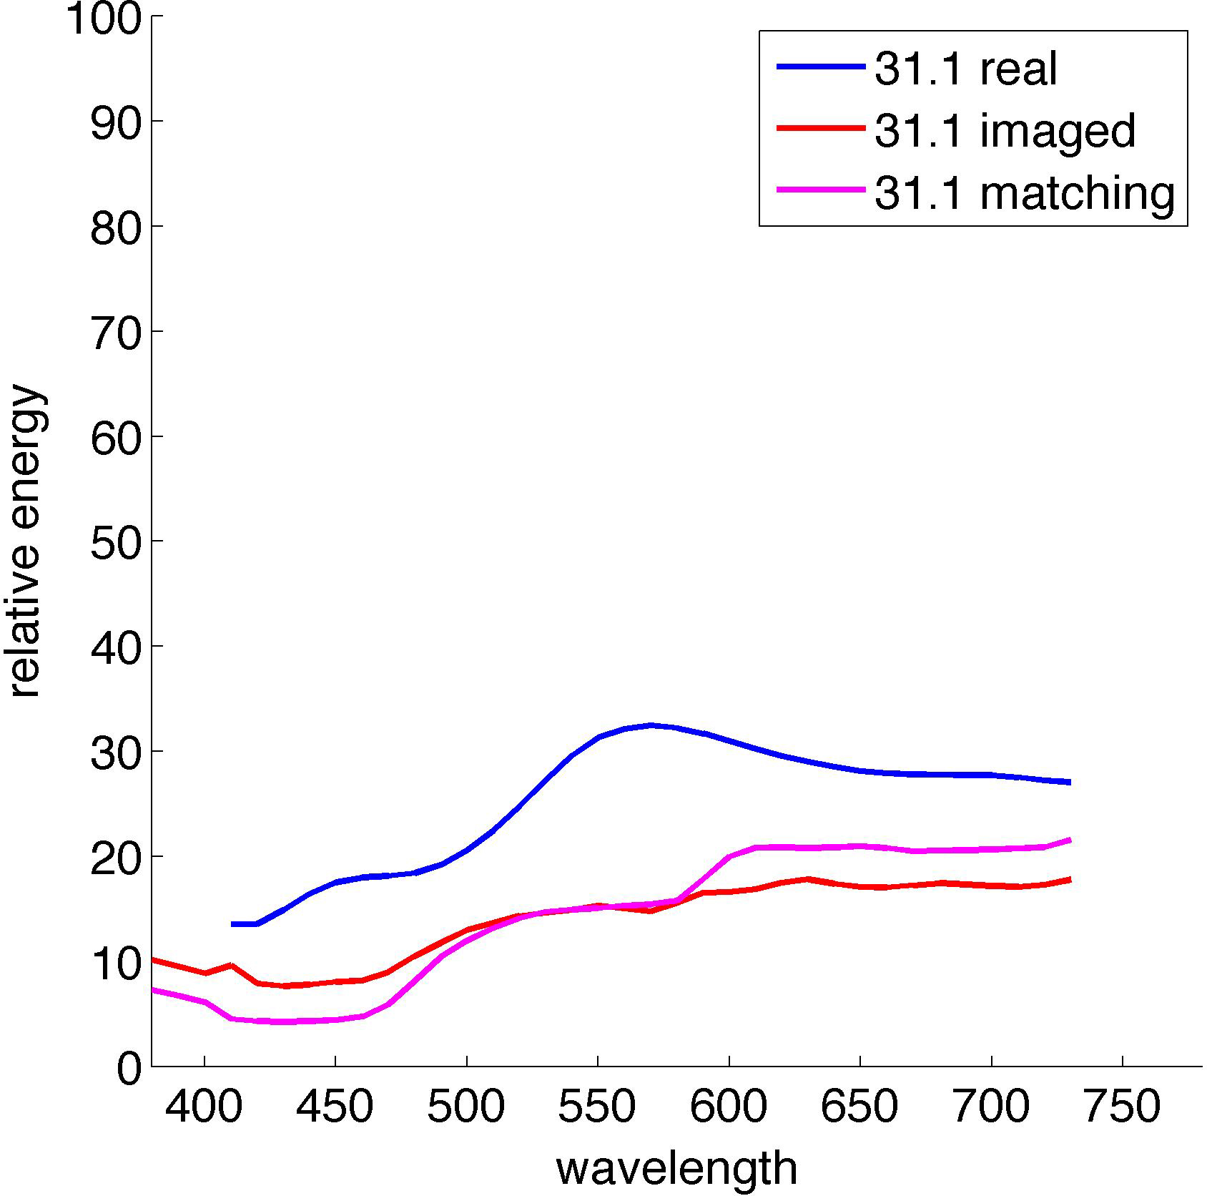 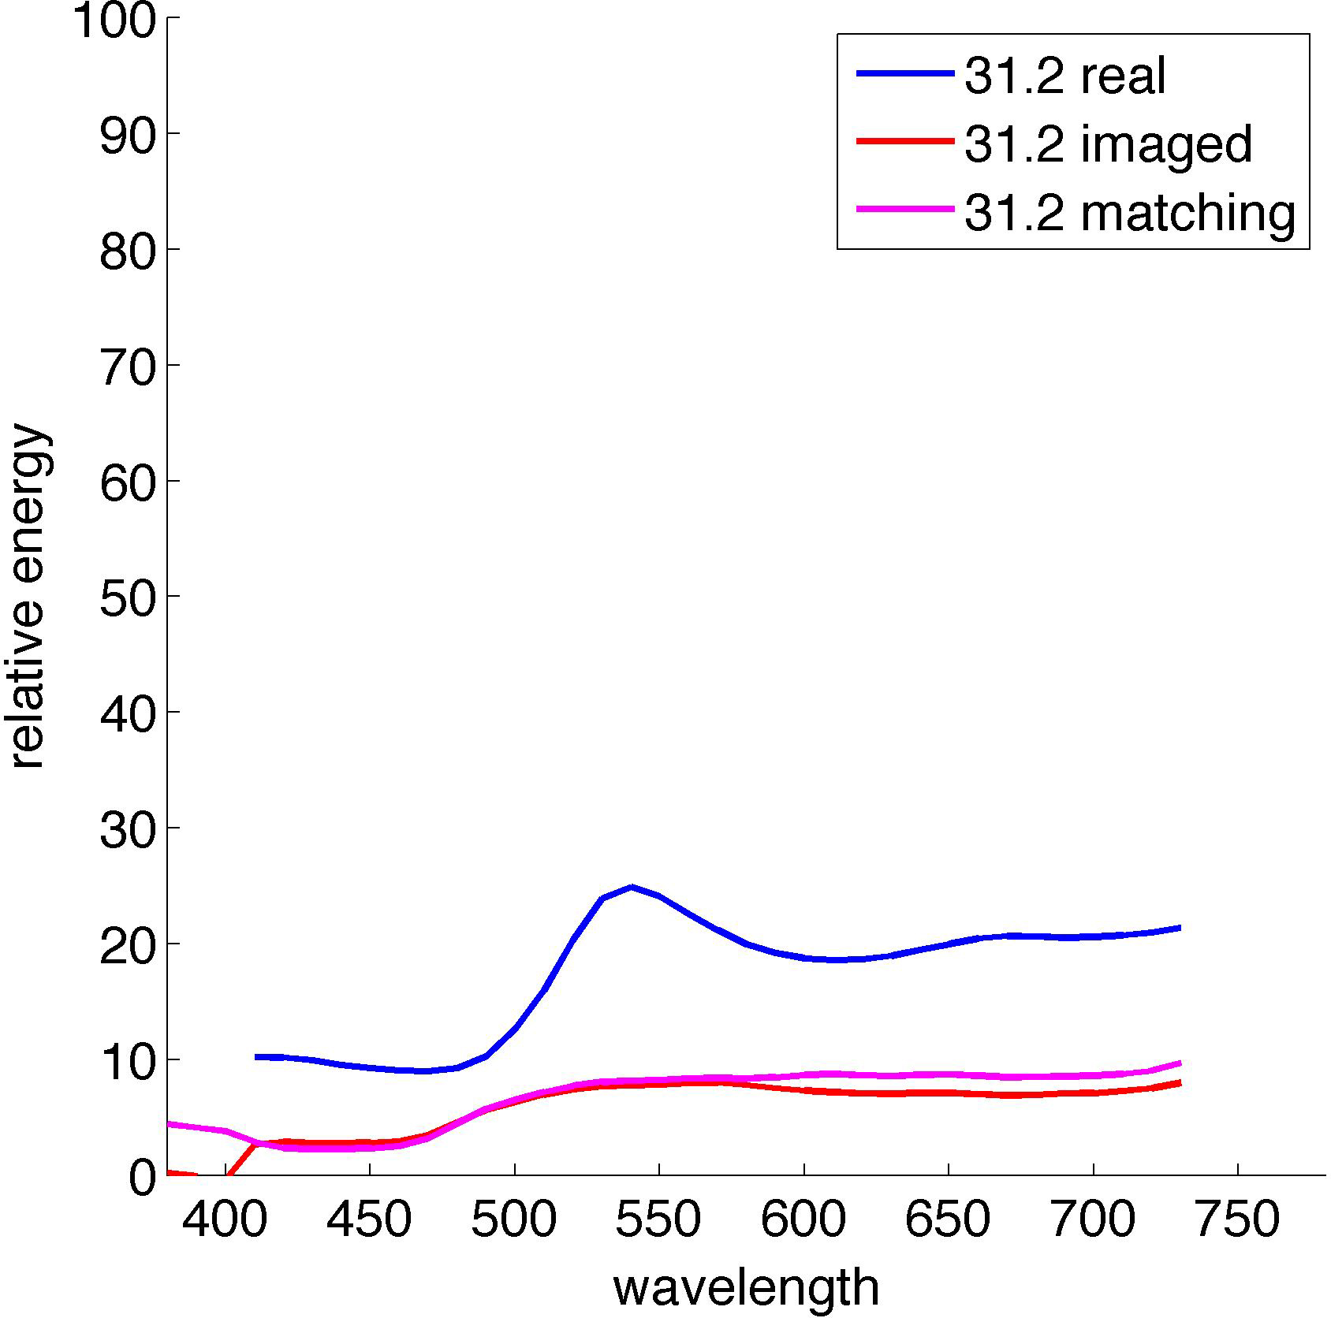

5) Perform the following tasks and briefly address the following questions.

The CIELab values measured by the ColorMunki relate to the perceived lightness (L 0-100), redness/greenness (a +500/-500), and yellowness/blueness (b +200/-200) of your patches. Differences (Δ’s) between patches indicate shifts in one attribute or another.

1. Take the CIELab values of your “real” patches as reference and calculate the ΔL, Δa, and Δb values of the corresponding “imaged” and “matching” patches (you should end up with data for four pairs). List or tabulate the differences for each pair below.

(e.g. Real/imaged #.1 pair - (ΔL, Δa, Δb): x.xx, x.xx, x.xx)

1. For each pair, describe the differences in color appearance that the Δ values indicate, and discuss how well the indicated differences agree with the differences you perceive.

(e.g. The ΔL, Δa, Δb values of real/imaged patch #.1 pair indicate that the imaged patch is darker, greener, and yellower than the real patch. The imaged patch definitely appears darker and greener than the real patch, but not so different in yellowness/blueness.)

1. Briefly discuss a) any problems you had with the project, b) any parts of the project you thought were valuable, and c) any improvements you’d like to see.

**6) Save your doc as a single PDF and submit it as teamX_project2_report.pdf**