PICKING THE BEST FEATURES OUT OF ALL OF THEM

Random forest - $b – feature 1 and 2

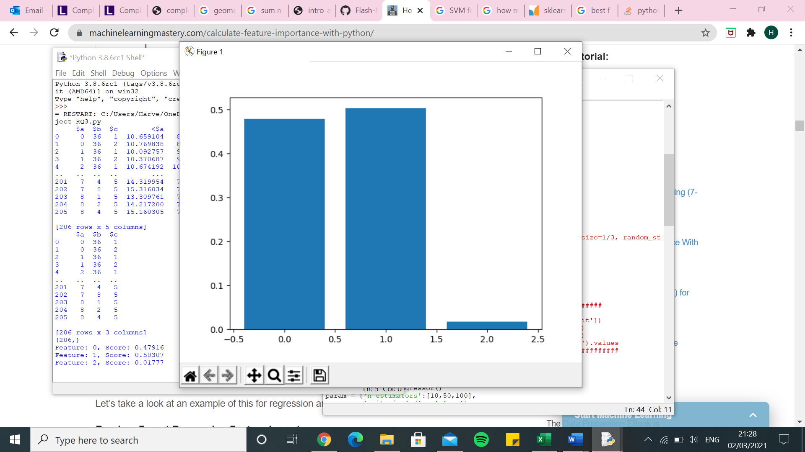

Random forest -$a

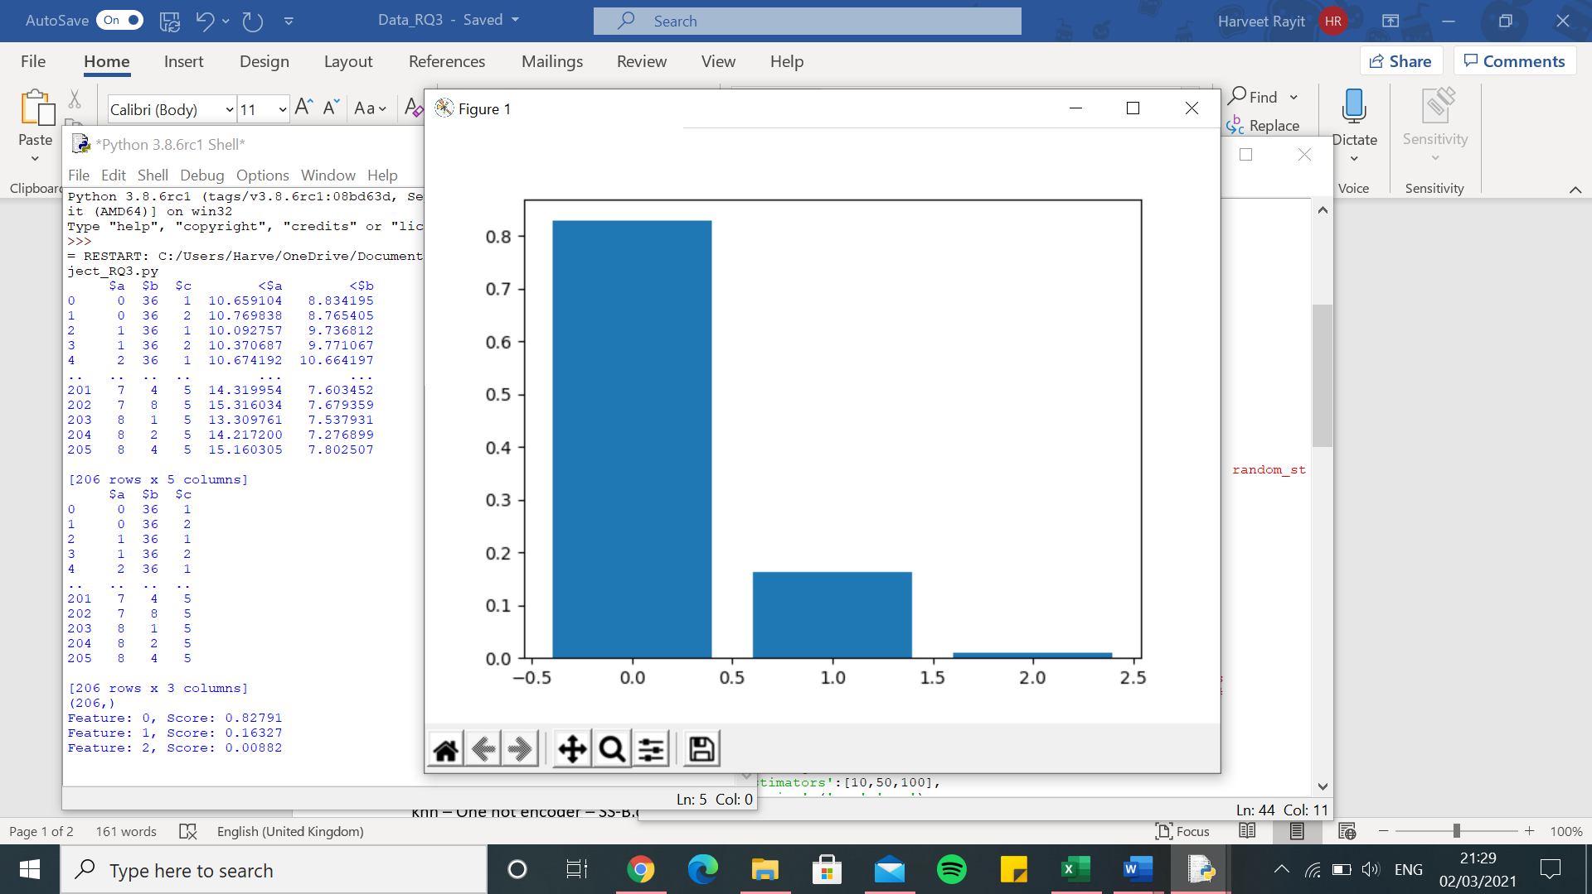

Random Forest – One hot encoder – SS-B.csv -$b

[2.089711654567883, 2.304495291688669, 2.0967263639733056, 1.823412033139117, 2.3919187123690193, 2.274047425383297, 2.1554350953941923, 2.3441507401021684, 2.5364336054806285, 2.4974172256577707, 2.177703610979934, 1.803788061196505, 2.681907351048438, 1.9087854300603484, 2.497424816996398, 2.3426133200400865, 1.7842270411324943, 2.178910512052274, 2.33606008237329, 2.064366445542685, 2.089338447995001, 2.258740402179937, 2.1715974841658094, 2.1367390835452285, 2.1965208023070857, 2.3929850103646224, 2.284984183859695, 2.881462279942128, 2.061539928341458, 2.48143970711518, 3.050815988221094, 2.1204756277736796, 1.9276889532053674, 3.2141162984046687, 1.9348422685616342, 1.9767835121385688, 2.5339837892612427, 1.6698062047252535, 1.8524201668420666, 3.1203133184458327, 2.313603448316885, 3.2303487209179034, 2.4689575105061414, 1.7866499693885485, 3.1634942210334995, 1.9267258271712877, 2.0624194534514286, 2.1795534806122823, 2.119072304451556, 2.238969937946841]

0.0 7.556929455863566e-10

Execution time: 2485.8546974658966 seconds

knn – One hot encoder – SS-B.csv -$b

[2.4558109726456996, 2.1809463393820874, 1.9578950822843473, 1.9082555058317356, 3.12524509626781, 2.7146343474381025, 2.441603829124527, 2.411513526928361, 2.4801271322920386, 2.341442344978204, 2.2940084875463156, 1.6374889865469036, 2.422416213078974, 1.8169081837412253, 2.508943000092469, 2.657777246579106, 1.6459195112405678, 2.408828474385551, 3.119489421551644, 2.5147296037251174, 2.1682521552980916, 2.9241744544160735, 2.944739063772216, 2.2414430347432526, 2.1911340874710103, 2.36444184051279, 2.7148231361931736, 2.0380612199225774, 2.412014774822346, 2.522685682854735, 3.1251201352504685, 2.0841021337278343, 1.95542570769106, 3.312650444623102, 1.894009676473177, 1.832930032988232, 2.070208953239675, 1.89313079823213, 2.3060691894979963, 3.067901954868717, 2.8168318801075514, 3.0452177100345903, 2.7269536900765985, 1.8912483778859326, 3.35307244934184, 2.0713542586638822, 2.0421714589547215, 2.159208313244933, 2.3001371527173253, 2.219861422779475]

0.0 7.556929455863566e-10

Execution time: 278.0349085330963 seconds

SVR – One hot encoder – SS-B.csv -$b

[2.3042330341773556, 2.1349580526043748, 1.9402970525102103, 1.8866986371161265, 2.4498269620951616, 2.365158742772355, 2.1303957226704537, 2.2444685689117247, 2.3714668751987715, 2.4049388483117244, 2.1129811244921655, 1.7319431239386707, 2.3405626682040555, 1.8533100641363347, 2.2835299737612944, 2.2657789859357105, 1.5949290111428394, 2.239615505317292, 2.576359155384171, 1.9606569181771223, 2.0622086620403026, 2.421330306485709, 2.449844225029905, 2.049027398211065, 2.1808941249383436, 2.1243878767575954, 2.6236606198882213, 2.321165761635688, 1.8920277884428955, 2.2202290431910203, 2.639114154759796, 1.8177207492676044, 1.9248433644651497, 3.0722780164392445, 1.8896735092668644, 1.8763177435817247, 2.1122854714525094, 1.5404854215270052, 1.823331614652314, 2.8139771715857687, 2.34702871811675, 2.677916335183003, 2.390377907923665, 1.666650695199531, 3.0080513461143514, 1.8008848665835244, 2.069086579213001, 2.2760691549368226, 2.240078579867224, 2.216599840035522]

0.0 7.556929455863566e-10

Execution time: 315.2122552394867 seconds

Decision tree – One hot encoder – SS-B.csv -$b

[2.4165799574991733, 2.56103342126498, 2.1538938409343777, 2.1091910045906257, 2.455212701726761, 2.532803399422803, 2.2704921543836596, 2.793055743153264, 2.5179210224072066, 2.636215641971542, 2.7255060618736677, 1.9877352580556689, 2.845978683548989, 1.9769222761529766, 2.0746908390721033, 2.6297156057084257, 1.846089939074511, 2.670632863959524, 2.417008455715123, 2.036084384251338, 2.112131882600442, 2.332971133164859, 2.119640894645847, 2.3313709719708795, 2.314236145505546, 2.5833078355106203, 2.5358296784073975, 2.7805133323585225, 1.7419718346547095, 2.433036119747715, 3.304065826770039, 2.0360741966452975, 1.914304126427164, 3.4324751963967537, 2.3907963469019546, 1.997856819216174, 2.4561207416717896, 1.9690969901483146, 1.8851345765680734, 3.4578320040161192, 2.5340472920877692, 3.353860071100854, 2.6491877151640795, 1.9151187373388674, 3.089249045031331, 2.1439545926666264, 2.4290127049420343, 2.395638361823882, 2.654135256826049, 2.3824594543131288]

0.0 7.556929455863566e-10

Execution time: 132.2720432281494 seconds

Linear regression – One hot encoder – SS-B.csv -$b

[2.1343109531617435, 2.4818023508961686, 2.1510232079687985, 2.1923306274226935, 2.1960479055834705, 2.5021811851093747, 2.3882120731580687, 2.0461755939945445, 2.5277091323437118, 2.6690326194313077, 2.2327283045374466, 2.019994780274929, 2.35919348810923, 1.9811290535431652, 2.44733256720013, 2.487909000610876, 1.728666676855371, 2.4110925310360867, 2.406631228673204, 1.9667061799440988, 2.0224818031249376, 2.360985800637956, 2.2807301845352304, 2.0566752892473805, 2.5287462881335308, 2.3664121054829783, 2.575867620026467, 2.8372810771272556, 1.834898397964653, 2.556174672166439, 3.1282130042525935, 1.9279995210942222, 1.925496144827634, 3.1456913179127604, 2.313969953716248, 2.0239251432079737, 2.4890453542295528, 1.7839506177223714, 1.9613880445192222, 2.8904741415346957, 2.41613127163422, 3.0254635673783743, 2.715682993358752, 1.6877419291805476, 3.087444684766573, 1.971082370385615, 2.0344191762580692, 2.4812691893398062, 2.67236997030097, 2.5086386206279254]

0.0 7.556929455863566e-10

Execution time: 8.121814489364624 seconds

Kernel ridge – One hot encoder – SS-B.csv -$b

[4.72816868573141, 7.250336029591364, 5.617843495004727, 6.061829780523615, 8.08418606526366, 5.629217928393493, 6.462650766409998, 7.268408835714871, 7.076943339959445, 6.2747294970687495, 7.420756568501657, 6.338765019526359, 4.267475296075588, 6.913625763003839, 6.922751910666681, 5.843275481191233, 8.247527943449747, 7.520618040838031, 5.266966010834246, 5.76147965634572, 7.26545735022523, 5.269712405645185, 6.559892284702331, 7.575769340546893, 4.484771640983565, 5.020832915319816, 7.994338759215523, 5.688206611538547, 7.105215010774217, 5.673012135358183, 6.696790939206036, 6.667858790220342, 7.591301652175773, 7.3141488174914695, 5.2815464063701345, 4.395491315725199, 6.509951722104478, 5.98307961956031, 5.928624646630176, 6.066997470160991, 7.603312457302834, 6.215253992683031, 6.289739482437807, 6.630575660428552, 6.900116743028613, 6.259797579265164, 6.795654948371391, 7.215879609472694, 5.607197107825512, 4.446331976742885]

0.0 7.556929455863566e-10

Execution time: 550.9132406711578 seconds

Random Forest – One hot encoder – SS-B.csv -$a

[1.4048702458424156, 2.5747827706151107, 1.5101815283990871, 1.4357607136357804, 1.680467768992921, 2.272534754543336, 1.9206070541595062, 1.7797632835681494, 1.779969263773331, 1.857652091957901, 1.5384495785740082, 1.9336297439738437, 1.76093698768634, 1.9275043314652358, 1.619531071401965, 2.172528564572021, 1.4564238068558253, 1.590863985953953, 2.6813713817255365, 1.9279149260875101, 1.958809944209937, 1.8494098640170789, 1.854698260392871, 1.3841784087031985, 1.5132700148580687, 1.8601783063069175, 2.2571274877142113, 2.1742066597684246, 1.8934091853311323, 2.2413987457747613, 1.7204238848894988, 1.7277640564356465, 1.0924349290480857, 1.4386590940549266, 2.8394395597654913, 2.1513099680123906, 1.8139527309314285, 2.0819516742784656, 2.0373901161040124, 1.3627783045112218, 1.6850680343473494, 1.8505268211579124, 1.1988497708214112, 1.45347065466852, 1.9910118198832079, 1.2614776756153048, 1.5248204346935923, 2.20412817190305, 1.2230138158592179, 2.0827177582240752]

0.0 7.556929455863566e-10

Execution time: 1309.9286723136902 seconds

knn – One hot encoder – SS-B.csv -$a

[1.459639784063479, 2.3630056835217204, 1.5502663800114973, 1.420894073323955, 2.0026081103903546, 1.9400731561158442, 1.6344483370478526, 1.5180259796853217, 1.2894614110015603, 1.394542916267694, 1.4690772859505972, 1.8720677236039598, 1.8013688617464731, 2.0368855782935262, 1.4066071613819433, 2.4885249288294764, 1.8749205465894887, 1.4986214619123286, 2.1787662922706956, 1.7393443869460519, 1.9311483115063561, 2.0672688302875786, 2.520125809441178, 1.3516555206561702, 1.3331078254641193, 1.992285102105391, 1.9226403186631866, 1.998169378921379, 1.8508179388633836, 2.0580920719378257, 1.770695446656078, 1.6563305421281682, 1.005088278970892, 1.2981522474593792, 2.221883581461227, 1.86356288981606, 1.86225324755809, 2.0308909338700185, 1.8693170417005436, 1.3145691108595123, 1.7584934254407822, 1.73309823577867, 1.0912907267262757, 1.3285600630917613, 2.422909148330759, 1.2047205060769888, 1.3015292951516504, 1.5943696186294247, 0.9452193754577618, 2.0207747285964275]

0.0 7.556929455863566e-10

Execution time: 748.2010748386383 seconds

SVR – One hot encoder – SS-B.csv -$a

[1.4175888294084997, 2.324652902309807, 1.5859414633873603, 1.3778636171675955, 1.8030352885934386, 1.6704544800583447, 1.7390369357636026, 1.5663550315951198, 1.0586090788326985, 1.559336431786335, 1.632575846104239, 1.9190503615985746, 1.8968019148152295, 1.9059566898822435, 1.5037878545942718, 2.2478240168995027, 1.2144814282940037, 1.4222753318343364, 2.3793144447374557, 1.6351327812126597, 1.8059051459554416, 1.7069436822056852, 1.5942102079864873, 1.4899647142546013, 1.3924191762507725, 1.7843954328671596, 1.7471436171600996, 1.9731411791714508, 1.9809010839696164, 1.8611787451114585, 1.5933521254925536, 1.7046526045937886, 1.1278554771448728, 1.3838406814040014, 2.2497421600540566, 1.9485869743642468, 1.5686333781187887, 1.9057630530613632, 1.8693124122729627, 1.1644234323157983, 1.6338625156750042, 1.836655710183063, 1.179882501647257, 1.3508579113025239, 2.350183927726031, 1.1285245532624968, 1.500094997562609, 1.4496743272040558, 0.9629375694833249, 1.930114590273221]

0.0 7.556929455863566e-10

Execution time: 456.9524085521698 seconds

Decision tree – One hot encoder – SS-B.csv -$a

[1.459639784063479, 3.446216341766224, 1.576732292162998, 1.5380214653983368, 2.047380717575416, 2.3302772246996937, 2.085843800922326, 1.4335963132560623, 1.394730577590166, 2.266767937664799, 1.749778167416362, 1.7804650440224983, 1.6767913110362969, 2.083256034249262, 1.508018392124448, 2.133016666603781, 1.9643570328617848, 1.6816249879200258, 2.387212565710214, 2.2297017977993097, 1.5838509282513922, 2.6758026607869003, 1.7050959410018653, 1.530755087708299, 1.342332154824231, 1.7829526840730747, 2.2692537068410923, 2.1190823377539147, 2.398008510455132, 2.758726207304869, 2.0262976229673053, 1.550150223845711, 1.6450729248616622, 1.3809208218456925, 2.8647495139035866, 2.3797836768845975, 2.2979286290064063, 2.232885953771705, 1.6296400162750697, 1.7061278344814828, 1.7751793005436716, 1.8000883940336005, 1.3900583654075556, 1.4425015199558033, 3.3047978966637586, 1.2177203918375876, 1.4940785420743787, 1.9653381400750896, 0.9745718045378197, 2.386985145451445]

0.0 7.556929455863566e-10

Execution time: 376.3052043914795 seconds

Linear regression – One hot encoder – SS-B.csv -$a

[1.4596397840634785, 2.154532593512541, 1.5185208251308082, 1.4002122375792652, 1.9480504782471038, 1.9128291024649577, 1.632584233240659, 1.5136880636336825, 1.2549735866362823, 1.4836589302867618, 1.5338102718362956, 1.8622288813332522, 1.790927776093402, 2.020292205805341, 1.391022138718785, 2.428700611528041, 1.2622086432466297, 1.4506552042130119, 2.070411981664778, 1.747120731230925, 1.8477105402340683, 2.1116016675482925, 1.6661070794641017, 1.3558579154934718, 1.4009484447158556, 1.82540897047683, 1.8684943466261927, 1.9803322547272577, 1.9114047828732372, 2.133427211920949, 1.7443445913995894, 1.6843551072500225, 1.035352822748462, 1.2596391205448194, 2.1763016683348555, 1.8310234762092683, 1.9116118217939206, 2.078598339189329, 1.9393935346752056, 1.245141421171499, 1.7611522697893913, 1.701451359691525, 1.0728936769406117, 1.3568413510907473, 2.294318692285384, 1.2047205060769883, 1.3533533206551098, 1.6210624578694175, 0.9728385676237215, 2.0825916132044955]

0.0 7.556929455863566e-10

Execution time: 16.054431915283203 seconds

Kernel ridge – One hot encoder – SS-B.csv -$a

[1.6592217139727323, 7.064083353550607, 6.105890905565977, 5.263449082366823, 6.816864320810696, 7.7501499317616505, 7.315948080896728, 5.430927368583792, 3.3985256519878, 5.670733092308322, 6.101974844565971, 9.277798347217507, 4.532267400049603, 6.2884169236134495, 6.482404225902856, 9.342192037725383, 7.001170438986953, 7.210722601309895, 5.345680914199433, 7.161062730030427, 7.1350240351524095, 7.122027939114266, 5.407477310205824, 8.55533159679434, 5.528795602034059, 7.917405568341187, 7.776967331351506, 7.483312986660849, 7.014775269447002, 9.118687404216343, 6.061649750630313, 5.993700096719957, 6.576652730748463, 4.143458857999807, 10.373424347386655, 5.93805908551711, 4.459620593066835, 8.054362095338119, 9.541636403436355, 4.419830168022704, 3.1607800423876005, 6.293600608560842, 5.411172178048888, 5.317685713315575, 7.964136951084269, 1.2441084620099248, 4.6772865041091105, 6.724492800993698, 2.3662611178038784, 5.99018649963298]

0.0 7.556929455863566e-10

Execution time: 1857.7459905147552 seconds

Random Forest – Integer encoder – SS-B.csv -$b

[1.5222231103658033, 1.3133414200529618, 1.0292833779700348, 1.1083543123556796, 1.5422500773788221, 1.6710951982711404, 0.9657727822657568, 1.4231404180448601, 1.4154520455273665, 1.101330084495895, 1.034881784571182, 1.007317101584954, 1.550073874751127, 1.3501208279016104, 1.6909891513405768, 1.522056867605048, 0.7046884689863213, 1.6847078855076094, 1.6365225332721955, 1.4154085987275302, 1.5180945482709909, 1.5270872229783277, 1.2012871512976504, 1.7978298134933155, 1.4867715974246118, 1.334433577338084, 1.1826342008838335, 1.4358741959176695, 1.5253209793143616, 1.8067625215582832, 1.6385924583234581, 1.4408638280449662, 1.48576903332703, 1.5368862981106077, 1.0786287974746853, 0.8747316282833006, 1.068713080999955, 1.3840838559832802, 1.7843429935256248, 1.1518340293860119, 1.7846635899319816, 1.6416300966826571, 1.3602970519541664, 1.3237318435790864, 1.3483019496085378, 1.1573769997301344, 1.4454235942541076, 0.8765251401954796, 1.4332584041211958, 1.8183142453742653]

0.0 7.556929455863566e-10

Execution time: 1711.4253709316254 seconds

knn – Integer encoder – SS-B.csv -$b

[1.596641359168944, 1.5397669277950052, 1.1487897788216395, 1.3104248378204728, 2.0887550121260237, 1.8143135747947303, 1.0827159342168646, 1.5754656219118772, 1.3829782534325739, 1.2649588871093653, 1.0748216854066646, 1.287927899802552, 1.8600527864483583, 1.3751457966400198, 1.489093738170483, 1.5036700728602914, 0.6964242757034693, 1.798711636577963, 2.009081855122456, 1.647368148142344, 1.3660222189679123, 1.5059986027673053, 1.8481600867984915, 1.6256150101590723, 1.5613507064237462, 1.2547806685948684, 1.1612402000053421, 1.290255491507515, 1.3985356454024418, 1.796645355294364, 1.7046801138125158, 1.2915920444485354, 1.2331244131895276, 1.5755762208373445, 0.9665576539418934, 1.2918052756969205, 1.102465771189745, 1.0740595744533346, 1.7277901611212585, 1.4544197821722589, 2.0756710899887705, 1.4859036793122034, 1.6848102786435717, 1.5347065045151862, 2.0773259701620446, 1.1643471873804618, 1.1545355339371954, 1.2210036173696843, 1.646031755031986, 1.9024123713407197]

0.0 7.556929455863566e-10

Execution time: 102.35906028747559 seconds

SVR – Integer encoder – SS-B.csv -$b

Decision tree – Integer encoder – SS-B.csv -$b

[1.4775628262968823, 1.6422527508086715, 1.6693979685777514, 1.6820941913255159, 1.8296187646741595, 2.473131596230031, 1.1310097175723197, 1.8100553715300582, 1.8444497836706308, 0.7799921273911271, 1.6070264371669662, 1.6040587699193887, 2.133978660202877, 1.6326533221169177, 1.687421836684842, 1.901465985949983, 1.0844362306972153, 1.797489639549071, 1.4231735424633565, 1.8552217276451386, 1.753339866068226, 1.9322676716191904, 1.9143116108601064, 1.8128018859930521, 2.220043054262788, 1.648367729380597, 1.6263105382863463, 2.0692550947769583, 1.8412883410849978, 2.6196001761921033, 2.0194488840649827, 1.604235051173455, 1.6989079113118464, 1.9915268388125755, 1.1298637339164466, 1.5376932001685517, 1.5879085048558779, 1.382006859135693, 1.8119109366745392, 1.700181772470058, 1.9348777394527668, 2.1310079978061633, 1.5055717862987474, 1.7147440827494258, 1.5932194565822224, 1.1983200270317396, 1.609948361477514, 1.6147269670380369, 1.9695828617563735, 1.5505634969290976]

0.0 7.556929455863566e-10

Execution time: 129.5918483734131 seconds

Linear regression – Integer encoder – SS-B.csv -$b

[0.786287735673098, 0.9314456359254099, 0.8278292013260788, 0.8628106096107612, 1.4656926100754657, 1.2564717704519577, 0.7379726048775644, 0.9335871228958242, 1.213521563037755, 0.6559116523335526, 1.009489568426928, 0.6972006857418865, 0.973832068388308, 0.7385231397836921, 1.1200310171938157, 0.7857411241052914, 0.5471956340468238, 1.307020528255964, 1.0209086020783997, 0.8582646221309244, 1.214632332222557, 1.2284247229015632, 0.7698171439727796, 1.0201212845155783, 0.7964640991110014, 0.6984828160758384, 0.8115762841599529, 1.0183162617794044, 1.1305906544039004, 1.3614498985780121, 0.8971462505823974, 1.072019284928393, 1.2985368533393702, 0.8717579765978254, 0.6063119188681101, 0.9561010240004221, 0.563777192720047, 0.883630407419868, 1.1367116935975716, 0.9752356915052883, 1.0537291155185515, 1.0949084400936386, 0.7012669849628397, 1.4558702740679306, 0.9069062216653119, 0.5987851473550176, 0.9047685834987279, 0.690167060702204, 1.1831691274606764, 1.0427449361533343]

0.0 7.556929455863566e-10

Execution time: 3.4697935581207275 seconds

Kernel ridge – Integer encoder – SS-B.csv -$b

[2.4556094520205827, 2.035690186001967, 2.1834580458913715, 2.010644360616075, 1.8599578761301692, 1.8497096538332385, 2.2976913071021845, 2.3354975685365775, 2.1678428704473713, 1.7576668917844651, 2.0403660825643857, 2.035449940831588, 1.9148954304572865, 2.752075828254374, 2.021102686514348, 2.0814301713678085, 1.8432378246685581, 1.8597058332381837, 2.6621852147227054, 2.0342769805514433, 2.739590974676232, 2.026818246609293, 2.0397435820645566, 1.771885292852171, 1.9970538775265714, 1.726965591939484, 2.6272641447181133, 2.0844375970427547, 2.2271908056220258, 1.8009804163836844, 2.000179944164626, 2.193445864238179, 1.980254373737368, 2.1263551880694997, 1.8380041537934917, 2.376781449662232, 2.517215412536662, 1.843187364373519, 2.139474119539964, 1.9181773834033127, 2.327378694833345, 1.9697515522330769, 2.175180600630802, 1.6900370898413877, 2.2882814622528556, 2.040007839073891, 2.159657246783846, 1.9840556446511894, 3.2785639081707525, 1.8599233621904117]

0.0 7.556929455863566e-10

Execution time: 424.3670434951782 seconds

Random Forest – Integer encoder – SS-B.csv -$a

[1.329349899893384, 1.0449432147660802, 0.8424425242628419, 0.9996072649996998, 1.3221753527722817, 1.5811715034664837, 0.9175604191571071, 1.3664449439555995, 1.1972371468851013, 0.7023441170380704, 1.1053719401512965, 0.7890219807465576, 1.5993622814433317, 1.6117791547154725, 1.190938395876651, 0.8960212555400398, 0.7337341705347916, 0.8859404379615982, 1.5941336953627887, 1.2295133843241712, 1.1813209253062678, 1.8029486987374932, 1.5295110036972706, 1.0893387731501831, 0.999063129711228, 0.9830274331999719, 1.1678734485481135, 1.2505018905969898, 1.091129422401794, 1.3455486724710335, 1.0982784257109992, 1.363766665791628, 0.8295972619984178, 0.861090612030804, 0.7682086678416663, 0.7995504079215456, 1.1225600170222467, 1.4201707991583425, 1.4180408545440149, 1.2450451819175339, 1.6924219498297914, 1.2308993188722752, 1.0594390337709712, 0.8750424056930893, 1.5480966722027583, 1.0541040801272672, 0.9531787660114674, 0.7306898825441391, 0.6009488407500773, 1.5751274302875882]

0.0 7.556929455863566e-10

Execution time: 1224.2617948055267 seconds

knn – Integer encoder – SS-B.csv -$a

[1.459639784063479, 2.2582990653646715, 1.3370549847283513, 1.8135413090552917, 2.2784636853770612, 2.108185290349186, 1.9938276985058137, 2.2228700656726423, 2.2074243847043133, 1.798807072355021, 1.5853143933968539, 1.4248431131180745, 2.122783040042489, 1.6865232723504353, 1.2279686401275516, 2.2159112803244314, 1.3702871260338598, 2.0536716982496213, 2.776132341561783, 1.474686305679117, 2.030780922879783, 2.101277837518934, 1.9191263564529228, 1.6071764347090238, 1.9266308262149259, 1.454420368569151, 2.12030697147812, 2.081710882139816, 1.4345795655039366, 2.294978305284016, 1.2451132908038682, 1.8326334724537796, 1.2373231652970507, 2.037052700003056, 2.274292211068391, 1.4984462066263342, 2.2451969609134497, 1.6918003668155306, 2.0386585712748517, 2.5424565500009146, 1.7604451976528366, 1.4634780132502652, 2.2794082424763347, 1.4950150937654463, 1.4903585746037273, 1.3560872895596083, 1.3948101836812687, 2.2812430168702567, 1.620893114848135, 2.2120110413934713]

0.0 7.556929455863566e-10

Execution time: 90.33246278762817 seconds

SVR – Integer encoder – SS-B.csv -$a

Decision tree – Integer encoder – SS-B.csv -$a

[1.3799899173994687, 0.9458642974524765, 0.9160601462105087, 1.2500983661475642, 1.5406860717836448, 1.470225251958425, 0.8506602738708984, 1.3070055889858374, 1.198633088459232, 0.8546511824689095, 1.0669520765605702, 0.61378127537564, 1.515214887398399, 1.7675645709087577, 1.296928310680359, 0.8823474150625178, 0.8941609912087717, 0.7175465952318645, 1.4591222057190674, 1.5994145891948521, 1.0903753276017685, 1.7390139352493332, 1.9164418539139587, 1.1092563246218692, 0.9941515743889552, 0.9706222310497238, 1.1392452840836098, 1.4184459873317032, 1.0991437963002604, 1.633302478124649, 1.288064700704161, 1.5045927291864443, 0.7894309259853061, 0.8087904911866175, 0.8307440865056664, 0.8631085379320399, 1.3032610916462735, 1.7055818135580523, 1.467186287225527, 1.1396579089292507, 1.7738377946981383, 1.4841555899246464, 1.0824281860474287, 0.9916942172467957, 1.3783763778240017, 1.2047205060769888, 0.8964465763024304, 0.7455799291455532, 0.7293184729720255, 1.8070121350886235]

0.0 7.556929455863566e-10

Execution time: 99.1648051738739 seconds

Linear regression – Integer encoder – SS-B.csv -$a

[1.0949922831908958, 0.7487779683939323, 0.5923590497142444, 0.8727618504886262, 1.467082662626158, 1.484174006261935, 0.6232513674882924, 1.0315996725113172, 1.093117146924816, 0.5574563102675625, 0.9404345408906601, 0.578431259165007, 1.1993951290372622, 1.311986590269669, 1.1696451602890845, 0.8060211066555977, 0.8762653615190851, 0.7640498306580915, 1.2048091247341637, 1.122282811079497, 1.082021835509404, 1.3477991213094056, 1.4821467199140048, 0.9212452359602057, 1.0792660997633372, 0.7923641729275209, 0.6762999881245967, 0.9199750755284114, 0.9099508447662674, 1.1197357379294037, 1.2412060645363823, 1.2829213089383138, 0.788535432954913, 0.7909797609074418, 0.6407665067408977, 0.911512799581496, 0.8674921473648988, 0.985896244394088, 1.2367799451057484, 1.4035413968228163, 1.395395233247815, 1.078368961324586, 1.0265551654432312, 0.7690342246218186, 1.484428689633898, 0.8939851202392679, 0.6670758961768148, 1.0521877219974678, 0.588173980938681, 1.1736544158828224]

0.0 7.556929455863566e-10

Execution time: 3.5027308464050293 seconds

Kernel ridge – Integer encoder – SS-B.csv -$a

[5.953020826103937, 5.720740492397049, 5.357912315167688, 5.540319218772536, 4.442941142157078, 6.512043238846003, 5.47080472262357, 5.758578817902966, 5.458789711413257, 5.627551626993214, 5.353267947663804, 4.94207889991832, 4.820597343702382, 5.5300002316864205, 6.078875146136178, 5.834423262895601, 5.504501192747076, 5.307409546569278, 6.122938888787645, 5.934744594271172, 5.542050242870776, 5.837171713907359, 5.2366256074418605, 5.002009204276527, 5.359547209512677, 5.419666163824217, 7.76507101942817, 5.706979643730571, 4.644109641967075, 5.758539746275326, 5.695547465703429, 4.949804918035934, 5.260162470800355, 5.669203382050146, 5.016474400833754, 4.674413868976042, 5.421576660238828, 5.3766503485344606, 6.374387078061378, 6.5711930084749826, 5.665476299670551, 5.274898974883054, 6.376239561461366, 4.250460219106778, 5.512567400926538, 4.812161852285645, 5.113687152152576, 7.41703268157514, 4.757926938298127, 5.728422713808475]

0.0 7.556929455863566e-10

Execution time: 414.5893225669861 seconds

Random forest - $throughput

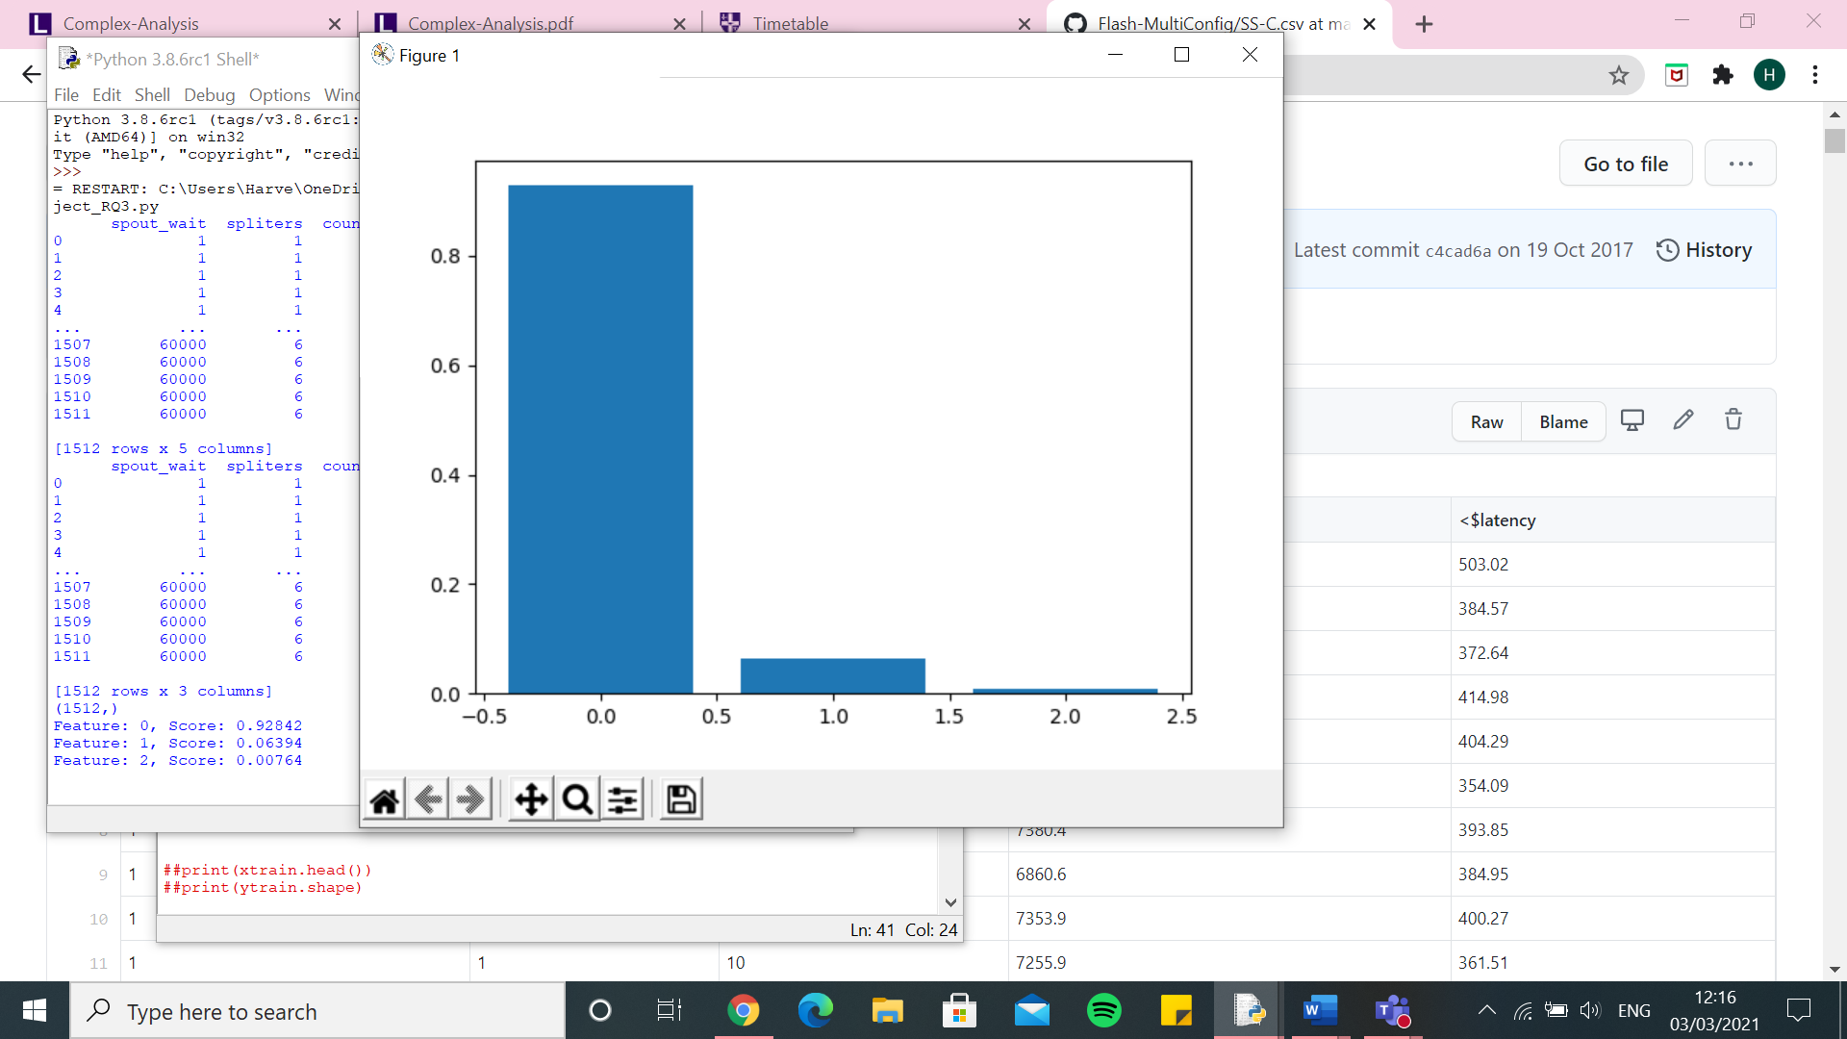

Random forest - $latency

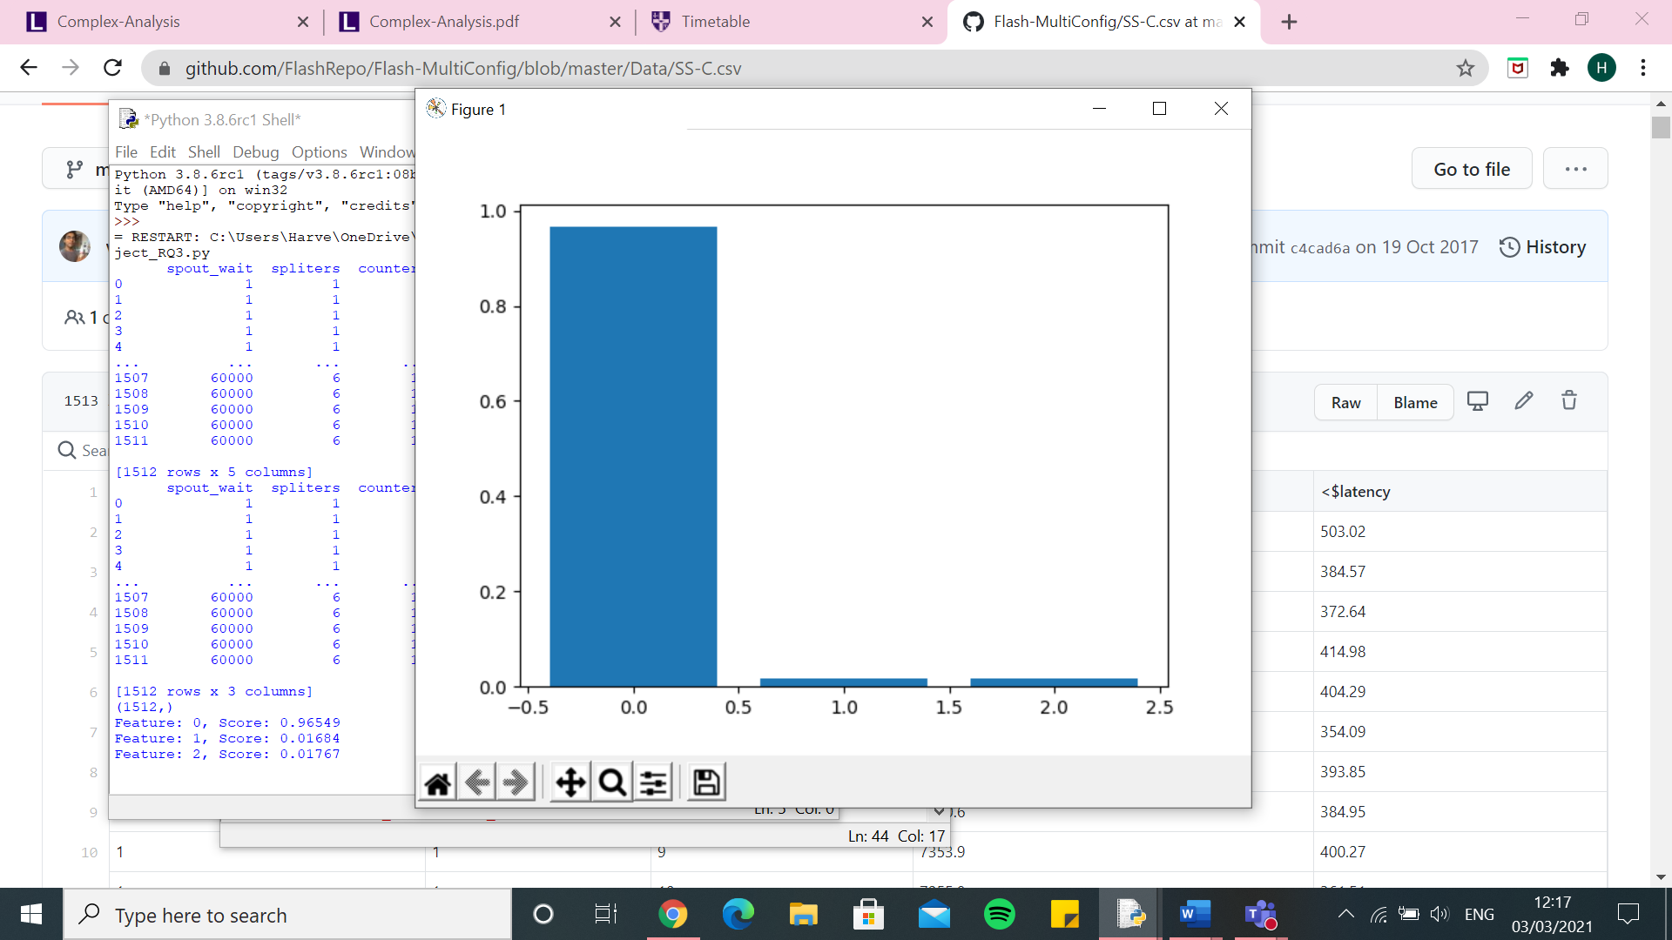

Random Forest – One hot encoder – SS-C.csv - $throughput

[3373.1538710662876, 3401.4880147164126, 3594.3328182279106, 4044.0281206295685, 3231.132177465298, 3587.2648407359434, 3152.578691771148, 3921.9670688772862, 3781.266367101313, 4304.761565715032, 3445.5164714028338, 3656.00049742861, 3665.18791745846, 3613.3110220652325, 3369.3414369592588, 3900.3586139352587, 4006.6087936836143, 3345.3551337778586, 3810.2102266871843, 3323.715858897276, 4212.710772796675, 3891.651802436592, 3146.015405066439, 3292.8544386508397, 3780.469776314817, 3699.1179005805416, 3938.970493389765, 3249.0967961913575, 3828.9305256771445, 3417.2946900064794, 3348.9002123294345, 3489.809755761659, 3281.1338311800873, 3880.325098315559, 3520.8210731830277, 3858.9329853658646, 3499.6515084884613, 3630.230464866567, 3693.7517193504423, 3392.595882459374, 3399.9038030140896, 3860.998436201281, 3781.796038455585, 3356.4311636406555, 4014.3804412189997, 3478.588652715335, 3104.1962054273267, 3433.5618304815634, 3407.7240616509603, 3911.345544207148]

0.0 7.556929455863566e-10

Execution time: 8132.210146188736 seconds

knn – One hot encoder – SS-C.csv - $throughput

SVR – One hot encoder – SS-C.csv - $throughput

[3538.3842206601894, 3604.131736591433, 3395.6056659406686, 3795.6877014728175, 3638.9138382416704, 3729.543117917423, 3594.1506651688524, 4009.9622998830478, 3948.7112615433903, 4276.79482732307, 3414.0480788678474, 3652.0212193770753, 3932.9772458965817, 3536.5649478644314, 3597.5285337032133, 3808.618744630221, 3854.4088083730503, 3327.8117812969135, 4014.5615706420062, 3590.9674126468385, 3614.40534816241, 3959.138140314175, 3562.614479464003, 4007.7687333427248, 3955.597355095675, 3684.088031806085, 4112.835280299986, 3664.4875697035695, 3759.952256222418, 3409.381095876568, 3863.318701602386, 3752.134967225113, 3596.09827675694, 4001.246193453605, 3617.3155803222126, 3571.7419037874447, 3921.862208487892, 4084.295850051227, 3799.0272958540563, 3734.075261232833, 3595.7064735290583, 3757.842246306192, 3792.8819423482582, 3890.6297645061745, 4170.547965419235, 3682.466945564501, 3850.087343936355, 3476.1342280037147, 3590.877771276732, 3754.7450715061877]

0.0 7.556929455863566e-10

Execution time: 5310.071343421936 seconds

Decision Tree – One hot encoder – SS-C.csv - $throughput

Linear Regression – One hot encoder – SS-C.csv - $throughput

Kernel Ridge – One hot encoder – SS-C.csv - $throughput

[6181.7996142311495, 6495.82155950612, 6497.589327886121, 6327.171829580028, 6665.887299795006, 6358.303769381623, 6640.287692465378, 6321.279725583471, 6191.049832744123, 6776.540689855451, 6558.243850156886, 6540.70044201602, 6271.704849382776, 6189.625948155191, 6429.499348530464, 6832.203819186624, 6868.901665557543, 6692.868296861457, 6492.69786438454, 7275.090049925162, 7066.035388584036, 5947.188857215754, 6552.231398106241, 6433.561341349763, 6505.496585182951, 6394.234721027876, 7636.369422717126, 6860.971773684108, 6528.313045766402, 6671.404379523855, 6782.078883810438, 6213.050093370055, 6449.3829317188765, 6511.286267736336, 6611.35230899769, 6540.694468252529, 6590.245541335285, 6575.329306754779, 6158.2610286668, 6656.762450792427, 6856.027640723924, 7359.607262913888, 5927.576484536638, 6659.2927997184615, 6425.310559354047, 6545.8304102598695, 6937.037170619916, 6638.790856630013, 6523.021771343017, 6579.4919760735165]

0.0 7.556929455863566e-10

Execution time: 12004.60717868805 seconds

Random Forest – One hot encoder – SS-C.csv - $latency

[9260.799848375598, 11466.845763405061, 9181.34376580479, 10276.332029845542, 10602.169475002913, 10710.342298253712, 10625.073662291106, 13586.170032426957, 13229.410780415084, 11682.821317086205, 8817.75698046373, 11320.760512703015, 11186.244281704481, 13661.397329861138, 10179.651910497316, 14411.657565310721, 12237.375597776603, 9649.39937537968, 8830.364518901415, 10001.433467998479, 13279.554030967933, 10521.761648422715, 9540.9924549193, 12817.987936127322, 14625.626648212385, 10020.327107650486, 10981.46116583221, 8778.246753676838, 8188.327391761216, 11397.069334864402, 13316.742762450172, 10934.349729263684, 9028.21279201721, 9279.791564134879, 13463.930564135604, 12558.250998000522, 11433.924340755, 9024.62532358358, 10020.034115729843, 11980.284143596176, 11734.314758639433, 12000.229804288947, 14382.570541423049, 10192.871140726389, 12381.06669677293, 9200.60468652072, 10093.772426790785, 8528.529183693692, 11395.09122019183, 10887.289374590047]

0.0 7.556929455863566e-10

Execution time: 8221.340154409409 seconds

knn – One hot encoder – SS-C.csv - $latency

SVR – One hot encoder – SS-C.csv - $latency

Decision Tree – One hot encoder – SS-C.csv - $latency

Linear Regression – One hot encoder – SS-C.csv - $latency

Kernel Ridge – One hot encoder – SS-C.csv - $latency

[9334.370325730963, 11600.084417302689, 9276.238597152202, 10372.048376205856, 10698.846213330135, 10744.22801145153, 10733.276017530316, 13724.517819693096, 13337.753479424702, 11783.757570706326, 8926.070217714267, 11421.98173211601, 11267.096138426235, 13808.838097223885, 10255.510060761264, 14010.575244912045, 12345.339281895103, 9750.014089710523, 8921.316123324294, 10085.303623666592, 13283.889663366208, 10644.80844609211, 9648.053882973492, 12945.41927518687, 14550.523017859534, 10111.695781464054, 11021.156201660018, 8871.03798033113, 8272.84941369838, 11493.860803208056, 13188.786895716119, 11030.283184481243, 9112.709786879659, 9362.636685276862, 13280.483328611712, 12598.740669535957, 11520.002321970878, 9146.79797167579, 10055.454950736355, 12089.865011765569, 11720.503171607823, 12100.564221032735, 14438.16580647407, 10299.950507383386, 12518.300586401267, 9277.907315307659, 9974.417196787044, 8620.502630535544, 11504.531039816431, 10854.120664233986]

0.0 7.556929455863566e-10

Execution time: 11239.388103485107 seconds

Random Forest – Integer encoder – SS-C.csv - $throughput

knn - Integer encoder – SS-C.csv - $throughput

SVR - Integer encoder – SS-C.csv - $throughput

Decision Tree – Integer encoder – SS-C.csv - $throughput

Linear Regression – Integer encoder – SS-C.csv - $throughput

Kernel Ridge – Integer encoder – SS-C.csv - $throughput

Random Forest – Integer encoder – SS-C.csv - $latency

knn – Integer encoder – SS-C.csv - $latency

SVR – Integer encoder – SS-C.csv - $latency

Decision Tree – Integer encoder – SS-C.csv - $latency

Linear Regression – Integer encoder – SS-C.csv - $latency

Kernel Ridge – Integer encoder – SS-C.csv - $latency