Specifications for SINful

Purpose

SINful is a 2D graphics library. It is intended to be used for creating 2D video games, but also other applications that can require rich 2D graphics.

Structure of a project

A project that uses SINful has a tree structure. The tree is used to order elements in a hierarchical way so that they can move, rotate and scale relatively to their parent.
The tree contains nodes and leafs :
- the nodes can have children. They so define the hierarchy of the 2D world with a single root node ;
- the leaves cannot have child and are the end of the branch. They can have a lot of use as seen later.

More precisely, a SINful project contains several trees. A tree is attached in a plane called parallax plane. A parallax plane represents the depth of the 2D world. Parallax planes are thus stacked.
To mimic the perspective, they can have a specific scroll speed.

Predefined hierarchies
Not only the world has a tree structure, but also some elements can be generated as a subpart of the hierarchy (subtree). They can thus be instanciated as a group of nodes and leaves and attached into the tree from their own root node. Several types of nodes can exist with their own logic mechanism. It must be possible for library users to create their own nodes in addition to the existing ones.

In the case of a video game, it can be a full character as seen in Picture 1. As an example, there are the steps to draw the character when moving :
- Root asks Behavior to compute the position of the Character ;
- Root gets position ;
- Root asks Graphics to draw content ;
- Graphics gets current animation data ;
- Graphics sends data to Body ;
- Body sends animation data to the corresponding child (loop on all children) ;
- Each direct or indirect child of Body draws its ImageEntity with the given transformations.
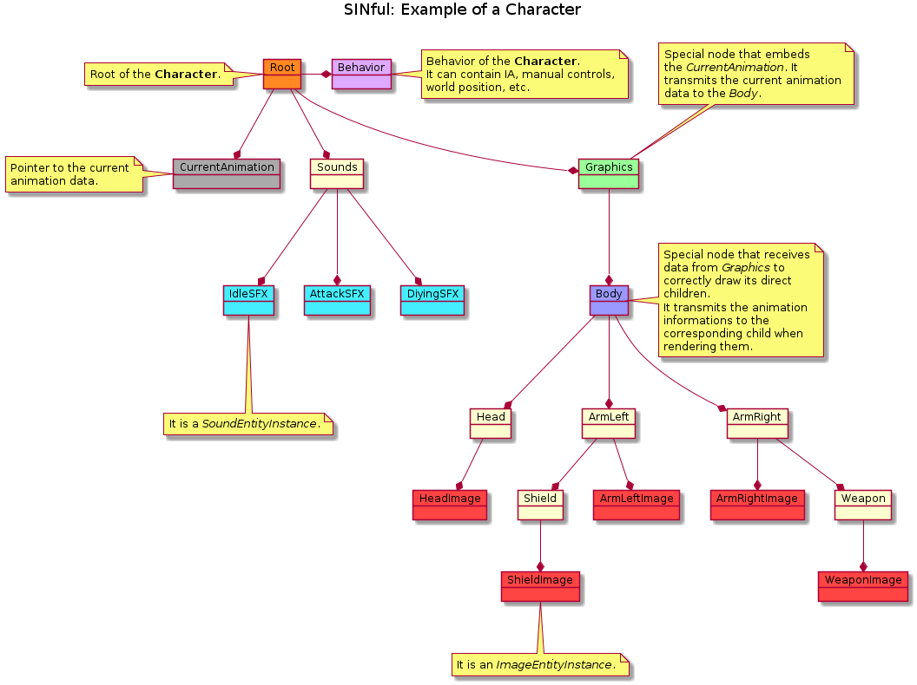Picture 1: Structure of a simple character example in SINful.

Files
There are two files for animated elements as characters :
- Skeleton description : .sink files ;
- Animation description : .sina files (optional, only if the element is animated).

SINk files
The skeleton description is a set of files :
- Images of the different parts of the (animated) element ;
- Sounds that can be played by the element ;
- Structure of the parts of the element.

Structure of the parts
The last point is a binary file that is structured as follows (italic texts are not represented in file) :
Graphics part | 4 (nodes)
« trunc » | Path to image | Relative position | Relative rotation | Relative scale
« head » | Path to image | Relative position | Relative rotation | Relative scale
« arm.r » | Path to image | Relative position | Relative rotation | Relative scale
« arm.l » | Path to image | Relative position | Relative rotation | Relative scale
1 (group) | « Body »
0 (group ID) | 0 (group root ID) | « trunc » is the root of the « Body » group
3 (links)
0 (ID of parent) | 1 (ID of child) | Add « head » as child of « trunc »
0 (ID of parent) | 2 (ID of child) | Add « arm.r » as child of « trunc »
0 (ID of parent) | 3 (ID of child) | Add « arm.l » as child of « trunc »

Sounds part | 5 (sound files)
Path to sound
Path to sound
Path to sound
Path to sound
Path to sound
2 (group of sounds) |  | AttackSFX | DyingSFX
0 (ID of group) | 3 (amount of sounds in group) | 0 (ID of sound) | 2 (ID of sound) | 3 (ID of sound)
1 (ID of group) | 2 (amount of sounds in group) | 1 (ID of sound) | 4 (ID of sound)

A link to the used SINa file is also written into the file (for animated elements only).

Whole SINk file
The whole SINk file is a zip file containing images, sounds and the description file :
- .kd (kinematic description file)
- images
  - trunc.png
  - head.png
  - arm.r.png
  - arm.l.png
- sounds
  - attack
    - attack1.wav
    - attack2.wav
    - attack3.wav
  - dying
    - dying1.wav
    - dying2.wav

Creation of instance from a SINk file
When a SINk file is loaded, it stores the data into an Element Pattern.
Element Pattern is an object that describes the organization of the character in order to create instances of the element.
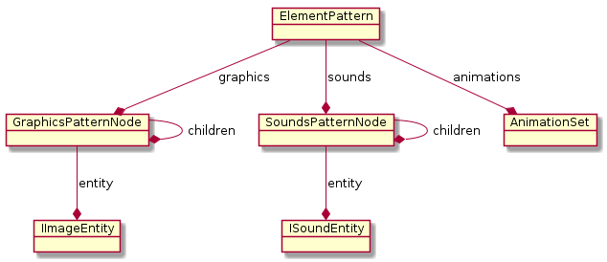Picture 2 : ElementPattern and its components to describe an element.
To generate an instance of the element into the scene tree, ElementPattern acts as a factory that returns the element instance :
- For each *PatternNode, a Node is created (with the corresponding hierarchy) ;
- When a *PatternNode contains en I*Entity, an instance of it is created and given to the Node.

SINa files
The animation description is a binary file that is not directly linked to a SINk file. It can be used with different SINk files. However, to share such informations, all the SINk that are using the same SINa file must have the same structure.
In the previous example of SINk file, all SINk using the same SINa file must thus contain 4 graphics nodes in the same order and hierarchy. They also must have the same sounds groups in same order. Yet, they do not have to use the same sounds or the same amount of sounds (sounds are randomly picked and played into the wanted group).

When a SINa file is loaded, the contained animations are stored into a manager of animation sets. An animation set contains all the animations of an animated element.

