Q. W.A.P. to demonstrate time control.

* Code:

Public Class Form1

Dim b_col(4) As Color

Dim f_col(4) As Color

Dim pg As Boolean

Public i As Byte

Private Sub Form1_Load(ByVal sender As System.Object, ByVal e As System.EventArgs) Handles MyBase.Load

b_col(0) = Color.Black

b_col(1) = Color.Blue

b_col(2) = Color.BlueViolet

b_col(3) = Color.Teal

b_col(4) = Color.HotPink

f_col(0) = Color.Wheat

f_col(1) = Color.Black

f_col(2) = Color.Red

f_col(3) = Color.White

f_col(4) = Color.Cyan

Label1.Text = TimeOfDay

Label2.Text = TimeOfDay

End Sub

Private Sub Timer1_Tick(ByVal sender As System.Object, ByVal e As System.EventArgs) Handles Timer1.Tick

Label2.BackColor = b_col(i)

Label2.ForeColor = f_col(i)

i += 1

If i >= 4 Then

i = 0

End If

If pg = False Then

Label2.Left = Label2.Left + 10

If Label2.Left >= 500 Then

pg = True

End If

Else

Label2.Left = Label2.Left - 10

If Label2.Left < 10 Then

pg = False

End If

End If

End Sub

Private Sub Button1_Click(ByVal sender As System.Object, ByVal e As System.EventArgs) Handles Button1.Click

Timer1.Start()

End Sub

Private Sub Button2_Click(ByVal sender As System.Object, ByVal e As System.EventArgs) Handles Button2.Click

Timer1.Stop()

End Sub

Private Sub Button3_Click(ByVal sender As System.Object, ByVal e As System.EventArgs) Handles Button3.Click

Me.Close()

End Sub

End Class

* Output:
* Start

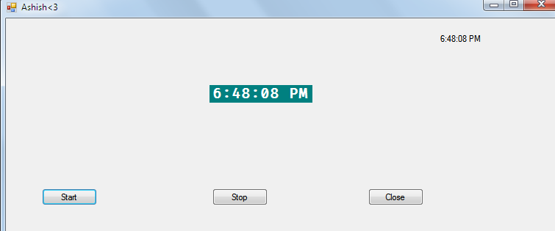

* Stop

