Q. Create a calculator in vb.NET

* Code:

Public Class Form1

Public num1, num2 As Integer

Public op As String

Private Sub Button1_Click(ByVal sender As System.Object, ByVal e As System.EventArgs) Handles Button1.Click

TextBox1.AppendText(1)

End Sub

Private Sub Button2_Click(ByVal sender As System.Object, ByVal e As System.EventArgs) Handles Button2.Click

TextBox1.AppendText(2)

End Sub

Private Sub Button3_Click(ByVal sender As System.Object, ByVal e As System.EventArgs) Handles Button3.Click

TextBox1.AppendText(3)

End Sub

Private Sub Button4_Click(ByVal sender As System.Object, ByVal e As System.EventArgs) Handles Button4.Click

TextBox1.AppendText(4)

End Sub

Private Sub Button5_Click(ByVal sender As System.Object, ByVal e As System.EventArgs) Handles Button5.Click

TextBox1.AppendText(5)

End Sub

Private Sub Button6_Click(ByVal sender As System.Object, ByVal e As System.EventArgs) Handles Button6.Click

TextBox1.AppendText(6)

End Sub

Private Sub Button7_Click(ByVal sender As System.Object, ByVal e As System.EventArgs) Handles Button7.Click

TextBox1.AppendText(7)

End Sub

Private Sub Button8_Click(ByVal sender As System.Object, ByVal e As System.EventArgs) Handles Button8.Click

TextBox1.AppendText(8)

End Sub

Private Sub Button9_Click(ByVal sender As System.Object, ByVal e As System.EventArgs) Handles Button9.Click

TextBox1.AppendText(9)

End Sub

Private Sub Button11_Click(ByVal sender As System.Object, ByVal e As System.EventArgs) Handles Button11.Click

TextBox1.AppendText(0)

End Sub

Private Sub Button10_Click(ByVal sender As System.Object, ByVal e As System.EventArgs) Handles Button10.Click

TextBox1.Clear()

End Sub

Private Sub Button13_Click(ByVal sender As System.Object, ByVal e As System.EventArgs) Handles Button13.Click

num1 = TextBox1.Text

op = "+"

TextBox1.Clear()

End Sub

Private Sub Button14_Click(ByVal sender As System.Object, ByVal e As System.EventArgs) Handles Button14.Click

num1 = TextBox1.Text

op = "-"

TextBox1.Clear()

End Sub

Private Sub Button15_Click(ByVal sender As System.Object, ByVal e As System.EventArgs) Handles Button15.Click

num1 = TextBox1.Text

op = "*"

TextBox1.Clear()

End Sub

Private Sub Button16_Click(ByVal sender As System.Object, ByVal e As System.EventArgs) Handles Button16.Click

num1 = TextBox1.Text

op = "/"

TextBox1.Clear()

End Sub

Private Sub Button12_Click(ByVal sender As System.Object, ByVal e As System.EventArgs) Handles Button12.Click

num2 = TextBox1.Text

Select Case op

Case "+"

TextBox1.Text = num1 + num2

Case "-"

TextBox1.Text = num1 - num2

Case "*"

TextBox1.Text = num1 * num2

Case "/"

TextBox1.Text = num1 / num2

End Select

End Sub

End Class

* Output:
* 12+12

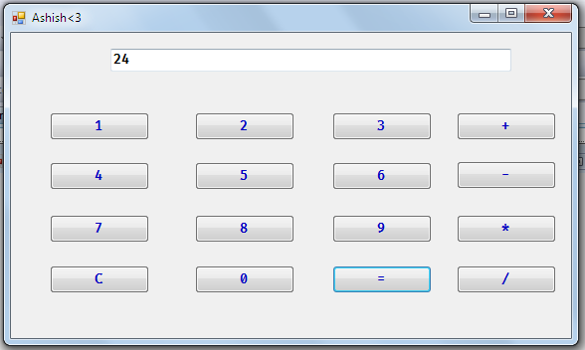

* 12-12

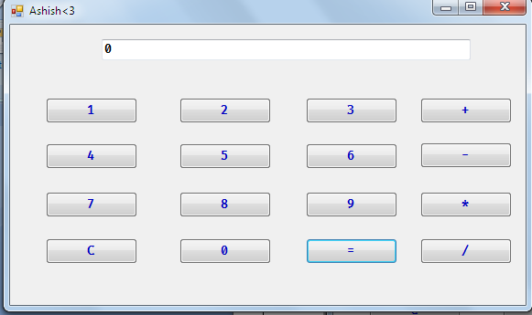

* 12*12

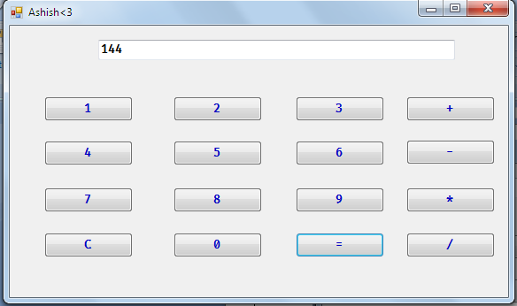

* 12/12

