Q. W.A.P. to create Stopwatch In VB.NET

* Code:

Public Class Form1

Private Sub Button5_Click(ByVal sender As System.Object, ByVal e As System.EventArgs) Handles Button5.Click

Me.Close()

End Sub

Private Sub Button1_Click(ByVal sender As System.Object, ByVal e As System.EventArgs) Handles Button1.Click

Timer1.Enabled = True

End Sub

Private Sub Button2_Click(ByVal sender As System.Object, ByVal e As System.EventArgs) Handles Button2.Click

Timer1.Enabled = False

End Sub

Private Sub Button3_Click(ByVal sender As System.Object, ByVal e As System.EventArgs) Handles Button3.Click

Timer1.Enabled = False

Label1.Text = "0.0"

End Sub

Private Sub Timer1_Tick(ByVal sender As System.Object, ByVal e As System.EventArgs) Handles Timer1.Tick

Label1.Text = Label1.Text + 0.1

End Sub

Private Sub Button4_Click(ByVal sender As System.Object, ByVal e As System.EventArgs) Handles Button4.Click

ListBox1.Items.Add("Recorded Time Is: " & Label1.Text)

End Sub

End Class

* Output:
* Start

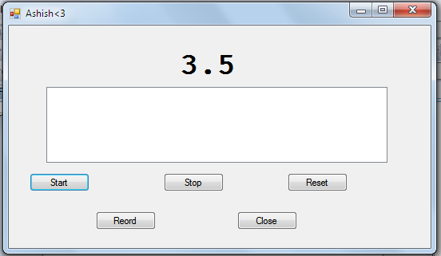

* Stop

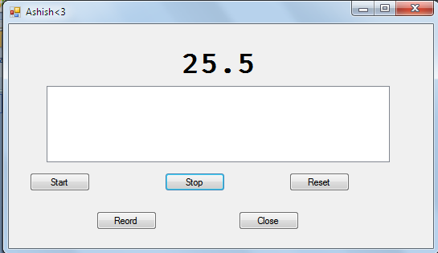

* Reset

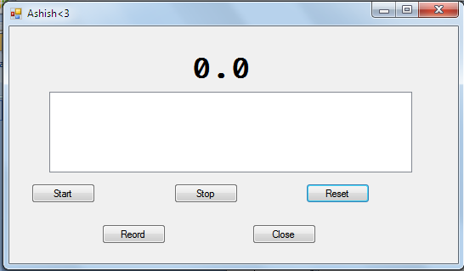

* Record

