Software Requirement Specification                       for

Online Shopping System

(For Furniture shop)

Prepared by: Team "Antictra"

**1. Introduction**

**1.1 Purpose**

This document is meant to delineate the features of Online Shopping System (OSS). The OSS is a web application which is intended to provide complete solutions for vendors, as well as customers, using the Internet. It will enable vendors to setup online shops, customers to browse through the shop and purchase items online, without having to visit the shop physically. The administration module will enable a system administrator to approve and reject requests for new shops and maintain various lists of shop category.

**1.2 Scope**

This system allows the customer’s to maintain their cart for add or remove the product over the internet.

**1.3 Definitions**

OSS- Online Shopping System

SRS- Software Requirement Specification

GUI- Graphical User Interface

Stockholder- The person who will participate in system

Ex. Customer, Administrator, Visitor etc.

**1.3.1 Overview**

This system provides an easy solution for customers to buy the product, without having to go to the shop, and also for shop owner to sell different products.

2. General Description

The Online Shopping system (OSS) application enables vendors to set up online shops, customers to browse through the shops, and a system administrator to approve and reject requests for new shops and maintain lists of shop categories. Also the developer is designing an online shopping site to manage the items in the shop and also help customers purchase them online without having to visit the shop physically.The online shopping system will use the internet as the sole method for selling goods to its consumers.

3. Interface Requirement

          Various interfaces for the product could be-

          1. Login Page

          2. Registration Form

3. A screen displaying information about products that the shop is having

3.1 Home page

4. Preliminary Schedule

4.Graphical User Interface

4.1. Login Page

HOME

REGISTER NEW USER

Register new user so you can take advantage of our system!

REGISTER

Already a user? Sign In!

USERNAME / EMAIL

PASSWORD

SIGN IN

3. 2. Registration Form

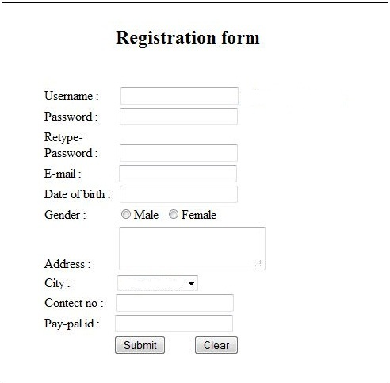

3.3. Products Page

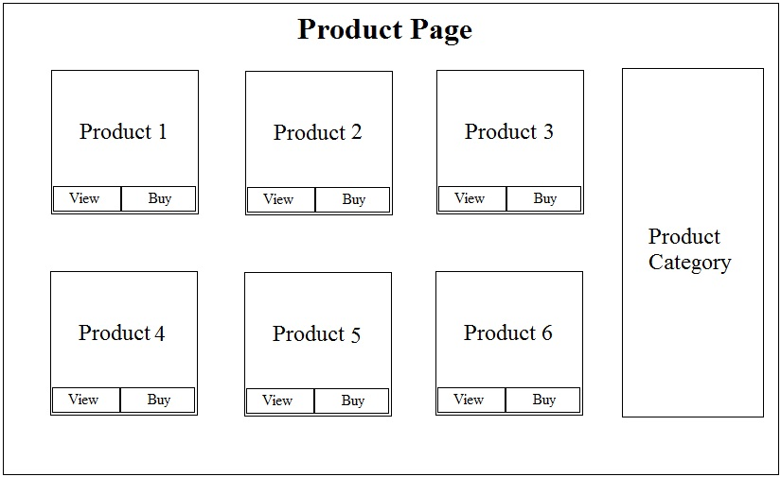

4. Preliminary Schedule

4.1 Model Diagram Admin

ADMIN

MANAGE PRODUCTS

MANAGE USERS

MANAGE ORDERS

ADD PRODUCTS

DELETE PRODUCTS

SEARCH PRODUCTS

UPDATE PRODUCT

ADD USER

DELETE / BLOCK USER

VIEW USER

VIEW ORDER

DELETE ORDER

4.2Model Diagram Customer

LOG IN AS USER

REGISTER AS USER

REMOVE ITEMS

SUBMIT ORDER

EDIT PROFILE

INSERT CREDIT CARD INFORMATION

INSERT DELIVERY INFORMATION

DELETE PROFILE

CANCEL ORDER

Customer

VIEW PRODUCTS

SEARCH PRODUCTS BY NAME

ADD TO CART

USERNAME

EMAIL

PASSWORD

LOG OUT

4.3Model Diagram Visitor

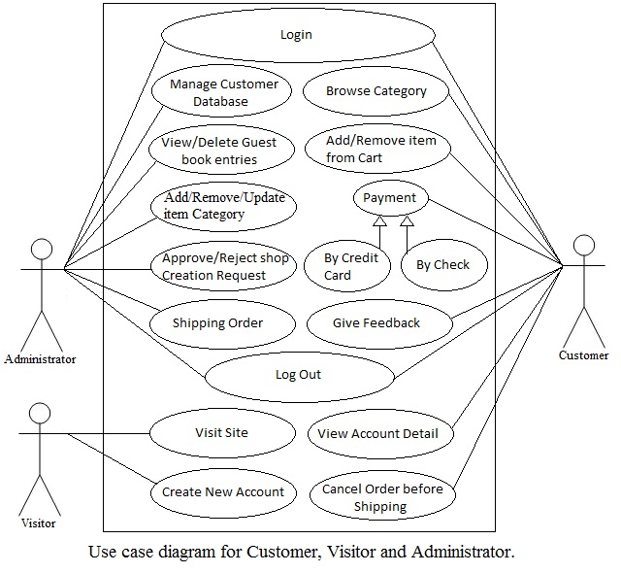

STUDY OF THE SYSTEM

MODULES:

The system after careful analysis has been identified to be presented with the following modules and roles.

The modules involved are:

-Administrator

-Customer

-Visitor

The system will have two external interfaces: for a credit card verification and for order shipping.

**credit card authorization system:**

The credit card authorization system will be used to accept and verify a customer's credit card information.

The information supplied in this screen will be sent directly to a credit card verification company. The Credit Card Input Screen will be displayed repeatedly with a prompt to re-enter the information in case of a credit card rejection.

**shipping system:**

The shipping system will be used to select a shipping method and to confirm the customer's shipping address and will be connected directly to a shipping company.

-ADMINISTRATOR:

The administrator is the super user of this application. Only admin

have access into this admin page. Admin may be the owner of the shop. The administrator has all the information about all the users and about all products.

This module is divided into different sub - modules.

1. Manage Products

2. Manage Customers

3. Manage Orders

MANAGE PRODUCTS

-Add Products

The shopping cart project contains different kind of products. The products can be classified into different categories by name. Admin can add new products into the existing system with all its details including an image.

-Delete Products

Administrator can delete the products based on the stock of that particular product.

-Search products

Admin will have a list view of all the existing products. He can also search for a particular product by name

MANAGE CUSTEMER

View Customer

The admin will have a list view of all the users registered in the system. Admin can view all the details of each user in the list except password.

Add Users

Admin has privileges to add a user directly by providing the details.

Delete & Block Users

Administrator has a right to delete or block a user.

MANAGE ORDERS

View Visitor

Administrator can view the Orders which is generated by the visitors.

He can verify the details of the purchase.

Delete order

Admin can delete order from the orders list when the product is taken for delivery

-Visitor

Visitors can only look at the items. They should log in as user to buy items.

-Customers

Registration

A new user will have to register in the system by providing essential details in order to view the products in the system. The admin must accept a new user by unblocking him.

Login

A user must login with his user name and password to the system after registration.

View Products

User can view the list of products based on their names after successful login. A detailed description of a particular product with product name, products details, product image, price can be viewed by users.

Search Product

Users can search for a particular product in the list by name.

Add to cart:

The user can add the desired product into his cart by clicking add to cart option on the product. He can view his cart by clicking on the cart button. All products added by cart can be viewed in the cart. User can remove an item from the cart by clicking remove.

Submit Cart:

After confirming the items in the cart the user can submit the cart by providing a delivery address. On successful submitting the cart will become empty.

History

In the history the user will have a view of pending orders.

Edit Profile

The user can view and edit its’ profile.

Specific Requirements

1.

Restrictions

1.1.

User Side

1.1.1.

Software

1.1.1.1.

Internet Explorer, Mozilla Firefox, Chrome, Opera, Safari

1.1.2.

Hardware

1.1.2.1.

Any device with operating system (Windows, Mac, Android)

1.2.

System Side

1.2.1.

Software

1.2.1.1.

Web - based application

1.2.1.2.

Database information storage system

1.2.1.3.

The system should use a Relational Database Management System (RDBMS)

2.

Data Structure

2.1.

Items have these attributes

2.1.1.

Unique ID (auto-incremented starting at 1, present only in the database tables)

2.1.2.

Name

2.1.3.

Producer

2.1.4.

Price

2.1.5.

Stock condition

2.1.6.

Stock availability (when the number of available pieces of the item drops to 0, the item should be made unavailable for sale)

2.1.7.

Color

2.1.8

Shipping cost, according to the destination

2.1.9.

Size

2.1.10

General Details

2.1.11

Specific Details (optional)

2.1.12

Feedbacks for the item

2.1.13

Rating

2.1.14

Description

2.1.15

Photos of the item

2.2.

Customer has these attributes

2.2.1.

Unique ID (auto-incremented starting at 1, present only in the database tables)

2.2.2.

Unique Username

2.2.3.

Password

2.2.4.

Full Name

2.2.4.

Email Address

2.2.5.

Postal Address

2.2.6

List of all orders made by the customer

2.2.7

User points

2.3.

Admin has these attributes

2.3.1.

Username

2.3.2.

Password

2.3.3.

Email address

2.3.4.

List of all banned users

2.3.5.

List of all deleted users

2.4.

Order log entries have these attributes:

2.4.1.

Unique ID (auto-incremented starting at 1, present only in the database tables)

2.4.2.

Time and date of the transaction

2.4.3.

Customer’s primary details

2.4.5.

Listing of the contents in customer’s shopping cart

3.

System

3.1.

Browse Inventory

3.1.1.

Organization

3.1.1.1.

Items Listed on single page

3.1.1.2.

Items shown in tabular format

3.1.1.3.

Each Item listing contains

3.1.1.3.1.

Name

3.1.1.3.2.

Producer

3.1.1.3.3.

Price

3.1.1.4.

Listing sorted by Ascending Item Title

3.1.1.5.

No individual Item pages

3.1.2.

Interaction

3.1.2.1.

Each Item has checkbox to mark selection

3.1.2.2.

Single button to add all selected items to Shopping Cart

3.2.

Search Inventory

3.2.1.

Search available only by name or producer

3.2.2.

Search is exact-match only

3.3.

Create, Update and Destroy (CRUD) Functionality

3.3.1.

Only admins are allowed to modify inventory

3.3.2.

Admins have an interface to:

3.3.2.1.

Create an item entry

3.3.2.2.

Update an item entry

3.3.2.3.

Update the stock/quantity of a particular item

3.3.3.

Administrator may delete items from the inventory

3.4.

Shopping Cart

3.4.1.

Logged In

3.4.1.1.

Can add items to cart

3.4.1.1.1.

If Item is not in stock, message displayed informing user to try again later

3.4.1.2.

If shopping cart not empty, a user may begin Checkout procedure

3.4.2.

Not Logged In

3.4.2.1.

Can add items to cart

3.4.2.2.

User required to login before they may begin Checkout procedure

3.5.

Checkout procedure

3.5.1.

User must successfully use shopping cart before beginning this procedure

3.5.2.

Checkout page consists of

3.5.2.1.

A text box for promotion entering

3.5.2.2.

An overview of the purchase

3.5.2.3.

A text box to hold the credit card number

3.5.2.4.

A button to complete the order

3.5.3.

Order details sent via email after the checkout has completed

3.5.4.

On order completion the inventory is decremented based on items purchased by user

**Test Scenarios for Login Page:**

1. Field length validation for User name (6-18 chars) and Password (6-18 chars)
2. Max length should be set for all the text boxes
3. Password field should be masked with asterisks (*****)
4. Left and right trimming should be done for Password field
5. Login credentials in UPPER case should not be treated as invalid
6. Forgot Password link should be present on the form
7. Reset button should clear data from all the text boxes in the form
8. Validation message should be shown when special characters are entered in the username field, or when invalid username and/or password is entered or the fields are left blank
9. User should be redirected to Login page if the Login URL is bypassed
10. Clicking on ‘Log out’ should take the user back to Home Page
11. If the user clicks on “Remember me” option, he should be redirected to appropriate page on next login
12. User should be redirected to appropriate page for Forgot password option
13. Clicking on Sign Up should take the user to registration page

**Test Scenarios for Search Functionality:**

1. The User Interface of the page which shows only one search result or does not give any search results should be presentable and consistent
2. When the search results span over multiple pages, the UI and pagination should work properly
3. Verify keyword search by entering First, middle or last  word of any title and verify that it is found in search results
4. Sorting order for search results should work properly for the fields where sorting is available
5. For a e-Commerce website
   * Adding a new item to the system should automatically make it searchable
   * If the title of an existing item is updated, the search results should show the item for old as well as new title
   * Deleting an item should remove it from the search fields as well
6. All the test cases should be separately run for logged In and not logged in user
7. Browser compatibility for the search functionality should be verified