**MARATHWADA MITRA MANDAL’S**

**COLLEGE OF COMMERCE**

202/A, Deccan Gymkhana, PUNE-411004

**A**

**PROJECT REPORT ON**

***‘ONLINE FOOD ORDERING SYSTEM’***

Submitted in partial fulfillment of the requirements

For the award of the Degree of

**Bachelor of Science (Computer Science)**

**Under guidance of**

**Asst.Prof. KOMAL DHOOT**

Submitted by:

***SAI ADHEGAONKAR***

***DIVYESH LODHA***

**SAVITRIBAI PHULE** **PUNE UNIVERSITY**

**(2020-2021)**



**MARATHWADA MITRA MANDAL’S COLLEGE**

Bachelor of Business Administration(Computer Application)

302/A, Deccan Gymkhana, PUNE-411004

**CERTIFICATE**

**This is to certify that**

***SAI ADHEGAONKAR***

***DIVYESH LODHA***

**Have completed the project entitled**

***‘ONLINE FOOD ORDERING SYSTEM’***

**in a partial fulfillment for the award of**

**Bachelor of Science (Computer Science)**

**Savitribai Phule Pune University**

**Academic Year 2020-2021**

**Internal Examiner External Examiner**

**Prof. ------------ Dr. Anpat S.M**

**INDEX**

|  |  |  |
| --- | --- | --- |
| **SR.NO** | **PARTICULARS** | **PAGE NO** |
| **1** | **INTRODUCTION** | 5 |
|  | 1.1 INTRODUCTION TO SYSTEM |  |
|  | 1.2 SCOPE OF SYSTEM |  |
|  | 1.3 PROPOSE SYSTEM |  |
| **2** | **SYSTEM ANALYSIS** | 10 |
|  | 2.1 FACT FINDING TECHNIQUE |  |
|  | 2.2 FEASIBILITY STUDY |  |
| **3** | **REQUIREMENT SPECIFICATION** | 11 |
|  | 3.1 HARDWARE REQUIREMENTS |  |
|  | 3.2 SOFTWARE REQUIREMENTS |  |
| **4** | **SYSTEM DESIGN** | 12 |
|  | 4.1 E-R DIAGRAM |  |
|  | 4.2 CONTEXT LEVEL DIAGRAM |  |
|  | 4.3 UML DIAGRAM |  |
|  | 4.4 FILE DESIGN |  |
|  | 4.5 DATA DICTIONARY |  |
| **5** | **EXPERIMENT DETAILS** | 25 |
| 6 | **RESULT** | 32 |
| 7 | **LIMITATIONS** | 33 |
| 8 | **CONCLUSION** | 34 |
| 9 | **FUTURE ENHANCEMENT** | 35 |

|  |  |  |
| --- | --- | --- |
|  |  |  |

**INRODUCTION :**

As industries are fast expanding, people are seeking for more ways to purchase products with much ease and still maintain cost effectiveness. The vendors need to purchase the products in order to sell to end users. The manual method of going to their local food sales outlets to purchase food is becoming obsolete and more tasking. Food can be ordered through the internet and payment made without going to the restaurant or the food vendor. So there is need for a wide range of publicity and enabling direct order, processing and delivering of food through online system. For this system, there will be a system administrator who will have the rights to enter the menu with current prices.

In the busy and fast paced world of today people want everything at the click of a button people are squeezed for time, where they do not even have time to take proper meals, going all the way restaurant for food placing an order waiting for food arrive, eating and asking the bill.

**Objective & Scope Of System:**

The main objective is create a system that allows customers to order food online. This process is ordering quick and convenient. This system is user friendly so that any person using it will not face any difficulties in operating it.

This system has facilities that allow users to view menu card select the items as required, add them to card views special food items select a time food delivery rate the items and services. This app make easy for user to buy a product from store with easy steps and store can get easy order.

**EXISTING SYSTEM:**

The existing system happen to be a non computerized opereating sytem were all the operation are done manually by the waiter carrying paper and to take down the order of the customers or making an order over the counter.

This leads to mistakes because the waiter might not understand what the customer had ordered therefore the serving him/her a different menu.This could be embrassing because the customer might not take it lightly with the waiter which lead misunderstanding.

**FEASIBILITY STUDY :**

A feasibility studies main goal is to access to economic viability of the proposed business. A feasibility study is a preliminary study undertaken to determine and document a projects capability or the discipline of planning, organizing , and managing resources to bring about the successful completion of specific project goals and objectives. The feasibilitystudy needs to answer the question: **“Does the idea make economic sense?”** The study should provide a thorough analysis of the business opportunity, including a look at all the possible roadblock that may stand in the way of the cooperative success.

**Economic Feasibility:** In Economic Feasibility no additional resources are needed for the development of this system. The cost incurred during the development of this system is negligible considering the wide availability of the software and hardware products used in the coding and development of the system. The system can be implemented on Windows platform, this platform is easily available. The system reduces a lot of paperwork and the time spends in doing it as **”Time is money‟**. The system is to be evaluated by cost and benefit analysis to ensure that effort is concentrated on project. The system is cost effectively and it gives more results with less cost. This system is standalone and no need to buy any software so that’s why this system is economically feasible.

**Operational Feasibility: -**

As the end user will be able to operate the system smoothly as it is a Graphical user Interface (GUI), has efficient error handling mechanism. The mechanism of filling the sale order is easy as compared to the manual where the user as to refer to many registers. This system is user friendly and maintenance product detail and payment details are efficiently handled in this system. The system is user friendly and accessible to any layman. Each and every thing is clearly shown on screen. It is more readable and easy to operate on the basis of reviews we get positive result here is some questions are asked for reviews1) Is it easy to use?2) Is system useful?On the basis of reviews, the system is technically feasible

**FACT FINDING METHOD:**

Fact finding is process of collection of data and information based on techniques which contain sampling of existing documents, research, observation, questionnaires, interviews, prototyping and joint requirements planning. System analysis uses suitable fact finding techniques to develop and implement the current existing system. Collecting required facts are very important to apply tools in System Development Life cycle, because tools can’t be used efficiently and effectively without proper extracting from facts. Fact finding techniques are used in the early stage of System analysis phase design and post implementation review. Fact include in any information system can be tested based on three steps: data facts used to create useful information process functions to perform the objectives and interface –designs to interact with users.

**Fact-finding technique-**

* Sampling of existing documentation, forms and database
* Research and Site visit
* Observation of the work environment
* Questionnaires
* Interviews
* Prototyping
* Joint requirements planning

**SOFTWARE REQUIREMENT :**

**Hardware Requirements:**

Hardware - Pentium

Speed - 1.1 GHz

RAM - 1 GB

Hard Disk - 20 GB

Floppy Drive - 1.44 MB

**Software Requirements:**

Operating System : Windows

Technology : PHP

Web Technologies : Html, JavaScript, CSS

IDE : Notepad++

Web Server : Xampp

Database : My SQL

**ENTITY RELATIONSHIP DIAGRAM :**

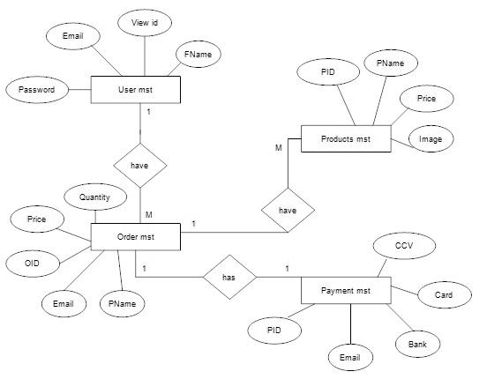

**DATA FLOW DIAGRAM :**

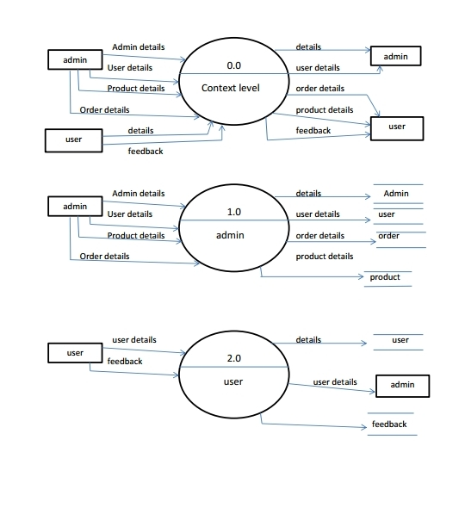

**UML DIAGRAM**

**USE CASE DIAGRAM :**

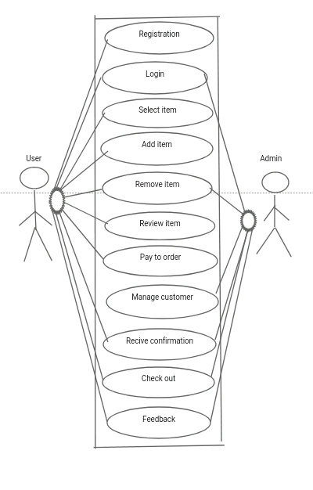

**CLASS DIAGRAM :**

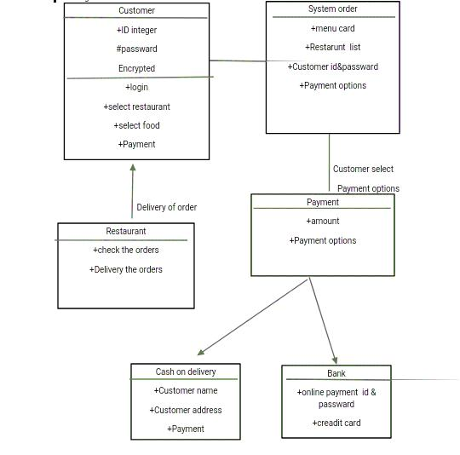**OBJECT DIAGRAM :**

Add Food

-UserFoodID

-UName

-Pass

-FoodName

-Image

-Prize

-Last Date

OrderFood

-Food Name

-Food ID

-Order

Feedback

-Comment

-UName

-Email-ID

-Mobno

Admin

-UID

-Pass

User

-UID

-UName

-Upass

-Confirmpass

-FName

-DOB

-Gender

-Email

-Mob

Management

-Manage User

-Send Mail

-Delete Food

**SEQUENCE :**

System

User

Admin

Registration

Confirm registration

Login Login

Confirm Login confirm login

View site Manage user

Add product

Confirm product

Order product

Confirm Order

Send mail to user

Confirm mail

Feedback

Confirm feedeback

**ACTIVITY DIAGRAM**

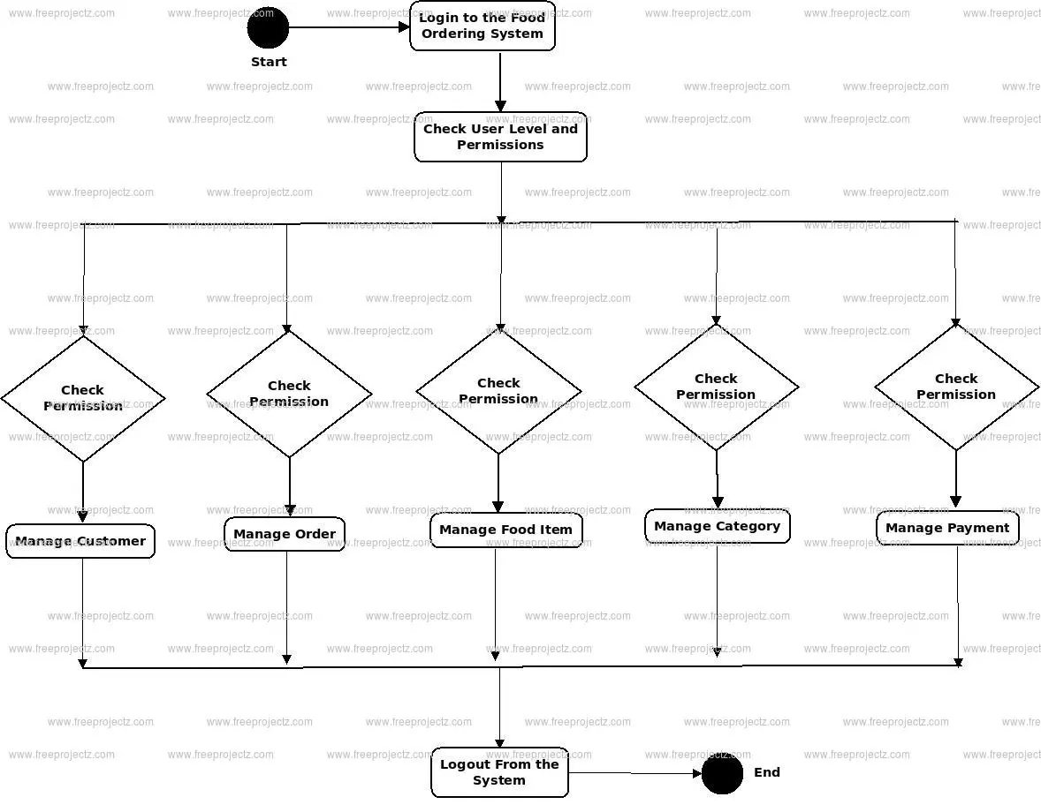

**FILE DESIGN :**

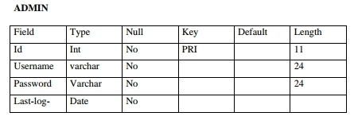

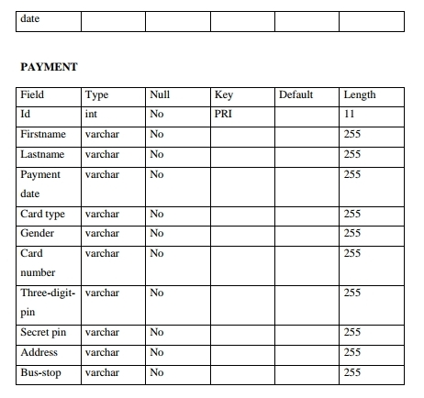

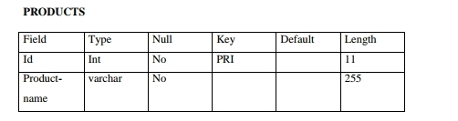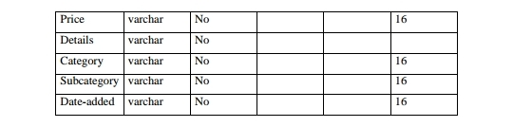

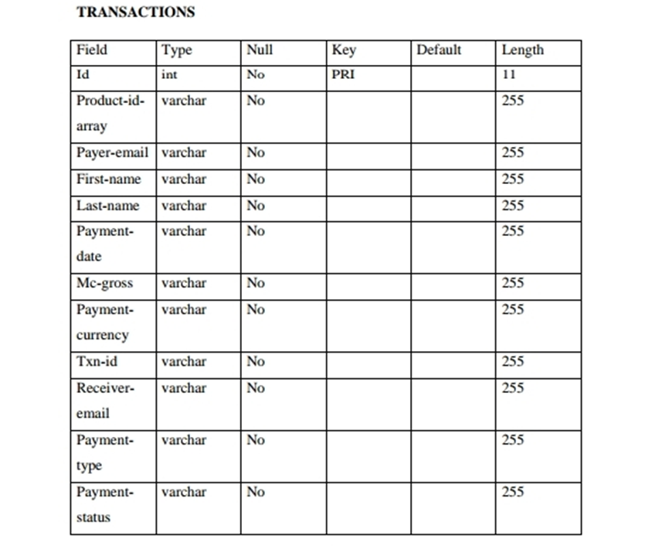

**DATA DICITIONARY :**

|  |  |  |  |
| --- | --- | --- | --- |
| **SCHEMA** | **NAME** | **TYPE** | **OWNER** |
| **public** | **Customer** | **Table** | **postgres** |
| **public** | **Login** | **Table** | **postgres** |
| **public** | **Admin** | **Table** | **postgres** |
| **public** | **Order** | **Table** | **postgres** |
| **public** | **Food** | **Table** | **postgres** |

**SCREENSHOT (RESULT) :**

**Homepage :**

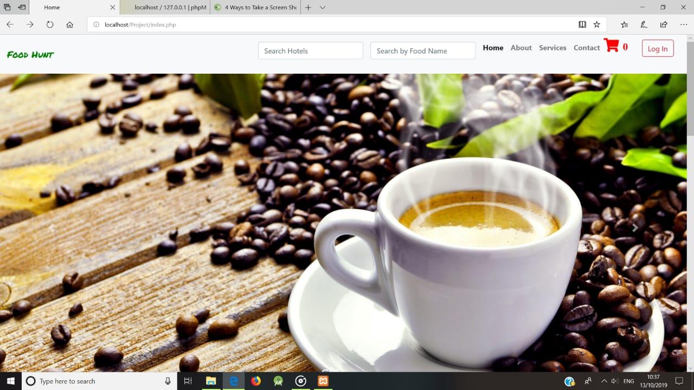

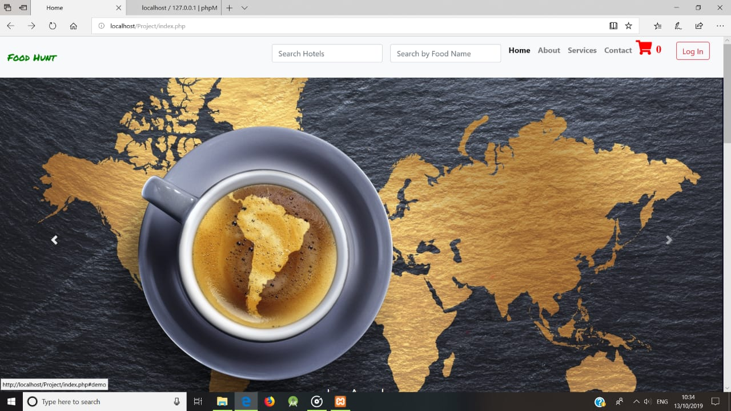

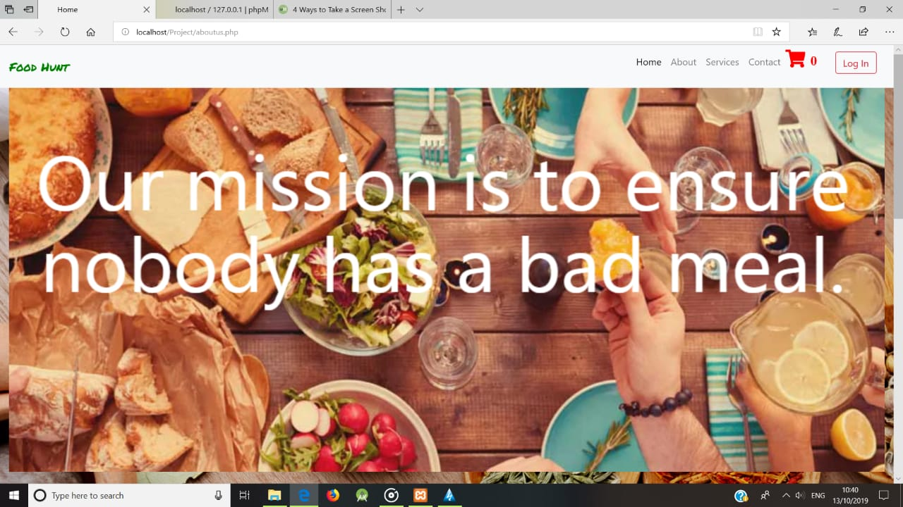



**Service page**

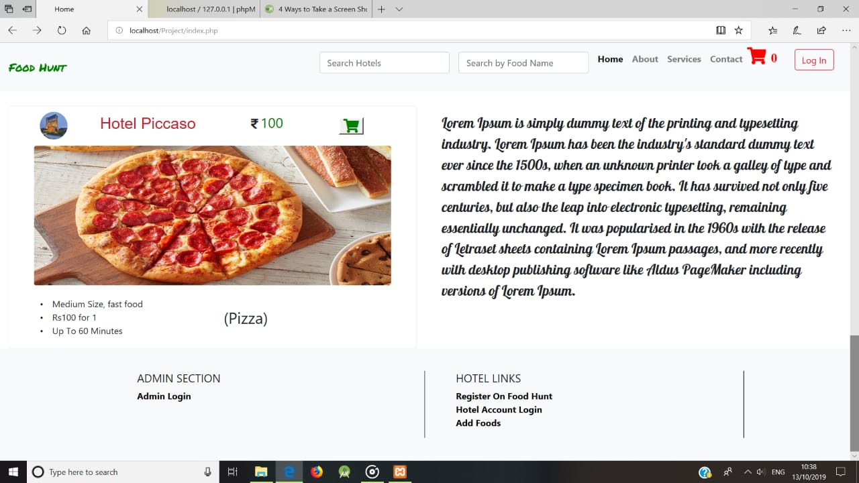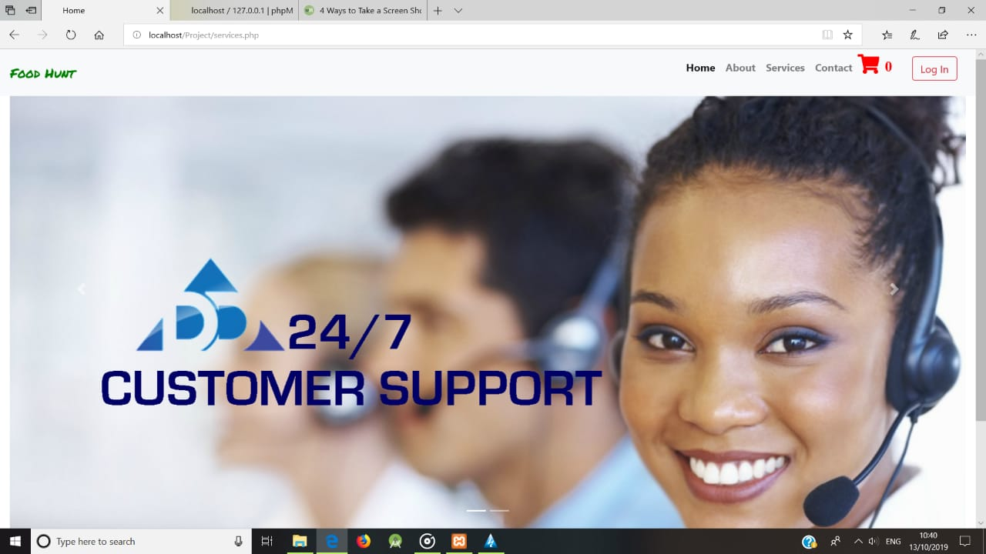

**Locate Us**

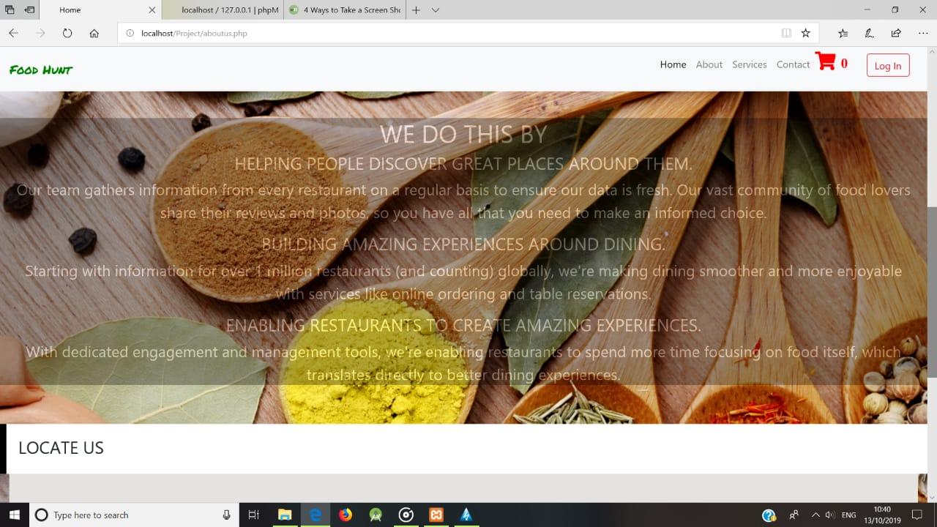

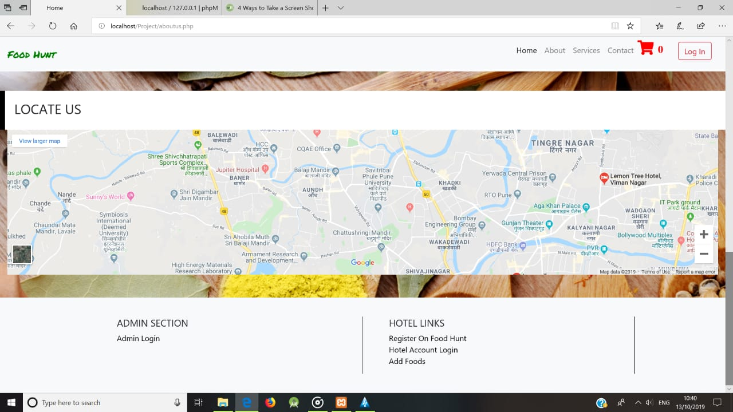

Admin :

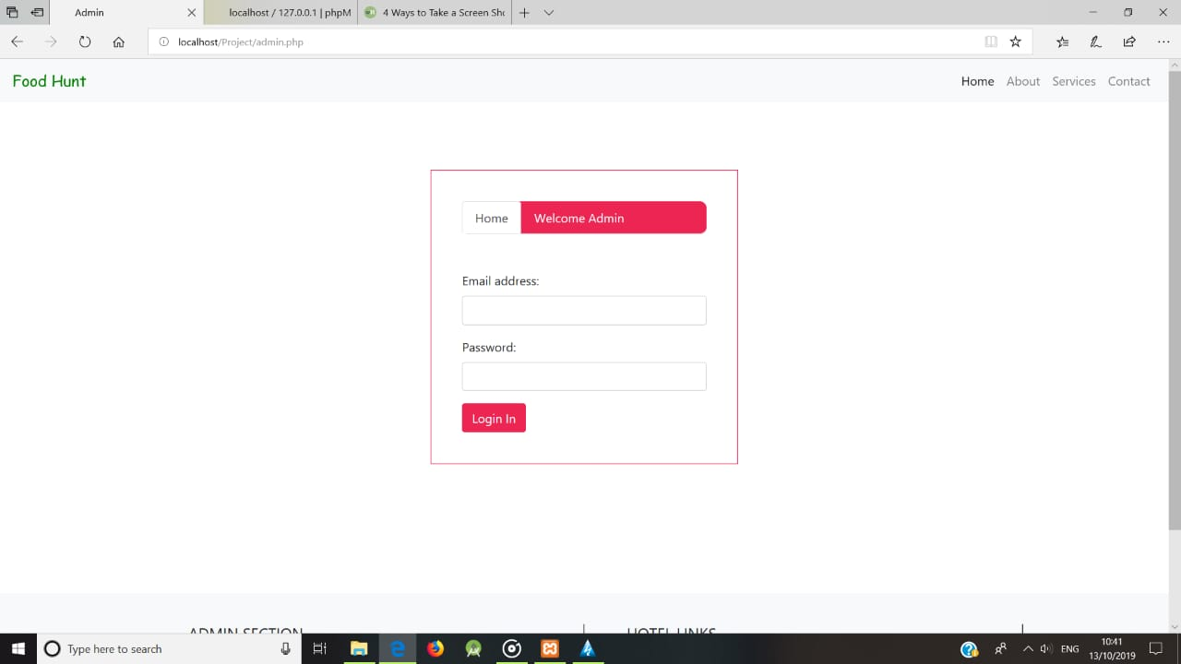

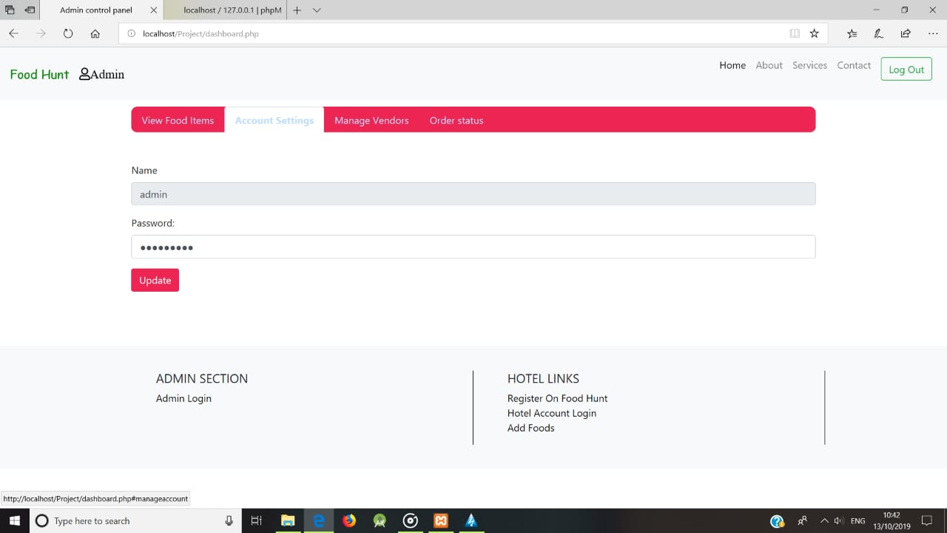

**User Registration**

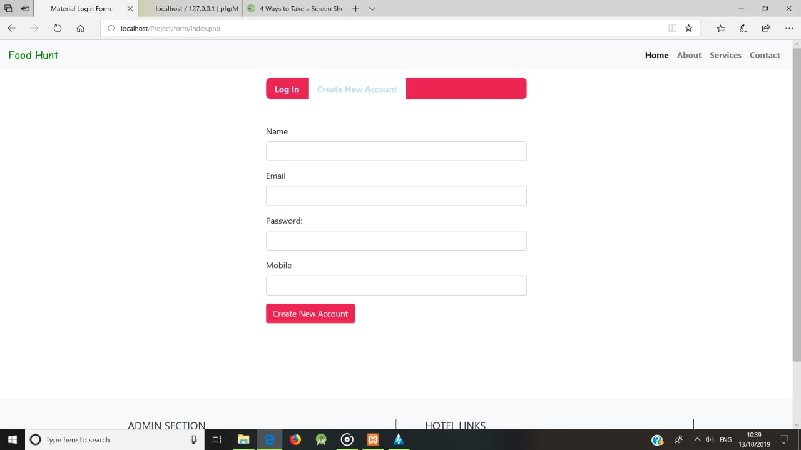

**User Login**

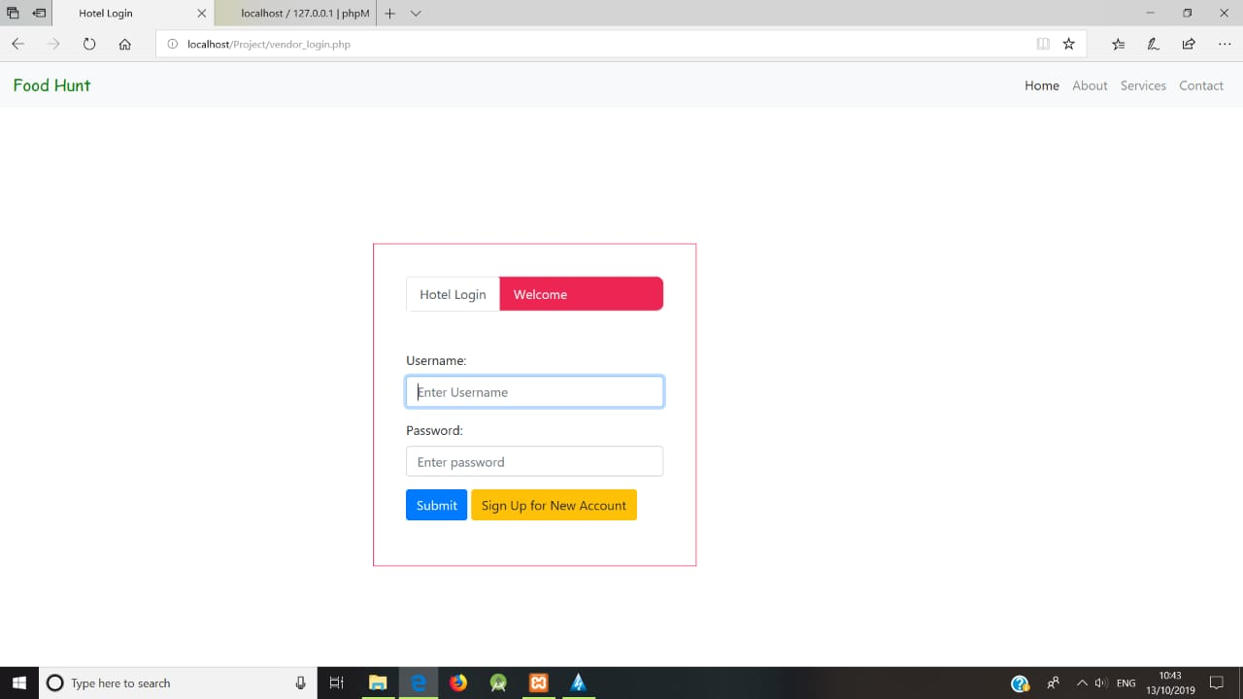

**Add Product**

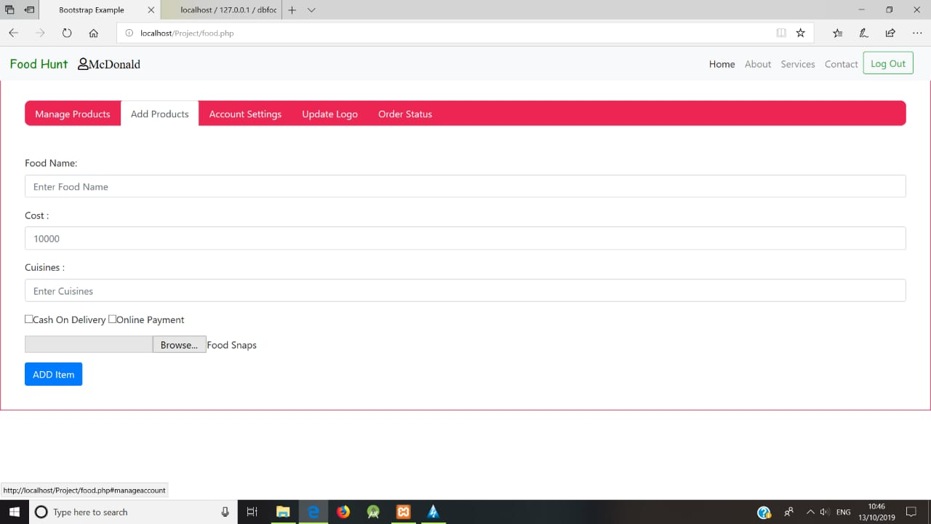

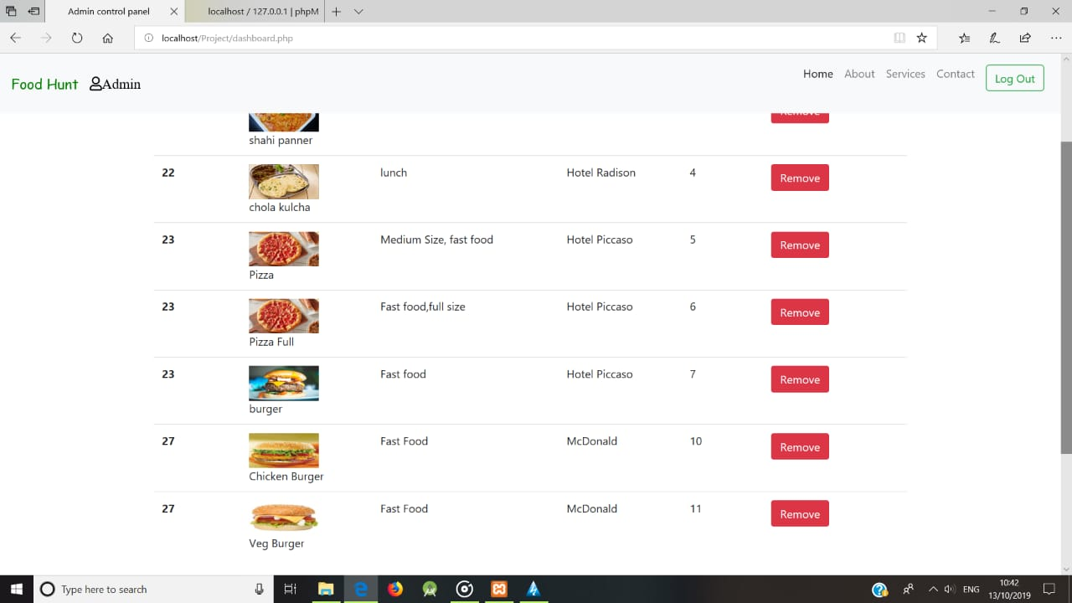

**Manage Vendors**

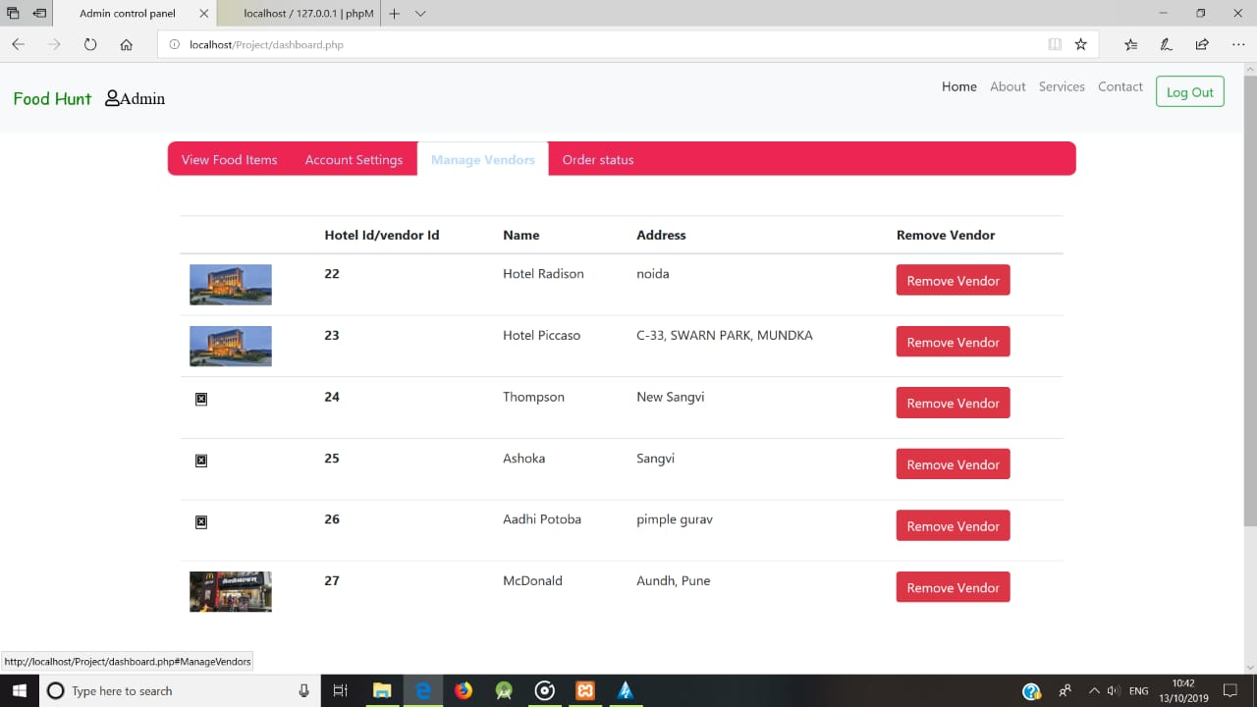

**Order Status**

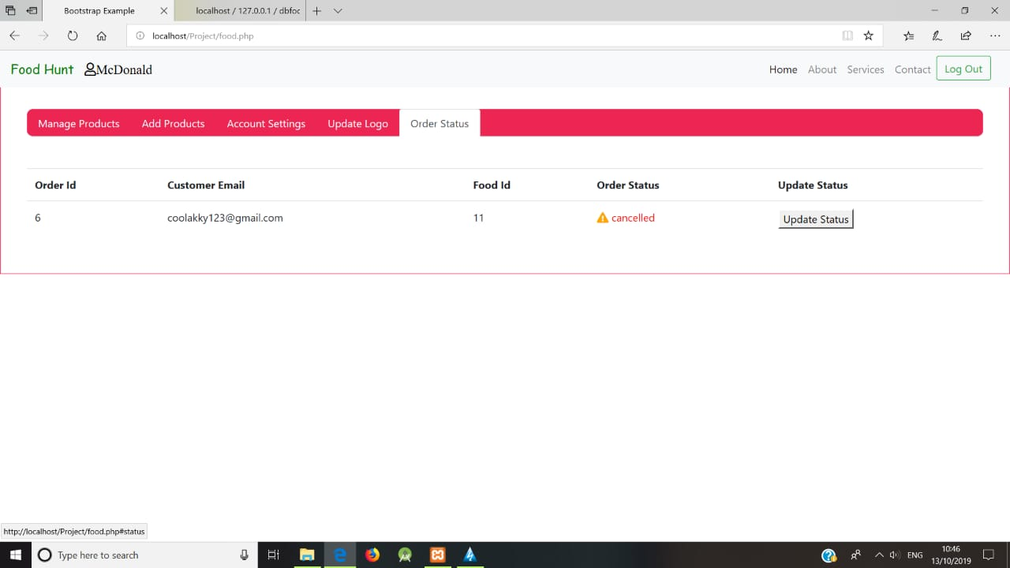

**Order Status**

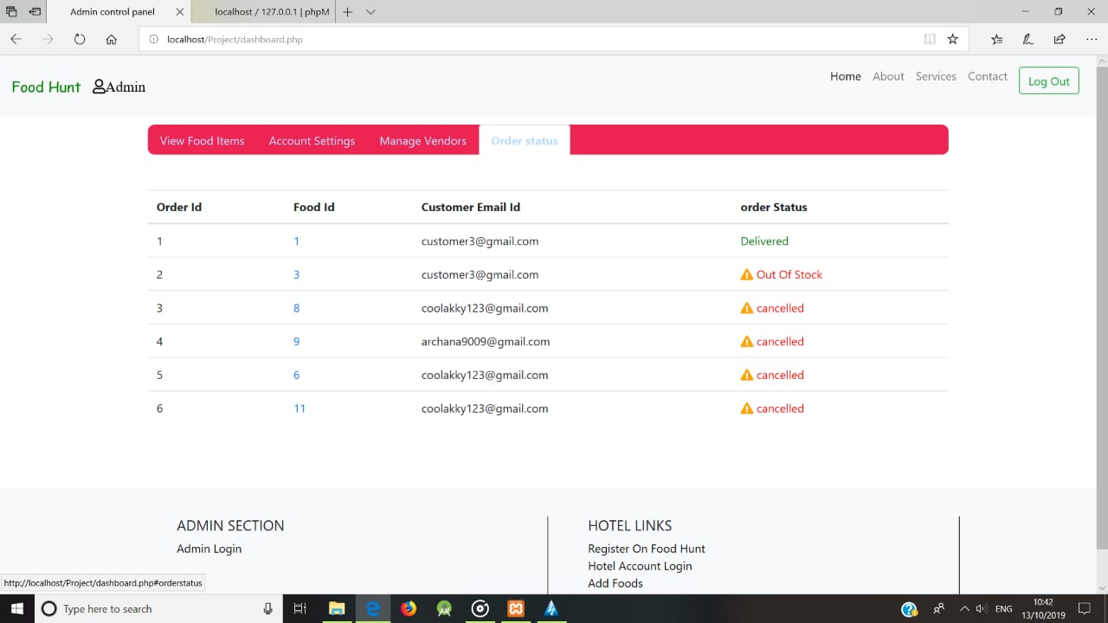

**Manage Product**

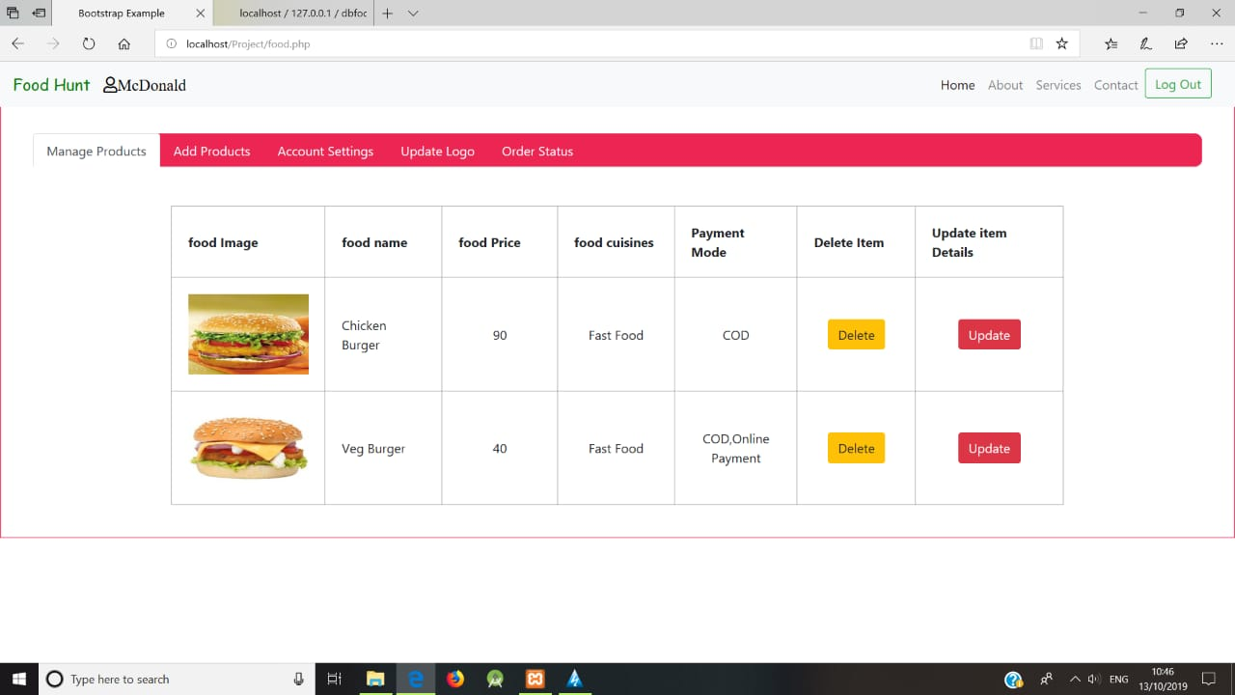

**Feedback**

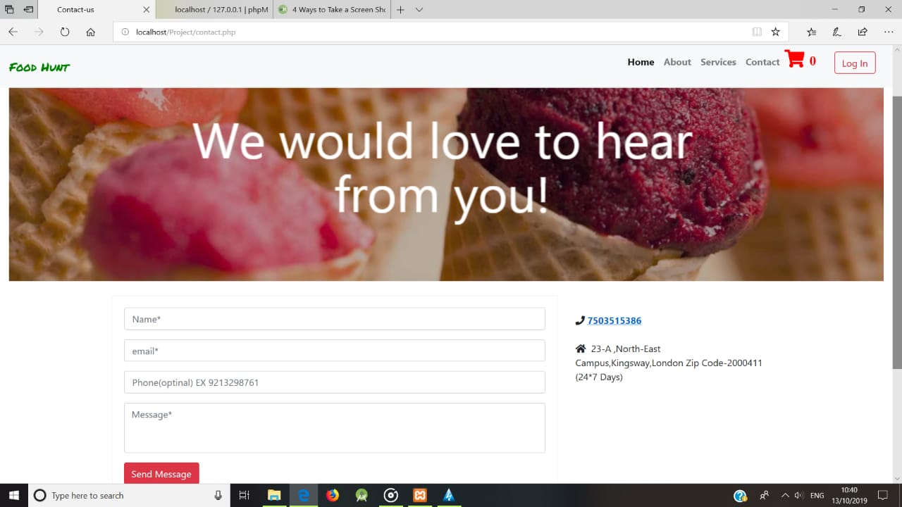

**LIMITATIONS :**

* Only registered users can use the Website.

### Deliverymen put themselves in danger –

Whether it is a heat wave boiling down the city or it is snowing or raining heavily, a Delivery Boy is waiting outside the restaurant to pick and deliver your order. Although we get the joy of our favourite food in any season, they are also humans who forget their human rights putting themselves in danger sometimes.

* **Disguised increased expense –**

We surely get attracted by yummy-looking food’s pictures on the app and a small but highlighting banner of cashback offer. However, we forget that despite cashback, it is costing us higher than the food which we can cook with the groceries available using all our magical cooking skills and spend blindly ordering the food online.

* **Juggling with your health –**

Another disadvantage of online ordering system for your restaurant is even though when you go to a restaurant you won’t be seeing the material they use in that mouth-watering Pasta dish that they bring at your table, still, you can get it replaced if you find any faults. However, you are again not going to know what they use, but you won’t be able to get it changed or sense any faults in it.

**Conclusion:**

With online food ordering system, a restaurant and mess menu online can be set up and the customers can easily place order. Also with a food menu online, tracking the orders is done easily, it maintain customer’s database and improve the food delivery service.

**FUTURE ENHANCEMENT :**

* Online food ordering has definitely transformed the global food market. On demand food delivery apps can bring customer everything from soup to fast food to Italian at their door-steps with just a couple of clicks.
* Ordering food online has become a trend has offers advantage to users.
* Apps like SWIGGY,ZOMATO,FOODPANDA are taking over the major market share.
* The rapid growth of the food delivery market also open new doors of opportunities for new kind of restaurants.

**Bibliography :**

* Sharma,I: How Online Food Ordering System helps you run more efficiently.
* De Leon,J : Best Online Food Ordering System..
* [www.scribd.com](http://www.scribd.com)
* [Www.slideshare.net](http://Www.slideshare.net)