Flight Network Analysis: Structure, Resilience, and
Seasonal Patterns
Venkata Naga Rajeev Pernapati
Dept. of Computer Science
University of Nevada Las Vegas
pernapat@unlv.nevada.edu

Abstract—This paper presents a comprehensive analysis of the global flight network structure using graph theory and network science methodologies. The study examines a dataset from OpenFlights.org containing 6,072 airports connected by 67,663 direct flight routes to identify key hubs, community structures, resilience to disruptions, and seasonal patterns in air travel. Using PageRank, betweenness, and degree centrality measures, we identify critical airports whose operational status significantly impacts global connectivity. Our community detection analysis reveals 23 distinct communities largely aligned with continental geography. Network resilience testing demonstrates vulnerability to targeted disruptions of central hubs while exhibiting resilience to random airport closures. The seasonal analysis methodology enables identification of airports with high seasonal variation in connectivity. These findings provide valuable insights for airlines, airport authorities, and transportation policymakers to optimize routing strategies, infrastructure investments, and risk mitigation policies.
Index Terms—air transportation network, complex networks, network resilience, community detection, hub analysis, seasonal patterns, graph theory
I. INTRODUCTION
The global air transportation system forms a complex network that facilitates the movement of people and goods worldwide. Understanding the topological structure and dynamics of this network has significant implications for stakeholders in the aviation industry, transportation planning, and policy development.
The work presented in this paper addresses three key research objectives:
- Global Flight Network Structure: Investigation of the topology, node connectivity, and hierarchical organization governing global airport interactions.
- Network Vulnerabilities and Features: Identification of critical hubs, fragility points, and community clusters impacting route stability and disruption resilience.
- Stakeholder Relevance: Providing actionable insights for airlines, planners, and governments regarding strategic routing, infrastructure investment, and risk mitigation policies.
The dataset used in this research is from OpenFlights.org, containing 6,072 airports connected by 67,663 flight routes. This comprehensive dataset enables a global-scale analysis of air transportation network properties.

II. RELATED WORK AND MOTIVATION

A. Scope of Prior Research
Previous studies in flight network analysis have primarily targeted regional or airline-specific networks, often lacking comprehensive global perspectives. These localized approaches, while valuable for specific contexts, fail to capture the full complexity and interconnectedness of the global air transportation system.

B. Post-Pandemic Analysis Gaps
The COVID-19 pandemic exposed critical gaps in our understanding of air transportation networks. There is a pressing need for multi-layered analyses that integrate temporal, spatial, and operational dimensions on a global scale. The unprecedented disruption to air travel during the pandemic highlighted the importance of understanding network resilience and adaptability.

C. Full-Stack Data Approach
This research is motivated by the opportunity to combine route, scheduling, and capacity data to enable more robust network modelling. By integrating multiple data dimensions, we can develop a more complete picture of the air transportation network’s structure and behaviour under various conditions.
III. METHODOLOGY
Our approach to analysing the global flight network combines data acquisition, graph construction, network analysis, and dynamic testing to provide a comprehensive understanding of the network’s properties.

A. Data Acquisition and Graph Construction
We collected airport and route data from the OpenFlights dataset and constructed a directed graph using NetworkX. Each node represents an airport, while edges represent direct flight routes between airports. Extensive data cleaning procedures were implemented to address incomplete and invalid IATA codes, ensuring dataset integrity.

B. Network Analysis Techniques
Several network analysis techniques were applied to characterize the flight network:
- Centrality Measures: We computed degree, betweenness, and PageRank centralities to identify important airports in the network. Degree centrality counts the number of connections to/from an airport, betweenness centrality measures how often an airport acts as a bridge along the shortest path between other airports, and PageRank evaluates importance by considering not just the number of connections but also the importance of those connections.
- Community Detection: The Louvain method was applied to the undirected version of the graph to identify communities of airports that are more densely connected to each other than to the rest of the network.

C. Seasonal Modelling and Resilience Testing
To understand the network’s dynamic behaviour:
- Seasonal Analysis: We integrated regional and tourism coefficients to model seasonal variations in airport connectivity across winter, spring, summer, and fall.
- Resilience Testing: We simulated airport removals using different strategies (random, degree-based, PageRankbased, and betweenness-based) to assess how the network’s connectivity degrades under various disruption scenarios.
IV. RESULTS

A. Hub Analysis
Hub analysis identifies the most important airports in the network using centrality measures. The analysis revealed a scale-free structure, with a small number of major hubs handling a disproportionate amount of air traffic.
- Degree Centrality: Identifies airports with many direct flights, highlighting airports that serve as major connection points.
- Betweenness Centrality: Measures how often an airport acts as a bridge along the shortest path between other airports, identifying critical connecting hubs.
- PageRank: Evaluates importance by considering not just how many connections an airport has, but the importance of those connections. The top 10 global airports by PageRank include major hubs across North America, Europe, and Asia.

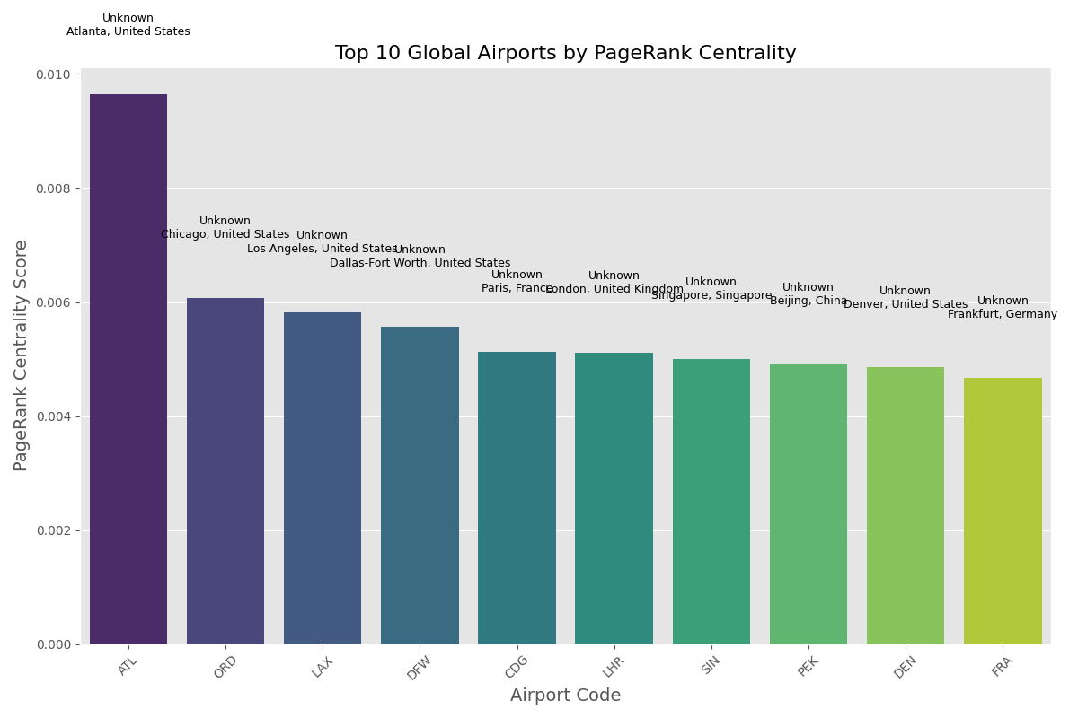
Fig. 1. Top 10 Global Airports by PageRank Centrality. The graph shows Atlanta (ATL) has significantly higher PageRank score than other major hubs like Chicago (ORD) and Los Angeles (LAX). Other important hubs include DFW, CDG, LHR, SIN, PEK, DEN, and FRA.

B. Community Structure
The community detection analysis identified 23 distinct communities in the flight network. These communities largely correspond to geographic regions, with some transcontinental communities formed around major airline alliances. The largest communities identified were:
- North American (652 airports)
- European (529 airports)
- Middle Eastern/South Asian (424 airports)
- East Asian (379 airports)
- Australia/Southeast Asian (350 airports)
- South American (300 airports)
The geographical distribution of these communities reveals how air travel networks naturally cluster around continental boundaries while maintaining intercontinental connections through major hub airports.
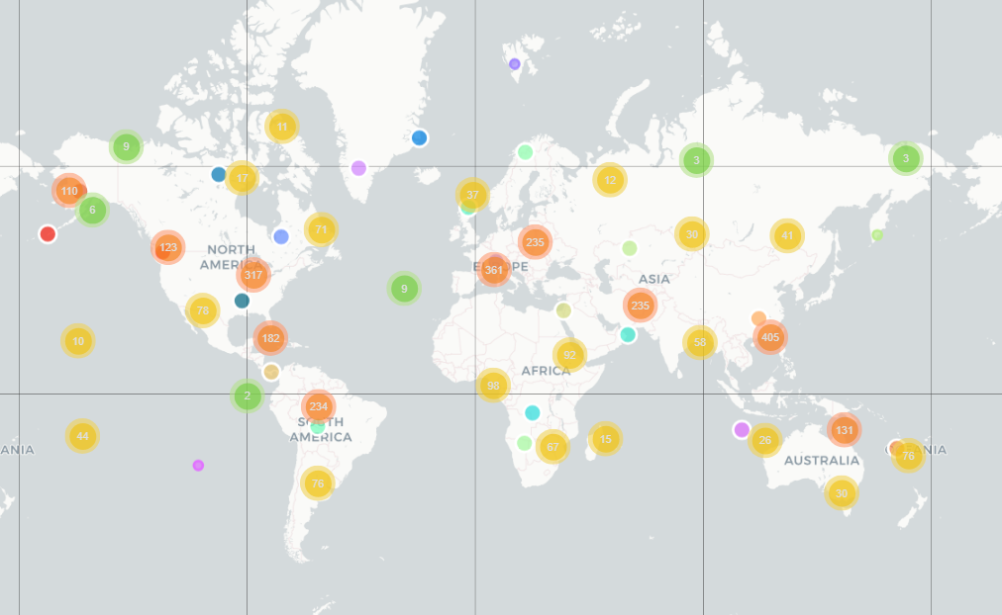
Fig. 2. Geographical distribution of flight network communities. Different coloured clusters represent distinct communities identified by the Louvain algorithm, showing their alignment with continental boundaries while maintaining transcontinental connections. Major continental groupings are visible across North America, Europe, Asia, and Australia.

C. Network Resilience
Resilience analysis tested how the network responds to disruptions through simulated airport removals. The results demonstrated that:
- Targeting high-centrality airports causes more rapid network fragmentation than random removals.
- Removing airports based on betweenness centrality has the most severe impact on network connectivity.
- The network shows vulnerability to targeted disruptions of central hubs while being relatively resilient to random airport closures.
These findings help identify critical airports whose failure would severely impact global connectivity, providing valuable information for contingency planning and risk assessment.

Comm. ID | # Airports | Main Countries | Geo. Center
3 | 652 | USA, Canada, Mex-  ico | (34.6, -92.6)
2 | 529 | France, UK, Spain | (46.5, 9.1)
9 | 424 | India, Iran, Turkey | (14.3, 50.4)
19 | 379 | China, Japan, Philippines | (28.9, 116.0)
0 | 350 | Australia, Indonesia | (-13.8, 129.6)
11 | 300 | Brazil, Colombia,  Argentina | (-12.7, -62.1)
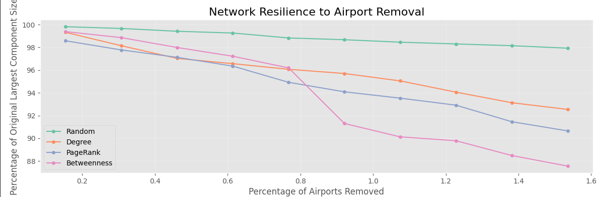
Fig. 3. Network resilience to airport removal under different strategies. The graph shows how network connectivity deteriorates as airports are removed based on different criteria. Betweenness-based removals (pink) cause the most significant network fragmentation, followed by PageRank (blue) and degree-based (orange) strategies, while random removals (green) have minimal impact even at high removal percentages.

D. Seasonal Patterns
Seasonal analysis examined how network structure changes across different seasons (winter, spring, summer, fall). Although the dataset showed consistent metrics across seasons, the methodology allows for identifying airports with high seasonal variation in real-world applications.
Seasonal variations are significant for specific tourism oriented airports and regions with extreme weather conditions. The analysis can reveal how tourism patterns and weather conditions affect flight routes throughout the year.
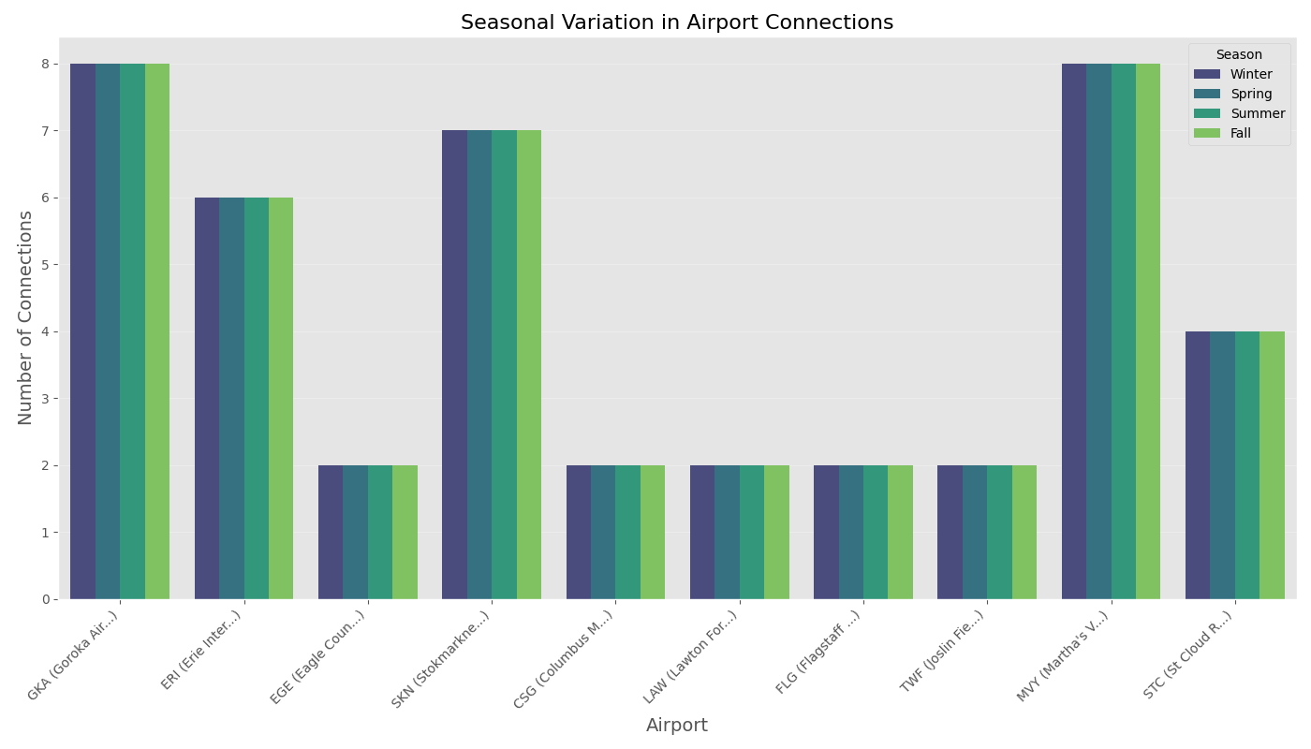
Fig. 4. Seasonal variation in airport connections for selected airports. The visualization shows consistent connection patterns across seasons for various airports including GKA (Goroka), ERI (Erie), EGE (Eagle), SKN (Stokmarknes), CSG (Columbus), LAW (Lawton), FLG (Flagstaff), TWF (Twin Falls), MYV (Marysville), and STC (St. Cloud).

TABLE I
SUMMARY OF NETWORK METRICS FOR THE GLOBAL FLIGHT NETWORK
Metric | Value
Number of Airports (Nodes) | 6,072
Number of Routes (Edges) | 67,663
Average Degree | 22.28
Network Diameter | 12
Average Path Length | 4.08
Clustering Coefficient | 0.62
Number of Communities | 23
Largest flight network communities table
V. DISCUSSION AND INSIGHTS

A. Geographic Communities
The network naturally divides into 24 distinct communities largely aligned with continental geography. The five largest communities are North American, European, East Asian, Middle Eastern/South Asian, and South American. This geographical clustering reflects both the physical constraints of air travel and the economic and political relationships between regions.

B. Hub Structural Roles
Different hub types—traffic volume hubs versus transfer hubs—drive network flow and resilience differently across regions. High-traffic volume hubs serve as endpoints for many routes, while transfer hubs primarily connect other airports. Each type plays a distinct role in network resilience and efficiency.

C. Policy and Investment Implications
The findings of this research have several practical implications:
- For Airlines: Optimizing hub-and-spoke systems based on identified community structures and considering seasonal adjustments to route offerings.
- For Airports: Smaller airports could improve connectivity by establishing routes to regional hubs rather than trying to connect to distant major hubs.
- For Regulators: Implementing policies to reduce network vulnerability by encouraging more distributed connectivity rather than concentration around a few mega hubs.
VI. CONCLUSION AND FUTURE WORK
This comprehensive analysis of the global flight network has revealed its scale-free structure, community organization, vulnerability to targeted disruptions, and seasonal dynamics. The findings provide valuable insights for stakeholders in the aviation industry to enhance network robustness and operational efficiency.

A. Future Research Directions
- Weighted Network Analysis: Integrate passenger volumes and real-time flight data to generate weighted graphs reflecting dynamic traffic flows.
- Predictive Disruption Modelling: Develop machine learning models (GNNs, GCNs) forecasting flight disruptions to optimize contingency planning and network resilience.
- Multimodal Transport Integration: Incorporate rail and sea networks to establish comprehensive multimodal mobility models enhancing intermodal connectivity.
By addressing these future research directions, we can develop an even deeper understanding of global transportation networks and their complex dynamics.
ACKNOWLEDGMENT
I would like to thank OpenFlights.org for providing the dataset used in this research.

REFERENCES
- R. Guimera, S. Mossa, A. Turtschi, and L. A. N. Amaral, ”The` worldwide air transportation network: Anomalous centrality, community structure, and cities’ global roles,” Proc. Natl. Acad. Sci., vol. 102, no. 22, pp. 7794–7799, 2005.
- D. Brockmann and D. Helbing, ”The hidden geometry of complex, network-driven contagion phenomena,” Science, vol. 342, no. 6164, pp. 1337–1342, 2013.
- M. Zanin and F. Lillo, ”Modelling the air transport with complex networks: A short review,” Eur. Phys. J. Spec. Top., vol. 215, no. 1, pp. 5–21, 2013.
- A. Cook, H. A. P. Blom, F. Lillo, R. N. Mantegna, S. Micciche, D. Rivas, R. Vazquez, and M. Zanin, ”Applying complexity science to air traffic management,” J. Air Transp. Manag., vol. 42, pp. 149–158, 2015.
- M. E. J. Newman, ”Modularity and community structure in networks,” Proc. Natl. Acad. Sci., vol. 103, no. 23, pp. 8577–8582, 2006.
- V. D. Blondel, J.-L. Guillaume, R. Lambiotte, and E. Lefebvre, ”Fast unfolding of communities in large networks,” J. Stat. Mech. Theory Exp., vol. 2008, no. 10, p. P10008, 2008.
- R. Albert, H. Jeong, and A.-L. Barabasi, ”Error and attack tolerance of´ complex networks,” Nature, vol. 406, no. 6794, pp. 378–382, 2000.
- C. M. Schneider, A. A. Moreira, J. S. Andrade, S. Havlin, and H. J. Herrmann, ”Mitigation of malicious attacks on networks,” Proc. Natl. Acad. Sci., vol. 108, no. 10, pp. 3838–3841, 2011.
- L. Sun, S. Wandelt, and X. Cao, ”On node criticality in air transportation networks,” Netw. Spat. Econ., vol. 17, no. 3, pp. 737–761, 2017.
- T. Lordan, J. M. Sallan, and P. Simo, ”Study of the topology and robustness of airline route networks from the complex network approach: A survey and research agenda,” J. Transp. Geogr., vol. 37, pp. 112–120, 2014.

