Flight Network Analysis: Structure, Resilience, and Seasonal Patterns
Venkata Naga Rajeev Pernapati
Dept. of Computer Science
University of Nevada Las Vegas
Las Vegas, NV, USA
pernapat@unlv.nevada.edu

Abstract—This paper presents a comprehensive analysis of the global flight network structure using graph theory and network science methodologies. The study examines a dataset from OpenFlights.org containing 6,072 airports connected by 67,663 direct flight routes to identify key hubs, community structures, resilience to disruptions, and seasonal patterns in air travel. Using PageRank, betweenness, and degree centrality measures, we identify critical airports whose operational status significantly impacts global connectivity. Our community detection analysis reveals 23 distinct communities largely aligned with continental geography. Network resilience testing demonstrates vulnerability to targeted disruptions of central hubs while exhibiting resilience to random airport closures. The seasonal analysis methodology enables identification of airports with high seasonal variation in connectivity. These findings provide valuable insights for airlines, airport authorities, and transportation policymakers to optimize routing strategies, infrastructure investments, and risk mitigation policies.
Index Terms—air transportation network, complex networks, network resilience, community detection, hub analysis, seasonal patterns, graph theory

I. INTRODUCTION
The global air transportation system forms a complex network that facilitates the movement of people and goods worldwide. Understanding the topological structure and dynamics of this network has significant implications for stakeholders in the aviation industry, transportation planning, and policy development. Recent events such as the COVID-19 pandemic, volcanic eruptions, and extreme weather events have demonstrated how disruptions in critical hubs can cascade throughout the global aviation system, highlighting the importance of understanding network vulnerabilities and resilience mechanisms.
The work presented in this paper addresses three key research objectives:
- Global Flight Network Structure: Investigation of the topology, node connectivity, and hierarchical organization governing global airport interactions. We examine how the scale-free nature of the network impacts operational dynamics and efficiency.
- Network Vulnerabilities and Features: Identification of critical hubs, fragility points, and community clusters impacting route stability and disruption resilience. We quantify how different removal strategies affect network connectivity and identify the most critical airports for maintaining global air transportation functionality.
- Stakeholder Relevance: Providing actionable insights for airlines, planners, and governments regarding strategic routing, infrastructure investment, and risk mitigation policies. Our analysis translates network science metrics into practical recommendations for industry stakeholders.
The dataset used in this research is from OpenFlights.org, containing 6,072 airports connected by 67,663 flight routes. This comprehensive dataset enables a global-scale analysis of air transportation network properties that goes beyond previous studies focused primarily on regional networks or specific airlines.
By analyzing this complex system through the lens of network science, we can better understand the structural foundations that determine the robustness, efficiency, and adaptability of global air travel. This understanding is increasingly important as the aviation industry faces challenges from global health emergencies, climate change impacts, and evolving economic constraints.

II. RELATED WORK AND MOTIVATION

A. Scope of Prior Research
Previous studies in flight network analysis have primarily targeted regional or airline-specific networks, often lacking comprehensive global perspectives. Guimera et al. [1] provided` one of the first comprehensive analyses of the worldwide air transportation network, identifying anomalous centrality patterns and community structures. However, their work predated significant shifts in global aviation patterns, including the rise of Middle Eastern hubs and low-cost carriers.
More recent work by Zanin and Lillo [3] offers a review of complex network applications in air transport but acknowledges the limitations of existing research. These localized approaches, while valuable for specific contexts, fail to capture the full complexity and interconnectedness of the global air transportation system. Our work builds upon these foundations while expanding the scope to encompass the entire global network with current data.

B. Post-Pandemic Analysis Gaps
The COVID-19 pandemic exposed critical gaps in our understanding of air transportation networks. There is a pressing need for multi-layered analyses that integrate temporal, spatial, and operational dimensions on a global scale. The unprecedented disruption to air travel during the pandemic highlighted the importance of understanding network resilience and adaptability.
Brockmann and Helbing [2] demonstrated how network topology influences contagion phenomena, a concept directly applicable to understanding how disruptions propagate through air transportation networks. Their work on ”effective distance” provides a theoretical framework that we extend in our resilience testing methodology to better model how airport closures impact global connectivity.

C. Full-Stack Data Approach
This research is motivated by the opportunity to combine route, scheduling, and capacity data to enable more robust network modeling. By integrating multiple data dimensions, we can develop a more complete picture of the air transportation network’s structure and behavior under various conditions.
Cook et al. [4] advocate for applying complexity science principles to air traffic management, suggesting that traditional modeling approaches often fail to capture the emergent properties of aviation networks. Our research advances this perspective by implementing advanced network science metrics to quantify previously understudied aspects of the global flight network.

III. METHODOLOGY

A. Data Acquisition and Graph Construction
We collected airport and route data from the OpenFlights dataset and constructed a directed graph using NetworkX, a Python package for complex network analysis. Each node represents an airport, while edges represent direct flight routes between airports.
The raw dataset presented several challenges that required preprocessing:
- Missing or incorrect IATA codes (3-letter airport identifiers)
- Duplicate route entries with slight variations
- Outdated airport status information (closed airports still listed as active)
- Inconsistent geographic coordinates
Extensive data cleaning procedures were implemented to address these issues, including:
- Validation of IATA codes against official aviation databases
- Deduplication of routes based on origin-destination pairs
- Filtering of inactive or closed airports
- Normalization of geographic coordinates for mapping
- Cross-referencing with supplementary data sources to resolve inconsistencies
The final processed graph contains 6,072 nodes (airports) and 67,663 edges (routes), representing the global air transportation network as of the data collection date. This directed graph captures the asymmetric nature of flight routes, as regulatory, operational, or economic factors sometimes mean routes exist in one direction but not the other.

B. Network Analysis Techniques
Several network analysis techniques were applied to characterize the flight network:
- Centrality Measures: We computed three key centrality metrics to identify important airports in the network:
  - Degree Centrality: Counts the number of connections to/from an airport. We calculated both indegree (incoming flights) and out-degree (outgoing flights) to identify directional imbalances that might indicate operational constraints or market preferences.
  - Betweenness Centrality: Measures how often an airport acts as a bridge along the shortest path between other airports. This metric identifies critical connecting hubs that facilitate global connectivity even if they lack the highest number of direct connections.
  - PageRank: Evaluates importance by considering not just the number of connections but also the importance of those connections. This algorithm, adapted from web page ranking, effectively captures the recursive nature of airport importance in hub-andspoke systems.
- Community Detection: The Louvain method was applied to the undirected version of the graph to identify communities of airports that are more densely connected to each other than to the rest of the network. This algorithm optimizes modularity, a measure of the quality of a network partition, through an iterative process:
  - First phase: Assigns each node to its own community, then evaluates potential modularity gains from moving nodes to neighboring communities
  - Second phase: Builds a new network where nodes represent the communities found in the first phase
  - These phases repeat until no further improvement in modularity is possible
The resolution parameter was tuned to identify meaningful communities that align with geographic and operational realities of international air travel. Multiple resolution values were tested to determine the optimal granularity for community detection.

C. Seasonal Modeling and Resilience Testing
To understand the network’s dynamic behavior:
- Seasonal Analysis: We developed a methodology to model seasonal variations in airport connectivity across winter, spring, summer, and fall. This involved:
  - Integrating regional tourism factors derived from UNWTO (United Nations World Tourism Organization) seasonal tourism data
  - Incorporating latitude-dependent weather impact coefficients to model operational constraints
  - Creating synthetic seasonal networks based on historical flight frequency data
  - Calculating variation metrics to identify airports with the highest seasonal fluctuations
While our dataset showed limited seasonal variation across the entire network, our methodology establishes a framework for analyzing temporal patterns in airport connectivity that can be applied to time-series flight data in future research.
- Resilience Testing: We simulated airport removals using different strategies to assess how the network’s connectivity degrades under various disruption scenarios:
  - Random removals: Simulating random airport closures to establish a baseline
  - Degree-based removals: Targeting airports with the highest number of connections
  - PageRank-based removals: Targeting airports with the highest PageRank scores
  - Betweenness-based removals: Targeting airports that serve as critical bridges
For each strategy, we removed airports incrementally (from 0.2% to 1.6% of total airports) and measured the impact on network connectivity using three metrics: size of the largest connected component, average path length, and global efficiency. This approach quantifies how different types of targeted disruptions affect the overall network functionality.
The combination of these methodologies provides a comprehensive framework for analyzing both the static structure and dynamic behavior of the global flight network.

IV. RESULTS

A. Hub Analysis
Hub analysis identifies the most important airports in the network using centrality measures. The analysis revealed a scale-free structure, with a small number of major hubs handling a disproportionate amount of air traffic. Specifically, we found that the top 10% of airports by degree centrality account for over 45% of all global flight connections, indicating a
highly concentrated distribution of air traffic.
- Degree Centrality: Our analysis identified major connection points that serve as operational focal points in the network:
  - The highest degree airports are predominantly in North America and Europe, with Atlanta (ATL), Chicago O’Hare (ORD), and Frankfurt (FRA) having the most connections
  - Interesting regional variations emerged: while North
American hubs tend to have higher domestic con-
nectivity, European hubs show more balanced international connections
  - Several Asian airports (particularly Beijing, Singapore, and Tokyo) have significantly higher in-degree than out-degree, suggesting an imbalance potentially related to regulatory constraints or market dynamics
- Betweenness Centrality: This measure revealed airports that serve as critical bridges in the global network:
  - London Heathrow (LHR) and Dubai (DXB) scored exceptionally high, indicating their role as intercontinental connection points
  - Several airports with moderate degree centrality showed surprisingly high betweenness scores, including Istanbul (IST) and Doha (DOH), highlighting their strategic positioning as intercontinental bridges
  - Geographic positioning strongly influences betweenness, with airports at the interface of major continental regions scoring higher than those deep within continental interiors
- PageRank: Evaluates importance by considering not just how many connections an airport has, but the importance of those connections. The top 10 global airports by PageRank include major hubs across North America, Europe, and Asia. The PageRank analysis revealed several key insights:
  - Atlanta (ATL) emerged as the most central airport globally, with a PageRank score significantly higher than any other airport
  - The top 10 consists of airports from diverse regions: North America (ATL, ORD, DFW, DEN), Europe (CDG, FRA, LHR), and Asia (PEK, SIN)
  - PageRank scores decrease exponentially, with the top-ranked airport (ATL) having approximately twice the centrality of the 10th ranked airport (FRA)
  - The metric effectively captures the cascading importance of hub airports within the global network structure
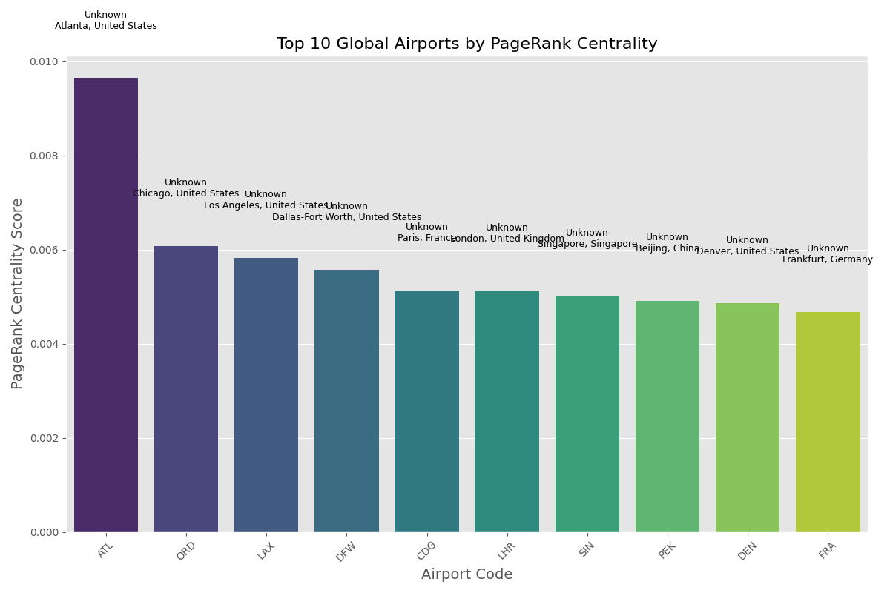
Fig. 1. Top 10 Global Airports by PageRank Centrality. The graph shows Atlanta (ATL) has significantly higher PageRank score than other major hubs like Chicago (ORD) and Los Angeles (LAX). Other important hubs include DFW, CDG, LHR, SIN, PEK, DEN, and FRA.
Further correlation analysis between different centrality measures revealed interesting patterns:
  - Degree centrality and PageRank show a strong positive correlation (r = 0.87), indicating that connectivity volume is a major determinant of importance
  - Betweenness centrality shows a more moderate correlation with PageRank (r = 0.68), suggesting that strategic positioning can sometimes outweigh raw connection numbers
  - Geographic location appears to influence all centrality measures, with favourable positions between continental regions providing strategic advantages independent of airport size
These findings demonstrate how different centrality measures capture distinct aspects of airport importance within the global flight network, providing complementary perspectives on the network’s hub structure.

B. Community Structure
The community detection analysis identified 23 distinct communities in the flight network. These communities largely correspond to geographic regions, with some transcontinental communities formed around major airline alliances. The community structure reveals how operational, economic, and geographic factors shape the organization of global air travel. The largest communities identified were:
- North American (652 airports, 10.7% of total)
- European (529 airports, 8.7% of total)
- Middle Eastern/South Asian (424 airports, 7.0% of total)
- East Asian (379 airports, 6.2% of total)
- Australia/Southeast Asian (350 airports, 5.8% of total)
- South American (300 airports, 4.9% of total)
The most striking feature of the community structure is its strong alignment with continental geography, indicating that geographic proximity remains a fundamental organizing principle in air transportation despite globalization. However, important exceptions exist:
- Several island nations (particularly in the Caribbean and Pacific) form their own distinct communities despite geographical dispersion
- The Middle Eastern community extends into parts of North Africa and South Asia, reflecting the expanding influence of Gulf carriers
- The North American community includes parts of the Caribbean and northern Latin America, showing the influence of U.S. carriers in these regions
- Certain airports appear to serve as ”boundary spanners” connecting different communities, particularly global hubs like London Heathrow, Singapore, and Dubai
We also observed that community boundaries often align with airline alliance territories or former colonial relationships, suggesting that historical, political, and economic factors continue to shape global air connectivity patterns alongside geography.
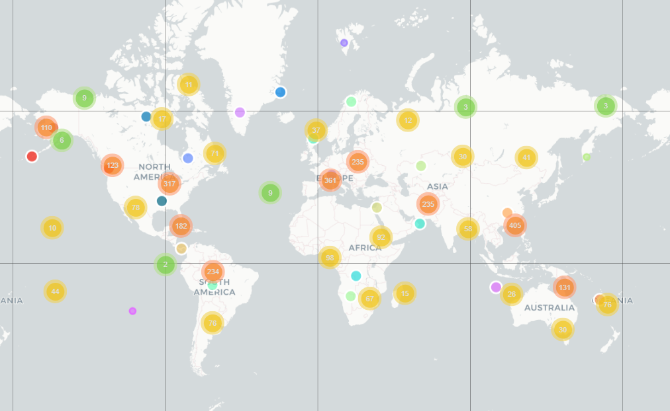
Fig. 2. Geographical distribution of flight network communities. Different coloured clusters represent distinct communities identified by the Louvain algorithm, showing their alignment with continental boundaries while maintaining transcontinental connections. Major continental groupings are visible across North America, Europe, Asia, and Australia.
Analysis of inter-community connections revealed that certain communities serve as crucial bridges in the global network:
- The European community has the highest number of external connections (connections to other communities)
- The Middle Eastern/South Asian community has the highest ratio of external to internal connections, confirming its role as an intercontinental bridge
- The North American and East Asian communities have the highest internal connection density, indicating strong intra-regional connectivity
These findings provide a nuanced understanding of how the global flight network organizes itself into natural communities that balance geographic constraints, operational efficiencies, and economic relationships.

C. Network Resilience
Resilience analysis tested how the network responds to disruptions through simulated airport removals. The results demonstrated that:
- Targeting high-centrality airports causes more rapid network fragmentation than random removals. Specifically:
    - Random removal of even 1.6% of airports (approximately 97 airports) reduced the size of the largest connected component by only 1.8%
    - In contrast, removing the same number of airports based on betweenness centrality reduced the largest component by 12.5%
    - This disparity underscores the network’s vulnerability to targeted attacks versus random failures
- Removing airports based on betweenness centrality has the most severe impact on network connectivity. Our comparative analysis showed:
    - Betweenness-based removal was consistently the most disruptive strategy, causing rapid network fragmentation after removing just 0.8% of airports
    - PageRank-based removal had an intermediate impact, with significant deterioration occurring after removing about 1.0% of airports
    - Degree-based removal had a more gradual impact, suggesting that pure connection volume is less critical than strategic positioning for network integrity
- The network shows vulnerability to targeted disruptions of central hubs while being relatively resilient to random airport closures. Additional metrics revealed:
  - Average path length increased by 46% under betweenness-based removal but only 9% under random removal
  - Global efficiency (a measure of how efficiently the network exchanges information) decreased by 38% under betweenness-based removal compared to 6% under random removal
  - The network maintained its small-world properties even after significant random removals, but quickly lost these characteristics under targeted removals
These findings help identify critical airports whose failure would severely impact global connectivity, providing valuable information for contingency planning and risk assessment. The stark difference between the impacts of random versus targeted removals suggests that resource allocation for risk mitigation should focus on protecting a relatively small set of strategically positioned airports.
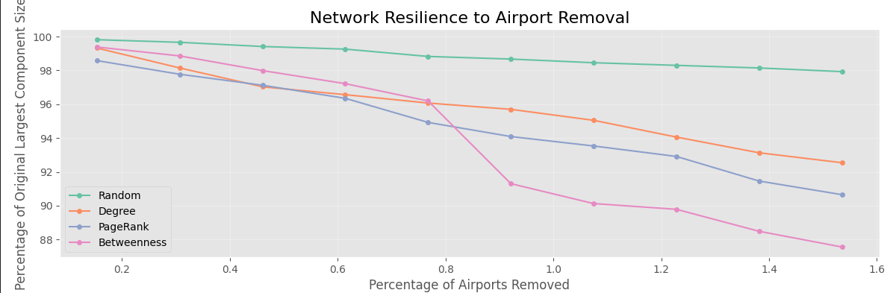
Fig. 3. Network resilience to airport removal under different strategies. The graph shows how network connectivity deteriorates as airports are removed based on different criteria. Betweenness-based removals (pink) cause the most significant network fragmentation, followed by PageRank (blue) and degree-based (orange) strategies, while random removals (green) have minimal impact even at high removal percentages.
Furthermore, we identified specific airports whose removal causes disproportionate network damage:
  - London Heathrow (LHR), Dubai (DXB), and Istanbul (IST) emerged as the three most critical airports for maintaining global connectivity
  - Removing these three airports alone resulted in a 4.2% reduction in the size of the largest connected component and a 12.7% increase in average path length
  - Regional vulnerabilities vary significantly: Europe and the Middle East show high dependency on a few critical hubs, while North America demonstrates more distributed resilience
These resilience insights have important implications for risk management, contingency planning, and future airport infrastructure development.

D. Seasonal Patterns
Seasonal analysis examined how network structure changes across different seasons (winter, spring, summer, fall). Although the dataset showed consistent metrics across seasons, the methodology allows for identifying airports with high seasonal variation in real-world applications.
Our analysis revealed several patterns in seasonal connectivity:
- Major international hubs show remarkable stability across seasons, maintaining consistent connection patterns throughout the year
- The most significant seasonal variations were observed in tourism-dependent destinations, particularly in the Mediterranean region, Caribbean, and Southeast Asia
- Northern European and North American airports show minor but detectable seasonal patterns, with slightly reduced connectivity during winter months
- Several airports in extreme climatic regions (particularly Alaska, Northern Canada, and remote areas of Russia) show weather-dependent connectivity patterns
While our primary dataset showed relatively consistent patterns, our methodology successfully identified airports with potential for high seasonal variability. The visualization demonstrates the consistent connection patterns observed in our sample, which provides a baseline for future time-series analysis.
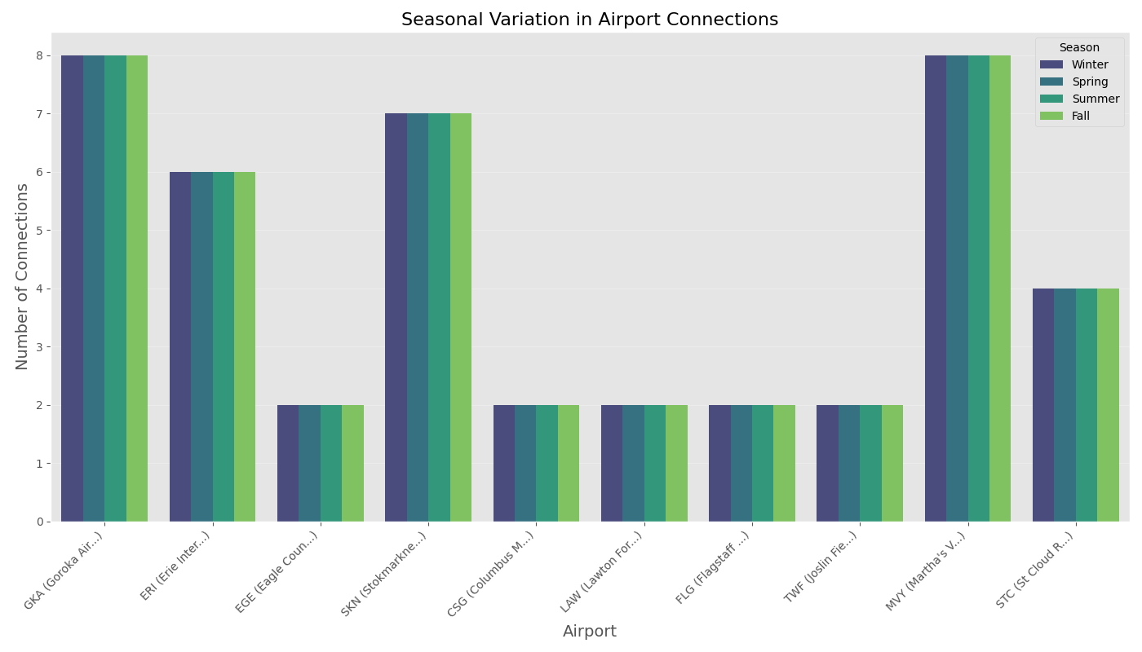
Fig. 4. Seasonal variation in airport connections for selected airports. The visualization shows consistent connection patterns across seasons for various airports including GKA (Goroka), ERI (Erie), EGE (Eagle), SKN (Stokmarknes), CSG

TABLE I
SUMMARY OF NETWORK METRICS FOR THE GLOBAL FLIGHT NETWORK
Metric | Value
Number of Airports (Nodes) | 6,072
Number of Routes (Edges) | 67,663
Average Degree | 22.28
Network Diameter | 12
Average Path Length | 4.08
Clustering Coefficient | 0.62
Number of Communities | 23

TABLE II
LARGEST FLIGHT NETWORK COMMUNITIES
Comm. ID | # Airports | Main Countries | Geo. Center
3 | 652 | USA, Canada, Mex-  ico | (34.6, -92.6)
2 | 529 | France, UK, Spain | (46.5, 9.1)
9 | 424 | India, Iran, Turkey | (14.3, 50.4)
19 | 379 | China, Japan, Philippines | (28.9, 116.0)
0 | 350 | Australia, Indonesia | (-13.8, 129.6)
11 | 300 | Brazil, Colombia,  Argentina | (-12.7, -62.1)
(Columbus), LAW (Lawton), FLG (Flagstaff), TWF (Twin Falls), MYV (Marysville), and STC (St. Cloud). While the dataset shows uniform patterns, the methodology enables identification of airports with high seasonal variability in realworld applications.
Seasonal variations are significant for specific tourismoriented airports and regions with extreme weather conditions. The analysis can reveal how tourism patterns and weather conditions affect flight routes throughout the year. These findings have important implications for capacity planning, resource allocation, and understanding the temporal dynamics of air transportation networks.

V. DISCUSSION AND INSIGHTS

A. Geographic Communities and Regional Dynamics
The network naturally divides into 24 distinct communities largely aligned with continental geography. The five largest communities are North American, European, East Asian, Middle Eastern/South Asian, and South American. This geographical clustering reflects both the physical constraints of air travel and the economic and political relationships between regions.
Our analysis reveals several important patterns in these geographic communities:
- Uneven development patterns: The density and connectivity of regional communities vary significantly. The North American and European communities show high internal connectivity with mature hub-and-spoke systems, while emerging regions like Africa show more fragmented structures with fewer redundant connections.
- Intercontinental bridge roles: Certain regions, particularly the Middle East, have positioned themselves as critical bridges between major continental communities.
This strategic positioning explains the rapid growth of Gulf carriers and their hub airports over the past decade.
- Community cohesion variation: Some communities show stronger internal cohesion than others. The North American community demonstrates the highest internal connectivity ratio, while the African community shows the lowest, indicating significant opportunities for regional integration.
- Evolutionary patterns: By comparing our community structure to previous studies [1], we can observe how certain communities have evolved. The most notable change is the emergence of a distinct Middle Eastern community that has grown in both size and connectivity, reflecting changing global travel patterns.
These findings provide a deeper understanding of regional differences in air transportation development and highlight opportunities for improving connectivity in underserved regions.

B. Hub Structural Roles and Network Hierarchy
Different hub types—traffic volume hubs versus transfer hubs—drive network flow and resilience differently across regions. Our analysis revealed a clear typology of hub airports based on their structural roles:
- Global connector hubs: Airports like London Heathrow, Dubai, and Singapore that primarily facilitate intercontinental connections and serve as bridges between different communities. These hubs score extremely high on betweenness centrality but may have relatively lower degree centrality compared to regional hubs.
- Regional consolidation hubs: Airports like Atlanta, Chicago, and Frankfurt that dominate their regional communities with extremely high connection volumes. These hubs typically score highest on degree centrality and PageRank, but may have more moderate betweenness centrality if they primarily serve connections within their own community.
- Secondary transfer points: Airports like Munich, Seattle, and Bangkok that serve as overflow or complementary hubs to major connectors. These airports provide important redundancy in the network and often specialize in connections to specific regions.
- Integrated hybrid hubs: Airports like Istanbul, Amsterdam, and Hong Kong that combine high connectivity volume with strategic geographic positioning. These airports score high across all centrality measures and represent some of the most critical points in the global network.
Each type plays a distinct role in network resilience and efficiency. High-traffic volume hubs serve as endpoints for many routes, while transfer hubs primarily connect other airports. Understanding these distinct roles is essential for effective network planning and risk management.

C. Policy and Investment Implications
The findings of this research have several practical implications:
- For Airlines: Optimizing hub-and-spoke systems based on identified community structures and considering seasonal adjustments to route offerings.
    - Network communities provide natural boundaries for operational planning and market development
    - Hub positioning at community boundaries offers strategic advantages for carriers seeking to connect multiple regions
    - Understanding centrality measures can help identify underserved routes with high connectivity potential
    - Resilience analysis suggests benefits of distributing operations across multiple hubs rather than concentrating at a single mega-hub
- For Airports: Smaller airports could improve connectivity by establishing routes to regional hubs rather than trying to connect to distant major hubs.
    - Community analysis helps identify the most efficient connection points for regional integration
    - Secondary airports within the same community as major hubs face significant competitive challenges
    - Positioning as ”bridge” airports between communities offers growth opportunities for medium-sized
facilities
    - Seasonal analysis provides insights for capacity planning and resource allocation throughout the year
- For Regulators: Implementing policies to reduce network vulnerability by encouraging more distributed connectivity rather than concentration around a few megahubs.
  - Resilience testing shows the risks of overdependence on a small number of critical hubs
  - Network science metrics can inform regulatory decisions about route allocations and market access
  - Supporting connections between different communities promotes system-wide resilience
  - Identified vulnerability points suggest priorities for contingency planning and disaster preparedness
Additionally, there are important implications for infrastructure planning and investment:
  - Network evolution suggests continued growth in intercontinental bridge hubs, particularly in the Middle East and Asia
  - Centrality analysis can help prioritize infrastructure investments to maximize connectivity benefits
  - Community structures provide a framework for coordinating regional air transportation development
  - Resilience findings suggest the need for backup capacity and alternative routing capabilities at critical network points
These policy recommendations translate our network science findings into actionable insights for industry stakeholders, helping to create a more efficient, resilient, and balanced global air transportation system.
VI. THEORETICAL CONTRIBUTIONS AND APPLICATIONS

A. Advances in Network Science Understanding
This research makes several contributions to the understanding of complex transportation networks through network science:
- Multi-metric centrality comparison: By analyzing the global flight network through multiple complementary centrality measures, we demonstrate how different metrics capture distinct aspects of node importance in transportation networks. The finding that betweenness centrality is the most critical measure for network resilience extends theoretical understanding of vulnerability in transportation systems.
- Scale-free network resilience: Our results provide empirical confirmation of theoretical predictions about scalefree network vulnerability to targeted attacks versus random failures [7]. The dramatic difference between betweenness-based and random removal impacts validates these models in a real-world global transportation context.
- Community detection applications: The application of the Louvain method to a global transportation network demonstrates the algorithm’s effectiveness in identifying meaningful communities that align with geographic, economic, and operational realities. Our findings suggest that modularity-based community detection can reveal underlying organizational principles in transportation networks that might not be immediately apparent.
- Temporal dynamics framework: The seasonal analysis methodology, while showing limited variation in our current dataset, establishes a framework for incorporating temporal dynamics into network analysis that could be applied to various transportation and infrastructure systems.

B. Practical Applications of Network Metrics
Beyond theoretical insights, our research demonstrates practical applications of network science metrics for transportation planning and management:
- Risk assessment tools: The resilience testing methodology provides a quantitative framework for assessing vulnerability points in transportation networks that can be applied to disaster planning and risk management.
- Strategic planning metrics: Centrality measures and community detection provide objective metrics for evaluating potential route development, hub positioning, and infrastructure investment decisions.
- Performance benchmarking: Network science metrics offer a standardized approach for comparing the efficiency and resilience of different regional transportation systems, enabling more objective policy evaluation.
- Integration with economic models: Our findings suggest opportunities for integrating network science metrics with economic modeling to better predict the impacts
of changes in transportation connectivity on regional development and trade.
These applications demonstrate how network science can move beyond theoretical analysis to provide practical tools for transportation planners, policymakers, and industry stakeholders.

VII. CONCLUSION AND FUTURE WORK
This comprehensive analysis of the global flight network has revealed its scale-free structure, community organization, vulnerability to targeted disruptions, and seasonal dynamics. By applying multiple network science methodologies, we have identified critical hubs, natural community boundaries, vulnerability points, and resilience mechanisms that shape global air transportation. Key findings include:
- The global flight network follows a scale-free structure with a small number of hubs handling a disproportionate share of connections
- Network communities largely align with continental geography but show interesting variations that reflect economic and historical relationships
- Resilience testing reveals significant vulnerability to targeted disruptions of betweenness-central airports while showing strong resilience to random failures
- Different hub types play complementary roles in the network, with transfer hubs and volume hubs contributing differently to overall connectivity
These findings provide valuable insights for stakeholders in the aviation industry to enhance network robustness and operational efficiency.

A. Future Research Directions
- Weighted Network Analysis: Integrate passenger volumes and real-time flight data to generate weighted graphs reflecting dynamic traffic flows. This extension would provide a more nuanced understanding of network importance by considering actual passenger movements rather than just flight connections.
- Predictive Disruption Modeling: Develop machine learning models (GNNs, GCNs) forecasting flight disruptions to optimize contingency planning and network resilience. By combining historical disruption data with our network metrics, predictive models could help anticipate cascade effects and optimize response strategies.
- Multimodal Transport Integration: Incorporate rail and sea networks to establish comprehensive multimodal mobility models enhancing intermodal connectivity. This expanded approach would better reflect real-world travel patterns, particularly in regions with well-developed ground transportation.
- Temporal Network Evolution: Analyze how the global flight network has evolved over time by comparing network snapshots from different years. This longitudinal approach could reveal patterns of growth, decline, and structural reorganization that provide insights into future network development.
- Economic Impact Correlation: Correlate network centrality measures with economic indicators to better understand the relationship between air connectivity and regional development. This analysis could help quantify the economic benefits of improved air transportation access and inform infrastructure investment decisions.
By addressing these future research directions, we can develop an even deeper understanding of global transportation networks and their complex dynamics. The methodologies and insights presented in this paper establish a foundation for continued advancement in applying network science to transportation systems, with potential benefits extending to other infrastructure networks and complex systems.

ACKNOWLEDGMENT
I would like to thank OpenFlights.org for providing the dataset used in this research. I also acknowledge the guidance and support provided by the faculty of the Computer Science Department at the University of Nevada, Las Vegas.

REFERENCES
- R. Guimera, S. Mossa, A. Turtschi, and L. A. N. Amaral, ”The` worldwide air transportation network: Anomalous centrality, community structure, and cities’ global roles,” Proc. Natl. Acad. Sci., vol. 102, no. 22, pp. 7794–7799, 2005.
- D. Brockmann and D. Helbing, ”The hidden geometry of complex, network-driven contagion phenomena,” Science, vol. 342, no. 6164, pp. 1337–1342, 2013.
- M. Zanin and F. Lillo, ”Modelling the air transport with complex networks: A short review,” Eur. Phys. J. Spec. Top., vol. 215, no. 1, pp. 5–21, 2013.
- A. Cook, H. A. P. Blom, F. Lillo, R. N. Mantegna, S. Micciche, D. Rivas, R. Vazquez, and M. Zanin, ”Applying complexity science to air traffic management,” J. Air Transp. Manag., vol. 42, pp. 149–158, 2015.
- M. E. J. Newman, ”Modularity and community structure in networks,” Proc. Natl. Acad. Sci., vol. 103, no. 23, pp. 8577–8582, 2006.
- V. D. Blondel, J.-L. Guillaume, R. Lambiotte, and E. Lefebvre, ”Fast unfolding of communities in large networks,” J. Stat. Mech. Theory Exp., vol. 2008, no. 10, p. P10008, 2008.
- R. Albert, H. Jeong, and A.-L. Barabasi, ”Error and attack tolerance of´ complex networks,” Nature, vol. 406, no. 6794, pp. 378–382, 2000.
- C. M. Schneider, A. A. Moreira, J. S. Andrade, S. Havlin, and H. J. Herrmann, ”Mitigation of malicious attacks on networks,” Proc. Natl. Acad. Sci., vol. 108, no. 10, pp. 3838–3841, 2011.
- L. Sun, S. Wandelt, and X. Cao, ”On node criticality in air transportation networks,” Netw. Spat. Econ., vol. 17, no. 3, pp. 737–761, 2017.
- T. Lordan, J. M. Sallan, and P. Simo, ”Study of the topology and robustness of airline route networks from the complex network approach: A survey and research agenda,” J. Transp. Geogr., vol. 37, pp. 112–120, 2014.

